Game Design Document

Fill up the following document

1. Write the title of your project.

BING BING BOO.

1. What is the goal of the game?

THE GOAL OF THE GAME IS TO FACE OBSTACLES AND REACH TILL

THE MIGHTY PORTAL.

1. Write a brief story of your game.

THERE IS NO SPECIFIC STORY OF THE GAME BUT YOU CAN SAY

THAT IT IS PARKOUR TYPE GAME.

1. Which are the playing characters of this game?

* Playing characters are the ones who respond to the user based on the input from the user.
* Cars, monkeys, dinos, wizards, etc., are the playing characters in the game.

|  |  |  |
| --- | --- | --- |
| Number | Character Name | What can this character do? |
| 1 | BING BING | THIS CHARCTER CAN MOVE N JUMP |
| 2 | - | - |
| 3 | - | - |
| 4 | - | - |
| 5 | - | - |
| 6 | - | - |
| 7 | - | - |
| 8 | - | - |

1. Which are the Non-Playing Characters of this game?

* Non-Playing characters are the ones that don't have an action or behavior when the user interacts with the game.
* Hurdles, stones, bananas, coins, etc., are non-playing characters in the game.

|  |  |  |
| --- | --- | --- |
| Number | Character Name | What can this character do? |
| 1 | BLOCK | THIS CHARACTER IS STATIC AND NO ONE CAN MOVE IT |
| 2 | MOVING BLOCK | THIS CHARCTER IS NOT STATIC BUT IT MOVE ON ITS OWN |
| 3 | PORTAL | THIS CHARACTER CAN TELEPORT PLAYERS FROM ONE PLACE TO ANOTHER |
| 4 | BOUNCY PAD | THIS CHARACTER CAN BOUNCE UP PLAYERS AT VERY HUGE DISTANCE |
| 5 | SPIKES | IF PLAYER TOUCHES THIS CHARACTER THE PLAYER WILL LOST |
| 6 | MIGHTY PORTAL | THIS CHARACTER IS BIGGER VERSION OF PORTAL AND THAT IS WHY IT CAN TELEPORT TO ANOTHER WORLD. |
| 7 | - | - |
| 8 | - | - |

Draw your imagination of this game. What does this game look like?

* Draw the game either on your computer or on paper.
* Add images of the game scenes to show each of the playing and non-playing characters at least once.

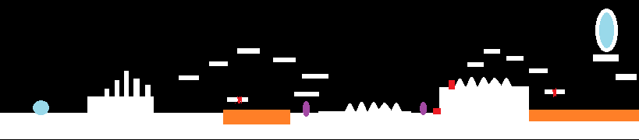

How do you plan to make your game engaging?

MY PLAN IS THAT AS PER THE PLAYER COMPLETE ONE LEVEL

THEN HE WILL PROMOTED TO NEXT LEVEL WHICH WILL BE MORE

DIFFICULT THAN FIRST. SO THE PLAYERS WILL TRY TO COMPLETE

THE LEVEL.