**CHAPTER 1**

**INTRODUCTION**

**CHAPTER 1**

**INTRODUCTION**

**1.1 NEED OF IPv6 AND ROUTING PROTOCOL ANALYSIS**

Now a days, computers have become tools which cannot be separated from our daily lives. From the simple task, up to the need to socialize using social networking sites such as facebook, twitter, etc. For this the Computers had to get connected to the remote host via internet initially, the computers in the network were using IPv4 addressing method. So that each computer can communicate with the other using it’s IP address as the identity while connected to the network. But IPv4 addressing space is limited and will soon be exhausted due to this reason IP protocol version 6 is developed.

IPv6 is the next generation IP protocol which will eventually replace the current protocol IPv4. IPv6 has number of improvements and simplifications when compared to IPv4.IPv6 has many advantages over IPv4 such as it provides large addressing space than IPv4, It includes quality of service mechanism, Increased security and many such advantages due to all these advantages of IPv6, In today’s world each and every networking company are willing to adopt IPv6 The basic requirement for developing an IPv6 network is routing and for this routing protocols are needed to be used therefore this project will conclude that which protocol amongst IS-IS, RIP, EIGRP, OSPF is best suited for an IPv6 networks.

**1.2 INTRODUCTION TO ROUTING**

Routing refers to the process of determining the best route for the transmission of data packets from source to destination and it is based upon routing protocols. Routing protocols are a set of rules which communication network follows when computers try to communicate with each other across networks and communication between two routing protocols is dependent upon the routing algorithm which is purely dependent upon the metrics to find the path to transfer the data across two networks. The metric can be defined as the cost of link which can be hop count, traffic, load at other end, bandwidth.

**1.3 INTRODUCTION TO ROUTING PROTOCOLS**

There are two types of routing protocols which are static and dynamic routing protocols, Static routing is manually configured routing technique in this static routes are fixed and do not change that is the route does not depend upon the metric. On the other hand dynamic routing is technique in which the routes are automatically decided depending upon the dynamic routing protocols It usually considers metric of a link to decide the routes.

There are again two types of dynamic routing protocols: Interior gateway protocol (IGP) and Exterior gateway protocol (EGP). Interior gateway protocols are used for routing within the autonomous system whereas exterior routing protocols are used for routing between the autonomous systems. Interior gateway protocols are EIGRP, RIP, OSPF, IS-IS and exterior gateway protocol is BGP.

RIP and EIGRP is a distance vector dynamic routing protocol that uses hop count as its routing metrics. OSPF and IS-IS is a link state routing protocol that uses cost and bandwidth as its routing metrics.

**ROUTING PROTOCOLS**

**INTERIOR GATEWAY**

**EXTERIOR GATEWAY**

**PATH VECTOR ROUTING**

**DISTANCE VECTOR ROUTING**

**LINK STATE ROUTING**

**BGP**

**RIP, EIGRP**

**OSPF, IS-IS**

**FIGURE 1.3:-ROUTING PROTOCOL CHART**

**CHAPTER 2**

**LITERATURE REVIEW**

**CHAPTER 2**

**LITERATRURE REVIEW**

**2.1 LITERATURE REVIEW 1**

**A comparative study on RIP and OSPF protocols**

The study of this paper represents a simple comparative study of RIP and OSPF protocols. It gives the information about RIP protocol and its versions such as RIP v1, RIP v2, RIPng. The difference between these versions is stated in the paper whereas it also gives information of OSPF and its versions The comparison between RIP and OSPF was carried out by considering parameters such as latency, Packet loss, Throughput, Convergence time**[1]**

At the end the result was concluded in the form of comparison graph. Here RIP sends the contents of the routing table every 30s whereas OSPF sends hello packets in every 10s and when any data is updated, it sends the updated data alone and not the whole routing database. RIP sends the whole routing information through periodic updates which overloads the network and results in unnecessary waste of bandwidth. RIP has higher convergence time than OSPF .OSPF on the other hand has fast convergence and efficiently uses the bandwidth. Since OSPF has fast convergence, packet loss is less. The throughput rate is higher for OSPF than RIP. Therefore all over analysis concludes that OSPF is better than RIP**[1]**

**2.2 LITERATURE REVIEW 2**

**RIP, OSPF, EIGRP Routing Protocols**

Study of this paper represents a detailed description of EIGRP, RIP, OSPF routing protocol and analysis of their performance. This paper also gives information about header format of the routing protocols. The performance analysis is based upon parameters such as router updates, Number of next hop updates, Utilization, Throughput, Queuing delay**[2]**

At the end result was been concluded depending upon performance of the protocols. It concluded that OSPF has the least cost of transmission and maximum throughput followed by EIGRP and RIP. In the case of queuing delay EIGRP has the least delay followed by OSPF, RIP EIGRP has the maximum link utilization followed by OSPF, and RIP**[2]**

**2.3 LITERATURE REVIEW 3**

**Performance evaluation of RIP and OSPF in IPv6 using opnet simulator 14.5**

The Study of this paper represents performance evaluation which was carried out for different routing protocol like RIP and OSPF for IPv6. OPNET simulation tool 14.5 was used to evaluate the performance of RIP and OSPF in three network models in which two network models will perform on one routing protocol only while the third are used to evaluate the performance of combination of RIP and OSPF protocols. The performance of these routing protocol are based on packet delay variation, end to end delay, traffic received, traffic sent, response time, jitter, page response time, object response time, traffic dropped for IPv6 Etc.**[3]**

By comparing these protocols performance, They have come across that the combined implementation of RIPNG and OSPFv3 routing protocol in the network in IPv6 performs better than individual RIPNG and individual OSPFv3. In the case of individual routing protocol performance, overall performance of OSPFv3 is better than RIPNG.**[3]**

**2.4 LITERATURE REVIEW 4**

**Performance evaluation of RIP and OSPF in IPv6 using opnet simulator 14.5**

In this paper they have evaluated the performance of different routing protocol like RIP and OSPF for IPv6. OPNET simulation tool 14.5 is used to evaluate the performance of RIP and OSPF in three network models in which two network models will perform on one routing protocol only while the third are used to evaluate the performance of these routing protocol are packet delay variation, end to end delay, traffic received, traffic sent, response time, jitter, page response time, object response time, traffic dropped for IPv6 Etc. They have designed three scenarios to compare their performance**.[4]**

In this work, the comparative performance among RIP, OSPF and combination of RIP and OSPF routing protocols in IPv6 for real time applications has been analyzed. By comparing these protocols performance, They have come across that the combined implementation of RIPNG and OSPFv3 routing protocol in the network in IPv6 performs better than RIPNG and OSPFv3. In the case of individual routing protocol performance, overall performance of OSPFv3 is better than RIPNG**.[4]**

**CHAPTER 3**

**PROBLEM STATEMENT**

Performance Evaluation and Analysis of RIP, OSPF,IS-IS and EIGRP Adaptive routing protocols in IPv6 network.

**CHAPTER 4**

**OBJECTIVES**

* . To Study the adaptive routing protocols
* To simulate EIGRP, RIP, OSPF, IS-IS networks using network simulator software and perform network analysis on hardware.
* To analyze and evaluate the performance of these protocols

**CHAPTER 5**

**METHODOLOGY**

**CHAPTER 5**

**METHODOLOGY**

**5.1 METHODOLOGY FOR SOFTWARE**

GNS3 Software is used to create a network consisting of switches, routers and computers. In this network the routers and computer ports are addressed using IPv6 addressing.

**IPv6 Addressing:-**

An IPv6 address is a 128-bit alphanumeric string that identifies an endpoint device in the Internet Protocol Version 6 (IPv6) addressing scheme. In more precise terms, an IPv6 address is 128 bits long and is arranged in eight groups, each of which is 16 bits.

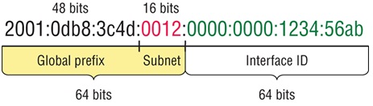

**FIGURE:-4.1 IPv6 Addressing**

After addressing we will configure the network based upon the protocols. Various routing protocols having different commands which are to be written in **CONFIG** terminal. The RIP, OSPF, EIGRP, IS-IS networks are then simulated using GNS3 and the performance of each network based upon the parameters will be evaluated using wireshark software by capturing packet which is been routed. And then result will be compared to get the efficient routing protocol for IPv6 network.

**5.1.1 PARAMETERS**

* **DELAY:-** Network delay is an important design and performance characteristic of a [computer network](https://en.wikipedia.org/wiki/Computer_network) or [telecommunications network](https://en.wikipedia.org/wiki/Telecommunications_network). The delay of a network specifies how long it takes for a bit of data to travel across the network from one node or endpoint to another. It is typically measured in multiples or fractions of seconds.

Delay is divided as follows:-

1. [**Processing delay**](https://en.wikipedia.org/wiki/Processing_delay)**–** time it takes router to process the packet header
2. [**Queuing delay**](https://en.wikipedia.org/wiki/Queuing_delay)**–** time the packet spends in routing queues
3. [**Transmission delay**](https://en.wikipedia.org/wiki/Transmission_delay)**–** time it takes to push the packet's bits onto the link
4. [**Propagation delay**](https://en.wikipedia.org/wiki/Propagation_delay)**–** time for a packet to reach its destination

* **THROUGHPUT:-** Throughput is a parameter that is used to know the speed of data transmission over a network. The throughput of a system is defined as the actual rate at which the information is sent over the channel. It is measured in bits/second or frames/second. However throughput is not same at every point in the network. It can have different values at different points.
* **PACKET LOSS:-**The performance of a network is also dependent on the number of packet lost during communication. When a packet arrives at a router, when some other packet is being processed, the recently arrived packet is stored in the input buffer of the router and waits for its turn. But the size of input buffer is however finite. Therefore, a time may come when it will be full and the next packet arriving at the buffer input has to be dropped. The lost packet need to be retransmitted by the source, this may result in over flow of input buffer and more loss of packet.

**5.1.2 PROCEDURAL BLOCK DIAGRAM OF SOFTWARE SIMULATION**

**SYSTEM UNDERSTANDING**

**SELECTION OF PARAMETERS USED FOR PERFORMANCE EVALUATION**

**SELECTION AND CREATING NETWORK MODEL**

**RUNNING SIMULATION**

**ST**

**COMPARATIVE ANALYSIS OF RESULT FROM DIFFERENT NETWORK MODEL**

**RESULTS**

**5.2 METHODOLOGY FOR HARDWARE:-**

* Make the connections between computers and routers using Ethernet cable. Select the cable between crossover and straight through depending upon the connections.
* By using console cable make connection between router and CPU of computer in order to configure the router.
* PUTTY software is used to configure the routers. RIP, OSPF, EIGRP, IS-IS network is configured using the commands.
* After configuring the routers check the network connection between two computers by using PING command.
* If the established connection is successful, Perform packet transferring, Then in wireshark do the packet capturing to evaluate the performance based upon parameters and do analysis on it.
* Perform analysis for every network and then compare the results to get the best routing protocol.

**CHAPTER 6**

**SYSTEM ARCHITECHTURE**

**CHAPTER 6**

**SYSTEM ARCHITECTURE**

**6.1 ROUTERS**

Router is a networking device which is used to forward the packets from source to destination. The main purpose of a router is to connect multiple networks and forward packets destined either for its own networks or other networks. Router performs the traffic directing operations on internet. 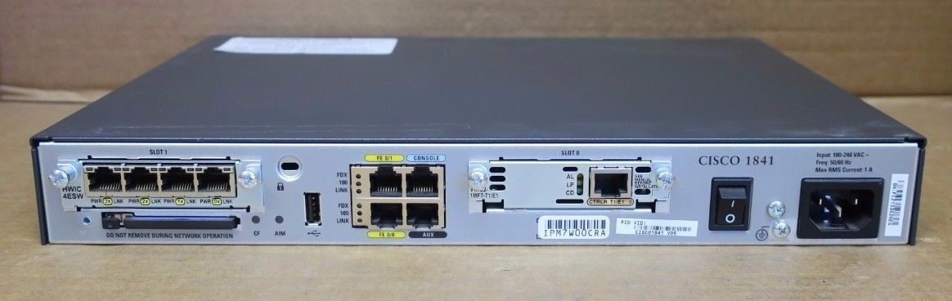

**FIGURE 6.1:- ROUTER**

When multiple routers are used in interconnected networks, the routers can exchange information about destination addresses using a [routing protocol](https://en.wikipedia.org/wiki/Routing_protocol). Each router builds up a [routing table](https://en.wikipedia.org/wiki/Routing_table) listing the preferred routes between any two systems on the interconnected networks.

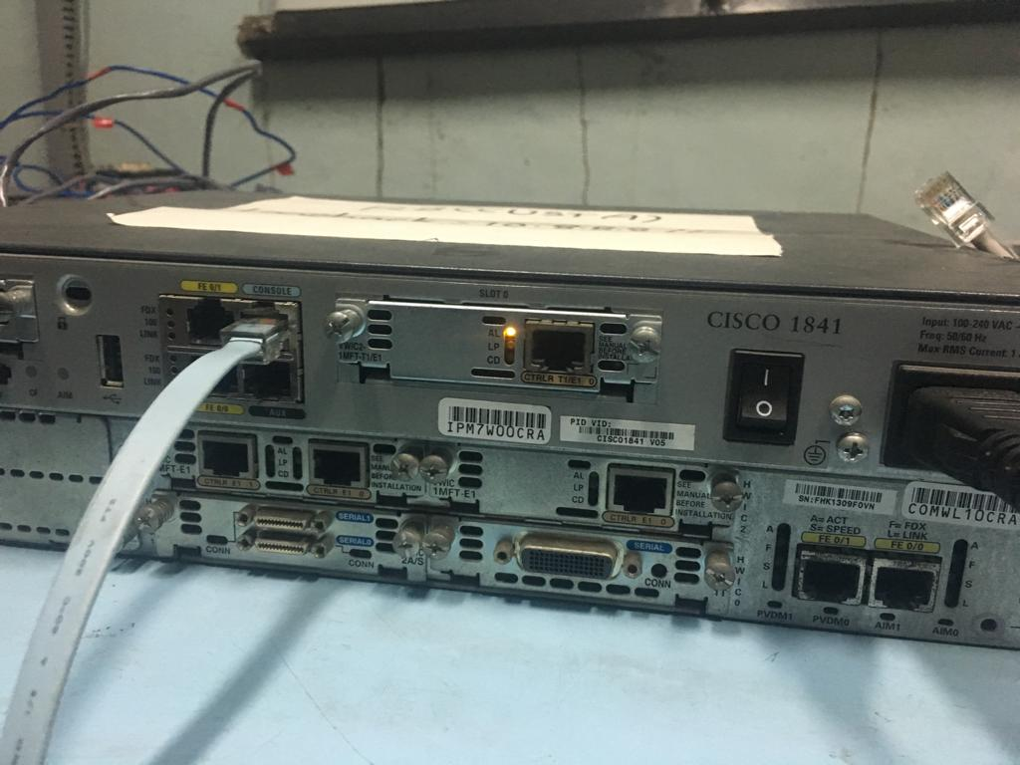

**FIGURE 6.1.:-ROUTER**

In router 3 ports are used for connection which are:-

* Fast Ethernet 0/0, Fast Ethernet 0/1 these ports are used to get connected to computer or any other router
* The 3rd port used is for console cable which is initially connected to CPU for configuring the router.

**4.2 CONSOLE CABLE**

Console cable is used for serial connection between the computer and router. It is connected to the serial port of computer CPU and other end is connected to the console port of router. This cable is typically flat and is light blue in color to help distinguish between other networking cable.

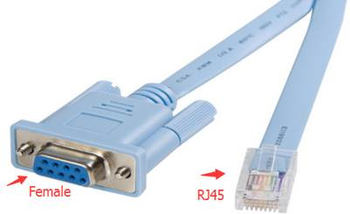

**FIGURE 6.2 :-CONSOLE CABLE**

It is connected to the console port of router in order to configure the router.

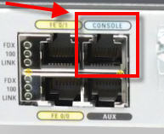

**FIGURE 6.2:- CONSOLE PORT OF ROUTER**

**6.3 ETHERNET CABLE**

The most popular LAN is called as Ethernet. It is bus based broadcast network with decentralized output. It is a system for connecting a number of computer systems to form a local area network, with protocols to control the passing of information and to avoid simultaneous transmission by two or more systems.

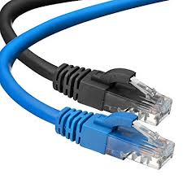

**FIGURE 6.3:- ETHERNET CABLE**

**6.3.1 TYPES OF ETHERNET CABLE**

* **Straight-Through cable**
* **Cross over cable**

**6.3.2 STRAIGHT-THROUGH CABLE**

A straight through cable is a type of twisted pair cable that is used in local area networks to connect a computer to a network hub such as a router. This type of cable is also sometimes called a patch cable and is an alternative to wireless connections where one or more computers access a router through a wireless signal. On a straight through cable, the wired pins match. Straight through cable use one wiring standard: both ends use T568A wiring standard or both ends use T568B wiring standard. The following figure shows a straight through cable of which both ends are wired as the T568B standard.

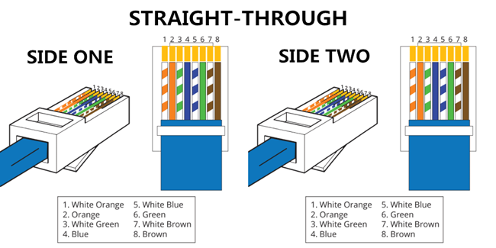

**FIGURE 6.3.2:- STRAIGHT-THROUGH CABLE**

**6.3.3 CROSS OVER CABLE**

An Ethernet crossover cable is a type of Ethernet cable used to connect computing devices together directly. Unlike straight through cable, crossover cables use two different wiring standards: one end uses the T568A wiring standard, and the other end uses the T568B wiring standard. The internal wiring of Ethernet crossover cables reverses the transmit and receive signals. It is most often used to connect two devices of the same type: e.g. two computers (via network interface controller) or two switches to each other.

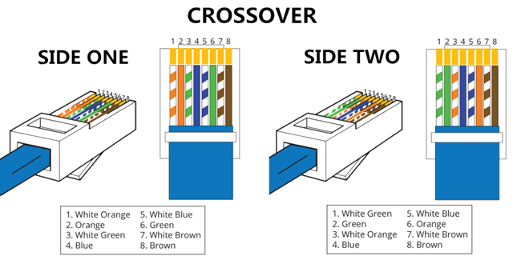

**FIGURE 6.3.3:- CROSS OVER CABLE**

**6.3.4 INTERNAL STRUCTURE OF ETHERNET CABLE**

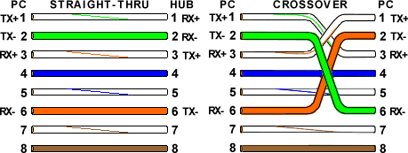

**FIGURE 6.3.4:- INTERNAL STRUCTURE OF ETHERNET CABLE**

As seen in straight through 1st wire and 2nd wire are the transmission wire on the sender side while at receiver side they act as receiver wires. Whereas 3rd and 6th wire at sender side act as receiver wires and at receiver side these wire are used for transmission. Remaining wires are unused.

In cross over 1st wire and 2nd wire are the transmission wire on the sender side while at receiver side 3rd and 6th  wires act as receiver wires. Whereas 3rd and 6th wire at sender side act as receiver wires and at receiver side 1st and 2nd wires are used for transmission.

**6.3.5 USE OF DIFFERENT TYPES OF ETHERNET**

Usually, straight through cables are primarily used for connecting unlike devices. And crossover cables are use for connecting unlike devices alike devices.

Below diagram shows the use:-

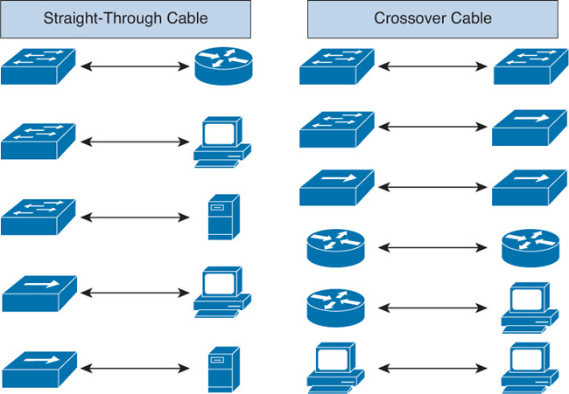

**FIGURE 6.3.5:- USE OF DIFFERENT TYPES OF ETHERNET**

**6.4 MAKING OF ETHERNET**

Ethernet is most important part of a network as it is used to connect the computers and routers. Based on the connection type we can have cross over or straight-through Ethernet. Ethernet cable can be generated using the crimping tool.

**Crimping Tool:-**

A Crimping Tool is used to crimp the RJ45 connector. Once the wires are set, the

connector is put between the slots and crimped by pressing the handles of the tool.

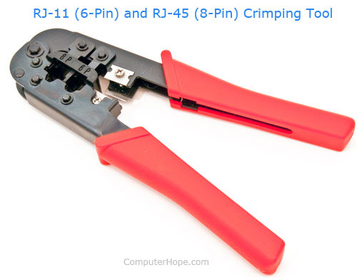

**FIGURE 6.4:-CRIMPING TOOL**

**6.5 SWITCH**

A network switch (also called switching hub, bridging hub, officially MAC bridge) is a [computer networking device](https://en.wikipedia.org/wiki/Computer_networking_device) that connects devices together on a [computer network](https://en.wikipedia.org/wiki/Computer_network) by using [packet switching](https://en.wikipedia.org/wiki/Packet_switching) to receive, process, and forward data to the destination device.

Multiple data cables are plugged into a switch to enable communication between different networked devices. Switches manage the flow of data across a network by transmitting a received [network packet](https://en.wikipedia.org/wiki/Network_packet) only to the one or more devices for which the packet is intended. Each networked device connected to a switch can be identified by its [network address](https://en.wikipedia.org/wiki/Network_address), allowing the switch to direct the flow of traffic maximizing the security and efficiency of the network.

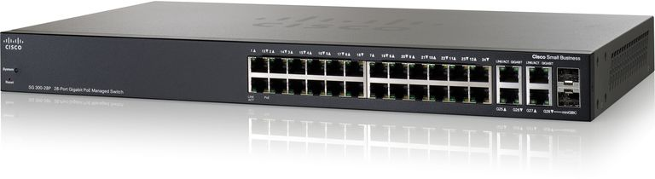

**FIGURE 6.5:-SWITCH**

**CHAPTER 7**

**NETWORK DESIGN**

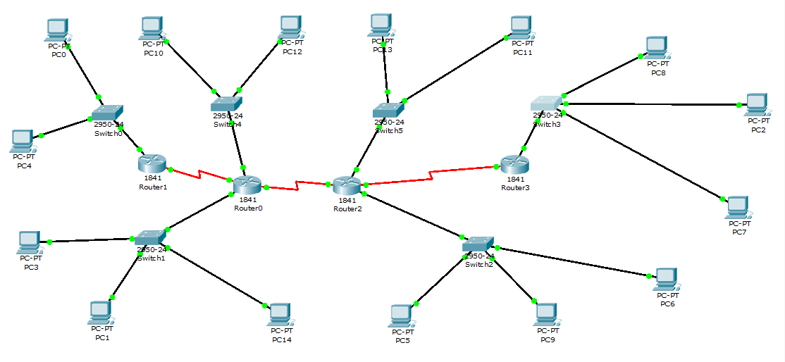

**FIGURE 7:- NETWORK DESIGN**

**NETWORK DESIGN CONSISTING OF 4 ROUTERS, 6 SWITCH’S AND 15 COMPUTERS**

**CHAPTER 8**

**EXPECTED RESULTS**

Comparative results of different protocol network models based on

* Delay
* Throughput
* Packet loss and various such parameters

**CHAPTER 9**

**REFERENCES**

**CHAPTER 9**

**REFERENCES**

* **[1] Megha Jaykumar, Dr.P.Bharathi “A comparative study on RIP and OSPF protocols” in *IEEE, 2nd International Conference on Innovations in Information Embedded and Communication Systems, 2015.***
* **[2] Zeyad Ghaleb Al-Mekhlafi and Rosilah Hassan “Evaluation Study on Routing Information Protocol and Dynamic Source Routing in Ad-Hoc Network” in *2011 7th International Conference on IT in Asia.***
* **[3] Mr. R. Jayaprakash, Ms. K. Saroja “ RIP, OSPF, EIGRP Routing Protocols” in *IJRCAR, Volume-3, Issue-7***
* **[4]Rajneesh Narula1, Pallavi Aggarwal “Performance evaluation of RIP and OSPF in IPv6 using opnet simulator 14.5” in International Journal of Technical Research and Volume 2, Issue 6 (Nov-Dec 2014)**
* **[5]Chandra Wijaya “Performance Analysis of Dynamic Routing Protocol EIGRP and OSPF in IPv4 and IPv6 Network” in 2011 First International Conference on Informatics and Computational Intelligence**
* **[6]Mr. R. Jayaprakash, Ms. K. Saroja “RIP, OSPF, EIGRP ROUTING Protocols” in INTERNATIONAL JOURNAL OF RESEARCH IN COMPUTER APPLICATIONS AND ROBOTICS ISSN 2320-7345**