SOFTWARE ENGINEERING

PRATICAL NO.01

Name : Omkar Londhe
PRN NO:202301040027
Batch:A4

Chosen Model: Iterative Development Model
For the Crop Disease Detection project, the Iterative Development Model has been adopted.

Justification for Selection
The Iterative model is the most suitable for an AI/ML-based application for the following reasons:
- Model Refinement: Machine learning is inherently experimental. We start with a base model (Iteration 1), evaluate its accuracy, and then refine the dataset or hyperparameters in subsequent iterations.
- Prototyping: It allows for the construction of a working prototype of the Android interface early, even while the high-accuracy deep learning model is still being trained.
- Risk Management: High risks, such as low model confidence or poor performance in low-light conditions, are identified and addressed in early cycles rather than at the end of the project.
- Feedback Loop: Performance metrics from the mobile app (inference speed, battery drain) directly inform the next round of model optimization.
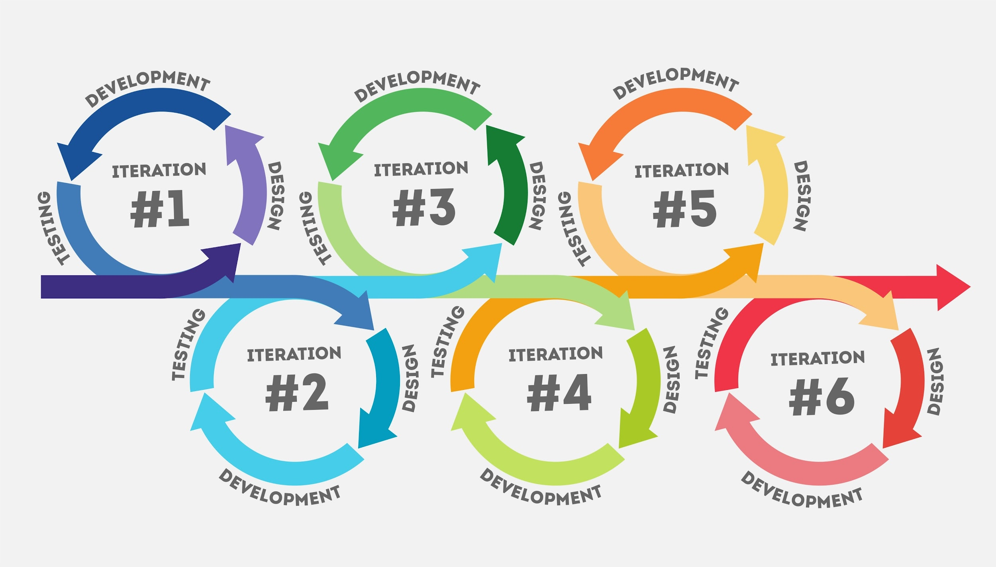
Shutterstock

Why Waterfall or V-Model is Avoided
- Waterfall: This model is too rigid. It assumes requirements and model performance are fixed from day one, which is impossible in deep learning where accuracy is discovered during the training process.
- V-Model: This focuses on strict verification of fixed requirements, leaving little room for the "trial and error" nature of tuning a Convolutional Neural Network (CNN).

Limitations of the Iterative Paradigm
Despite its benefits for ML, the Iterative model has several limitations:
- Resource Intensive: Each iteration requires repeating the phases of design, implementation, and testing, which can consume significant computational power (GPU/CPU).
- Scope Creep: Without strict management, the project can keep moving through iterations indefinitely as developers chase "perfect" accuracy.
- System Architecture Issues: Frequent changes to the model and app interface can sometimes lead to a messy underlying architecture if not properly refactored.
- Dependency Problems: Progress on the mobile app interface may be delayed if a specific iteration of the model fails to meet the minimum performance threshold.

Proposed Revised Paradigm: Agile (Scrum)
To overcome these limitations, a shift to the Agile (Scrum) paradigm is proposed for the long-term improvement of the system.

Justification for the Revised Paradigm
- Sprints for Feature Delivery: Developing in 2-week sprints allows for the delivery of specific features (e.g., "Leaf Spot Detection" or "Weather Integration") in a structured way.
- Continuous Integration: Unlike basic iterations, Agile emphasizes continuous testing and integration, ensuring that the Android app and the ML model stay synced and stable.
- Stakeholder Transparency: Regular "Daily Stand-ups" and "Sprint Reviews" ensure that the project remains focused on user needs, preventing scope creep.
- Flexibility with Precision: Agile allows us to pivot the training focus based on real-world data collected from early users, making the system more reliable across different crop types.
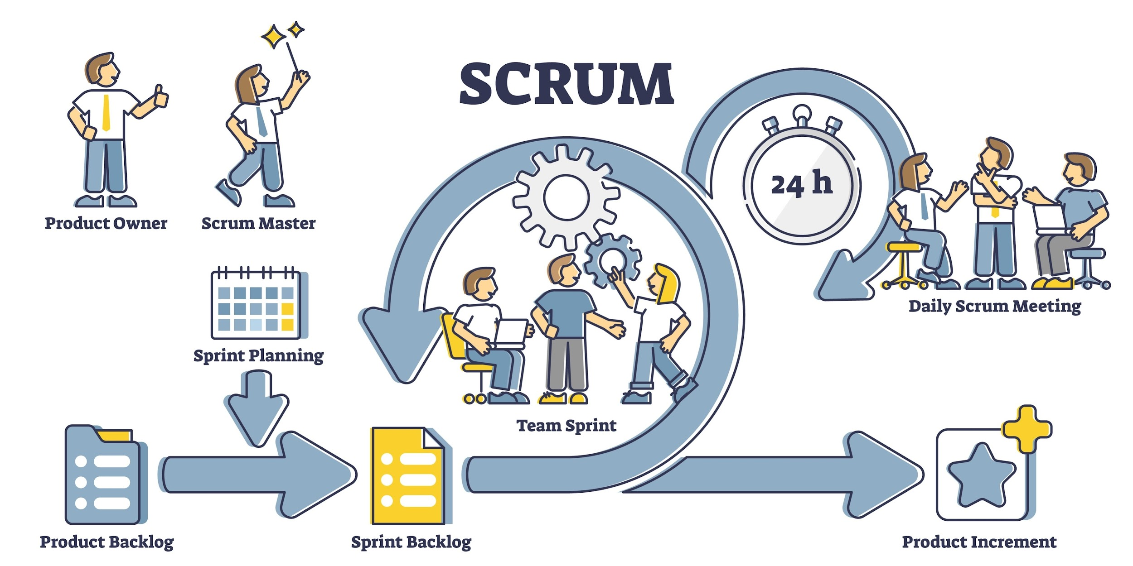
Shutterstock
Would you like me to help you draft the System Architecture or the Hardware/Software Requirements for this project?

