Software Requirements Specification (SRS)

Project: AI-Based Crop Disease Detection System
Version: 1.2
Status: Draft
Target Model: MobileNetV2 (CNN)
Platform: Android (Client) & Firebase (Backend)

1. Introduction

1.1 Purpose
The purpose of this document is to provide a detailed description of the Crop Disease Detection System. It covers the functional and non-functional requirements, system architecture, and user interfaces. This project aims to help farmers identify crop diseases in real-time using image processing.

1.2 Scope
The system uses a MobileNetV2 architecture trained on a leaf dataset (e.g., PlantVillage). Users can capture or upload images of infected leaves via an Android app. The app will then classify the disease and provide recommended treatments or precautions.

1.3 Definitions and Abbreviations
- CNN: Convolutional Neural Network
- MobileNetV2: A lightweight deep learning model optimized for mobile devices.
- TFLite: TensorFlow Lite, used for running ML models on mobile.
- SDLC: Software Development Life Cycle.
- Dataset: A collection of labeled images used for training.

2. Overall Description

2.1 Product Perspective
This is a standalone mobile application that interacts with a cloud database (Firebase) for user authentication and disease history storage. The core processing happens locally (via TFLite) or via a cloud API.

2.2 Product Functions
- Image Capture: Using the mobile camera to take photos of leaves.
- Disease Diagnosis: Identifying the disease using the trained ML model.
- Treatment Suggestion: Providing localized solutions for the detected disease.
- History Tracking: Saving previous scans for the user to monitor crop health over time.
- Offline Support: Basic detection capabilities without active internet (if TFLite is used).

2.3 User Classes and Characteristics
- Farmers: Primary users with basic technical knowledge.
- Agricultural Students/Researchers: Users interested in testing model accuracy and data.

2.4 Design and Implementation Constraints
- The model must be under 50MB to ensure smooth mobile performance.
- Requires a high-quality dataset for high accuracy (minimum 85%).
- Android version 8.0 (Oreo) or higher is required.

3. Software Development Life Cycle (SDLC) Model

3.1 Primary Choice: Iterative Development Model
The Iterative model is the most suitable for an AI/ML-based project like Crop Disease Detection for the following reasons:
- Continuous Model Refinement: Machine learning is inherently an experimental process. The iterative approach allows us to start with a baseline model (Iteration 1), rigorously evaluate its accuracy, and then continuously improve it by adjusting the dataset or hyperparameters in subsequent cycles.
- Early Prototyping: A functional prototype of the Android application can be developed and tested in early iterations, even as the high-accuracy disease detection model undergoes further training and optimization.
- Effective Risk Mitigation: Major risks, such as achieving low model confidence or ensuring reliable performance under poor lighting conditions, are identified and actively addressed early in the development lifecycle, preventing costly surprises at the end of the project.
- Performance-Driven Feedback Loop: Real-world performance metrics from the mobile application (e.g., inference speed and battery consumption) provide crucial data that directly informs and guides the next round of model and application optimization.

3.2 Secondary/Alternative Choice: Spiral Model
If the Iterative model is not utilized, the Spiral Model is the best alternative for this project.
Why the Spiral Model fits:
- Risk-Driven Approach: The biggest risk in this project is "Model Failure" (the AI not being accurate enough for field use). The Spiral model focuses on identifying and mitigating these risks in every quadrant.
- Evolutionary Prototyping: Each "spin" of the spiral produces a more refined prototype. For example:
  - Spiral 1: Basic model (Detects 2 diseases).
  - Spiral 2: Optimized model (Detects 10 diseases + lower latency).
  - Spiral 3: Full app integration with Firebase.
- Customer Evaluation: In each cycle, the "product" can be shown to agricultural experts to ensure the treatment suggestions are scientifically accurate.

3.3 Why Waterfall or V-Model is Avoided
- Waterfall: Too rigid. It assumes requirements and model performance are fixed from day one, which is impossible in deep learning where accuracy is discovered during training.
- V-Model: Focuses on strict verification of fixed requirements, leaving little room for the experimentation required to tune a MobileNetV2 architecture.

4. System Features (Functional Requirements)

4.1 User Authentication
- REQ-1: The system shall allow users to sign up and log in using email or Google Auth (via Firebase).
- REQ-2: The system shall maintain a user profile including name and farm location.

4.2 Image Processing & Detection
- REQ-3: The system shall allow the user to capture a real-time image using the camera.
- REQ-4: The system shall provide a classification result (Disease Name + Confidence Score) within 3 seconds.
- REQ-5: The model shall be able to identify at least 10 common crop diseases (e.g., Potato Early Blight, Tomato Leaf Mold).

4.3 Information Dissemination
- REQ-6: For every detected disease, the system shall display "Symptoms," "Causes," and "Treatment Measures."

4.4 History & Data Management
- REQ-7: The system shall store scan results in Firebase Firestore for later retrieval.

5. Non-Functional Requirements

5.1 Performance
- Latency: The detection logic (MobileNetV2 inference) should take less than 2 seconds on mid-range devices.
- Accuracy: The model should achieve a minimum of 90% validation accuracy during the training phase.

5.2 Scalability
- The system should handle up to 1000 concurrent users using Firebase's scalable infrastructure.

5.3 Usability
- The UI should be simple, using icons and minimal text to accommodate users with varying literacy levels.

5.4 Availability
- The cloud-based features (History/Authentication) should have 99.9% uptime.

6. System Architecture
- Frontend: XML/Compose for Android UI, Java/Kotlin for logic.
- ML Engine: TensorFlow Lite (MobileNetV2 .tflite file).
- Backend: Firebase Auth, Firestore (Database), Firebase Storage (for images).

7. External Interface Requirements

7.1 User Interfaces
- Dashboard: Shows recent scans and a "Scan Now" button.
- Camera Interface: Overlay showing the target area for the leaf.
- Result Screen: Card-based layout showing disease details and an accuracy percentage.

7.2 Software Interfaces
- Android SDK: For mobile OS interaction.
- Camera2 API: For high-resolution image capture.
- Firebase SDK: For database and auth integration.

8. Visual Documentation
- Figure 1:
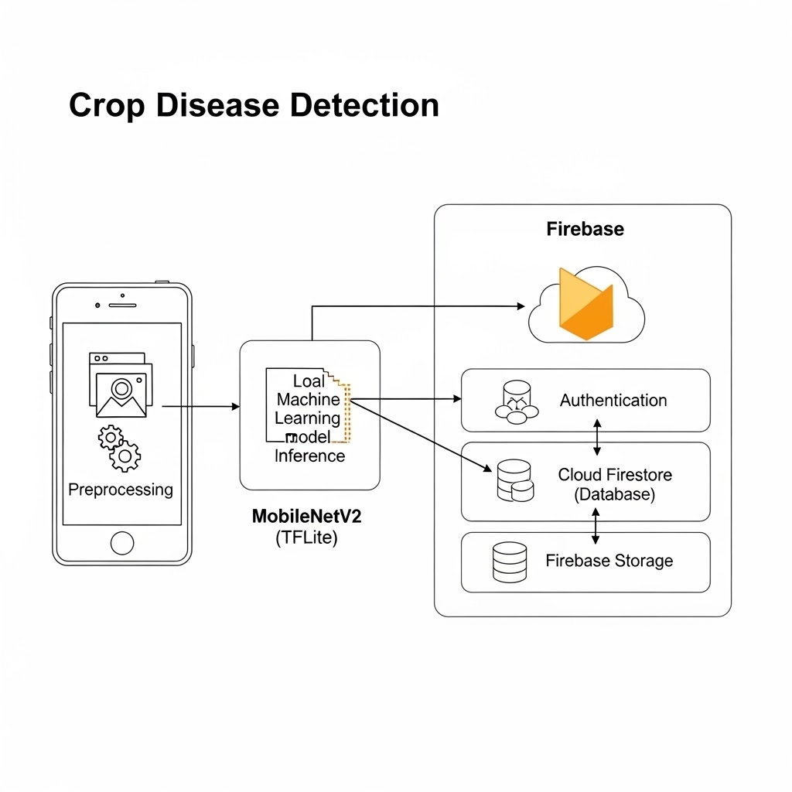
- Figure 2: Workflow Diagram
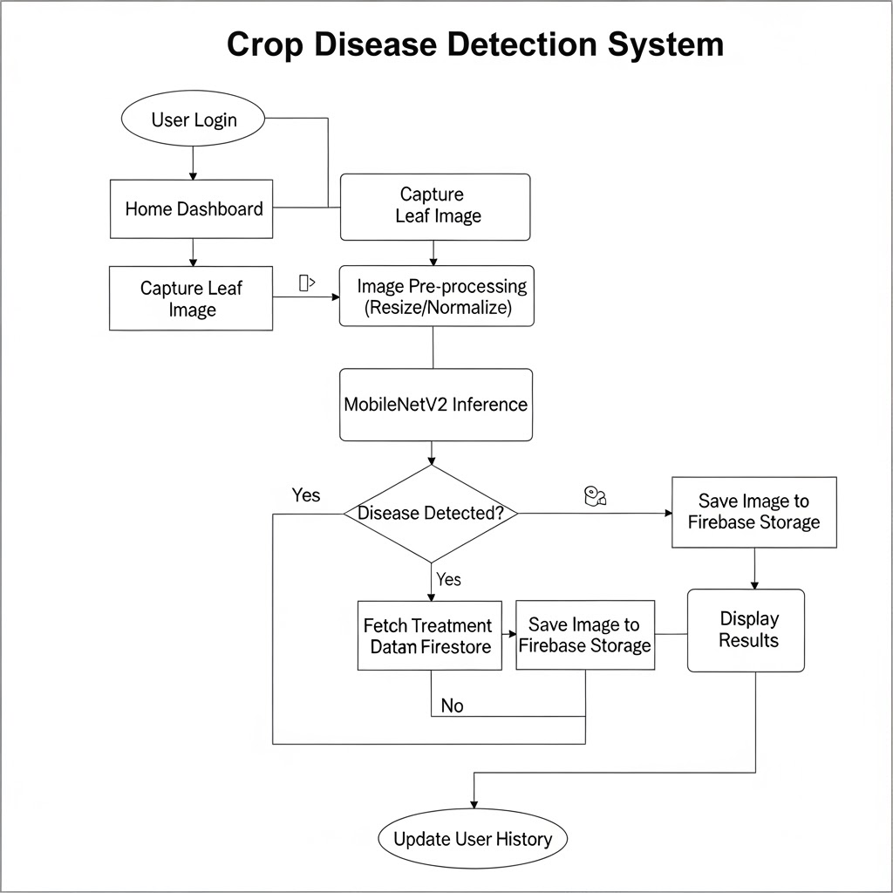
- Figure 3: Use Case Diagram (Standardized)

