Q.1. Implementation of Logistic Regression.
# Implementation of Logistic Regression
# Google Colab Ready Program

# Step 1: Import Libraries
import numpy as np
import pandas as pd
import matplotlib.pyplot as plt

from sklearn.datasets import load_breast_cancer
from sklearn.model_selection import train_test_split
from sklearn.linear_model import LogisticRegression
from sklearn.metrics import accuracy_score
from sklearn.metrics import confusion_matrix
from sklearn.metrics import classification_report

# Step 2: Load Dataset

data = load_breast_cancer()

X = data.data
y = data.target

print("Feature Shape:", X.shape)
print("Target Shape:", y.shape)

# Step 3: Split Dataset
X_train, X_test, y_train, y_test = train_test_split(
X,
y,
test_size=0.2,
random_state=42
)

# Step 4: Create Logistic Regression Model

model = LogisticRegression(max_iter=5000)

# Train Model
model.fit(X_train, y_train)

# Step 5: Predictions

y_pred = model.predict(X_test)

print("\nPredicted Values:")
print(y_pred)

# Step 6: Accuracy

accuracy = accuracy_score(y_test, y_pred)

print("\nAccuracy of Logistic Regression:")
print(accuracy)

# Step 7: Confusion Matrix

cm = confusion_matrix(y_test, y_pred)

print("\nConfusion Matrix:")
print(cm)

# Step 8: Classification Report

report = classification_report(y_test, y_pred)
print("\nClassification Report:")
print(report)
# Step 9: Plot Actual vs Predicted

plt.figure(figsize=(8,5))

plt.plot(y_test[:30], label='Actual')
plt.plot(y_pred[:30], label='Predicted')

plt.title("Actual vs Predicted")
plt.xlabel("Samples")
plt.ylabel("Class")

plt.legend()

plt.show()

OutPut:
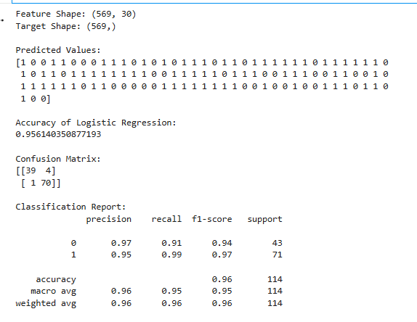
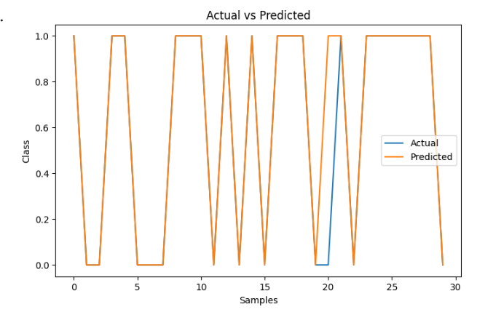

Q.2. Implementation of Classifying data using Support Vector Machine(SVM).
# Implementation of Support Vector Machine (SVM)

# Step 1: Import Libraries
import numpy as np
import pandas as pd
import matplotlib.pyplot as plt

from sklearn.datasets import load_iris
from sklearn.model_selection import train_test_split
from sklearn.svm import SVC
from sklearn.metrics import accuracy_score
from sklearn.metrics import confusion_matrix
from sklearn.metrics import classification_report

# Step 2: Load Dataset

iris = load_iris()

X = iris.data
y = iris.target

print("Feature Shape:", X.shape)
print("Target Shape:", y.shape)

# Step 3: Split Dataset

X_train, X_test, y_train, y_test = train_test_split(
X,
y,
test_size=0.2,
random_state=42
)
# Step 4: Create SVM Model

model = SVC(kernel='linear')

# Train Model
model.fit(X_train, y_train)

# Step 5: Predict Values

y_pred = model.predict(X_test)

print("\nPredicted Values:")
print(y_pred)

# Step 6: Accuracy

accuracy = accuracy_score(y_test, y_pred)

print("\nAccuracy of SVM:")
print(accuracy)

# Step 7: Confusion Matrix

cm = confusion_matrix(y_test, y_pred)

print("\nConfusion Matrix:")
print(cm)

# Step 8: Classification Report

report = classification_report(y_test, y_pred)

print("\nClassification Report:")
print(report)

# Step 9: Plot Actual vs Predicted
plt.figure(figsize=(8,5))

plt.plot(y_test[:30], label='Actual')
plt.plot(y_pred[:30], label='Predicted')

plt.title("Actual vs Predicted using SVM")
plt.xlabel("Samples")
plt.ylabel("Class")

plt.legend()

plt.show()

OUTPUT:
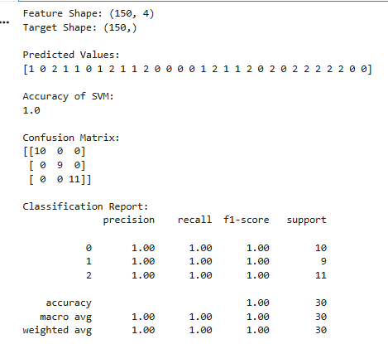
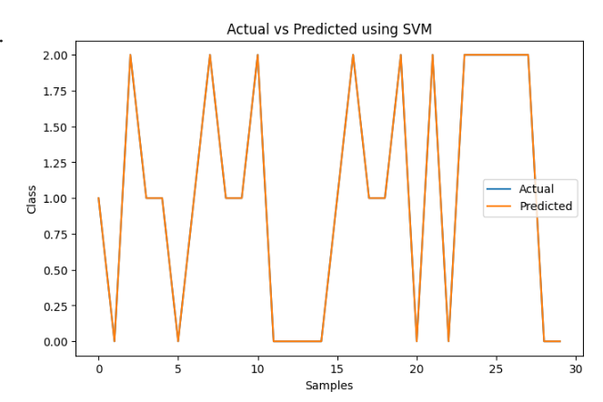

Q.3. Implement Elbow method or K-means Clustering.
#Implementation of K-Means Clustering with Elbow Method

# Step 1: Import Libraries
import numpy as np
import matplotlib.pyplot as plt

from sklearn.datasets import make_blobs
from sklearn.cluster import KMeans

# Step 2: Create Dataset

X, y = make_blobs(
n_samples=300,
centers=4,
cluster_std=1.0,
random_state=42
)

print("Dataset Shape:", X.shape)

# Step 3: Apply Elbow Method

wcss = []

# Try different K values
for i in range(1, 11):

kmeans = KMeans(
n_clusters=i,
init='k-means++',
random_state=42
)
kmeans.fit(X)

# Store WCSS value
wcss.append(kmeans.inertia_)

# Step 4: Plot Elbow Graph

plt.figure(figsize=(8,5))

plt.plot(range(1, 11), wcss, marker='o')

plt.title("Elbow Method")
plt.xlabel("Number of Clusters")
plt.ylabel("WCSS")

plt.show()

# Step 5: Apply K-Means with Optimal Clusters

kmeans = KMeans(
n_clusters=4,
init='k-means++',
random_state=42
)

y_kmeans = kmeans.fit_predict(X)

# Step 6: Visualize Clusters

plt.figure(figsize=(8,6))
# Plot clusters
plt.scatter(
X[:,0],
X[:,1],
c=y_kmeans,
cmap='viridis',
s=50

)
# Plot centroids
plt.scatter(
kmeans.cluster_centers_[:,0],
kmeans.cluster_centers_[:,1],
color='red',
marker='X',
s=300,
label='Centroids'
)

plt.title("K-Means Clustering")
plt.xlabel("Feature 1")
plt.ylabel("Feature 2")

plt.legend()

plt.show()

OUTPUT:
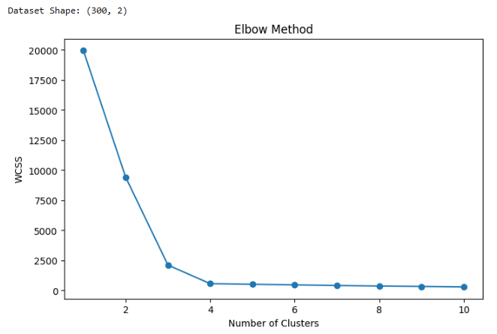
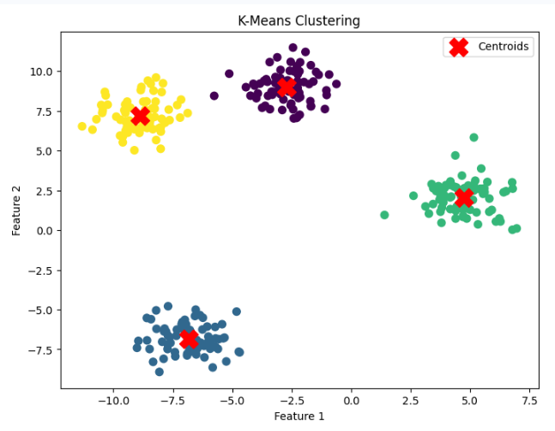

Q.4. Implementation of Bagging Algorithm: Random Forest.
#Implementation of Bagging Algorithm : Random Forest

# Step 1: Import Libraries
import numpy as np
import pandas as pd
import matplotlib.pyplot as plt

from sklearn.datasets import load_iris
from sklearn.model_selection import train_test_split
from sklearn.ensemble import RandomForestClassifier

from sklearn.metrics import accuracy_score
from sklearn.metrics import confusion_matrix
from sklearn.metrics import classification_report

# Step 2: Load Dataset

iris = load_iris()

X = iris.data
y = iris.target

print("Feature Shape:", X.shape)
print("Target Shape:", y.shape)

# Step 3: Split Dataset

X_train, X_test, y_train, y_test = train_test_split(
X,
y,
test_size=0.2,
random_state=42
)

# Step 4: Create Random Forest Model

model = RandomForestClassifier(
n_estimators=100,
random_state=42
)

# Train Model
model.fit(X_train, y_train)

# Step 5: Predict Values

y_pred = model.predict(X_test)

print("\nPredicted Values:")
print(y_pred)

# Step 6: Accuracy

accuracy = accuracy_score(y_test, y_pred)

print("\nAccuracy of Random Forest:")
print(accuracy)

# Step 7: Confusion Matrix

cm = confusion_matrix(y_test, y_pred)

print("\nConfusion Matrix:")
print(cm)

# Step 8: Classification Report

report = classification_report(y_test, y_pred)
print("\nClassification Report:")

print(report)

# Step 9: Feature Importance

importance = model.feature_importances_

feature_names = iris.feature_names

print("\nFeature Importance:")

for i in range(len(feature_names)):
print(feature_names[i], ":", importance[i])

# Step 10: Plot Feature Importance

plt.figure(figsize=(8,5))

plt.bar(feature_names, importance)

plt.title("Feature Importance in Random Forest")
plt.xlabel("Features")
plt.ylabel("Importance")

plt.xticks(rotation=15)

plt.show()

OUTPUT:
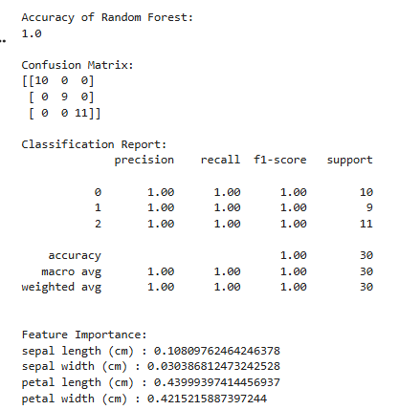
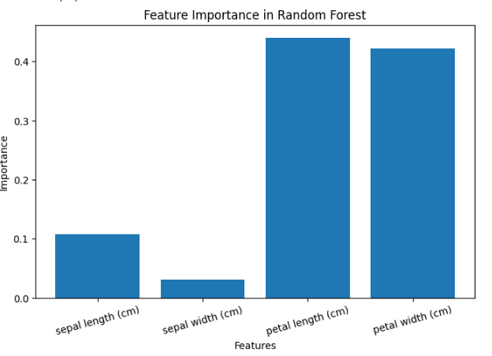

Q.5.Implementation of Boosting Algorithms: AdaBoost.
# Implementation of Boosting Algorithm : AdaBoost

# Step 1: Import Libraries
import numpy as np
import pandas as pd
import matplotlib.pyplot as plt

from sklearn.datasets import load_iris
from sklearn.model_selection import train_test_split
from sklearn.ensemble import AdaBoostClassifier

from sklearn.metrics import accuracy_score
from sklearn.metrics import confusion_matrix
from sklearn.metrics import classification_report

# Step 2: Load Dataset

iris = load_iris()

X = iris.data
y = iris.target

print("Feature Shape:", X.shape)
print("Target Shape:", y.shape)

# Step 3: Split Dataset

X_train, X_test, y_train, y_test = train_test_split(
X,
y,
test_size=0.2,
random_state=42
)

# Step 4: Create AdaBoost Model

model = AdaBoostClassifier(
n_estimators=100,
learning_rate=1.0,
random_state=42
)

# Train Model
model.fit(X_train, y_train)

# Step 5: Predict Values

y_pred = model.predict(X_test)

print("\nPredicted Values:")
print(y_pred)

# Step 6: Accuracy

accuracy = accuracy_score(y_test, y_pred)

print("\nAccuracy of AdaBoost:")
print(accuracy)

# Step 7: Confusion Matrix

cm = confusion_matrix(y_test, y_pred)

print("\nConfusion Matrix:")
print(cm)

# Step 8: Classification Report
report = classification_report(y_test, y_pred)

print("\nClassification Report:")
print(report)

# Step 9: Feature Importance

importance = model.feature_importances_

feature_names = iris.feature_names

print("\nFeature Importance:")

for i in range(len(feature_names)):
print(feature_names[i], ":", importance[i])

# Step 10: Plot Feature Importance

plt.figure(figsize=(8,5))

plt.bar(feature_names, importance)

plt.title("Feature Importance in AdaBoost")
plt.xlabel("Features")
plt.ylabel("Importance")

plt.xticks(rotation=15)

plt.show()

OUTPUT:
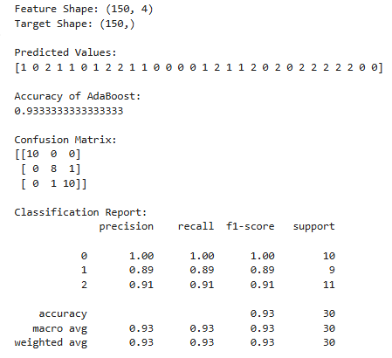
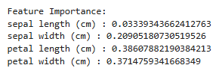
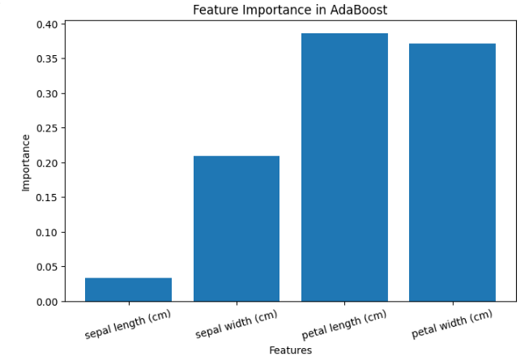

Q.6. Write a program to implement Boosting Algorithms : Stochastic Gradient Boosting , Voting Ensemble.
# Implementation of Stochastic Gradient Boosting

# Step 1: Import Libraries
import numpy as np
import pandas as pd
import matplotlib.pyplot as plt

from sklearn.datasets import load_iris
from sklearn.model_selection import train_test_split
from sklearn.ensemble import GradientBoostingClassifier

from sklearn.metrics import accuracy_score
from sklearn.metrics import confusion_matrix
from sklearn.metrics import classification_report

# Step 2: Load Dataset

iris = load_iris()

X = iris.data
y = iris.target

print("Feature Shape:", X.shape)
print("Target Shape:", y.shape)
#
# Step 3: Split Dataset
#
X_train, X_test, y_train, y_test = train_test_split(
X,
y,
test_size=0.2,
random_state=42

)

# Step 4: Create Gradient Boosting Model

model = GradientBoostingClassifier(
n_estimators=100,
learning_rate=0.1,
subsample=0.8, # Stochastic Boosting
random_state=42
)

# Train Model
model.fit(X_train, y_train)

# Step 5: Prediction

y_pred = model.predict(X_test)

print("\nPredicted Values:")
print(y_pred)

# Step 6: Accuracy

accuracy = accuracy_score(y_test, y_pred)

print("\nAccuracy:")
print(accuracy)

# Step 7: Confusion Matrix

cm = confusion_matrix(y_test, y_pred)

print("\nConfusion Matrix:")
print(cm)
# Step 8: Classification Report

report = classification_report(y_test, y_pred)

print("\nClassification Report:")
print(report)

# Step 9: Feature Importance Plot

importance = model.feature_importances_

plt.figure(figsize=(8,5))

plt.bar(iris.feature_names, importance)

plt.title("Feature Importance")
plt.xlabel("Features")
plt.ylabel("Importance")

plt.xticks(rotation=15)

plt.show()

OUTPUT:
