Q.1. Implementation of Features Extraction and selection , Normalization, Transformation, Principal of components Analysis.
# AIML Practical: Feature Extraction, Feature Selection,
# Normalization, Transformation, and PCA

# Step 1: Import Libraries
import pandas as pd
import numpy as np

from sklearn.datasets import load_iris
from sklearn.model_selection import train_test_split

# Feature Selection
from sklearn.feature_selection import SelectKBest, chi2

# Normalization & Transformation
from sklearn.preprocessing import MinMaxScaler
from sklearn.preprocessing import StandardScaler

# PCA
from sklearn.decomposition import PCA

# Step 2: Load Dataset
iris = load_iris()

X = iris.data
y = iris.target
# Create DataFrame
df = pd.DataFrame(X, columns=iris.feature_names)
print("Original Dataset")
print(df.head())

# Step 3: Feature Extraction

# Creating a new feature from existing features

df['petal_area'] = df['petal length (cm)'] * df['petal width (cm)']

print("\nDataset after Feature Extraction")
print(df.head())

# Step 4: Feature Selection
# Select Best 2 Features using Chi-Square Test

selector = SelectKBest(score_func=chi2, k=2)

X_selected = selector.fit_transform(X, y)

selected_features = selector.get_support(indices=True)

print("\nSelected Feature Indexes:")
print(selected_features)

print("\nSelected Features Data")
print(X_selected[:5])

# Step 5: Normalization
# Min-Max Scaling (Values between 0 and 1)

minmax = MinMaxScaler()

X_normalized = minmax.fit_transform(X)

print("\nNormalized Data")
print(X_normalized[:5])

# Step 6: Transformation
# Standardization (Mean = 0, Standard Deviation = 1)

standard = StandardScaler()

X_transformed = standard.fit_transform(X)

print("\nTransformed Data using StandardScaler")
print(X_transformed[:5])

# Step 7: Principal Component Analysis (PCA)
# Reduce Features into 2 Principal Components

pca = PCA(n_components=2)

X_pca = pca.fit_transform(X_transformed)

print("\nPCA Result")
print(X_pca[:5])

# Step 8: Explained Variance

print("\nExplained Variance Ratio:")
print(pca.explained_variance_ratio_)

# Step 9: Train-Test Split (Optional for ML Model)

X_train, X_test, y_train, y_test = train_test_split(
X_pca, y, test_size=0.2, random_state=42
)

print("\nTraining Data Shape:", X_train.shape)
print("Testing Data Shape:", X_test.shape)

# End of Program

OUTPUT:
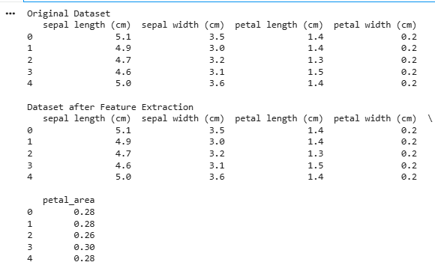
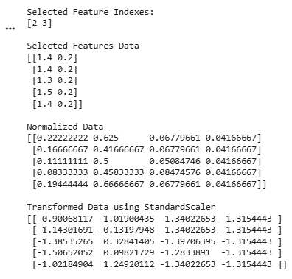
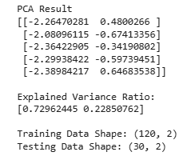

Q.2. Write a program to implement K-medoid clustering algorithm.
# K-Medoids Clustering
# Step 1: Import Libraries
import numpy as np
import matplotlib.pyplot as plt
from sklearn.datasets import make_blobs
from sklearn.metrics import pairwise_distances

# Step 2: Create Dataset

X, y = make_blobs(
n_samples=300,
centers=3,
random_state=42
)

# Step 3: Define K-Medoids Algorithm

class KMedoids:

def __init__(self, k=3, max_iter=100):
self.k = k
self.max_iter = max_iter

def fit(self, X):

m, n = X.shape

# Randomly select medoids
random_indices = np.random.choice(m, self.k, replace=False)
self.medoids = X[random_indices]

for _ in range(self.max_iter):

# Assign clusters
distances = pairwise_distances(X, self.medoids)
labels = np.argmin(distances, axis=1)

new_medoids = []

# Update medoids
for i in range(self.k):

cluster_points = X[labels == i]

cluster_distances = pairwise_distances(
cluster_points,
cluster_points
)

total_distances = cluster_distances.sum(axis=1)

medoid_index = np.argmin(total_distances)

new_medoids.append(cluster_points[medoid_index])

new_medoids = np.array(new_medoids)

# Stop if medoids do not change
if np.all(self.medoids == new_medoids):
break

self.medoids = new_medoids

self.labels = labels

# Step 4: Apply K-Medoids
model = KMedoids(k=3)

model.fit(X)

# Step 5: Plot Clusters

plt.figure(figsize=(8,6))

plt.scatter(
X[:,0],
X[:,1],
c=model.labels,
cmap='viridis',
s=50
)

# Plot medoids
plt.scatter(
model.medoids[:,0],
model.medoids[:,1],
color='red',
marker='X',
s=300,
label='Medoids'
)

plt.title("K-Medoids Clustering")
plt.xlabel("Feature 1")
plt.ylabel("Feature 2")
plt.legend()

plt.show()

OUTPUT:
