1. Introduction to Python Programming: Learn the different libraries - NumPy, Pandas, SciPy, Matplotlib, Scikit Learn.
# Introduction to Python Programming in AIML
# Libraries: NumPy, Pandas, SciPy, Matplotlib, Scikit-Learn

# Step 1: Import Libraries

import numpy as np
import pandas as pd
import scipy
import matplotlib.pyplot as plt

from sklearn.datasets import load_iris
from sklearn.model_selection import train_test_split
from sklearn.linear_model import LogisticRegression
from sklearn.metrics import accuracy_score

print("All Libraries Imported Successfully")

# NUMPY

print("\n================ NUMPY =================")
# Create NumPy Array
arr = np.array([10, 20, 30, 40, 50])
print("NumPy Array:")
print(arr)

# Array Operations
print("\nMean:", np.mean(arr))
print("Sum:", np.sum(arr))
print("Maximum:", np.max(arr))

# PANDAS

print("\n================ PANDAS =================")

# Create DataFrame
data = {
'Name': ['A', 'B', 'C'],
'Marks': [85, 90, 95]
}

df = pd.DataFrame(data)

print("\nPandas DataFrame:")
print(df)

# Display Information
print("\nDataFrame Information:")
print(df.info())

# SCIPY

print("\n================ SCIPY =================")

from scipy import stats

# Sample Data
marks = [85, 90, 95, 100, 80]

# Calculate Statistics
mean_value = np.mean(marks)
mode_value = stats.mode(marks)

print("Mean:", mean_value)
print("Mode:", mode_value.mode)

# MATPLOTLIB
print("\n================ MATPLOTLIB =================")

# Sample Graph Data
x = [1, 2, 3, 4, 5]
y = [10, 20, 30, 40, 50]

# Plot Graph
plt.figure(figsize=(7,5))

plt.plot(x, y, marker='o')

plt.title("Simple Line Graph")
plt.xlabel("X Values")
plt.ylabel("Y Values")

plt.grid(True)

plt.show()

# SCIKIT-LEARN

print("\n================ SCIKIT-LEARN =================")

# Load Dataset
iris = load_iris()

X = iris.data
y = iris.target

print("Dataset Shape:", X.shape)

# Split Dataset
X_train, X_test, y_train, y_test = train_test_split(
X,
y,
test_size=0.2,
random_state=42
)
# Create Model
model = LogisticRegression(max_iter=500)

# Train Model
model.fit(X_train, y_train)

# Prediction
y_pred = model.predict(X_test)

# Accuracy
accuracy = accuracy_score(y_test, y_pred)

print("\nModel Accuracy:")
print(accuracy)

OUTPUT:
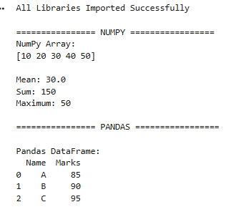
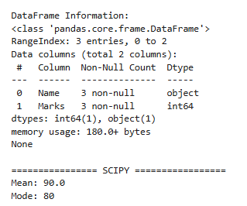
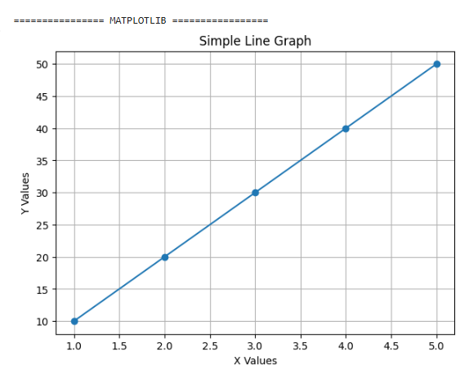
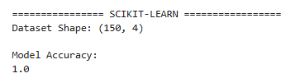

2. Implement Perceptron algorithm for OR operation
# Implementation of Perceptron Algorithm for OR Operation

# Step 1: Import Library
import numpy as np

# Step 2: Input Dataset for OR Gate

# Input Values
X = np.array([
[0, 0],
[0, 1],
[1, 0],
[1, 1]
])

# Target Output for OR Operation
y = np.array([0, 1, 1, 1])

print("Input Data:")
print(X)

print("\nTarget Output:")
print(y)

# Step 3: Initialize Weights and Bias

weights = np.zeros(2)

bias = 0

learning_rate = 0.1

epochs = 10

# Step 4: Activation Function

def activation_function(x):

if x >= 0:
return 1
else:
return 0

# Step 5: Training the Perceptron

for epoch in range(epochs):

print("\nEpoch:", epoch + 1)

for i in range(len(X)):

# Net Input
net_input = np.dot(X[i], weights) + bias

# Predicted Output
prediction = activation_function(net_input)

# Error Calculation
error = y[i] - prediction

# Update Weights and Bias
weights = weights + learning_rate * error * X[i]

bias = bias + learning_rate * error

print("Input:", X[i],
"Prediction:", prediction,
"Error:", error)
# Step 6: Final Weights and Bias

print("\nFinal Weights:")
print(weights)

print("\nFinal Bias:")
print(bias)

# Step 7: Testing the Perceptron

print("\nTesting Perceptron for OR Operation")

for i in range(len(X)):

net_input = np.dot(X[i], weights) + bias

prediction = activation_function(net_input)

print(X[i], "OR =", prediction)

OUTPUT:
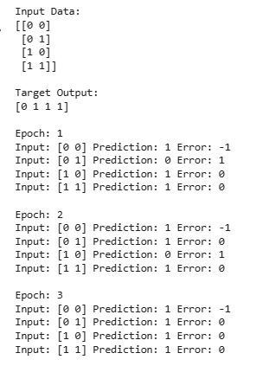
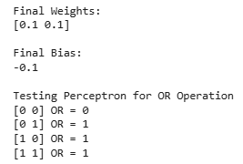

3. Improve the prediction accuracy by estimating the weight values for the training data using stochastic gradient descent.(Perceptron)
# Perceptron using Stochastic Gradient Descent (SGD)
# Improve Prediction Accuracy by Updating Weights

# Step 1: Import Libraries
import numpy as np

# Step 2: Training Dataset
# OR Gate Dataset

X = np.array([
[0, 0],
[0, 1],
[1, 0],
[1, 1]
])

# Target Output
y = np.array([0, 1, 1, 1])

print("Input Data:")
print(X)

print("\nTarget Output:")
print(y)

# Step 3: Initialize Parameters
# Initial Weights
weights = np.random.rand(2)
# Initial Bias
bias = np.random.rand()

# Learning Rate

learning_rate = 0.1

# Number of Iterations
epochs = 20

print("\nInitial Weights:", weights)
print("Initial Bias:", bias)

# Step 4: Sigmoid Activation Function
def sigmoid(z):
return 1 / (1 + np.exp(-z))

# Step 5: Training using Stochastic Gradient Descent

for epoch in range(epochs):

total_error = 0

for i in range(len(X)):

# Forward Propagation
z = np.dot(X[i], weights) + bias

prediction = sigmoid(z)

# Error
error = y[i] - prediction

total_error += error**2

# Gradient Calculation
gradient = error * prediction * (1 - prediction)

# Update Weights
weights += learning_rate * gradient * X[i]

# Update Bias
bias += learning_rate * gradient

print(f"Epoch {epoch+1} - Error: {total_error}")

# Step 6: Final Weights and Bias

print("\nFinal Weights:")
print(weights)

print("\nFinal Bias:")
print(bias)

# Step 7: Testing the Model

print("\nTesting the Perceptron Model")

for i in range(len(X)):
z = np.dot(X[i], weights) + bias
prediction = sigmoid(z)
# Convert probability into binary output
output = 1 if prediction >= 0.5 else 0

print(X[i], "OR =", output)

OUTPUT:
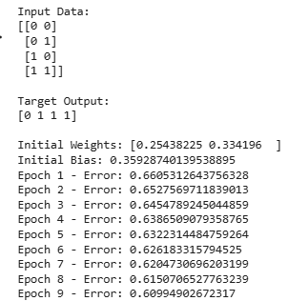
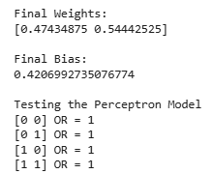

4. Implement Adaline algorithm for AND operation

# Implementation of Adaline Algorithm for AND Operation

# Step 1: Import Library
import numpy as np

# Step 2: Input Dataset for AND Gate

# Input Values
X = np.array([
[0, 0],
[0, 1],
[1, 0],
[1, 1]
])

# Target Output for AND Operation
y = np.array([0, 0, 0, 1])

print("Input Data:")
print(X)

print("\nTarget Output:")
print(y)

# Step 3: Initialize Weights and Bias

# Random Weights
weights = np.random.rand(2)

# Random Bias
bias = np.random.rand()
# Learning Rate

learning_rate = 0.1

# Number of Epochs
epochs = 20

print("\nInitial Weights:", weights)
print("Initial Bias:", bias)

# Step 4: Linear Activation Function

def activation(net_input):
return net_input

# Step 5: Train Adaline Model

for epoch in range(epochs):

total_error = 0

for i in range(len(X)):

# Calculate Net Input
net_input = np.dot(X[i], weights) + bias

# Predicted Output
output = activation(net_input)

# Calculate Error
error = y[i] - output

total_error += error**2

# Update Weights
weights = weights + learning_rate * error * X[i]
# Update Bias

bias = bias + learning_rate * error

print(f"Epoch {epoch+1} - Error: {total_error}")

# Step 6: Final Weights and Bias

print("\nFinal Weights:")
print(weights)

print("\nFinal Bias:")
print(bias)

# Step 7: Testing Adaline Model

print("\nTesting Adaline for AND Operation")

for i in range(len(X)):

# Net Input
net_input = np.dot(X[i], weights) + bias

# Threshold Function
prediction = 1 if net_input >= 0.5 else 0

print(X[i], "AND =", prediction)

OUTPUT:
