Q1. Implement Tokenization of text.

import nltk
from nltk.tokenize import word_tokenize, sent_tokenize
nltk.download('punkt')
nltk.download('punkt_tab')

text = "Hello Everyone My name is omkar, I am currently living in navi mumbai."
sentences = sent_tokenize(text)
print(sentences)

words = word_tokenize(text)
print(words)

Output –

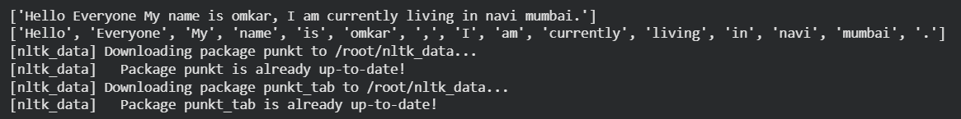

Q2. Implement Stop word removal.

import nltk
from nltk.corpus import stopwords
from nltk.tokenize import word_tokenize
nltk.download('punkt')
nltk.download('stopwords')

stop_words = set(stopwords.words('english'))

filtered_data = []

for word in words:
if word.lower() not in stop_words:
filtered_data.append(word)

print("Original Tokens:", words)
print("Filtered Data:", filtered_data)

Output –

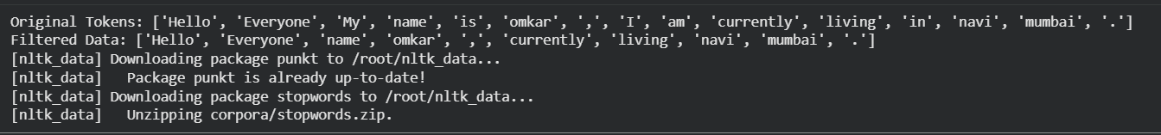

import nltk
from nltk.corpus import stopwords
from nltk.tokenize import word_tokenize

nltk.download('punkt')
nltk.download('punkt_tab')
nltk.download('stopwords')

data = input("enter the text :")

# Tokenization
tokens = word_tokenize(data)
# Load English stop words
stop_words = set(stopwords.words('english'))

# Remove stop words
filtered_tokens = []
for word in tokens:
if word.lower() not in stop_words:
filtered_tokens.append(word)

print("Original text:", data)
print("Tokens:", tokens)
print("Filtered tokens (without stopwords):", filtered_tokens)

Output –

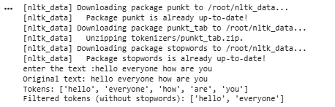

Q3. Implement Stemming of text.

import nltk
from nltk.stem import PorterStemmer, LancasterStemmer
from nltk.tokenize import word_tokenize
from nltk.corpus import stopwords

nltk.download('punkt')
nltk.download('punkt_tab')

text = input("Enter ther text: ")
tokens = word_tokenize(text)
print("tokens", tokens)
nltk.download('stopwords')
stop_words = set(stopwords.words('english'))

filtered_data = []
for word in tokens:
if word.lower() not in stop_words:
filtered_data.append(word)
print("tokens after removing stopwords", filtered_data)

porter = PorterStemmer()
lancaster = LancasterStemmer()

# Apply stemming
porter_stemmed = [porter.stem(word) for word in filtered_data]
lancaster_stemmed = [lancaster.stem(word) for word in filtered_data]

print("Original Words:", tokens)
print("tokens after removing stopwords", filtered_data)
print("Porter Stemmed Words:", porter_stemmed)
print("Lancaster Stemmed Words:", lancaster_stemmed)

Output –

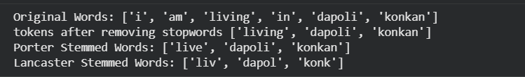
Q4. Implement Lemmatization.

- Rule based lemmatization

import nltk
nltk.download('punkt_tab')
from nltk.tokenize import word_tokenize
sentence = "NLTK is a powerful library for natural language processing."
tokens = word_tokenize(sentence)
print("Original Sentence:", sentence)
print("Tokenized Sentence:", tokens)
print("lemmatization (noun)")

for w in tokens:
print(w,"->",lemmatizer.lemmatize(w))
print("lemmatization (verb)")

for w in tokens:
lemma=lemmatizer.lemmatize(w,pos="v") #specify verb POS
print(w,"(POS=verb)->",lemma)
print("lemmatization (adverb)")
for w in tokens:
lemma=lemmatizer.lemmatize(w,pos="a") #specify verb POS (a for adverb )
print(w,"(POS=adverb)->",lemma)

output –

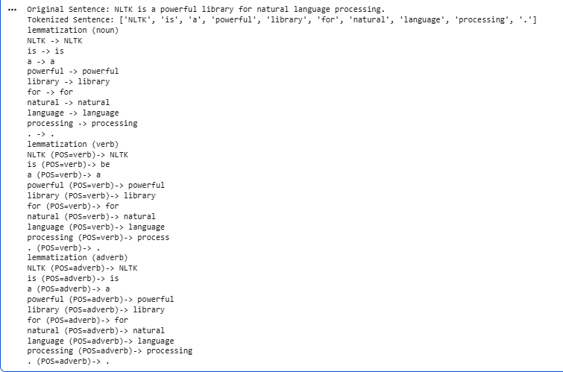
- Statistical pipeline lemmatization

import spacy
nlp=spacy.load("en_core_web_sm")

doc=nlp("The children are running faster")

for token in doc:
print("WORD:",token.text)
print("lemma:",token.lemma_)

Output –

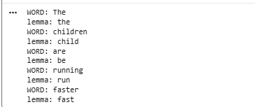

Q5. Implement N-gram model.

import nltk
from nltk.tokenize import word_tokenize
from nltk.util import ngrams
from collections import Counter, defaultdict

nltk.download('punkt')
nltk.download('punkt_tab')

user_input = input("Enter something: ")

tokens = word_tokenize(user_input)
print("Tokens:", tokens)

# Generate Unigrams
unigrams = list(ngrams(tokens, 1))
print("Unigrams:", unigrams)

# Generate Bigrams
bigrams = list(ngrams(tokens, 2))
print("Bigrams:", bigrams)

# Generate Trigrams
trigrams = list(ngrams(tokens, 3))
print("Trigrams:", trigrams)

# Bigram frequency
bigram_freq = Counter(bigrams)
print("Bigram frequencies:")
print(bigram_freq)

# Trigram frequency
trigram_freq = Counter(trigrams)
print("Trigram frequencies:")
print(trigram_freq)

# Unigram frequency
unigram_freq = Counter(tokens)

# Bigram probability
bigram_prob = {}

for w1, w2 in bigram_freq:
bigram_prob[(w1, w2)] = bigram_freq[(w1, w2)] / unigram_freq[w1]

print("Bigram Probabilities:")
print(bigram_prob)

# Predict next word using bigram frequency
def predict_next_word(word, bigram_freq):
candidates = {}

for (w1, w2), freq in bigram_freq.items():
if w1 == word:
candidates[w2] = freq

if candidates:
print("Candidate Dictionary:")
for key, value in candidates.items():
print(f"{key}: {value}")
return max(candidates, key=candidates.get)
else:
return None

# Example prediction
print("Predicted next word:", predict_next_word('i', bigram_freq))

Output –

