- Implementation of POS tagging.

- Using NLTK
import nltk
from nltk.tokenize import word_tokenize
from nltk import pos_tag
nltk.download('punkt_tab')
nltk.download('averaged_perceptron_tagger_eng')

words = input("please enter-")
tokenize = word_tokenize(words)
print(tokenize)

pos_tags = nltk.pos_tag(tokenize)
print(pos_tags)

Output –

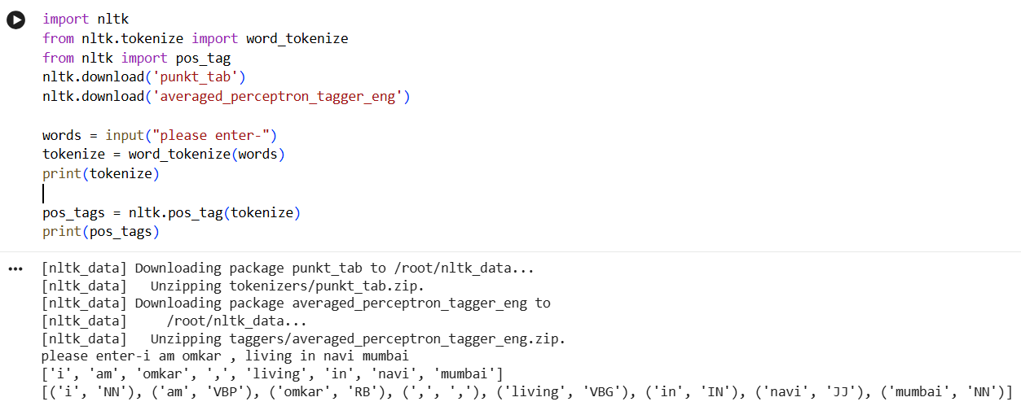

- using spaCy

import spacy
nlp = spacy.load("en_core_web_sm")
words = input("please enter-")
doc = nlp(words)

for token in doc:
print(token.text, token.pos_, token.tag_)

Output –

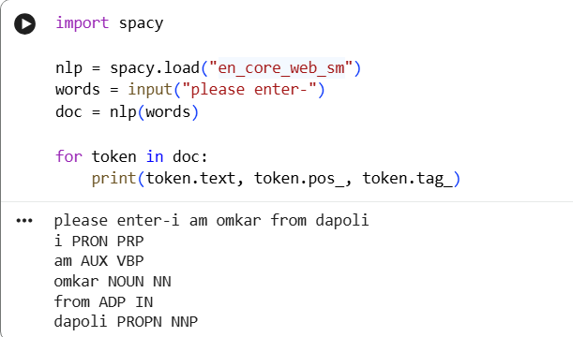

- Implementation of Building a custom NER system

import spacy
from spacy.training import Example
# Load a pre-trained English model with entity recognition capabilities
try:
nlp = spacy.load("en_core_web_sm")
except OSError:
print("Model 'en_core_web_sm' not found. Trying to download...")
import subprocess
subprocess.run(["python", "-m", "spacy", "download", "en_core_web_sm"])
nlp = spacy.load("en_core_web_sm")
print("Model 'en_core_web_sm' loaded successfully.")

# Get sentence input from the user
user_sentence = input("Please enter a sentence: ")

# Process the sentence with the NER-enabled model
doc = nlp(user_sentence)

print("\nOriginal Sentence:", user_sentence)
print("\nTokens:")
for token in doc:
print("-", token.text)

print("\nEntities for each token (if any):")
for token in doc:
if token.ent_type_:
print(f" - Token: '{token.text}', Entity: '{token.ent_type_}', Label: '{token.ent_iob_}'")
else:
print(f" - Token: '{token.text}', Entity: None")

Output –

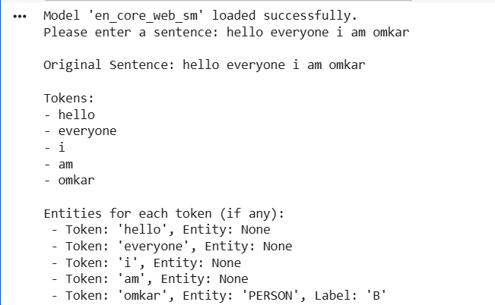
Spacy basic tokenization

import spacy

# Load a blank English model
nlp = spacy.blank("en")

# Process text
doc = nlp("Hello world! This is a spacy example.")

# Iterate through tokens and print the text
print("Tokens in the document:")
for token in doc:
print(token.text)

output –

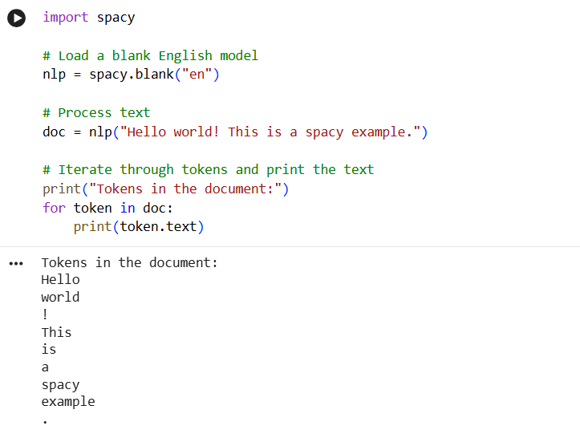

Custom NER Training

import spacy
from spacy.training.example import Example

nlp = spacy.blank("en")

ner = nlp.add_pipe("ner")

ner.add_label("ORG")
ner.add_label("SKILL")
# Training data (text, annotations)
TRAIN_DATA = [
("OpenAI builds powerful AI models", {"entities": [(0, 6, "ORG")]}),
("I love Python programming", {"entities": [(7, 13, "SKILL")]}),
("Google uses machine learning", {"entities": [(0, 6, "ORG")]}),
]
# Training loop
nlp.begin_training()

for epoch in range(20):
losses = {}
for text, annotations in TRAIN_DATA:
doc = nlp.make_doc(text)
example = Example.from_dict(doc, annotations)
nlp.update([example], losses=losses)
print(f"Epoch {epoch} Losses:", losses)

# Save model
nlp.to_disk("custom_ner_model")

Output –

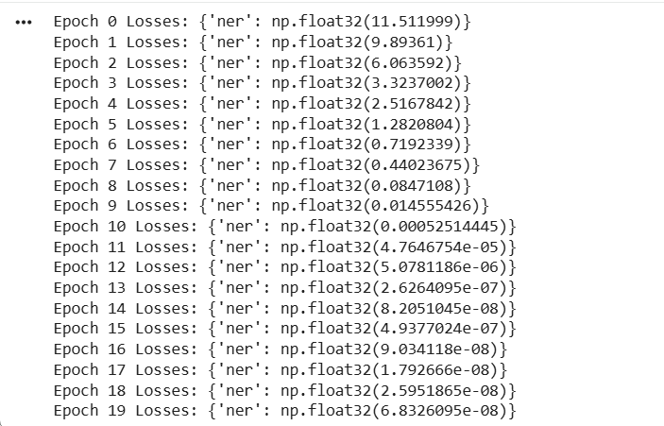

import spacy
from spacy.training.example import Example

# Create blank English model
nlp = spacy.blank("en")

# Add NER pipeline
ner = nlp.add_pipe("ner")
# Add labels
ner.add_label("PERSON")
ner.add_label("CITY")

# Training data
TRAIN_DATA = [
("John lives in Mumbai", {"entities": [(0, 4, "PERSON"), (14, 20, "CITY")]}),
("Amit moved to Delhi", {"entities": [(0, 4, "PERSON"), (14, 19, "CITY")]}),
]

# Train model
optimizer = nlp.begin_training()
for i in range(10):
losses = {}
for text, annotations in TRAIN_DATA:
doc = nlp.make_doc(text)
example = Example.from_dict(doc, annotations)
nlp.update([example], losses=losses)
print("Iteration", i, "Loss:", losses)

# Test the model
test_text = "John lives in Mumbai"
doc = nlp(test_text)
print("\nEntities found:")
for ent in doc.ents:
print(ent.text, "->", ent.label_)

Output –

