Q1. Design ASP.NET web page to demonstrate page life cycle
Ans.

PageLifeCycle.aspx –

<%@ Page Language="C#" AutoEventWireup="true" CodeBehind="PageLifeCycle.aspx.cs" Inherits="WebApplication1.PageLifeCycle" %>

<!DOCTYPE html>

<html xmlns="http://www.w3.org/1999/xhtml">
<head runat="server">
<title></title>
</head>
<body>
<form id="form1" runat="server">
<div>
<center>
<h1>
Demonstrating Page LifeCycle
</h1>
<h4><asp:Label ID="Label1" runat="server" Text="Label"></asp:Label></h4>
<asp:Button ID="Button1" runat="server" Text="Submit" OnClick="Button1_Click" />
</center>
</div>
</form>
</body>
</html>

PageLifeCycle.aspx.cs –

using System;
using System.Collections.Generic;
using System.Configuration;
using System.Linq;
using System.Reflection.Emit;
using System.Web;
using System.Web.UI;
using System.Web.UI.WebControls;

namespace WebApplication1
{
public partial class PageLifeCycle : System.Web.UI.Page
{
protected void Page_PriInit(object sender, EventArgs e)
{
Label1.Text = Label1.Text + "<br/>" + "I am PriInit Event";
}
protected void Page_Init(object sender, EventArgs e)
{
Label1.Text = Label1.Text + "<br/>" + "I am Init Event";
}
protected void Page_InitComplete(object sender, EventArgs e)
{
Label1.Text = Label1.Text + "<br/>" + "I am InitComplete Event";
}
protected override void OnPreLoad(EventArgs e)
{
Label1.Text = Label1.Text + "<br/>" + "I am PreLoad Event";
}
protected void Page_Load(object sender, EventArgs e)
{
Label1.Text = Label1.Text + "<br/>" + "I am a Load Event";
}
protected void Page_LoadComplete(object sender, EventArgs e)
{
Label1.Text = Label1.Text + "<br/>" + "I am a LoadComplete Event";
}
protected override void OnPreRender(EventArgs e)
{
Label1.Text = Label1.Text + "<br/>" + "I am PreRender Event";
}
protected void Page_UnLoad(object sender, EventArgs e)
{
Label1.Text = Label1.Text + "<br/>" + " I am a UnLoad Event";
}
protected void Button1_Click(object sender, EventArgs e)
{
Label1.Text = Label1.Text + "<br/>" + " I am ButtonClick Event ... ";
}}
}
Output –

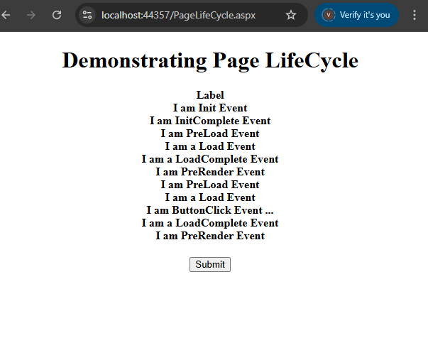

Q2. Design registration form using Web Server controls
Ans.
Registration.aspx –

<%@ Page Language="C#" AutoEventWireup="true" CodeBehind="StudentRegistration.aspx.cs" Inherits="WebApplication1.StudentRegistration" %>

<!DOCTYPE html>

<html xmlns="http://www.w3.org/1999/xhtml">
<head runat="server">
<title></title>
</head>
<body>
<form id="form1" runat="server">
<center>
<div>
<h1>Student Registration Form</h1> <asp:Label ID="Label1" runat="server" Text="Student Name"></asp:Label>
:
<asp:TextBox ID="TextBox1" runat="server"></asp:TextBox>
<br />
<br />
Email id :
<asp:TextBox ID="TextBox2" runat="server"></asp:TextBox>
<br />
<br />
Password : <asp:TextBox ID="TextBox3" runat="server" TextMode="Password"></asp:TextBox>
<br />
<br />
Gender:<asp:RadioButton ID="Male" runat="server" Text="Male" />
&nbsp;
<asp:RadioButton ID="Female" runat="server" Text="Female" />
<br />
<br />
Date of Birth<br />
<br />

<asp:Calendar ID="Calendar1" runat="server" BackColor="White" BorderColor="#999999" CellPadding="4" DayNameFormat="Shortest" Font-Names="Verdana" Font-Size="8pt" ForeColor="Black" Height="180px" Width="200px">
<DayHeaderStyle BackColor="#CCCCCC" Font-Bold="True" Font-Size="7pt" />
<NextPrevStyle VerticalAlign="Bottom" />
<OtherMonthDayStyle ForeColor="#808080" />
<SelectedDayStyle BackColor="#666666" Font-Bold="True" ForeColor="White" />
<SelectorStyle BackColor="#CCCCCC" />
<TitleStyle BackColor="#999999" BorderColor="Black" Font-Bold="True" />
<TodayDayStyle BackColor="#CCCCCC" ForeColor="Black" />
<WeekendDayStyle BackColor="#FFFFCC" />
</asp:Calendar>
<br />
Course:
Course:
<asp:CheckBox ID="MCA" runat="server" Text="MCA" />
&nbsp;
<asp:CheckBox ID="BCA" runat="server" Text="BCA" />
&nbsp;
<asp:CheckBox ID="MBA" runat="server" Text="MBA" />
&nbsp;
<asp:CheckBox ID="BBA" runat="server" Text="BBA" />

<br />
<br />
<asp:Button ID="Button1" runat="server" Text="register" OnClick="Button1_Click" />
<br />
<br />
<asp:TextBox ID="TextBox4" runat="server" TextMode="MultiLine"></asp:TextBox>
<br />
<br />
<br />
</div>
</center>
</form>
</body>
</html>

Registration.aspx.cs –

using System;
using System.Web.UI;

namespace WebApplication1
{
public partial class StudentRegistration : System.Web.UI.Page
{
protected void Page_Load(object sender, EventArgs e)
{
}
protected void Button1_Click(object sender, EventArgs e)
{
string formdetail = "";

formdetail += "Hello " + TextBox1.Text + "\n";
formdetail += "Your email id is " + TextBox2.Text + "\n";

if (Male.Checked)
formdetail += "Gender: Male\n";

if (Female.Checked)
formdetail += "Gender: Female\n";

formdetail += "Date of Birth: " + Calendar1.SelectedDate.ToShortDateString() + "\n";

if (MCA.Checked)
formdetail += "Course selected: MCA\n";

if (BCA.Checked)
formdetail += "Course selected: BCA\n";

if (MBA.Checked)
formdetail += "Course selected: MBA\n";
if (BBA.Checked)
formdetail += "Course selected: BBA\n";
TextBox4.Text = formdetail;
}
}
}

Output –

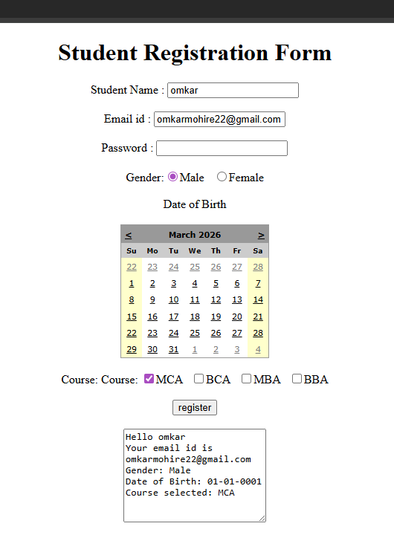

Q.3 Create a simple calculator using server-side controls and operators in ASP.NET
Ans.

Basic_calculator.aspx –

<%@ Page Language="C#" AutoEventWireup="true" CodeBehind="BasicCalcultaor.aspx.cs" Inherits="WebApplication2.BasicCalcultaor" %>

<!DOCTYPE html>
<html xmlns="http://www.w3.org/1999/xhtml">
<head runat="server">
<title></title>
</head>
<body>
<form id="form1" runat="server">
<div>
<center>
<h1>Basic Calculator</h1>
<asp:Label ID="Label1" runat="server" Text="Enter number 1: " />
<asp:TextBox ID="TextBox1" runat="server"></asp:TextBox>
<br /><br />

<asp:Label ID="Label2" runat="server" Text="Enter number 2: " />
<asp:TextBox ID="TextBox2" runat="server"></asp:TextBox>
<br /><br />
<asp:Button ID="btnAdd" runat="server" Text="+" OnClick="btnAdd_Click" />
&nbsp;&nbsp;
<asp:Button ID="btnSub" runat="server" Text="-" OnClick="btnSub_Click" />
&nbsp;&nbsp;
<asp:Button ID="btnMul" runat="server" Text="*" OnClick="btnMul_Click" style="width: 19px" />
&nbsp;&nbsp;
<asp:Button ID="btnDiv" runat="server" Text="/" OnClick="btnDiv_Click" />
&nbsp;&nbsp;
<asp:Button ID="btnSqrt" runat="server" Text="Sqrt" OnClick="btnSqrt_Click" />
&nbsp;&nbsp;
<asp:Button ID="btnPow" runat="server" Text="^" OnClick="btnPow_Click" />
&nbsp;&nbsp;
<asp:Button ID="btnClear" runat="server" Text="C" OnClick="btnClear_Click" />

<br /><br />

<asp:TextBox ID="TextBox3" runat="server" ReadOnly="true"></asp:TextBox>

</center>
</div>
</form>
</body>
</html>

Basic_calculator.aspx.cs –

using System;
using System.Collections.Generic;
using System.Linq;
using System.Web;
using System.Web.UI;
using System.Web.UI.WebControls;
namespace WebApplication2
{
public partial class BasicCalcultaor : System.Web.UI.Page
{
protected void btnAdd_Click(object sender, EventArgs e)
{
double n1 = Convert.ToDouble(TextBox1.Text);
double n2 = Convert.ToDouble(TextBox2.Text);
TextBox3.Text = (n1 + n2).ToString();
}
protected void btnSub_Click(object sender, EventArgs e)
{
double n1 = Convert.ToDouble(TextBox1.Text);
double n2 = Convert.ToDouble(TextBox2.Text);
TextBox3.Text = (n1 - n2).ToString();
}
protected void btnMul_Click(object sender, EventArgs e)
{
double n1 = Convert.ToDouble(TextBox1.Text);
double n2 = Convert.ToDouble(TextBox2.Text);
TextBox3.Text = (n1 * n2).ToString();

}
protected void btnDiv_Click(object sender, EventArgs e)
{
double n1 = Convert.ToDouble(TextBox1.Text);
double n2 = Convert.ToDouble(TextBox2.Text);
TextBox3.Text = (n1 / n2).ToString();
}
protected void btnSqrt_Click(object sender, EventArgs e)
{
double n1;
n1 = Convert.ToDouble(TextBox1.Text);
TextBox3.Text = Math.Sqrt(n1).ToString();
}
protected void btnPow_Click(object sender, EventArgs e)
{
double n1, n2;
n1 = Convert.ToDouble(TextBox1.Text);
n2 = Convert.ToDouble(TextBox2.Text);
TextBox3.Text = Math.Pow(n1, n2).ToString();
}
protected void btnClear_Click(object sender, EventArgs e)
{
TextBox1.Text = "";
TextBox2.Text = "";
TextBox3.Text = "";
}
}
}

Output –

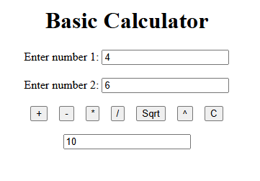
(Addition)

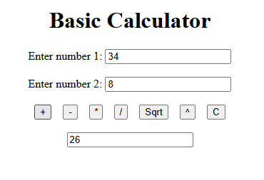
(Division)

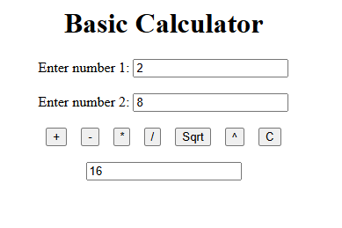
(Multiplication)

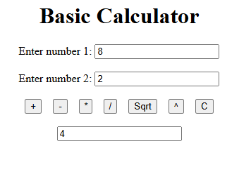
(Division)

Q.4 Design web for list the squares of given range of numbers in a list box
Ans.

Square_of_numbers.aspx –

<%@ Page Language="C#" AutoEventWireup="true" CodeBehind="Square_Of_Numbers.aspx.cs" Inherits="WebApplication1.Square_Of_Numbers" %>
<!DOCTYPE html>
<html xmlns="http://www.w3.org/1999/xhtml">
<head runat="server">
<title></title>
</head>
<body>
<form id="form1" runat="server">
<div>
<center>
<h1>Square Of Numbers</h1>
<p>Enter Starting Number :
<asp:TextBox ID="TextBox1" runat="server"></asp:TextBox>
</p>
<p>Enter Ending Number :
<asp:TextBox ID="TextBox2" runat="server" OnTextChanged="TextBox2_TextChanged"></asp:TextBox>
</p>
<p>
<asp:Button ID="Button1" runat="server" OnClick="Button1_Click" Text="Square" />
&nbsp;&nbsp;&nbsp;&nbsp;&nbsp;
<asp:Button ID="Button2" runat="server" Text="Clear" OnClick="Button2_Click" /> </p> <p>
<asp:ListBox ID="ListBox1" runat="server" Height="258px" OnSelectedIndexChanged="ListBox1_SelectedIndexChanged" Width="216px"></asp:ListBox>
</p>
<p>&nbsp;</p>
</center>
</div>
</form>
</body>
</html>
Square_of_numbers.aspx.cs –

using System;
using System.Collections.Generic;
using System.Linq;
using System.Web;
using System.Web.UI;
using System.Web.UI.WebControls;

namespace WebApplication1
{
public partial class Square_Of_Numbers : System.Web.UI.Page
{
protected void Page_Load(object sender, EventArgs e)
{
}
protected void Button1_Click(object sender, EventArgs e)
{
int num1, num2, sq;
num1 = Convert.ToInt32(TextBox1.Text);
num2 = Convert.ToInt32(TextBox2.Text);
int sqr;
for (int i = num1; i < num2; i++)
{
sqr = i * i;
ListBox1.Items.Add("Square of" + i.ToString() + "is" + sqr.ToString());
}
}
protected void TextBox2_TextChanged(object sender, EventArgs e)
{
}
protected void ListBox1_SelectedIndexChanged(object sender, EventArgs e)
{
}
protected void Button2_Click(object sender, EventArgs e)
{
TextBox1.Text = String.Empty;
TextBox2.Text = String.Empty;
ListBox1.Items.Clear();
} }
}
Output –

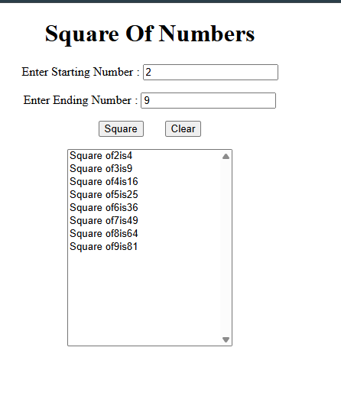

Q.5 Implement a Cross Page Postback feature to pass data between two web pages
Ans.

CrossPage.aspx –

<%@ Page Language="C#" AutoEventWireup="true"
CodeBehind="CrossPage.aspx.cs"
Inherits="Unit1BasicApplication.CrossPage" %>
<!DOCTYPE html>
<html xmlns="http://www.w3.org/1999/xhtml">
<head runat="server">
<title>Demonstration of Cross Page PostBack</title>
</head>
<body>
<center>
<h2>Demonstration of Cross Page PostBack</h2>
<form id="form1" runat="server">
<div>
<asp:TextBox
ID="TextBox1"
runat="server"
BorderColor="Black"
Width="200px">
</asp:TextBox>
&nbsp;&nbsp;
<asp:Button
ID="Button1"
runat="server"
Text="Post Back"
PostBackUrl="~/Display.aspx">
</asp:Button>
</div>
</form>
</center>
</body>
</html>

Display.aspx –

<%@ Page Language="C#" AutoEventWireup="true"
CodeBehind="Display.aspx.cs"
Inherits="Unit1BasicApplication.Display" %>

<!DOCTYPE html>
<html xmlns="http://www.w3.org/1999/xhtml">
<head runat="server">
<title>Display Page</title>
</head>
<body>
<center>
<form id="form1" runat="server">
<div>
<asp:Label
ID="Label1"
runat="server"
Font-Size="Large"
Text="Label">
</asp:Label>
</div>
</form>
</center>
</body>
</html>

Display.aspx.cs –

using System;
using System.Web.UI;
using System.Web.UI.WebControls;

namespace Unit1BasicApplication
{
public partial class Display : System.Web.UI.Page
{
protected void Page_Load(object sender, EventArgs e)
{
if (PreviousPage != null && PreviousPage.IsCrossPagePostBack)
{
TextBox txt =
(TextBox)PreviousPage.FindControl("TextBox1");

if (txt != null)
{
Label1.Text = "Welcome " + txt.Text;
}
}
}
}
}

Output –

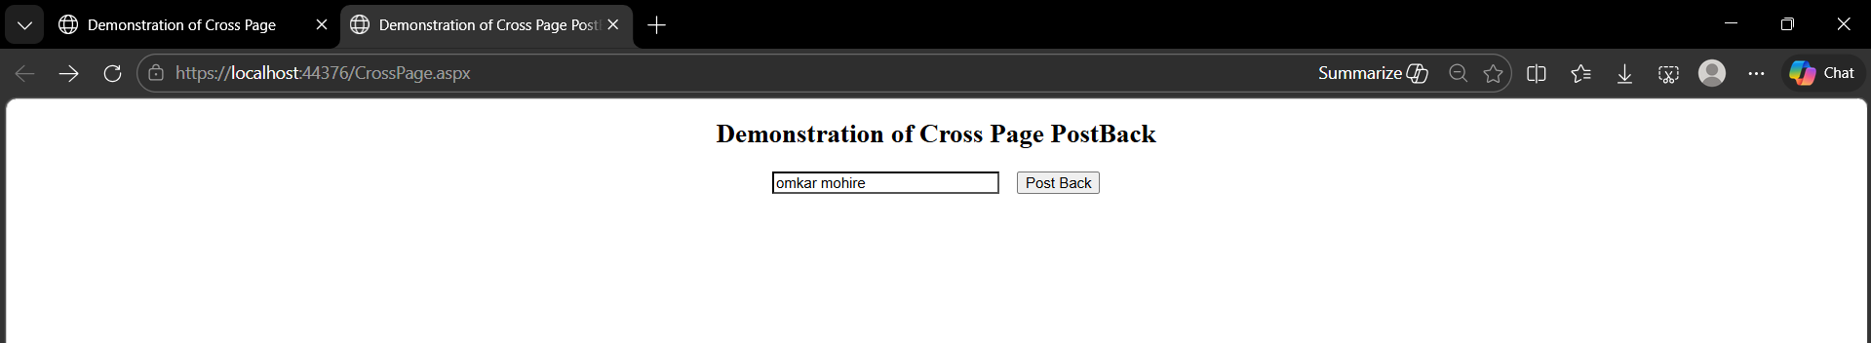

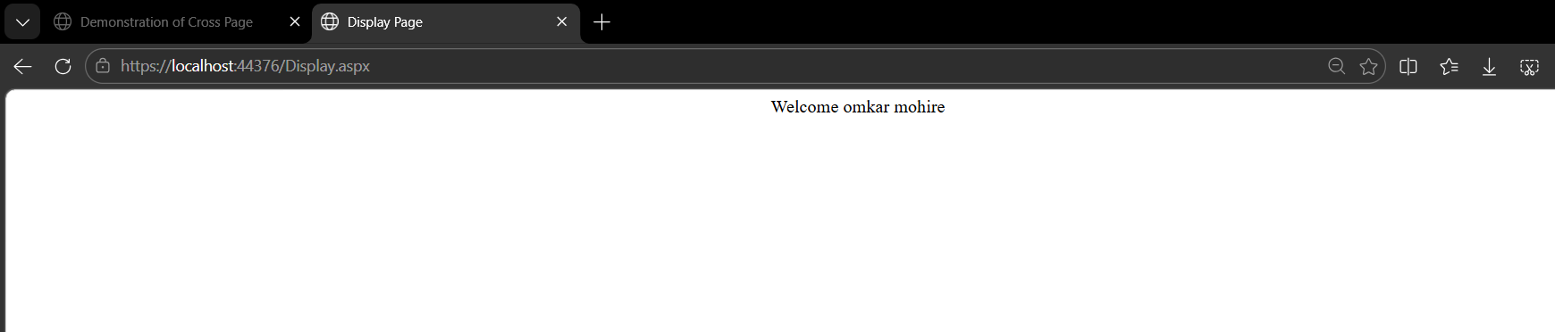

Q.6 Develop a web application demonstrating AutoPostback using a dropdown list to select and display items
Ans:

AutoPostBack.aspx –

<%@ Page Language="C#" AutoEventWireup="true" CodeBehind="AutoPostBack.aspx.cs" Inherits="Unit1BasicApplication.AutoPostBack" %>
<!DOCTYPE html>
<html xmlns="http://www.w3.org/1999/xhtml">
<head runat="server">
<title>Auto Post Back</title>
</head>
<body>
<center>
<h2>Auto Post Back</h2>
<form id="form1" runat="server">
<div>
<asp:DropDownList
ID="DropDownList1"
runat="server"
Height="16px"
Width="88px"
AutoPostBack="True"
OnSelectedIndexChanged="DropDownList1_SelectedIndexChanged">
<asp:ListItem>MCA</asp:ListItem>
<asp:ListItem>BCA</asp:ListItem>
<asp:ListItem>MBA</asp:ListItem>
<asp:ListItem>BBA</asp:ListItem>
</asp:DropDownList>
<br /> <br />
<asp:Label
ID="Label1"
runat="server"
Text="Label">
</asp:Label>
</div>
</form>
</center>
</body>
</html>

AutoPostBack.aspx.cs –

using System;
using System.Collections.Generic;
using System.Linq;
using System.Reflection.Emit;
using System.Web;
using System.Web.UI;
using System.Web.UI.WebControls;

namespace Unit1BasicApplication
{
public partial class AutoPostBack : System.Web.UI.Page
{
protected void Page_Load(object sender, EventArgs e)
{
}
protected void DropDownList1_SelectedIndexChanged(object sender, EventArgs e)
{
if (DropDownList1.SelectedItem != null)
{
Label1.Text = "You Selected " + DropDownList1.SelectedItem.Text;
}
else
{
Label1.Text = "Please select a course";
}
}
}
}

Output –

