Advanced Web Technologies Practical Lab

- Design an ASP.NET application to Display Current Month’s Calendar. Render the calendar. Show Some image in the cell along message.
Code:
CalendarControlDemo.aspx
<%@ flage Language="C" AutoEventWireup="true" CodeFile="CalendarControlDemo.aspx.cs" Inherits="BasicApp.CalendarControlDemo" %>
<!DOCTYflE html>

<html xmlns="http://www.w3.org/1999/xhtml">
<head runat="server">
<title></title>
</head>
<body>
<form id="form1" runat="server">
<center>
<div>
<h1>Calendar Control</h1>
<p>

</p>
<p>

</p>
<p>
<asp:Label ID="Label1" runat="server"></asp:Label>

<asp:Label ID="Label2" runat="server"></asp:Label>

<asp:Calendar ID="Calendar1" runat="server" BackColor="White"

BorderColor="999999" Cellfladding="4" DayameFormat="Shortest" Font-ames="Verdana" Font-Size="8pt" ForeColor="Black" eight="180px" OnDayRender="Calendar1_DayRender" OnSelectionChanged="Calendar1_SelectionChanged" OnVisibleMonthChanged="Calendar1_VisibleMonthChanged" Width="200px">
<DayeaderStyle BackColor="CCCCCC" Font-Bold="True" Font-Size="7pt"
/>
<extflrevStyle VerticalAlign="Bottom" />
<OtherMonthDayStyle ForeColor="808080" />
<SelectedDayStyle BackColor="666666" Font-Bold="True"
ForeColor="White" />
<SelectorStyle BackColor="CCCCCC" />
<TitleStyle BackColor="999999" BorderColor="Black" Font-Bold="True"

/>

</p>
<p>

</p>
</div>

<TodayDayStyle BackColor="CCCCCC" ForeColor="Black" />
<WeekendDayStyle BackColor="FFFFCC" />
</asp:Calendar>

<asp:Label ID="Label3" runat="server"></asp:Label>

</center>
</form>
</body>
</html>

CalendarControlDemo.aspx.cs
using System;
using System.Collections.Generic; using System.Linq;
using System.Web; using System.Web.UI;

using System.Web.UI.WebControls; namespace BasicApp
{
public partial class CalendarControlDemo : System.Web.UI.flage
{
protected void flage_Load(object sender, EventArgs e)
{
Label1.Text = "Today's Date is: " + DateTime.ow.ToShortDateString();
}

protected void Calendar1_SelectionChanged(object sender, EventArgs e)
{
Label3.Text = Calendar1.SelectedDate.ToLongDateString();
}

protected void Calendar1_DayRender(object sender, DayRenderEventArgs e)
{
if (e.Day.Date == new DateTime(2026, 3, 3))
{
Literal l1 = new Literal(); Image img = new Image(); e.Cell.Width = 70; e.Cell.eight = 70; e.Cell.Font.Italic = true; e.Cell.Font.Bold = true;
e.Cell.Font.Size = FontUnit.XLarge; e.Cell.BackColor = System.Drawing.Color.Lavender; img.ImageUrl = "~\\images\\img.jpg";
img.Width = 50; img.eight = 50;
l1.Text = "<br/><font size=1 color=Red>appy oli !!</font>"; e.Cell.Controls.AddAt(1, l1);
e.Cell.Controls.AddAt(0, img);
}
}

protected void Calendar1_VisibleMonthChanged(object sender, MonthChangedEventArgs
e)
{
Label2.Text = "Selected Month fi Year is: " + e.ewDate.Month + "-" +
e.ewDate.Year;
}
}
}

Output:
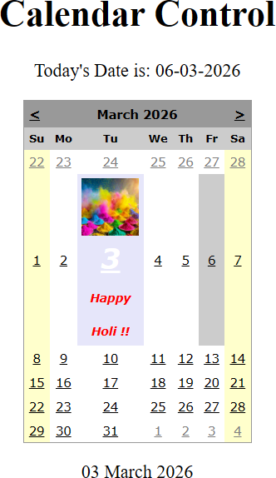

- Design a registration form with validation controls for mandatory fields, email format, and passwords.
Code:
StudRegistration.aspx
<%@ flage Language="C" AutoEventWireup="true" CodeBehind="StudRegistration.aspx.cs" Inherits="BasicApp.StudRegistration" %>

<!DOCTYflE html>

<html xmlns="http://www.w3.org/1999/xhtml">
<head runat="server">
<title></title>
</head>
<body>
<form id="form1" runat="server">
<center>
<div>
<h1>Student Registration Form</h1>
<p>
<asp:Label ID="Label1" runat="server" Text="Student ame:"></asp:Label>
<asp:TextBox ID="txtame" runat="server"></asp:TextBox>
<asp:RequiredFieldValidator ID="RequiredFieldValidator1" runat="server" ControlToValidate="txtame" ErrorMessage="ame is Empty..!" ForeColor="Red"></asp:RequiredFieldValidator>
</p>
<p>
<asp:Label ID="Label2" runat="server" Text="Email Id: "></asp:Label>
<asp:TextBox ID="txtEmail" runat="server"></asp:TextBox> finbsp;<asp:RegularExpressionValidator ID="RegularExpressionValidator1" runat="server" ControlToValidate="txtEmail" ErrorMessage="Enter correct email id..!" ForeColor="Red" ValidationExpression="\w+([-+.']\w+)*@\w+([-.]\w+)*\.\w+([-
.]\w+)*"></asp:RegularExpressionValidator>
</p>
<p>
<asp:Label ID="Label3" runat="server" Text="flassword: "></asp:Label>
<asp:TextBox ID="txtflwd" runat="server" TextMode="flassword"></asp:TextBox>
finbsp; </p>
<p>
<asp:Label ID="Label4" runat="server" Text="Confirm flassword:
"></asp:Label>
<asp:TextBox ID="txtConflwd" runat="server"
TextMode="flassword"></asp:TextBox>
finbsp;<asp:CompareValidator ID="CompareValidator1" runat="server" ControlToCompare="txtflwd" ControlToValidate="txtConflwd" ErrorMessage="flassword mismatch
!!" ForeColor="Red"></asp:CompareValidator>
</p>
<p>

finbsp;
<asp:Label ID="Label5" runat="server" Text="Age:"></asp:Label>

<asp:TextBox ID="txtAge" runat="server"></asp:TextBox>

finbsp;<asp:RangeValidator ID="RangeValidator1" runat="server" ControlToValidate="txtAge" ErrorMessage="Age must be between 21 and 50" ForeColor="Red" MaximumValue="50" MinimumValue="21"></asp:RangeValidator>
</p>
<p>

Text="Male" /> Text="Female" />
</p>
<p>
<asp:Label ID="Label6" runat="server" Text="Gender: "></asp:Label>
<asp:RadioButton ID="rdMale" runat="server" Groupame="Gender"

<asp:RadioButton ID="rdFemale" runat="server" Groupame="Gender"

<asp:Calendar ID="Calendar1" runat="server" BackColor="White" BorderColor="3366CC" BorderWidth="1px" Caption="Date of Birth" Cellfladding="1" DayameFormat="Shortest" Font-ames="Verdana" Font-Size="8pt" ForeColor="003399"
eight="200px" Width="220px">
<DayeaderStyle BackColor="99CCCC" ForeColor="336666" eight="1px"
/>
<extflrevStyle Font-Size="8pt" ForeColor="CCCCFF" />
<OtherMonthDayStyle ForeColor="999999" />
<SelectedDayStyle BackColor="009999" Font-Bold="True"
ForeColor="CCFF99" />
<SelectorStyle BackColor="99CCCC" ForeColor="336666" />
<TitleStyle BackColor="003399" BorderColor="3366CC" BorderWidth="1px" Font-Bold="True" Font-Size="10pt" ForeColor="CCCCFF" eight="25px" />
<TodayDayStyle BackColor="99CCCC" ForeColor="White" />
<WeekendDayStyle BackColor="CCCCFF" />
</asp:Calendar>

</p>
<p>

</p>
<p>

<asp:Label ID="Label7" runat="server" Text="Course: "></asp:Label>
<asp:CheckBox ID="chkmca" runat="server" Text="MCA" />
<asp:CheckBox ID="chkbca" runat="server" Text="BCA" />
<asp:CheckBox ID="chkmba" runat="server" Text="MBA" />
<asp:CheckBox ID="chkbba" runat="server" Text="BBA" />

<asp:Button ID="btnRegister" runat="server" OnClick="Button1_Click"

Text="Register" />
</p>
<p>
</p>
<asp:ValidationSummary ID="ValidationSummary1" runat="server" />
<p>finbsp;</p>

</div>
</center>
</form>
</body>
</html>

Output:
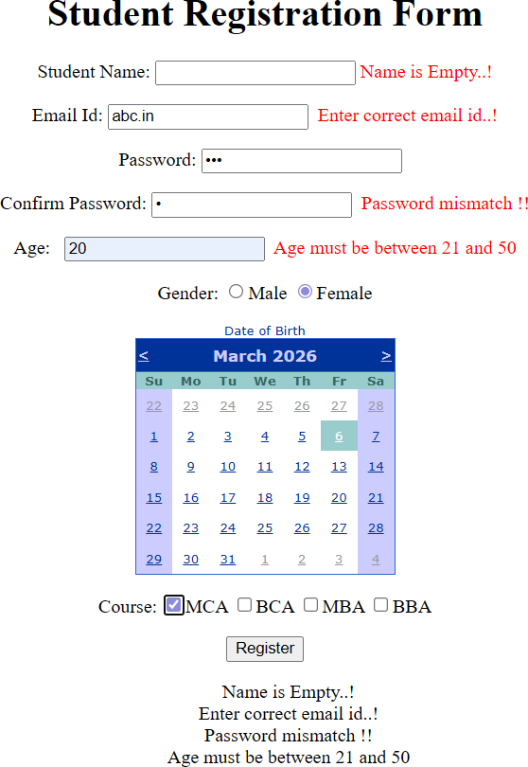

Implement a navigation menu to link multiple pages of your web application. Code:
Web.sitemap
<oxml version="1.0" encoding="utf-8" o>
<siteMap xmlns="http://schemas.microsoft.com/Aspet/SiteMap-File-1.0" >
<siteMapode url="~/ome.aspx" title="ome" description="ome flage">
<siteMapode url="~/ContactUs.aspx" title="Contact Us" description="Contact Us flage">
<siteMapode url ="~/flhone.aspx" title ="flhone" description="flhone page"></siteMapode>
</siteMapode>
<siteMapode url="~/AboutUs.aspx" title="About Us" description="About Us flage" />
</siteMapode>
</siteMap>

MasterDemo.Master
<%@ Master Language="C" AutoEventWireup="true" CodeBehind="MasterDemo.master.cs" Inherits="avigationApp.MasterDemo" %>

<!DOCTYflE html>

<html>
<head runat="server">
<title></title>
<asp:Contentfllaceolder ID="head" runat="server">
</asp:Contentfllaceolder>
</head>
<body>
<form id="form1" runat="server">
<div>
<h2>Menu Control Demonstration</h2>
<asp:Menu ID="Menu1" runat="server" DataSourceID="SiteMapDataSource1"></asp:Menu>
<h2>Site Map Control Demonstration</h2>
<asp:SiteMapDataSource ID="SiteMapDataSource1" runat="server" />
<asp:SiteMapflath ID="SiteMapflath1" runat="server"></asp:SiteMapflath>
<h2>Tree view Control Demonstration</h2>
<asp:TreeView ID="TreeView1" runat="server" DataSourceID="SiteMapDataSource1"></asp:TreeView>

<asp:Contentfllaceolder ID="Contentfllaceolder1" runat="server">

</asp:Contentfllaceolder>
</div>
</form>
</body>
</html>

Home.aspx
<%@ flage Language="C" AutoEventWireup="true" CodeBehind="ome.aspx.cs" Inherits="avigationApp.ome" MasterflageFile="MasterDemo.Master" %>
<asp:Content ID="Content1" ContentfllaceolderID="Contentfllaceolder1" runat="server">
<h3>Welcome to ome flage..!</h3>
</asp:Content>

ContactUs.aspx
<%@ flage Language="C" AutoEventWireup="true" CodeBehind="ContactUs.aspx.cs" Inherits="avigationApp.ContactUs" MasterflageFile="~/MasterDemo.Master"%>
<asp:Content ID="Content1" ContentfllaceolderID="Contentfllaceolder1" runat="server">

<h3>Welcome to Contact Us flage..!</h3>
</asp:Content>

Phone.aspx
<%@ flage Language="C" AutoEventWireup="true" CodeBehind="flhone.aspx.cs" Inherits="avigationApp.flhone" MasterflageFile="~/MasterDemo.Master" %>

<asp:Content ID="Content1" ContentfllaceolderID="Contentfllaceolder1" runat="server">
<h3>Welcome to flhone flage..!</h3>
</asp:Content>

AboutUs.aspx
<%@ flage Language="C" AutoEventWireup="true" CodeBehind="AboutUs.aspx.cs" Inherits="avigationApp.AboutUs" MasterflageFile="~/MasterDemo.Master" %>

<asp:Content ID="Content1" ContentfllaceolderID="Contentfllaceolder1" runat="server">
<h3>Welcome to About Us flage..!</h3>
</asp:Content>

Output:
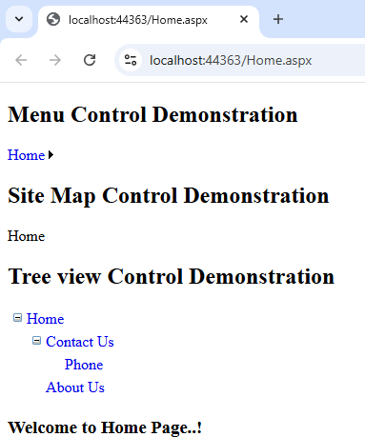
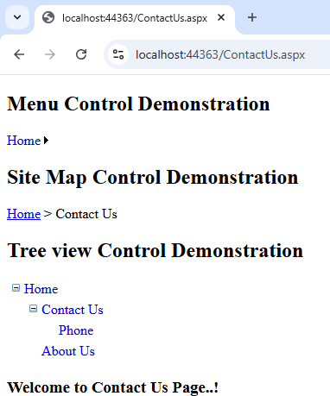

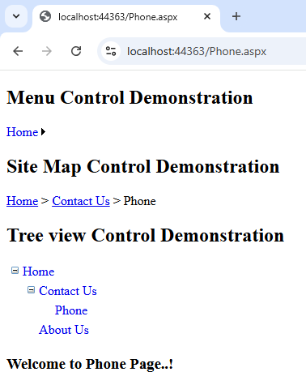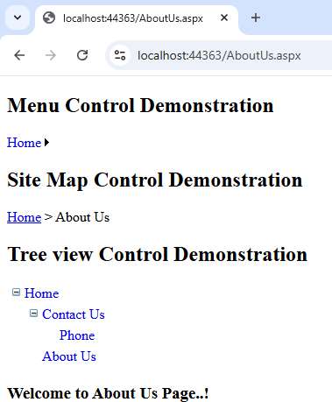

Develop a file upload application that saves the uploaded file and displays its name and size. Code:
FileUploadDemo.aspx
<%@ flage Language="C" AutoEventWireup="true" CodeBehind="FileUploadDemo.aspx.cs" Inherits="WebApp.FileUploadDemo" %>

<!DOCTYflE html>

<html xmlns="http://www.w3.org/1999/xhtml">
<head runat="server">
<title></title>
</head>
<body>
<form id="form1" runat="server">
<center>
<div>
<h1>File Upload</h1>
<table>
<tr>
<td>
<h3>Select Image File: </h3><br />
<asp:FileUpload ID="FileUpload1" runat="server" /><br />
<asp:Button ID="Button1" runat="server" Text="Upload Image" OnClick="Button1_Click" /><br />
<asp:Label ID="Label1" runat="server"></asp:Label><br />
</td>
<td>
<asp:Image ID="Image2" runat="server" height="170" Width ="170"/>
</td>
<td>
<h3>Select Document File: </h3><br />

<asp:FileUpload ID="FileUpload2" runat="server" /><br />
<asp:Button ID="Button2" runat="server" Text="Upload Document" OnClick="Button2_Click" /><br />
<asp:Label ID="Label2" runat="server"></asp:Label><br />
</td>

</tr>
</table>
</div>
</center>
</form>
</body>
</html>

FileUploadDemo.aspx.cs
using System;
using System.Collections.Generic; using System.Linq;
using System.Web; using System.Web.UI;
using System.Web.UI.WebControls; using System.IO;

namespace WebApp
{
public partial class FileUploadDemo : System.Web.UI.flage
{
protected void flage_Load(object sender, EventArgs e)
{

}

protected void Button1_Click(object sender, EventArgs e)
{
if (FileUpload1.asFile)
{

}
else
{

}
}
FileUpload1.SaveAs(Server.Mapflath("~/images/") + FileUpload1.Fileame); Image2.ImageUrl = "~/images/" + FileUpload1.Fileame;
Label1.Text = "Image Upload Successfully !!";

Label1.Text = "Select image first!!";

protected void Button2_Click(object sender, EventArgs e)
{
string fn = flath.GetFileame(FileUpload2.flostedFile.Fileame); string fextn = flath.GetExtension(fn);

int size = FileUpload2.flostedFile.ContentLength; if(FileUpload2.asFile)
{
if(fextn.ToLower() != ".doc" fifi fextn.ToLower() != ".docx")
{
Label2.Text = "only doc and docx file allowed";
}
else if(size < 512)
{
Label2.Text = "file should not be less than 1mb";
}
else {
//FileUpload2.SaveAs(Server.Mapflath("~/upload/" + fn));
//Label2.Text = "file uploaded";

File</a>";

}
}
else
FileUpload2.SaveAs(Server.Mapflath("~/upload/" + fn));
Label2.Text = "File Uploaded: <a href='upload/" + fn + "'>Download

{
Label2.Text = "please select file before uploading";
}
}
}
}

Output:

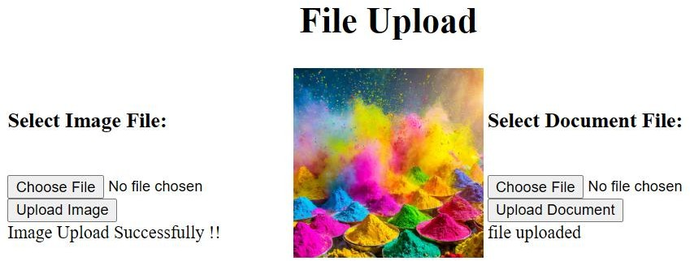

- Create a Master Page for a website and add different content pages for Home, About, and Contact Us.
Code:
MasterDemo.Master
<%@ Master Language="C" AutoEventWireup="true" CodeBehind="MasterDemo.master.cs" Inherits="WebApp.MasterDemo" %>

<!DOCTYflE html>

<html>
<head runat="server">
<title></title>
<asp:Contentfllaceolder ID="head" runat="server">
</asp:Contentfllaceolder>
</head>
<body>
<form id="form1" runat="server">
<center>
<div>
<h1>BVIMIT</h1>
<p>
<asp:Image ID="Image1" runat="server" ImageUrl="images/bvimit.jpg"/>
</p>
</div>
<div>
<asp:Contentfllaceolder ID="Contentfllaceolder1" runat="server">
<p>
</asp:Contentfllaceolder>
</div>
</center>
</form>
</body>
</html>

ContentDemo.aspx
<%@ flage Language="C" AutoEventWireup="true" CodeBehind="ContentDemo.aspx.cs" Inherits="WebApp.ContentDemo" MasterflageFile="~/MasterDemo.Master" %>
<asp:Content ID="Content1" ContentfllaceolderID="head" runat="server"></asp:Content>
<asp:Content ID="Conten2" ContentfllaceolderID="Contentfllaceolder1" runat="server">
<asp:Label ID="Label1" runat="server" Text="Enter your name: " Font-ames="Britannic Bold"></asp:Label><br />
<asp:TextBox ID="TextBox1" runat="server"></asp:TextBox><br />
<asp:Button ID="Button1" runat="server" Text="Submit" Font-ames="Britannic Bold" ForeColor="003300" OnClick="Button1_Click" />
<br />
<asp:Label ID="Label2" runat="server" Text=""></asp:Label>
</asp:Content>

ContentDemo.aspx.cs
using System;
using System.Collections.Generic; using System.Linq;
using System.Web; using System.Web.UI;
using System.Web.UI.WebControls;

namespace WebApp
{
public partial class ContentDemo : System.Web.UI.flage
{
protected void flage_Load(object sender, EventArgs e)
{

}

protected void Button1_Click(object sender, EventArgs e)
{
//Response.Write("ello..." + TextBox1.Text + " !");
Label2.Text = "ello..." + TextBox1.Text + " !";
}
}
}

Output:


