Q1. Design an ASP.NET application to Display Current Month’s Calendar. Render the
calendar. Show Some image in the cell along message.
Ans.

Calender_Page.aspx –

<%@ Page Language="C#" AutoEventWireup="true" CodeBehind="Calender_Page.aspx.cs" Inherits="Assignment2.Calender_Page" %>
<!DOCTYPE html>
<html xmlns="http://www.w3.org/1999/xhtml">
<head runat="server">
<title>Calendar Control</title>
</head>
<body>
<form id="form1" runat="server"> <center>
<h1>Calendar Control</h1>
<p> <asp:Label ID="Label1" runat="server"></asp:Label></p>
<p> <asp:Label ID="Label2" runat="server"></asp:Label> </p>
<p>
<asp:Calendar
ID="Calendar1"
runat="server"
BackColor="White"
BorderColor="#999999"
CellPadding="4"
DayNameFormat="Shortest"
Font-Names="Verdana"
Font-Size="8pt"
ForeColor="Black"
Height="200px"
Width="250px
OnSelectionChanged="Calendar1_SelectionChanged"
OnDayRender="Calendar1_DayRender"
OnVisibleMonthChanged="Calendar1_VisibleMonthChanged">
<DayHeaderStyle BackColor="#CCCCCC" Font-Bold="True" />
<SelectedDayStyle BackColor="#666666" ForeColor="White" />
<TodayDayStyle BackColor="#CCCCCC" ForeColor="Black" />
<WeekendDayStyle BackColor="#FFFFCC" />
</asp:Calendar>
</p>
<p> <asp:Label ID="Label3" runat="server"></asp:Label></p> </center>
</form>
</body>
</html>

Calender_page.aspx.cs –

using System;
using System.Web.UI;
using System.Web.UI.WebControls;

namespace Assignment2
{
public partial class Calender_Page : System.Web.UI.Page
{
protected void Page_Load(object sender, EventArgs e)
{
Label1.Text = "Today's Date is: " + DateTime.Now.ToShortDateString();
}
protected void Calendar1_SelectionChanged(object sender, EventArgs e)
{
Label3.Text = "Selected Date: " + Calendar1.SelectedDate.ToLongDateString();
}

protected void Calendar1_DayRender(object sender, DayRenderEventArgs e)
{
if (e.Day.Date == new DateTime(2026, 3, 3))
{
Literal l1 = new Literal();
Image img = new Image();
e.Cell.Width = 60;
e.Cell.Height = 60;
e.Cell.Font.Bold = true;
e.Cell.BackColor = System.Drawing.Color.Lavender;
img.ImageUrl = "Image/Correct.png";
img.Width = 25;
img.Height = 25;
l1.Text = "<br/><font size='1' color='Red'>Special Day!</font>";
e.Cell.Controls.AddAt(0, img);
e.Cell.Controls.AddAt(1, l1);
}
}
protected void Calendar1_VisibleMonthChanged(object sender, MonthChangedEventArgs e)
{
Label2.Text = "Selected Month & Year: " + e.NewDate.Month + " - " + e.NewDate.Year;
}
}
}

Output –

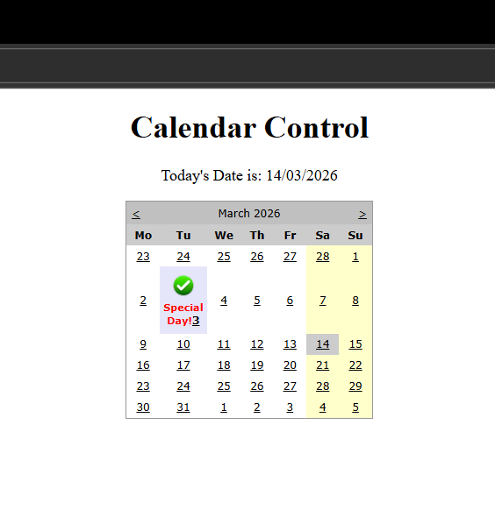

Q2. Design a registration form with validation controls for mandatory fields, email
format, and passwords.
Ans.

StudentRegistration.aspx –

<%@ Page Language="C#" AutoEventWireup="true" CodeBehind="StudRegistration.aspx.cs" Inherits="BasicApp.StudRegistration" %>
<!DOCTYPE html>
<html xmlns="http://www.w3.org/1999/xhtml"
<head runat="server">
<title></title>
</head>
<body
<form id="form1" runat="server">
<center>
<div>
<h1>Student Registration Form</h1>
<p>
<asp:Label ID="Label1" runat="server" Text="Student Name:"></asp:Label>
<asp:TextBox ID="txtName" runat="server"></asp:TextBox>
<asp:RequiredFieldValidator ID="RequiredFieldValidator1" runat="server" ControlToValidate="txtName" ErrorMessage="Name is Empty..!" ForeColor="Red"></asp:RequiredFieldValidator>
</p>
<p>
<asp:Label ID="Label2" runat="server" Text="Email Id: "></asp:Label>
<asp:TextBox ID="txtEmail" runat="server"></asp:TextBox>
<asp:RegularExpressionValidator ID="RegularExpressionValidator1" runat="server" ControlToValidate="txtEmail" ErrorMessage="Enter correct email id..!" ForeColor="Red" ValidationExpression="\w+([-+.']\w+)*@\w+([-.]\w+)*\.\w+([-.]\w+)*"></asp:RegularExpressionValidator>
</p>
<p>
<asp:Label ID="Label3" runat="server" Text="Password: "></asp:Label>
<asp:TextBox ID="txtPwd" runat="server" TextMode="Password"></asp:TextBox>
</p>
<p>
<asp:Label ID="Label4" runat="server" Text="Confirm Password: "></asp:Label>
<asp:TextBox ID="txtConPwd" runat="server" TextMode="Password"></asp:TextBox>
<asp:CompareValidator ID="CompareValidator1" runat="server" ControlToCompare="txtPwd" ControlToValidate="txtConPwd" ErrorMessage="Password mismatch !!" ForeColor="Red"></asp:CompareValidator>
</p><p>
<asp:Label ID="Label5" runat="server" Text="Age:"></asp:Label>
<asp:TextBox ID="txtAge" runat="server"></asp:TextBox>
<asp:RangeValidator ID="RangeValidator1" runat="server"
ControlToValidate="txtAge" ErrorMessage="Age must be between 21 and 50" ForeColor="Red" MaximumValue="50" MinimumValue="21"></asp:RangeValidator>
</p>
<p>
<asp:Label ID="Label6" runat="server" Text="Gender: "></asp:Label>
<asp:RadioButton ID="rdMale" runat="server" GroupName="Gender" Text="Male" />
<asp:RadioButton ID="rdFemale" runat="server" GroupName="Gender" Text="Female" />
</p>
<p>
<asp:Calendar ID="Calendar1" runat="server" BackColor="White" BorderColor="#3366CC" BorderWidth="1px" Caption="Date of Birth" CellPadding="1" DayNameFormat="Shortest" Font-Names="Verdana" Font-Size="8pt" ForeColor="#003399" Height="200px" Width="220px">
<DayHeaderStyle BackColor="#99CCCC" ForeColor="#336666" Height="1px" />
<NextPrevStyle Font-Size="8pt" ForeColor="#CCCCFF" />
<OtherMonthDayStyle ForeColor="#999999" />
<SelectedDayStyle BackColor="#009999" Font-Bold="True" ForeColor="#CCFF99" />
<SelectorStyle BackColor="#99CCCC" ForeColor="#336666" />
<TitleStyle BackColor="#003399" BorderColor="#3366CC" BorderWidth="1px" Font-Bold="True" Font-Size="10pt" ForeColor="#CCCCFF" Height="25px" />
<TodayDayStyle BackColor="#99CCCC" ForeColor="White" />
<WeekendDayStyle BackColor="#CCCCFF" />
</asp:Calendar>
</p>
<p>
<asp:Label ID="Label7" runat="server" Text="Course: "></asp:Label>
<asp:CheckBox ID="chkmca" runat="server" Text="MCA" />
<asp:CheckBox ID="chkbca" runat="server" Text="BCA" />
<asp:CheckBox ID="chkmba" runat="server" Text="MBA" />
<asp:CheckBox ID="chkbba" runat="server" Text="BBA" />
</p>

<p>
<asp:Button ID="btnRegister" runat="server" Text="Register" OnClick="Button1_Click" />
</p>
<p>
<asp:ValidationSummary ID="ValidationSummary1" runat="server" /></p>
</div>
</center>
</form>
</body>
</html>

Output –

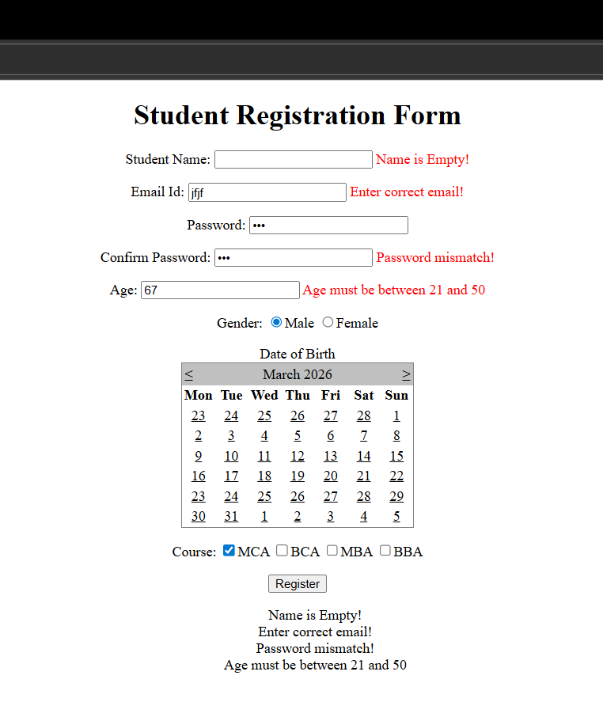

Q3. Implement a navigation menu to link multiple pages of your web application.
Ans.

Web.sitemap –

<?xml version="1.0" encoding="utf-8" ?>
<siteMap xmlns="http://schemas.microsoft.com/AspNet/SiteMap-File-1.0" >
<siteMapNode url="~/Home.aspx" title="Home" description="Home Page">
<siteMapNode url="~/ContactUs.aspx" title="Contact Us" description="Contact Us Page">
<siteMapNode url ="~/Phone.aspx" title ="Phone" description="Phone page"></siteMapNode>
</siteMapNode>
<siteMapNode url="~/AboutUs.aspx" title="About Us" description="About Us Page" />
</siteMapNode>
</siteMap>

MasterDemo.Master –

<%@ Master Language="C#" AutoEventWireup="true" CodeBehind="MasterDemo.master.cs" Inherits="NavigationApp.MasterDemo" %>
<!DOCTYPE html>
<html>
<head runat="server">
<title></title>
<asp:ContentPlaceHolder ID="head" runat="server">
</asp:ContentPlaceHolder>
</head>
<body>
<form id="form1" runat="server">
<div>
<h2>Menu Control Demonstration</h2>
<asp:Menu ID="Menu1" runat="server" DataSourceID="SiteMapDataSource1"></asp:Menu>
<h2>Site Map Control Demonstration</h2>
<asp:SiteMapDataSource ID="SiteMapDataSource1" runat="server" />
<asp:SiteMapPath ID="SiteMapPath1" runat="server"></asp:SiteMapPath>
<h2>Tree view Control Demonstration</h2>
<asp:TreeView ID="TreeView1" runat="server" DataSourceID="SiteMapDataSource1"></asp:TreeView>
<asp:ContentPlaceHolder ID="ContentPlaceHolder1" runat="server">
</asp:ContentPlaceHolder>
</div>
</form>
</body>
</html>

Home.aspx –

<%@ Page Language="C#" AutoEventWireup="true" CodeBehind="Home.aspx.cs" Inherits="NavigationApp.Home" MasterPageFile="MasterDemo.Master" %>
<asp:Content ID="Content1" ContentPlaceHolderID="ContentPlaceHolder1" runat="server">
<h3>Welcome to Home Page..!</h3>
</asp:Content>

ContactUs.aspx –

<%@ Page Language="C#" AutoEventWireup="true" CodeBehind="ContactUs.aspx.cs" Inherits="NavigationApp.ContactUs" MasterPageFile="~/MasterDemo.Master"%>
<asp:Content ID="Content1" ContentPlaceHolderID="ContentPlaceHolder1" runat="server">
<h3>Welcome to Contact Us Page..!</h3>
</asp:Content>

Phone.aspx –

<%@ Page Language="C#" AutoEventWireup="true" CodeBehind="Phone.aspx.cs" Inherits="NavigationApp.Phone" MasterPageFile="~/MasterDemo.Master" %>

<asp:Content ID="Content1" ContentPlaceHolderID="ContentPlaceHolder1" runat="server">
<h3>Welcome to Phone Page..!</h3>
</asp:Content>

AboutUs.aspx –

<%@ Page Language="C#" AutoEventWireup="true" CodeBehind="AboutUs.aspx.cs" Inherits="NavigationApp.AboutUs" MasterPageFile="~/MasterDemo.Master" %>

<asp:Content ID="Content1" ContentPlaceHolderID="ContentPlaceHolder1" runat="server">
<h3>Welcome to About Us Page..!</h3>
</asp:Content>

Output –

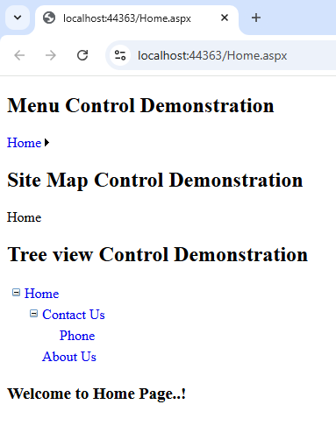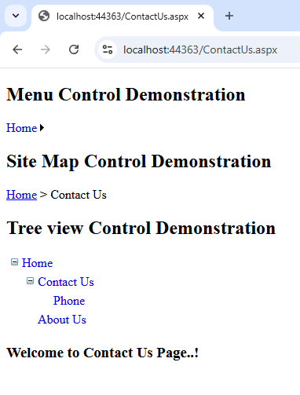

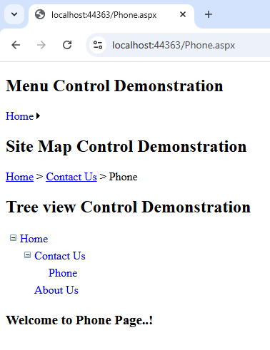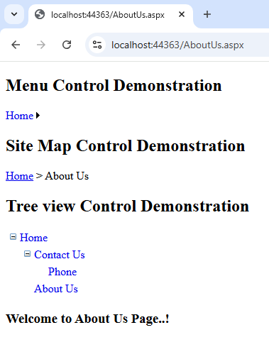

Q4. Develop a file upload application that saves the uploaded file and displays its name
and size.
Ans.

FileUpload.aspx –

<%@ Page Language="C#" AutoEventWireup="true" CodeBehind="FileUpload.aspx.cs" Inherits="Assignment2.FileUpload" %>

<!DOCTYPE html>

<html xmlns="http://www.w3.org/1999/xhtml">
<head runat="server">
<title></title>
</head>
<body>
<form id="form1" runat="server">
<center>
<div>
<h1>File Upload</h1>
<table>
<tr>
<td>
<h3>Select Image File: </h3><br />
<asp:FileUpload ID="FileUpload1" runat="server" /><br />
<asp:Button ID="Button1" runat="server" Text="Upload Image" OnClick="Button1_Click" /><br />
<asp:Label ID="Label1" runat="server"></asp:Label><br />
</td>
<td>
<asp:Image ID="Image2" runat="server" height="170" Width ="170"/>
</td>
<td>
<h3>Select Document File: </h3><br />

<asp:FileUpload ID="FileUpload2" runat="server" /><br />
<asp:Button ID="Button2" runat="server" Text="Upload Document" OnClick="Button2_Click" /><br />
<asp:Label ID="Label2" runat="server"></asp:Label><br />
</td>
</tr>
</table>
</div>
</center>
</form>
</body>
</html>

FileUpload.aspx.cs –

using System;
using System.IO;
using System.Web.UI;

namespace Assignment2
{
public partial class FileUpload : System.Web.UI.Page
{
protected void Page_Load(object sender, EventArgs e)
{

}

protected void Button1_Click(object sender, EventArgs e)
{
if (FileUpload1.HasFile)
{
string path = Server.MapPath("~/images/");

if (!Directory.Exists(path))
{
Directory.CreateDirectory(path);
}

string fileName = FileUpload1.FileName;

FileUpload1.SaveAs(path + fileName);

Image2.ImageUrl = "~/images/" + fileName;
Label1.Text = "Image Uploaded Successfully!";
}
else
{
Label1.Text = "Please select an image first.";
}
}
protected void Button2_Click(object sender, EventArgs e)
{
if (FileUpload2.HasFile)
{
string fileName = Path.GetFileName(FileUpload2.FileName);
string extension = Path.GetExtension(fileName).ToLower();
int fileSize = FileUpload2.PostedFile.ContentLength;

if (extension != ".doc" && extension != ".docx")

{
Label2.Text = "Only DOC and DOCX files allowed.";
}
else if (fileSize < 1024)
{
Label2.Text = "File should not be less than 1 KB.";
}
else
{
string path = Server.MapPath("~/upload/");

if (!Directory.Exists(path))
{
Directory.CreateDirectory(path);
}

FileUpload2.SaveAs(path + fileName);

Label2.Text = "File Uploaded: <a href='upload/" + fileName + "'>Download File</a>";
}
}
else
{
Label2.Text = "Please select a file before uploading.";
}
}
}
}

Output –

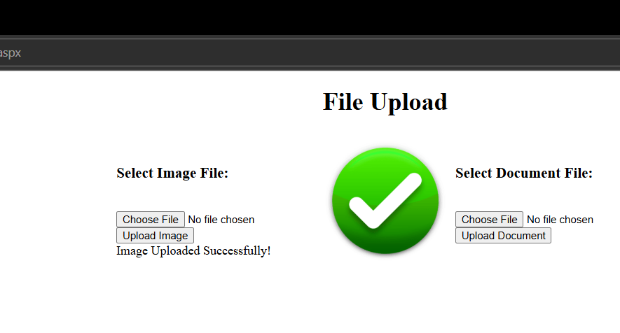

Q5. Create a Master Page for a website and add different content pages for Home,
About, and Contact Us.
Ans.

MasterDemo.Master

<%@ Master Language="C#" AutoEventWireup="true" CodeBehind="MasterDemo.master.cs" Inherits="WebApp.MasterDemo" %>

<!DOCTYPE html>

<html>
<head runat="server">
<title></title>
<asp:ContentPlaceHolder ID="head" runat="server">
</asp:ContentPlaceHolder>
</head>
<body>
<form id="form1" runat="server">
<center>
<div>
<h1>BVIMIT</h1> <p>
<asp:Image ID="Image1" runat="server" ImageUrl="images/bvimit.jpg"/>
</p>
</div>
<div>
<asp:ContentPlaceHolder ID="ContentPlaceHolder1" runat="server"> <p>
</asp:ContentPlaceHolder>
</div>
</center>
</form>
</body>
</html>

ContentDemo.aspx –

<%@ Page Language="C#" AutoEventWireup="true" CodeBehind="ContentDemo.aspx.cs" Inherits="WebApp.ContentDemo" MasterPageFile="~/MasterDemo.Master" %>
<asp:Content ID="Content1" ContentPlaceHolderID="head" runat="server"></asp:Content>
<asp:Content ID="Conten2" ContentPlaceHolderID="ContentPlaceHolder1" runat="server">
<asp:Label ID="Label1" runat="server" Text="Enter your name: " Font-Names="Britannic Bold"></asp:Label><br />
<asp:TextBox ID="TextBox1" runat="server"></asp:TextBox><br />
<asp:Button ID="Button1" runat="server" Text="Submit" Font-Names="Britannic Bold" ForeColor="#003300" OnClick="Button1_Click" />

<br />
<asp:Label ID="Label2" runat="server" Text=""></asp:Label>
</asp:Content>

ContentDemo.aspx.cs –

using System;
using System.Collections.Generic;
using System.Linq;
using System.Web;
using System.Web.UI;
using System.Web.UI.WebControls;

namespace WebApp
{
public partial class ContentDemo : System.Web.UI.Page
{
protected void Page_Load(object sender, EventArgs e)
{
}
protected void Button1_Click(object sender, EventArgs e)
{
//Response.Write("Hello..." + TextBox1.Text + "....!");
Label2.Text = "Hello..." + TextBox1.Text + "....!";
}
}
}

Output –



