Q1. Create a web application to connect to a database using ADO.NET and
display data in a GridView.(connected and disconnected)

Database.aspx –

<%@ Page Language="C#" AutoEventWireup="true" CodeBehind="database.aspx.cs" Inherits="WebApplication3.database" %>
<!DOCTYPE html>
<html xmlns="http://www.w3.org/1999/xhtml">
<head runat="server">
<title>Connected Disconnected Architecture</title>
</head>
<body>
<center>
<form id="form1" runat="server">
<div>
<h1>Connected Disconnected Architecture</h1>
<br />
</div>
<asp:Button
ID="Button1"
runat="server"
Text="Connected"
OnClick="Button1_Click" />
&nbsp;&nbsp;&nbsp;&nbsp;&nbsp;&nbsp;&nbsp;&nbsp;&nbsp;
<asp:Button
ID="Button2"
runat="server"
Text="Disconnected"
OnClick="btnDisc_Click" />
<br /><br />
<asp:GridView
ID="GridView1"
runat="server"
CellPadding="4"
ForeColor="#333333"
GridLines="None">
<AlternatingRowStyle BackColor="White" ForeColor="#284775" />
<EditRowStyle BackColor="#999999" />
<FooterStyle BackColor="#5D7B9D" Font-Bold="True" ForeColor="White" />
<HeaderStyle BackColor="#5D7B9D" Font-Bold="True" ForeColor="White" />
<PagerStyle BackColor="#284775" ForeColor="White" HorizontalAlign="Center" />
<RowStyle BackColor="#F7F6F3" ForeColor="#333333" />
<SelectedRowStyle BackColor="#E2DED6" Font-Bold="True" ForeColor="#333333" />
<SortedAscendingCellStyle BackColor="#E9E7E2" />
<SortedAscendingHeaderStyle BackColor="#506C8C" />
<SortedDescendingCellStyle BackColor="#FFFDF8" />
<SortedDescendingHeaderStyle BackColor="#6F8DAE" />
</asp:GridView>
</form>
</center></body></html>
Database.aspx.cs

using System;
using System.Data;
using System.Data.SqlClient;

namespace WebApplication3
{
public partial class database : System.Web.UI.Page
{
SqlConnection con;
protected void Button1_Click(object sender, EventArgs e)
{
con = new SqlConnection(@"Data Source=(LocalDB)\MSSQLLocalDB;AttachDbFilename=D:\OMKAR\STUDENTDB.MDF;Integrated Security=True");

SqlCommand cmd = new SqlCommand("SELECT * FROM Student31", con);
con.Open();
SqlDataReader dr = cmd.ExecuteReader();

GridView1.DataSource = dr;
GridView1.DataBind();
con.Close();
}

protected void btnDisc_Click(object sender, EventArgs e)
{
SqlDataAdapter objDa = new SqlDataAdapter();
DataSet objDs = new DataSet();
SqlConnection objConn = new SqlConnection(@"Data Source=(LocalDB)\MSSQLLocalDB;AttachDbFilename=D:\OMKAR\STUDENTDB.MDF;Integrated Security=True");

SqlCommand objCmd = new SqlCommand("SELECT * FROM student31", objConn);
objDa.SelectCommand = objCmd;
objConn.Open();
objDa.Fill(objDs, "emp");
objConn.Close();
GridView1.DataSource = objDs.Tables["emp"];
GridView1.DataBind();
}
}
}

Output –

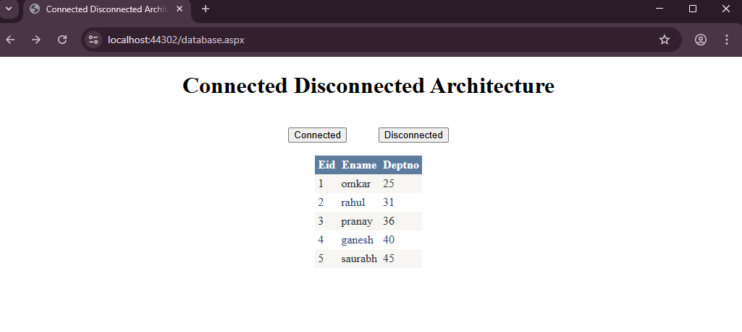

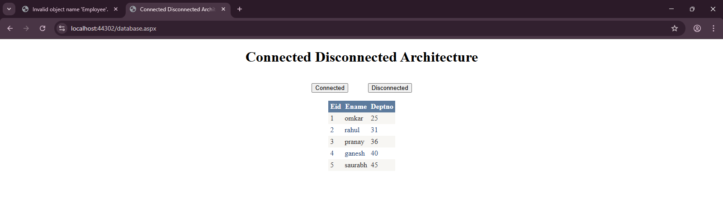

Q2. Implement a form to insert, update, delete, and display student records
using connected architecture.

Connected.aspx –

<%@ Page Language="C#" AutoEventWireup="true" CodeBehind="Connected.aspx.cs" Inherits="Assignment3.Connected" %>

<!DOCTYPE html>
<html xmlns="http://www.w3.org/1999/xhtml">
<head runat="server">
<title></title>
</head>
<body>
<form id="form1" runat="server">
<center>
<div><b><h2>
&nbsp;&nbsp;&nbsp;Connected Architecture<br />
<br />
</h2></b>
&nbsp;Eid :-
<asp:TextBox ID="TextBox1" runat="server"></asp:TextBox>
<br />
EmpName :-
<asp:TextBox ID="TextBox2" runat="server"></asp:TextBox>
<br />
Designation:-<asp:TextBox ID="TextBox3" runat="server"></asp:TextBox>
<br />
Salary :-
<asp:TextBox ID="TextBox4" runat="server"></asp:TextBox>
<br />
<br />
<asp:GridView ID="GridView1" runat="server">
</asp:GridView>
<br />
<br />
<asp:Button ID="INSERT" runat="server" OnClick="INSERT_Click" Text="INSERT" Width="62px" />
&nbsp;
<asp:Button ID="UPDATE" runat="server" Text="UPDATE" />
&nbsp;
<asp:Button ID="DELETE" runat="server" Text="DELETE" />
&nbsp;<asp:Button ID="DISPLAY" runat="server" Text="DISPLAY" OnClick="DISPLAY_Click" />
&nbsp;<asp:Button ID="RecordCOUNT" runat="server" Text="RecordCOUNT" />
&nbsp;<asp:Button ID="SEARCH" runat="server" Text="SEARCH" />
</div>
</center>
</form>
</body>
</html>
Connected.aspx.cs –

using System;
using System.Collections.Generic;
using System.Data.SqlClient;
using System.Linq;
using System.Security.Cryptography;
using System.Web;
using System.Web.UI;
using System.Web.UI.WebControls;
using System.Data;

namespace Assignment3
{
public partial class Connected : System.Web.UI.Page
{
SqlConnection conn;
SqlCommand cmd;
SqlDataReader rdr;
protected void Page_Load(object sender, EventArgs e)
{
conn = new SqlConnection("Data Source=(LocalDB)\\MSSQLLocalDB;AttachDbFilename=C:\\Users\\Admin\\Documents\\StudentDB.mdf;Integrated Security=True;Connect Timeout=30");
}

protected void DISPLAY_Click(object sender, EventArgs e)
{
Displaytable();
}

void Displaytable()
{
cmd = new SqlCommand(" select * from EmployeeA68", conn);
conn.Open();
rdr = cmd.ExecuteReader();
GridView1.DataSource = rdr;
GridView1.DataBind();
conn.Close();
}
protected void INSERT_Click(object sender, EventArgs e)
{
conn.Open();
cmd = new SqlCommand("insert into EmployeeA68(Eid ,Ename,EDept,Salary)values('" + TextBox1.Text + "','" + TextBox2.Text + "' ,' " + TextBox3.Text + "',' " + TextBox4.Text + "')", conn);
cmd.ExecuteNonQuery();
Response.Write("one record inserted");
conn.Close();
Displaytable();

}

protected void DELETE_Click(object sender, EventArgs e)
{

cmd = new SqlCommand("delete from EmployeeA68 where Eid = '" +TextBox1.Text+"'", conn);
conn.Open();
cmd.ExecuteNonQuery();
Response.Write("one record deleted");
conn.Close();
Displaytable();
}

protected void UPDATE_Click(object sender, EventArgs e)
{

cmd = new SqlCommand("update EmployeeA68 set Ename = '" + TextBox2.Text + "',EDept='"+TextBox3.Text+ "',Salary ='"+TextBox4.Text+"' where Eid = '"+TextBox1.Text+" '", conn);

conn.Open();
cmd.ExecuteNonQuery();
Response.Write("one record updated");
conn.Close();
Displaytable();
}

protected void SEARCH_Click(object sender, EventArgs e)
{
cmd = new SqlCommand("SELECT Eid, Ename, EDept, Salary FROM EmployeeA68 where Eid='" + TextBox1.Text+"'", conn);
conn.Open();
Response.Write("one record searched:");
rdr = cmd.ExecuteReader();
GridView1.DataSource = rdr;
GridView1.DataBind();
conn.Close();
}

protected void RecordCOUNT_Click(object sender, EventArgs e)
{
conn.Open();
cmd = new SqlCommand("select Count(*) from EmployeeA68", conn);
int a = (int)cmd.ExecuteScalar();
Response.Write("Total Record :-- > " + a.ToString());

conn.Close();
}
}
}

Output –

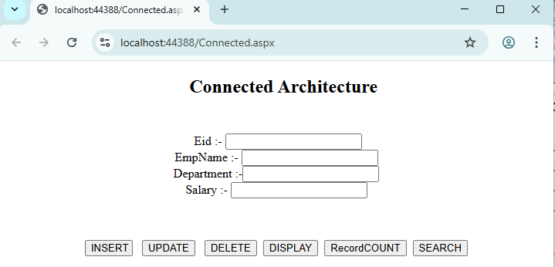

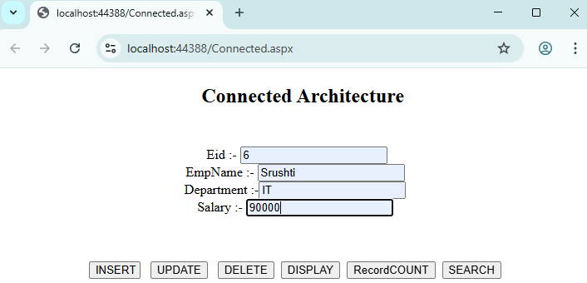

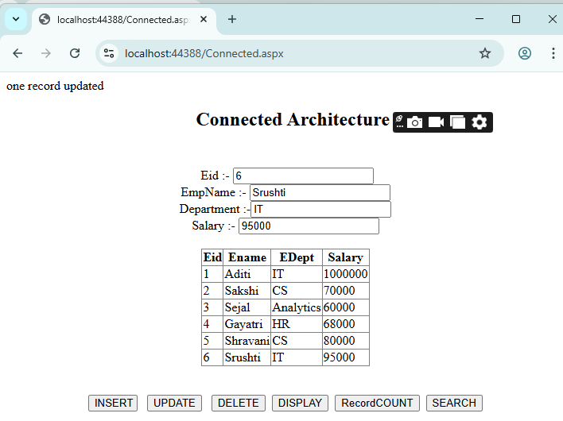
Q3. Design a web application using disconnected architecture (DataSet and
DataAdapter) for managing data.

Disconnected.aspx –

<%@ Page Language="C#" AutoEventWireup="true" CodeBehind="Disconnected.aspx.cs" Inherits="Assignment3.Disconnected" %>
<!DOCTYPE html>
<html xmlns="http://www.w3.org/1999/xhtml">
<head runat="server">
<title></title>
</head>
<body>
<form id="form2" runat="server">
<center>
<div><b><h2>
Disconnected Architecture</h2>
</b>&nbsp;Eid :-
<asp:TextBox ID="TextBox1" runat="server"></asp:TextBox>
<br />
EmpName :-
<asp:TextBox ID="TextBox2" runat="server"></asp:TextBox>
<br />
Department :-<asp:TextBox ID="TextBox3" runat="server"></asp:TextBox>
<br />
Salary :-
<asp:TextBox ID="TextBox4" runat="server"></asp:TextBox>
<br />
<br />
<asp:GridView ID="GridView1" runat="server" BackColor="#CCCCCC" BorderColor="#999999" BorderStyle="Solid" BorderWidth="3px" CellPadding="4" CellSpacing="2" ForeColor="Black">
<FooterStyle BackColor="#CCCCCC" />
<HeaderStyle BackColor="Black" Font-Bold="True" ForeColor="White" />
<PagerStyle BackColor="#CCCCCC" ForeColor="Black" HorizontalAlign="Left" />
<RowStyle BackColor="White" />
<SelectedRowStyle BackColor="#000099" Font-Bold="True" ForeColor="White" />
<SortedAscendingCellStyle BackColor="#F1F1F1" />
<SortedAscendingHeaderStyle BackColor="#808080" />
<SortedDescendingCellStyle BackColor="#CAC9C9" />
<SortedDescendingHeaderStyle BackColor="#383838" />
</asp:GridView>
<br />
<br />
<asp:Button ID="INSERT" runat="server" OnClick="INSERT_Click" Text="INSERT" Width="62px" />
&nbsp;
<asp:Button ID="UPDATE" runat="server" Text="UPDATE" OnClick="UPDATE_Click" />

&nbsp;
<asp:Button ID="DELETE" runat="server" Text="DELETE" OnClick="DELETE_Click" />
&nbsp;<asp:Button ID="DISPLAY" runat="server" Text="DISPLAY" OnClick="DISPLAY_Click" />
&nbsp;&nbsp;</div>
</center>
</form>
<form id="form1" runat="server">
<div>
</div>
</form>
</body>
</html>

Disconnected.aspx.cs –

using System;
using System.Collections.Generic;
using System.Data;
using System.Data.SqlClient;
using System.Linq;
using System.Web;
using System.Web.UI;
using System.Web.UI.WebControls;

namespace Assignment3
{
public partial class Disconnected : System.Web.UI.Page
{
SqlConnection conn;
SqlCommand cmd;
SqlDataAdapter da;
DataSet ds;
protected void Page_Load(object sender, EventArgs e)
{
conn = new SqlConnection("Data Source=(LocalDB)\\MSSQLLocalDB;AttachDbFilename=C:\\Users\\Admin\\Documents\\StudentDB.mdf;Integrated Security=True;Connect Timeout=30");
da = new SqlDataAdapter();
ds = new DataSet();

}
protected void INSERT_Click(object sender, EventArgs e)
{
cmd = new SqlCommand("insert into EmployeeA68(Eid ,Ename,EDept,Salary)values('" + TextBox1.Text + "','" + TextBox2.Text + "' ,' " + TextBox3.Text + "',' " + TextBox4.Text + "')", conn);
da.InsertCommand = cmd;

conn.Open();
da.InsertCommand.ExecuteNonQuery();
conn.Close();
Response.Write("Record Inserted...");
Display();

}

protected void UPDATE_Click(object sender, EventArgs e)
{
cmd = new SqlCommand("update EmployeeA68 set Ename = '" + TextBox2.Text + "',EDept='" + TextBox3.Text + "',Salary ='" + TextBox4.Text + "' where Eid = '" + TextBox1.Text + " '", conn);
da.UpdateCommand = cmd;
conn.Open();
da.UpdateCommand.ExecuteNonQuery();
conn.Close();
Response.Write("Record Updated...");
Display();
}

protected void DELETE_Click(object sender, EventArgs e)
{

cmd = new SqlCommand("delete from EmployeeA68 where Eid = '" + TextBox1.Text + "'", conn);
da.DeleteCommand = cmd;
conn.Open();
da.DeleteCommand.ExecuteNonQuery();
conn.Close();
Response.Write("Record Deleted");
Display();
}

protected void DISPLAY_Click(object sender, EventArgs e)
{
Display();
}
void Display()
{
cmd = new SqlCommand(" select * from EmployeeA68", conn);
da.SelectCommand = cmd;
conn.Open();
da.SelectCommand.ExecuteReader();
conn.Close();
da.Fill(ds, "Emp");
GridView1.DataSource = ds;
GridView1.DataBind();
}
}
}
Output –

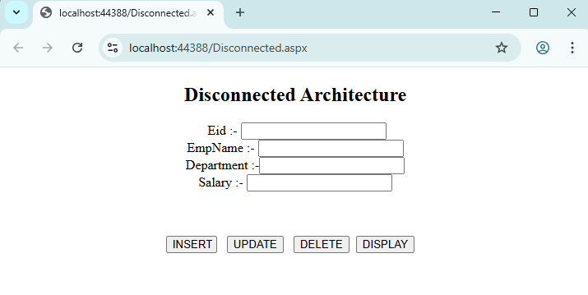

Q4. Develop a stored procedure to fetch employee details and display them
using a DetailsView control.

Procedure – omkar

CREATE PROCEDURE [dbo].[omkar]
@Action VARCHAR(10),
@eid VARCHAR(20)=NULL,
@ename VARCHAR(50)=NULL,
@designation varchar(50)=NULL,
@salary VARCHAR(50)=NULL
AS
BEGIN
SET NOCOUNT ON;
IF @Action ='SELECT'
BEGIN
SELECT eid, ename, designation, salary FROM emp
END
IF @Action ='INSERT'
BEGIN
INSERT INTO emp(eid, ename, designation, salary) VALUES (@eid, @ename, @designation, @salary)
END
IF @Action ='UPDATE'
BEGIN
UPDATE emp SET ename = @ename, designation = @designation,salary = @salary WHERE eid = @eid
END
IF @Action ='DELETE'
BEGIN
DELETE FROM emp WHERE eid = @eid
END
END

Parameterized.aspx –

<%@ Page Language="C#" AutoEventWireup="true" CodeBehind="Parametarized.aspx.cs" Inherits="DataBound.Parametarized" %>
<!DOCTYPE html>
<html xmlns="http://www.w3.org/1999/xhtml">
<head runat="server">
<title></title>
</head>
<body>
<form id="form1" runat="server">
<div>
<center>
<h1>
Parameterized Procedure
</h1>
<p> &nbsp;</p>

<asp:GridView ID="GridView1" runat="server">
</asp:GridView>
<br />
Emp ID :
<asp:TextBox ID="TextBox1" runat="server"></asp:TextBox>
<br />
Ename :
<asp:TextBox ID="TextBox2" runat="server"></asp:TextBox>
<br />
Designation :&nbsp;
<asp:TextBox ID="TextBox3" runat="server"></asp:TextBox>
<br />
Salary :&nbsp;
<asp:TextBox ID="TextBox4" runat="server"></asp:TextBox>
<br />
<br />
<input id="Button1" type="button" value="ADD" />&nbsp;
<input id="Button2" type="button" value="UPDATE"/>&nbsp;
<input id="Button3" type="button" value="DELETE" /></form>
</center>
</div>
</body>
</html>

Parametarized.aspx.cs –

using System;
using System.Data;
using System.Data.SqlClient;
using System.Web.UI;
namespace DataBound
{
public partial class Parametarized : System.Web.UI.Page
{
protected void Page_Load(object sender, EventArgs e)
{
Display();
}
void Display()
{
SqlConnection conn = new SqlConnection(@"Data Source=(LocalDB)\MSSQLLocalDB;AttachDbFilename=C:\Users\Admin\Documents\studentdb1.mdf;Integrated Security=True;Connect Timeout=30");
SqlCommand cmd = new SqlCommand("omkar", conn);
conn.Open();
cmd.CommandType = CommandType.StoredProcedure;
cmd.Parameters.AddWithValue("@Action", "SELECT");
SqlDataReader rdr = cmd.ExecuteReader();
GridView1.DataSource = rdr;
GridView1.DataBind();
conn.Close();

}
protected void btnInsert_Click(object sender, EventArgs e)
{
SqlConnection conn = new SqlConnection(@"Data Source=(LocalDB)\MSSQLLocalDB;AttachDbFilename=C:\Users\Admin\Documents\studentdb1.mdf;Integrated Security=True;Connect Timeout=30");
SqlCommand cmd = new SqlCommand("omkar", conn);

conn.Open();
cmd.CommandType = CommandType.StoredProcedure;
cmd.Parameters.AddWithValue("@Action", "INSERT");
cmd.Parameters.AddWithValue("@eid", TextBox1.Text);
cmd.Parameters.AddWithValue("@ename", TextBox2.Text);
cmd.Parameters.AddWithValue("@edesig", TextBox3.Text);
cmd.Parameters.AddWithValue("@esal", TextBox4.Text);
cmd.ExecuteNonQuery();
conn.Close();
Display();
}
protected void btnUpdate_Click(object sender, EventArgs e)
{
SqlConnection conn = new SqlConnection(@"Data Source=(LocalDB)\MSSQLLocalDB;AttachDbFilename=C:\Users\Admin\Documents\studentdb1.mdf;Integrated Security=True;Connect Timeout=30");
SqlCommand cmd = new SqlCommand("omkar", conn);
conn.Open();
cmd.CommandType = CommandType.StoredProcedure;
cmd.Parameters.AddWithValue("@Action", "UPDATE");
cmd.Parameters.AddWithValue("@eid", TextBox1.Text);
cmd.Parameters.AddWithValue("@ename", TextBox2.Text);
cmd.Parameters.AddWithValue("@edesig", TextBox3.Text);
cmd.Parameters.AddWithValue("@esal", TextBox4.Text);
cmd.ExecuteNonQuery();
conn.Close();
Display();
}
protected void btnDelete_Click(object sender, EventArgs e)
{
SqlConnection conn = new SqlConnection(@"Data Source=(LocalDB)\MSSQLLocalDB;AttachDbFilename=C:\Users\Admin\Documents\studentdb1.mdf;Integrated Security=True;Connect Timeout=30");
SqlCommand cmd = new SqlCommand("omkar", conn);
conn.Open();
cmd.CommandType = CommandType.StoredProcedure;
cmd.Parameters.AddWithValue("@Action", "DELETE");
cmd.Parameters.AddWithValue("@eid", TextBox1.Text);
cmd.ExecuteNonQuery();
conn.Close();
Display();
}
}}
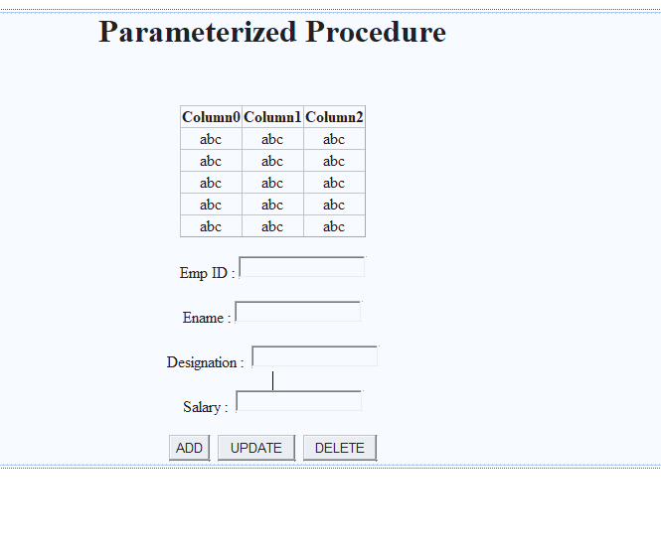

Output –

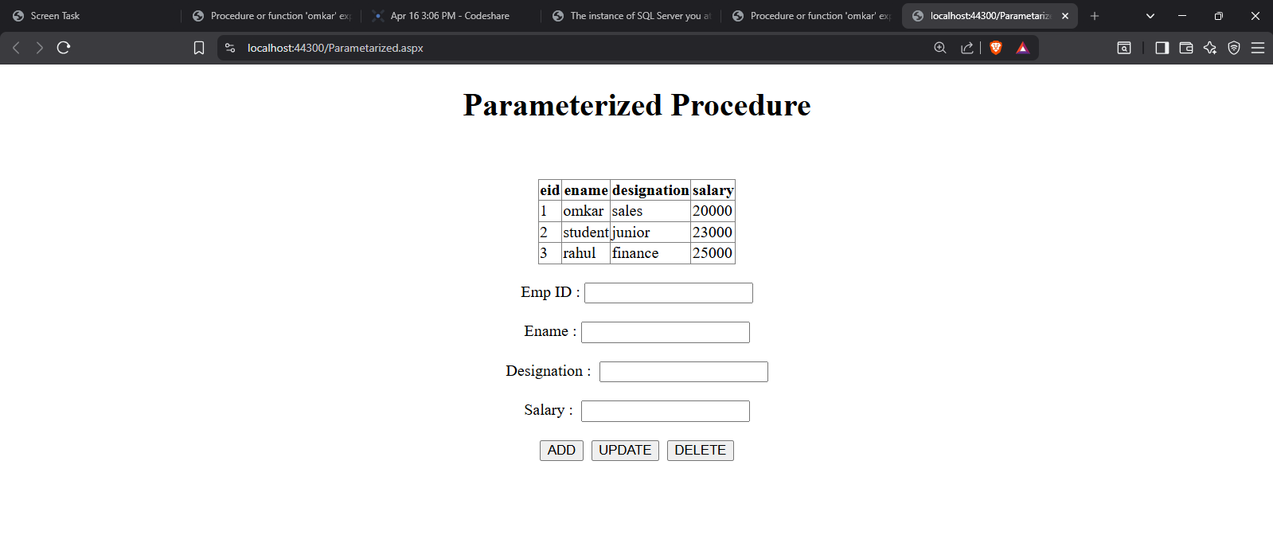

Q5. Web Application to demonstrate LINQ with object data source.

LINQ.aspx –

<%@ Page Language="C#" AutoEventWireup="true" CodeBehind="LINQ.aspx.cs" Inherits="Project.LINQ" %>

<!DOCTYPE html>

<html xmlns="http://www.w3.org/1999/xhtml">
<head runat="server">
<title></title>
</head>
<body>
<form id="form1" runat="server">
<div>
<center>
LINQ TO OBJECT
<br />
<asp:GridView ID="GridView1" runat="server">
</asp:GridView>
</center>
</div>
</form>
</body>
</html>

LINQ.aspx.cs –

using System;
using System.Collections.Generic;
using System.Linq;
using System.Web;
using System.Web.UI;
using System.Web.UI.WebControls;
namespace Project
{
public partial class LINQ : System.Web.UI.Page
{
public List<DeptClass> getdata()
{
return new List<DeptClass>
{
new DeptClass{ DepartmentId = 1, Name = "Account" },
new DeptClass{ DepartmentId = 2, Name = "Sales" },
new DeptClass{ DepartmentId = 3, Name = "Marketing" },
};
}
protected void Page_Load(object sender, EventArgs e)
{
var departmentList = getdata();
var q = from d in departmentList

where d.Name.Contains("les") && d.DepartmentId == 2
select d;
GridView1.DataSource = q;
GridView1.DataBind();
}
}
}

DeptClass.cs

using System;
using System.Collections.Generic;
using System.Linq;
using System.Web;
namespace Project
{
public class DeptClass
{
int deptid;
string name;
public int DepartmentId
{ get { return deptid; }
set { deptid = value; }
}
public string Name
{ get { return name; } set { name = value; } }
}
}

Output –

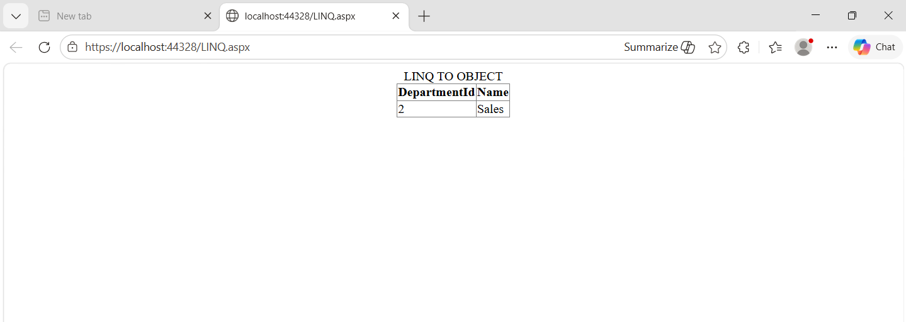
Q6. Web Application to demonstrate LINQ with data set.

LIQNDataset.aspx

<%@ Page Language="C#" AutoEventWireup="true" CodeBehind="LINQDataset.aspx.cs" Inherits="Project.LINQDataset" %>

<!DOCTYPE html>

<html xmlns="http://www.w3.org/1999/xhtml">
<head runat="server">
<title></title>
</head>
<body>
<form id="form1" runat="server">
<div>
<center>

<asp:GridView ID="GridView1" runat="server">
</asp:GridView>

</center>
</div>
</form>
</body>
</html>

LIQNDataset.aspx.cs –

using System;
using System.Collections.Generic;
using System.Data;
using System.Data.SqlClient;
using System.Linq;
using System.Web;
using System.Web.UI;
using System.Web.UI.WebControls;

namespace Project
{
public partial class LINQDataset : System.Web.UI.Page
{
protected void Page_Load(object sender, EventArgs e)
{
Display();
}
protected void Display()
{
DataSet ds = new DataSet();
SqlConnection conn = new SqlConnection(@"Data Source=(LocalDB)\MSSQLLocalDB;AttachDbFilename=C:\Users\Admin\Documents\Study.mdf;Int

egrated Security=True;Connect Timeout=30");
conn.Open();

SqlCommand cmd = new SqlCommand("select * from Employee", conn);

SqlDataAdapter da = new SqlDataAdapter(cmd);
da.Fill(ds);
conn.Close();

if (ds.Tables[0].Rows.Count > 0)
{
var result = from dt in ds.Tables[0].AsEnumerable()
//where dt.Field<string>("EmpName").Contains("i")
select new
{
Id = dt.Field<int>("Id"),
Name = dt.Field<string>("Name"),
Designation = dt.Field<string>("Designation"),
Salary = dt.Field<int>("Salary")
};

GridView1.DataSource = result;
GridView1.DataBind();
}
}
}
}

Output –

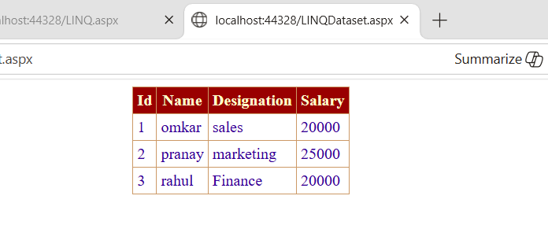

Q7. Create a webpage that demonstrates the use of data bound controls

DataBound.aspx –

<%@ Page Language="C#" AutoEventWireup="true" CodeBehind="DataBound.aspx.cs" Inherits="DataBound.DataBound" %>
<!DOCTYPE html>
<html xmlns="http://www.w3.org/1999/xhtml">
<head runat="server">
<title></title>
</head>
<body>
<form id="form1" runat="server">
<div>
<h1>Demonstration of DataBound Control </h1>
<h2>DataList</h2>
<asp:DataList ID="DataList1" runat="server" DataKeyField="eid" DataSourceID="SqlDataSource1">
<ItemTemplate>
ename:
<asp:Label ID="enameLabel" runat="server" Text='<%# Eval("ename") %>' />
<br />
salary:
<asp:Label ID="salaryLabel" runat="server" Text='<%# Eval("salary") %>' />
<br />
eid:
<asp:Label ID="eidLabel" runat="server" Text='<%# Eval("eid") %>' />
<br />
<br />
</ItemTemplate>
</asp:DataList>
<h2>Details View</h2>
<asp:DetailsView ID="DetailsView1" runat="server" Height="50px" Width="125px" AutoGenerateRows="False" DataKeyNames="eid" DataSourceID="SqlDataSource1">
<Fields>
<asp:BoundField DataField="ename" HeaderText="ename" SortExpression="ename" />
<asp:BoundField DataField="salary" HeaderText="salary" SortExpression="salary" />
<asp:BoundField DataField="eid" HeaderText="eid" ReadOnly="True" SortExpression="eid" />
</Fields>
</asp:DetailsView>
<h2>FormView</h2>
<asp:FormView ID="FormView1" runat="server" DataKeyNames="eid" DataSourceID="SqlDataSource1">

<EditItemTemplate>
ename:
<asp:TextBox ID="enameTextBox" runat="server" Text='<%# Bind("ename") %>' />
<br />
salary:
<asp:TextBox ID="salaryTextBox" runat="server" Text='<%# Bind("salary") %>' />
<br />
eid:
<asp:Label ID="eidLabel1" runat="server" Text='<%# Eval("eid") %>' />
<br />
<asp:LinkButton ID="UpdateButton" runat="server" CausesValidation="True" CommandName="Update" Text="Update" />
&nbsp;<asp:LinkButton ID="UpdateCancelButton" runat="server" CausesValidation="False" CommandName="Cancel" Text="Cancel" />
</EditItemTemplate>
<InsertItemTemplate>
ename:
<asp:TextBox ID="enameTextBox" runat="server" Text='<%# Bind("ename") %>' />
<br />
salary:
<asp:TextBox ID="salaryTextBox" runat="server" Text='<%# Bind("salary") %>' />
<br />
eid:
<asp:TextBox ID="eidTextBox" runat="server" Text='<%# Bind("eid") %>' />
<br />
<asp:LinkButton ID="InsertButton" runat="server" CausesValidation="True" CommandName="Insert" Text="Insert" />
&nbsp;<asp:LinkButton ID="InsertCancelButton" runat="server" CausesValidation="False" CommandName="Cancel" Text="Cancel" />
</InsertItemTemplate>
<ItemTemplate>
ename:
<asp:Label ID="enameLabel" runat="server" Text='<%# Bind("ename") %>' />
<br />
salary:
<asp:Label ID="salaryLabel" runat="server" Text='<%# Bind("salary") %>' />
<br />
eid:
<asp:Label ID="eidLabel" runat="server" Text='<%# Eval("eid") %>' />
<br />
</ItemTemplate>
</asp:FormView>
<h2>GridView</h2>

<asp:GridView ID="GridView1" runat="server" AutoGenerateColumns="False" DataKeyNames="eid" DataSourceID="SqlDataSource1">
<Columns>
<asp:BoundField DataField="ename" HeaderText="ename" SortExpression="ename" />
<asp:BoundField DataField="salary" HeaderText="salary" SortExpression="salary" />
<asp:BoundField DataField="eid" HeaderText="eid" ReadOnly="True" SortExpression="eid" />
</Columns>
</asp:GridView>
<h2>ListView</h2>
<asp:ListView ID="ListView1" runat="server" DataSourceID="SqlDataSource1">
<ItemTemplate>
ename:
<asp:Label ID="enameLabel" runat="server" Text='<%# Bind("ename") %>' />
<br />
salary:
<asp:Label ID="salaryLabel" runat="server" Text='<%# Bind("salary") %>' />
<br />
eid:
<asp:Label ID="eidLabel" runat="server" Text='<%# Eval("eid") %>' />
<br />
</ItemTemplate>
</asp:ListView>
<h2>Repeater</h2>
<asp:Repeater ID="Repeater1" runat="server" DataSourceID="SqlDataSource1">
<ItemTemplate>
ename:
<asp:Label ID="enameLabel" runat="server" Text='<%# Bind("ename") %>' />
<br />
salary:
<asp:Label ID="salaryLabel" runat="server" Text='<%# Bind("salary") %>' />
<br />
eid:
<asp:Label ID="eidLabel" runat="server" Text='<%# Eval("eid") %>' />
<br />
</ItemTemplate>
</asp:Repeater>
<asp:SqlDataSource ID="SqlDataSource1" runat="server" ConnectionString="<%$ ConnectionStrings:studentDBConnectionString %>" SelectCommand="SELECT [ename], [salary], [eid] FROM [dba51]"></asp:SqlDataSource>
</div>
</form>
</body>
</html>
Output –

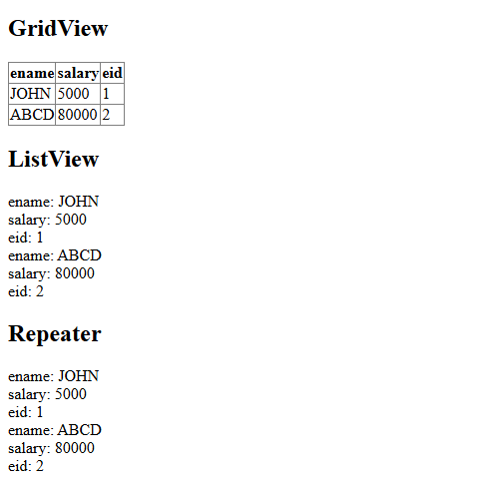

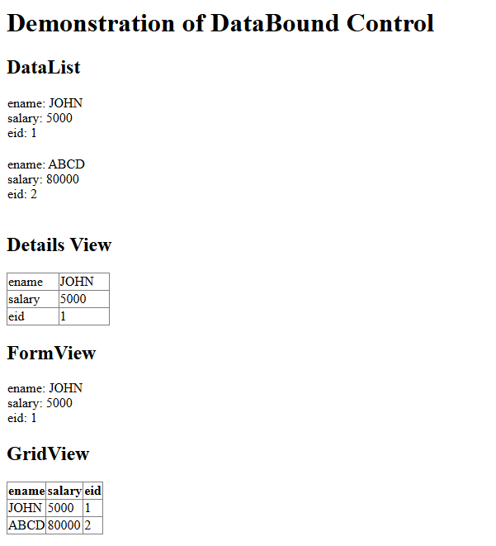

Q8. Build websites to demonstrate the working of entity framework.

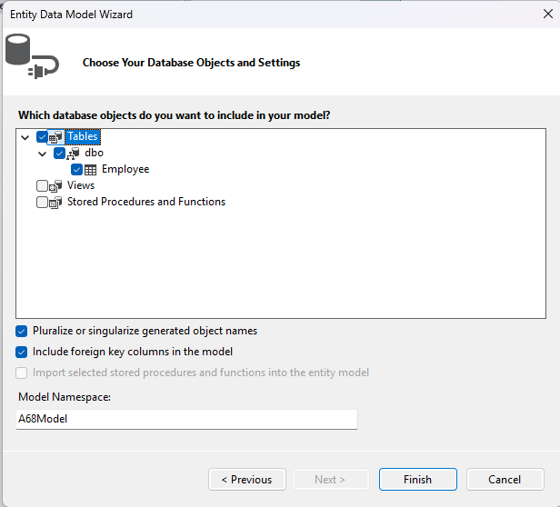

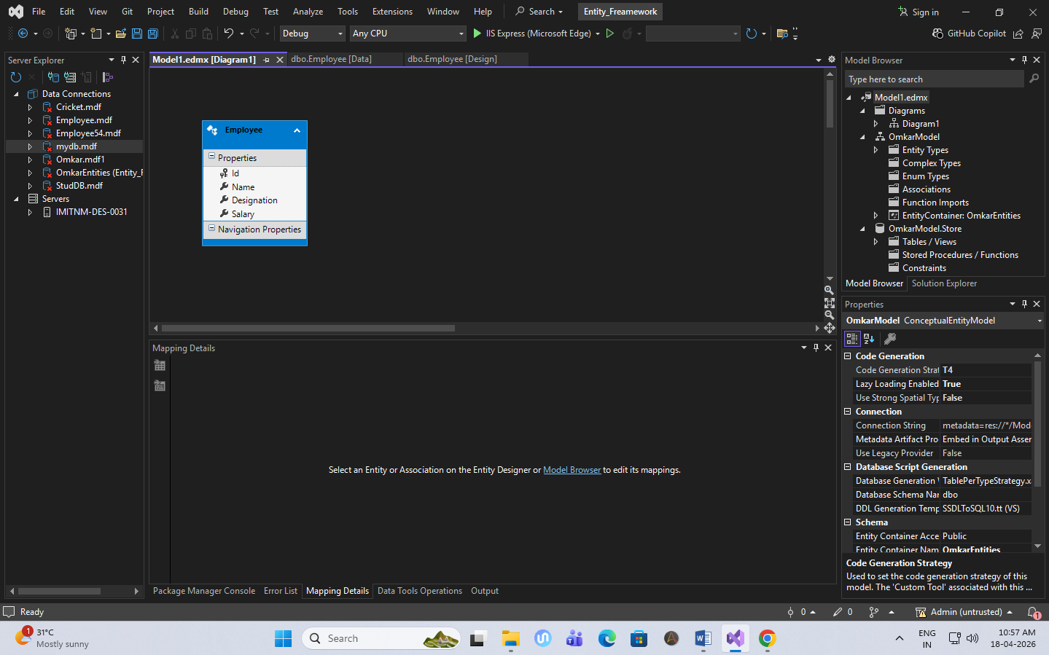

Entity.aspx –

<%@ Page Language="C#" AutoEventWireup="true" CodeBehind="Entity.aspx.cs" Inherits="Entity_Freamework.Entity" %>

<!DOCTYPE html>

<html xmlns="http://www.w3.org/1999/xhtml">
<head runat="server">
<title></title>
</head>
<body>
<form id="form1" runat="server">
<div>
<center>
<h1>Build Website to Demonstrate the working of Entity Framework</h1><br />
<br />
Emp ID : <asp:TextBox ID="TextBox1" runat="server"></asp:TextBox>
<br />
<br />
Ename : <asp:TextBox ID="TextBox2" runat="server" OnTextChanged="TextBox2_TextChanged"></asp:TextBox>
<br />
<br />
Designation :
<asp:TextBox ID="TextBox3" runat="server"></asp:TextBox>

<br />
<br />
Salary :
<asp:TextBox ID="TextBox4" runat="server"></asp:TextBox>
<br />
<br />
<asp:Button ID="Button1" runat="server" Text="ADD" OnClick="Button1_Click" />
&nbsp;
<asp:Button ID="Button2" runat="server" Text="Edit" />
&nbsp;
<asp:Button ID="Button3" runat="server" Text="Delete" OnClick="Button3_Click" />

&nbsp;<br />
<br />
&nbsp;<asp:Button ID="Button4" runat="server" Text="Search" OnClick="Button4_Click" />
&nbsp;<asp:TextBox ID="TextBox5" runat="server"></asp:TextBox>
<br />
<asp:GridView ID="GridView1" runat="server" BackColor="#CCCCCC" BorderColor="#999999" BorderStyle="Solid" BorderWidth="3px" CellPadding="4" CellSpacing="2" ForeColor="Black">
<FooterStyle BackColor="#CCCCCC" />
<HeaderStyle BackColor="Black" Font-Bold="True" ForeColor="White" />
<PagerStyle BackColor="#CCCCCC" ForeColor="Black" HorizontalAlign="Left" />
<RowStyle BackColor="White" />

<SelectedRowStyle BackColor="#000099" Font-Bold="True" ForeColor="White" />
<SortedAscendingCellStyle BackColor="#F1F1F1" />
<SortedAscendingHeaderStyle BackColor="#808080" />
<SortedDescendingCellStyle BackColor="#CAC9C9" />
<SortedDescendingHeaderStyle BackColor="#383838" />
</asp:GridView>
&nbsp;</center>
</div>
</form>
</body>
</html>

Entity.aspx.cs –

using System;
using System.Collections.Generic;
using System.Data.Entity.Migrations;
using System.Linq;
using System.Web;
using System.Web.UI;
using System.Web.UI.WebControls;
namespace Entity_Freamework
{
public partial class Entity : System.Web.UI.Page
{
OmkarEntities db = new OmkarEntities();
Employee emp1 = new Employee ();

protected void Page_Load(object sender, EventArgs e)
{
Display();
}
void Display()
{
var result = (from emp1 in db.Employees select emp1).ToList();
GridView1.DataSource = result;
GridView1.DataBind();
}
protected void btnAdd_Click(object sender, EventArgs e)
{
emp1.Id = int.Parse(TextBox1.Text);
emp1.Name = TextBox2.Text;
emp1.Designation = TextBox3.Text;
emp1.Salary = int.Parse(TextBox5.Text);
db.Employees.Add(emp1);
db.SaveChanges();
Display(); }
protected void btnEdit_Click(object sender, EventArgs e)
{
emp1.Id = int.Parse(TextBox1.Text);
var result = (from emp in db.Employees where emp.Id == emp1.Id select emp).Single();
result.Name = TextBox2.Text;
result.Designation = TextBox3.Text;
result.Salary = int.Parse(TextBox5.Text);
db.Employees.AddOrUpdate(result);
db.SaveChanges();
Display();
}

protected void btnDelete_Click(object sender, EventArgs e)
{
emp1.Id = int.Parse(TextBox1.Text);
var result = (from emp in db.Employees where emp.Id == emp1.Id select emp).Single();
db.Employees.Remove(result);
db.SaveChanges();
Display();
}

protected void btnSearch_Click(object sender, EventArgs e)
{
emp1.Id = int.Parse(TextBox4.Text);
var result = (from emp in db.Employees where emp.Id == emp1.Id select emp).Single();
GridView1.DataSource = result;
GridView1.DataBind();
}
}
}

Output –

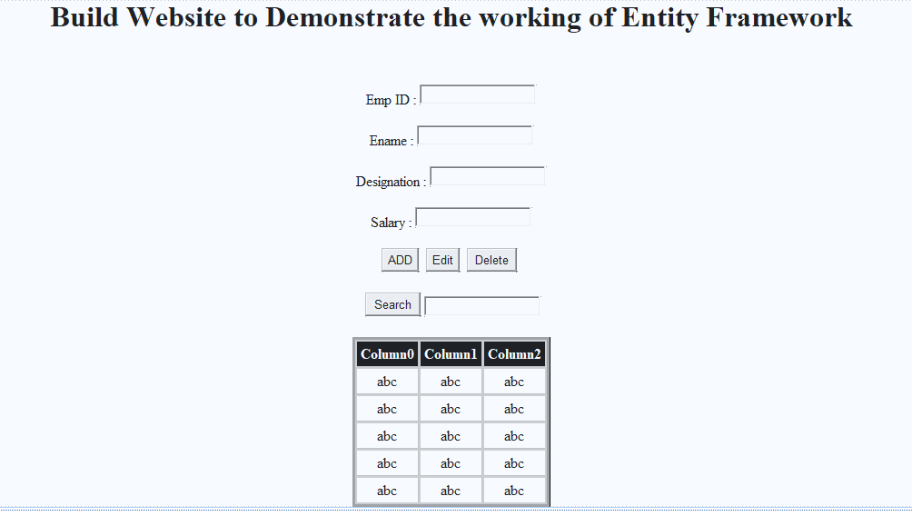

Q9. Design a web page to perform CRUD operation using SqlDataSource

CRUDDataSource.aspx –

<%@ Page Language="C#" AutoEventWireup="true" CodeBehind="CRUDDataSource.aspx.cs" Inherits="DataBound.CRUDDataSource" %>

<!DOCTYPE html>
<html xmlns="http://www.w3.org/1999/xhtml">
<head runat="server">
<title></title>
</head>
<body>
<form id="form1" runat="server">
<div>
<center>
<div style="text-align:center">

<h2>SQL DATASOURCE</h2>

Eid:
<asp:TextBox ID="txtEid" runat="server"></asp:TextBox>
<br /><br />

Ename:
<asp:TextBox ID="txtEname" runat="server"></asp:TextBox>
<br /><br />

Designation:
<asp:TextBox ID="txtDept" runat="server"></asp:TextBox>
<br /><br />

Salary:
<asp:TextBox ID="txtSalary" runat="server"></asp:TextBox>
<br /><br />

<asp:Button ID="btnAdd" runat="server" Text="ADD" OnClick="btnAdd_Click" />
<br /><br />
<!-- GridView -->
<br />
<!-- SQL Data Source -->
<asp:GridView ID="GridView1" runat="server" AutoGenerateColumns="False" DataKeyNames="eid" DataSourceID="SqlDataSource1">
<Columns>
<asp:CommandField ShowDeleteButton="True" ShowEditButton="True" ShowSelectButton="True" />
<asp:BoundField DataField="eid" HeaderText="eid" ReadOnly="True" SortExpression="eid" />
<asp:BoundField DataField="ename" HeaderText="ename" SortExpression="ename" />

<asp:BoundField DataField="designation" HeaderText="designation" SortExpression="designation" />
<asp:BoundField DataField="salary" HeaderText="salary" SortExpression="salary" />
</Columns>
</asp:GridView>
<asp:SqlDataSource ID="SqlDataSource1" runat="server" ConnectionString="<%$ ConnectionStrings:studentDBConnectionString %>" DeleteCommand="DELETE FROM [dba51] WHERE [eid] = @original_eid" InsertCommand="INSERT INTO [dba51] ([eid], [ename], [designation], [salary]) VALUES (@eid, @ename, @designation, @salary)" OldValuesParameterFormatString="original_{0}" SelectCommand="SELECT * FROM [dba51]" UpdateCommand="UPDATE [dba51] SET [ename] = @ename, [designation] = @designation, [salary] = @salary WHERE [eid] = @original_eid">
<DeleteParameters>
<asp:Parameter Name="original_eid" Type="Int32" />
</DeleteParameters>
<InsertParameters>
<asp:ControlParameter Name="eid" Type="Int32" ControlID="txtEid" />
<asp:Parameter Name="ename" Type="String" />
<asp:Parameter Name="designation" Type="String" />
<asp:Parameter Name="salary" Type="Int32" />
</InsertParameters>
<UpdateParameters>
<asp:Parameter Name="ename" Type="String" />
<asp:Parameter Name="designation" Type="String" />
<asp:Parameter Name="salary" Type="Int32" />
<asp:Parameter Name="original_eid" Type="Int32" />
</UpdateParameters>
</asp:SqlDataSource>

</div>
</center>
</div>
</form>
</body>
</html>

CRUDDataSource.aspx.cs –

using System;
using System.Collections.Generic;
using System.Linq;
using System.Web;
using System.Web.UI;
using System.Web.UI.WebControls;

namespace DataBound
{
public partial class CRUDDataSource : System.Web.UI.Page
{
protected void Page_Load(object sender, EventArgs e)

{
}
protected void btnAdd_Click(object sender, EventArgs e)
{
SqlDataSource1.Insert();
}
}
}

Output –

