Advanced Web Technologies Practical Lab(Assignment 4)
- Display the number of times current page is visited using View State, Session, Cookies and Application State.
Code:
StateManagement.aspx
<%@ Page Language="C#" AutoEventWireup="true" CodeBehind="StateManagement.aspx.cs" Inherits="Unit4AWT.StateManagement" %>
<!DOCTYPE html>

<html xmlns="http://www.w3.org/1999/xhtml">
<head runat="server">
<title></title>
</head>
<body>
<form id="form1" runat="server">
<center>
<div>
<h2>State Management</h2>

<asp:Label ID="Label1" runat="server"></asp:Label> <asp:Button ID="btnCookie" runat="server" Text="Cookies" Font-Bold="True" Width="100px" OnClick="btnCookie_Click" />
<br />
<asp:Label ID="Label2" runat="server"></asp:Label> <asp:Button ID="btnSession" runat="server" Text="Session" Font-Bold="True" Width="100px" OnClick="btnSession_Click" />
<br />
<asp:Label ID="Label3" runat="server"></asp:Label> <asp:Button ID="btnViewState" runat="server" Text="ViewState" Font-Bold="True" Width="101px" OnClick="btnViewState_Click" />
<br />
<asp:Label ID="Label4" runat="server"></asp:Label> <asp:Button ID="btnApplication" runat="server" Text="Application" Font-Bold="True" Width="101px" OnClick="btnApplication_Click" />
</div>
</center>
</form>
</body>
</html>

StateManagement.aspx.cs
using System;
using System.Collections.Generic;
using System.Linq;
using System.Web;
using System.Web.UI;
using System.Web.UI.WebControls;

namespace Unit4AWT
{
public partial class StateManagement : System.Web.UI.Page
{
int cook = 0;
protected void Page_Load(object sender, EventArgs e)
{
if (!IsPostBack == true)
{
Label1.Text = "0";
Label2.Text = "0";
Label3.Text = "0";
Label4.Text = "0";
}
}

protected void btnCookie_Click(object sender, EventArgs e)
{
int cook1;
if (Request.Cookies["cook"] == null)
{
cook1 = 0;
}
else
{
cook1 = int.Parse(Request.Cookies["cook"].Value);
}
cook1++;
Response.Cookies["cook"].Value = cook1.ToString();
Response.Cookies["cook"].Expires = DateTime.Now.AddMinutes(10);
Label1.Text = Request.Cookies["cook"].Value;
}

protected void btnSession_Click(object sender, EventArgs e)
{
if (Session["count"] != null)
{
Session["count"] = Convert.ToInt32(Session["count"]) + 1;
}
else
{
Session["count"] = Convert.ToInt32(Session["count"] = 1);
}
Label2.Text = Session["count"].ToString();
}

protected void btnViewState_Click(object sender, EventArgs e)
{

if (ViewState["num"] != null)
{
ViewState["num"] = Convert.ToInt32(ViewState["num"]) + 1;
}
else
{
ViewState["num"] = Convert.ToInt32(ViewState["num"] = 1);
}
Label3.Text = ViewState["num"].ToString();
}

protected void btnApplication_Click(object sender, EventArgs e)
{
if (Application["num"] != null)
{
Application["num"] = Convert.ToInt32(Application["num"]) + 1;
}
else
{
Application["num"] = Convert.ToInt32(Application["num"] = 1);
}
Label4.Text = Application["num"].ToString();
}
}
}

Output:
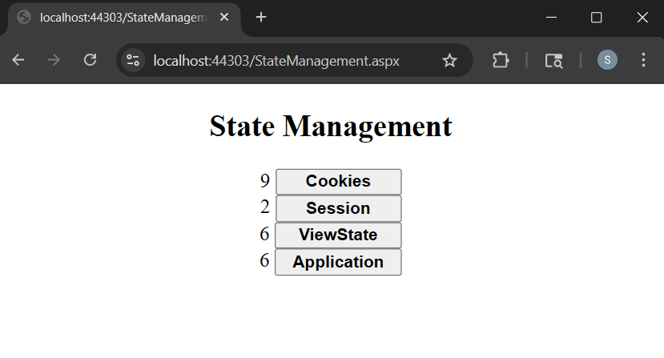
- Design a webpage to read, write and remove cookies.
Code:
Cookies.aspx
<%@ Page Language="C#" AutoEventWireup="true" CodeBehind="Cookies.aspx.cs" Inherits="Unit4AWT.Cookies" %>

<!DOCTYPE html>

<html xmlns="http://www.w3.org/1999/xhtml">
<head runat="server">
<title></title>
</head>
<body>
<form id="form1" runat="server">
<center>
<div>
<h2>Cookies</h2>
<asp:Label ID="Label1" runat="server" Text="Enter Cookie Value:"></asp:Label> &nbsp;<asp:TextBox ID="TextBox1" runat="server"></asp:TextBox>
<br />
<br />
<asp:Button ID="Button1" runat="server" Text="CREATE" OnClick="Button1_Click" />&nbsp;<asp:Button ID="Button2" runat="server" Text="READ" OnClick="Button2_Click" />&nbsp;<asp:Button ID="Button3" runat="server" Text="DELETE" OnClick="Button3_Click" />

<br />

<asp:Label ID="Label2" runat="server"></asp:Label>
</div>
</center>
</form>
</body>
</html>

Cookies.aspx.cs
using System;
using System.Collections.Generic;
using System.Linq;
using System.Web;
using System.Web.UI;
using System.Web.UI.WebControls;

namespace Unit4AWT
{
public partial class Cookies : System.Web.UI.Page
{
protected void Page_Load(object sender, EventArgs e)
{

}

protected void Button1_Click(object sender, EventArgs e)
{
HttpCookie cook1 = new HttpCookie("username");
cook1.Values["username"] = TextBox1.Text;
cook1.Expires = DateTime.Now.AddSeconds(10);
Response.Cookies.Add(cook1);
Label2.Text = "Cookie " + TextBox1.Text + " Created";
}

protected void Button2_Click(object sender, EventArgs e)
{
if (Request.Cookies["username"] != null)
{
Label2.Text = "Cookie Read: " + Request.Cookies["username"].Value;
}
else
{
Label2.Text = "Cookie Empty";
}
}

protected void Button3_Click(object sender, EventArgs e)
{
Response.Cookies["username"].Expires = DateTime.Now.AddHours(-1);
Label2.Text = "Cookie Deleted";
}
}
}
Output:
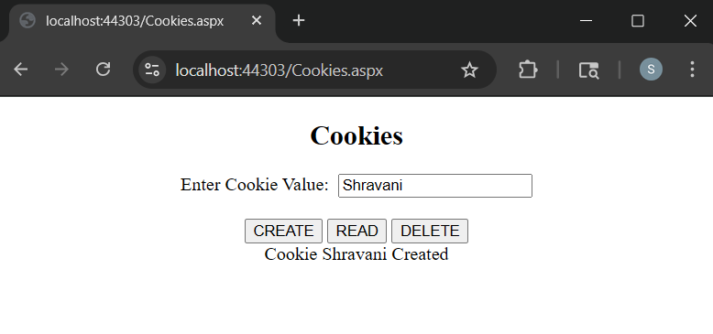
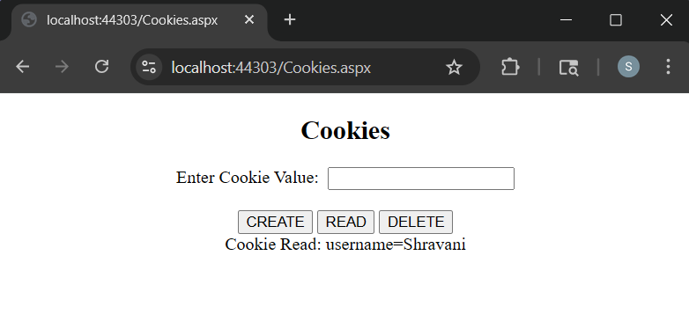
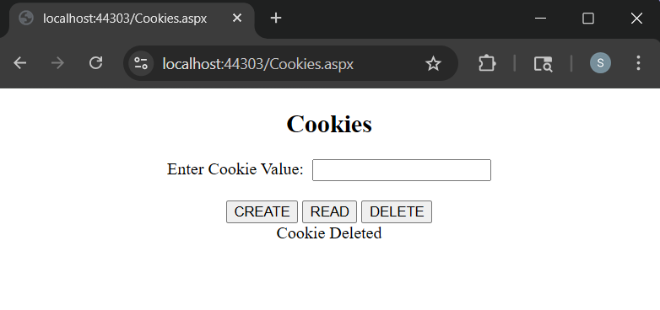
- Design a session-based login system where users are redirected to a dashboard upon successful login.
Code:
LoginPage.aspx
<%@ Page Language="C#" AutoEventWireup="true" CodeBehind="LoginPage.aspx.cs" Inherits="Unit4AWT.LoginPage" %>

<html xmlns="http://www.w3.org/1999/xhtml">
<head runat="server">
<title></title>
</head>
<body>
<form id="form1" runat="server">
<center>
<div>
<h2>Login</h2>
<asp:Label ID="Label1" runat="server" Text="Username: "></asp:Label>&nbsp;<asp:TextBox ID="TextBox1" runat="server"></asp:TextBox>
<br />
<br />
<asp:Label ID="Label2" runat="server" Text="Password: "></asp:Label>&nbsp;<asp:TextBox ID="TextBox2" runat="server"></asp:TextBox>

<br />
<br />

<asp:Button ID="Button1" runat="server" Text="Login" OnClick="Button1_Click" />
<br />
<br />
<asp:Label ID="Label3" runat="server" Text=""></asp:Label>
</div>
</center>
</form>
</body>
</html>

LoginPage.apsx.cs
using System;
using System.Collections.Generic;
using System.Linq;
using System.Web;
using System.Web.UI;
using System.Web.UI.WebControls;

namespace Unit4AWT
{
public partial class LoginPage : System.Web.UI.Page
{
protected void Page_Load(object sender, EventArgs e)
{

}

protected void Button1_Click(object sender, EventArgs e)
{
if ((TextBox1.Text == "Admin") || (TextBox1.Text == "Shra") && TextBox2.Text == "123")
{
Session["id"] = TextBox1.Text;
Response.Redirect("SessionRedirect.aspx");

}
else
{
Label3.Text = "You're username and word is incorrect";
Label3.ForeColor = System.Drawing.Color.Red;
}
}
}
}
SessionRedirect.aspx
<%@ Page Language="C#" AutoEventWireup="true" CodeBehind="SessionRedirect.aspx.cs" Inherits="Unit4AWT.SessionRedirect" %>

<!DOCTYPE html>

<html xmlns="http://www.w3.org/1999/xhtml">
<head runat="server">
<title></title>
</head>
<body>
<form id="form1" runat="server">
<center>
<div>
<h2>Hello EveryOne!!! Welcome To My Page...!!!</h2>

<asp:Image ID="Image1" runat="server" Height="450px" Width="700px" ImageUrl="~/Images/img1.png" />
<br />
<br />
<asp:Label ID="Label1" runat="server" Text=""></asp:Label>
<br />
<br />
<asp:Button ID="Button1" runat="server" Text="Logout" OnClick="Button1_Click" />
</div>
</center>
</form>
</body>
</html>

SessionRedirect.aspx.cs
using System;
using System.Collections.Generic;
using System.Linq;
using System.Web;
using System.Web.UI;
using System.Web.UI.WebControls;

namespace Unit4AWT
{
public partial class SessionRedirect : System.Web.UI.Page
{
protected void Page_Load(object sender, EventArgs e)
{
Label1.Text = "Hello. .! " + Session["id"].ToString();
}

protected void Button1_Click(object sender, EventArgs e)
{
Response.Redirect("LoginPage.aspx");
}
}
}
Output:
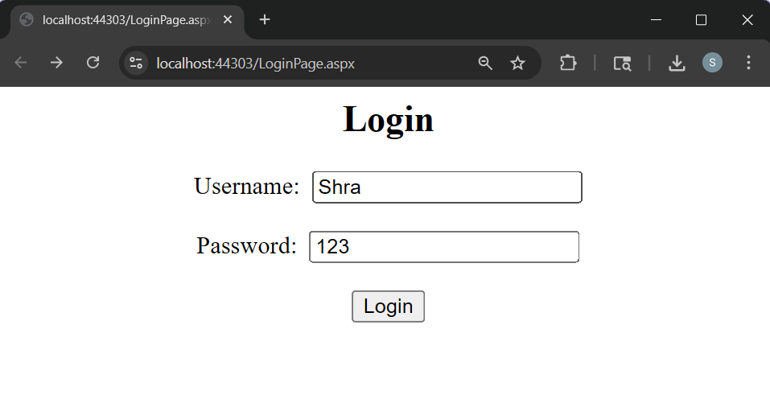
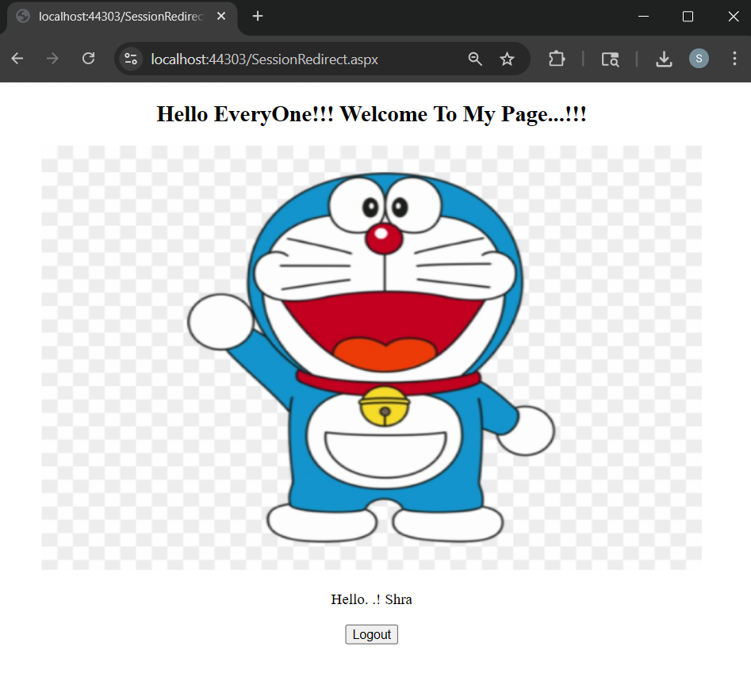
- Design Web Application to show a list of books.on click of submit button selected book should be added in session and book details should be displayed on another page.
Code:
BookSessionForm.aspx
<%@ Page Language="C#" AutoEventWireup="true" CodeBehind="BookSessionForm.aspx.cs" Inherits="Unit4AWT.BookSessionForm" %>

<!DOCTYPE html>

<html xmlns="http://www.w3.org/1999/xhtml">
<head runat="server">
<title></title>
</head>
<body>
<form id="form1" runat="server">
<center>
<div>
<h2>Application to show list of Books</h2>
<h3>List of Books</h3><br />
<asp:ListBox ID="ListBox1" runat="server" Height="102px" Width="151px">
<asp:ListItem>ASP .net</asp:ListItem>
<asp:ListItem>Advance Java</asp:ListItem>
<asp:ListItem>ADBMS</asp:ListItem>
<asp:ListItem>Python</asp:ListItem>
<asp:ListItem>Aiml</asp:ListItem>
</asp:ListBox>
<br />
<br />
<asp:Button ID="btnSubmit" runat="server" Text="Submit Book" OnClick="btnSubmit_Click" />

</div>
</center>
</form>
</body>
</html>
BookSessionForm.aspx.cs
using System;
using System.Collections.Generic;
using System.Linq;
using System.Web;
using System.Web.UI;
using System.Web.UI.WebControls;

namespace Unit4AWT
{
public partial class BookSessionForm : System.Web.UI.Page
{
protected void Page_Load(object sender, EventArgs e)
{
}
protected void btnSubmit_Click(object sender, EventArgs e)
{
Session["bookname"] = ListBox1.SelectedItem;
if (Session["bookname"] == null)
{
Response.Write("<script>alert('Book NOT selected')</script>");
}
else
{
Response.Redirect("SubmitBook.aspx");
}
}
}
}
SubmitBook.aspx
<%@ Page Language="C#" AutoEventWireup="true" CodeBehind="SubmitBook.aspx.cs" Inherits="Unit4AWT.SubmitBook" %>

<!DOCTYPE html>

<html xmlns="http://www.w3.org/1999/xhtml">
<head runat="server">
<title></title>
</head>
<body>
<form id="form1" runat="server">
<center>
<div>
<h2>Book Selected</h2>
<asp:Label ID="Label1" runat="server" Text=""></asp:Label>
</div>
</center>
</form>
</body>
</html>

SubmitBook.aspx.cs
using System;
using System.Collections.Generic;
using System.Linq;
using System.Web;
using System.Web.UI;
using System.Web.UI.WebControls;

namespace Unit4AWT
{
public partial class SubmitBook : System.Web.UI.Page
{
protected void Page_Load(object sender, EventArgs e)
{
Label1.Text = Session["bookname"].ToString();
}
}
}
Output:
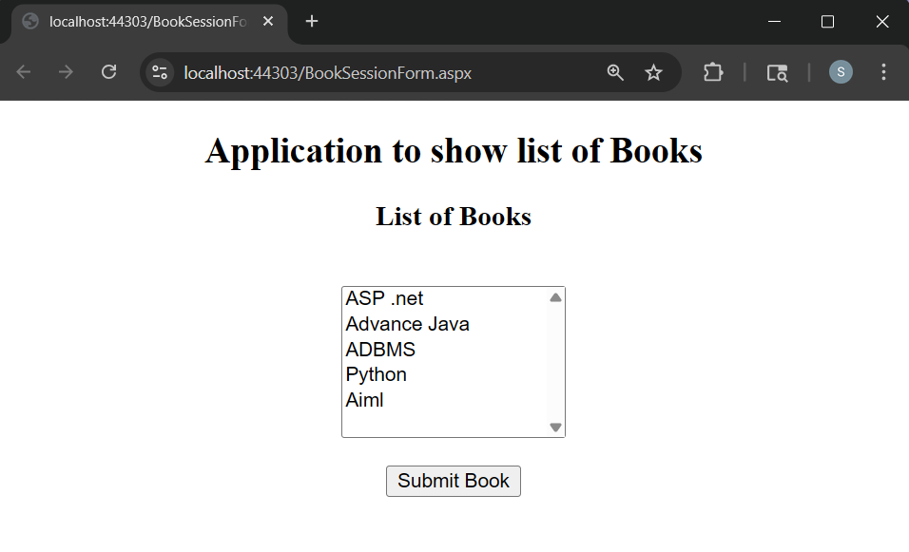
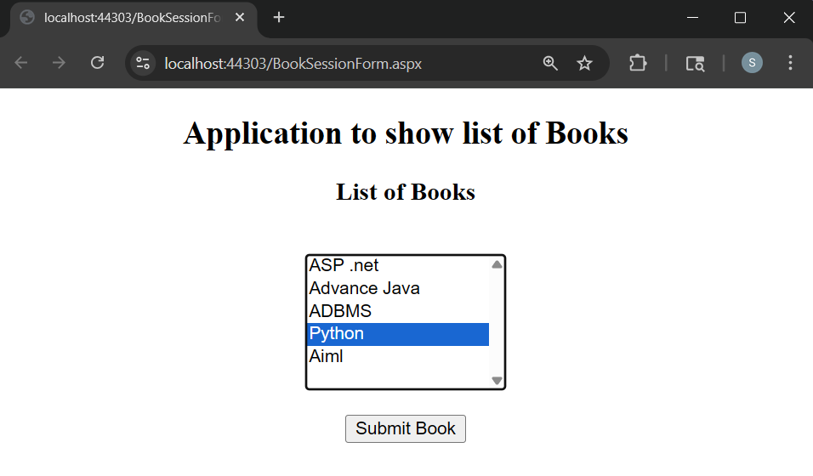
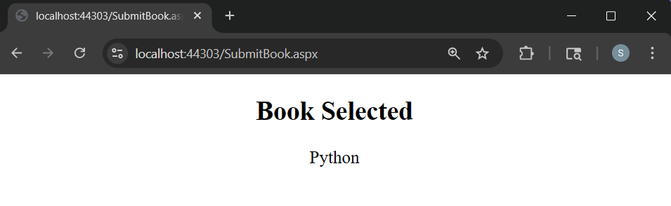

- Design Web Application to read 10 students info from database table into a gridview.cache this output for 10 sec.use cache object.
Code:
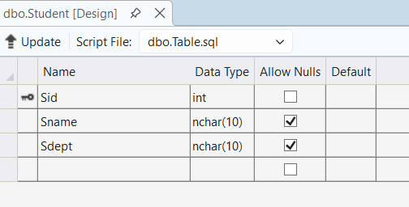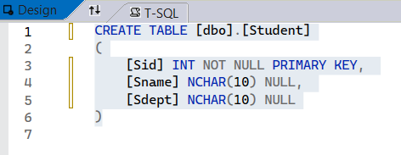
EachObject.aspx
<%@ Page Language="C#" AutoEventWireup="true" CodeBehind="EachObject.aspx.cs" Inherits="Unit4AWT.EachObject" %>

<!DOCTYPE html>

<html xmlns="http://www.w3.org/1999/xhtml">
<head runat="server">
<title></title>
</head>
<body>
<form id="form1" runat="server">
<center>
<div>
<h2>Student Info</h2>
<asp:GridView ID="GridView1" runat="server" AutoGenerateColumns="False" CellPadding="4" DataKeyNames="Sid" DataSourceID="SqlDataSource1" ForeColor="#333333" GridLines="None">
<AlternatingRowStyle BackColor="White" />
<Columns>
<asp:BoundField DataField="Sid" HeaderText="Sid" ReadOnly="True" SortExpression="Sid" />
<asp:BoundField DataField="Sname" HeaderText="Sname" SortExpression="Sname" />
<asp:BoundField DataField="Sdept" HeaderText="Sdept" SortExpression="Sdept" />
</Columns>
<EditRowStyle BackColor="#2461BF" />
<FooterStyle BackColor="#507CD1" Font-Bold="True" ForeColor="White" />
<HeaderStyle BackColor="#507CD1" Font-Bold="True" ForeColor="White" />
<PagerStyle BackColor="#2461BF" ForeColor="White" HorizontalAlign="Center" />
<RowStyle BackColor="#EFF3FB" />
<SelectedRowStyle BackColor="#D1DDF1" Font-Bold="True" ForeColor="#333333" />
<SortedAscendingCellStyle BackColor="#F5F7FB" />
<SortedAscendingHeaderStyle BackColor="#6D95E1" />
<SortedDescendingCellStyle BackColor="#E9EBEF" />
<SortedDescendingHeaderStyle BackColor="#4870BE" />
</asp:GridView>
<asp:SqlDataSource ID="SqlDataSource1" runat="server" ConnectionString="<%$ ConnectionStrings:StudDBConnectionString %>" ProviderName="<%$ ConnectionStrings:StudDBConnectionString.ProviderName %>" SelectCommand="SELECT * FROM [Student]"></asp:SqlDataSource>
</div>
</center>
</form>
</body>
</html>

EachObject.aspx.cs
using System;
using System.Collections.Generic;
using System.Linq;
using System.Web;
using System.Web.UI;
using System.Web.UI.WebControls;

namespace Unit4AWT
{
public partial class EachObject : System.Web.UI.Page
{
protected void Page_Load(object sender, EventArgs e)
{

}
}
}

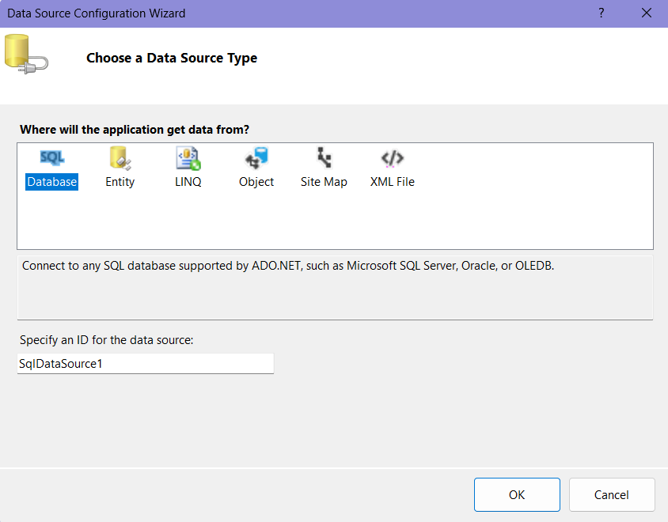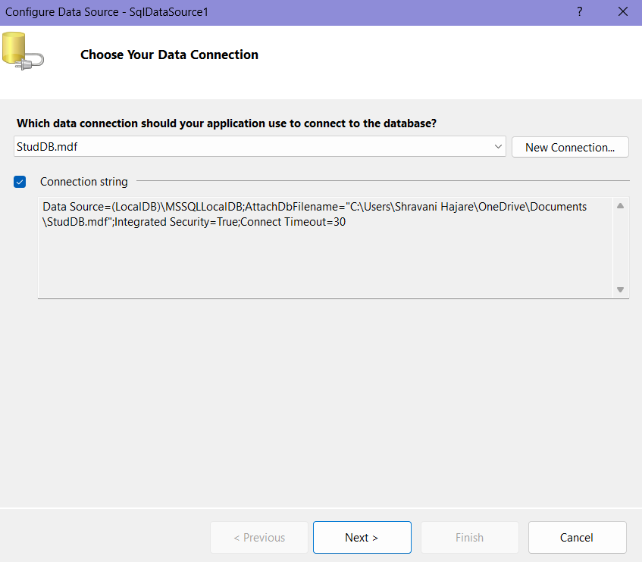

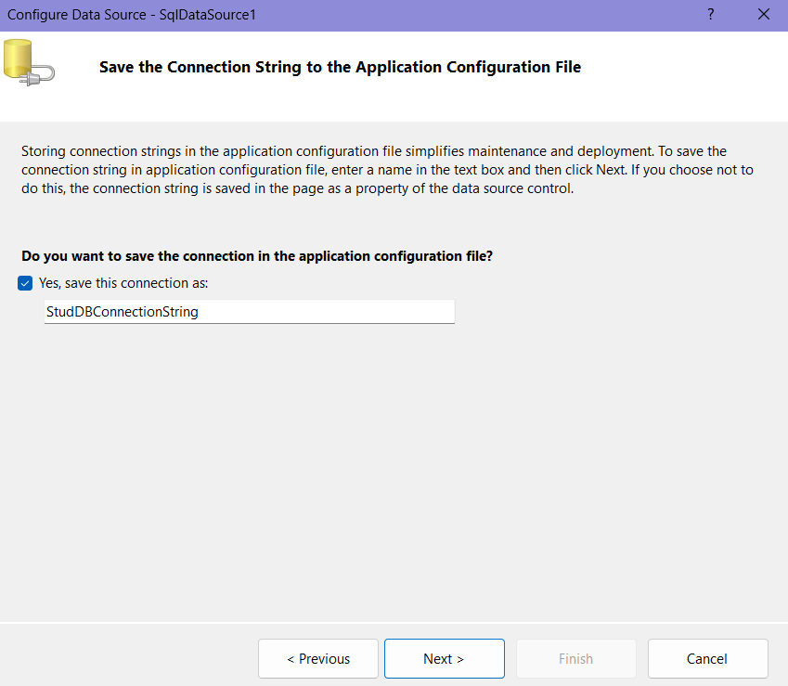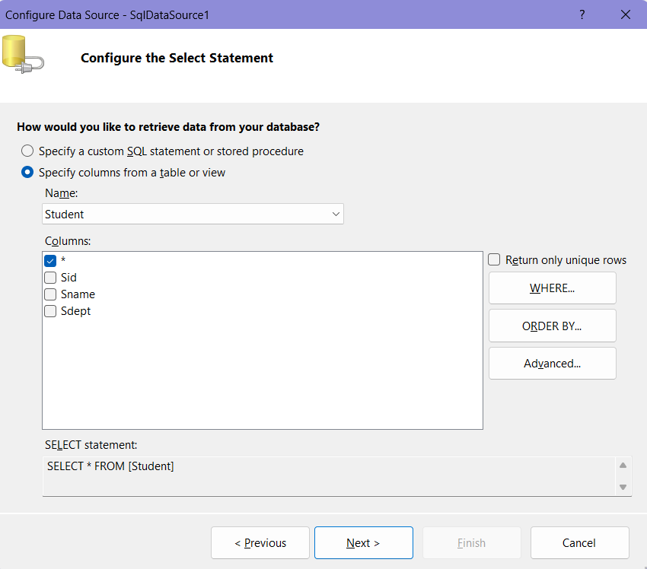

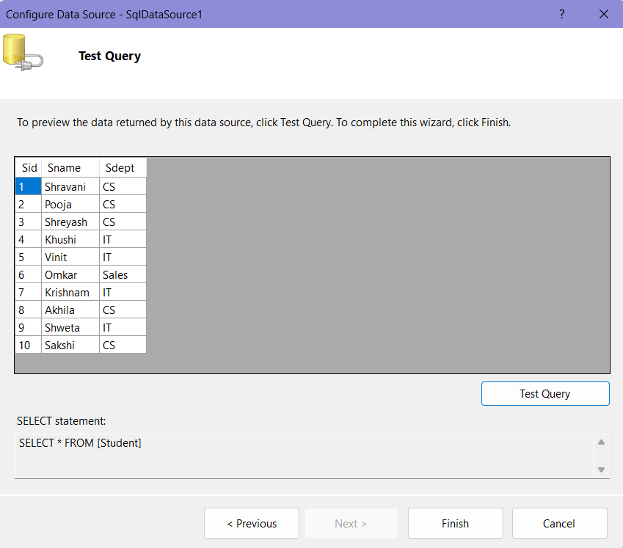
Output:
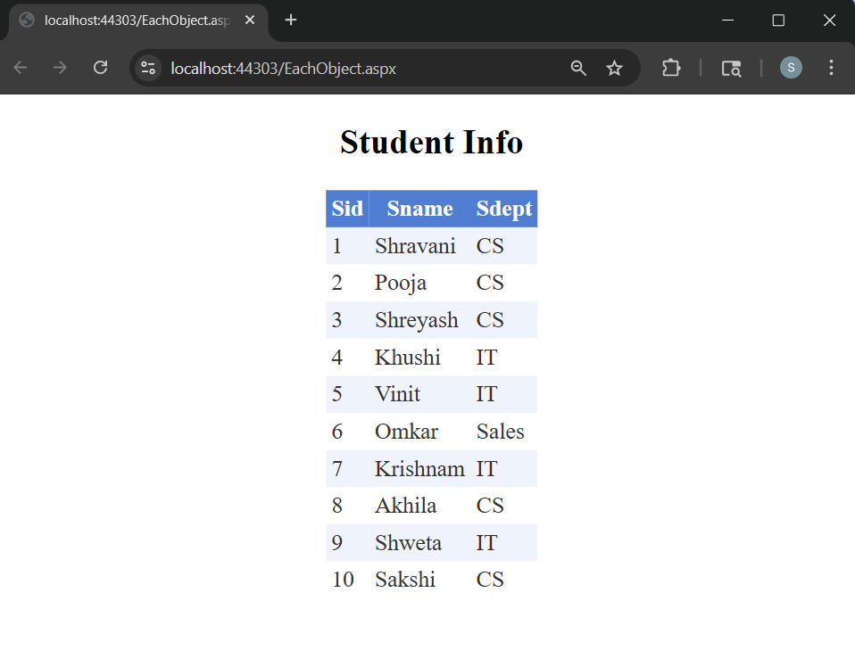

- Implement an AJAX-enabled web form to fetch user details without reloading the page.
Code:
AjaxControl.aspx
<%@ Page Language="C#" AutoEventWireup="true" CodeBehind="AjaxControl.aspx.cs" Inherits="Unit4AWT.AjaxControl" %>

<!DOCTYPE html>

<html xmlns="http://www.w3.org/1999/xhtml">
<head runat="server">
<title></title>
</head>
<body>
<form id="form1" runat="server">
<center>
<div>
<h2>AJAX Control Demo</h2>
<asp:ScriptManager ID="ScriptManager1" runat="server"></asp:ScriptManager>
<asp:UpdatePanel ID="UpdatePanel1" runat="server">
<ContentTemplate>
<asp:Button ID="btnPPB" runat="server" Text="Partial PostBack" OnClick="btnPPB_Click" />
<br /><br />
<asp:Label ID="Label1" runat="server" Text="Label"></asp:Label>
</ContentTemplate>
</asp:UpdatePanel>
<asp:Button ID="btnTPB" runat="server" Text="Total PostBack" OnClick="btnTPB_Click" />
<br /><br />
<asp:Label ID="Label2" runat="server" Text="Label"></asp:Label>
</div>
</center>
</form>
</body>
</html>

AjaxControl.aspx.cs
using System;
using System.Collections.Generic;
using System.Linq;
using System.Web;
using System.Web.UI;
using System.Web.UI.WebControls;

namespace Unit4AWT
{
public partial class AjaxControl : System.Web.UI.Page
{
string time = DateTime.Now.ToLongTimeString();
protected void Page_Load(object sender, EventArgs e)
{

}

protected void btnPPB_Click(object sender, EventArgs e)
{
Label1.Text = "Showing time from Panel : " + time;
Label2.Text = "Showing time from OutSide : " + time;
}

protected void btnTPB_Click(object sender, EventArgs e)
{
Label1.Text = "Showing time from Panel : " + time;
Label2.Text = "Showing time from OutSide : " + time;
}
}
}

Output:
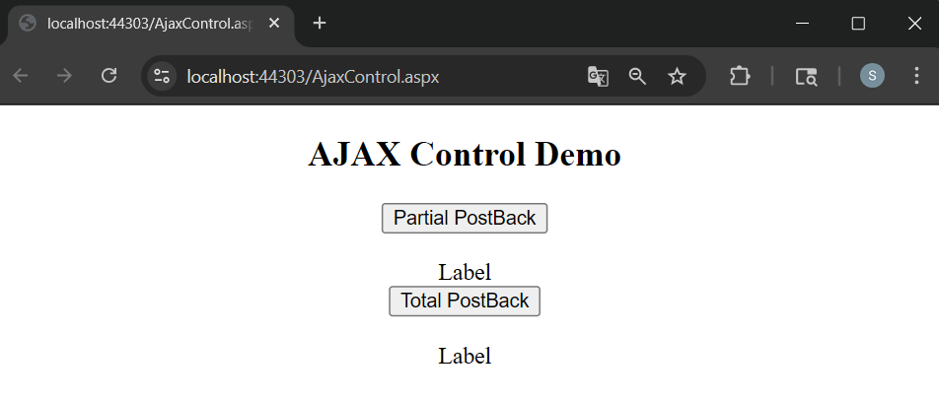
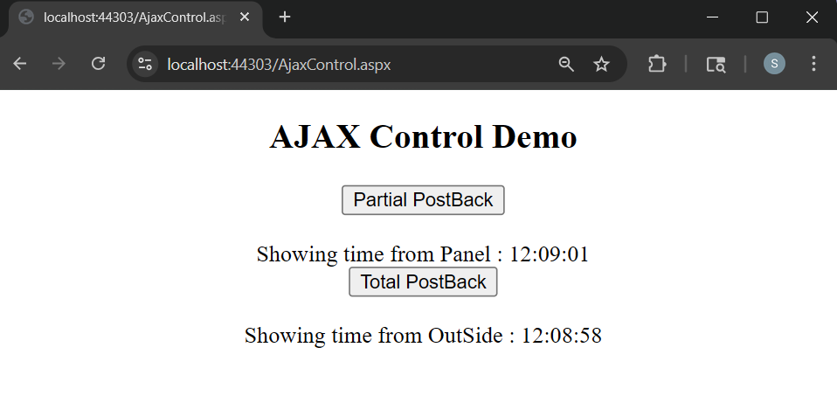

- Develop a simple to-do list application using AJAX controls and update panels.
Code:
AjaxToDoList.aspx
<%@ Page Language="C#" AutoEventWireup="true" CodeBehind="AjaxToDoList.aspx.cs" Inherits="Unit4AWT.AjaxToDoList" %>

<!DOCTYPE html>

<html xmlns="http://www.w3.org/1999/xhtml">
<head runat="server">
<title></title>
</head>
<body>
<form id="form1" runat="server">
<center>
<div>
<h2>AJAX Todo List</h2>
<asp:ScriptManager ID="ScriptManager1" runat="server"></asp:ScriptManager>
<asp:UpdatePanel ID="UpdatePanel1" runat="server">
<ContentTemplate>
<asp:TextBox ID="TextBox1" runat="server"></asp:TextBox>
<asp:Button ID="btnAdd" runat="server" Text="Add Task" OnClick="btnAdd_Click" />
<br />
<br />
<asp:ListBox ID="ListBox1" runat="server"></asp:ListBox>
<br />
<asp:Button ID="btnDelete" runat="server" Text="Delete Selected Task" OnClick="btnDelete_Click" />
</ContentTemplate>
</asp:UpdatePanel>
<asp:UpdateProgress ID="UpdateProgress1" runat="server">
<ProgressTemplate>
Loading.....
</ProgressTemplate>
</asp:UpdateProgress>

</div>
</center>
</form>
</body>
</html>

AjaxToDoList.aspx.cs
using System;
using System.Collections.Generic;
using System.Linq;
using System.Web;
using System.Web.UI;
using System.Web.UI.WebControls;

namespace Unit4AWT
{
public partial class AjaxToDoList : System.Web.UI.Page
{
protected void Page_Load(object sender, EventArgs e)
{
if (!IsPostBack)
{
ListBox1.Items.Add("Complete Assignment");
}
}

protected void btnAdd_Click(object sender, EventArgs e)
{
System.Threading.Thread.Sleep(2000);
ListBox1.Items.Add(TextBox1.Text);
}

protected void btnDelete_Click(object sender, EventArgs e)
{
System.Threading.Thread.Sleep(2000);
ListBox1.Items.RemoveAt(ListBox1.SelectedIndex);
}
}
}

Output:
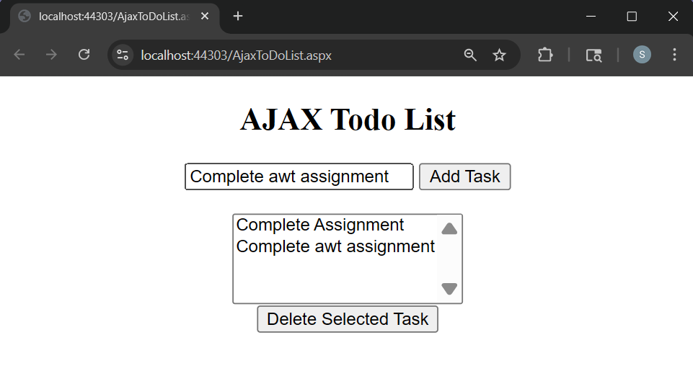
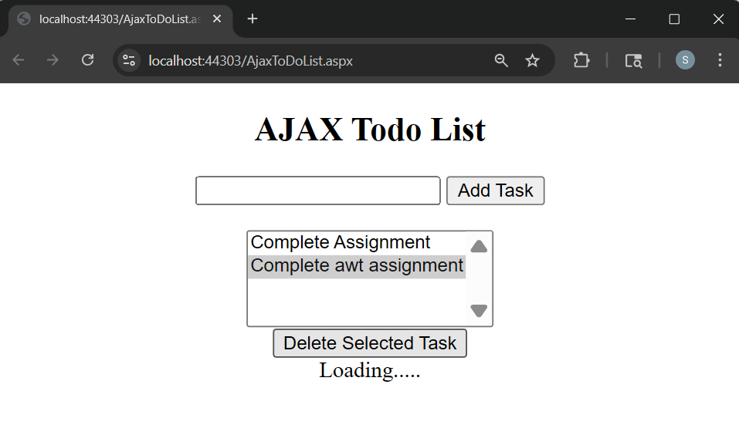
- Demonstrate the use of the Global.asax file for handling application-level events.
Code:
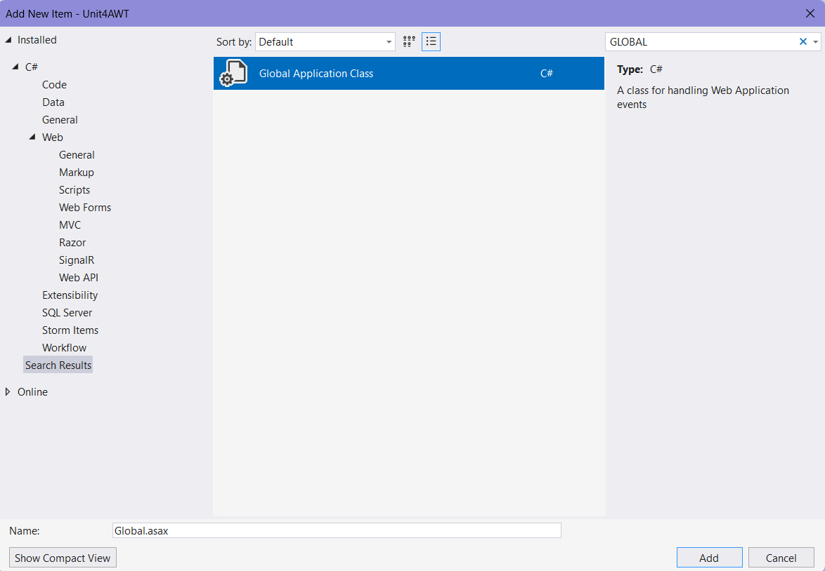
Global.asax.cs
using System;
using System.Collections.Generic;
using System.Linq;
using System.Web;
using System.Web.Security;
using System.Web.SessionState;

namespace Unit4AWT
{
public class Global : System.Web.HttpApplication
{
protected void Application_Start(object sender, EventArgs e)
{
Application["count1"] = 0;
}
protected void Session_Start(object sender, EventArgs e)
{
Application["count1"] = (int)Application["count1"] + 1;
Session["name1"] = "Guest";
}
protected void Application_BeginRequest(object sender, EventArgs e)
{
}
protected void Application_AuthenticateRequest(object sender, EventArgs e)
{
}
protected void Application_Error(object sender, EventArgs e)
{

}
protected void Session_End(object sender, EventArgs e)
{
}
protected void Application_End(object sender, EventArgs e)
{
}
}
}
GlobalAsaxApp.aspx
<%@ Page Language="C#" AutoEventWireup="true" CodeBehind="GlobalAsaxApp.aspx.cs" Inherits="Unit4AWT.GlobalAsaxApp" %>

<!DOCTYPE html>

<html xmlns="http://www.w3.org/1999/xhtml">
<head runat="server">
<title></title>
</head>
<body>
<form id="form1" runat="server">
<center>
<div>
<h2> Demonstrate the use of the Global.asax File for handling application-level events</h2>

<asp:Label ID="Label1" runat="server" Text="Username: "></asp:Label>&nbsp;&nbsp;
<asp:TextBox ID="TextBox1" runat="server"></asp:TextBox>
<br /><br />
<asp:Button ID="Button1" runat="server" Text="Submit" OnClick="Button1_Click" />
</div>
</center>
</form>
</body>
</html>

GlobalAsaxApp.aspx.cs
using System;
using System.Collections.Generic;
using System.Linq;
using System.Web;
using System.Web.UI;
using System.Web.UI.WebControls;

namespace Unit4AWT
{
public partial class GlobalAsaxApp : System.Web.UI.Page
{
protected void Page_Load(object sender, EventArgs e)
{
}

protected void Button1_Click(object sender, EventArgs e)
{
if (TextBox1.Text != "")
{
Session["name1"] = TextBox1.Text;
}
Response.Redirect("RedirectPage.aspx");
}
}
}
RedirectPage.aspx
<%@ Page Language="C#" AutoEventWireup="true" CodeBehind="RedirectPage.aspx.cs" Inherits="Unit4AWT.RedirectPage" %>

<!DOCTYPE html>

<html xmlns="http://www.w3.org/1999/xhtml">
<head runat="server">
<title></title>
</head>
<body>
<form id="form1" runat="server">
<center>
<div>
<h2> Welcome !!</h2>
<br />
<asp:Button ID="Button1" runat="server" Text="Back" OnClick="Button1_Click" />
</div>
</center>
</form>
</body>
</html>

RedirectPage.aspx.cs
using System;
using System.Collections.Generic;
using System.Linq;
using System.Web;
using System.Web.UI;
using System.Web.UI.WebControls;

namespace Unit4AWT
{
public partial class RedirectPage : System.Web.UI.Page
{
protected void Page_Load(object sender, EventArgs e)
{
if (!IsPostBack)
{
Response.Write("Session Name: " + Session["name1"].ToString() + "<br/>");
Response.Write("Application Count: " + Application["count1"].ToString());
}
}

protected void Button1_Click(object sender, EventArgs e)
{
Response.Redirect("GlobalAsaxApp.aspx");
}
}
}
Output:
