- Display the number of times current page is visited using View State, Session, Cookies and Application State.
StateManagement.aspx –
<%@ Page Language="C#" AutoEventWireup="true" CodeBehind="State_Management.aspx.cs" Inherits="Entity_Freamework.State_Management" %>

<!DOCTYPE html>

<html xmlns="http://www.w3.org/1999/xhtml">
<head runat="server">
<title></title>
</head>
<body>
<form id="form1" runat="server">
<div>
</div>
<center>

<br />
<asp:Label ID="Label1" runat="server"></asp:Label>
&nbsp;<asp:Button ID="Button1" runat="server" OnClick="btnCookies_Click" Text="Cookies" Height="44px" Width="103px" />
<br />
<br />
<asp:Label ID="Label2" runat="server"></asp:Label>
&nbsp;<asp:Button ID="Button2" runat="server" OnClick="btnSession_Click" Text="Session" Height="44px" Width="107px" />
<br />
<br />
<asp:Label ID="Label3" runat="server"></asp:Label>
&nbsp;<asp:Button ID="Button3" runat="server" OnClick="btnViewState_Click" Text="ViewState" Height="43px" Width="110px" />
<br />
<br />
<asp:Label ID="Label4" runat="server"></asp:Label>
&nbsp;<asp:Button ID="Button4" runat="server" OnClick="btnApplication_Click" Text="Application" Height="44px" Width="114px" />
</center>
</form>
</body>
</html>

StateManagement.aspx.cs -
StateManagement.aspx.cs
using System;
using System.Collections.Generic;
using System.Linq;
using System.Reflection.Emit;
using System.Web;
using System.Web.UI;
using System.Web.UI.WebControls;

namespace Entity_Freamework
{
public partial class State_Management : System.Web.UI.Page
{
//int cook = 0;
protected void Page_Load(object sender, EventArgs e)
{
if (!IsPostBack == true)
{
Label1.Text = "0";
Label2.Text = "0";
Label3.Text = "0";
Label4.Text = "0";
}
}

protected void btnCookies_Click(object sender, EventArgs e)
{
int cook1;
if (Request.Cookies["cook"] == null)
{
cook1 = 0;
}
else
{
cook1 = int.Parse(Request.Cookies["cook"].Value);
}
cook1++;
Response.Cookies["cook"].Value = cook1.ToString();
Response.Cookies["cook"].Expires = DateTime.Now.AddMinutes(10);
Label1.Text = Request.Cookies["cook"].Value;
}

protected void btnSession_Click(object sender, EventArgs e)
{
if (Session["count"] != null)

{
Session["count"] = Convert.ToInt32(Session["count"]) + 1;
}
else
{
Session["count"] = Convert.ToInt32(Session["count"] = 1);
}
Label2.Text = Session["count"].ToString();
}

protected void btnViewState_Click(object sender, EventArgs e)
{
if (ViewState["num1"] != null)
{
ViewState["num1"] = Convert.ToInt32(ViewState["num1"]) + 1;
}
else
{
ViewState["num1"] = Convert.ToInt32(ViewState["num1"] = 1);
}
Label3.Text = ViewState["num1"].ToString();
}

protected void btnApplication_Click(object sender, EventArgs e)
{
if (Application["num"] != null)
{
Application["num"] = Convert.ToInt32(Application["num"]) + 1;
}
else
{
Application["num"] = Convert.ToInt32(Application["num"] = 1);
}
Label4.Text = Application["num"].ToString();
}
}
}

Output –
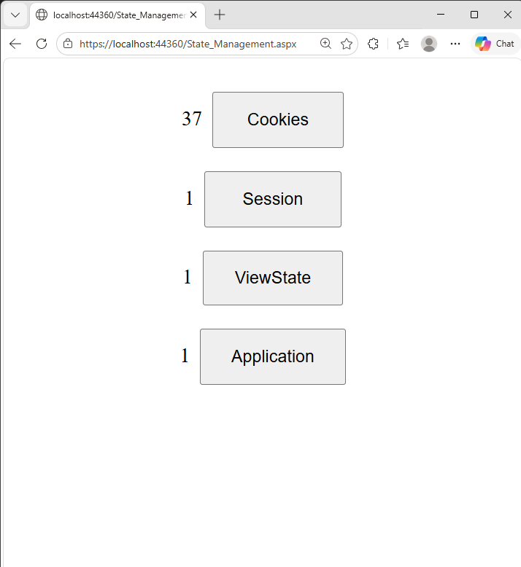

- Design a webpage to read, write and remove cookies.

Cookie.aspx

<%@ Page Language="C#" AutoEventWireup="true" CodeBehind="Cookies.aspx.cs" Inherits="Entity_Freamework.Cookies" %>

<!DOCTYPE html>

<html xmlns="http://www.w3.org/1999/xhtml">
<head runat="server">
<title></title>
</head>
<body>
<form id="form1" runat="server">
<div>
<center>
<br />
<br />
<asp:Label ID="Label1" runat="server" Text="Enter Cokie Value"></asp:Label>
&nbsp;
<asp:TextBox ID="TextBox1" runat="server"></asp:TextBox>
<br />
<br />
<asp:Button ID="Button1" runat="server" OnClick="Button1_Click" Text="CREATE" />
&nbsp;
<asp:Button ID="Button2" runat="server" Height="21px" OnClick="Button2_Click" style="margin-top: 0px" Text="READ" Width="78px" />
&nbsp;
<asp:Button ID="Button3" runat="server" OnClick="Button3_Click" Text="DELETE" Width="74px" />
<br />
<br />
<asp:Label ID="Label2" runat="server"></asp:Label>
<br />
</center>
</div>
</form>
</body>
</html>

Cookie.aspx.cs -

using System;
using System.Collections.Generic;
using System.Linq;
using System.Web;
using System.Web.UI;
using System.Web.UI.WebControls;

namespace Entity_Freamework
{
public partial class Cookies : System.Web.UI.Page
{
protected void Page_Load(object sender, EventArgs e)
{

}

protected void Button1_Click(object sender, EventArgs e)
{
HttpCookie cook1 = new HttpCookie("username");
cook1.Values["username"] = TextBox1.Text;
cook1.Expires = DateTime.Now.AddSeconds(10);
Response.Cookies.Add(cook1);
Label2.Text = "Cookie " + TextBox1.Text + " Created";
}

protected void Button2_Click(object sender, EventArgs e)
{
if (Request.Cookies["username"] != null)
{
Label2.Text = "Cookie Read: " + Request.Cookies["username"].Value;
}
else
{
Label2.Text = "Cookie Empty";
}
}

protected void Button3_Click(object sender, EventArgs e)
{
Response.Cookies["username"].Expires = DateTime.Now.AddHours(-1);
Label2.Text = "Cookie Deleted";
}
}
}

Output –

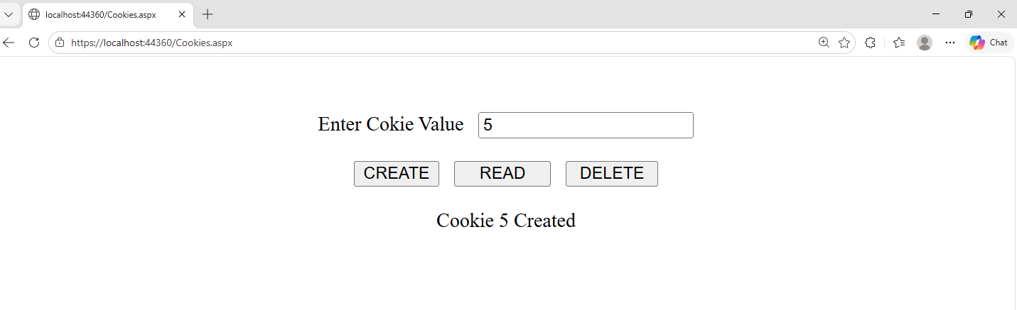

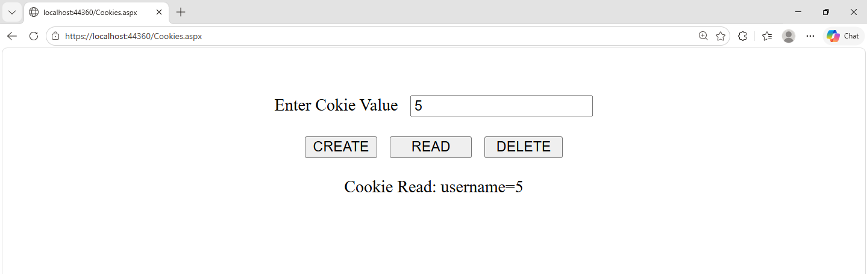

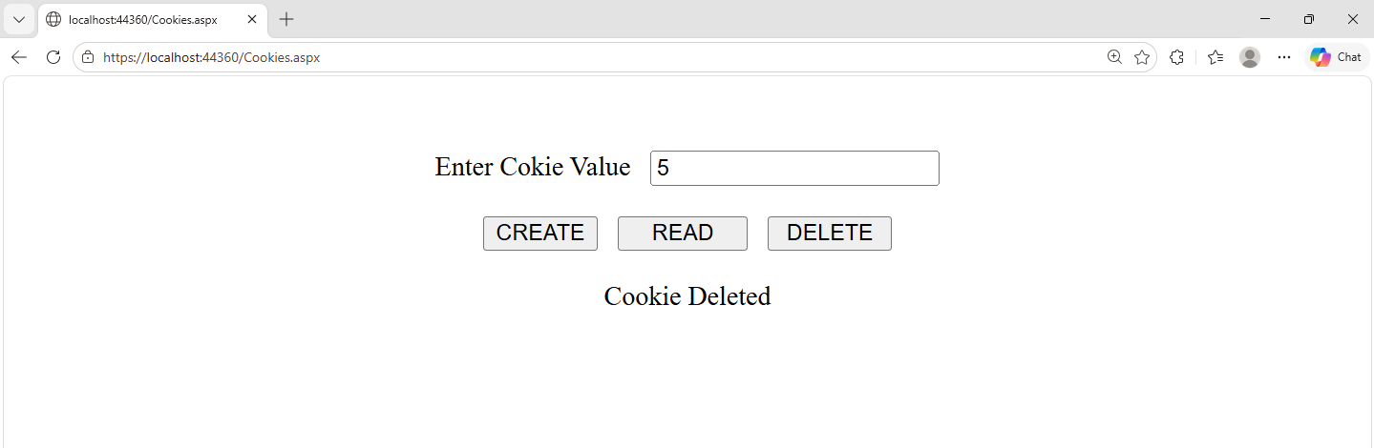

- Design a session-based login system where users are redirected to a dashboard upon successful login.

Login.aspx –

<%@ Page Language="C#" AutoEventWireup="true" CodeBehind="login.aspx.cs" Inherits="WebApplication01.login" %>

<!DOCTYPE html>
<html xmlns="http://www.w3.org/1999/xhtml">
<head runat="server">
<title>Login</title>
</head>
<body>
<center>
<form id="form1" runat="server">
<div class="login-box">
<h2>Login</h2>
<div class="form-row">
<asp:Label ID="lblUsername" runat="server" Text="Username"></asp:Label>
&nbsp;
<asp:TextBox ID="txtUsername" runat="server"></asp:TextBox>
<br />
</div>
<div class="form-row">
<asp:Label ID="lblPassword" runat="server" Text="Password"></asp:Label>
&nbsp;
<asp:TextBox ID="txtPassword" runat="server" TextMode="Password"></asp:TextBox>
</div><br />

<div class="form-row">
<asp:Button ID="btnLogin" runat="server" Text="Login" OnClick="btnLogin_Click" />
</div><br />
<div class="form-row">
<asp:Label ID="Label3" runat="server" ></asp:Label>
</div>
</div>
</form>
</center>
</body>
</html>

Login.aspx.cs

using System;
using System.Collections.Generic;
using System.Linq;
using System.Web;
using System.Web.UI;
using System.Web.UI.WebControls;

namespace WebApplication01
{
public partial class login : System.Web.UI.Page
{
protected void Page_Load(object sender, EventArgs e)
{
}
protected void btnLogin_Click(object sender, EventArgs e)
{
if ((txtUsername.Text == "Admin" || txtUsername.Text == "Sud") && txtPassword.Text == "123")
{
Session["id"] = lblUsername.Text;
Response.Redirect("logoutput.aspx");
}
else
{
Label3.Text = "You're username and word is incorrect";
Label3.ForeColor = System.Drawing.Color.Red;
}
}
}
}

Logoutput.aspx –

<%@ Page Language="C#" AutoEventWireup="true" CodeBehind="logoutput.aspx.cs" Inherits="WebApplication01.logoutput" %>

<!DOCTYPE html>
<html xmlns="http://www.w3.org/1999/xhtml">
<head runat="server">
<title>Session Redirect Page</title>
</head>
<body>
<center>
<form id="form1" runat="server">

<div class="container">
<h2>Hello Everyone...!!! Welcome to my Page...!!!!</h2>
<asp:Image ID="Image1" runat="server"
ImageUrl="~/Images/image.jpg"
CssClass="main-image" />
<br /><br />
<asp:Label ID="Label2" runat="server" Text="[Label2]"></asp:Label>
<br /><br />
<asp:Button ID="btnLogout" runat="server" Text="Logout" OnClick="btnLogout_Click" />
</div>
</form>
</center>
</body>
</html>

Logoutput.aspx.cs

using System;
using System.Collections.Generic;
using System.Linq;
using System.Web;
using System.Web.UI;
using System.Web.UI.WebControls;

namespace WebApplication01
{
public partial class logoutput : System.Web.UI.Page
{
protected void Page_Load(object sender, EventArgs e)
{
Label2.Text = "Hello..! " + Session["id"].ToString();
}

protected void btnLogout_Click(object sender, EventArgs e)
{
Response.Redirect("login.aspx");
}
}
}

Output –

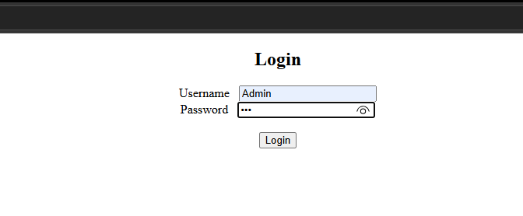

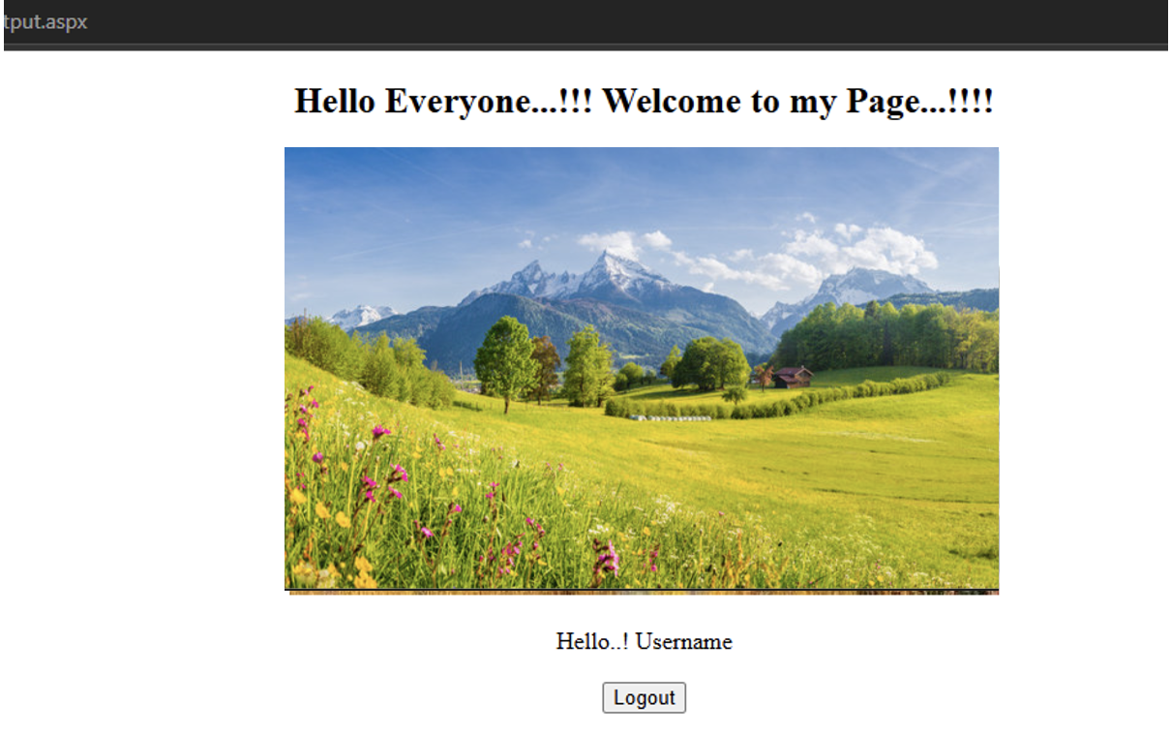

- Design Web Application to show a list of books.on click of submit button selected book should be added in session and book details should be displayed on another page.

List_Books.aspx -

<%@ Page Language="C#" AutoEventWireup="true" CodeBehind="List_Books.aspx.cs" Inherits="Omkar_31.List_Books" %>

<!DOCTYPE html>

<html xmlns="http://www.w3.org/1999/xhtml">
<head runat="server">
<title></title>
</head>
<body>
<form id="form1" runat="server">
<div>
<center>
<h3>Application to show List of Books</h3>

<h5>List of Books</h5>
<p>
<asp:ListBox ID="ListBox1" runat="server" Height="76px" OnSelectedIndexChanged="ListBox1_SelectedIndexChanged" Width="156px"></asp:ListBox>
</p>
<p>
<asp:Button ID="Button1" runat="server" OnClick="Button1_Click" Text="Submit Books" Width="158px" />
</p>
</center>
</div>
</form>
</body>
</html>

List_Books.aspx.cs –

using System;
using System.Collections.Generic;
using System.Linq;
using System.Web;
using System.Web.UI;
using System.Web.UI.WebControls;

namespace Omkar_31
{
public partial class List_Books : System.Web.UI.Page
{
protected void Page_Load(object sender, EventArgs e)
{
if (!IsPostBack)
{
ListBox1.Items.Add("Advanced .net");
ListBox1.Items.Add("ASP .net");
ListBox1.Items.Add("Advance .net");
ListBox1.Items.Add("ADBMS");
ListBox1.Items.Add("Python");
}
}

protected void Button1_Click(object sender, EventArgs e)
{
Session["bookname"] = ListBox1.SelectedItem;
if (Session["bookname"] == null)
{
Response.Write("<script>alert('Book NOT selected')</script>");
}
else
{
Response.Redirect("List_Books_2.aspx");
}
}
}
}

List_Books_2.aspx –

<%@ Page Language="C#" AutoEventWireup="true" CodeBehind="List_Books_2.aspx.cs" Inherits="Omkar_31.List_Books_2" %>

<!DOCTYPE html>

<html xmlns="http://www.w3.org/1999/xhtml">
<head runat="server">
<title></title>
</head>
<body>
<form id="form1" runat="server">
<div>
<center>

<asp:Label ID="Label1" runat="server" Text="Book Selected"></asp:Label>
<br />
<br />
<asp:Label ID="Label2" runat="server"></asp:Label>

</center>
</div>
</form>
</body>
</html>

List_Books_2.aspx.cs –

using System;
using System.Collections.Generic;
using System.Linq;
using System.Web;
using System.Web.UI;
using System.Web.UI.WebControls;

namespace Omkar_31
{
public partial class List_Books_2 : System.Web.UI.Page
{
protected void Page_Load(object sender, EventArgs e)
{
Label1.Text = Session["bookname"].ToString();
}
}
}
Output -

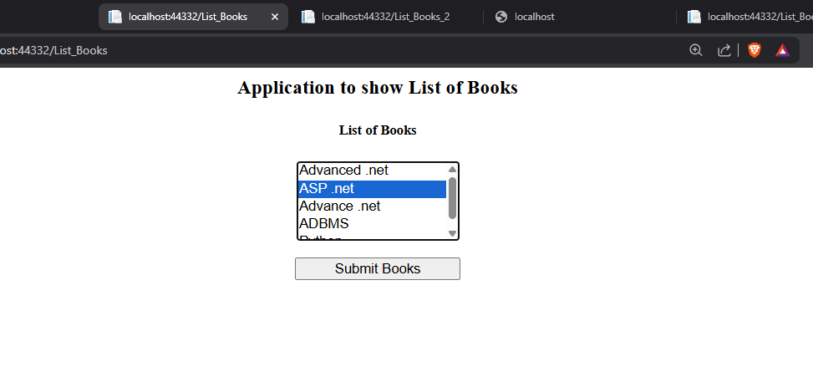

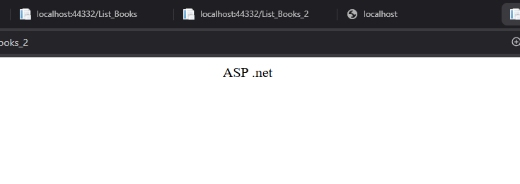

- Design Web Application to read 10 students info from database table into a gridview.cache this output for 10 sec.use cache object.

CachObject.aspx –

<%@ Page Language="C#" AutoEventWireup="true" CodeBehind="CachObject.aspx.cs" Inherits="Omkar_31.CachObject" %>

<!DOCTYPE html>

<html xmlns="http://www.w3.org/1999/xhtml">
<head runat="server">
<title></title>
</head>
<body>
<form id="form1" runat="server">
<div>
<center>
<b><h2>Employee Information</h2>
<p>
<asp:GridView ID="GridView1" runat="server" AutoGenerateColumns="False" DataKeyNames="Id" DataSourceID="SqlDataSource1" Height="121px" Width="199px">
<Columns>
<asp:BoundField DataField="Id" HeaderText="Id" ReadOnly="True" SortExpression="Id" />
<asp:BoundField DataField="Ename" HeaderText="Ename" SortExpression="Ename" />
<asp:BoundField DataField="DeptNo" HeaderText="DeptNo" SortExpression="DeptNo" />
</Columns>
</asp:GridView>
</p>
<p>
<asp:SqlDataSource ID="SqlDataSource1" runat="server" CacheDuration="15" ConnectionString="<%$ ConnectionStrings:omkarConnectionString %>" EnableCaching="True" ProviderName="<%$ ConnectionStrings:omkarConnectionString.ProviderName %>" SelectCommand="SELECT * FROM [Study]"></asp:SqlDataSource>
</p>
<p>&nbsp;</p></b>
</center>
</div>
</form>
</body>
</html>

Output –

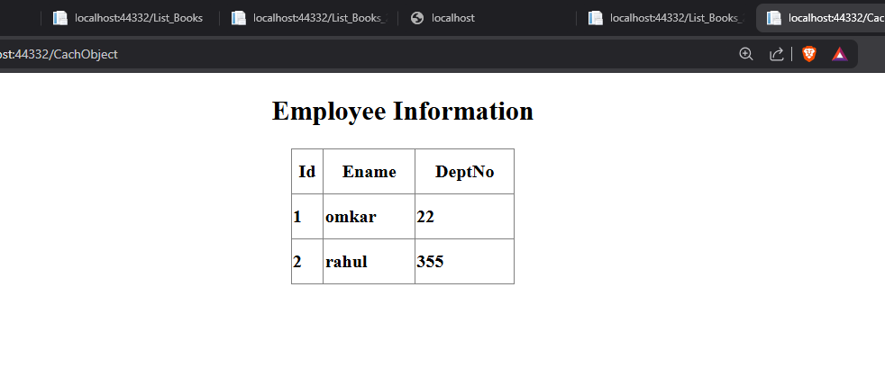

- Implement an AJAX-enabled web form to fetch user details without reloading the page.

AjaxControl.aspx –

<%@ Page Language="C#" AutoEventWireup="true" CodeBehind="AjaxControl.aspx.cs" Inherits="Omkar_31.AjaxControl" %>

<!DOCTYPE html>

<html xmlns="http://www.w3.org/1999/xhtml">
<head runat="server">
<title></title>
<style type="text/css">
#Button1 {
width: 132px;
}
</style>
</head>
<body style="height: 198px">
<form id="form1" runat="server">
<div>
<center>
<asp:ScriptManager ID="ScriptManager1" runat="server">
</asp:ScriptManager>
<br />
<asp:UpdatePanel ID="UpdatePanel1" runat="server">
<ContentTemplate>
<asp:Button ID="Button1" runat="server" Text="Partial Postback" />
<br />
<br />
<asp:Label ID="Label1" runat="server"></asp:Label>
</ContentTemplate>
</asp:UpdatePanel>
<br />
<asp:Button ID="Button2" runat="server" Text="Total Postback" OnClick="Button2_Click" />
<br />
<br />
<asp:Label ID="Label2" runat="server"></asp:Label>
<br />
</center>
</div>
</form>
</body>
</html>

AjaxControl.aspx.cs –

using System;
using System.Collections.Generic;
using System.Linq;
using System.Web;
using System.Web.UI;
using System.Web.UI.WebControls;

namespace Omkar_31
{
public partial class AjaxControl : System.Web.UI.Page
{
string time = DateTime.Now.ToLongTimeString();
protected void Page_Load(object sender, EventArgs e)
{

}
protected void Button1_Click(object sender, EventArgs e)
{
Label1.Text = "Showing time from panel" + time;
Label2.Text = "Showing time from outside" + time;

}
protected void Button2_Click(object sender, EventArgs e)
{
Label1.Text = "Showing time from panel" + time;
Label2.Text = "Showing time from outside" + time;
}
}
}

Output –

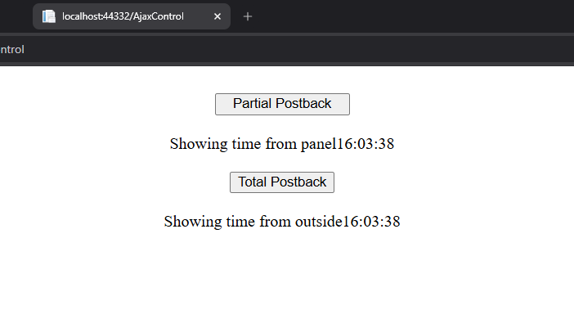

- Develop a simple to-do list application using AJAX controls and update panels.

Ajax_to_do_list.aspx –

<%@ Page Language="C#" AutoEventWireup="true" CodeBehind="Ajax_To_Do_List.aspx.cs" Inherits="Omkar_31.Ajax_To_Do_List" %>

<!DOCTYPE html>

<html xmlns="http://www.w3.org/1999/xhtml">
<head runat="server">
<title></title>
</head>
<body>
<form id="form1" runat="server">
<div>
<center>
<h1>AJAX To- DO- List</h1>
<p>
<asp:ScriptManager ID="ScriptManager1" runat="server">
</asp:ScriptManager>
</p>
<asp:UpdatePanel ID="UpdatePanel1" runat="server">
<ContentTemplate>
<asp:TextBox ID="TextBox1" runat="server"></asp:TextBox>
<asp:Button ID="Button1" runat="server" Text="Add Task" />

<br />
<br />
<asp:ListBox ID="ListBox1" runat="server" Width="99px"></asp:ListBox>
<br />

<br />
<asp:Button ID="Button2" runat="server" Text="Delete Selected Task" />
</ContentTemplate>

</asp:UpdatePanel>
</form>
</div>
</center>
</body>
</html>

Ajaxtodolist.aspx.cs –

using System;
using System.Collections.Generic;
using System.Linq;
using System.Web;
using System.Web.UI;
using System.Web.UI.WebControls;

namespace WebApplication143
{
public partial class ajaxtodolist : System.Web.UI.Page
{
protected void Page_Load(object sender, EventArgs e)
{
if (!IsPostBack)
{
ListBox1.Items.Add("Complete IS assignment");
}
}
protected void btnAdd_task_Click(object sender, EventArgs e)
{
System.Threading.Thread.Sleep(2000);
ListBox1.Items.Add(TextBox1.Text);
}

protected void btnSelected_task_Click(object sender, EventArgs e)
{
System.Threading.Thread.Sleep(2000);
ListBox1.Items.RemoveAt(ListBox1.SelectedIndex);
}
}
}

Output –

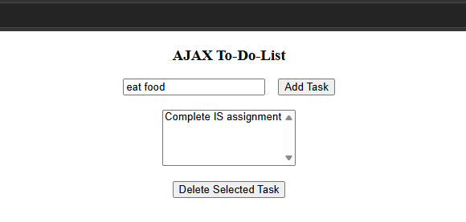

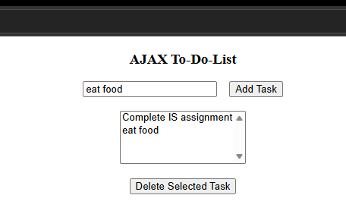

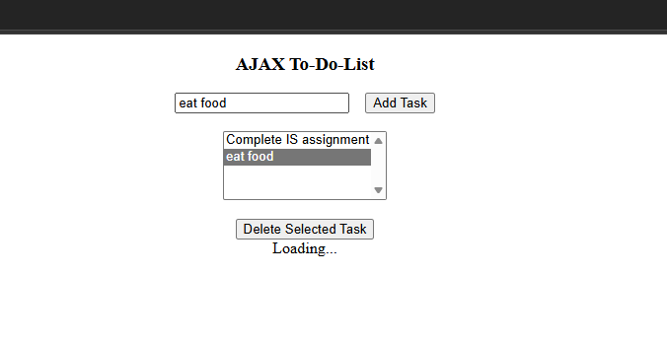

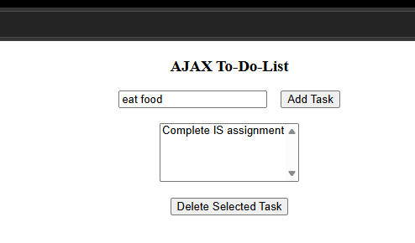

- Demonstrate the use of the Global.asax file for handling application-level events.

Global.ascx –

using System;
using System.Collections.Generic;
using System.Linq;
using System.Web;
using System.Web.Optimization;
using System.Web.Routing;
using System.Web.Security;
using System.Web.SessionState;

namespace Global
{
public class Global : HttpApplication
{
protected void Application_Start(object sender, EventArgs e)
{
Application["count1"] = 0;
}

protected void Session_Start(object sender, EventArgs e)
{
Application["count1"] = (int)Application["count1"] + 1;
Session["name1"] = "Guest";
}
}
}

Application Global.aspx –

<%@ Page Language="C#" AutoEventWireup="true" CodeBehind="Application Global.aspx.cs" Inherits="Global.Application_Global" %>

<!DOCTYPE html>

<html xmlns="http://www.w3.org/1999/xhtml">
<head runat="server">
<title></title>
</head>
<body>
<form id="form1" runat="server">
<div>
<center>
<h3>Demonstrate the use of the Global.asax file for handling application level events</h3>

<h5>UserName :
<asp:TextBox ID="TextBox1" runat="server"></asp:TextBox>
</h5>
<p>
<asp:Button ID="Button1" runat="server" OnClick="Button1_Click" Text="Submit" />
</p>

</center>
</div>
</form>
</body>
</html>

Application Global.aspx.cs –

using System;
using System.Collections.Generic;
using System.Linq;
using System.Web;
using System.Web.UI;
using System.Web.UI.WebControls;

namespace Global
{
public partial class Application_Global : System.Web.UI.Page
{
protected void Page_Load(object sender, EventArgs e)
{

}
protected void Button1_Click(object sender, EventArgs e)
{
if (TextBox1.Text != "")
{
Session["name1"] = TextBox1.Text;
}
Response.Redirect("RedirectApplication.aspx");
}
}
}

RedirectApplication.aspx –

<%@ Page Language="C#" AutoEventWireup="true" CodeBehind="RedirectApplication.aspx.cs" Inherits="Global.RedirectApplication" %>

<!DOCTYPE html>

<html xmlns="http://www.w3.org/1999/xhtml">
<head runat="server">
<title></title>
</head>
<body>
<form id="form1" runat="server">
<div>
<center>
<h4>Welcome !!!</h4>
<p>
<asp:Button ID="Button1" runat="server" OnClick="Button1_Click" Text="Back" />
</p>

</center>
</div>
</form>
</body>
</html>

RedirectApplication.aspx.cs –

using System;
using System.Collections.Generic;
using System.Linq;
using System.Web;
using System.Web.UI;
using System.Web.UI.WebControls;

namespace Global
{
public partial class RedirectApplication : System.Web.UI.Page
{
protected void Page_Load(object sender, EventArgs e)
{
if(!IsPostBack)
{

Response.Write("Session Name: " + Session["name1"].ToString() + "<br/>");
Response.Write("Application Count" + Application["count1"].ToString());
}
}

protected void Button1_Click(object sender, EventArgs e)
{
Response.Redirect("Application Global.aspx");
}
}
}

Output –

