- Create xml based webservice to create calculator and consume it in website.
Code:
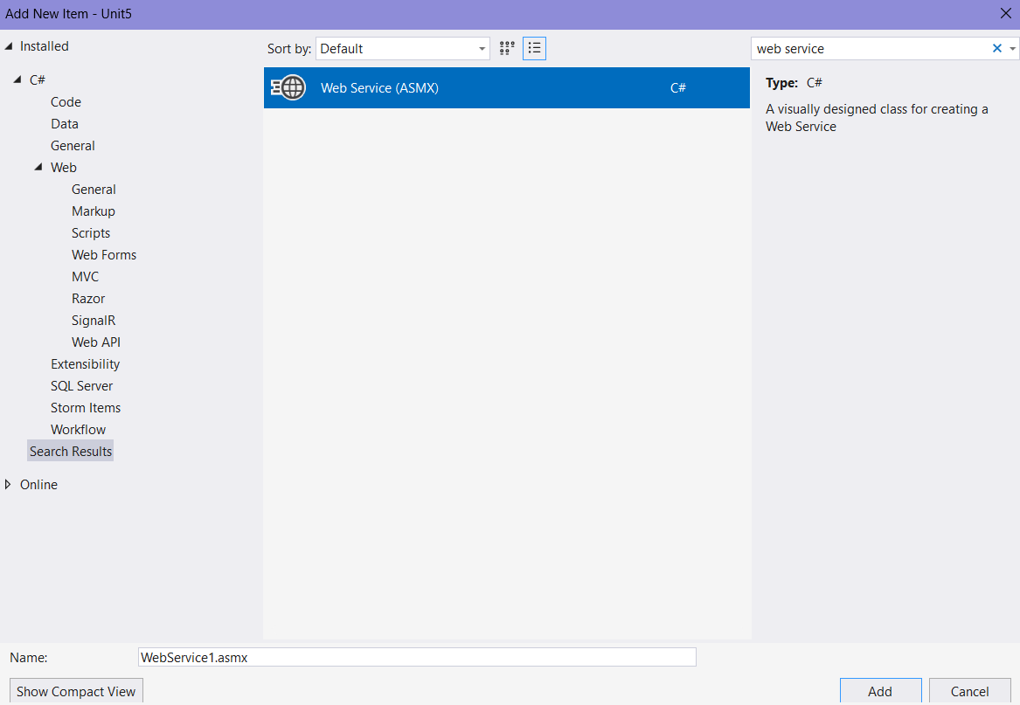

WebService1.asmx
using System;
using System.Collections.Generic;
using System.Linq;
using System.Web;
using System.Web.Services;

namespace Unit5
{
/// <summary>
/// Summary description for WebService1
/// </summary>
[WebService(Namespace = "http://tempuri.org/")]
[WebServiceBinding(ConformsTo = WsiProfiles.BasicProfile1_1)]
[System.ComponentModel.ToolboxItem(false)]
// To allow this Web Service to be called from script, using ASP.NET AJAX, uncomment the following line.

// [System.Web.Script.Services.ScriptService]
public class WebService1 : System.Web.Services.WebService
{

[WebMethod]
public double addition(double n1, double n2)
{
return (n1 + n2);
}

[WebMethod]
public double subtraction(double n1, double n2)
{
return (n1 - n2);
}

[WebMethod]
public double multiplication(double n1, double n2)
{
return (n1 * n2);
}

[WebMethod]
public double division(double n1, double n2)
{
return (n1 / n2);
}
}
}

Run the file and copy the url
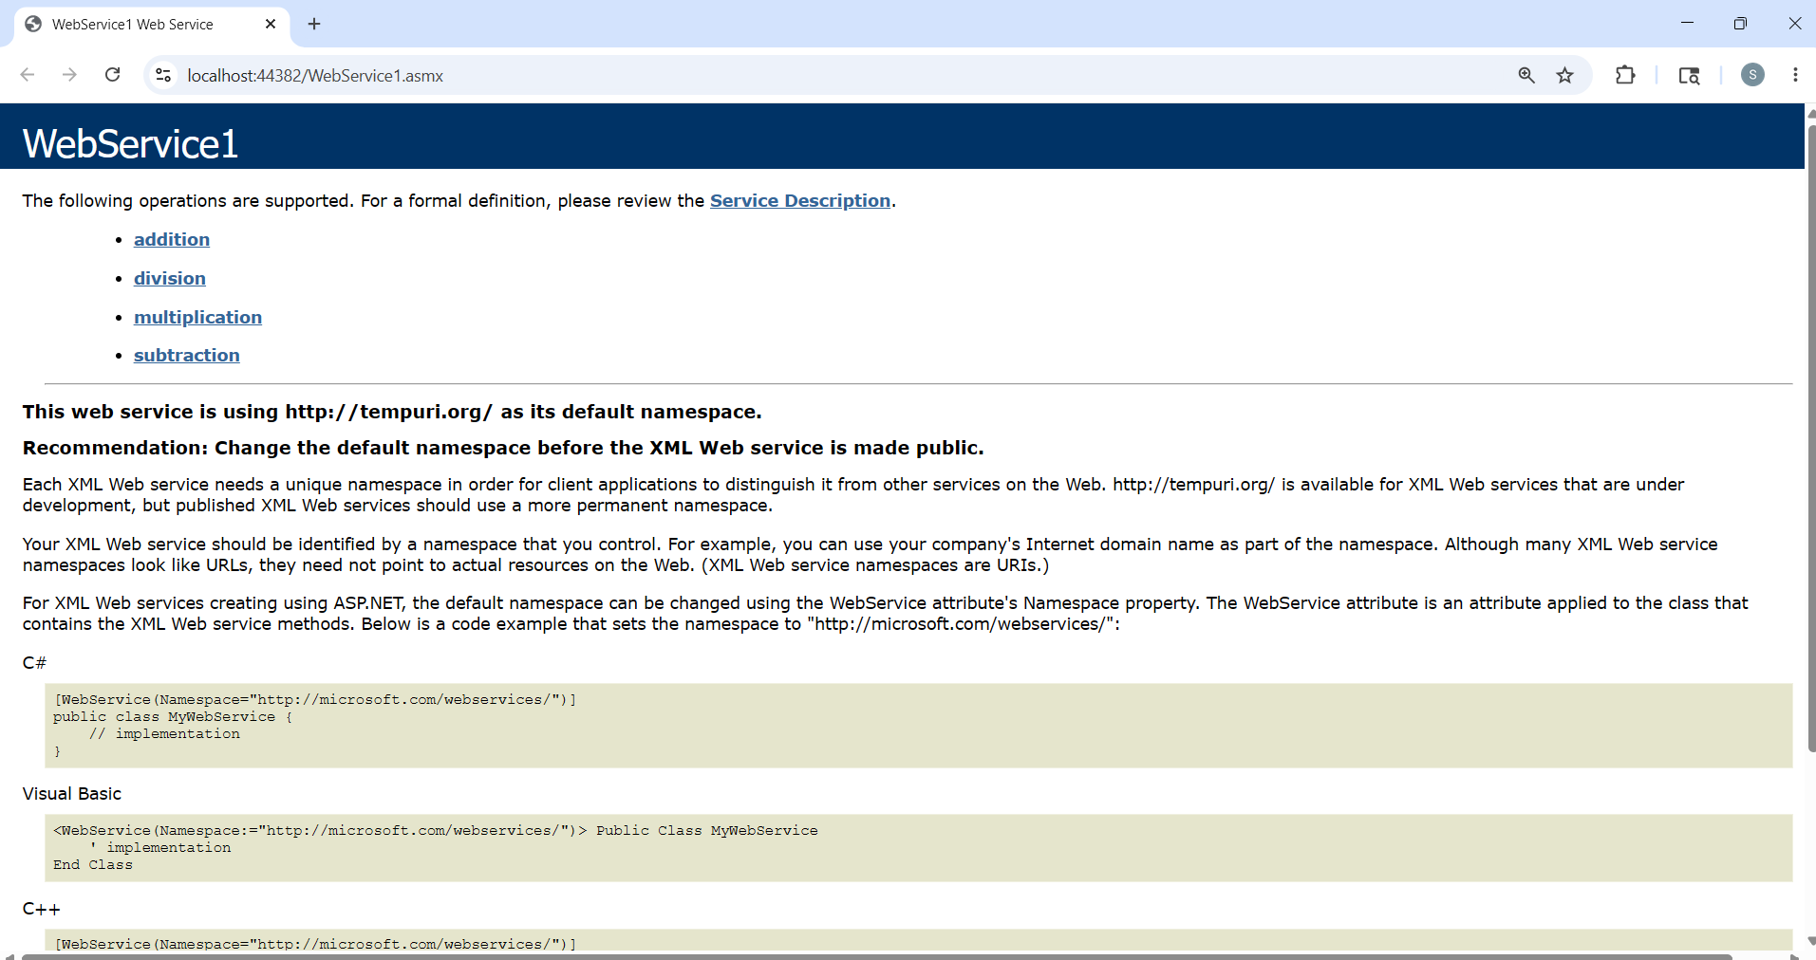
https://localhost:44382/WebService1.asmx -
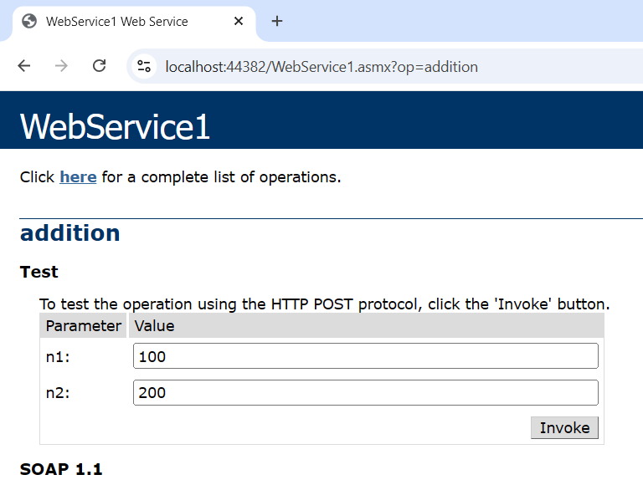
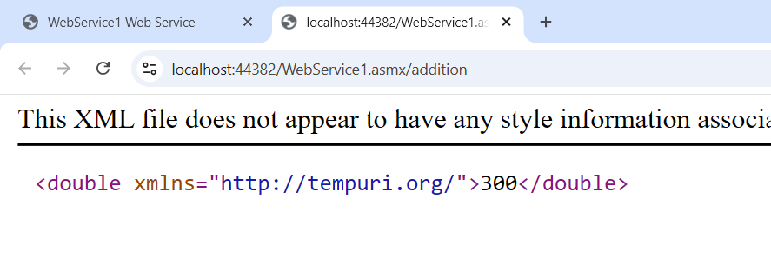
Now Service Reference
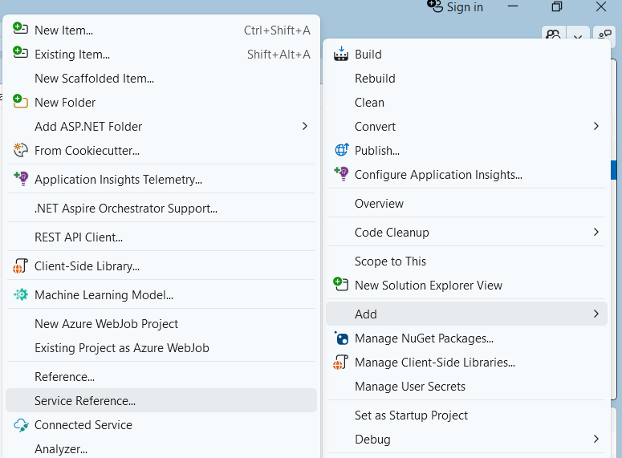
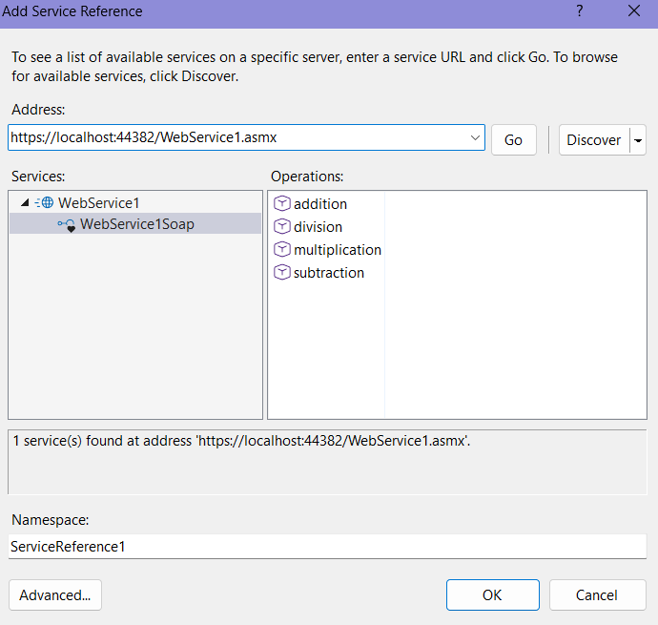

Create a web form:
WsCalculator.aspx
<%@ Page Language="C#" AutoEventWireup="true" CodeBehind="WsCalculator.aspx.cs" Inherits="Unit5.WsCalculator" %>

<!DOCTYPE html>

<html xmlns="http://www.w3.org/1999/xhtml">
<head runat="server">
<title></title>
</head>
<body>
<form id="form1" runat="server">
<center>
<div>
<h2>SIMPLE CALCULATOR USING SIMPLE WEB SERVICE</h2>
<asp:Label ID="Label1" runat="server" Text="Enter Number 1: "></asp:Label>

<asp:TextBox ID="TextBox1" runat="server"></asp:TextBox>
<br />
<br />
<asp:Label ID="Label2" runat="server" Text="Enter Number 2: "></asp:Label>
<asp:TextBox ID="TextBox2" runat="server"></asp:TextBox>
<br />
<br />
<asp:Label ID="LabelResult" runat="server"></asp:Label>
<br />
<br />
<asp:Button ID="btnAdd" runat="server" Text="ADD" OnClick="btnAdd_Click" />
&nbsp;&nbsp;&nbsp;
<asp:Button ID="btnSubtract" runat="server" Text="SUBTRACT" OnClick="btnSubtract_Click" />
&nbsp;&nbsp;&nbsp;
<asp:Button ID="btnMul" runat="server" Text="MULTIPLY" OnClick="btnMul_Click" />
&nbsp;&nbsp;&nbsp;
<asp:Button ID="btnDiv" runat="server" Text="DIVIDE" OnClick="btnDiv_Click" />
</div>
</center>
</form>
</body>
</html>

WsCalculator.aspx.cs
using System;
using System.Collections.Generic;
using System.Linq;
using System.Web;
using System.Web.UI;
using System.Web.UI.WebControls;

namespace Unit5
{
public partial class WsCalculator : System.Web.UI.Page
{
WebService1 svc = new WebService1();
protected void Page_Load(object sender, EventArgs e)
{

}

protected void btnAdd_Click(object sender, EventArgs e)
{
double result = svc.addition(double.Parse(TextBox1.Text),double.Parse(TextBox2.Text));
LabelResult.Text = "Result of Addition is: " + result;
}

protected void btnSubtract_Click(object sender, EventArgs e)
{
double result = svc.subtraction(double.Parse(TextBox1.Text),double.Parse(TextBox2.Text));
LabelResult.Text = "Result of Subtraction is: " + result;
}

protected void btnMul_Click(object sender, EventArgs e)
{
double result = svc.multiplication(double.Parse(TextBox1.Text),double.Parse(TextBox2.Text));
LabelResult.Text = "Result of Multiplication is: " + result;
}

protected void btnDiv_Click(object sender, EventArgs e)
{
double result = svc.division(double.Parse(TextBox1.Text),double.Parse(TextBox2.Text));
LabelResult.Text = "Result of Division is: " + result;
}
}}

Output:

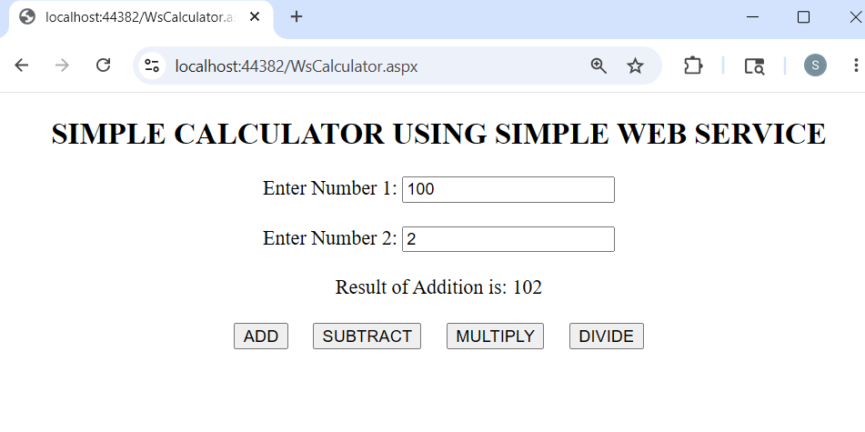
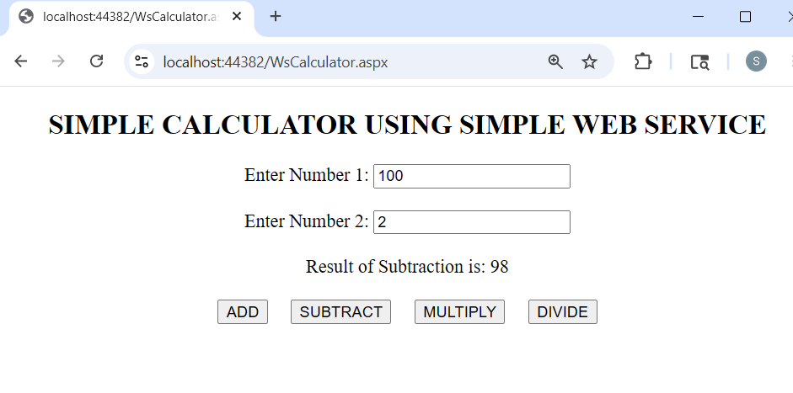
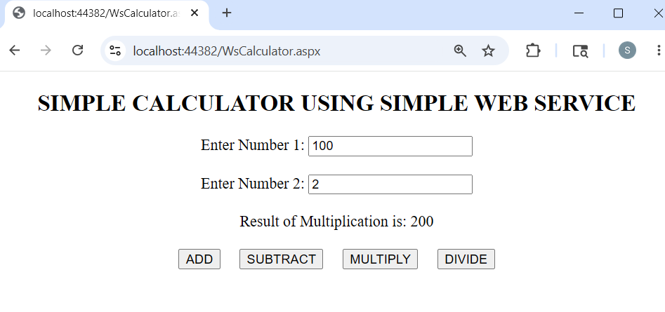
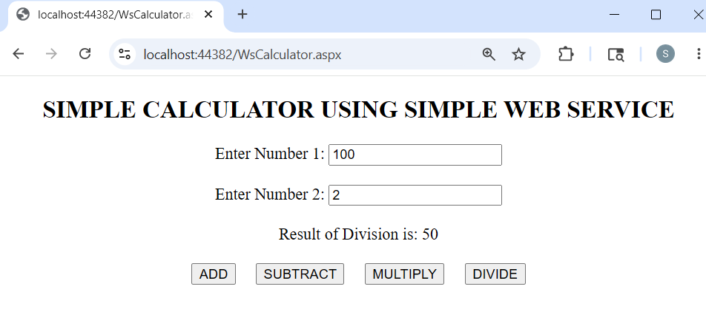
- Design a Web Service to Fetch & insert Details of Students Table using ADO.NET. Design a Web Client to show contents of table in a Grid View.
Code:
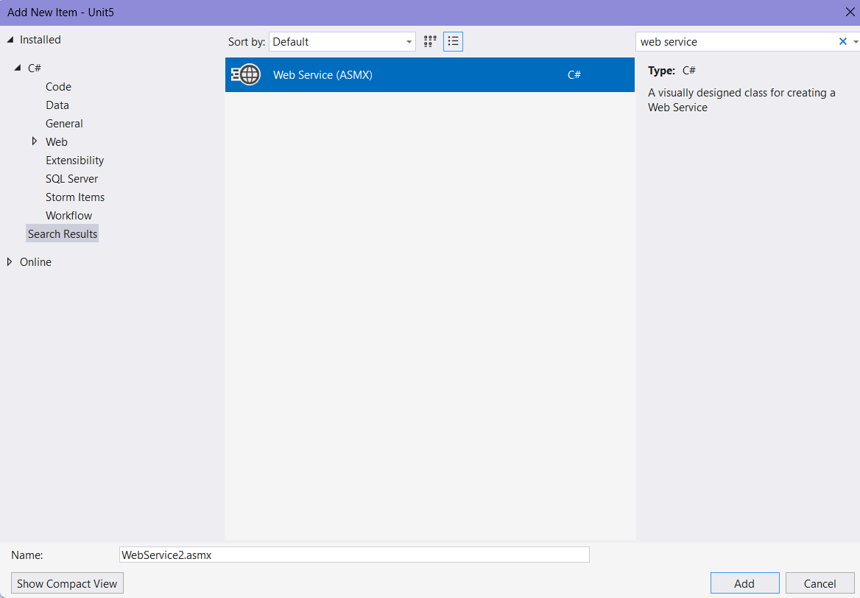
WebService2.asmx
using System;
using System.Collections.Generic;
using System.Data;
using System.Data.SqlClient;
using System.Linq;
using System.Security.Cryptography;
using System.Web;
using System.Web.Services;
using System.Xml.Linq;

namespace Unit5
{
/// <summary>
/// Summary description for WebService2
/// </summary>
[WebService(Namespace = "http://tempuri.org/")]
[WebServiceBinding(ConformsTo = WsiProfiles.BasicProfile1_1)]

[System.ComponentModel.ToolboxItem(false)]
// To allow this Web Service to be called from script, using ASP.NET AJAX, uncomment the following line.
// [System.Web.Script.Services.ScriptService]
public class WebService2 : System.Web.Services.WebService
{

[WebMethod]

public DataSet getdata()
{
SqlConnection conn = new SqlConnection("");

SqlCommand cmd = new SqlCommand("select * from Emp", conn);
SqlDataAdapter adapter = new SqlDataAdapter();
DataSet ds = new DataSet();
conn.Open();
adapter.SelectCommand = cmd;
adapter.Fill(ds);
conn.Close();
return ds;
}

[WebMethod]

public int setdata(int Eid, string ename, string desg, int salary)
{
SqlConnection conn = new SqlConnection("");
SqlCommand cmd = new SqlCommand("Insert into Emp(Eid, Ename, Designation, Salary) values('" + Eid +
"','" + ename + "','" + desg + "','" + salary + "')", conn);
conn.Open();
int cnt = cmd.ExecuteNonQuery();
conn.Close();
return cnt;
}
}
}

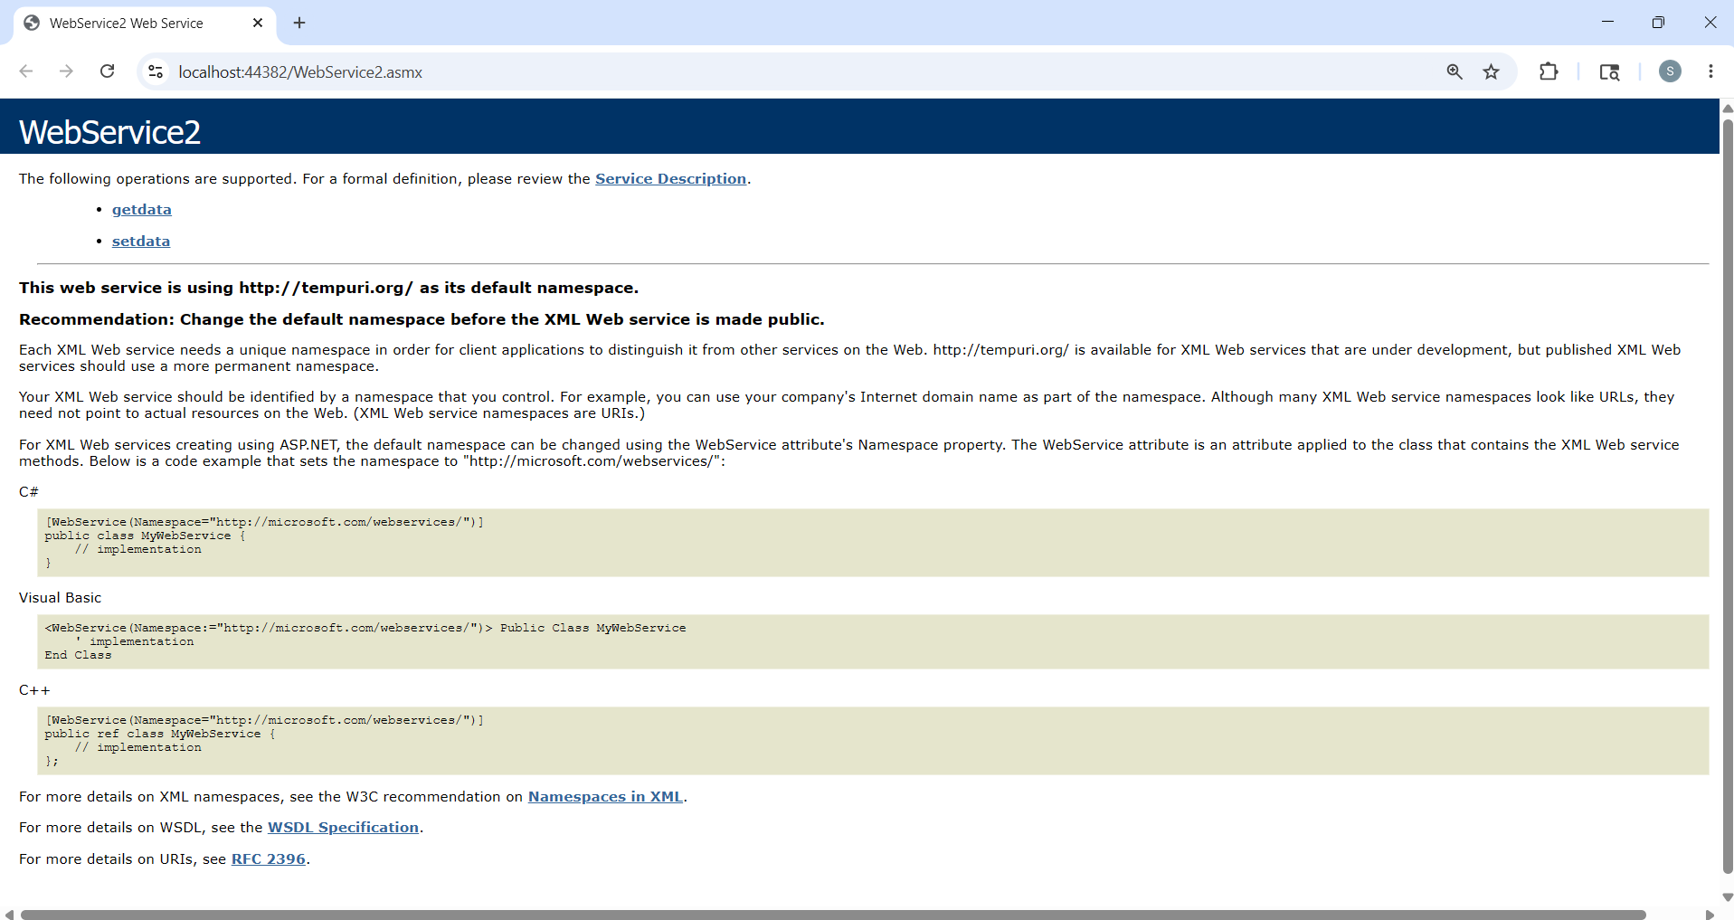
Cope the url: https://localhost:44382/WebService2.asmx
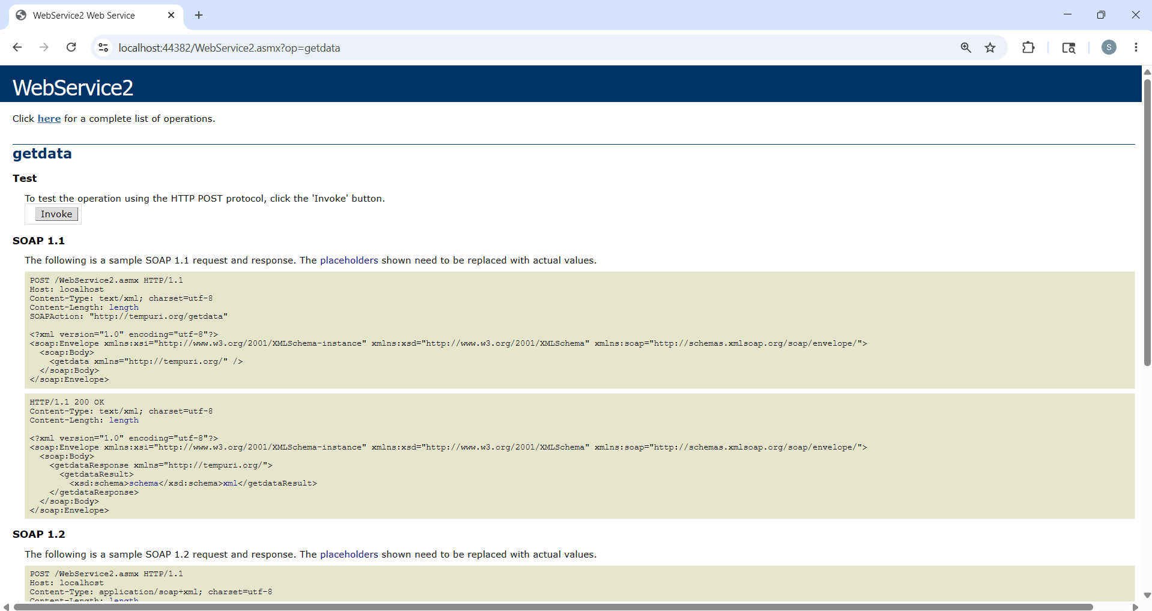
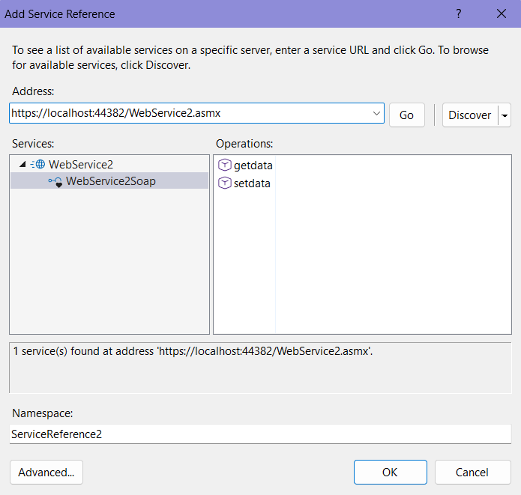

Create a web form:
WebServiceDatabase.aspx
<%@ Page Language="C#" AutoEventWireup="true" CodeBehind="WebServiceDatabase.aspx.cs" Inherits="Unit5.WebServiceDatabase" %>

<!DOCTYPE html>

<html xmlns="http://www.w3.org/1999/xhtml">
<head runat="server">
<title></title>
</head>
<body>
<form id="form1" runat="server">
<center>
<div>
<h1> Simple WebService DataBase </h1>
<asp:Label ID="Label1" runat="server" Text="Eid: "></asp:Label>&nbsp;&nbsp;

<asp:TextBox ID="TextBox1" runat="server"></asp:TextBox>
<br /><br />
<asp:Label ID="Label2" runat="server" Text="EName: "></asp:Label>&nbsp;&nbsp;
<asp:TextBox ID="TextBox2" runat="server"></asp:TextBox>
<br /><br />

<asp:Label ID="Label3" runat="server" Text="Designation"></asp:Label>&nbsp;&nbsp;
<asp:TextBox ID="TextBox3" runat="server"></asp:TextBox>
<br /><br />
<asp:Label ID="Label4" runat="server" Text="Salary: "></asp:Label>&nbsp;&nbsp;
<asp:TextBox ID="TextBox4" runat="server"></asp:TextBox>
<br /><br />

<asp:Button ID="Button1" runat="server" Text="Show" OnClick="Button1_Click" />&nbsp;&nbsp;
<asp:Button ID="Button2" runat="server" Text="Save" OnClick="Button2_Click" />
<asp:GridView ID="GridView1" runat="server"></asp:GridView>

<asp:Label ID="Label5" runat="server" Text=""></asp:Label>
</div>
</center>
</form>
</body>
</html>

WebServiceDatabase.aspx.cs
using System;
using System.Collections.Generic;
using System.Linq;
using System.Web;
using System.Web.UI;
using System.Web.UI.WebControls;
using static System.Net.Mime.MediaTypeNames;

namespace Unit5
{
public partial class WebServiceDatabase : System.Web.UI.Page
{
WebService2 svc = new WebService2();
protected void Page_Load(object sender, EventArgs e)
{

}
protected void Button1_Click(object sender, EventArgs e)
{
GridView1.DataSource = svc.getdata();
GridView1.DataBind();
Label5.Text = "";

}

protected void Button2_Click(object sender, EventArgs e)
{
int cnt =svc.setdata(int.Parse(TextBox1.Text), TextBox2.Text, TextBox3.Text, int.Parse(TextBox4.Text));
if (cnt > 0)
{
Label5.Text = "Record updated successfully";
}
}
}}

Output:
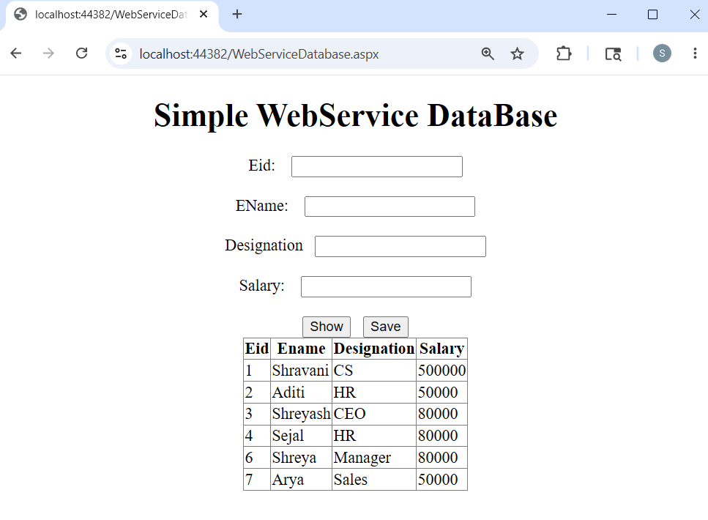
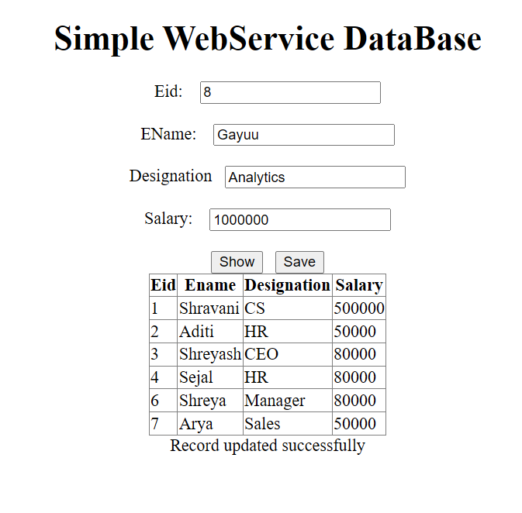
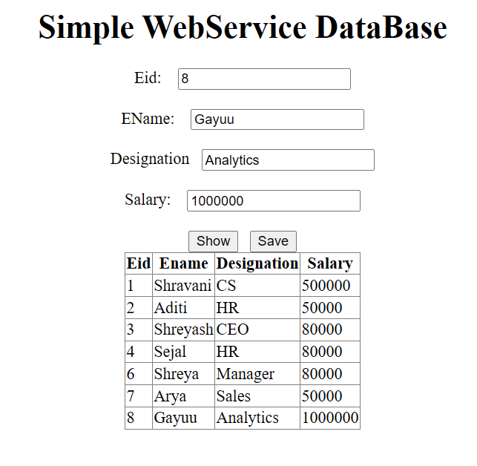

- Create and consume the WCF service to calculate simple interest.
Code:
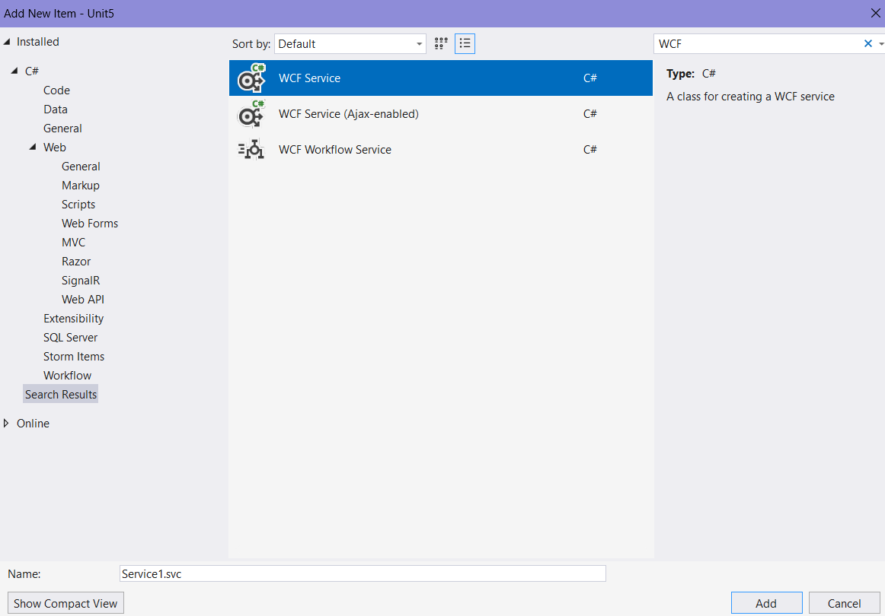
IService1.cs
using System;
using System.Collections.Generic;
using System.Linq;
using System.Runtime.Serialization;
using System.ServiceModel;
using System.Text;

namespace Unit5
{
[ServiceContract]
public interface IService1
{
[OperationContract]
double getSI(double p, int n, double r);
}
}
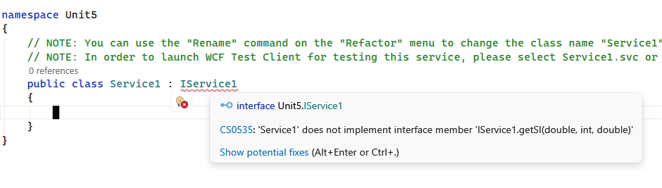
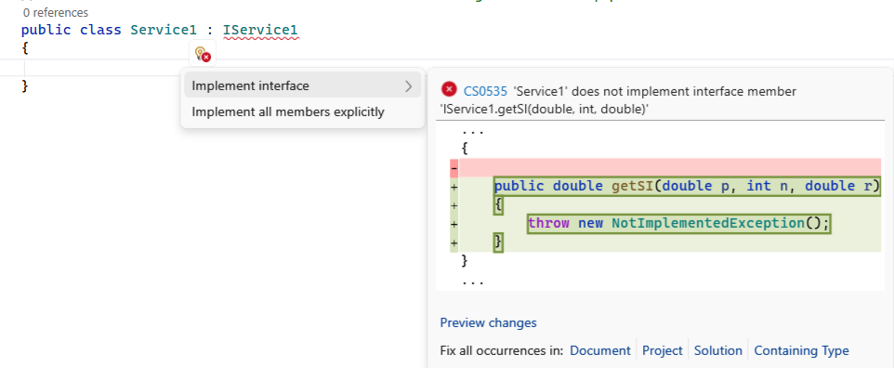
Service1.svc.cs
using System;
using System.Collections.Generic;
using System.Linq;
using System.Runtime.Serialization;
using System.ServiceModel;
using System.Text;

namespace Unit5
{
public class Service1 : IService1
{
public double getSI(double p, int n, double r)
{
return ((p * n * r) / 100);
}
}
}

Run the file and test
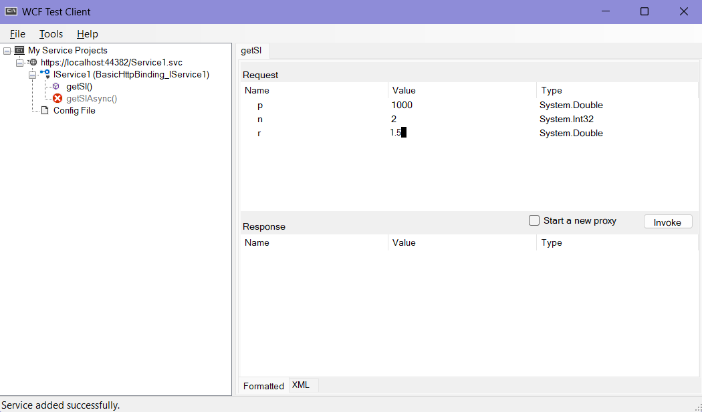
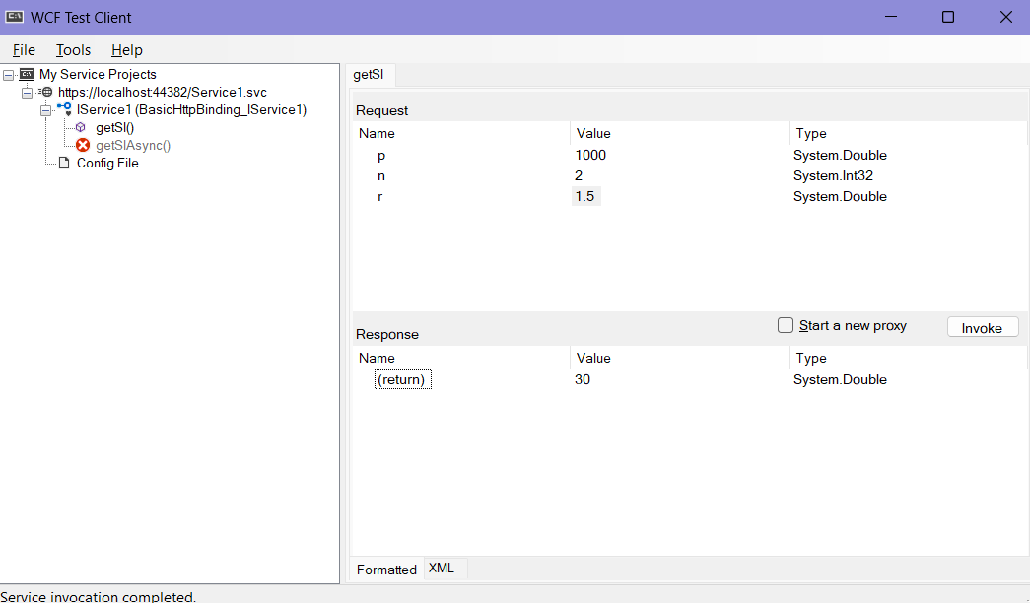

Copy the url: https://localhost:44382/Service1.svc

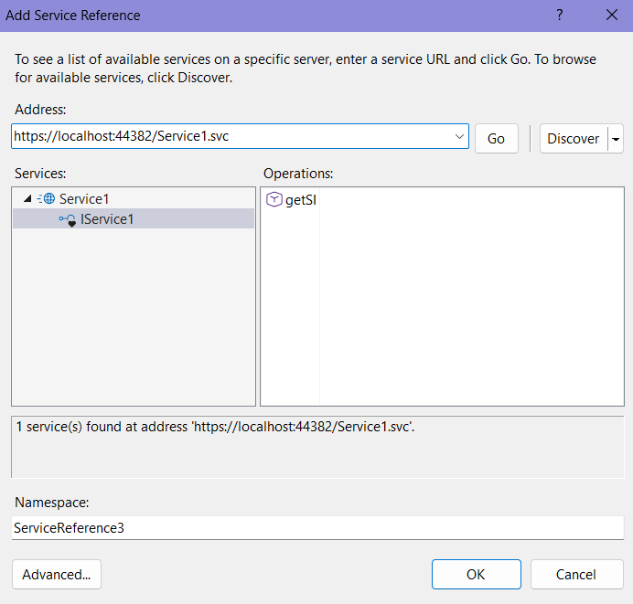
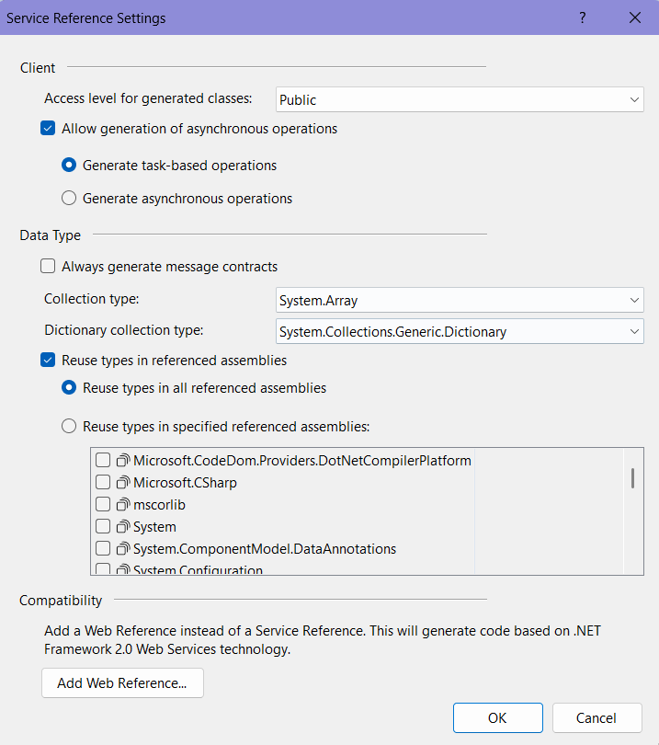
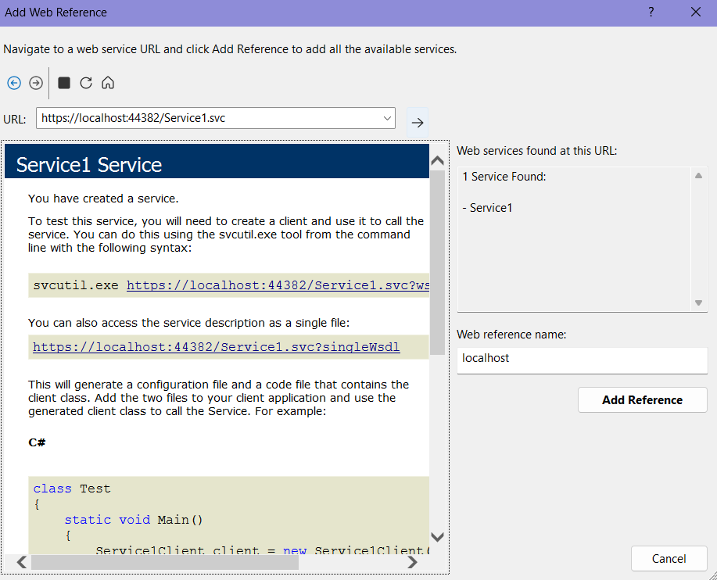

Create a web form:
WebServiceSimpleInterest.aspx
<%@ Page Language="C#" AutoEventWireup="true" CodeBehind="WebServiceSimpleInterest.aspx.cs" Inherits="Unit5.WebServiceSimpleInterest" %>

<!DOCTYPE html>

<html xmlns="http://www.w3.org/1999/xhtml">
<head runat="server">
<title></title>
</head>
<body>
<form id="form1" runat="server">
<center>
<div>
<h1> WCF Service to Calculate Simple Interest </h1>
Principal:&nbsp;&nbsp;&nbsp; <asp:TextBox ID="TextBox1" runat="server"></asp:TextBox><br /><br />
Years:&nbsp;&nbsp; <asp:TextBox ID="TextBox2" runat="server"></asp:TextBox><br

/><br />
Rate of Interest:&nbsp;&nbsp; <asp:TextBox ID="TextBox3" runat="server"></asp:TextBox><br /><br />
<asp:Button ID="Button1" runat="server" Text="CALCULATE SI" OnClick="Button1_Click" /><br /><br />
<asp:Label ID="Label1" runat="server" Text=""></asp:Label>
</div>
</center>
</form>
</body>
</html>

WebServiceSimpleInterest.aspx.cs
using System;
using System.Collections.Generic;
using System.Linq;
using System.Web;
using System.Web.UI;
using System.Web.UI.WebControls;

namespace Unit5
{
public partial class WebServiceSimpleInterest : System.Web.UI.Page
{
Service1 svc = new Service1();
protected void Page_Load(object sender, EventArgs e)
{
}
protected void Button1_Click(object sender, EventArgs e)
{
Label1.Text = "The Simple Interest is " + svc.getSI(double.Parse(TextBox1.Text), int.Parse(TextBox2.Text),double.Parse(TextBox3.Text)).ToString();
}
}
}

Output:
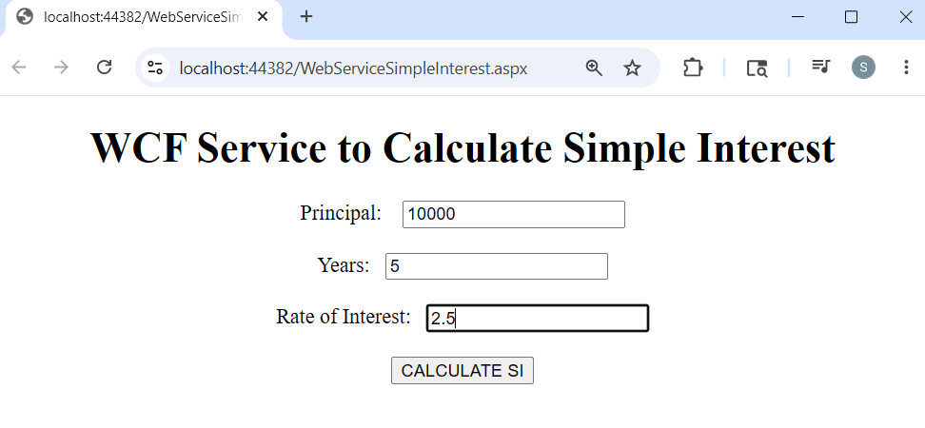
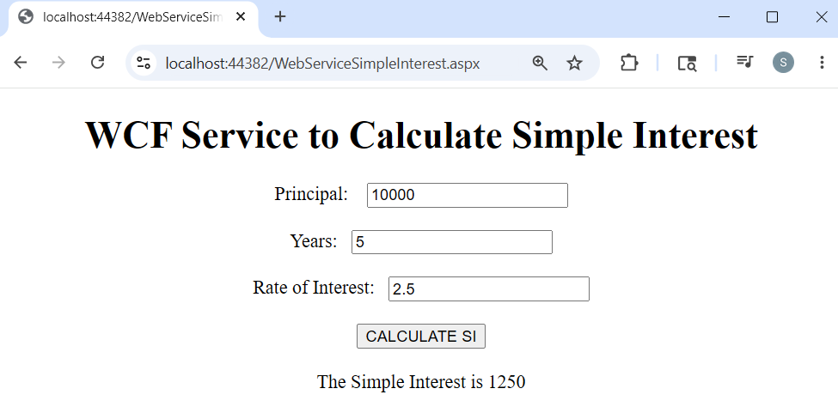

- Create a WCF Web Service Using Database
Code:
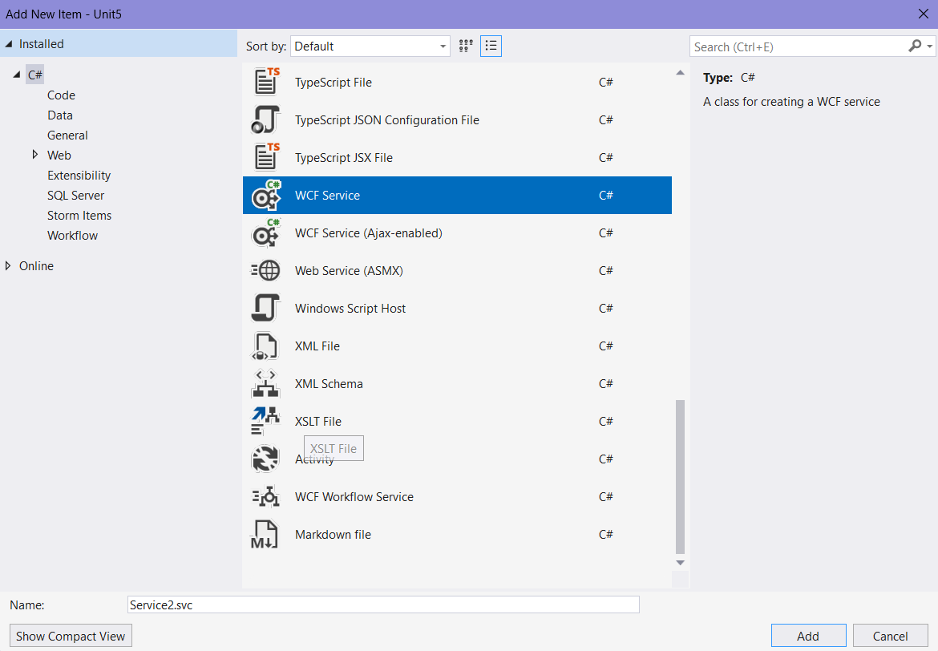

IService2.cs
using System;
using System.Collections.Generic;
using System.Data;
using System.Linq;
using System.Runtime.Serialization;
using System.ServiceModel;
using System.Text;

namespace Unit5
{
public interface IService2
{
[OperationContract]
DataSet getdata();
[OperationContract]
int savedata(int eid, string ename, string desg, int sal);
}
}
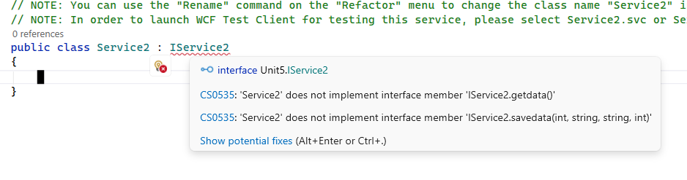
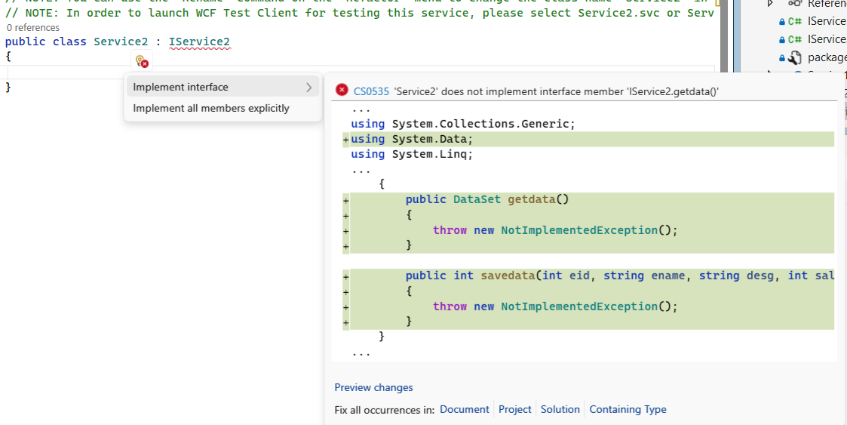
Service2.svc.cs
using System;
using System.Collections.Generic;
using System.Data;
using System.Data.SqlClient;
using System.Linq;
using System.Runtime.Serialization;
using System.Security.Cryptography;
using System.ServiceModel;
using System.Text;
using System.Xml.Linq;
namespace Unit5
{
public class Service2 : IService2
{
public DataSet getdata()
{
SqlConnection conn = new SqlConnection("Data Source=(LocalDB)\\MSSQLLocalDB;AttachDbFilename=\"C:\\Users\\Shravani Hajare\\OneDrive\\Documents\\EmpDB.mdf\";Integrated Security=True;Connect Timeout=30;Encrypt=False");
SqlCommand cmd = new SqlCommand("select * from Emp", conn);
SqlDataAdapter da = new SqlDataAdapter();
da.SelectCommand = cmd;
DataSet ds = new DataSet();
conn.Open();
da.Fill(ds);
conn.Close();
return ds;
}

public int savedata(int eid, string ename, string desg, int sal)
{
SqlConnection conn = new SqlConnection("Data Source=(LocalDB)\\MSSQLLocalDB;AttachDbFilename=\"C:\\Users\\Shravani Hajare\\OneDrive\\Documents\\EmpDB.mdf\";Integrated Security=True;Connect Timeout=30;Encrypt=False");
SqlCommand cmd = new SqlCommand("insert into Emp(Eid, Ename, Designation, Salary) values('" + eid + "','" + ename + "','" + desg + "','" + sal + "')", conn);
conn.Open();
int cnt = cmd.ExecuteNonQuery();
return cnt;
}
}
}

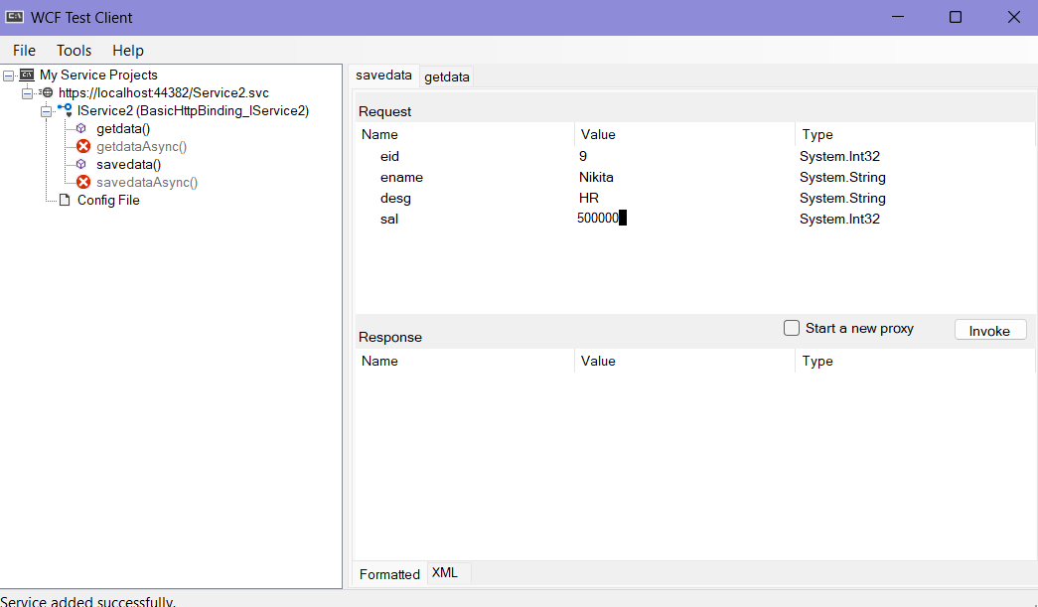
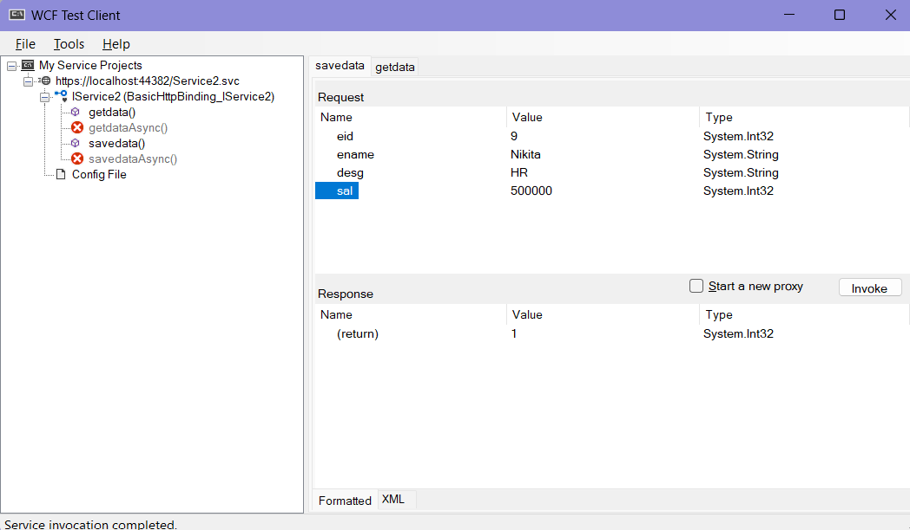
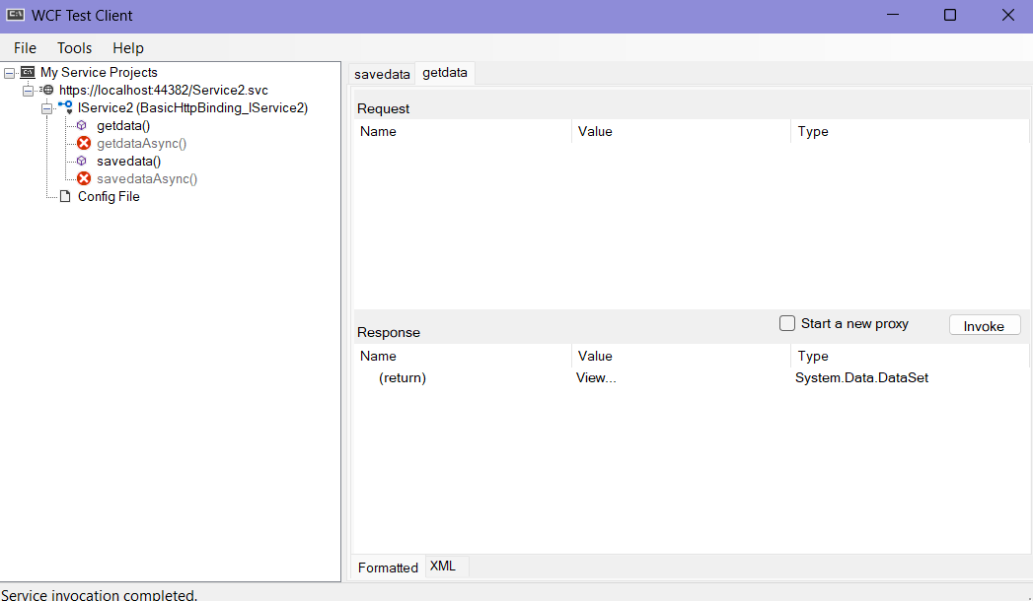
Copy the url: https://localhost:44382/Service2.svc
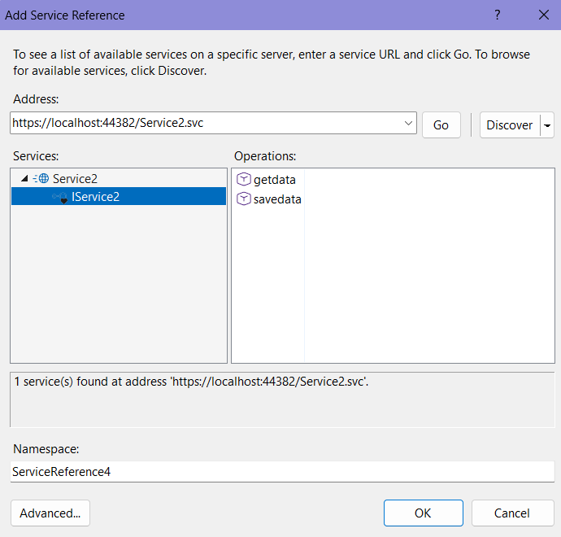
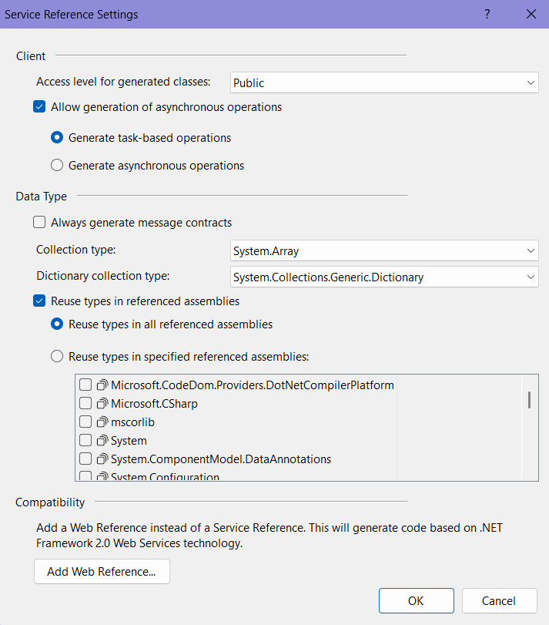
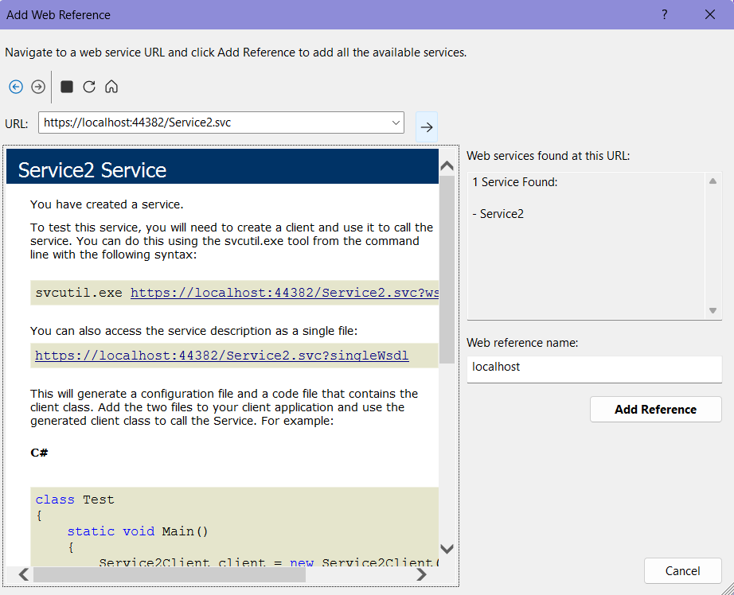
Create a new web form:
WCFwithDatabase.aspx
<%@ Page Language="C#" AutoEventWireup="true" CodeBehind="WCFwithDatabase.aspx.cs" Inherits="Unit5.WCFwithDatabase" %>

<!DOCTYPE html>

<html xmlns="http://www.w3.org/1999/xhtml">
<head runat="server">
<title></title>
</head>
<body>
<form id="form1" runat="server">
<div>
<center>
<h1> WCF SERVICE WITH DATABASE</h1>
Eid: <asp:TextBox ID="TextBox1" runat="server"></asp:TextBox><br /><br />
Ename: <asp:TextBox ID="TextBox2" runat="server"></asp:TextBox><br /><br />

Designation: <asp:TextBox ID="TextBox3" runat="server"></asp:TextBox><br /><br />
Salary: <asp:TextBox ID="TextBox4" runat="server"></asp:TextBox><br /><br />

<asp:Button ID="Button1" runat="server" Text="SHOW" OnClick="Button1_Click" />&nbsp;&nbsp;
<asp:Button ID="Button2" runat="server" Text="SAVE" OnClick="Button2_Click" /><br /><br />

<asp:Label ID="Label1" runat="server" Text=""></asp:Label><br /><br />

<asp:GridView ID="GridView1" runat="server"></asp:GridView>
</center>
</div>
</form>
</body>
</html>

WCFwithDatabase.aspx.cs
using System;
using System.Collections.Generic;
using System.Linq;
using System.Web;
using System.Web.UI;
using System.Web.UI.WebControls;

namespace Unit5
{
public partial class WCFwithDatabase : System.Web.UI.Page
{
Service2 svc = new Service2();
protected void Page_Load(object sender, EventArgs e)
{

}

protected void Button1_Click(object sender, EventArgs e)
{
GridView1.DataSource = svc.getdata();
GridView1.DataBind();
}

protected void Button2_Click(object sender, EventArgs e)
{
int eid = int.Parse(TextBox1.Text);
int sal = int.Parse(TextBox4.Text);
int cnt = svc.savedata(eid, TextBox2.Text, TextBox3.Text, sal);
if (cnt > 0)
{
Label1.Text = "Record Inserted Successfully...!!! ";
}
}
}}

Output:
