- MVC Application With Model view controller
Create a ASP.NET Core Web App (Model-View-Controller) project for MVC FRAMEWORK.
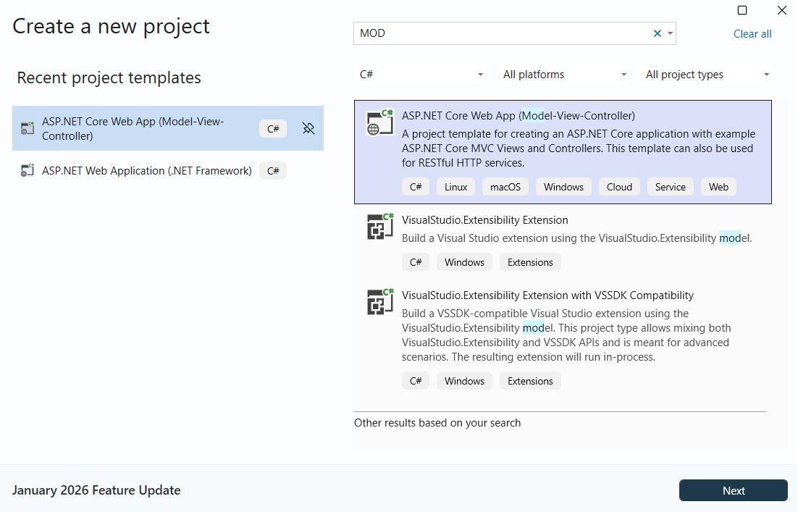
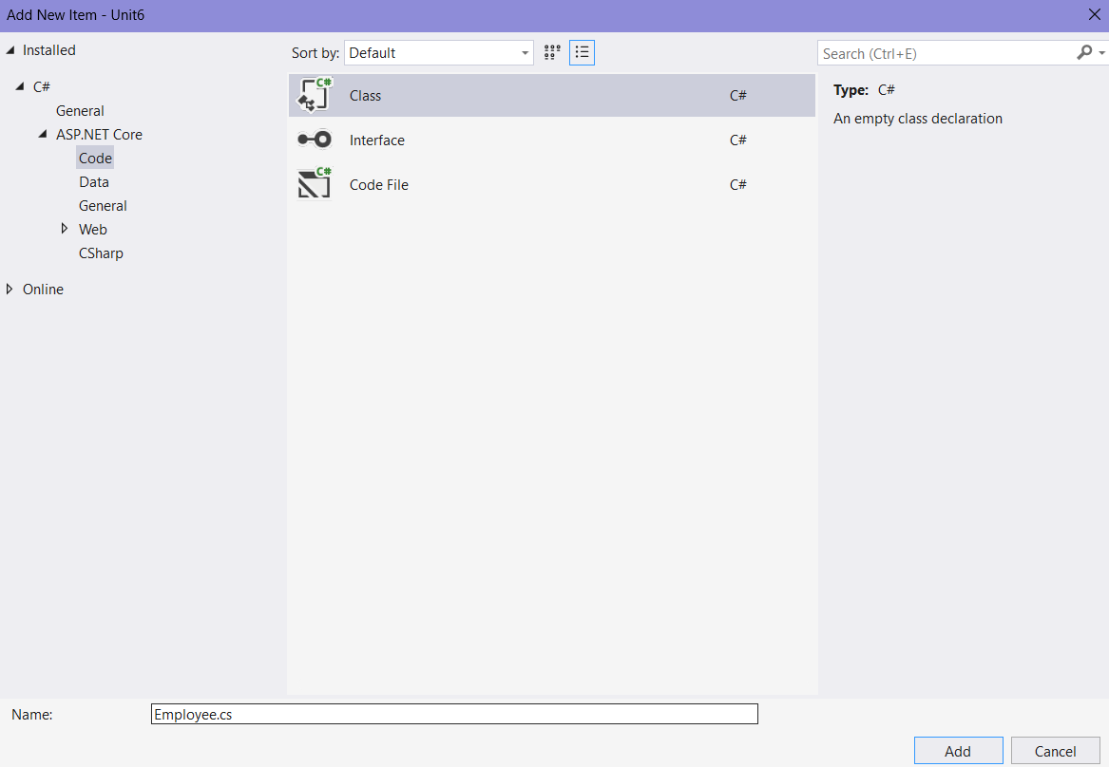

Employee.cs
using System;
using System.Collections.Generic;

namespace Unit6.Models;

public partial class Employee
{
public int Eid { get; set; }

public string? Ename { get; set; }

public string? Designation { get; set; }
public int Salary { get; set; }
}

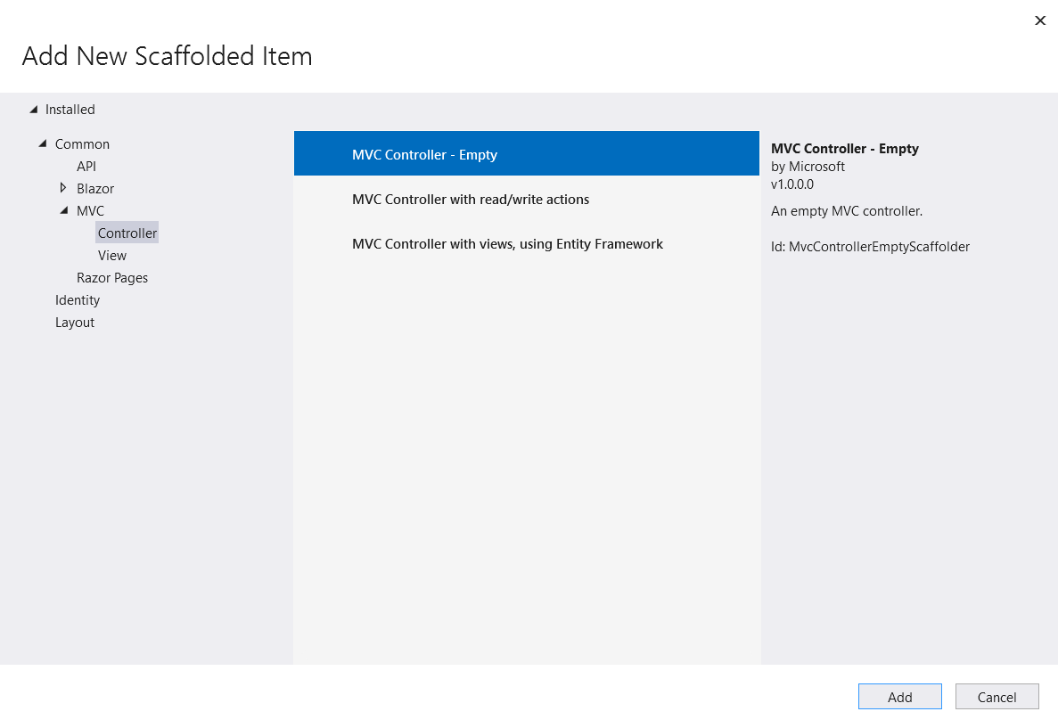
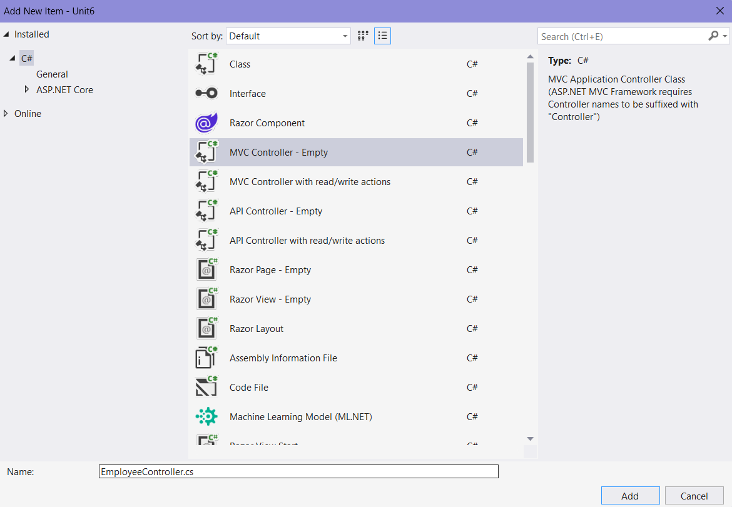
EmployeeController.cs
using Microsoft.AspNetCore.Mvc;
using Unit6.Models;

namespace Unit6.Controllers
{
public class EmployeeController : Controller
{
public IActionResult Index()
{
List<Employee> emplist = new List<Employee>()
{ new Employee(){ Eid=1,Ename="Shravani",Designation="Analyst", Salary=42000},
new Employee() { Eid=2, Ename="Nikita",Designation="Analyst", Salary=52000}
};

return View(emplist);
}
}
}

Add view
Right click on Index -> Add view –>Razor View
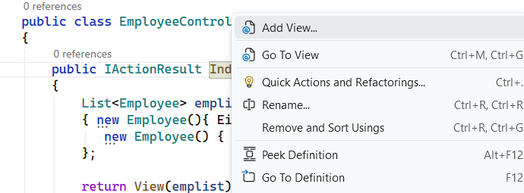

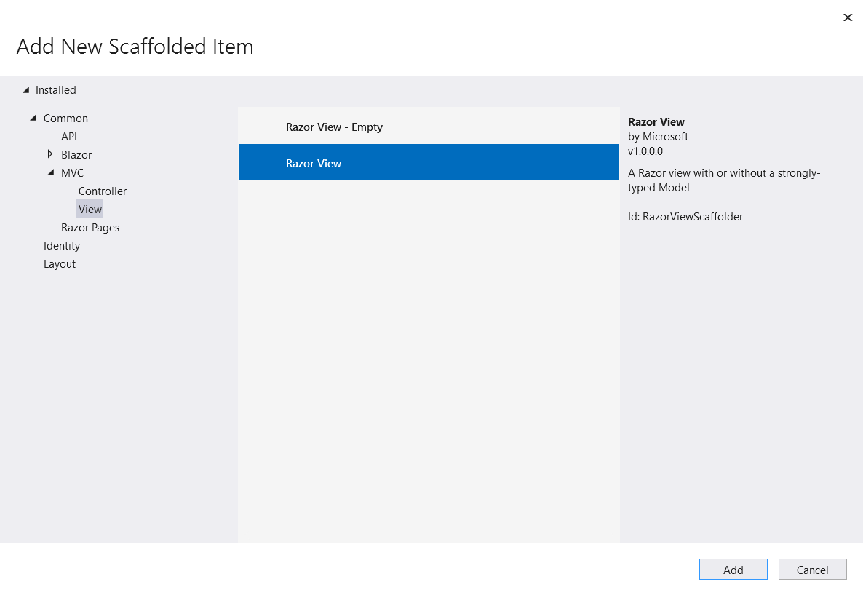
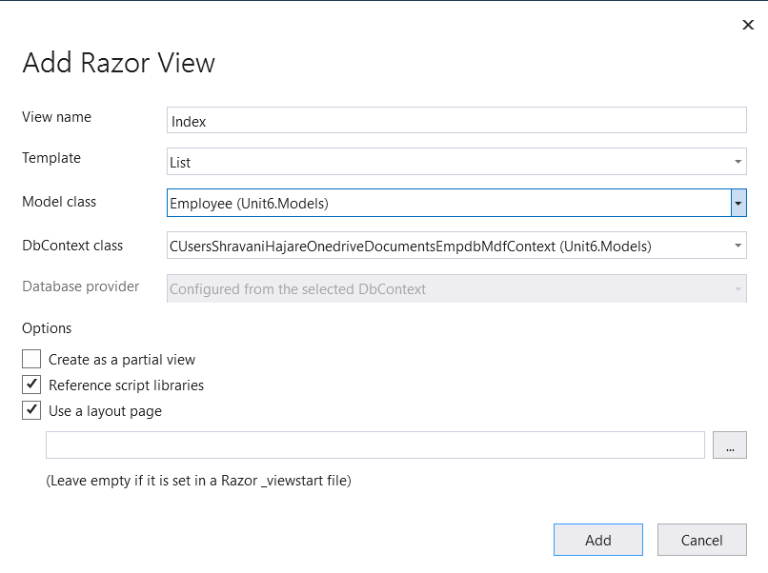

Output:
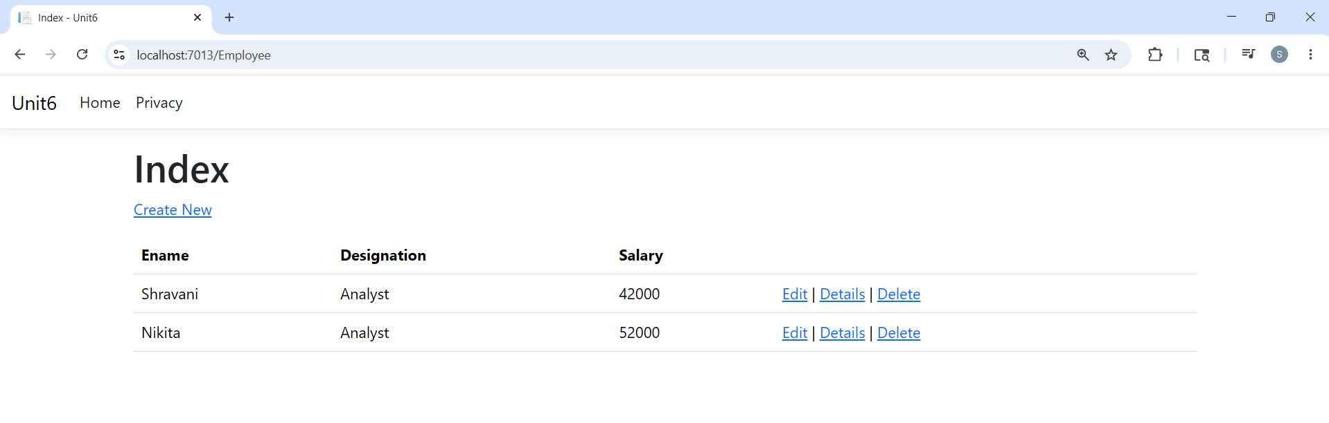

- MVC Application for customer data entry using data annotations for validation and display appropriate error messages.

Right click on Models -> Add -> Class -> Customer.cs
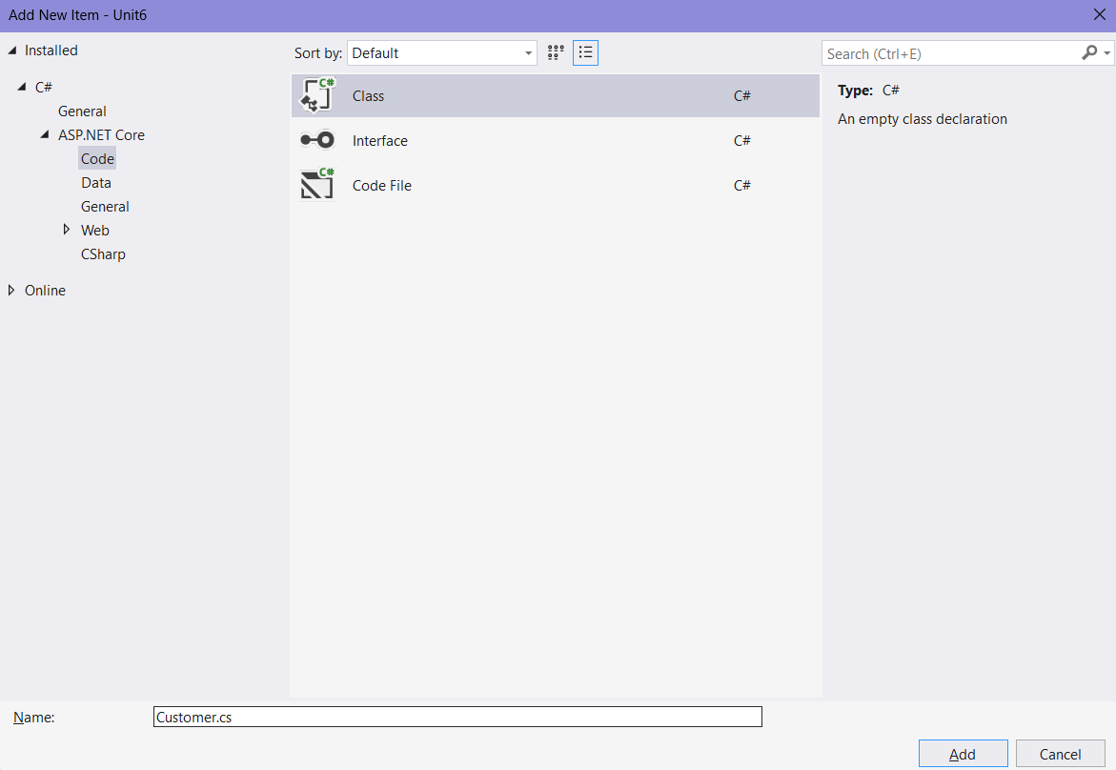
Customer.cs
using System.ComponentModel.DataAnnotations;

namespace Unit6.Models
{
public class Customer
{
[Required(ErrorMessage = "Customer ID is required..!")]
[Display(Description = "Customer id")]
public int custId { get; set; }

[Required(ErrorMessage = "CustName is complusory..")]
public string? custName { get; set; }

[Required]
public string? custAdd { get; set; }

[Range(20, 80, ErrorMessage = "Customer Age must be between 20 and 80")]

public string? custAge { get; set; }
[EmailAddress(ErrorMessage = "Not a valid email address...!")]
public string? custEmail { get; set; }

}
}

Create a controller:
Right click Controllers -> Add -> Controller
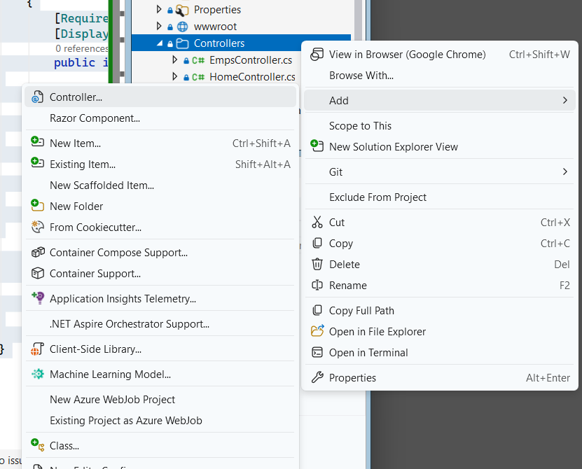

Create MVC Controller – Empty -> CustomerController.cs
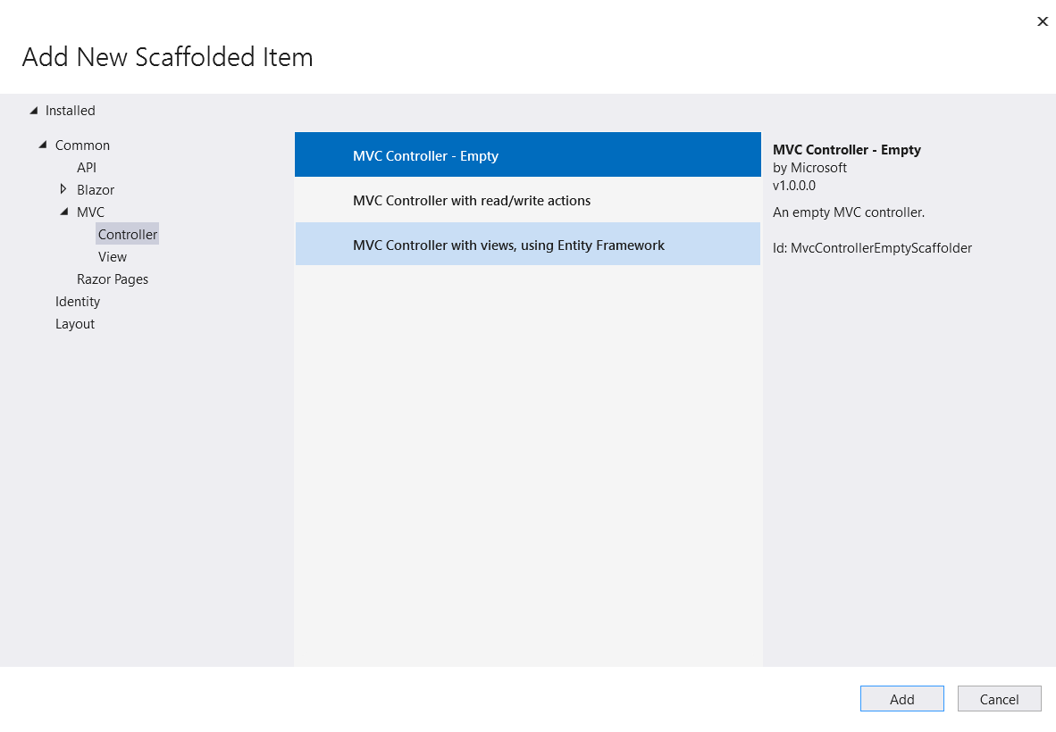

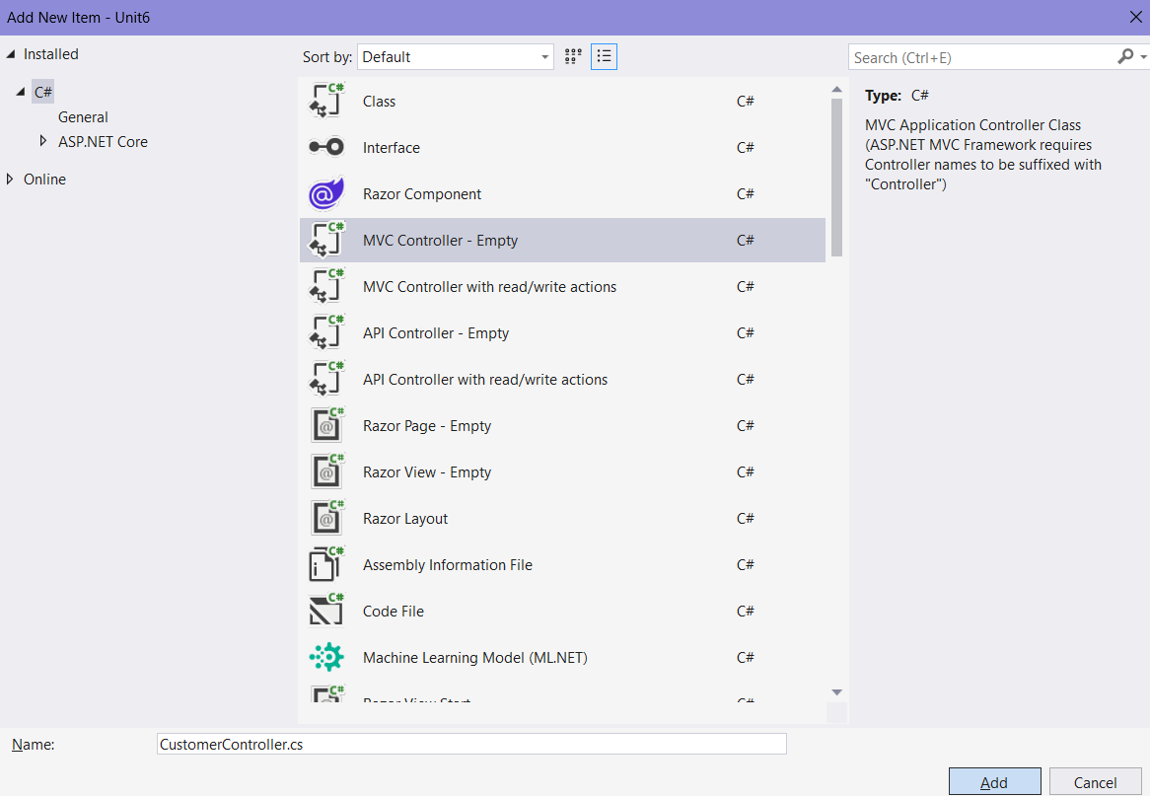

CustomerController.cs
using Microsoft.AspNetCore.Mvc;
using Unit6.Models;

namespace Unit6.Controllers
{
public class CustomerController : Controller
{
public IActionResult Index()
{
return View();
}
[HttpGet]
public IActionResult CustomerInput()
{
return View(new Customer());
}

[HttpPost]
public IActionResult CustomerInput(Customer custInfo)
{
ViewBag.Account = custInfo;
return View("CustomerDisplay");
}
}
}

Add view for Index
Right click on Index -> Add view -> Razor Empty
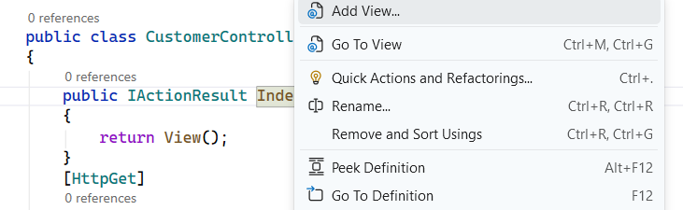
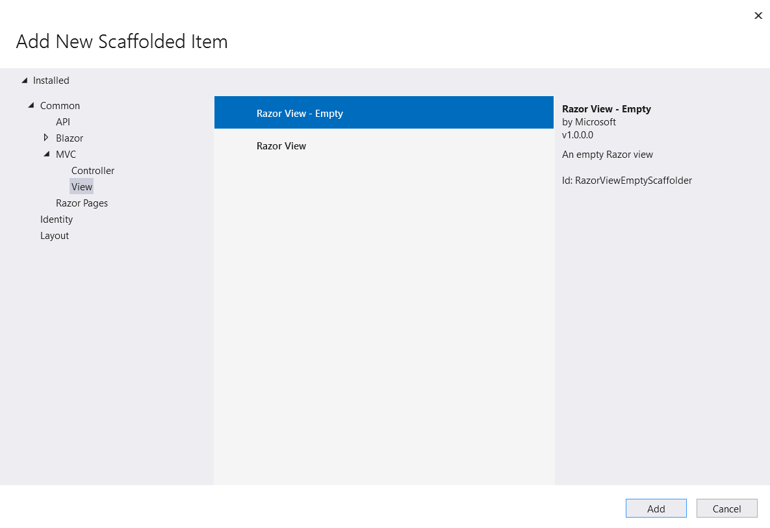
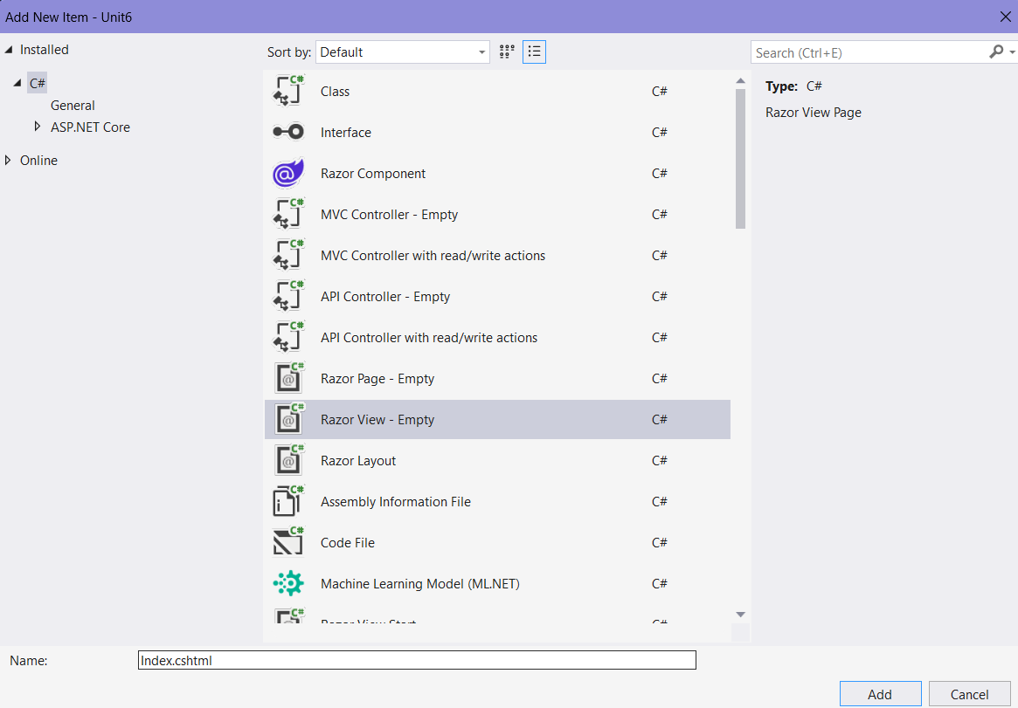
Add view for CustomerInput
Right click on CustomerInput -> Add view -> Razor View

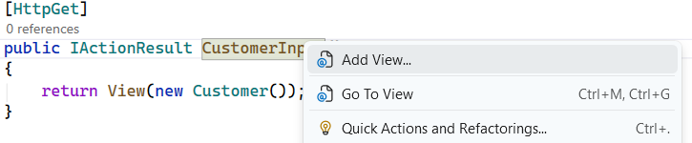
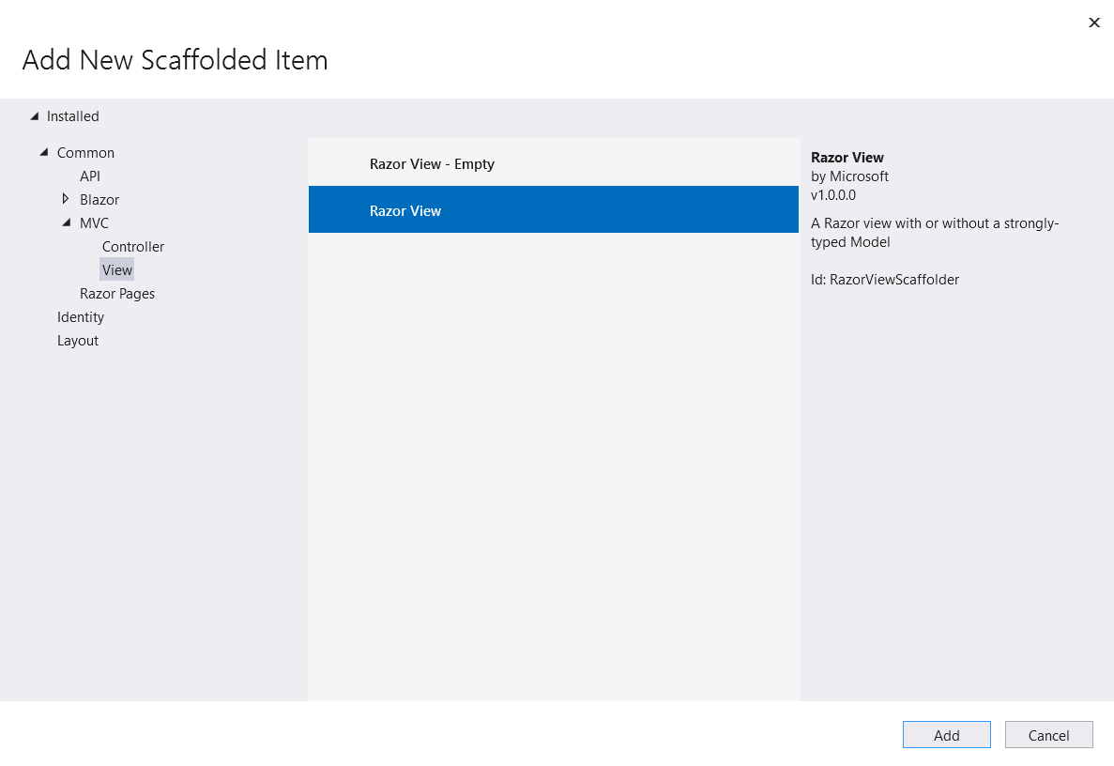
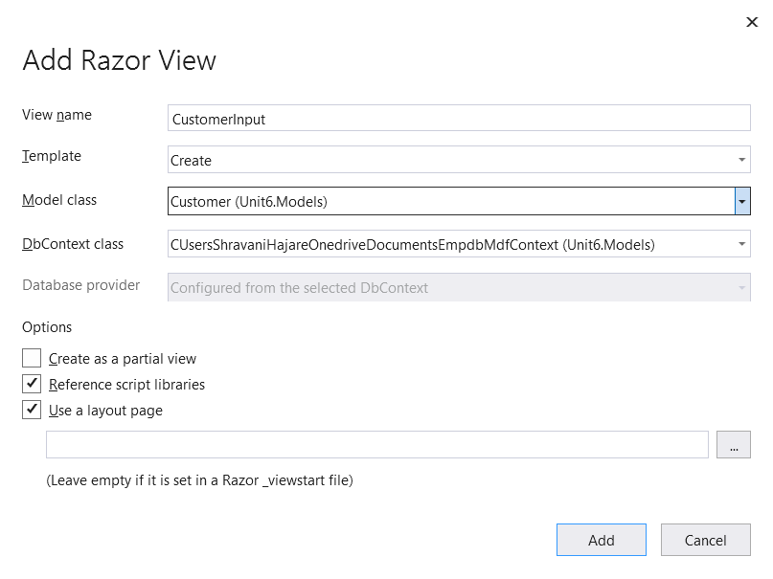

CustomerInput.cshtml
@model Unit6.Models.Customer

@{
ViewData["Title"] = "CustomerInput";
}

<h1>CustomerInput</h1>

<h4>Customer</h4>
<hr />
<div class="row">
<div class="col-md-4">
<form asp-action="CustomerInput">
<div asp-validation-summary="ModelOnly" class="text-danger"></div>
<div class="form-group">
<label asp-for="custName" class="control-label"></label>
<input asp-for="custName" class="form-control" />
<span asp-validation-for="custName" class="text-danger"></span>
</div>
<div class="form-group">
<label asp-for="custAdd" class="control-label"></label>
<input asp-for="custAdd" class="form-control" />
<span asp-validation-for="custAdd" class="text-danger"></span>
</div>
<div class="form-group">
<label asp-for="custAge" class="control-label"></label>
<input asp-for="custAge" class="form-control" />
<span asp-validation-for="custAge" class="text-danger"></span>
</div>
<div class="form-group">
<label asp-for="custEmail" class="control-label"></label>
<input asp-for="custEmail" class="form-control" />
<span asp-validation-for="custEmail" class="text-danger"></span>
</div>
<div class="form-group">
<input type="submit" value="Create" class="btn btn-primary" />
</div>
</form>
</div>
</div>

<div>
<a asp-action="Index">Back to List</a>
</div>

@section Scripts {
@{await Html.RenderPartialAsync("_ValidationScriptsPartial");}
}
Add view for CustomerDisplay
Right click on CustomerInput -> Add view -> Razor View

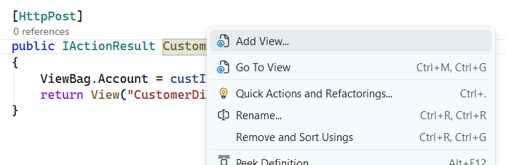
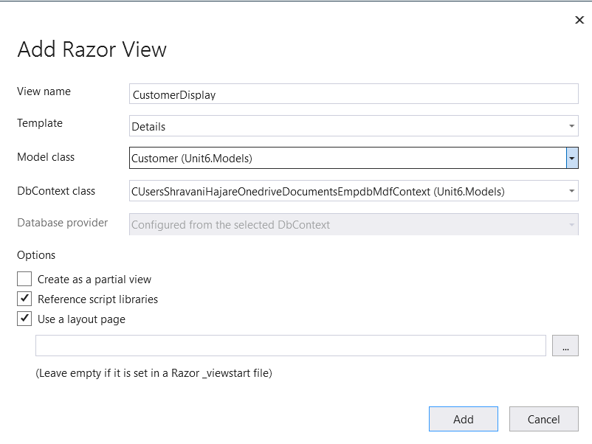

CustomerDisplay.cshtml
@model Unit6.Models.Customer

@{
ViewData["Title"] = "CustomerDisplay";
}

<h1>CustomerDisplay</h1>

<div>
<h4>Customer</h4>
<hr />
<dl class="row">
<dt class = "col-sm-2">
@Html.DisplayNameFor(model => model.custName)
</dt>
<dd class = "col-sm-10">
@ViewBag.Account.custName;
</dd>
<dt class = "col-sm-2">
@Html.DisplayNameFor(model => model.custAdd)
</dt>
<dd class = "col-sm-10">
@ViewBag.Account.custAdd;
</dd>
<dt class = "col-sm-2">
@Html.DisplayNameFor(model => model.custAge)
</dt>
<dd class = "col-sm-10">
@ViewBag.Account.custAge;
</dd>
<dt class = "col-sm-2">
@Html.DisplayNameFor(model => model.custEmail)
</dt>
<dd class = "col-sm-10">
@ViewBag.Account.custEmail;
</dd>
</dl>
</div>
<div>
<a asp-action="Edit" asp-route-id="@Model?.custId">Edit</a> |
<a asp-action="Index">Back to List</a>
</div>

Output:
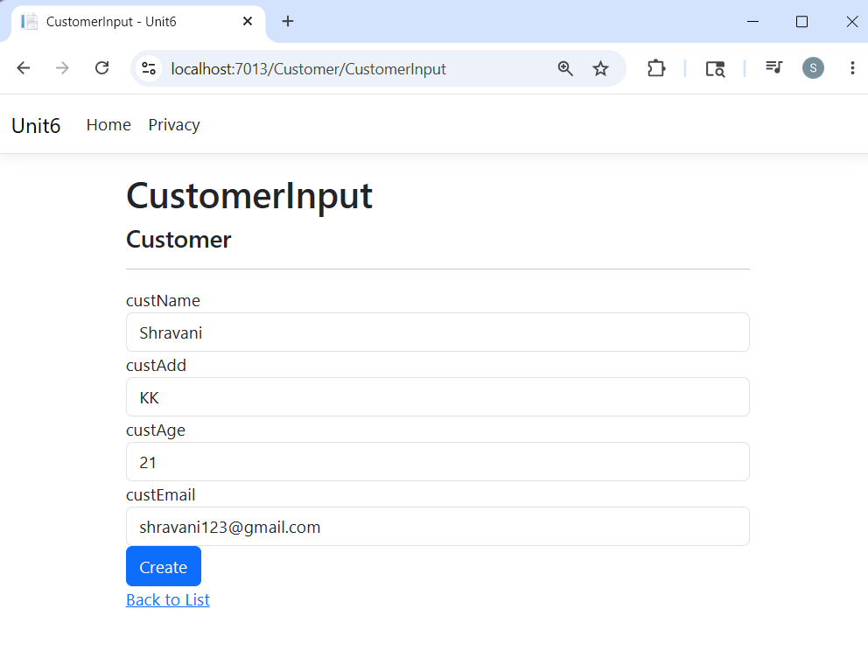
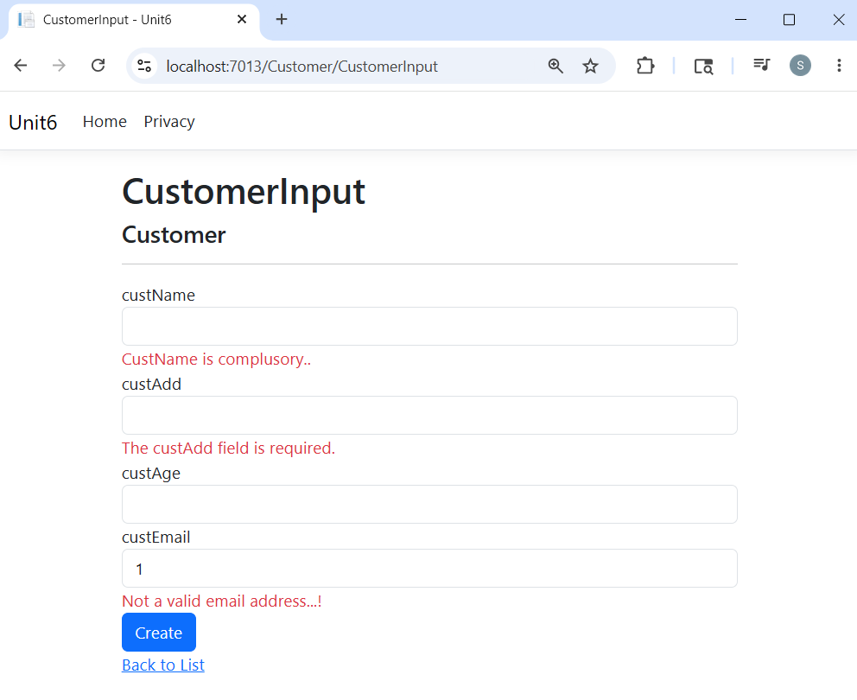
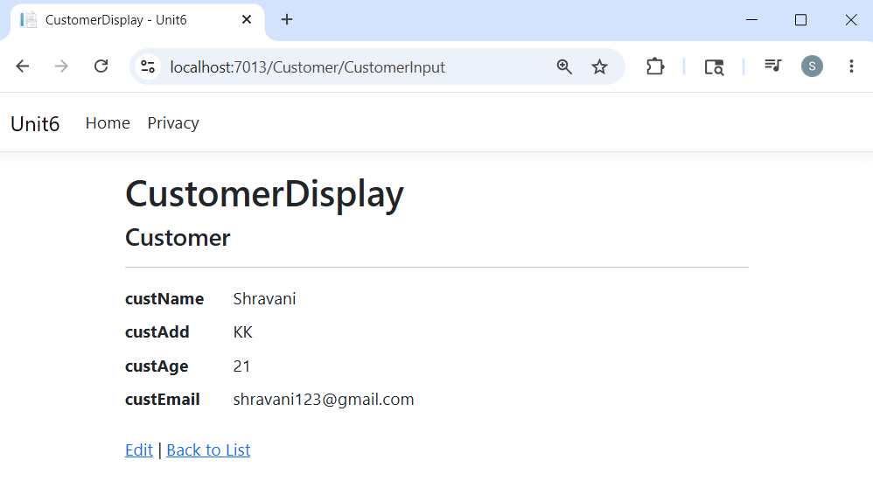

- Implement CRUD operations using Entity Framework Code-First approach for emp data.
Right click on the project name -> Select Manage NuGet Packages -> Install 2 packages
- Microsoft.EntityFrameworkCore.sqlserver
- Microsoft.EntityFrameworkCore.tools
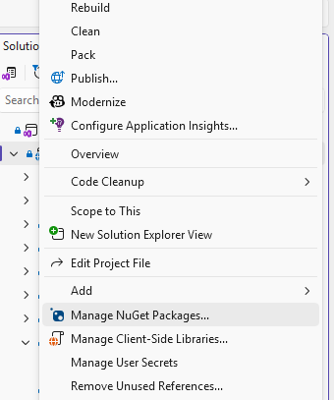
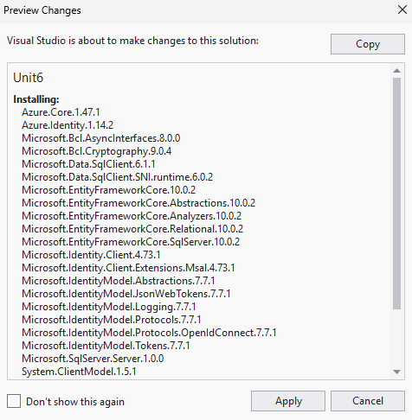
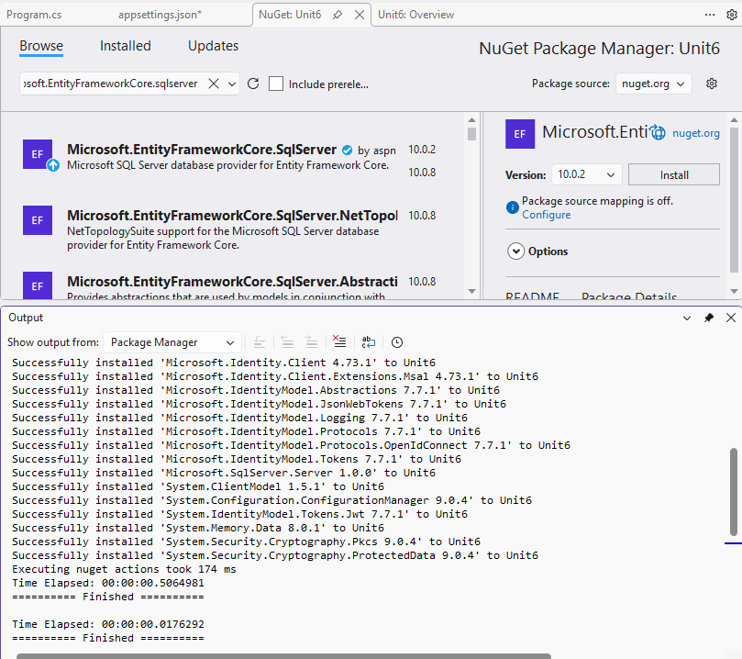
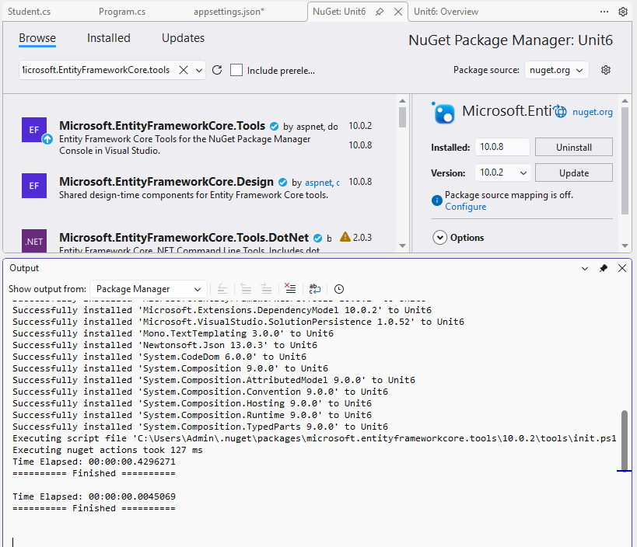
Right click on models -> Click Select class
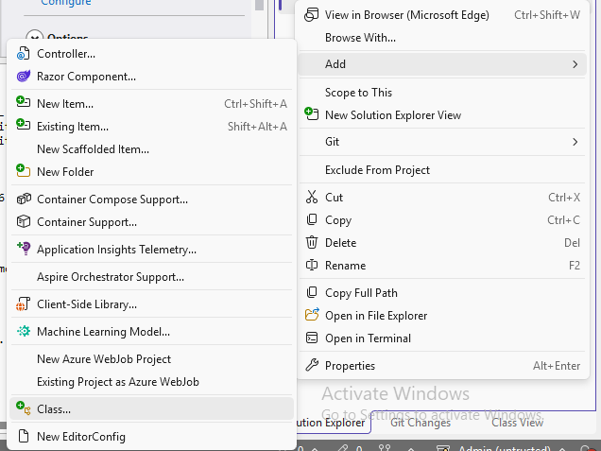
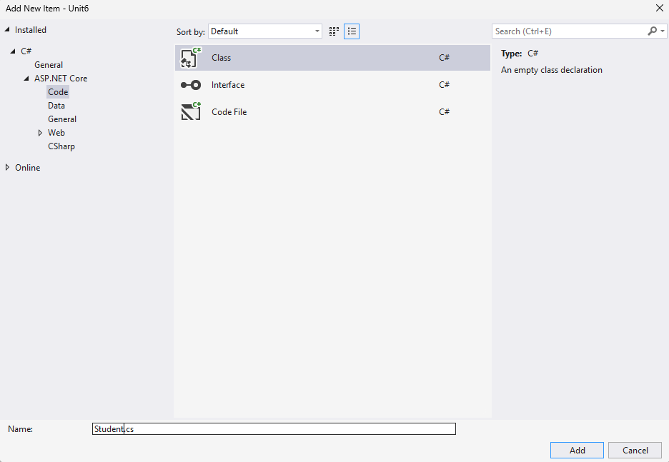

Student.cs
using System.ComponentModel.DataAnnotations;

namespace Unit6.Models
{
public class Student
{
[Key]
public int sid { get; set; }
public string? sname { get; set; }
public string? course { get; set; }
}
}

Create another class with name StudentDbContext.cs
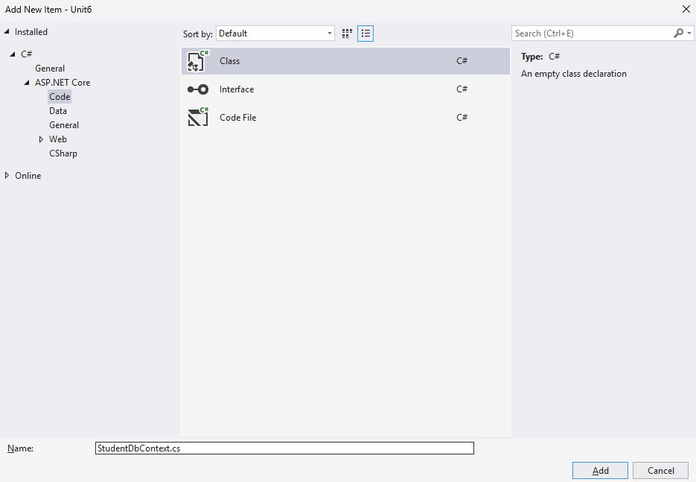

StudentDbContext.cs
using Microsoft.EntityFrameworkCore;

namespace Unit6.Models
{
public class StudentDbContext:DbContext
{
public StudentDbContext(DbContextOptions options) : base(options)
{ }
public DbSet<Student> students { get; set; }
}
}

Go to appsettings.json and add the following code:
{
"Logging": {
"LogLevel": {
"Default": "Information",
"Microsoft.AspNetCore": "Warning"
}
},
"AllowedHosts": "*",
"ConnectionStrings": { "DbConnect": "Data Source=(LocalDB)\\MSSQLLocalDB;AttachDbFilename=C:\\Users\\Admin\\Documents\\TestDB.mdf;Integrated Security=True;Connect Timeout=30" }
}

Click on Program.cs -> add the following code:
builder.Services.AddDbContext<StudentDbContext>
(options => options.UseSqlServer(builder.Configuration.GetConnectionString("DbConnect")));

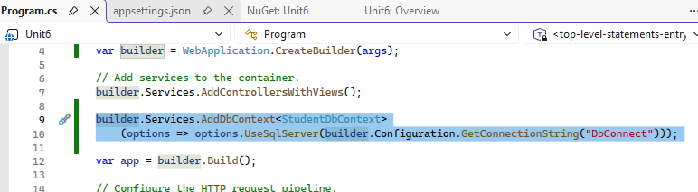

Click on Tools -> Click NuGet Package Manager -> Package manager console
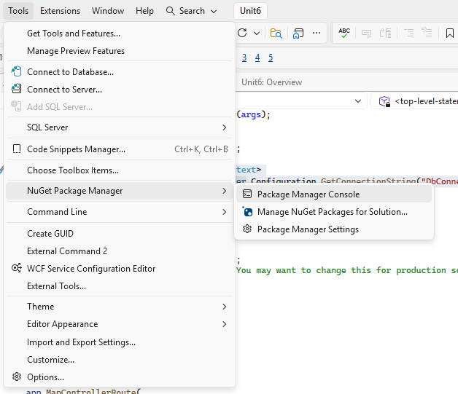
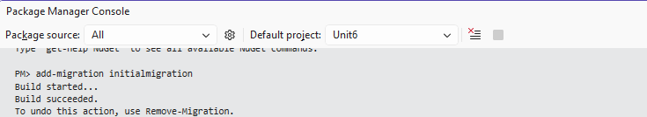
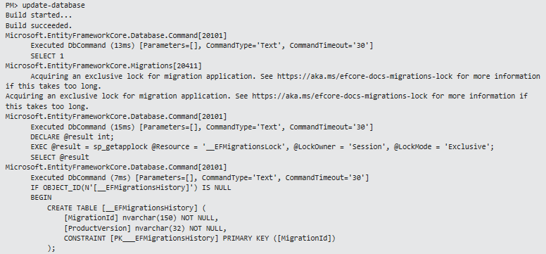

Now click Build and select Rebuild Solution.
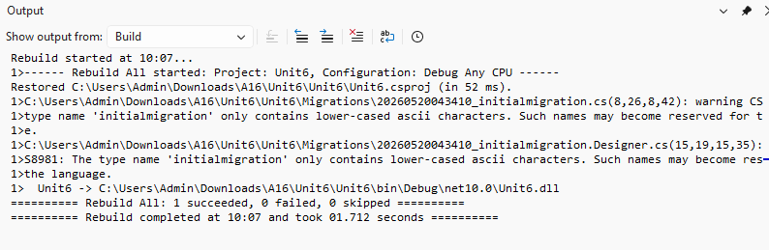

Right click Controller -> Add -> Controller
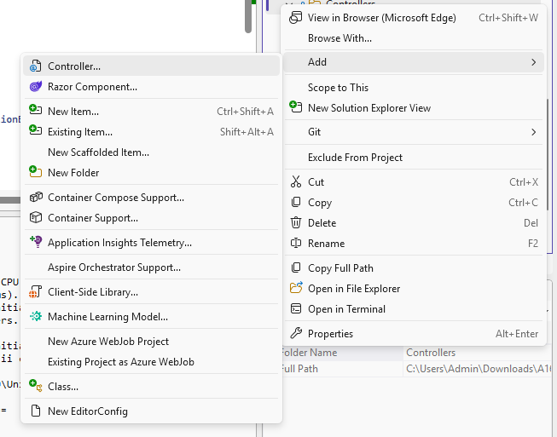

Click mvc controller with views using Entity Framework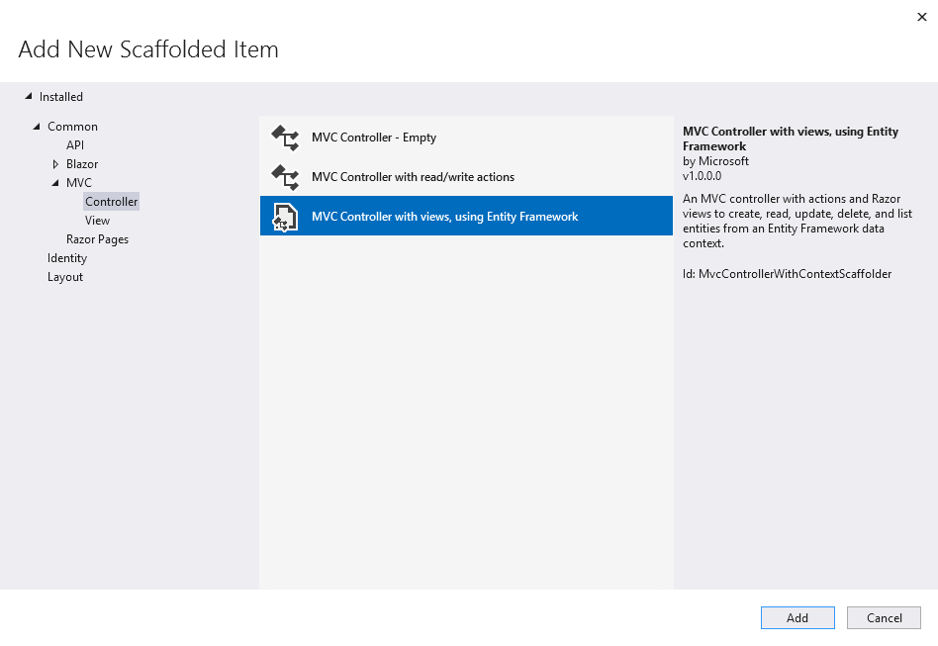
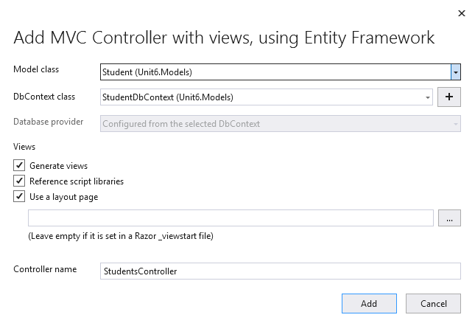

Student table would be Created
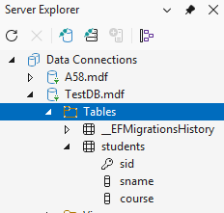
cshtml would be created..
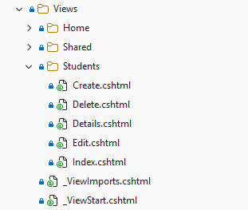

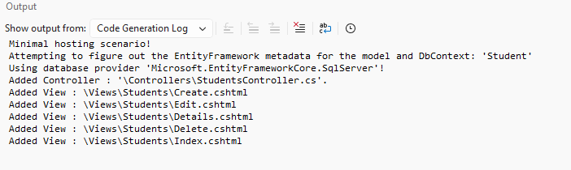

Run the StudentController.cs
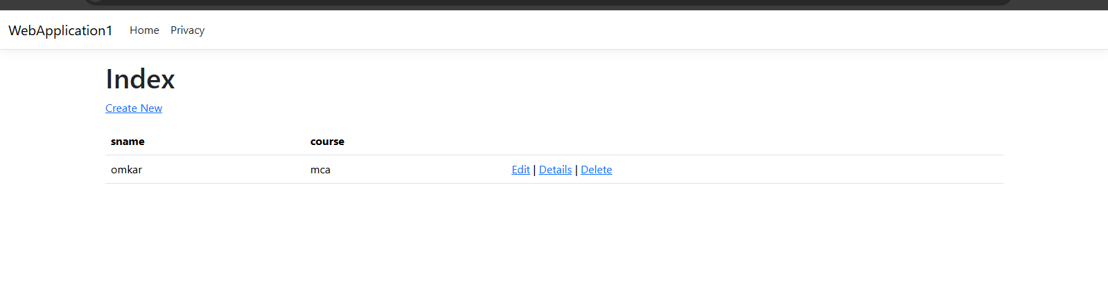

- ASP.NET Core MVC with EF Core DB First
Right click on project -> Manage NuGet Packages -> install the following 2 packages (Version 10.0.2)
- Microsoft.EntityFrameworkCore.sqlserver
- Microsoft.EntityFrameworkCore.tools
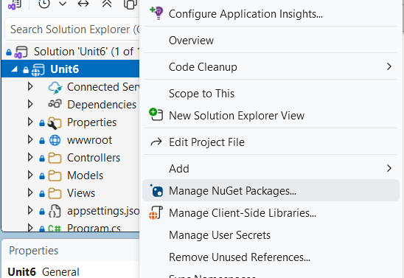
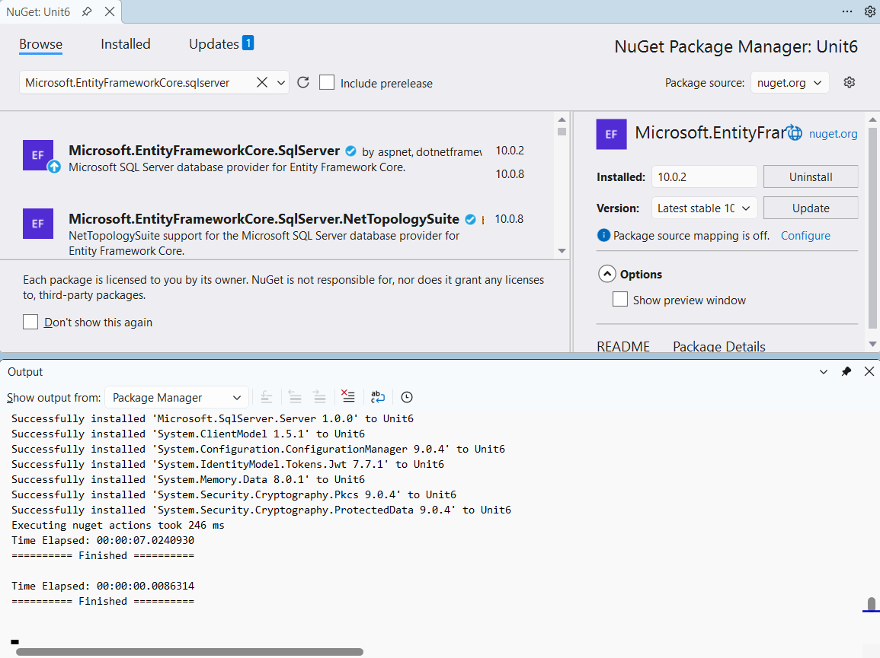
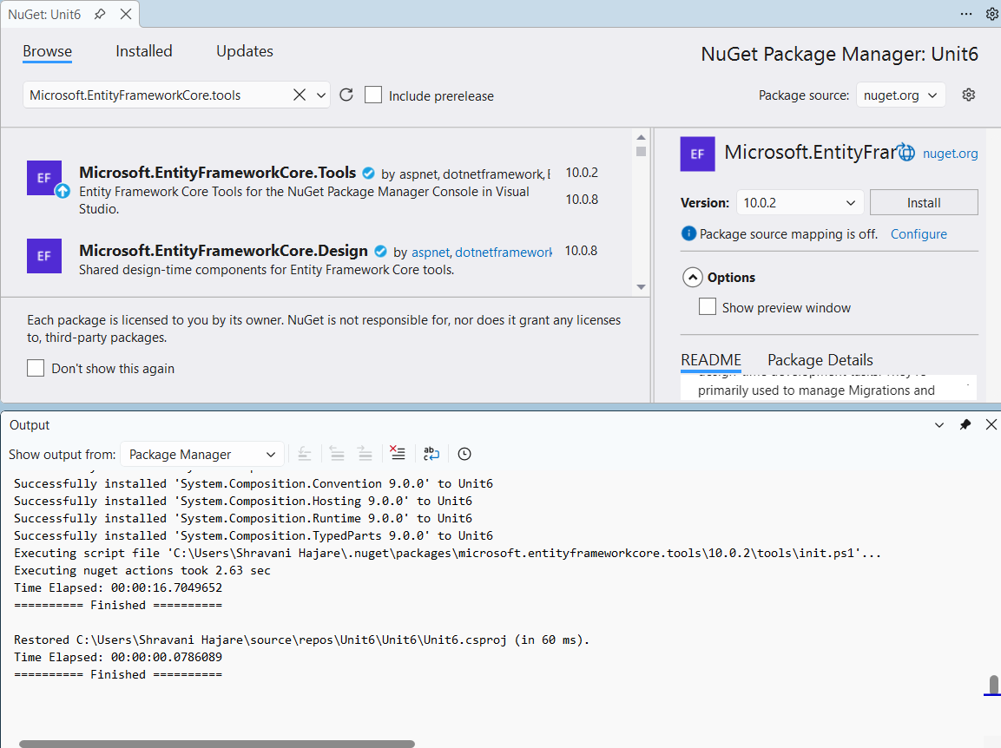
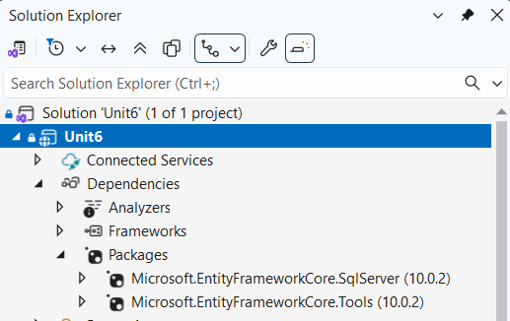

Click on Tools -> NuGet Package Manager -> Package Manager Console
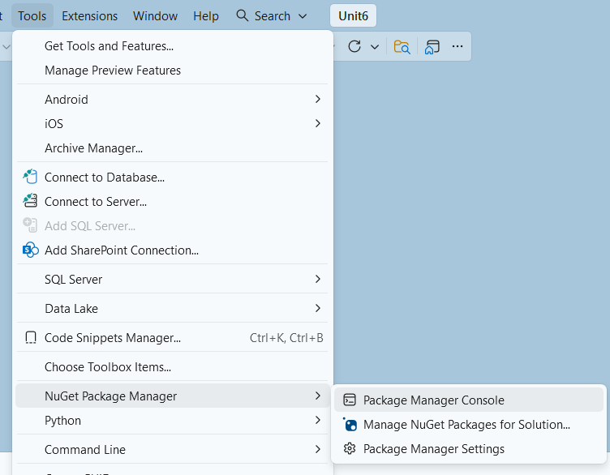
Write the following command inside package manager console:
Scaffold-DbContext "Data Source=(LocalDB)\MSSQLLocalDB;AttachDbFilename=C:\Users\Shravani Hajare\OneDrive\Documents\EmpDB.mdf;Integrated Security=True;Connect Timeout=30;Encrypt=True" Microsoft.EntityFrameworkCore.SqlServer -OutputDir Models
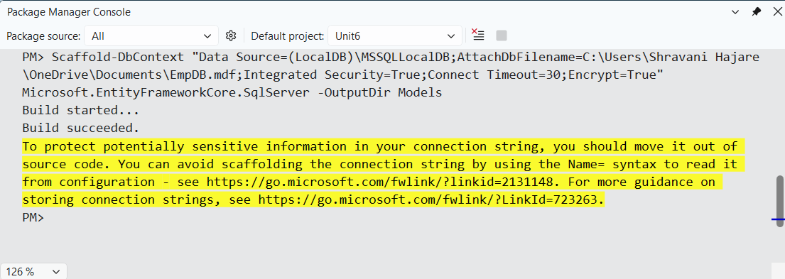
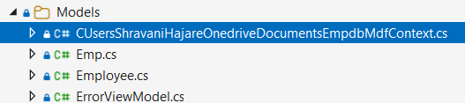

Code:
using System;
using System.Collections.Generic;
using Microsoft.EntityFrameworkCore;

namespace Unit6.Models;

public partial class CUsersShravaniHajareOnedriveDocumentsEmpdbMdfContext : DbContext
{
public CUsersShravaniHajareOnedriveDocumentsEmpdbMdfContext()
{
}

public CUsersShravaniHajareOnedriveDocumentsEmpdbMdfContext(DbContextOptions<CUsersShravaniHajareOnedriveDocumentsEmpdbMdfContext> options)
: base(options)
{
}

public virtual DbSet<Emp> Emps { get; set; }

public virtual DbSet<Employee> Employees { get; set; }

protected override void OnConfiguring(DbContextOptionsBuilder optionsBuilder)
=> optionsBuilder.UseSqlServer("Data Source=(LocalDB)\\MSSQLLocalDB;AttachDbFilename=C:\\Users\\Shravani Hajare\\OneDrive\\Documents\\EmpDB.mdf;Integrated Security=True;Connect Timeout=30;Encrypt=True");

protected override void OnModelCreating(ModelBuilder modelBuilder)
{
modelBuilder.Entity<Emp>(entity =>
{
entity.HasKey(e => e.Eid).HasName("PK__Emp__C1971B5302440748");

entity.ToTable("Emp");

entity.Property(e => e.Eid).ValueGeneratedNever();
entity.Property(e => e.Designation)
.HasMaxLength(10)
.IsFixedLength();
entity.Property(e => e.Ename)
.HasMaxLength(10)
.IsFixedLength();
});

modelBuilder.Entity<Employee>(entity =>
{
entity.HasKey(e => e.Eid).HasName("PK__Employee__C1971B5364F9F43B");

entity.ToTable("Employee");

entity.Property(e => e.Eid).ValueGeneratedNever();
entity.Property(e => e.Ename)
.HasMaxLength(10)
.IsFixedLength();
});

OnModelCreatingPartial(modelBuilder);
}

partial void OnModelCreatingPartial(ModelBuilder modelBuilder);
}

Emp.cs
using System;
using System.Collections.Generic;

namespace Unit6.Models;

public partial class Emp
{
public int Eid { get; set; }

public string? Ename { get; set; }

public string? Designation { get; set; }

public int? Salary { get; set; }
}

appsettings.json : inside it add connection string
{
"Logging": {
"LogLevel": {
"Default": "Information",
"Microsoft.AspNetCore": "Warning"
}
},
"AllowedHosts": "*",
"ConnectionStrings": {"DbConnection": "Data Source=(LocalDB)\\MSSQLLocalDB;AttachDbFilename=C:\\Users\\Shravani Hajare\\OneDrive\\Documents\\EmpDB.mdf;Integrated Security=True;Connect Timeout=30;Encrypt=True"}
}

Program.cs
using Microsoft.EntityFrameworkCore;
using Unit6.Models;

var builder = WebApplication.CreateBuilder(args);

// Add services to the container.
builder.Services.AddControllersWithViews();
builder.Services.AddDbContext<CUsersShravaniHajareOnedriveDocumentsEmpdbMdfContext>
(options => options.UseSqlServer(builder.Configuration.GetConnectionString("DBConnection")));

var app = builder.Build();

// Configure the HTTP request pipeline.
if (!app.Environment.IsDevelopment())
{
app.UseExceptionHandler("/Home/Error");
// The default HSTS value is 30 days. You may want to change this for production scenarios, see https://aka.ms/aspnetcore-hsts.
app.UseHsts();
}

app.UseHttpsRedirection();
app.UseRouting();

app.UseAuthorization();

app.MapStaticAssets();

app.MapControllerRoute(
name: "default",
pattern: "{controller=Home}/{action=Index}/{id?}")
.WithStaticAssets();

app.Run();
Build -> Rebuilt solution
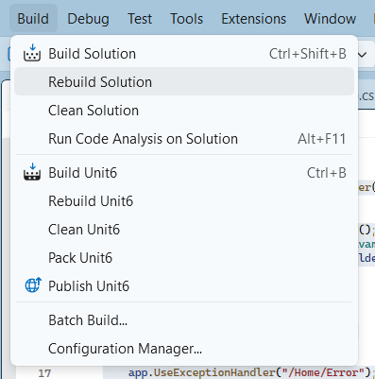
Create a new Controller
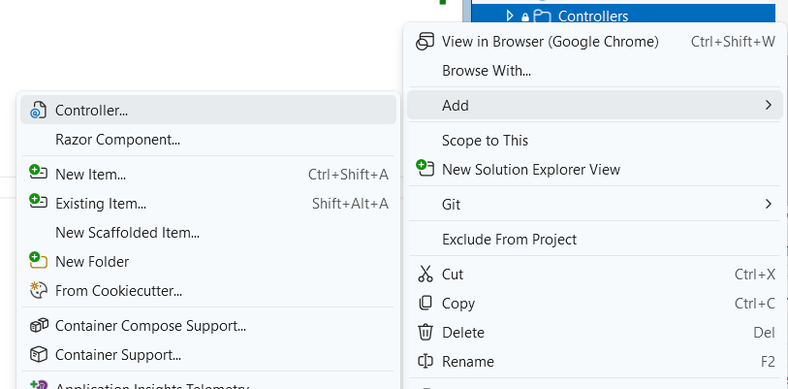
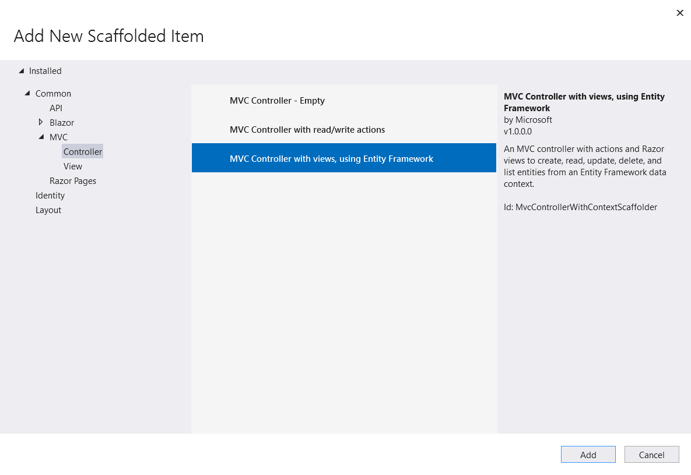
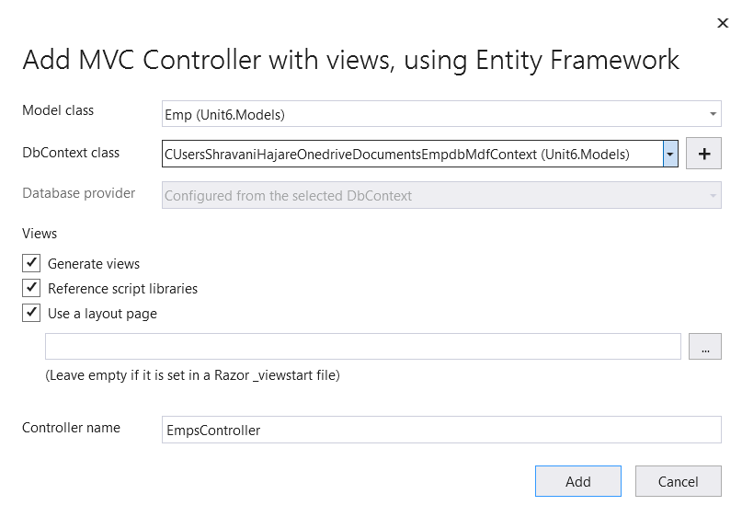
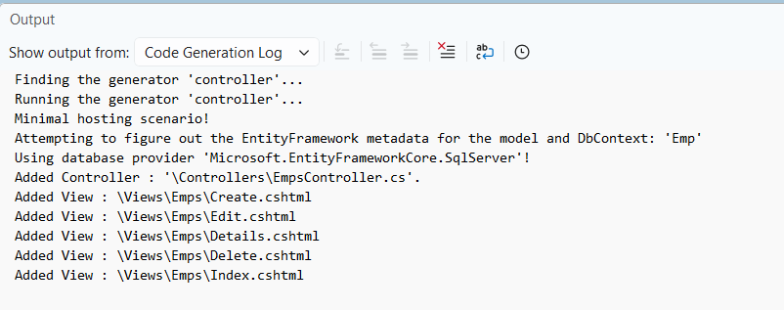

EmpsController.cs (Automatically generated)
using System;
using System.Collections.Generic;
using System.Linq;
using System.Threading.Tasks;
using Microsoft.AspNetCore.Mvc;
using Microsoft.AspNetCore.Mvc.Rendering;
using Microsoft.EntityFrameworkCore;
using Unit6.Models;

namespace Unit6.Controllers
{
public class EmpsController : Controller
{
private readonly CUsersShravaniHajareOnedriveDocumentsEmpdbMdfContext _context;

public EmpsController(CUsersShravaniHajareOnedriveDocumentsEmpdbMdfContext context)
{
_context = context;
}

// GET: Emps
public async Task<IActionResult> Index()
{
return View(await _context.Emps.ToListAsync());
}

// GET: Emps/Details/5
public async Task<IActionResult> Details(int? id)
{
if (id == null)
{
return NotFound();
}

var emp = await _context.Emps
.FirstOrDefaultAsync(m => m.Eid == id);
if (emp == null)
{
return NotFound();
}

return View(emp);
}

// GET: Emps/Create
public IActionResult Create()
{
return View();
}
[HttpPost]
[ValidateAntiForgeryToken]
public async Task<IActionResult> Create([Bind("Eid,Ename,Designation,Salary")] Emp emp)
{
if (ModelState.IsValid)
{
_context.Add(emp);
await _context.SaveChangesAsync();
return RedirectToAction(nameof(Index));
}
return View(emp);
}

// GET: Emps/Edit/5
public async Task<IActionResult> Edit(int? id)
{
if (id == null)
{
return NotFound();
}

var emp = await _context.Emps.FindAsync(id);
if (emp == null)
{
return NotFound();
}
return View(emp);
}
[HttpPost]
[ValidateAntiForgeryToken]
public async Task<IActionResult> Edit(int id, [Bind("Eid,Ename,Designation,Salary")] Emp emp)
{
if (id != emp.Eid)
{
return NotFound();
}

if (ModelState.IsValid)
{
try
{
_context.Update(emp);
await _context.SaveChangesAsync();
}
catch (DbUpdateConcurrencyException)
{
if (!EmpExists(emp.Eid))
{
return NotFound();
}
else
{
throw;
}
}
return RedirectToAction(nameof(Index));
}
return View(emp);
}

// GET: Emps/Delete/5
public async Task<IActionResult> Delete(int? id)
{
if (id == null)
{
return NotFound();
}

var emp = await _context.Emps
.FirstOrDefaultAsync(m => m.Eid == id);
if (emp == null)
{
return NotFound();
}

return View(emp);
}

// POST: Emps/Delete/5
[HttpPost, ActionName("Delete")]
[ValidateAntiForgeryToken]
public async Task<IActionResult> DeleteConfirmed(int id)
{
var emp = await _context.Emps.FindAsync(id);
if (emp != null)
{
_context.Emps.Remove(emp);
}

await _context.SaveChangesAsync();
return RedirectToAction(nameof(Index));
}

private bool EmpExists(int id)
{
return _context.Emps.Any(e => e.Eid == id);
}
}
}
Run the file EmpsController.cs
