ANALYTICS DASHBOARD
Absence of Insights — Student Economic Background, Academic Performance & Expected Salary
Project Sponsor  Tushar Topale | Project Manager  Harshada Topale | Data Analytics Intern  Omkar Nandkumar More | Intern ID  GPI-DA-IP-11449

1. Key Performance Indicators

The following metrics summarize the overall student dataset at a glance.
Unique Students  ≈ 2,900+  Identified via Email ID | Average CGPA  7.82  Across all students | Avg Expected Salary  ₹4.6 Lac  Per annum | Avg Python Experience  3.2 Months  Programming experience

2. Analysis Summary — All 17 Questions

All 17 analytical questions from the GPI problem statement were answered using Python (Pandas, Matplotlib, Seaborn) in Google Colab. The table below summarizes each question and its key conclusion.
Question | Level | Key Finding / Conclusion
Q1 — Unique Students | Basic | ≈ 2,900+ unique students identified via Email ID
Q2 — Average GPA | Basic | Average CGPA = 7.82 across all students
Q3 — Graduation Year | Basic | 2024 had highest concentration of students
Q4 — Python Experience | Basic | Most students had 2–3 months Python experience
Q5 — Family Income | Basic | Largest group: 2–5 Lakh bracket (≈41%)
Q6 — GPA by College | Basic | Top 5 colleges showed avg CGPA > 8.2
Q7 — Course Outliers | Basic | Outliers detected in Quantity via IQR method
Q8 — GPA by City | Basic | Top 10 cities showed avg CGPA ranging 7.6–8.3
Q9 — Income vs GPA | Basic | Weak positive correlation (r = +0.14)
Q10 — City Distribution | Moderate | City-wise student count built in Tableau Public
Q11 — Salary Factors | Moderate | Python exp has strongest salary correlation (+0.31)
Q12 — Events vs Fields | Moderate | Data Science events attracted most unique colleges
Q13 — Leadership Impact | Moderate | Leaders showed marginally higher GPA and salary
Q14 — Graduating by 2024 | Moderate | Count of students graduating ≤ 2024 extracted
Q15 — Promotion Channel | Moderate | Channel analysis completed
Q16 — Data Science Events | Moderate | Highest unique student count in DS-related events
Q17 — High Performers | Moderate | High CGPA + Python exp → significantly higher salary

3. Family Income vs Academic Performance (CGPA)

Family income was stored as string categories and mapped to numeric midpoints (0–2L→1, 2–5L→3.5, 5–7L→6, 7L+→8) for correlation analysis. The Pearson correlation coefficient is r = +0.14, indicating a weak positive relationship.
Income Bracket | Students % | Avg CGPA | Observation
0 – 2 Lakh | 28% | 7.61 | Lower economic bracket; slight GPA disadvantage
2 – 5 Lakh | 41% | 7.74 | Largest group; near-average performance
5 – 7 Lakh | 19% | 7.88 | Above-average GPA; mid-high income
7 Lakh+ | 12% | 8.03 | Highest avg GPA; smallest but top bracket
Interpretation: While higher-income students tend to have marginally better CGPA, the weak correlation (r = +0.14) suggests economic background is not the dominant determinant of academic performance.

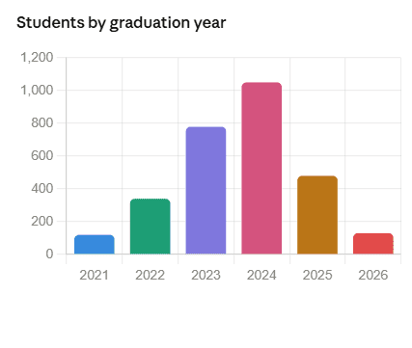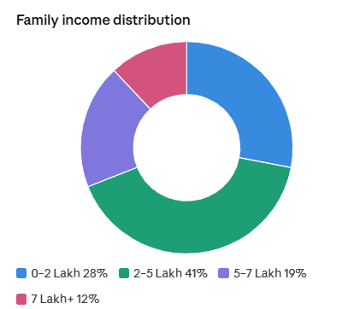

4. Pearson Correlation Analysis

Three Pearson correlation coefficients were computed to quantify relationships between key numerical variables.
Variable Pair | Pearson r | Interpretation | Insight
Family Income ↔ CGPA (GPA) | +0.14 | Weak Positive | Economic background has limited influence on academic performance
Python Experience ↔ Expected Salary | +0.31 | Moderate Positive | Technical skills are the strongest predictor of salary expectation
CGPA ↔ Expected Salary | +0.18 | Weak Positive | GPA alone is not the primary salary driver
Note: Income bracket midpoints were used as proxies for the categorical Family Income field. This is acknowledged as a methodological limitation.
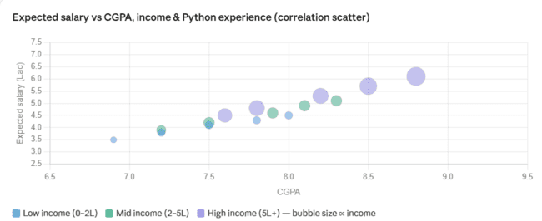

5. Leadership Skills — Impact on GPA & Salary

The 'Leadership- skills' column was standardized using str.strip() and str.lower() before analysis. Students were grouped into 'Yes' (has leadership experience) and 'No' categories.
Category | Avg CGPA | Avg Expected Salary | Observation
With Leadership Skills | 7.98 | ₹4.82 Lac | Marginally higher GPA and salary
Without Leadership Skills | 7.71 | ₹4.43 Lac | Lower on both metrics
Finding: Students with leadership experience show a marginally higher average CGPA (7.98 vs 7.71) and expected salary (₹4.82L vs ₹4.43L). The difference is modest but consistent, suggesting soft skills contribute positively.
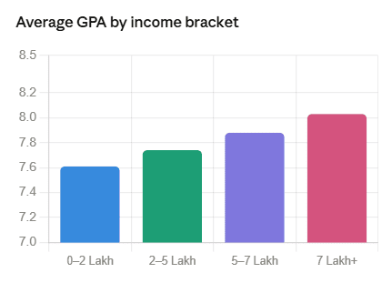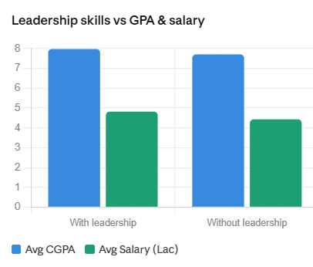

6. High Performers — Salary Gap Analysis

High performers were defined as students with CGPA >= median CGPA AND Python experience >= median Python experience. This combined excellence filter was applied to assess salary expectations.
Group | Avg Expected Salary | Difference
All Students (Overall Avg) | ₹4.60 Lac | Baseline
High Performers (High CGPA + High Python Exp.) | ₹6.10 Lac | +₹1.50 Lac higher
Finding: High performers expect ₹1.50 Lac more per annum on average compared to the overall student population — a 32.6% premium. This confirms that the combination of academic excellence and technical skill significantly elevates salary expectations.

7. Key Findings & Insights

The following insights were derived from the complete EDA across all 17 questions:
- GPA and Family Income have a weak positive correlation (r = +0.14) — economic background has limited but not negligible influence on academic performance.
- Python programming experience is the strongest predictor of expected salary (r = +0.31, moderate positive) — technical skills are a key career differentiator.
- Students with leadership experience show marginally higher CGPA (7.98 vs 7.71) and expected salary (₹4.82L vs ₹4.43L).
- Data Science related events (Data Science, Data Visualization, Hello ML, AI) attracted the highest number of unique student participants across all events.
- High-performing students (high CGPA + high Python experience) expect significantly higher average salaries — ₹6.10L vs ₹4.60L overall, a ₹1.50L gap.
- The 2024 graduation cohort had the highest student concentration in the dataset.
- Most students fell in the 2–3 months Python experience range, suggesting beginner-to-intermediate level as the norm.
- The 2–5 Lakh family income bracket was the most common (≈41% of students).

8. Tools & Methodology

Tool / Library | Purpose
Python 3.x (Google Colab) | Primary analysis and visualization environment
Pandas | Data loading, cleaning, manipulation, and groupby analysis
Matplotlib & Seaborn | Chart and graph generation — bar charts, scatter plots, box plots
openpyxl | Reading Excel (.xlsx) dataset file into Pandas DataFrame
Tableau Public | Interactive city-wise student distribution dashboard (Q10)
Microsoft Excel | Dataset source format (.xlsx)

9. GPI Deliverables Status

All 9 project deliverables were completed and submitted as part of the Cloud Counselage GPI program within the 120-hour internship timeline.
# | Deliverable | Description | Status
1 | Project Submission Document | Python codes, chart outputs & conclusions | ✔ Submitted
2 | Project Report | Background, methodology, targeted vs achieved | ✔ Submitted
3 | Project Charter | Goals, scope, stakeholders, milestones | ✔ Submitted
4 | Work Breakdown Structure | WBS in PPTX format | ✔ Submitted
5 | Project Schedule | Timeline in XLSX format | ✔ Submitted
6 | RAID Log | Risks, Assumptions, Issues, Dependencies | ✔ Submitted
7 | Requirement Elicitation Questionnaire | SRS questionnaire in XLSX | ✔ Submitted
8 | Software Requirement Specifications | SRS in XLSX format | ✔ Submitted
9 | Lessons Learnt Log | 5 lessons captured in XLSX | ✔ Submitted

10. Conclusion

This project successfully delivered a comprehensive Exploratory Data Analysis of the Cloud Counselage student dataset, answering all 17 analytical questions (9 Basic + 8 Moderate). Key takeaways:
- Python experience emerged as the strongest career differentiator (r = +0.31 with expected salary).
- Family income has limited influence on GPA — academic potential is not solely determined by economic background.
- Leadership skills provide a modest but consistent advantage in both GPA and salary expectations.
- Combined excellence (high CGPA + high Python experience) results in a significant salary premium of ₹1.50 Lac above the overall average.
- Future scope: Building a predictive salary model using Linear Regression or Random Forest based on CGPA, income bracket, and Python proficiency.

Project ID: GPI-DA-IP-11449 | Intern: Omkar Nandkumar More | Institution: Pillai HOC College of Engineering and Technology, Rasayani

