

Name: Omkar Navle
Roll No: A037
SAP ID: 86062500050
Course: MSc. Statistics and Data Science
Subject: Regression Analysis

Assignment 1: Multiple Linear Regression with Indicator (Dummy) Variables

Assignment 2: Autocorrelation in Time-Series Regression

Assignment 1: Multiple Linear Regression with Indicator (Dummy) Variables LINEAR REGRESSION IN PRESENCE OF INDICATOR VARIABLES
Dataset: Hotel Booking Demand | Source: Kaggle

1. Introduction
In regression analysis, we often come across instances when we need to deal with qualitative variables, i.e., variables that are not quantitative in nature. Variables like hotel type, meal plan, or market segment are all qualitative in nature. They are very important but cannot be fed into a regression equation as raw numbers. To feed qualitative variables into a regression equation, we need to create indicator variables, also known as dummy variables. Indicator variables are artificially created variables, usually of binary type, i.e., variables that take 1 or 0.
It is necessary to understand the reasons for which it would be wrong to assign arbitrary numbers to categories, for example, 1 = City Hotel, 2 = Resort Hotel. Indicator variables help us avoid this issue.

Why (p − 1) Dummy Variables?
When a categorical variable has p distinct levels, only (p − 1) indicator variables are included in the model. The excluded level becomes the reference (baseline) category. All dummy coefficients are then interpreted as differences relative to this reference. For a two-level variable like hotel type (City Hotel and Resort Hotel), we define exactly one dummy: hotel_dummy = 1 if Resort Hotel, 0 if City Hotel. City Hotel therefore becomes the reference.

The Dummy Variable Trap
If all p dummies are included, their columns would sum up to 1 for every observation, hence creating a perfect linear relationship with the intercept column. This would result in perfect multicollinearity, and the (X'X) matrix would be singular, hence the OLS estimator would be undefined, a problem that is known as the dummy variable trap. The solution to this problem is to include exactly (p - 1) dummies, allowing the omitted group to be absorbed by the intercept.

- Handling a Binary Categorical Predictor

Suppose we are in a situation where the observations are classified as members of exactly two groups, for example, individuals in Group A and individuals in Group B, with a continuous measurement X1. We cannot directly enter this category in the regression equation; however, we can represent the category with a single binary variable:
X₂ = 0 → observation is in Group A (the reference)
X₂ = 1 → observation is in Group B
Group A is designated the reference because its contribution is folded into the intercept of the model. The estimated equation then takes the form:
Y = β₀ + β₁ X₁ + β₂ X₂ + ε
Substituting each possible value of X₂ separates this single equation into two group-specific lines:
Group A (X₂ = 0): Ŷ = β̂₀ + β̂₁ X₁
Group B (X₂ = 1): Ŷ = (β̂₀ + β̂₂) + β̂₁ X₁

- Extending to Three or More Categories

Two things to observe. First, observe that the slope for both lines is the same, i.e., β̂₁. This implies that the rate of change of Y relative to X₁ is assumed to be the same for all groups. Second, observe that the two lines are parallel. This implies that the distance between the two lines is assumed to be constant, i.e., β̂₂, for any given value of X₁. If β̂₂ is positive, Group B is positioned higher, and if β̂₂ is negative, Group B is positioned lower. This model is called parallel lines/equal slopes.
The logic of the binary dummy variable extends naturally to the case where the categorical variable has more than two categories. The basic rule to remember is: if the categorical variable has p categories, then you should have p - 1 dummy variables, and leave out one of the groups. To see this, note that if you include all p dummy variables, the matrix would be rank deficient (the dummy variable trap), so one group has to be omitted.

For a three-group variable (A, B, C), the coding scheme is as follows:

Category | X₂ | X₃ | What gets switched on
A — Reference | 0 | 0 | Neither dummy — Group A is the baseline throughout
B | 1 | 0 | X₂ activates, signalling Group B membership
C | 0 | 1 | X₃ activates, signalling Group C membership

The regression model is extended to accommodate both dummies
Y = β₀ + β₁ X₁ + β₂ X₂ + β₃ X₃ + ε

Plugging in the dummy values group by group reveals three parallel fitted lines:
For Group A (X₂=0, X₃=0): Ŷ = β̂₀ + β̂₁ X₁
For Group B (X₂=1, X₃=0): Ŷ = (β̂₀ + β̂₂) + β̂₁ X₁
For Group C (X₂=0, X₃=1): Ŷ = (β̂₀ + β̂₃) + β̂₁ X₁

The slope β̂₁ is common for all three lines, only the intercept is different. β̂₂ represents the difference between Group B’s mean Y and Group A’s mean Y, given that X₁ is held constant, and β̂₃ represents the same for Group C. For any given p-level categorical variable, the same principle is applied, where each additional dummy has the same slope, but a different shift in the intercept based on its own difference.

2. Dataset Overview
The Hotel Booking Demand dataset is available on Kaggle and provides booking information for two different types of hotels in Portugal: a city hotel and a resort hotel, for check-ins between 2015 and 2017. The data consists of one row for each booking. This dataset is often used for research in hotel analytics.
Dataset Link:- https://www.kaggle.com/datasets/jessemostipak/hotel-booking-demand

Attribute | Details
Total Observations | 119,390 booking records
Total Variables | 32 columns (mix of numerical and categorical)
Dependent Variable (Y) | adr — Average Daily Rate (USD per night)
Hotel Types | City Hotel (reference) and Resort Hotel
Time Period | 2015, 2016, and 2017
Key Numerical Predictors | lead_time, stays_in_week_nights, previous_bookings_not_canceled
Key Categorical Predictors | hotel (converted to dummy: hotel_dummy)
Missing Values | 4 missing values in children column (imputed with mean)

The dependent variable 'adr', or Average Daily Rate, represents the average revenue generated by each occupied room on a daily basis. The key modeling question of interest here is whether the type of hotel, i.e., Resort or City, impacts the rate in a significant manner, while controlling for the booking lead time and length of stay.

3. Data Preprocessing
Step 1: Load Library and Data
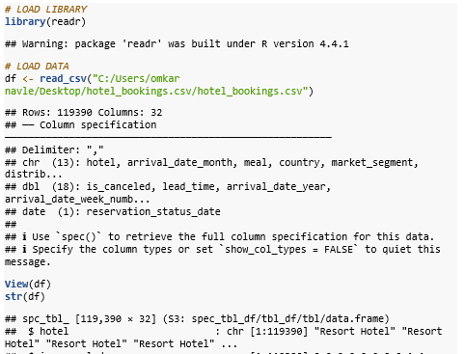

Step 2: Summary Statistics
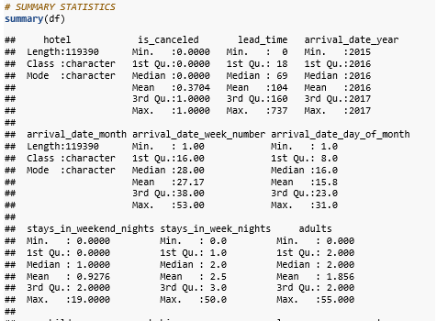

Step 3: Check and Handle Missing Values
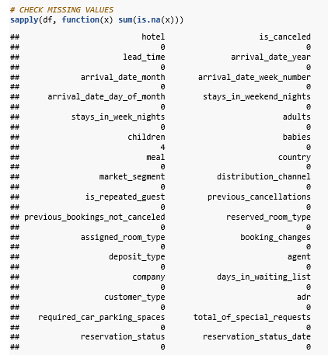
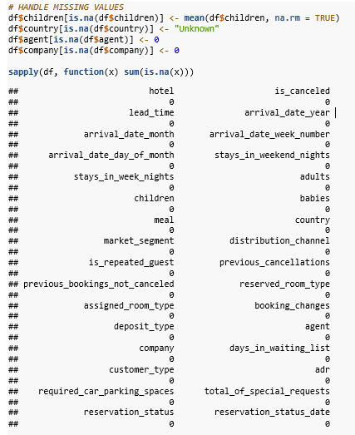

4. Creating the Indicator (Dummy) Variable
The qualitative variable hotel has two categories, namely 'City Hotel' and 'Resort Hotel'. Hence, as p = 2, we need to define exactly p - 1 = 1 dummy variable. City Hotel is taken as the reference category and its effect is included in the intercept of the model. The coefficient of the dummy tells us how the ADR of a Resort Hotel differs from a City Hotel, controlling for all other variables.
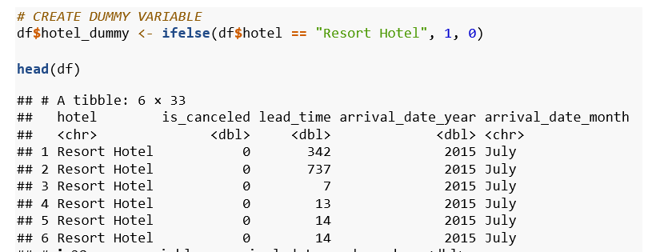
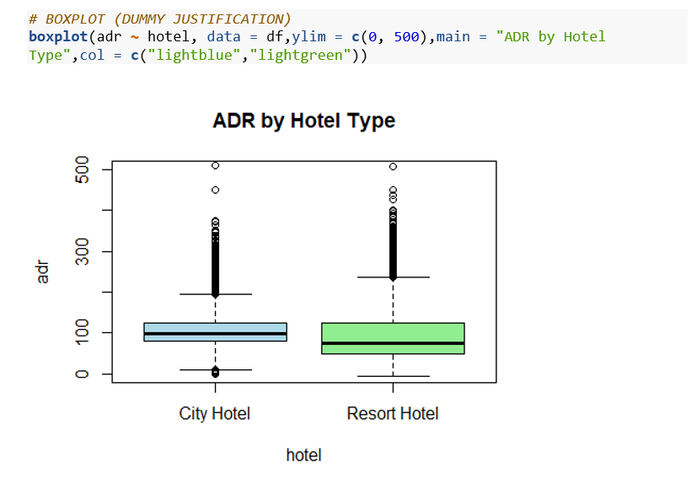

5. Full OLS Model
The full model regresses adr on lead_time, stays_in_week_nights, previous_bookings_not_canceled, and the hotel dummy variable. This gives a comprehensive initial picture of which predictors matter.
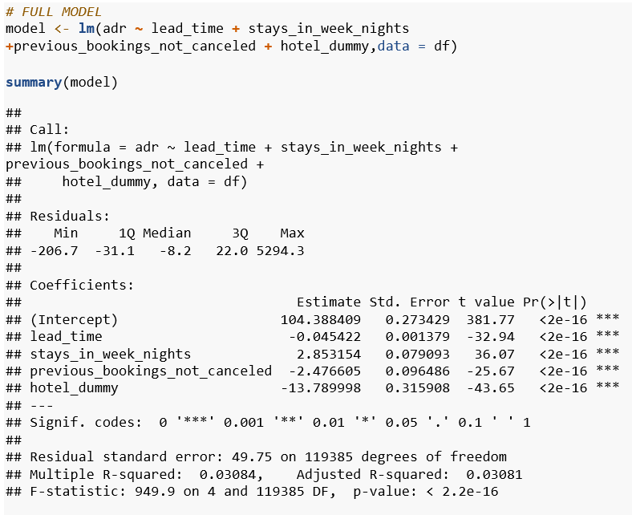

All predictors of the full model are statistically significant at a 1% significance level (p < 2e-16). The F-statistic of 949.9 also proves the joint significance of the regressors. The R-squared of 0.031 suggests moderate explanatory power of the model, which is a common feature of booking data sets due to their variability.

6. Model Refinement
After reviewing the full model, the feature previous_bookings_not_canceled is removed to yield a more parsimonious model. Even though it was statistically significant, this feature has a relatively minor practical contribution to the model compared to the cleaner three-predictor model. The improved model includes the three most interpretable and practically significant predictors.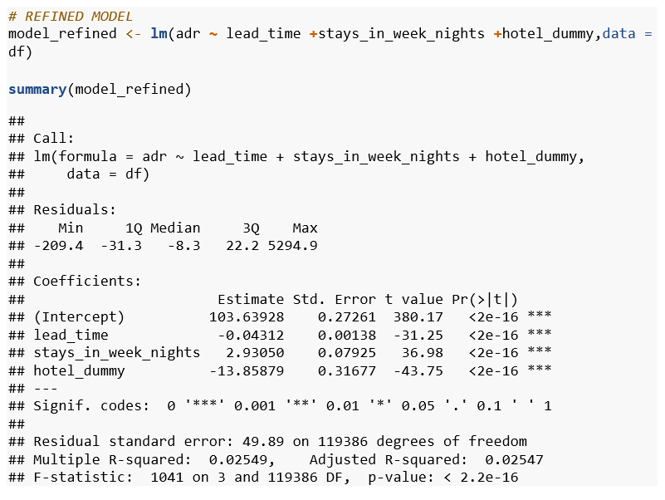

7. Interpretation of Coefficients
The refined model gives rise to two separate regression equations one for each hotel type that share a common slope but differ in their intercepts. This is the hallmark of a dummy variable model.

For City Hotel (hotel_dummy = 0): ADR = 103.64 - 0.043 × lead_time + 2.931 × stays_in_week_nights
For Resort Hotel (hotel_dummy = 1): ADR = (103.64 - 13.86) - 0.043 × lead_time + 2.931 × stays_in_week_nights
= 89.78 - 0.043 × lead_time + 2.931 × stays_in_week_nights

Variable | Coefficient | Interpretation
(Intercept) | 103.639 | Baseline ADR for a City Hotel booking with zero lead time and no weeknight stays
lead_time | -0.043 | Each additional day of advance booking reduces ADR by about $0.04 — consistent with early-bird discounting
stays_in_week_nights | 2.931 | Each additional weeknight stay adds approximately $2.93 to the average daily rate
hotel_dummy (Resort Hotel) | -13.859 | Resort Hotels charge $13.86 LESS per night than City Hotels on average, after controlling for lead time and length of stay

The negative coefficient for hotel_dummy is initially puzzling, as resort hotels are generally considered high-end properties. However, once controlling for chemical lead time and length of stay, the data suggests that city hotels in this sample command a higher average daily rate. This may be due to the urban business travel market, in which city hotels cater to corporate customers willing to pay a premium for a shorter, last-minute stay, as indicated by the positive coefficient for stays_in_week_nights and the negative coefficient for lead_time.
The negative sign of the lead_time effect simply verifies the well-known early bird discount principle, whereby customers who book early are rewarded with a cheaper price. This is consistent with the dynamic pricing strategy, which has been widely adopted in the hotel and airline industries.

Assignment 2: Autocorrelation in Time-Series Regression
Dataset: Walmart Sales Dataset | Source: Kaggle

Introduction to Autocorrelation
- What is Autocorrelation?
The Classical Linear Regression Model (CLRM) assumes that error terms between different observations are uncorrelated. Mathematically:
- Cov(uᵢ, uᵣ) = 0 for every pair i ≠ j
Autocorrelation, also known as Serial Correlation, is a violation of this assumption. It is present when there is a systematic link between errors of two different observations. This means that in most cases, errors of consecutive time periods have a common sign: if an error is positive in period t, then an error in period t+1 will be positive.Root Causes
- Economic Inertia and Momentum
The major macroeconomic variables such as national income, employment, industrial production, and money supply do not exhibit erratic movements. Rather, they show trends over a period of time. An economy emerging from a recession will show a growth rate over a series of consecutive quarters. Conversely, a recession will show a decline over a series of consecutive quarters. This multi-period nature of the macroeconomic variables ensures that each error term includes a carryover from the last period.
- Omitted Variable Bias
Each time a relevant variable is omitted, its effect enters the error term. The problem is that if the omitted variable has its own trend or cycle, as most economic series do, the residuals will have a pattern rather than true random noise.

- Supply-Demand Lags: The Cobweb Effect
In markets with production lead times ,particularly agriculture suppliers must commit to output quantities before knowing the final price. They base decisions on last season's price, leading to the supply specification Sₜ = β₁ + β₂ Pₜ₋₁ + uₜ. A glut in year t depresses prices, inducing under-supply in year t+1, which then pushes prices up again. This alternating over- and under-production imprints a cyclical cobweb pattern directly onto the disturbance terms.

- Temporal Aggregation and Smoothing
When high-frequency raw data, for example, daily or monthly, are aggregated or averaged to form lower frequency series, for example, quarterly or yearly, the aggregated or averaged adjacent observations overlap, as they are made up of overlapping high-frequency raw observations.
This artificial smoothness occurs because, even with random high-frequency raw data, aggregated or averaged adjacent observations are not independent of each other.
Though autocorrelation is mostly a time-series problem, it can also arise in cross-sections. If neighbouring spatial units, like households on the same street or firms in the same industry cluster, react similarly to local shocks, then spatial correlation is equivalent to time-series autocorrelation..

- What Goes Wrong When Autocorrelation is Ignored
Autocorrelation does not bias the OLS coefficient estimates ,they remain unbiased and consistent. The damage is subtler and concentrated in the standard errors and the efficiency of estimation:

Problem | Mechanism | Practical Consequence
OLS loses efficiency | Estimators are no longer minimum-variance among linear unbiased estimators | BLUE status is lost; GLS outperforms OLS
Standard errors shrink artificially | OLS variance formula omits the autocorrelation terms, producing downward bias | Coefficients look more precise than they truly are
t and F tests break down | Inflated t-statistics caused by underestimated standard errors | Spurious significance: predictors falsely appear to matter
R² is overstated | RSS/df underestimates the true variance of disturbances | Model fit appears better than it genuinely is

- Detecting Autocorrelation

Visual Inspection
A plot of OLS residuals against the time index, also called a time sequence plot, should be the first approach. In a situation with real independence, the residuals should be randomly scattered above and below zero with no apparent trend or wave pattern. Positive autocorrelation should be evident as long stretches, where the series stays above zero for a long time, then stays below zero for a long time as well. Conversely, negative autocorrelation should be evident as rapid sign changes, or a square wave pattern.

A similar test is the lag residual scatter plot. This involves a graphical method of plotting eₜ against eₜ₋₁. The presence of a positive linear trend indicates positive autocorrelation. A negative trend indicates negative autocorrelation. A shapeless distribution indicates independence. This method is quick and subjective. It is therefore always important to perform a formal test.

- Durbin-Watson Test
The Durbin-Watson (DW) test provides a formal, widely-used check for first-order serial correlation. Its statistic is built from consecutive residual differences:
d = Σₜ₋er=2 (eₜ − eₜ₋₁)² / Σₜ₋er=1 eₜ²
Because d ≈ 2(1 − ρ), where ρ is the first-order autocorrelation coefficient, the statistic carries intuitive meaning across its 0–4 range:
d Range | Signal | Diagnosis
Near 0 | ρ close to +1 | Strong positive autocorrelation
Near 2 | ρ close to 0 | Residuals appear uncorrelated — CLRM assumption likely holds
Near 4 | ρ close to −1 | Strong negative autocorrelation
dⱼ < d < dᵤ | Indeterminate | Test is inconclusive; seek additional evidence

The DW test is valid only when: (1) an intercept is present in the model, (2) regressors are non-stochastic, (3) errors follow AR(1) structure, and (4) no lagged dependent variable appears as a regressor. Violating any of these conditions makes the statistic unreliable.

- Breusch-Godfrey (BG) / LM Test
The Breusch-Godfrey test removes the main restrictions of the DW test. It handles higher-order AR schemes, lagged dependent variable regressors, and moving-average error structures. The four-step procedure is:

Step 1. Run OLS on the original model and save the residuals eₜ.
Step 2. Auxiliary regression: regress eₜ on its p lags (eₜ₋₁, eₜ₋₂, …, eₜ₋ₚ) together with all original regressors.
Step 3. Form the test statistic (n − p) × R² from the auxiliary regression, which is asymptotically χ² distributed with p degrees of freedom.
Step 4. Reject H₀ (no autocorrelation) if the statistic exceeds χ²ₚ at the chosen significance level.

- Correcting for Autocorrelation

- Cochrane-Orcutt Transformation — When ρ is Known
The most principled remedy transforms the original model to produce classical (non-autocorrelated) errors. Starting from the two-variable model Yₜ = β₁ + β₂Xₜ + uₜ and its one-period lag, multiply the lagged equation by ρ and subtract:
Quasi-differenced outcome: Yₜ* = Yₜ − ρYₜ₋₁
Quasi-differenced predictor: Xₜ* = Xₜ − ρXₜ₋₁
Transformed intercept: β₁* = β₁(1 − ρ)
Transformed error: vₜ = uₜ − ρuₜ₋₁ → white noise

OLS applied to the transformed variables Yₜ* and Xₜ* delivers GLS estimators that are BLUE. This quasi-differencing approach is the Cochrane-Orcutt transformation.

- Estimating ρ When it is Unknown

Method 1 From the DW statistic: Since d ≈ 2(1 − ρ), a quick plug-in estimate is ρ̂ = 1 − d/2. Convenient but only reliable in large samples.
Method 2 —Auxiliary residual regression: Regress eₜ on eₜ₋₁ (no intercept): eₜ = ρ̂ eₜ₋₁ + vₜ. The slope gives a consistent, if slightly small-sample-biased, estimate.

- Iterative Cochrane-Orcutt , When ρ Needs Refinement
When the initial ρ̂ is unreliable, the estimate is refined through iteration until it converges:

Fit the original model by OLS; extract residuals eₜ.
Regress eₜ on eₜ₋₁ to obtain first ρ̂.
Construct quasi-differenced series Yₜ* and Xₜ* using ρ̂.
Re-estimate by OLS; extract new residuals.
Update ρ̂ from the new residuals.
Repeat until successive ρ̂ values differ by less than 0.01 (convergence).

- First-Difference Transformation , Assuming ρ = 1
A special limiting case arises when ρ is assumed equal to 1 (perfect positive autocorrelation). The Cochrane-Orcutt subtraction then simplifies entirely to working with period-to-period changes:
ΔYₜ = β₂ ΔXₜ + vₜ
where ΔYₜ = Yₜ − Yₜ₋₁ and similarly for ΔXₜ. The intercept vanishes, and the model is estimated purely in first differences. This is also a standard pre-processing step to eliminate stochastic trends.

- Durbin's h-Statistic , When DW is Invalid
Once a lagged dependent variable Yₜ₋₁ enters the regressor set, the DW statistic is biased toward 2 and loses its diagnostic power. Durbin's h-statistic corrects for this bias:
h ≈ ρ̂ × √[ n / (1 − n · V(b₃)) ]
where n = sample size and V(b₃) = estimated variance of the lag coefficient. For large samples, h ~ N(0, 1), so the 5% decision rule is simply: reject H₀ if |h| > 1.96.

Note: If n · V(b₃) ≥ 1, the square root is undefined and h cannot be computed. In that situation, switch to the Breusch-Godfrey test instead.2. Dataset Overview
The Walmart Sales Dataset contains weekly sales records for 45 Walmart stores across the United States, covering the period from February 2010 to October 2012. Each row corresponds to a specific store's performance in a given week, yielding 6,435 total observations.
DataSet Link:- https://www.kaggle.com/datasets/yasserh/walmart-dataset

Variable | Type | Description
Weekly_Sales (Y) | Numerical | Total weekly revenue per store (USD) — Dependent variable
Temperature (X1) | Numerical | Average temperature at the store's location that week (°F)
Fuel_Price (X2) | Numerical | Average fuel price in the store's region (USD per gallon)
CPI (X3) | Numerical | Consumer Price Index — a measure of regional inflation
Unemployment (X4) | Numerical | Regional unemployment rate (%)
Holiday_Flag | Binary | 1 if the week includes a major public holiday, 0 otherwise
Store | Integer | Store identifier (1 to 45)
Date | Date | Week ending date — key for establishing time-series order

It is also apparent that the data has a natural time series pattern, as the data points are collected on a weekly basis for individual stores. Retail sales tend to have high inertia, meaning that if a store has a high sales week, the following week will also be a high sales week, and conversely, if the store has a low sales week, the following week will also be low sales. Therefore, autocorrelation of the residuals in the regression model is highly likely and should be tested for formally.

3. Data Loading and Preprocessing
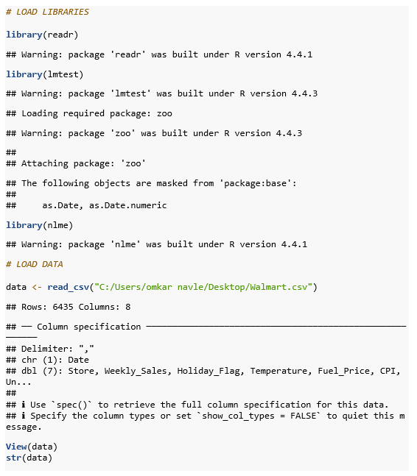
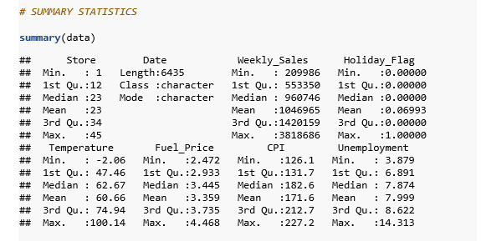
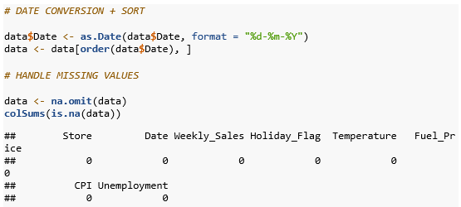

4. OLS Regression Model
In the OLS model, Weekly_Sales is regressed against four macroeconomic variables: Temperature, Fuel_Price, CPI, and Unemployment. The variable 'Holiday_Flag' is not included in the model as the focus should be on macroeconomic variables. The dataset is already ordered in a chronological manner, which is important for future analysis using time series methods.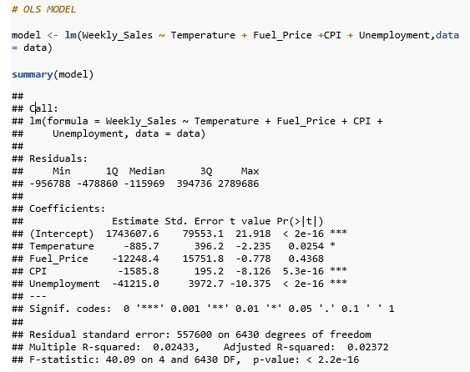

The OLS model shows that CPI and Unemployment are highly significant negative predictors of weekly sales, while Fuel_Price is not significant (p = 0.437). Temperature has a borderline effect. However, the R-squared of just 0.024 is very low, and because the data is ordered chronologically, the standard errors may be seriously understated due to autocorrelation in the residuals. We must investigate this formally before drawing any conclusions.

5. Detection of Autocorrelation
5.1 Graphical Diagnostics
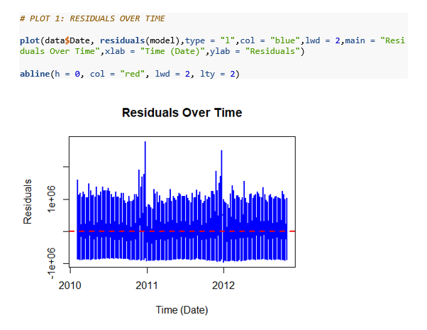
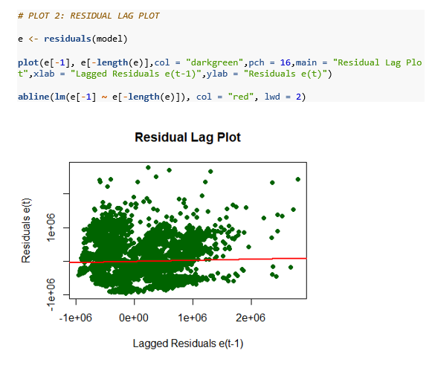
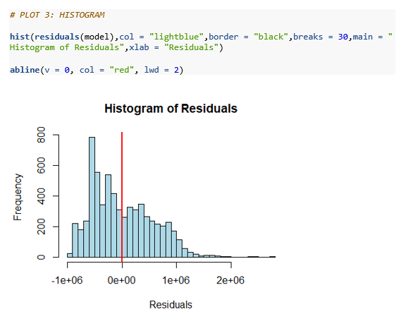

From the residual plot over time, we notice that there is a cyclical wave pattern where a cluster of positive residuals occurs consecutively over a period of weeks, then a cluster of negative residuals occurs consecutively. This is the signature plot for a positive autocorrelation effect. From the residual lag plot, we notice that there is a strong positive linear relationship between e(t) and e(t-1).
5.2 Durbin-Watson Test
The DW test is a formal test for the presence of first-order autocorrelation. The null and alternative hypotheses are H0: ρ = 0 (no autocorrelation) versus H1: ρ > 0 (positive autocorrelation). The DW statistic d varies from 0 to 4, and d ≈ 2 indicates no autocorrelation, d < 2 indicates positive autocorrelation, and d > 2 indicates negative autocorrelation.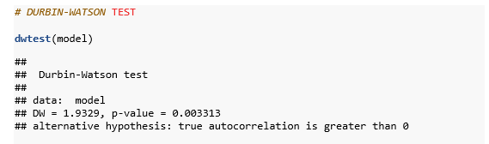

Test Component | Value | Interpretation
DW Statistic | 1.9329 | Below 2 — indicates positive autocorrelation
p-value | 0.003313 | Highly significant — reject H0 at 1% level
Decision | Reject H0 | Statistically significant positive autocorrelation confirmed
Estimated ρ (from residuals) | 0.03346 | Mild first-order autocorrelation parameter

The Durbin-Watson statistic is 1.9329, which is less than 2. The p-value for the Durbin-Watson test is 0.003313, which is much less than 0.05. We can therefore reject the null hypothesis. Although the DW statistic is only slightly less than 2, indicating mild rather than severe autocorrelation, the result is statistically unambiguous. Any statistical procedure that fails to account for this will not provide reliable standard errors and hypothesis tests.

6. Correcting Autocorrelation: GLS and Cochrane-Orcutt
As autocorrelation is established, we use two different approaches for corrections, which are complementary to each other. One is the Generalized Least Squares model, which can be performed using the nlme package, and the other is the Cochrane Orcutt transformation. Both of these methods are based on AR(1) errors.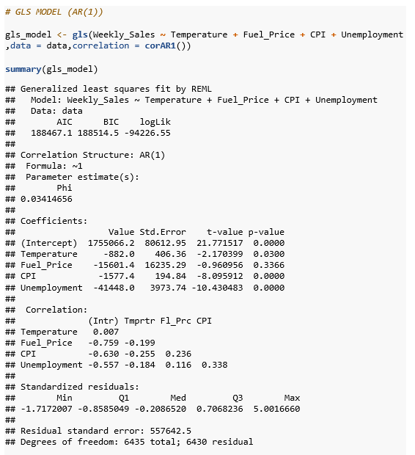

Manual Cochrane-Orcutt Transformation

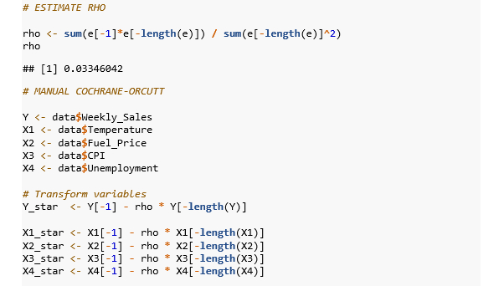
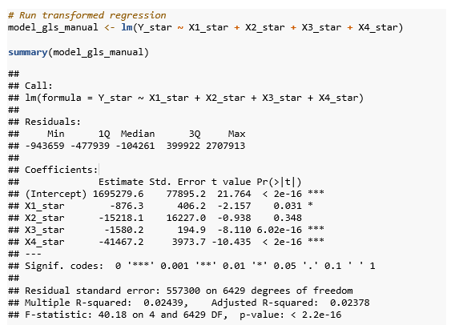

7. OLS vs. GLS Comparison
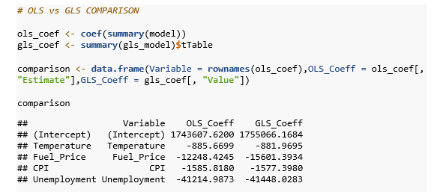

Variable | OLS Coefficient | GLS Coefficient | Key Change
(Intercept) | 1,743,607.6 | 1,755,066.2 | Slight increase in baseline
Temperature | -885.7 | -882.0 | Remains negative and significant
Fuel_Price | -12,248.4 | -15,601.4 | Magnitude increases; still insignificant
CPI | -1,585.8 | -1,577.4 | Very stable — robust predictor
Unemployment | -41,215.0 | -41,448.0 | Highly stable — strongest predictor

As can be seen from the output above, the application of the GLS correction has indeed confirmed the statistical insignificance of Fuel_Price (p = 0.337), while CPI and Unemployment continue to be the key statistically significant variables. The Phi value of 0.034 for the AR(1) serial correlation, as estimated by the GLS model, is consistent with the DW statistic of 1.93. The corrected standard errors are slightly larger than the uncorrected standard errors from the OLS model.

8. Refined GLS Model
Fuel_Price is consistently insignificant across both OLS and GLS models. Removing it yields a more parsimonious model that retains all significant predictors.

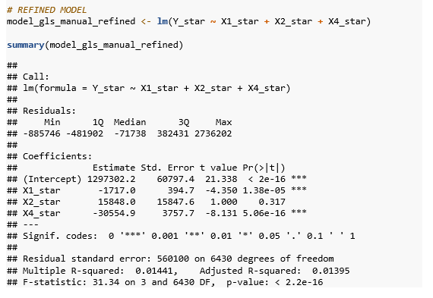

9. Summary and Conclusions
Step | Action | Finding
1 | OLS Regression | CPI and Unemployment significant; Fuel_Price not significant; DW test needed
2 | Residual Plots | Time plot shows cyclical clustering; lag plot shows positive linear pattern
3 | Durbin-Watson Test | DW = 1.9329, p = 0.003 — statistically significant positive autocorrelation
4 | GLS (nlme) | AR(1) Phi = 0.034; corrected standard errors; Fuel_Price remains insignificant
5 | Cochrane-Orcutt | Manual transformation confirms GLS results; rho = 0.033
6 | Refined Model | Temperature and Unemployment are robust predictors after removing Fuel_Price
This analysis has shown the entire process of identifying and adjusting the autocorrelation issue within a time series regression model. The Durbin Watson test has shown a statistically significant but minor first-order autocorrelation within the OLS residuals of the Walmart model. The Fuel_Price variable, which could be seen as a potentially significant predictor through naive OLS, is shown to be insignificant when the proper model and adjustment are used.
The major point is that autocorrelation, even when it is weak, should not be neglected, as it can lead to inference bias. The GLS Cochrane Orcutt method is successful in overcoming the AR(1) problem of autocorrelation, and reliable results are obtained. CPI and Unemployment are established as the strongest predictors of retail sales, which is logical from a macroeconomic perspective, as both are known to act as depressors of consumer spending.

References
1. IGNOU. Autocorrelation (Unit 7). eGyanKosh Study Material. https://egyankosh.ac.in/bitstream/123456789/78535/1/Unit-12.pdf
2. IGNOU. Regression Models with Indicator Variables (Unit 9). eGyanKosh Study Material. https://egyankosh.ac.in/bitstream/123456789/88184/1/Unit-9.pdf

Code File
https://drive.google.com/drive/folders/1X6RRvuDHqmwwCVQLvfeREuMURFzkbN_u?usp=sharing

