|  |  |  |
| --- | --- | --- |
| **Element** | **Color Code** | **Description** |
| **Primary Sidebar Background** | #004E89 | Deep Blue - Corporate Sidebar |
| **Active Menu Highlight** | #0077C8 | Bright Blue - For active menu item |
| **Hover/Interactive Blue** | #005A99 | Slightly lighter blue for hover states |
| **Dashboard Background** | #F5F7FA | Soft Light Grey Background |
| **Card Background** | #FFFFFF | Pure White Cards |
| **Card Border Shadow** | rgba(0,0,0,0.1) | Subtle Shadow for Card Elevation |
| **Text Primary** | #172B4D | Dark Navy for headings & main text |
| **Text Secondary** | #6B778C | Subtle Grey for supporting text |
| **Success (Approved)** | #36B37E | Green - Approved Status |
| **Warning (Pending)** | #FFAB00 | Yellow - Pending Status |
| **Error (Rejected)** | #FF5630 | Red - Rejected/Error Status |

**💡 UI Design Suggestions for Your Dashboard**

✅ **Sidebar Menu:**

* Use solid #004E89 Deep Blue
* White icons, slight hover highlight with #005A99
* Active menu item background #0077C8, rounded edges

Shape

✅ **Dashboard Cards:**

* White cards with soft shadow for elevation
* Title text in Dark Navy #172B4D
* Important numbers (Leave counts, Payroll dates) in Green #36B37E for positive values
* Avoid mixed green/purple text to improve consistency
* Use subtle border-bottom accent in Blue #0077C8 for card separation

Shape

✅ **Status Tags (Leave History Table):**

* Approved = Green Badge #36B37E
* Pending = Yellow Badge #FFAB00
* Rejected = Red Badge #FF5630
* Badges with rounded corners, slight padding for clean appearance

✅ **Typography:**

* Consistent font sizes across cards
* Heading (Dashboard, Leave History) bold, large
* Subtext (Used, dates) smaller, muted grey

Shape

✅ **Responsive & Interactive:**

* Hover animations on cards
* Subtle icon animations on sidebar menu hover
* Ensure layout is mobile-friendly, cards stack vertically

Align dashboard visuals to the geometric style of the logo by adding consistent icons:

|  |  |
| --- | --- |
| **Section** | **Suggested Icon** |
| Annual Leave | 🗓️ |
| Sick Leave | 🤒 |
| Casual Leave | ☀️ |
| Attendance | 👥 |
| Next Payroll | 💰 |
| Holidays | 🎉 |

 User Registration Form - UI Design (Updated)

**1. Updated Visual Design**

a. Background Color:- Use light blue (#e6f0ff) instead of white for the form card background.

b. Input Field Size:- Reduce the height and padding of input boxes to make them smaller.

c. Overall Layout:- Keep the form centered with spacing, but compact.

d. Updated Button:- Maintain rounded corners and hover effects.

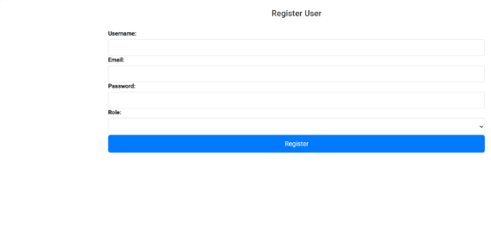

**2.Employee Management**

When the **"Employee Management"** menu item is clicked, it should:

**Expand to show sub-items**:



Add Employee



Employee List



Onboarding



Exit Management



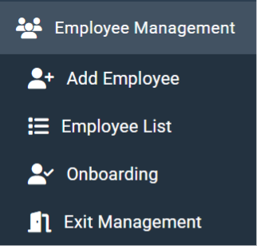

1. **Department:  In this also font color should be light Blue**

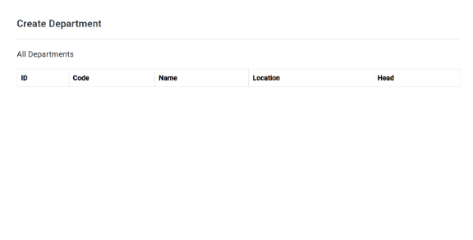

1. **Leave**

·  Be **horizontally and vertically centered**

·  Work on **all screen sizes** (responsive)

·  Maintain **padding/margin** from the edges on small screens.

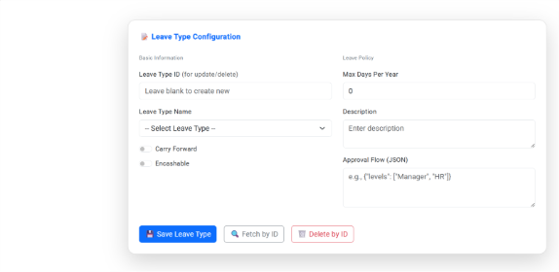

1. Attendence Management

It is shown something like this

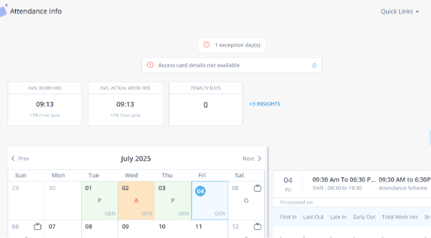

Leave Type Configuration

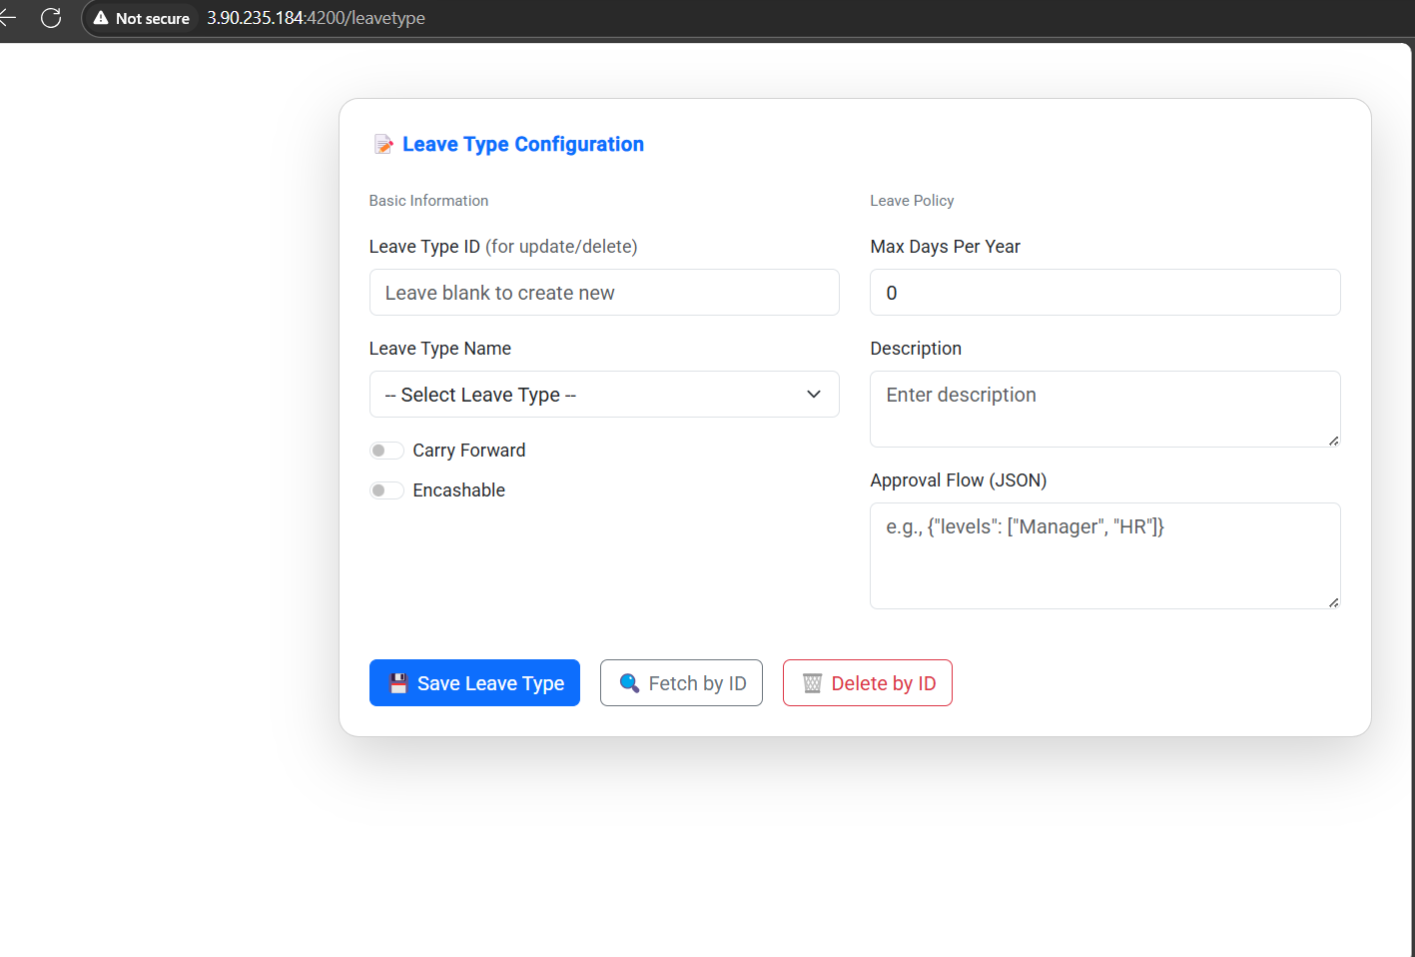

* Can add Quantumsoft logo somewhere in the form of header or at top left to reinforce brand identity.
* Else we can keep the frame of leave type configuration in the middle of the page.

Employee Benefits

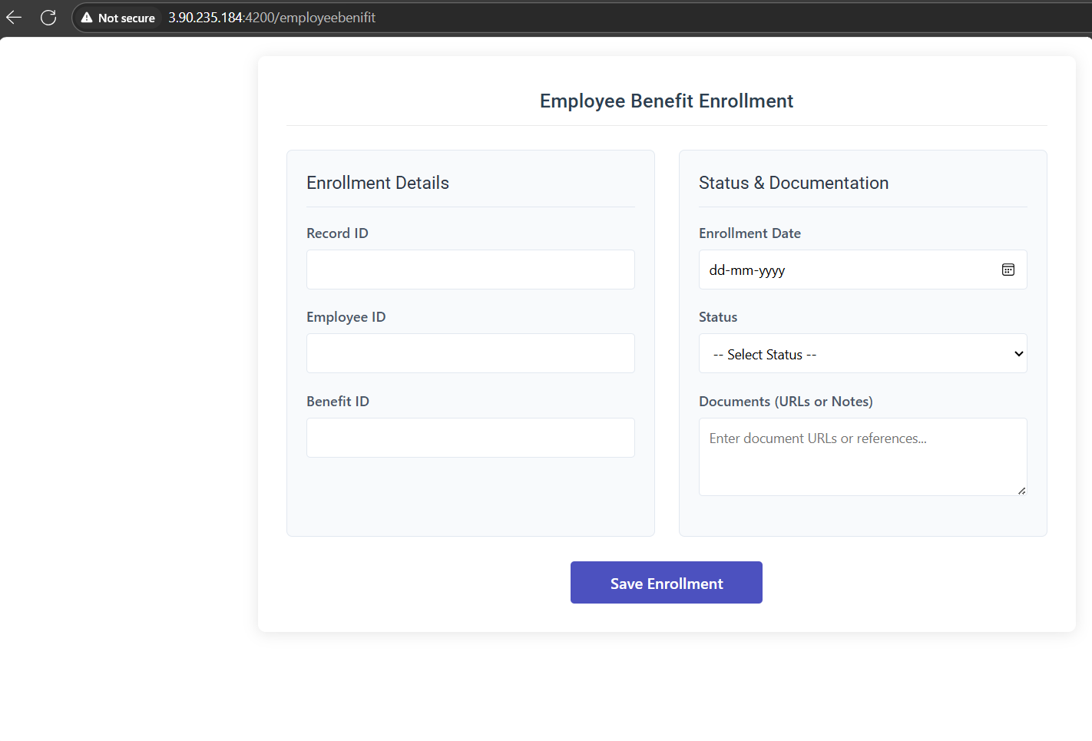

* Can add Quantumsoft logo at the left top to reinforece brand identity.
* Can change the colour of “Save Enrollment” to match with Quantumsoft logo.
* Can replace with **logo's blue shades**, e.g.:
* Primary Blue: #0066B3 or #005082
* Accent Blue (from stripes): #00A8E8 or #009FDA

Compliance

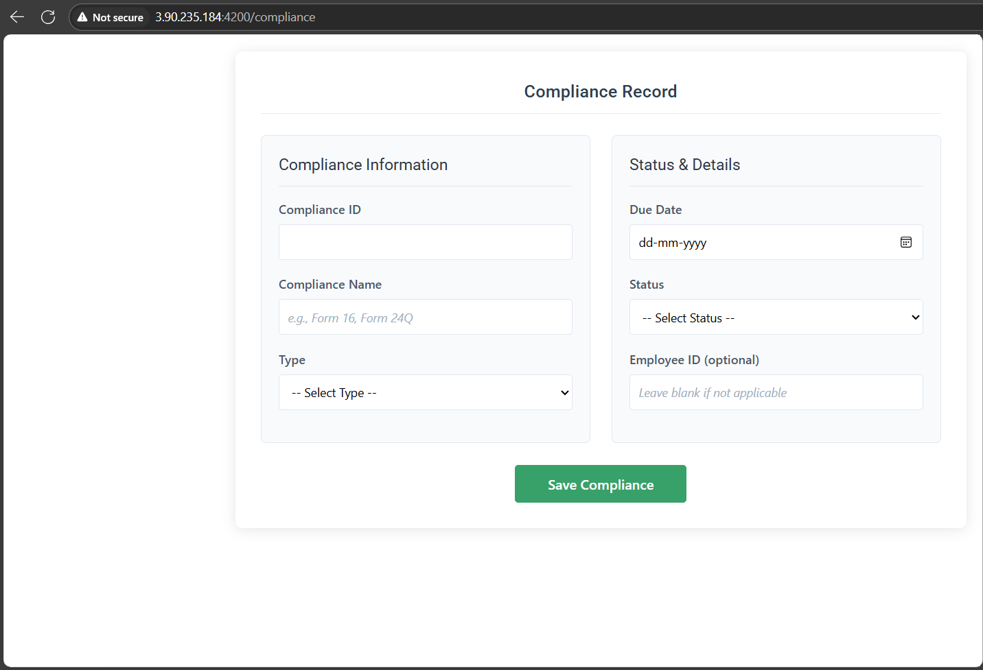

* Can add Quantumsoft logo at the left top to reinforece brand identity.
* Can change the colour of “Save Compliance” to match with Quantumsoft logo, as the colour is totally different from the logo.
* Can change the colour of “Compliance Information”, as it is the section header.
* Can change the font weight “Compliance Record”.

Aligned replacement:  
 **Primary Blue** #0066B3  
 **Hover Blue** #009FDA

Performance Review

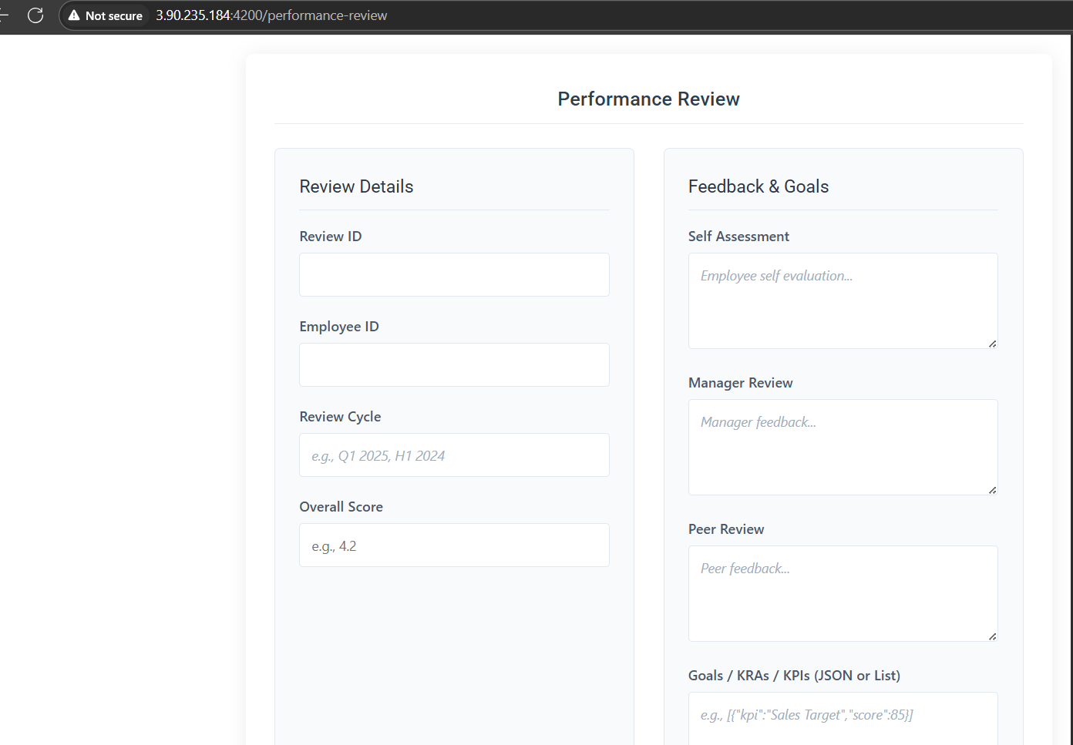

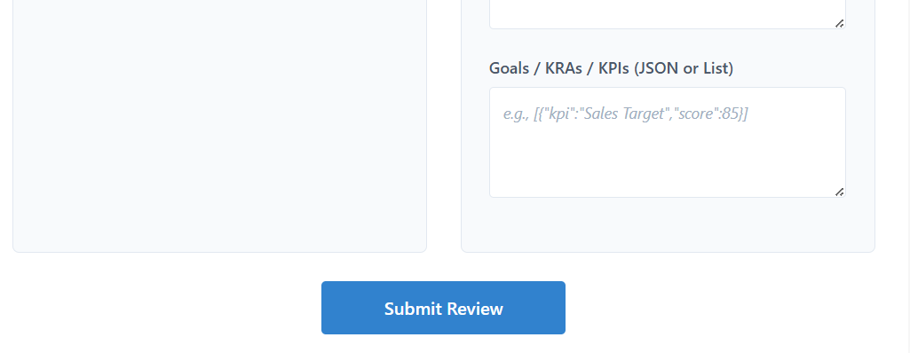

* Can add Quantumsoft logo at the left top to reinforece brand identity.
* Can change the colour of “Submit Review”, so that it matches with the logo.
* Consider adding subtle **icons** next to:
  + Self Assessment → 🧑‍💼
  + Manager Review → 👔
  + Peer Review → 👥
  + Overall Score → ⭐
  + Goals / KPIs → 🎯

Document

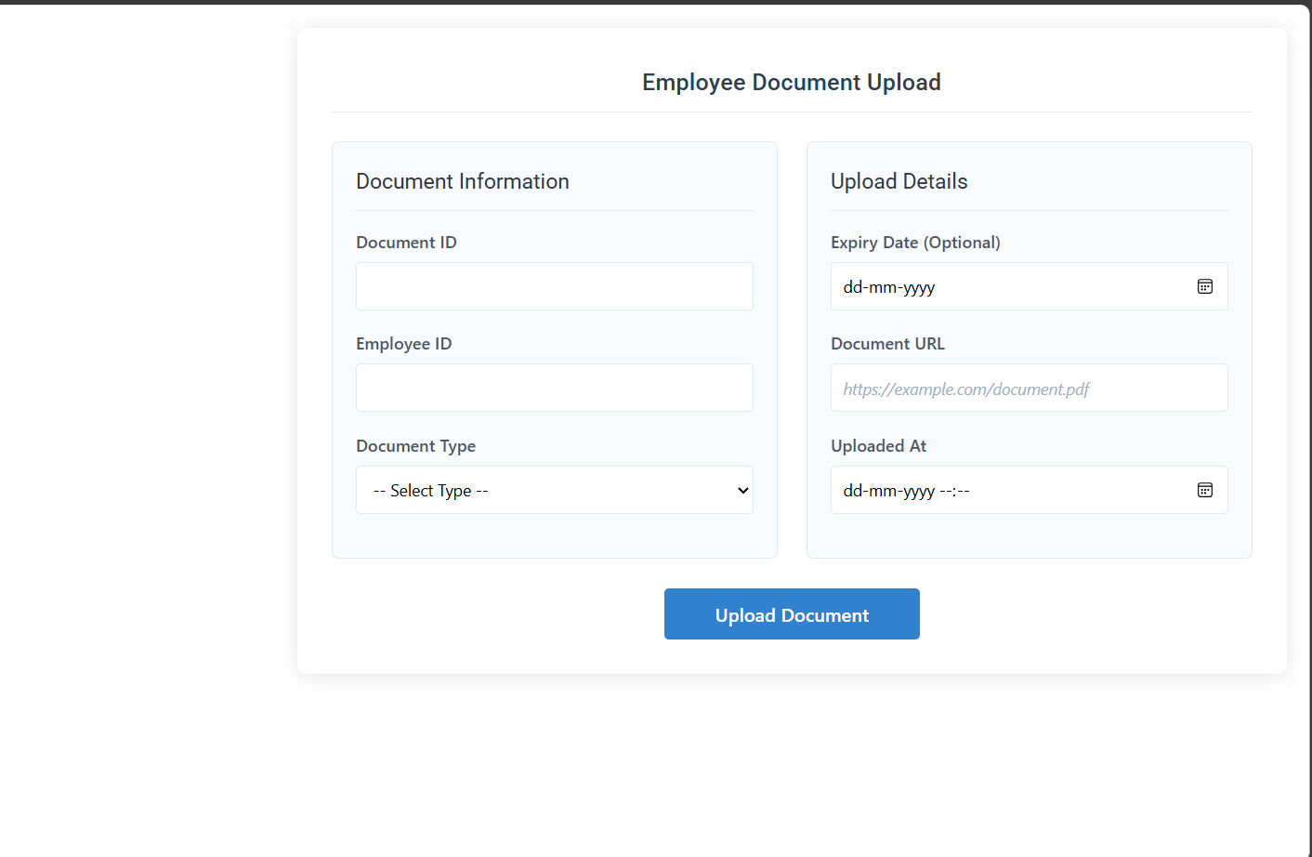

* Can add Quantumsoft logo at the left top to reinforece brand identity.
* Can keep the employee document frame at the center.
* Can change the colour of “Upload Document”, so that it matches with the logo.
  + Use **#0066B3** as primary color
  + Use **#009FDA** or lighter blue on hover
* Consider subtle left-aligned icons to:
* Document ID → 🧾
* Document Type → 🗂️
* URL → 🔗
* Date → 📅

1. Ticket Information:-

* Use Card Borders with Depth

Add subtle shadows or elevation to both **"Ticket Information"** and **"Ticket    Details"** sections to make them visually pop.

* **Contrast & Readability**

1. Slightly darken field labels or use bold.
2. Use lighter background sections with **consistent padding**.

* **Section Separator**

Add a faint vertical divider between the two columns (for wide screens).

On smaller screens: stack them vertically (responsive behavior).

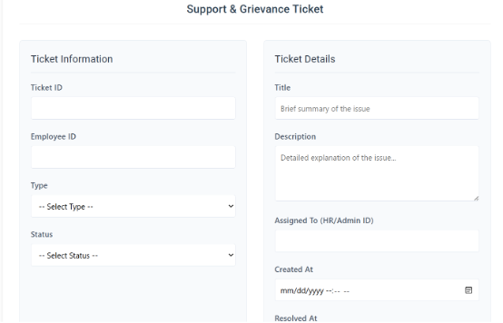

* Training Details

1. Add light Blue colour in this page.
2. Use **section cards** with subtle shadows (e.g., “General Info”, “Assignment”, “Tracking”).
3. Add light gray or pastel background inside each group to visually separate them.
4. Align left and right columns evenly.

Replace scrollable multi-selects with **tag-style dropdowns** (e.g., using chips/pills).

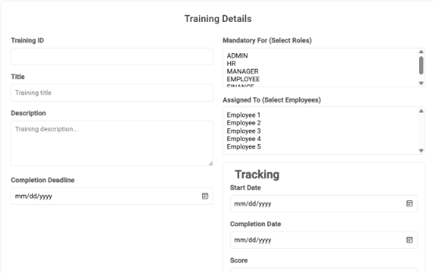

* DEI Dashboard

1. **Section Cards**: Wrap “Employee Information” and “DEI Details” in subtle bordered cards or background blocks for better separation and emphasis.
2. **Add a Divider Line or Label**: Below “DEI Details”, add a light gray line or label like *“Optional Disclosure”*.
3. **Form Width**: Slightly reduce the max-width for improved readability on large screens.
4. Add a **light background box** or card around the checkbox and optionally include

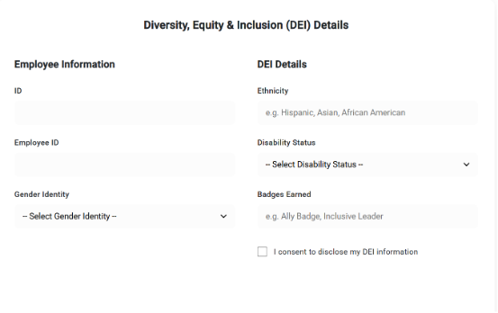

* Audit Log Entry

Add section headers or separators for clarity.

* **Compact the Form**

**Consider a two-column layout for wider screens to reduce scrolling.**[Text Wrapping Break]**Example: Left: Log ID, Action, Timestamp                               Right: User ID, Module, IP Address.**

* **Padding & Elevation**

1. **Add consistent spacing between fields.**
2. **Wrap the form in a card with shadow or border-radius for modern look.**

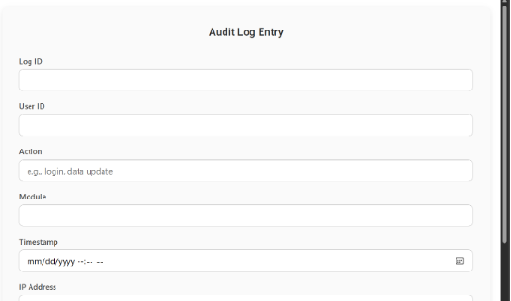

* ADD Company Logo In Dashboard:

