
A Mini Project Report on
AI-Powered Business Finance and Inventory Analysis System
Finance Management · Inventory Analytics · Demand Forecasting · Expense Anomaly Detection
Submitted in partial fulfilment of the requirements of
SEWDL Lab
TY B.Tech — Information Technology, Semester V
Submitted by
Prathamesh Salunkhe (Roll No: 24101C0021)
Omkar Padhi (Roll No: 24101C0003)
Atharva Chavan (Roll No: 24101C0006)
Aryan Kelkar (Roll No: 24101C0020)
Under the guidance of
Prof. Debarati Ghosal
Department of Information Technology
Vidyalankar Institute of Technology
Wadala (E), Mumbai – 400037
(Affiliated to University of Mumbai)
Academic Year 2026–2027

CERTIFICATE
This is to certify that the mini project entitled
“AI-Powered Business Finance and Inventory Analysis System”
is a bonafide work done by
Prathamesh Salunkhe (24101C0021)
Omkar Padhi (24101C0003)
Atharva Chavan (24101C0006)
Aryan Kelkar (24101C0020)
and is submitted in partial fulfilment of the requirements of SEWDL Lab, TY B.Tech Information Technology, Semester V, at Vidyalankar Institute of Technology, Wadala, Mumbai, during the academic year 2026–2027.
Prof. Debarati Ghosal  Project Guide | Head of the Department | Principal

Date:
Place: Mumbai

ACKNOWLEDGEMENT
We express our sincere gratitude to our project guide, Prof. Debarati Ghosal, for her guidance, encouragement and valuable feedback throughout this project. We thank the Head of the Department of Information Technology and the Principal of Vidyalankar Institute of Technology for providing the facilities and support needed to carry out this work.
We are also grateful to the faculty members and laboratory staff of the department for their help, and to our families and friends for their constant encouragement during the semester.

Prathamesh Salunkhe (24101C0021)
Omkar Padhi (24101C0003)
Atharva Chavan (24101C0006)
Aryan Kelkar (24101C0020)

ABSTRACT
Small and medium enterprises (SMEs) usually keep sales, expenses and stock in separate registers or spreadsheets. As a result the owner cannot see at a glance whether the business is profitable, why cash is short in a month that shows a profit, which products are about to run out, or which expenses are unusual. This project presents the AI-Powered Business Finance and Inventory Analysis System, a web-based business-intelligence platform that brings these views together in one place.
The system is built with Python and Flask on a MySQL database, with an automatic SQLite fallback so that it can always be demonstrated. A demo dataset covering twelve months (October 2025 – September 2026) is generated deterministically: 24 products in 8 categories, 20 customers, 6 staff, 4,828 sales orders with 9,448 order lines and 253 expenses in 8 categories. An analytics engine computes revenue, cost of goods sold, gross and net profit, margins, cash inflow and outflow, inventory value, stock status and sales performance directly from the database.
Four intelligent features are implemented on top of these analytics: (1) demand forecasting that fits a scikit-learn linear-regression trend on seasonally adjusted monthly sales and recommends stock levels with a safety buffer; (2) expense anomaly detection using a robust (median / MAD) Z-score and month-over-month spike rules; (3) a deterministic Financial Health Score out of 100 built from five measured factors; and (4) a rule-based AI recommendation engine that turns these results into prioritised actions. A customer panel allows customers to register, browse products and place orders, which immediately update stock and analytics.
On the demo data the system reports revenue of ₹2.07 crore, net profit of ₹25.59 lakh (12.3% net margin), a Financial Health Score of 76/100, seven products at or below their minimum stock and four planted unusual expenses, all of which are detected. The average back-test accuracy of the demand forecast is 73% across the 24 products.
Keywords: business intelligence, SME finance, inventory management, demand forecasting, anomaly detection, robust Z-score, financial health score, Flask, MySQL, scikit-learn.

TABLE OF CONTENTS
1. Introduction 1
1.1 Background 1
1.2 Motivation 1
1.3 Scope of the Work 1
1.4 Organisation of the Report 1
2. Problem Statement and Objectives 2
3. Review of Existing Approaches 3
4. Requirements Specification 4
4.1 Functional Requirements 4
4.2 Non-Functional Requirements 4
4.3 Hardware and Software Requirements 4
5. Proposed System and Architecture 6
6. System Design (UML Diagrams) 9
6.1 Use Case Diagram 9
6.2 Class Diagram 9
6.3 Sequence Diagrams 10
6.4 Activity Diagrams 12
6.5 Data Flow Diagram (Level 1) 13
6.6 Entity–Relationship Diagram 15
7. Database Design and Dataset 16
7.1 Tables 16
7.2 Demo Dataset 16
8. Analytics and AI Methodology 18
8.1 Finance Metrics 18
8.2 Demand Forecasting 18
8.3 Expense Anomaly Detection 18
8.4 Financial Health Score 19
8.5 AI Recommendation Engine 19
9. Implementation and Modules 20
10. Testing 29
11. Results and Discussion 30
11.1 Financial Results 30
11.2 Inventory and Forecast Results 30
11.3 Anomaly Detection Results 30
11.4 Financial Health Score 31
11.5 Limitations 31
12. Conclusion and Future Scope 32
12.1 Conclusion 32
12.2 Future Scope 32
References 33

LIST OF FIGURES
Figure 1: System Architecture
Figure 2: Deployment Diagram
Figure 3: Use Case Diagram
Figure 4: Class Diagram
Figure 5: Sequence Diagram — Customer Places an Order
Figure 6: Sequence Diagram — Add Expense and Anomaly Check
Figure 7: Activity Diagram — Order Processing
Figure 8: Activity Diagram — Demand Forecast and Stock Recommendation
Figure 9: Data Flow Diagram — Level 1
Figure 10: Entity–Relationship Diagram
Figure 11: Staff Sign-in Page
Figure 12: Business Dashboard
Figure 13: Revenue and Profit Analysis
Figure 14: Cash Flow
Figure 15: Expense Management
Figure 16: Expense Anomaly Detection
Figure 17: Inventory Management
Figure 18: Low Stock Alerts
Figure 19: Sales Analytics
Figure 20: Demand Forecast — Actual vs Predicted (Wireless Mouse)
Figure 21: Financial Health Score
Figure 22: AI Business Recommendations
Figure 23: Customer Orders (Staff View)
Figure 24: Customer Panel — Product Catalogue
Figure 25: Customer Panel — Cart and Checkout
Figure 26: Customer Panel — My Orders

LIST OF TABLES
Table 1: Comparison of existing approaches with the proposed system
Table 2: Functional requirements
Table 3: Software and hardware used
Table 4: Database tables
Table 5: Summary of the demo dataset
Table 6: Expense categories
Table 7: Finance formulas used
Table 8: Financial Health Score factors (20 points each)
Table 9: Recommendation rules
Table 10: Application modules
Table 11: Test cases
Table 12: Monthly profit and cash flow (₹)
Table 13: Unusual expenses detected
Table 14: Financial Health Score on the demo data

1. Introduction

1.1 Background
Every business records three kinds of facts: what it sells, what it spends and what it holds in stock. Large companies use ERP and business-intelligence suites to combine these facts, but most SMEs in India still rely on bill books, a separate accounting package and spreadsheets for stock. The data exists, but it is not connected, so the owner has to calculate profit, cash position and re-order needs manually, usually at the end of the month when it is too late to act.

1.2 Motivation
The original version of this project, “Smart Retail Analytics”, was an e-commerce storefront with a small admin dashboard and only ten sample orders. We transformed it into a decision-support system for the business owner. The motivation was to answer practical questions directly from the data: Is the business healthy? Why did cash fall in a profitable month? Which products will run out next month? Which expenses look wrong? What should be done first?

1.3 Scope of the Work
- Finance: revenue, cost of goods sold (COGS), gross profit, operating expenses, net profit, margins, growth and cash flow.
- Expenses: recording, categorising, filtering, CSV export and automatic detection of unusual expenses.
- Inventory: stock levels, minimum levels, inventory value, stock status, low-stock and out-of-stock alerts, restocking.
- Sales: top-selling and slow-moving products, category performance and demand trends.
- Intelligence: demand forecasting, a Financial Health Score and AI business recommendations.
- Customer panel: registration, product catalogue, cart, checkout and order tracking, with staff-side order management.

1.4 Organisation of the Report
Chapter 2 states the problem and objectives, Chapter 3 reviews existing approaches, and Chapter 4 lists the requirements. Chapter 5 describes the proposed system and its architecture, and Chapter 6 presents the UML and design diagrams. Chapter 7 covers the database and dataset, Chapter 8 the analytics and AI methodology, and Chapter 9 the implemented modules. Chapters 10 and 11 cover testing and results, and Chapter 12 concludes with limitations and future scope.

2. Problem Statement and Objectives
Problem statement: *to design and implement a web-based system that combines the sales, expense and inventory records of a small or medium business, computes its financial and inventory position automatically, and uses forecasting, anomaly detection and rule-based reasoning to tell the owner what needs attention.*
The objectives of the project are:
- To design a normalised relational database (MySQL) for products, customers, orders, order items, expenses, staff and salaries, and to populate it with twelve months of realistic demo data.
- To compute finance metrics — revenue, COGS, gross profit, operating expenses, net profit, margins, growth and cash flow — directly from transactional data.
- To provide inventory management with stock status, inventory valuation and automatic low-stock alerts where current stock ≤ minimum stock.
- To forecast product demand for the next three months and recommend stock levels, shortages and overstock.
- To detect unusual expenses with a statistical method and explain why each one is unusual.
- To compute a deterministic Financial Health Score out of 100 and explain every point.
- To generate prioritised business recommendations from the analytics.
- To provide a professional, responsive interface for staff and a customer panel for placing orders.

3. Review of Existing Approaches
SMEs currently use one or more of the following approaches. Table 1 compares them with the proposed system on the features this project targets.
Table 1: Comparison of existing approaches with the proposed system
Feature | Manual registers / spreadsheets | Stand-alone accounting software | Proposed system
Single view of sales, expenses and stock | No | Partly (accounts only) | Yes
Profit and cash flow computed automatically | Manual formulas | Yes | Yes, monthly with trend charts
Low-stock alerts | No | Sometimes (separate module) | Yes, with days of cover
Demand forecast and recommended stock | No | Rarely | Yes (trend × seasonal index)
Unusual-expense detection | No | No | Yes (robust Z-score + spikes)
Overall health score with explanation | No | No | Yes (5 factors × 20 points)
Plain-language recommended actions | No | No | Yes (rule engine)
Cost for a small business | Low, but labour-intensive | Licence cost | Open-source stack

The gap identified is not the lack of data but the lack of interpretation: existing tools record transactions but leave analysis to the owner. The proposed system focuses on turning the same records into explanations and actions.

4. Requirements Specification

4.1 Functional Requirements
Table 2: Functional requirements
ID | Requirement
FR1 | Staff shall sign in with email and password; customers shall register and sign in separately.
FR2 | The dashboard shall show total revenue, total expenses, net profit, net cash flow, inventory value, low-stock count, sales growth and the Financial Health Score.
FR3 | Staff shall add, filter (category, month, text, unusual only), delete and export expenses.
FR4 | The system shall compute monthly revenue, COGS, gross profit, operating expenses, net profit, margin and growth.
FR5 | The system shall compute monthly cash inflow, outflow, net cash flow and cumulative cash, and project the next three months.
FR6 | Staff shall view and filter all products with SKU, category, stock, minimum stock, prices, value, sales, supplier and status; add products and receive stock.
FR7 | The system shall list products with current stock ≤ minimum stock, and out-of-stock and overstocked products separately.
FR8 | The system shall show top-selling, slow-moving and rising products and category performance.
FR9 | The system shall forecast three months of demand per product with recommended stock, shortage and overstock.
FR10 | The system shall flag unusual expenses with the reason and severity.
FR11 | The system shall compute the Financial Health Score and explain each factor.
FR12 | The system shall generate prioritised recommendations from the analytics.
FR13 | Customers shall browse products, manage a cart, place orders and track them; staff shall update order status, and cancelling shall return stock.

4.2 Non-Functional Requirements
- Accuracy and determinism: every figure is calculated from database rows; the same data always produces the same score, forecast and recommendations.
- Availability for demonstration: if MySQL is not running, the application switches automatically to a local SQLite database with the same data.
- Performance: all analytics are computed once and cached until the data changes (a version counter is incremented on every write).
- Security: passwords are stored as salted PBKDF2-SHA256 hashes; staff and customer sessions are separate; all SQL uses parameterised queries.
- Usability: responsive layout, Indian number formatting (lakh / crore), status badges, filters and CSV export; Chart.js is bundled locally so the application works offline.

4.3 Hardware and Software Requirements
Table 3: Software and hardware used
Item | Specification
Operating system | Windows 10/11 or Linux
Language / framework | Python 3.10+, Flask 3, Jinja2 templates
Database | MySQL 8 (administered with MySQL Workbench); SQLite fallback
Libraries | scikit-learn, NumPy, mysql-connector-python, python-dotenv, Werkzeug
Front end | HTML5, CSS3, JavaScript, Chart.js 4
Hardware | Any PC with 4 GB RAM; modern web browser

5. Proposed System and Architecture
The proposed system is a single web application with two user-facing parts — a staff dashboard with thirteen pages and a customer panel — sharing one backend and one database. It follows a three-tier architecture (Figure 1).
- Presentation tier: server-rendered Jinja2 pages styled with a custom CSS theme; Chart.js draws all charts in the browser.
- Application tier: Flask routes in app.py handle authentication, validation, page rendering and CSV export. The analytics and AI engine in analytics.py computes all metrics, forecasts, anomalies, the health score and recommendations.
- Data tier: db.py connects to MySQL, creates and seeds the database on first run, and falls back to SQLite when MySQL is unavailable.
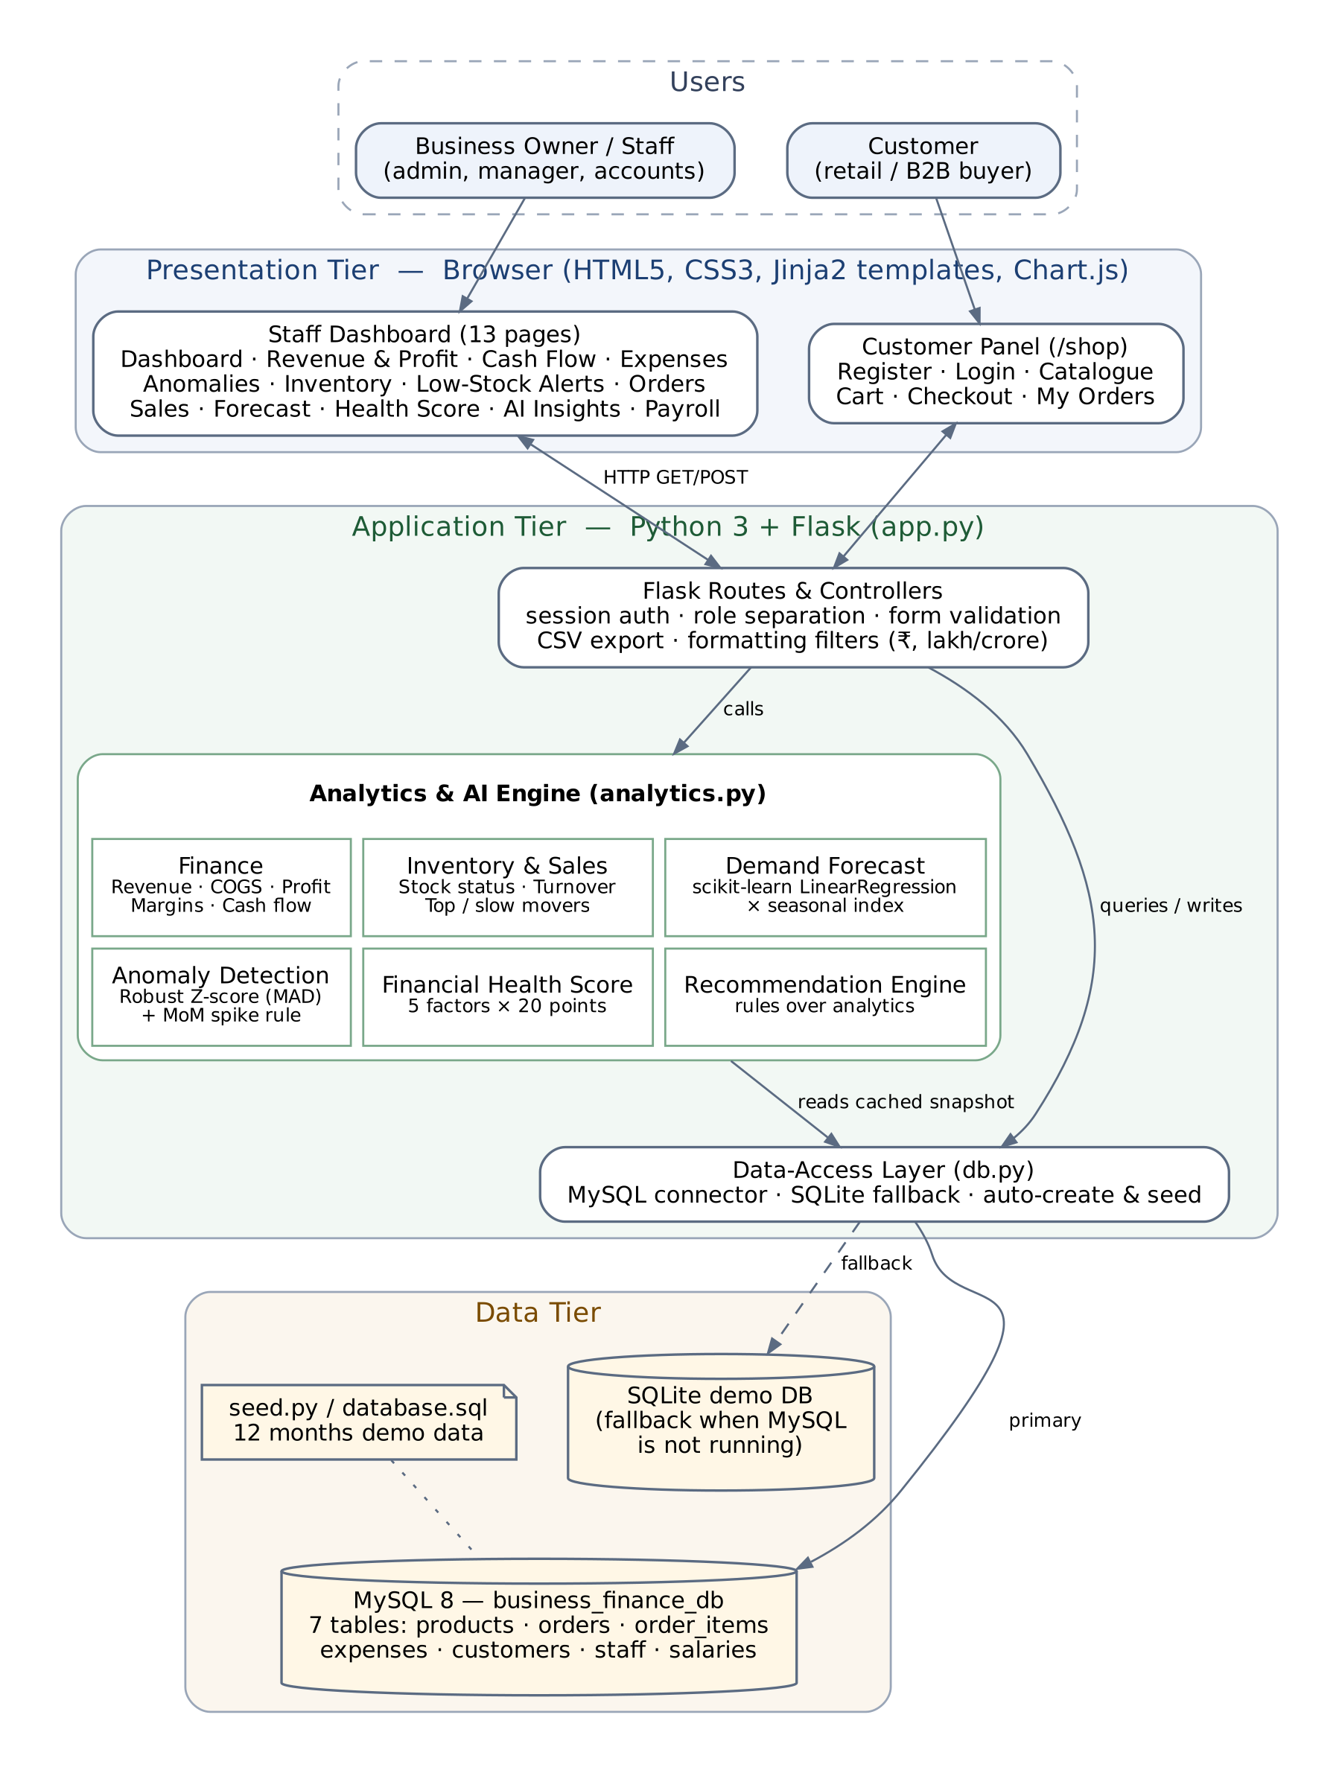
Figure 1: System Architecture
Figure 2 shows the deployment view: the browser communicates with the Flask server on port 5000, which connects to the MySQL server on port 3306. MySQL Workbench is used to administer and inspect the database.
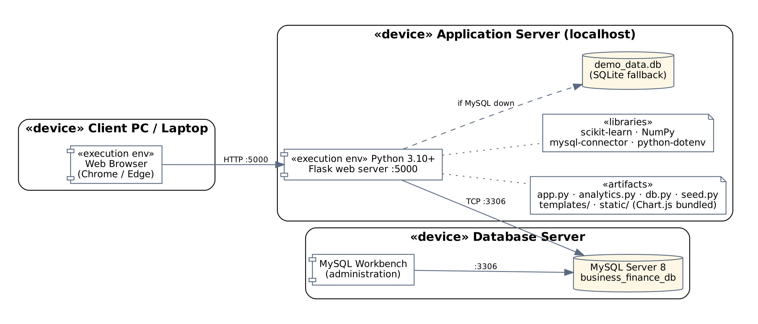
Figure 2: Deployment Diagram

6. System Design (UML Diagrams)

6.1 Use Case Diagram
The system has two actors. The Staff / Admin actor uses the finance, inventory, sales and AI features and manages customer orders. The Customer actor registers, browses products, manages a cart, places orders and tracks them. Placing an order includes managing the cart, and reviewing anomalies extends expense management.
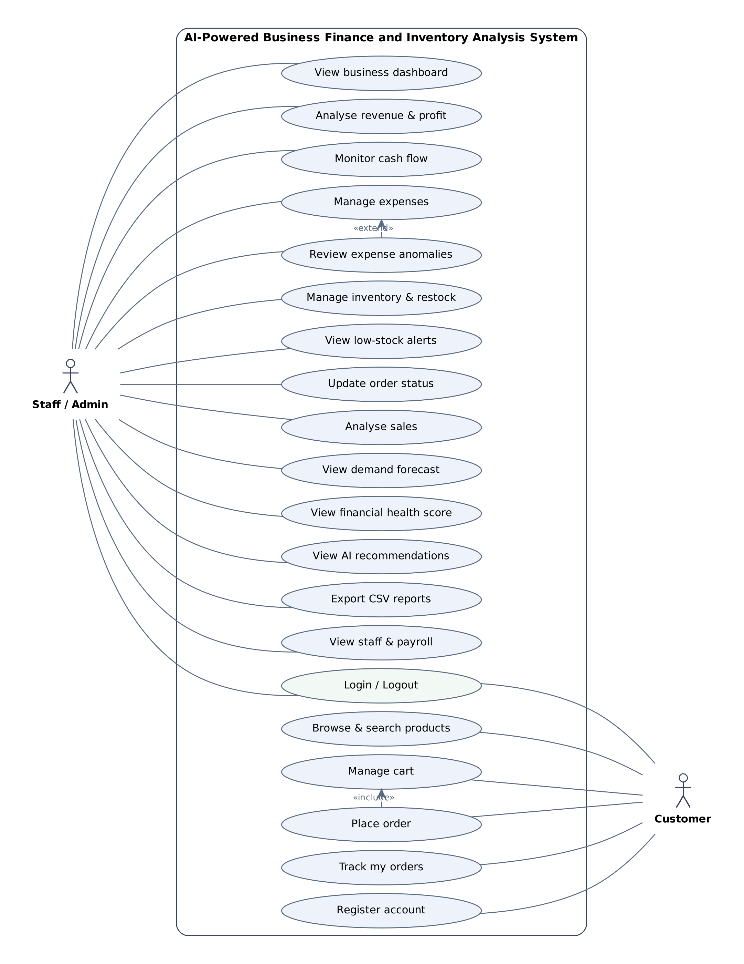
Figure 3: Use Case Diagram

6.2 Class Diagram
Figure 4 shows the main software components and the domain entities. FlaskApp uses the AnalyticsEngine and the DB data-access class; the engine loads a cached snapshot through DB; Seed generates demo data for an empty database. A Customer places Orders, each Order is composed of one or more OrderItems, and each OrderItem refers to a Product.
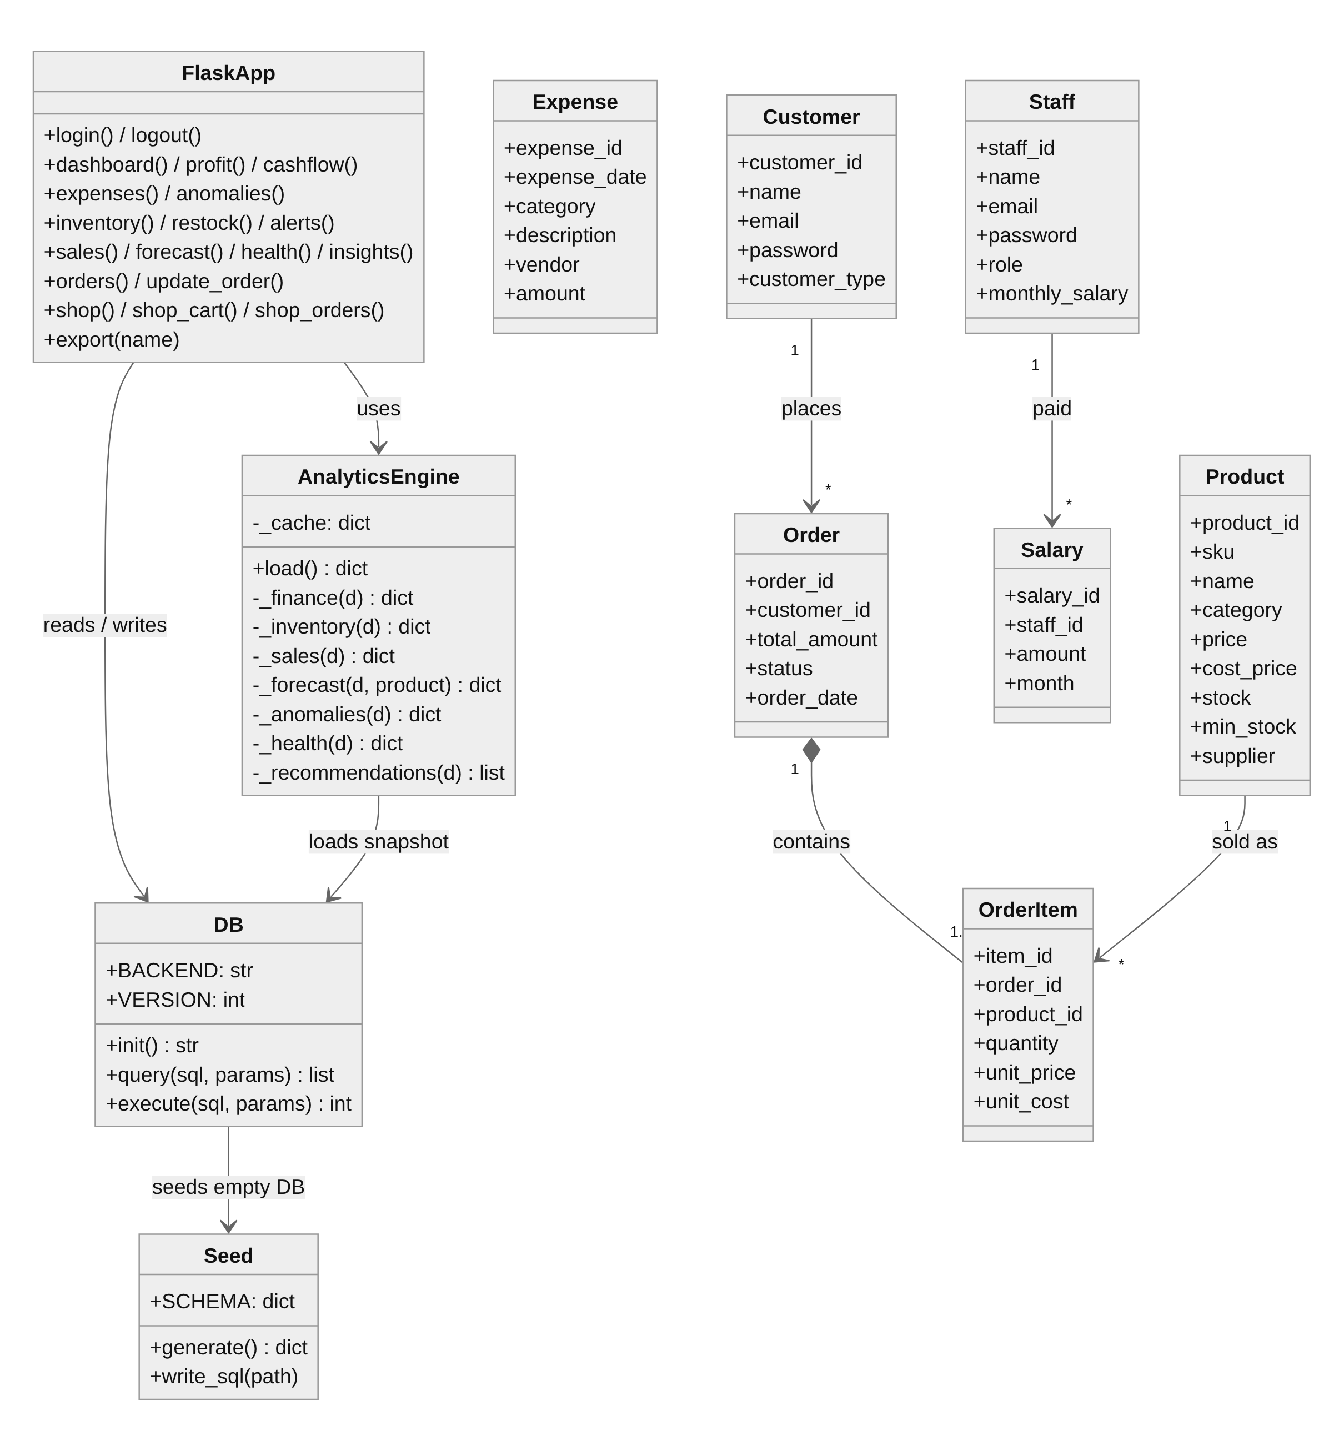
Figure 4: Class Diagram

6.3 Sequence Diagrams
Figure 5 shows the customer placing an order. Stock is checked when a product is added to the cart and again at checkout; the order, its items and the stock reduction are written, and the next time staff open the alerts page the analytics snapshot is reloaded because the data version has changed.
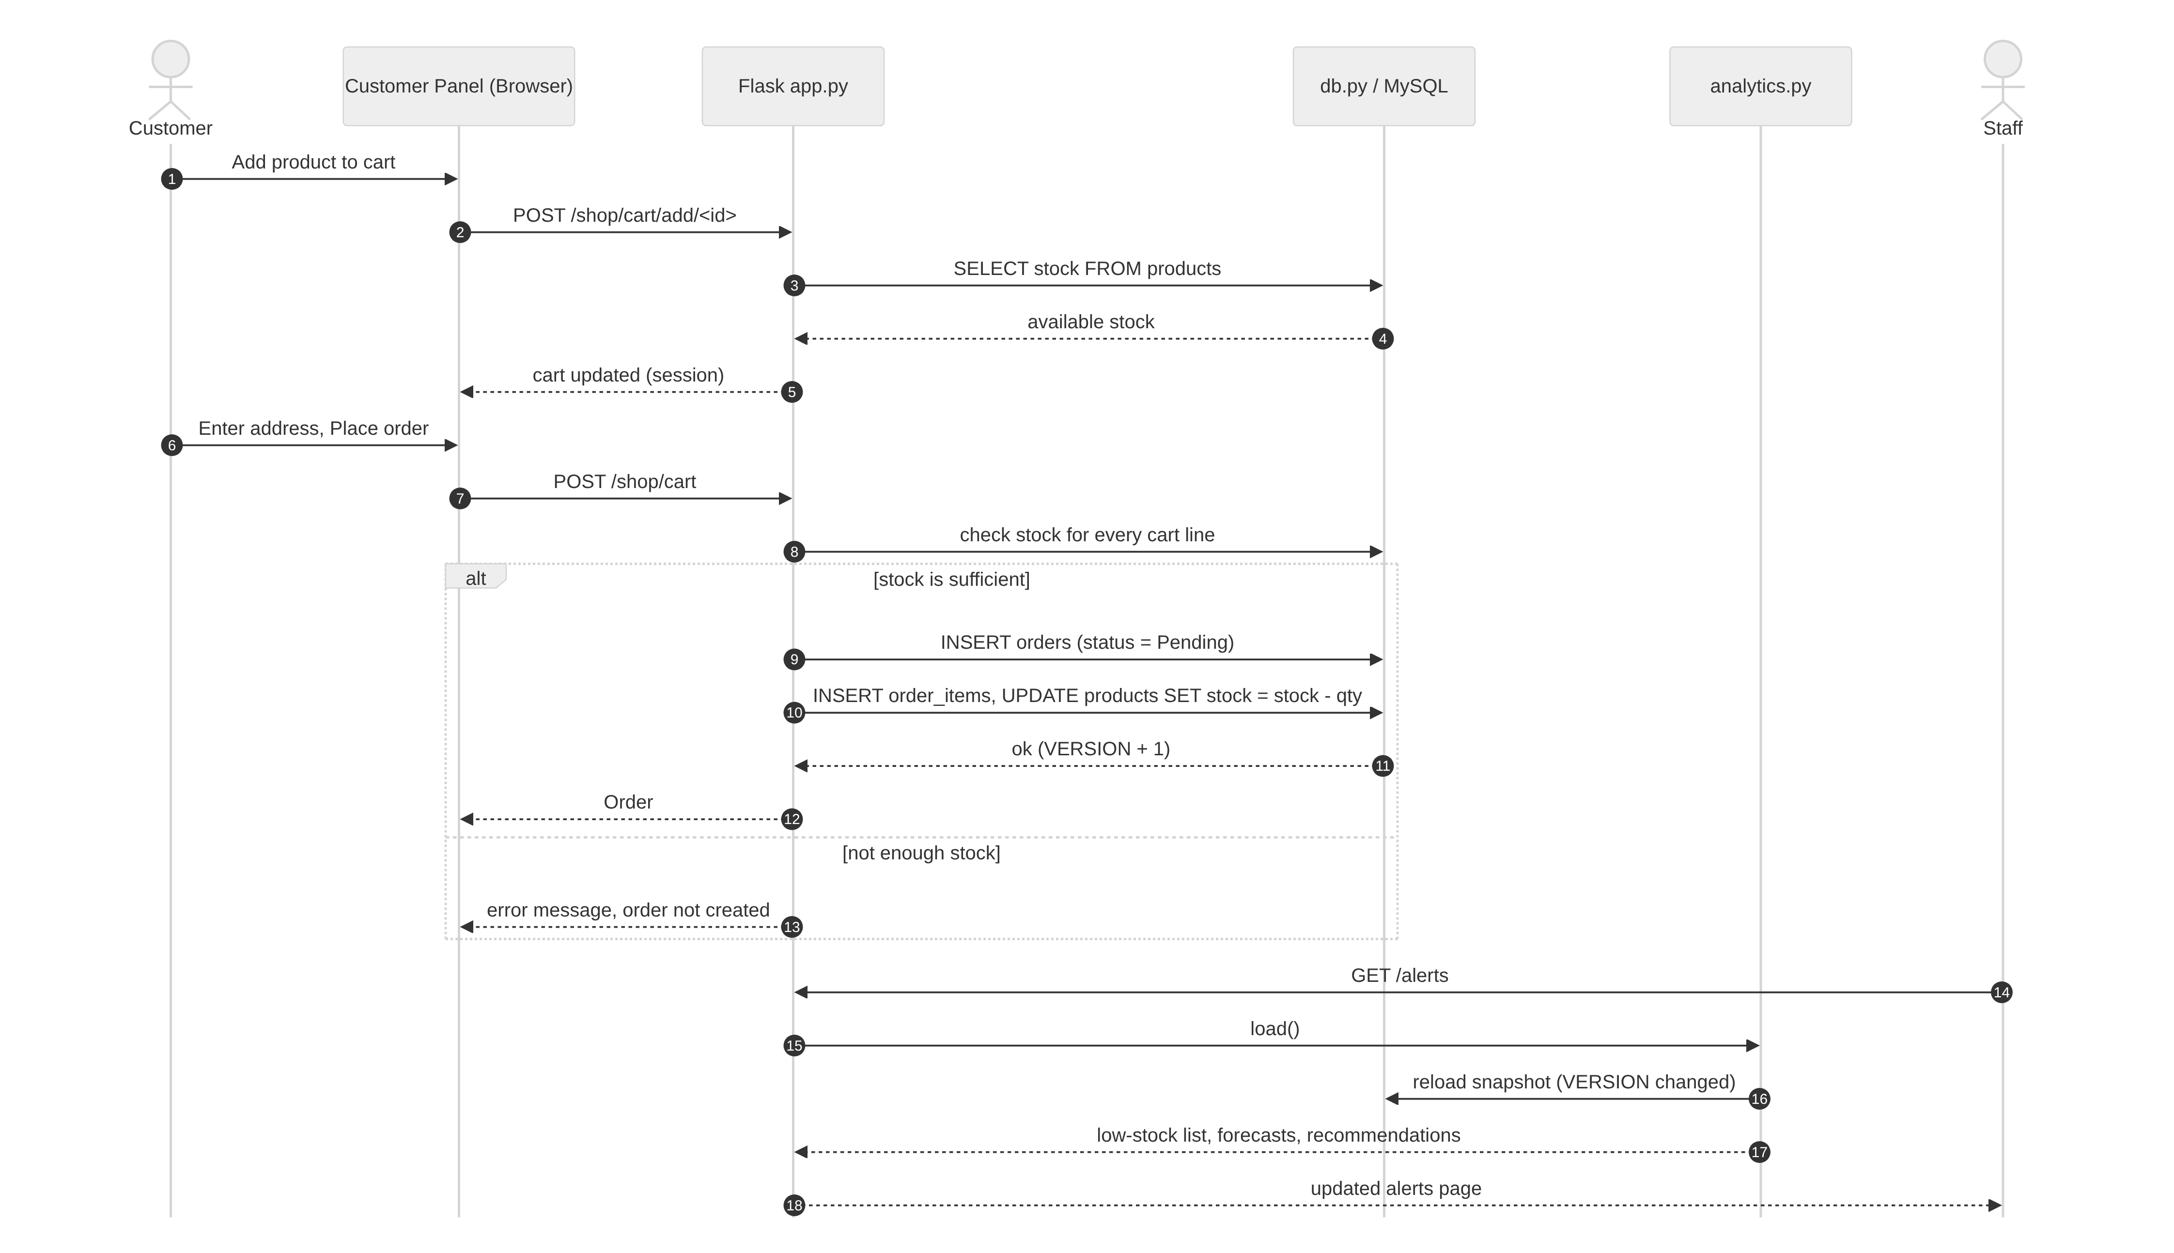
Figure 5: Sequence Diagram — Customer Places an Order
Figure 6 shows a staff member adding an expense. After the insert, the analytics engine recomputes finance, inventory, sales, forecasts, anomalies, the health score and recommendations, so the new expense is immediately checked for unusual amounts.
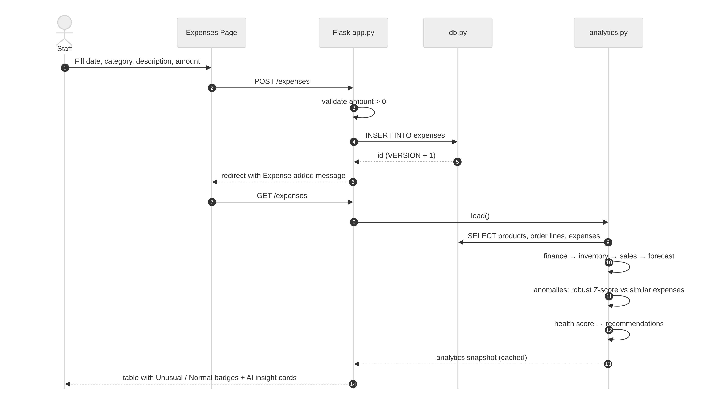
Figure 6: Sequence Diagram — Add Expense and Anomaly Check

6.4 Activity Diagrams
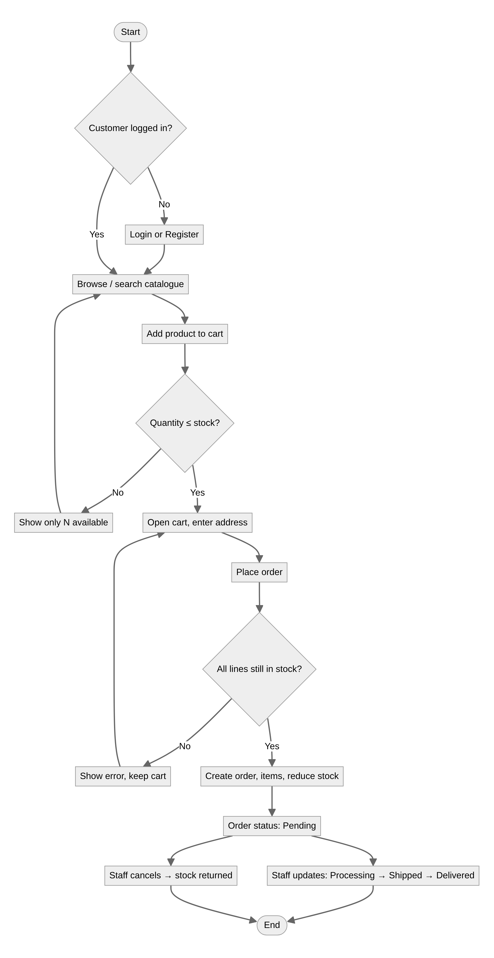
Figure 7: Activity Diagram — Order Processing
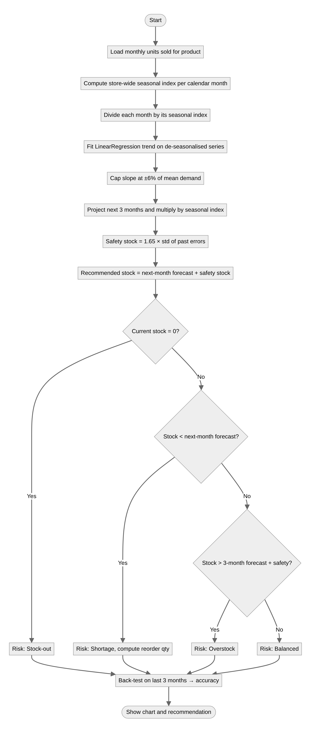
Figure 8: Activity Diagram — Demand Forecast and Stock Recommendation

6.5 Data Flow Diagram (Level 1)
Figure 9 shows the five main processes, their data stores and the two external entities.
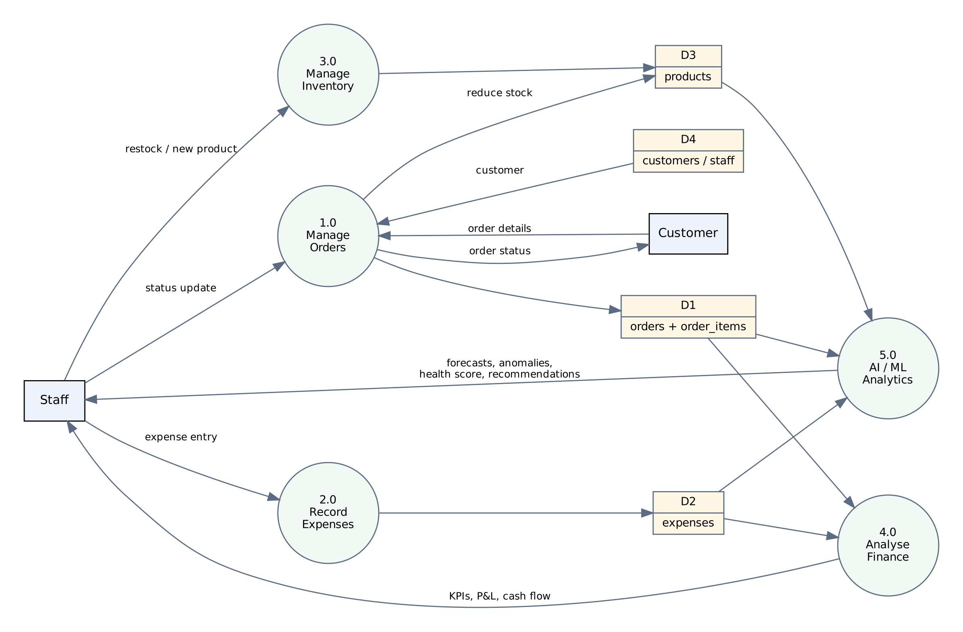
Figure 9: Data Flow Diagram — Level 1

6.6 Entity–Relationship Diagram
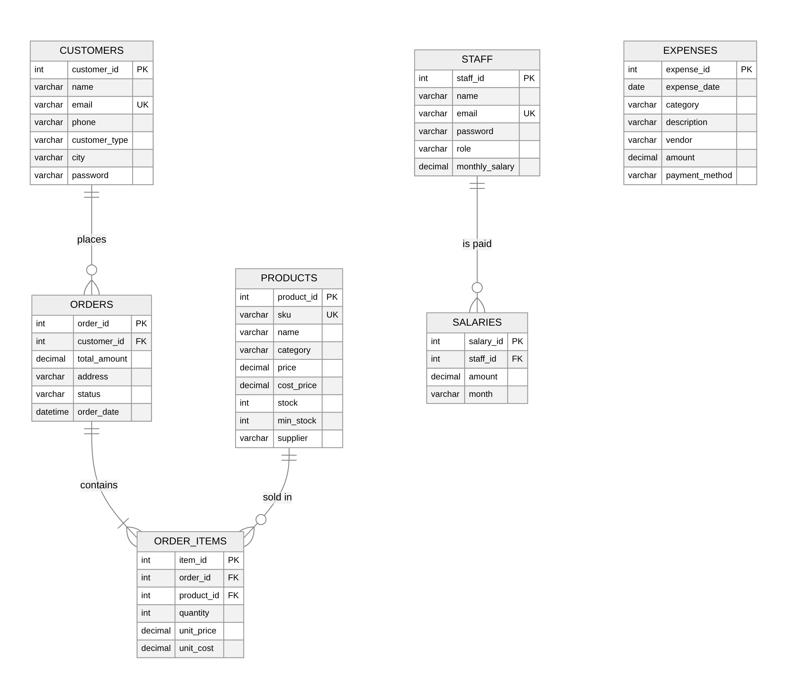
Figure 10: Entity–Relationship Diagram

7. Database Design and Dataset

7.1 Tables
The database business_finance_db contains seven tables in third normal form. Order items store the unit cost at the time of sale so that historical profit does not change when a product’s cost price is updated later.
Table 4: Database tables
Table | Key columns | Purpose
products | product_id (PK), sku (UK), price, cost_price, stock, min_stock, supplier | Product master and current stock
customers | customer_id (PK), email (UK), customer_type, password | Retail and B2B customers; customer-panel login
orders | order_id (PK), customer_id (FK), total_amount, status, order_date | Sales orders: Pending → Processing → Shipped → Delivered / Cancelled
order_items | item_id (PK), order_id (FK), product_id (FK), quantity, unit_price, unit_cost | Order lines; source of revenue and COGS
expenses | expense_id (PK), expense_date, category, description, vendor, amount | All money paid out, in 8 categories
staff | staff_id (PK), email (UK), password, role, monthly_salary | Staff accounts for the dashboard
salaries | salary_id (PK), staff_id (FK), amount, month | Monthly payroll history

7.2 Demo Dataset
Because a real business’s books could not be used, a deterministic generator (seed.py, fixed random seed 42) creates twelve months of data. The same file writes database.sql for import into MySQL Workbench. The data intentionally contains festive-season peaks, growing and declining products, low-stock, out-of-stock and overstocked items, and four planted unusual expenses so that every feature has meaningful examples.
Table 5: Summary of the demo dataset
Property | Value | Property | Value
Period | Oct 2025 – Sep 2026 | Products | 24 in 8 categories
Sales orders | 4,828 (4,736 not cancelled) | Order lines | 9,448
Expenses | 253 in 8 categories | Customers / staff | 20 (6 B2B) / 6
Total revenue | ₹2,07,41,820 | Units sold | 15,244
Average order value | ₹4,380 | Inventory value (cost) | ₹14,45,460

Table 6: Expense categories
Category | Examples in the data
Rent | Shop and warehouse rent
Salaries | Monthly payroll for 6 employees
Utilities | Electricity, internet and phone, water
Marketing | Social-media ads, search ads, flyers, festive campaign
Inventory Purchase | Stock replenishment purchase orders
Transportation | Courier and inbound freight
Operations | Software subscriptions, maintenance, packaging
Miscellaneous | Stationery, refreshments, penalties

8. Analytics and AI Methodology

8.1 Finance Metrics
Table 7: Finance formulas used
Metric | Formula
Revenue | Σ quantity × unit_price over non-cancelled orders
Cost of goods sold (COGS) | Σ quantity × unit_cost over non-cancelled orders
Gross profit / gross margin | Revenue − COGS; Gross profit ÷ Revenue × 100
Operating expenses | All expenses except Inventory Purchase
Net profit / net margin | Gross profit − Operating expenses; Net profit ÷ Revenue × 100
Cash inflow / outflow | Sales receipts; all expenses including stock purchases
Net cash flow | Inflow − Outflow (can be negative in a profitable month when stock is bought ahead)
Sales growth | Last 3 months’ revenue vs the previous 3 months
Inventory turnover | Annual COGS ÷ inventory value at cost

Stock status uses the average daily demand of the last three months: Out of Stock when stock = 0, Low Stock when stock ≤ minimum stock, Overstock when stock covers more than 120 days, otherwise In Stock. A month that has only just started (less than 25% of a typical month’s revenue) is shown separately as “in progress” so that a few new orders do not distort growth and forecasts.

8.2 Demand Forecasting
For each product the monthly units sold are divided by a store-wide seasonal index (each month’s total units divided by the overall linear trend). A linear trend is fitted to the de-seasonalised series with scikit-learn’s LinearRegression, the slope is limited to ±6% of average demand per month so that one unusual month cannot dominate, the trend is projected three months ahead and multiplied by the seasonal index of each target month.
- Safety stock = ⌈1.65 × standard deviation of the model’s past errors⌉ (about a 95% service level).
- Recommended stock = next month’s forecast + safety stock; reorder quantity = recommended stock − current stock.
- Shortage when stock < next month’s forecast; overstock when stock > three months’ forecast + safety stock.
- Accuracy is a back-test: the model is trained without the last three months, predicts them, and accuracy = 100% − weighted absolute percentage error.

8.3 Expense Anomaly Detection
Each operating expense is compared with similar expenses — those with the same description when at least six exist, otherwise the whole category. A robust Z-score is used because the mean and standard deviation are themselves distorted by the outliers being searched for:
z = (amount − median) ÷ (1.4826 × MAD), where MAD is the median absolute deviation.
An expense is flagged when z ≥ 3.5 and it is at least 1.5 times the typical (median) amount; it is High severity at 3 times or more, otherwise Medium. Separately, a category is flagged for a month when its total rose more than 30% over the previous month and is more than 30% above its typical month. Stock purchases are excluded because they follow sales volume.

8.4 Financial Health Score
Table 8: Financial Health Score factors (20 points each)
Factor | Measured value | Scoring rule
Profitability | Net profit margin | 0 at break-even, full marks at 15% or more
Expense Control | Operating expenses ÷ revenue | Full marks at 20% or less, 0 at 40%
Cash Flow | Share of cash-positive months; last-3-month net cash ÷ inflow | 10 points each; full at all months positive and at 10% of inflow
Revenue Growth | Last 3 months vs previous 3 | 0 at −10%, 10 at 0%, full at +10%
Inventory Efficiency | Turnover; share of products at healthy stock | 10 points each; full at 8× a year and at 90% healthy

Each factor is scaled linearly between its zero and full-marks points and clipped. The total is graded Excellent (80+), Good (65–79), Fair (50–64) or Needs Attention (below 50). No random or hand-set values are used.

8.5 AI Recommendation Engine
The recommendation engine applies rules to the outputs above and ranks the results High, Medium or Low. Each recommendation quotes the figures that triggered it and links to the page with the details.
Table 9: Recommendation rules
Area | Rule (trigger) | Recommended action
Inventory | Product out of stock | Raise a purchase order for the recommended quantity with the supplier
Inventory | Stock lasts less than 30 days against the forecast | Reorder to reach the recommended stock
Inventory | Stock above 3 months of forecast demand | Pause reorders; clearance or bundle offer
Sales | Units up ≥ 10% (last 3 months vs previous 3) | Increase stock cover and promotion
Sales | Units down ≥ 10% | Review pricing or discount before reordering
Expenses | Category spike in the latest month; unusual expenses found | Verify approval and return on the spend
Expenses | Operating costs growing faster than revenue | Set category budgets
Cash flow | Latest month cash-negative / improved | Stagger supplier payments; keep one month’s buffer
Profit | Net margin moved by ≥ 1 point | Review the largest expense changes

9. Implementation and Modules
The application consists of four Python files and twenty-two Jinja2 templates. The table below lists the modules, and the figures that follow show the running system.
Table 10: Application modules
Module | Route | Main content
Business Dashboard | / | 8 KPI cards, 7 charts, top AI insights
Revenue & Profit | /profit | Stacked revenue split, margin trend, growth, P&L table
Cash Flow | /cashflow | Inflow vs outflow, net cash, cumulative cash with projection, decision notes
Expenses | /expenses | Add / filter / delete, category charts, unusual-expense insight, CSV
Expense Anomalies | /anomalies | Flagged expenses with reason and severity, category spikes
Inventory | /inventory | Product table, value by category, status, add product, receive stock
Low Stock Alerts | /alerts | Out-of-stock, low-stock and overstock cards with restock
Customer Orders | /orders | Order list by status, status update, cancellation returns stock
Sales Analytics | /sales | Top / slow / rising products, categories, product demand
Demand Forecast | /forecast | Actual vs predicted chart, recommendation table
Financial Health | /health-score | Score, factor breakdown and explanation
AI Recommendations | /insights | Prioritised recommendation cards with filters
Customer Panel | /shop | Register, login, catalogue, cart, checkout, my orders

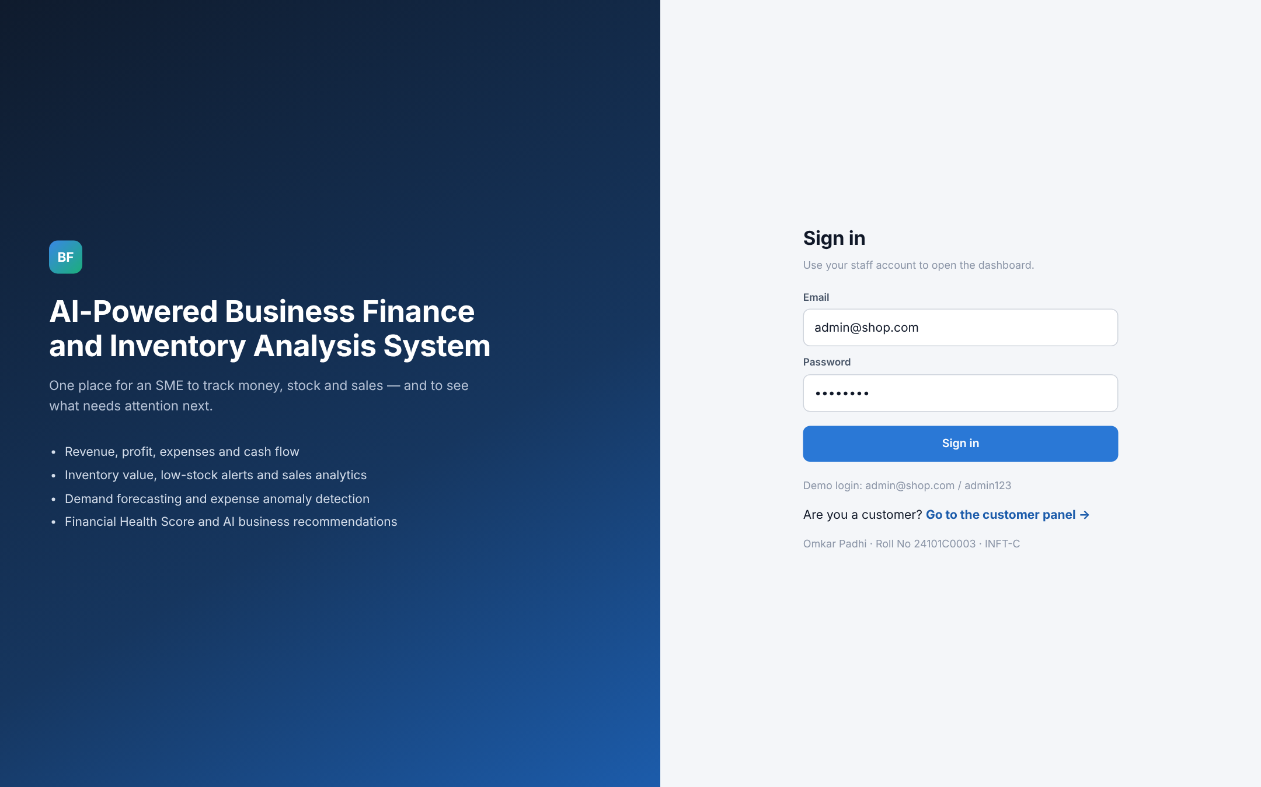
Figure 11: Staff Sign-in Page
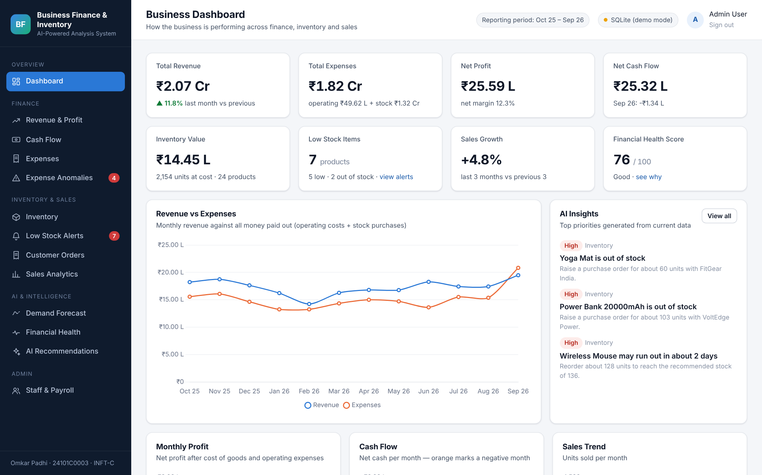
Figure 12: Business Dashboard
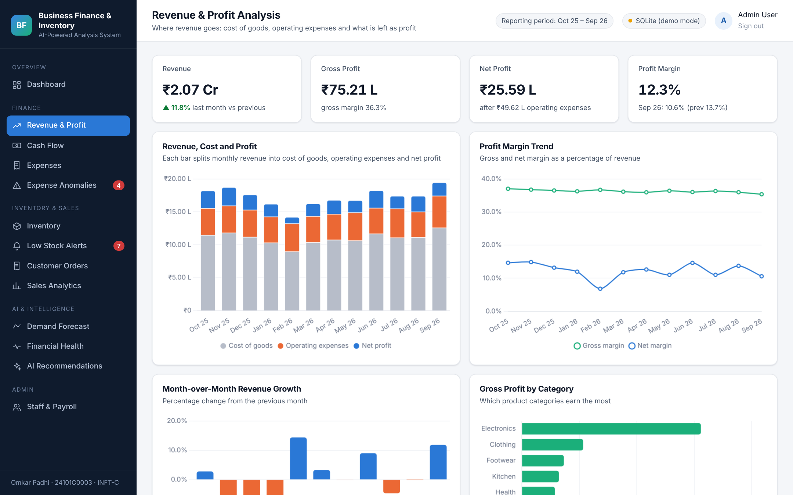
Figure 13: Revenue and Profit Analysis
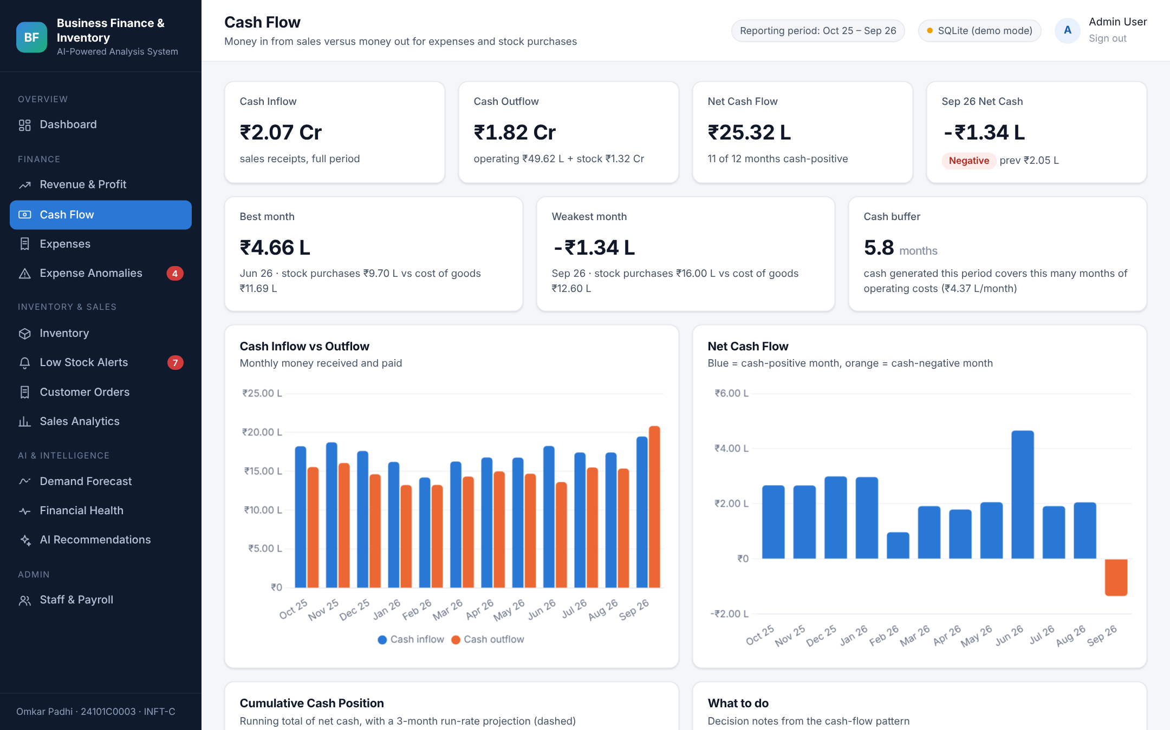
Figure 14: Cash Flow
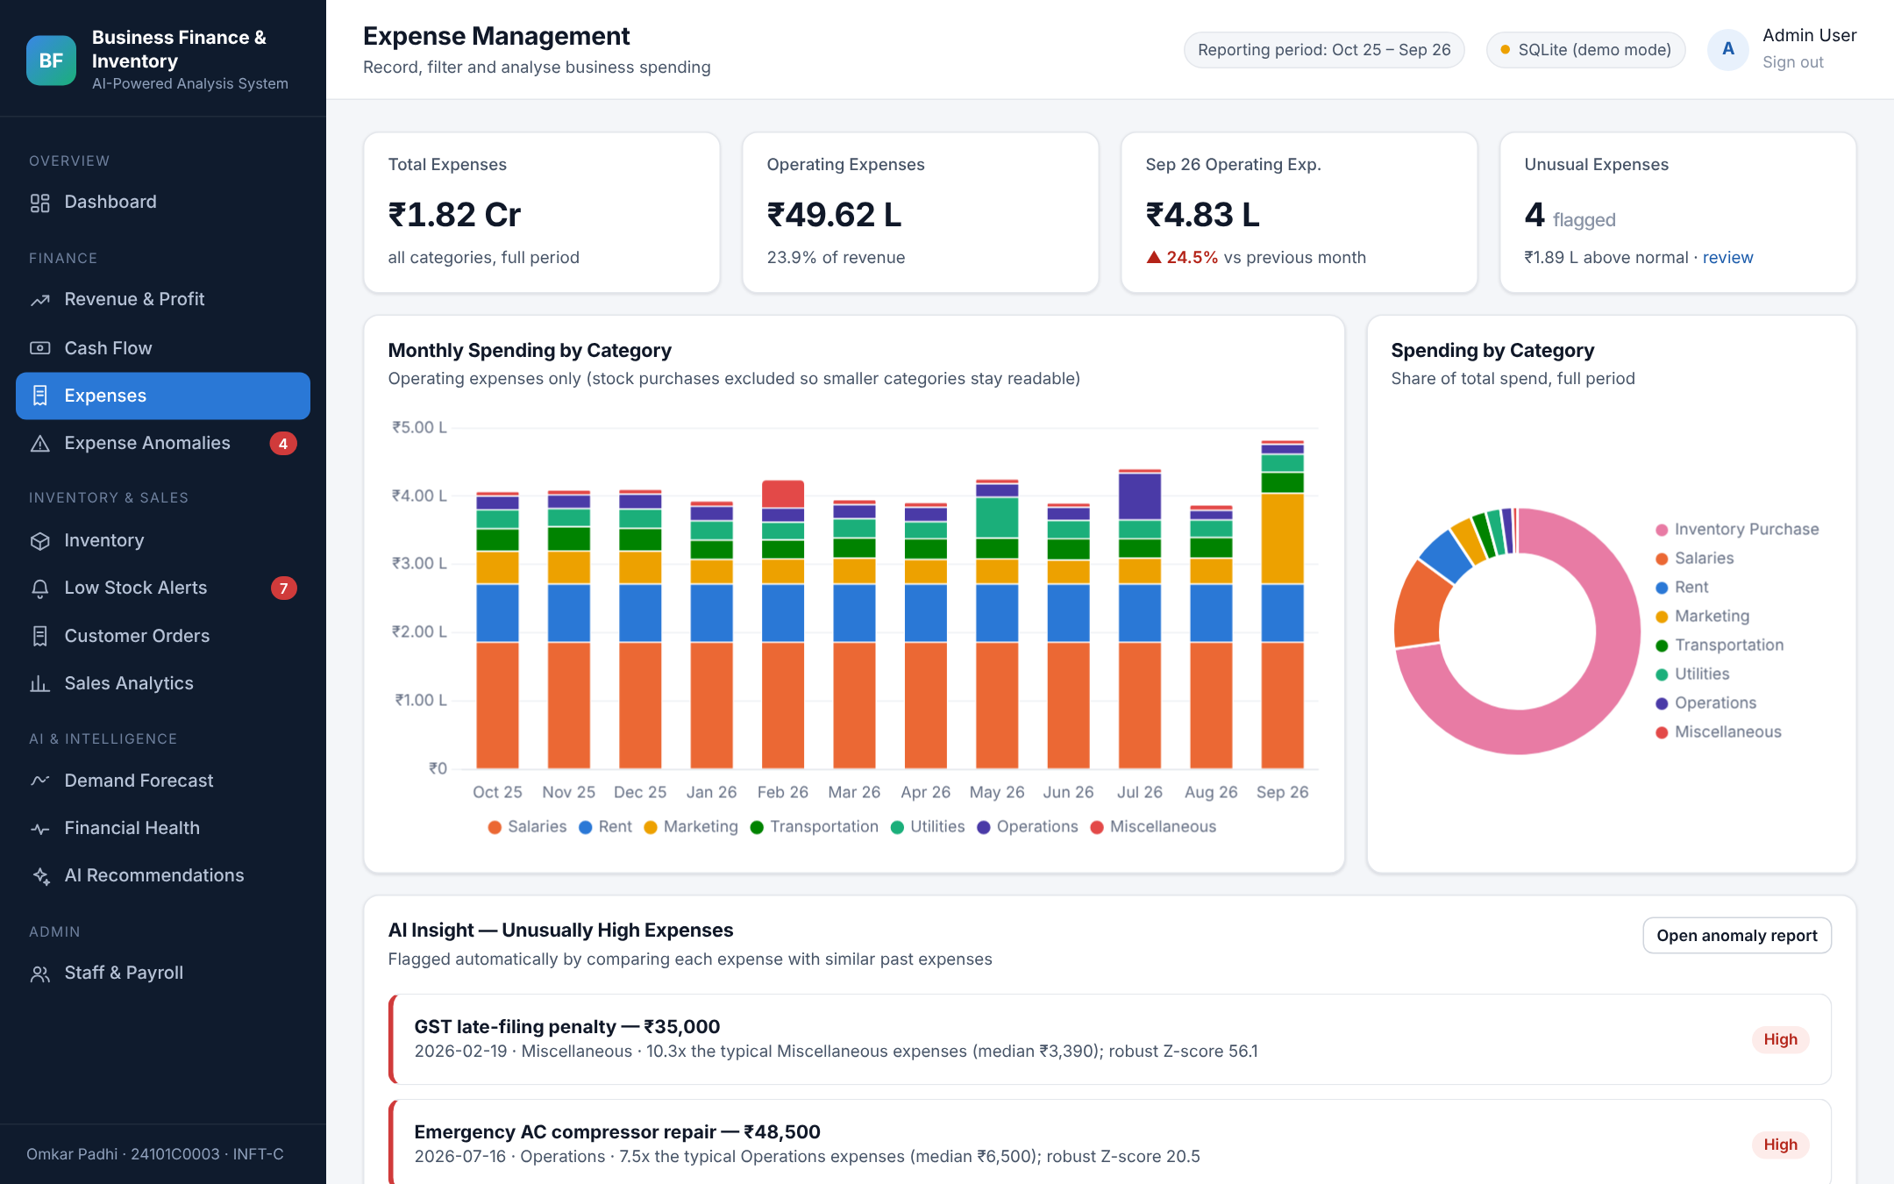
Figure 15: Expense Management
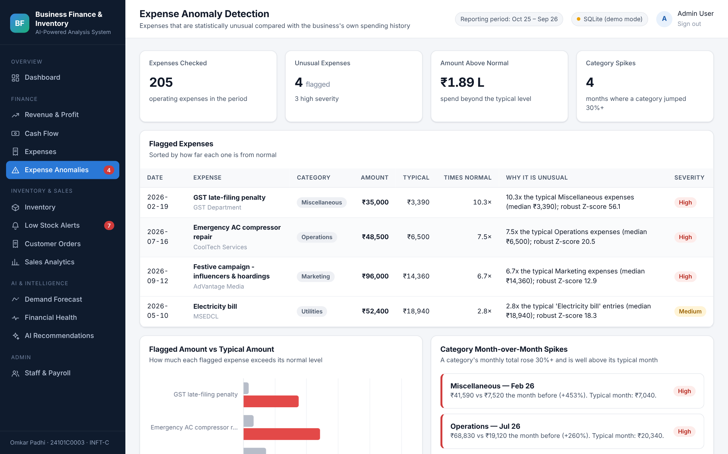
Figure 16: Expense Anomaly Detection
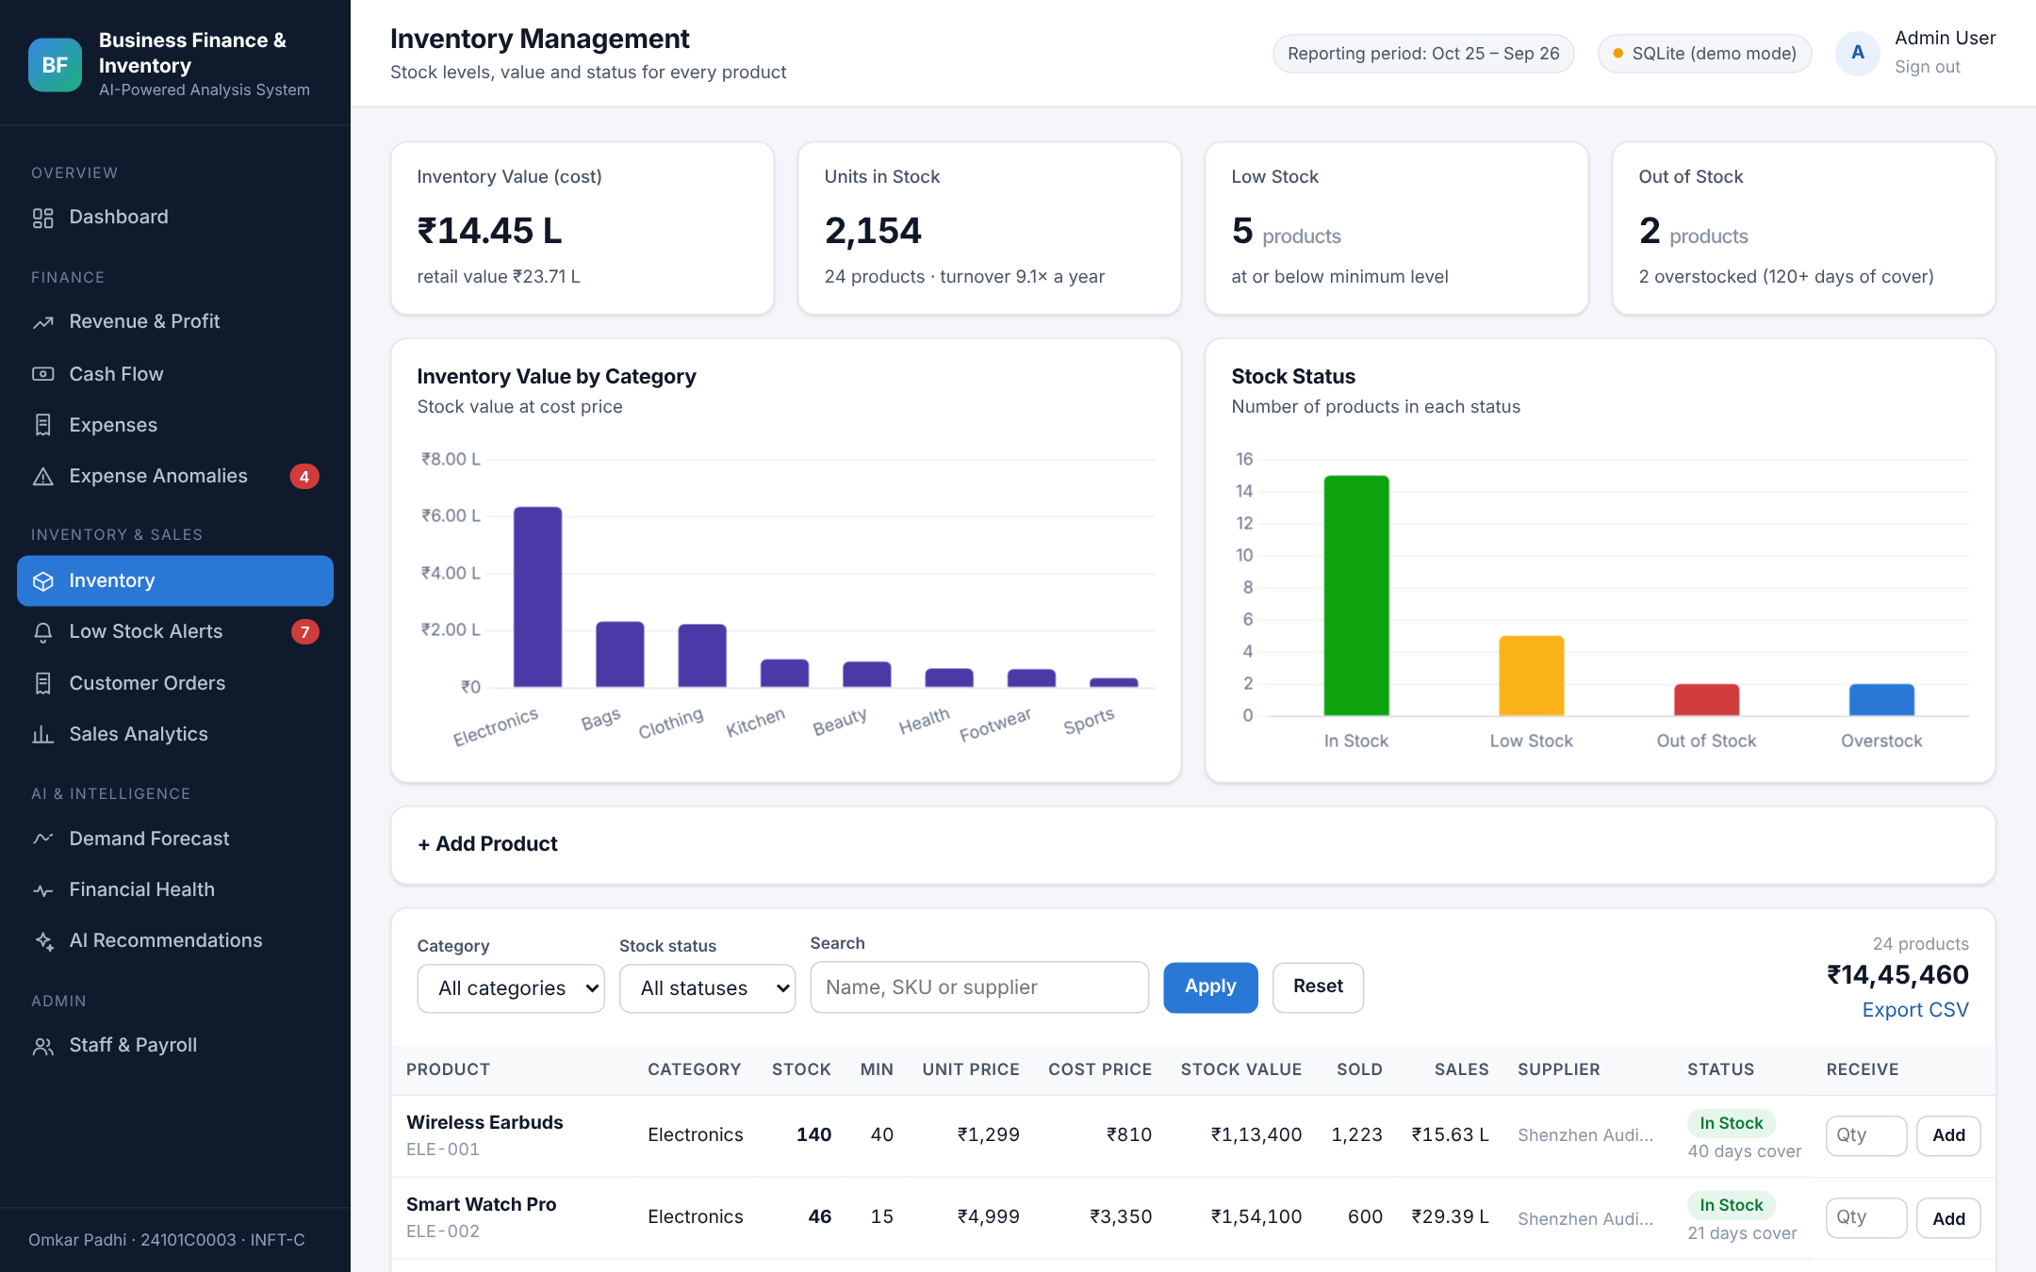
Figure 17: Inventory Management
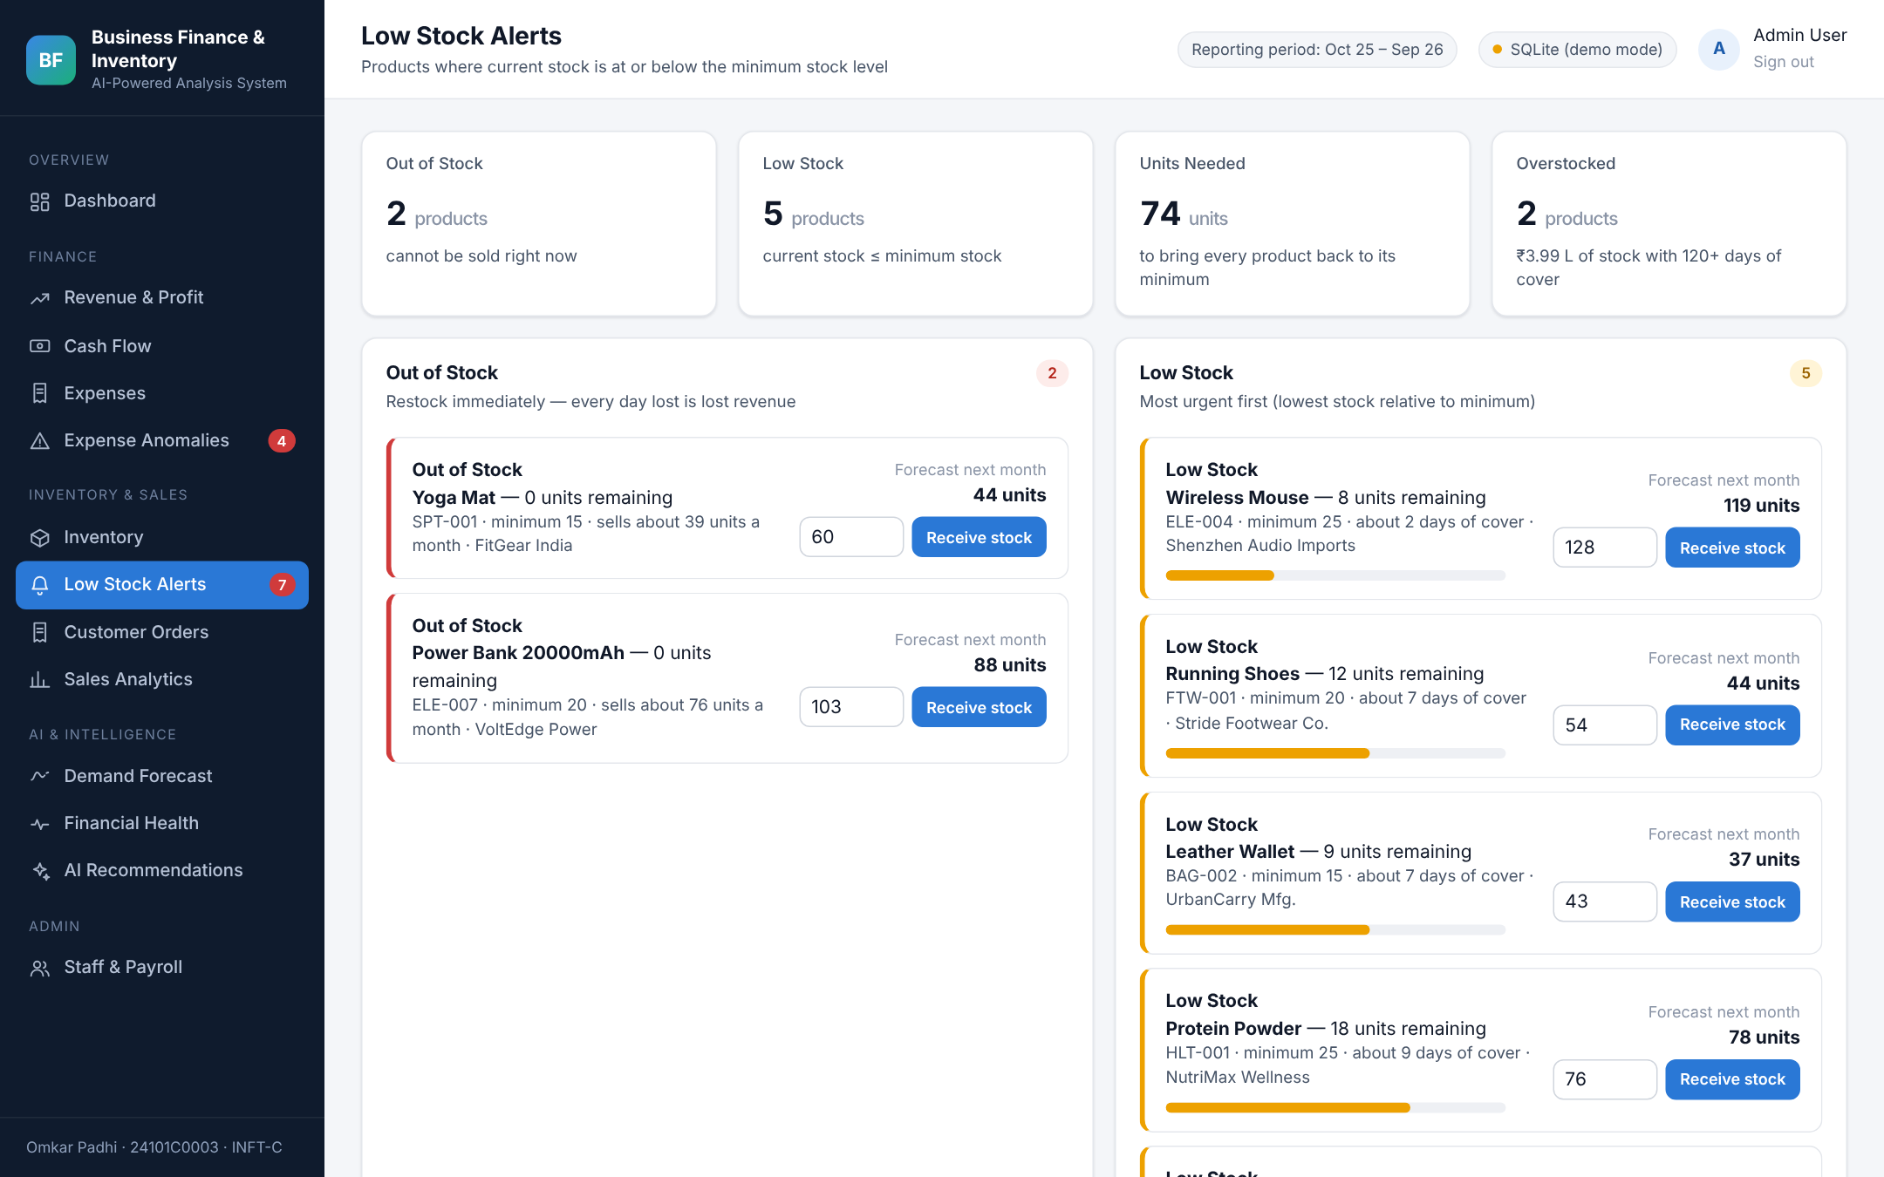
Figure 18: Low Stock Alerts
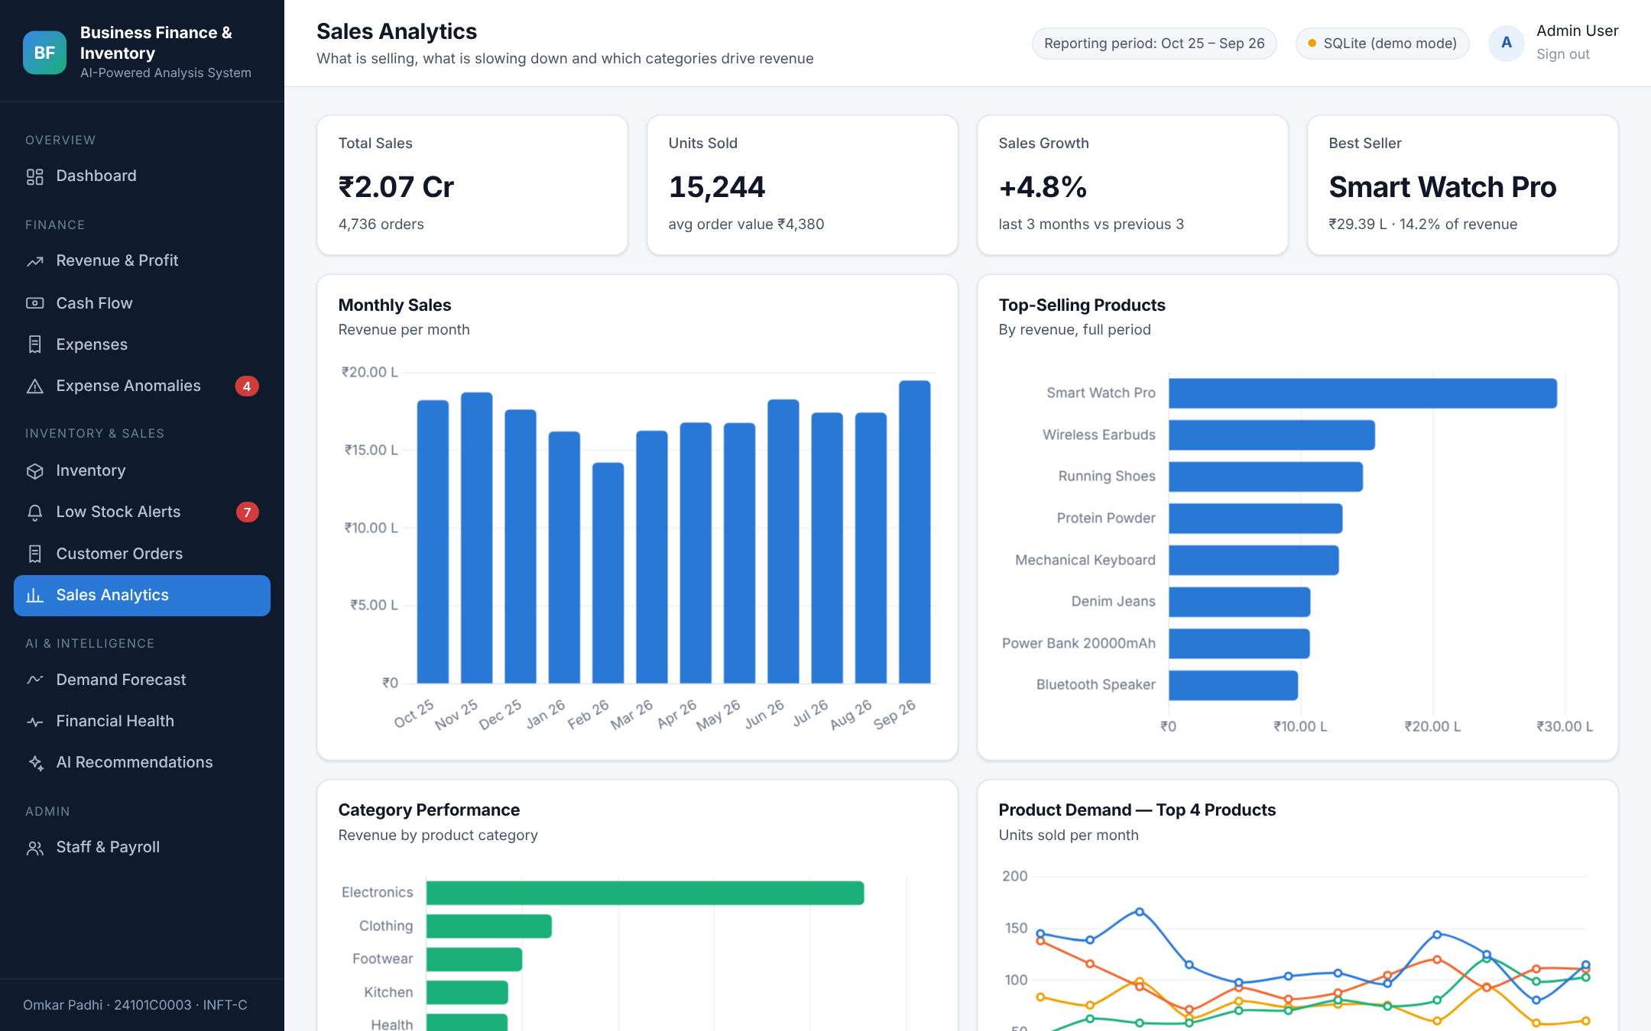
Figure 19: Sales Analytics
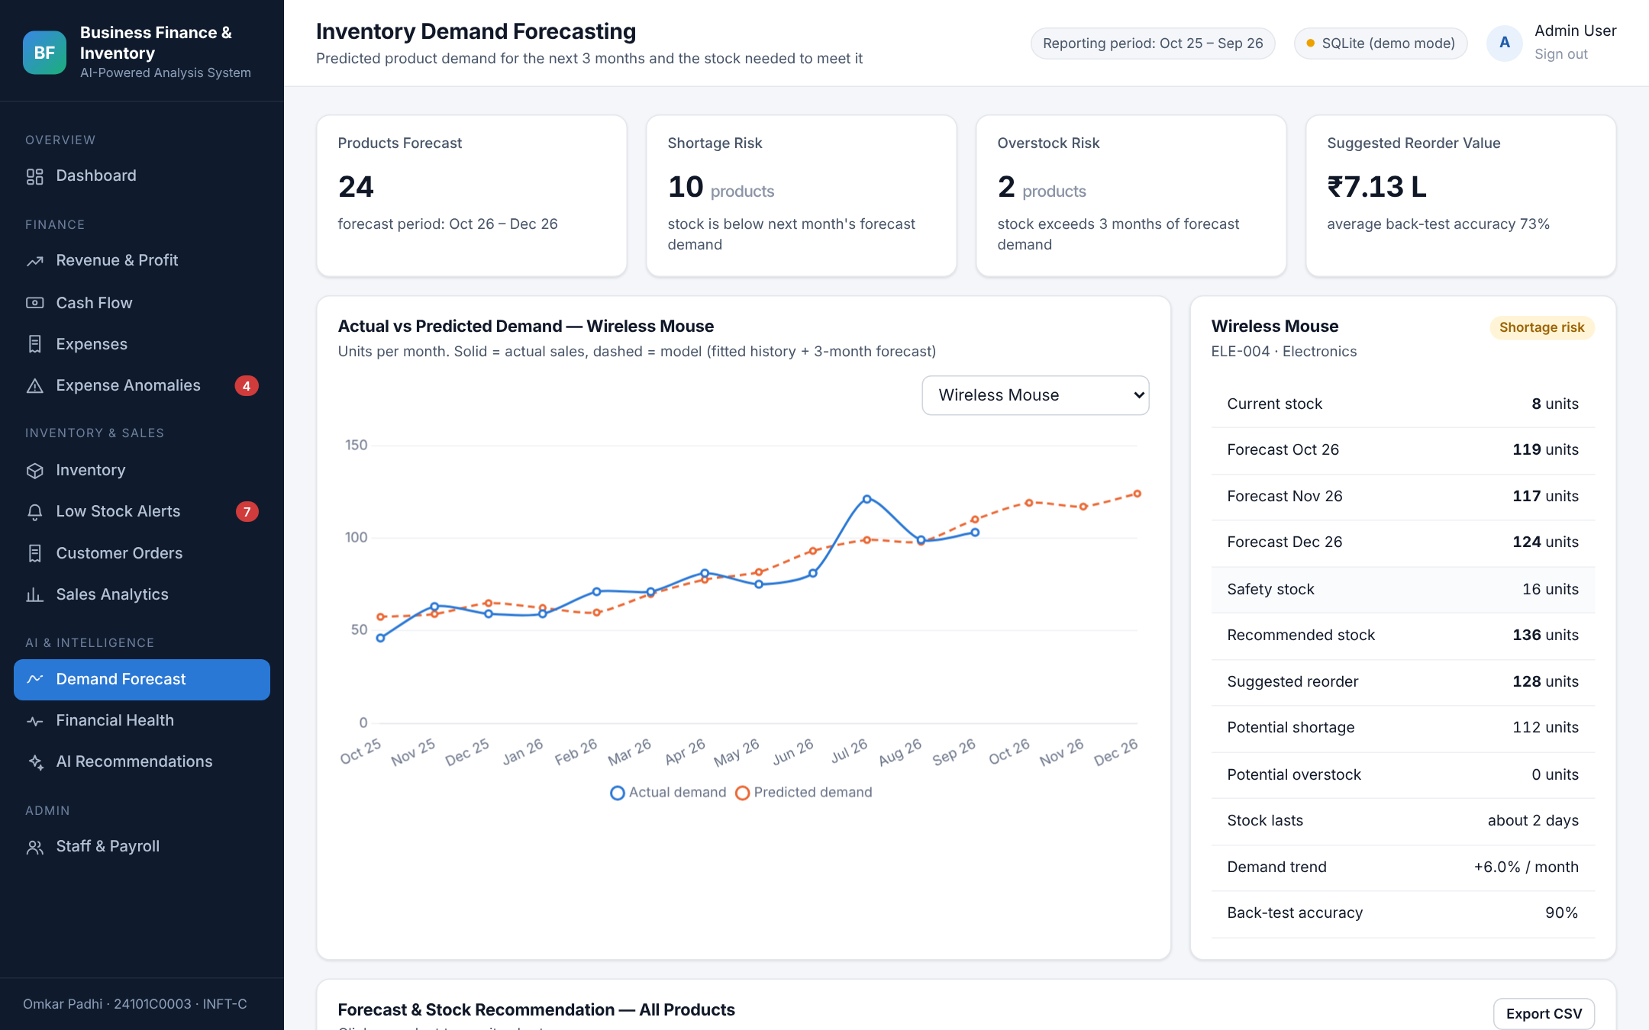
Figure 20: Demand Forecast — Actual vs Predicted (Wireless Mouse)
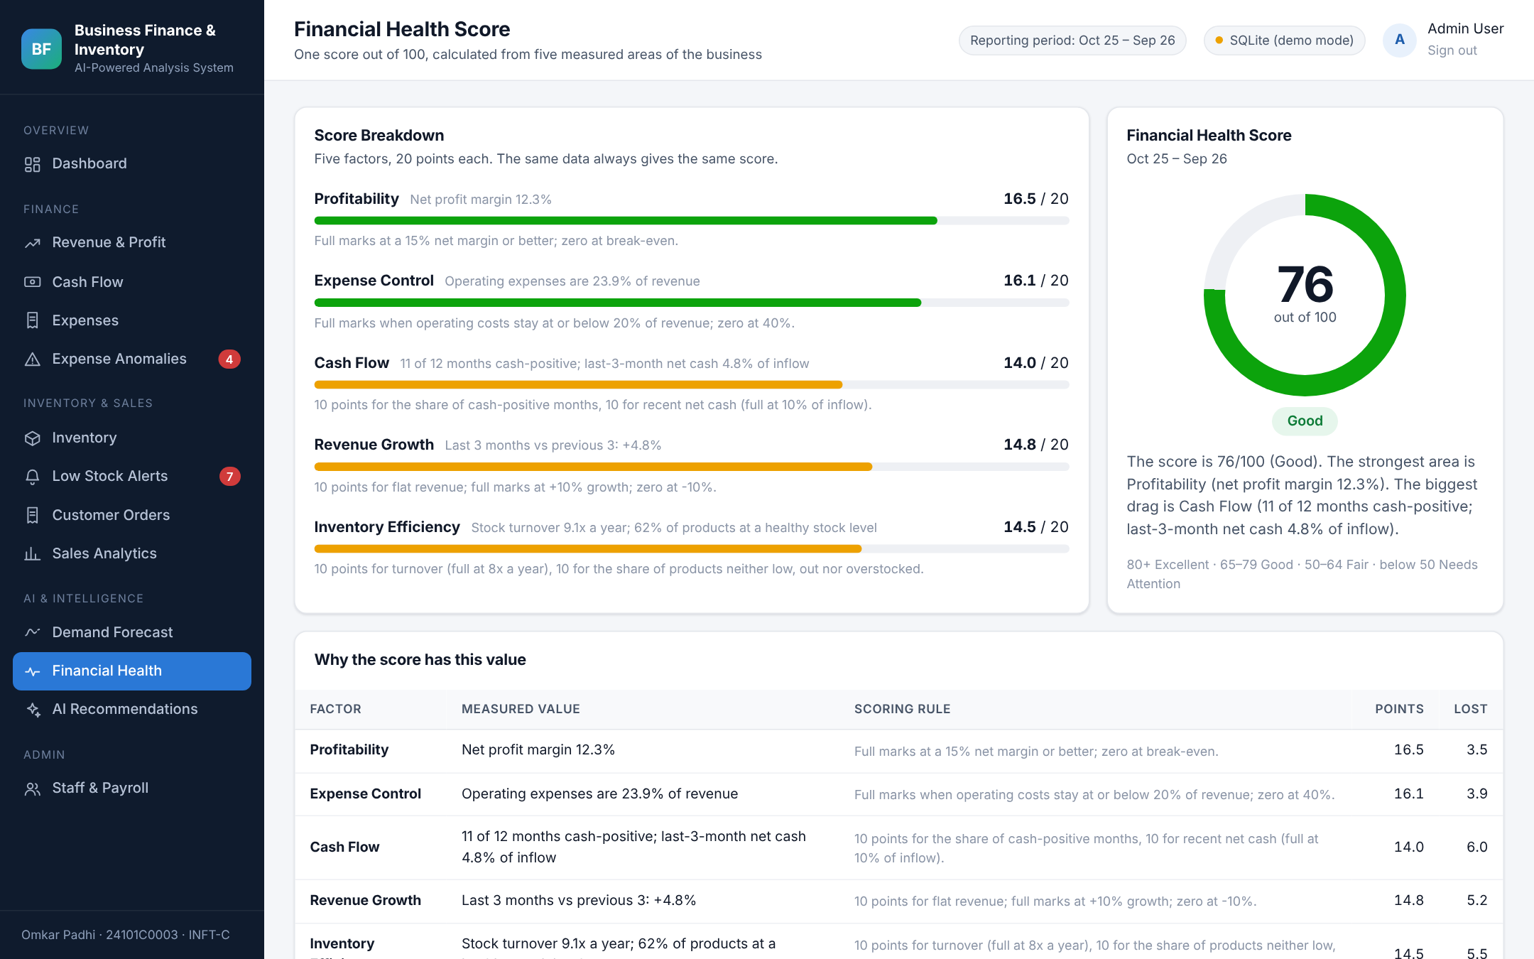
Figure 21: Financial Health Score
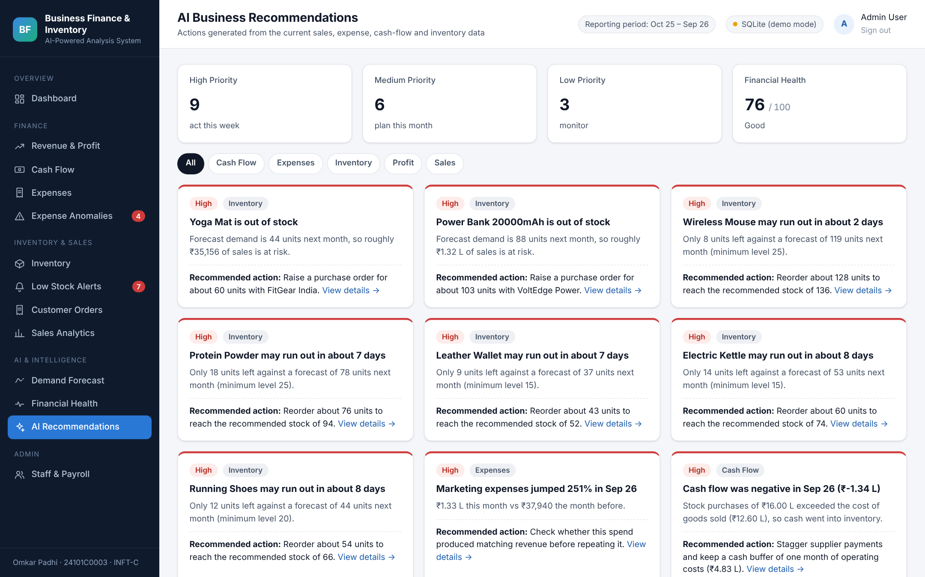
Figure 22: AI Business Recommendations
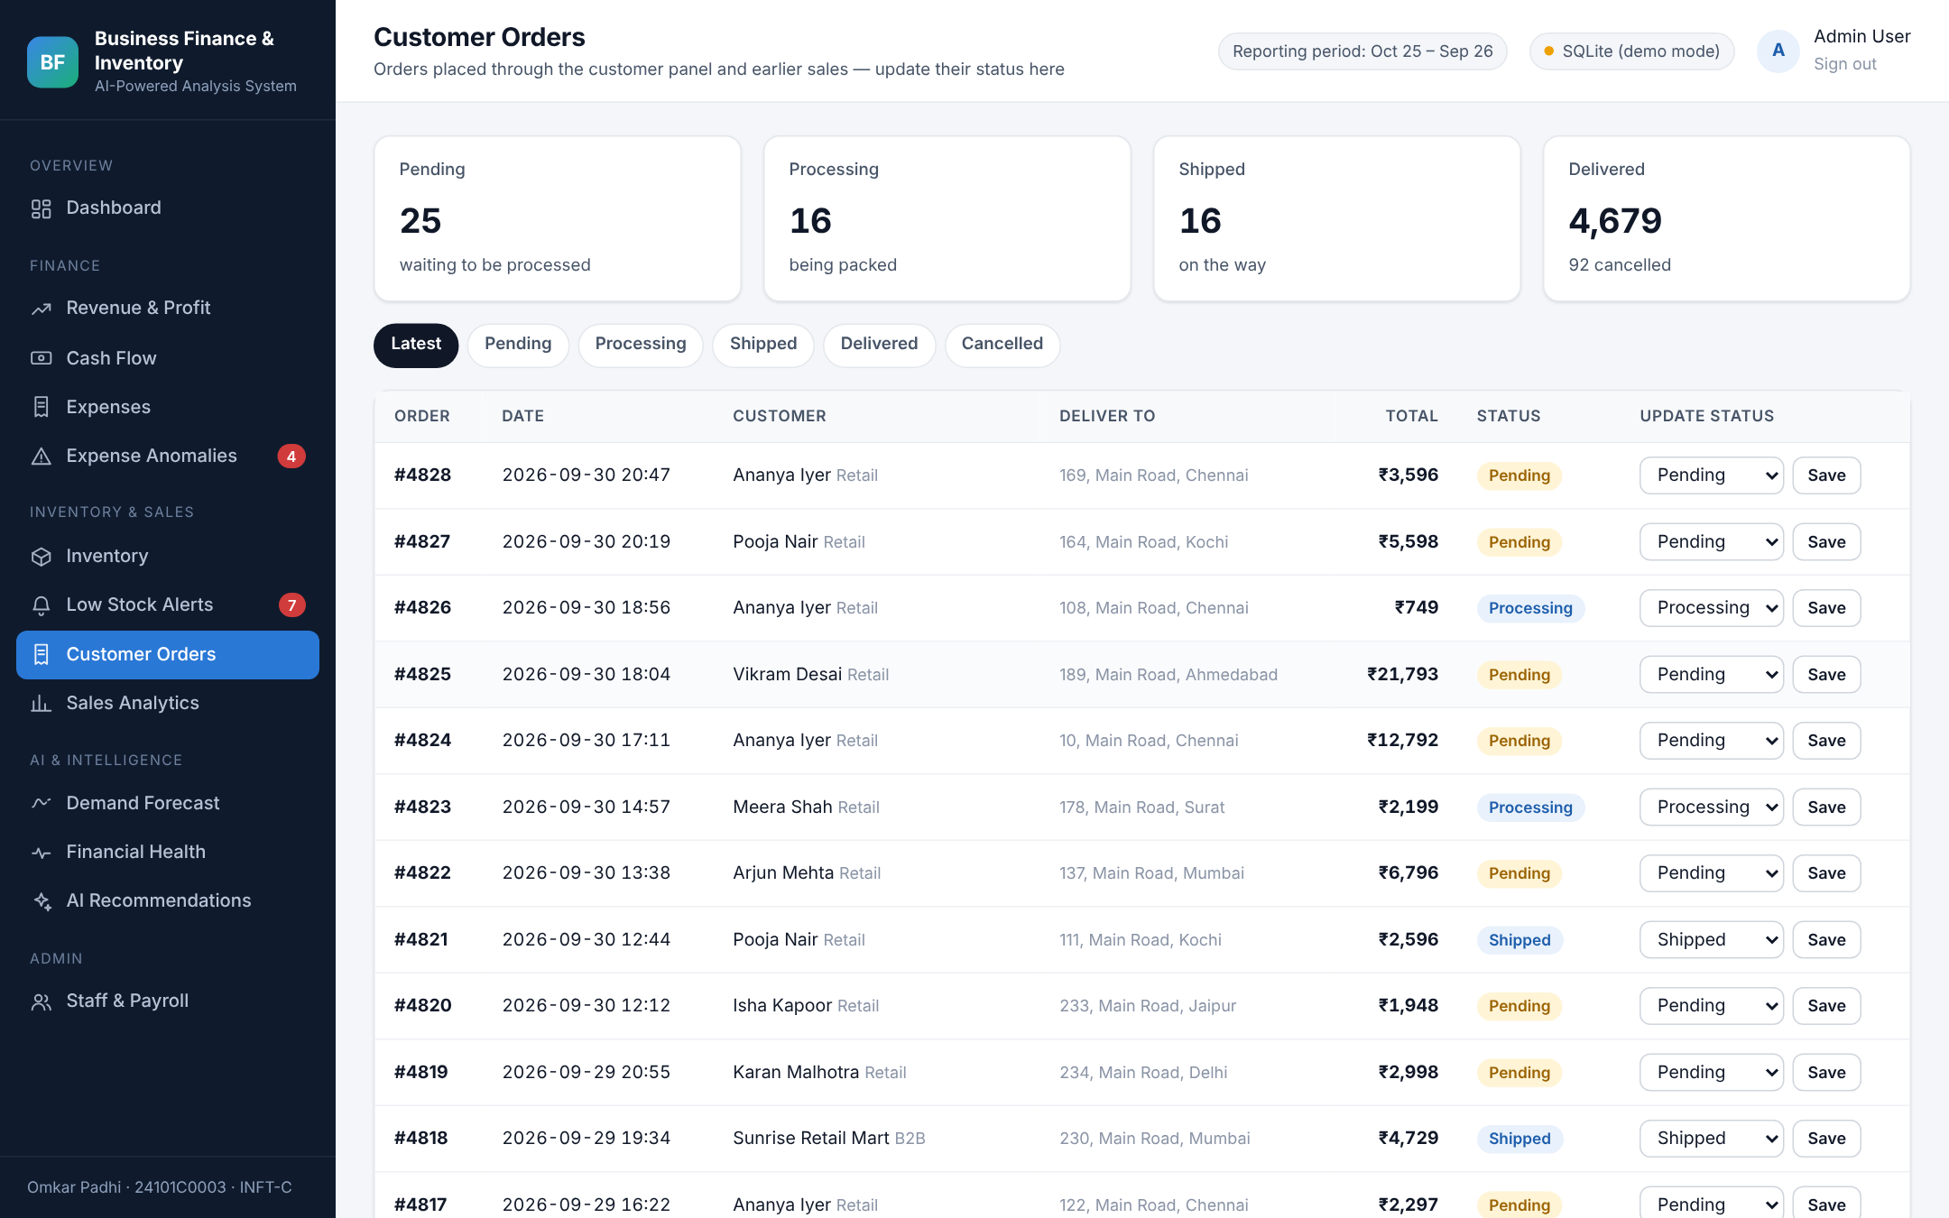
Figure 23: Customer Orders (Staff View)
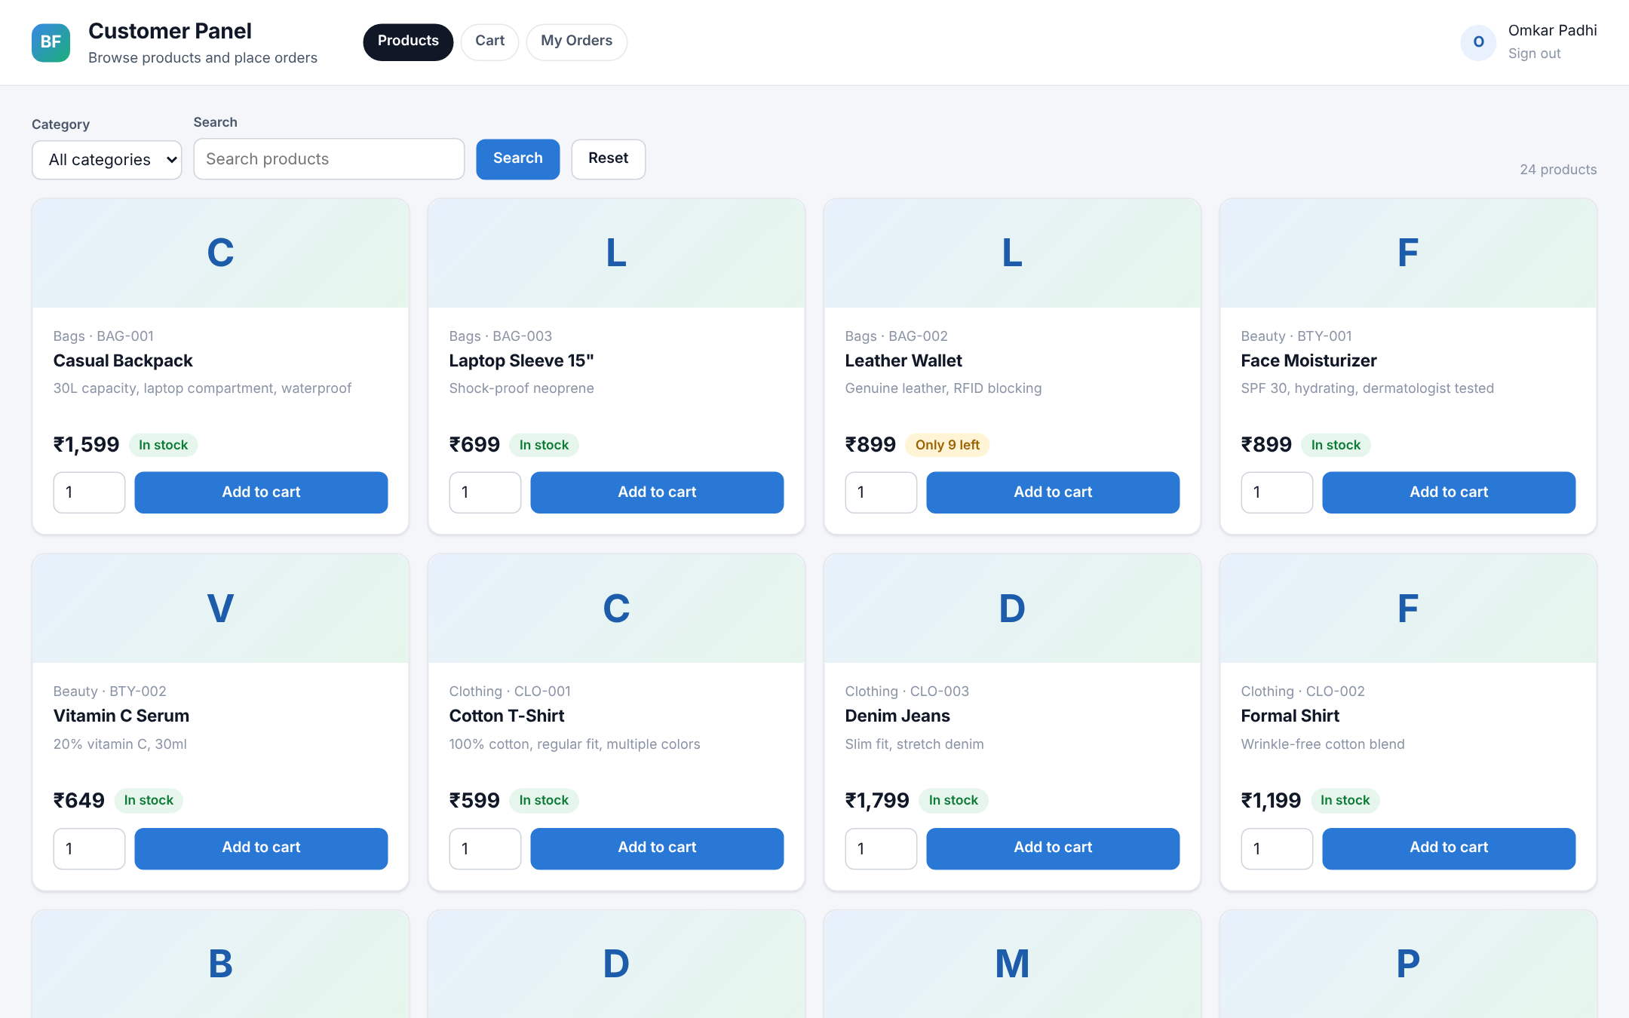
Figure 24: Customer Panel — Product Catalogue
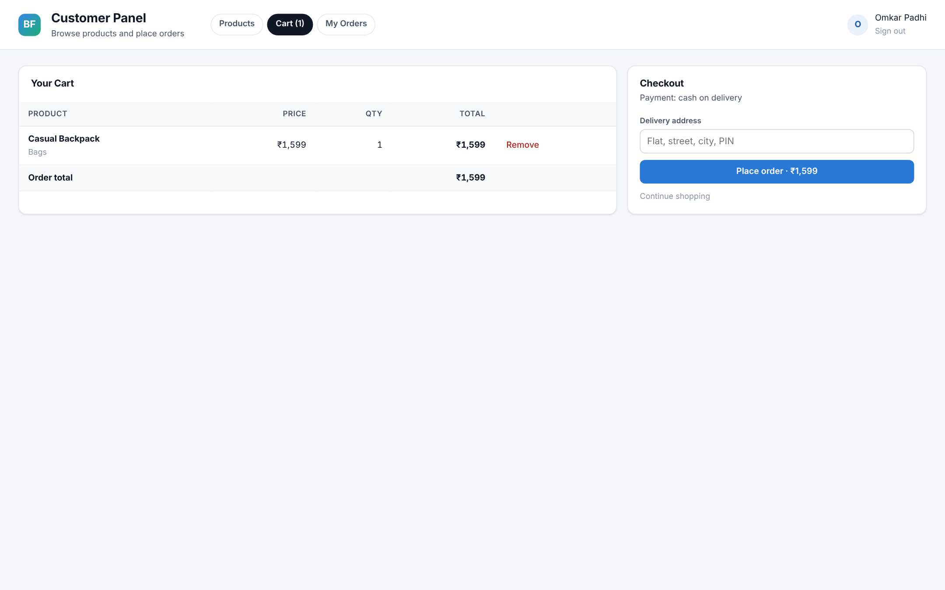
Figure 25: Customer Panel — Cart and Checkout
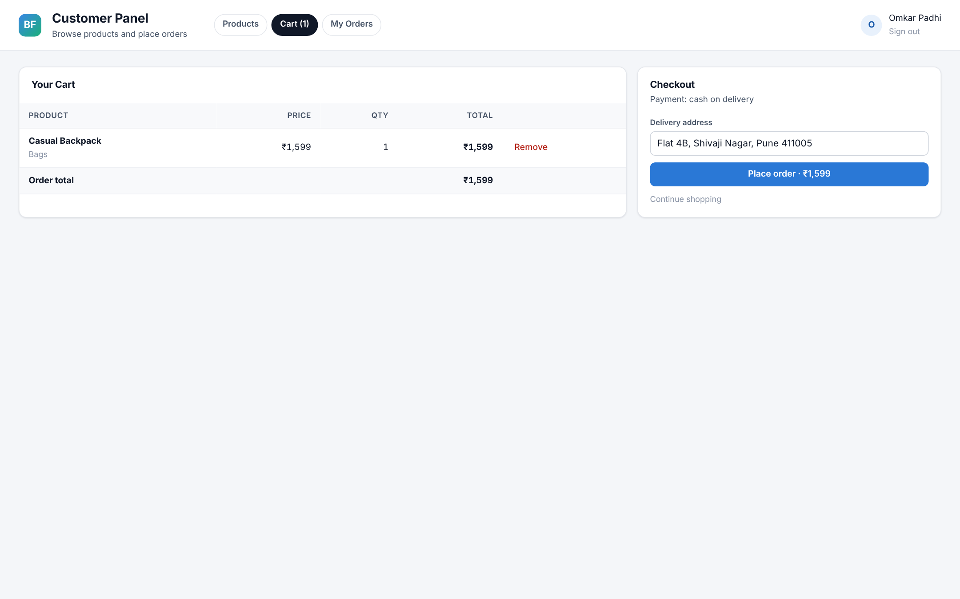
Figure 26: Customer Panel — My Orders

10. Testing
Automated end-to-end tests were written with Flask’s test client and run against both the MySQL path (MariaDB server) and the SQLite fallback; the user interface was additionally checked in a headless Chromium browser for JavaScript errors.
Table 11: Test cases
# | Test case | Expected result | Result
1 | Open a staff page without signing in | Redirect to the sign-in page | Pass
2 | Staff sign-in with a wrong password | “Invalid email or password” | Pass
3 | Open all 13 staff pages and 4 CSV exports | HTTP 200 for every page | Pass
4 | Add an expense of ₹2,50,000 in Marketing | Saved; flagged on the anomaly page | Pass
5 | Delete that expense | Removed from the anomaly list | Pass
6 | Receive 5 units of stock | Stock increases by 5 | Pass
7 | Add a product with a new SKU | Product added | Pass
8 | Customer adds an out-of-stock product | “That product is out of stock” | Pass
9 | Customer places an order for 2 units | Order created, stock reduced by 2 | Pass
10 | Register a new customer | Account created and signed in | Pass
11 | Staff cancels the order | Status Cancelled, 2 units returned to stock | Pass
12 | New order in a new month | Shown as “in progress”; trend months unchanged | Pass
13 | Import database.sql into MySQL | 4,828 orders, 9,448 lines, 253 expenses | Pass
14 | Start with MySQL stopped | Falls back to SQLite with the same data | Pass
15 | Upgrade an older database without the customer password column | Column added automatically | Pass

11. Results and Discussion

11.1 Financial Results
Table 12: Monthly profit and cash flow (₹)
Month | Revenue | COGS | Operating exp. | Net profit | Margin | Net cash flow
Oct 25 | 18,22,742 | 11,48,250 | 4,07,429 | 2,67,063 | 14.7% | 2,67,113
Nov 25 | 18,73,102 | 11,84,770 | 4,09,789 | 2,78,543 | 14.9% | 2,66,613
Dec 25 | 17,62,292 | 11,19,420 | 4,10,689 | 2,32,183 | 13.2% | 2,99,303
Jan 26 | 16,21,289 | 10,33,910 | 3,93,659 | 1,93,720 | 11.9% | 2,97,130
Feb 26 | 14,21,903 | 9,00,190 | 4,24,969 | 96,744 | 6.8% | 96,734
Mar 26 | 16,25,855 | 10,38,450 | 3,95,579 | 1,91,826 | 11.8% | 1,91,776
Apr 26 | 16,78,891 | 10,75,650 | 3,91,559 | 2,11,682 | 12.6% | 1,79,532
May 26 | 16,76,400 | 10,66,300 | 4,25,739 | 1,84,361 | 11.0% | 2,05,761
Jun 26 | 18,27,013 | 11,69,160 | 3,90,989 | 2,66,864 | 14.6% | 4,65,624
Jul 26 | 17,42,123 | 11,09,470 | 4,40,929 | 1,91,724 | 11.0% | 1,91,694
Aug 26 | 17,42,086 | 11,15,390 | 3,87,839 | 2,38,857 | 13.7% | 2,05,447
Sep 26 | 19,48,124 | 12,59,590 | 4,82,899 | 2,05,635 | 10.6% | −1,34,375
Total | 2,07,41,820 | 1,32,20,550 | 49,62,068 | 25,59,202 | 12.3% | 25,32,352

The business is profitable in every month, with a gross margin of 36.3% and a net margin of 12.3%. September 2026 shows the most important insight of the system: net profit was ₹2.06 lakh, but net cash flow was −₹1.34 lakh because stock purchases of ₹16.00 lakh were made ahead of the festive season. A profit-only report would hide this cash shortfall.

11.2 Inventory and Forecast Results
Of the 24 products, 15 are In Stock, 5 Low Stock, 2 Out of Stock (Yoga Mat, Power Bank 20000mAh) and 2 Overstocked (Desk Lamp LED, Laptop Sleeve 15″). Inventory turnover is 9.1 times a year. The forecast marks 10 products at shortage risk and 2 at overstock risk, with a suggested reorder value of ₹7.13 lakh. The average back-test accuracy is 73% (range 31% to 90%); products with steady demand such as Wireless Mouse (90%) forecast well, while products with sharply falling demand such as Desk Lamp LED and Laptop Sleeve forecast poorly.

11.3 Anomaly Detection Results
Table 13: Unusual expenses detected
Expense | Amount | Typical | Robust z | Severity
GST late-filing penalty (Feb 26) | ₹35,000 | ₹3,390 | 56.1 | High
Emergency AC compressor repair (Jul 26) | ₹48,500 | ₹6,500 | 20.5 | High
Festive campaign – influencers & hoardings (Sep 26) | ₹96,000 | ₹14,360 | 12.9 | High
Electricity bill (May 26) | ₹52,400 | ₹18,940 | 18.3 | Medium

All four expenses planted in the data were detected and no regular expense was flagged. The category-spike rule additionally flags the same four months (Miscellaneous in February, Utilities in May, Operations in July and Marketing in September).

11.4 Financial Health Score
Table 14: Financial Health Score on the demo data
Factor | Measured value | Points
Profitability | Net margin 12.3% | 16.5 / 20
Expense Control | Operating expenses 23.9% of revenue | 16.1 / 20
Cash Flow | 11 of 12 months positive; last-3-month net cash 4.8% of inflow | 14.0 / 20
Revenue Growth | +4.8% (last 3 months vs previous 3) | 14.8 / 20
Inventory Efficiency | Turnover 9.1×; 62% of products at healthy stock | 14.5 / 20
Total |  | 76 / 100 (Good)

The engine produced 18 recommendations on this data (9 High, 6 Medium, 3 Low), for example: “Wireless Mouse may run out in about 2 days — only 8 units left against a forecast of 119 units next month; reorder about 128 units.”

11.5 Limitations
- The results are obtained on synthetic demo data generated by the project; they demonstrate the methods but are not measurements of a real business.
- The seasonal index is estimated from a single year of history, so forecasts should be treated as planning estimates; accuracy is low for products whose demand is falling sharply.
- The recommendation engine is rule-based; it does not learn from which recommendations the owner accepted.
- There is a single staff role level: every staff account sees all pages. Payment is cash on delivery only, and the system runs on a single machine.

12. Conclusion and Future Scope

12.1 Conclusion
The project transformed a basic e-commerce storefront into a working business-intelligence platform for SMEs. Sales, expenses and inventory are stored in one MySQL database and analysed together, so the owner can see profit, cash flow, stock risk and unusual spending on one dashboard. The forecasting, anomaly detection, health score and recommendation features are computed from the data with transparent, explainable rules and formulas, and every page was tested end to end on both the MySQL and SQLite back ends. The most useful result is the link between profit and cash: the system shows when a profitable month is still cash-negative and why.

12.2 Future Scope
- Role-based access for different staff roles (for example, sales staff limited to inventory and orders).
- Import of real bills and bank statements (CSV / Excel) and GST-ready reports.
- Forecasting with more history and more advanced models (for example, Prophet or gradient boosting) with weekly granularity.
- Automatic purchase-order generation and supplier lead-time tracking.
- Email or WhatsApp alerts for stock-outs and unusual expenses; online payments in the customer panel.
- Cloud deployment with HTTPS and scheduled database backups.

References
- J. Han, M. Kamber and J. Pei, Data Mining: Concepts and Techniques, 3rd ed. Morgan Kaufmann, 2011.
- R. J. Hyndman and G. Athanasopoulos, Forecasting: Principles and Practice, 3rd ed. OTexts, 2021. https://otexts.com/fpp3/
- B. Iglewicz and D. C. Hoaglin, How to Detect and Handle Outliers. ASQC Quality Press, 1993.
- P. J. Rousseeuw and C. Croux, “Alternatives to the Median Absolute Deviation,” Journal of the American Statistical Association, vol. 88, no. 424, pp. 1273–1283, 1993.
- F. Pedregosa et al., “Scikit-learn: Machine Learning in Python,” Journal of Machine Learning Research, vol. 12, pp. 2825–2830, 2011.
- R. Elmasri and S. B. Navathe, Fundamentals of Database Systems, 7th ed. Pearson, 2016.
- I. Sommerville, Software Engineering, 10th ed. Pearson, 2016.
- Flask documentation, https://flask.palletsprojects.com; MySQL 8.0 Reference Manual, https://dev.mysql.com/doc/; Chart.js documentation, https://www.chartjs.org/docs/.

