**Third Year B. Tech., Sem V 2021-22**

**Programming Lab-3**

**Practical no- 5B**

Git-hub link: <https://github.com/omkarpatil01/2019BTECS00104_PL3>

**Problem Statement 1**: Design and develop a static web page using HTML for a Data Science blog. Access it locally and in LAN using a web server. It should have following sections:

1. Header – Title and authorship information of a blog

2. Three links to other technical blogs

3. Article – At least two articles should be there

4. Contact Information of author

<!DOCTYPE html>

<html lang="en">

    <head>

        <meta charset="UTF-8">

        <meta http-equiv="X-UA-Compatible" content="IE=edge">

        <meta name="viewport" content="width=device-width, initial-scale=1.0">

        <title>Data Science</title>

    </head>

    <body style="background-color: bisque;">

        <header>

            <H1 style="text-align: center;font-family: 'Times New Roman', Times, serif;">DATA SCIENCE BLOG<br>by Thinkful</H1>

            <ul>

                <li>

                    <a href="https://www.thinkful.com/">HOME</a>

                </li>

                <li>

                    <a href="https://www.thinkful.com/about/">ABOUT</a>

                </li>

                <li>

                    <a href="https://www.thinkful.com/?call=true#mentorship">CONTACT US</a>

                </li>

            </ul>

        </header>

        <main>

            <article>

                <section>

                    <h2 style="text-align: center;">The Data Science</h2>

                    <p style="text-align: center;"> <img src="blue-colored-data-science-illustration.jpg" alt="img" width="550vw"></p>

                </section>

                <h1 style="text-align: center;">What is Data Science?</h1>

                <section>

                    <p>

                        Data science, in its most basic terms, can be defined as obtaining insights and information, really anything of value, out of data. Like any new field, it's often tempting but counterproductive to try to put concrete bounds on its definition. This is data science. This is not. In reality, data science is evolving so fast and has already shown such enormous range of possibility that a wider definition is essential to understanding it and while it's hard to pin down a specific definition, it's quite easy to see and feel its impact. Data science, when applied to different fields can lead to incredible new insights and the folks that are using it are already reaping the benefits…

                        In simple terms — Data Science is some sort of science to analyze, process and convert large chunks of data into information so that it can be used to predict the next thing you would want to buy. Also useful for education, healthcare, fashion, you name it.

                    </p>

            </article>

        </section>

            <h1 style="text-align: center;">It’s hard to imagine a world before data.</h1>

            <section>

                It has become ubiquitous, even more so for people who work in tech. We've gone so far as to personify data in everyday conversation. We ask what it means, what it says. But do we even know what it is? What makes something count as data? Is a handwritten ledger from the year 1500 considered data? Is a book sitting on a store shelf data? Are we all just data? In the context of data science, the only form of data that matters is digital data. Digital data is information that is not easily interpreted by an individual but instead relies on machines to interpret, process, and alter it. The words you are reading on your computer screen are an example of this. These digital letters are actually a systematic collection of ones and zeros that encodes to pixels in various hues and at a specific density. In recent years, digital information has gotten so pervasive and essential that we've almost become unwilling to handle anything that isn't in a digital form.

                Go ask a data scientist to work on something that isn't digitized. Hand them a table scrawled on a wrinkly piece of paper. Or, to better replicate the scale of what we're going to talk about, entire libraries of thick books, overflowing with tables of information. Stack them on their desk (if you can) and they'd probably run away and never come back. It is because the digital elements of information have become essential. We cannot do modern work without them.

            </section>

            <section>

                <h1 style="text-align: center;">It's hard to find another moment in human history where there was an innovation that made all previous stored information invalid.</h1>

                <p>

                    If you really want a sense of how big this moment is in the context of what we're here to talk about, data science, just open any newspaper over the past 10 years. Inside, you will find countless stories of individuals, companies, and in some cases countries racing to digitize any and all information. From books to health records to government services, it's becoming increasingly challenging to find corners of society not impacted by the digital revolution.

                    <br>

                    <br>

                    It's incredible to think that while it may seem hyperbolic, it's hard to find another moment in human history where there was an innovation that made all previous stored information invalid. Even after the introduction of the printing press, handwritten works were still just as valid as a resource. But now, literally every piece of information that we want to endure has to be translated into a new form.

                    <br>

                    <br>

                    Of course, the digitization of data isn't the whole story. It was simply the first chapter in the origins of data science. To get to the point where the digital world would become intertwined with almost every person's life, data had to grow. It had to get big. Welcome to Big Data.

                    <br>

                    <br>

                    The short answer to what you can do with the billions upon billions upon of data points being collected is the same as the answer to the first question we asked: <b>Data science.</b>

                </p>

            </section>

        </article>

            <section>

               <p>

                Whether you work in medicine, media, finance, or manufacturing, data science will likely play a big role moving forward. Just think about it:

                <br>

                <br>

                Every field has big questions.

                <br>

                <br>

                Every field has big sets of data.

                <br>

                <br>

                So every field needs data scientists!

                <br>

                <br>

                If you feel excited about data science, now is a perfect time to start exploring. Stats suggest that data science skills are in high demand and making the career transition can happen in as little as 6 months. Granted those will probably be the 6 toughest months of your life, but in the end, and trust us on this one, it will be worth it. Data scientists are some of America’s best paid and happiest workers. To quote famous data scientist Dr. Kirk Borne:

                <br>

                <br>

                <i>As a successful data scientist, your day can begin and end with you counting your blessings that you are living your dream by solving real-world problems with data.</i>

                <br>

                <br>

                Is now the time for you to live your dream too?

                <br>

                <br>

                Learn more about how you can become a data scientist by exploring Thinkful's <a href="https://www.thinkful.com/bootcamp/data-science/">data science bootcamp</a>.

               </p>

            </section>

            <div>

                <pre>

<hr>

<strong>About Thinkful</strong>

We’re an online education platform with career support to get our students new jobs and life long careers.

Founded in 2012, we’re a 100% remote company with over 600 employees dedicated to our students’ learning journey.

<strong>Connect</strong>

<nav>

    <a href="https://twitter.com/thinkful">Twitter</a>

    <a href="https://www.facebook.com/thinkful/">Facebook</a>

    <a href="https://www.instagram.com/thinkfulhq/">Instagram</a>

    <a href="https://www.thinkful.com/blog/">Thinkful Blog</a>

</nav>

                </pre>

            </div>

        </main>

        <footer>

            <p>

                &copy; 2021 Thinkful.

            </p>

        </footer>

    </body>

</html>

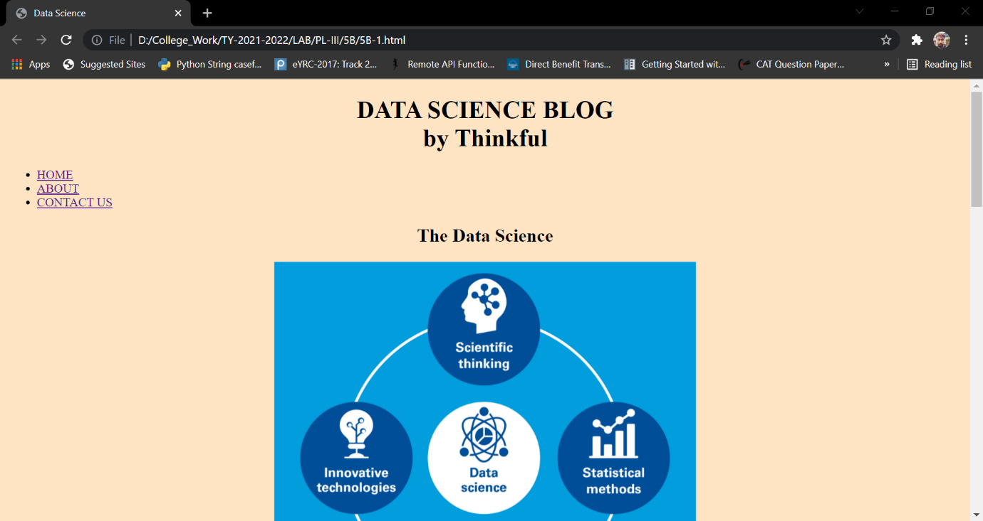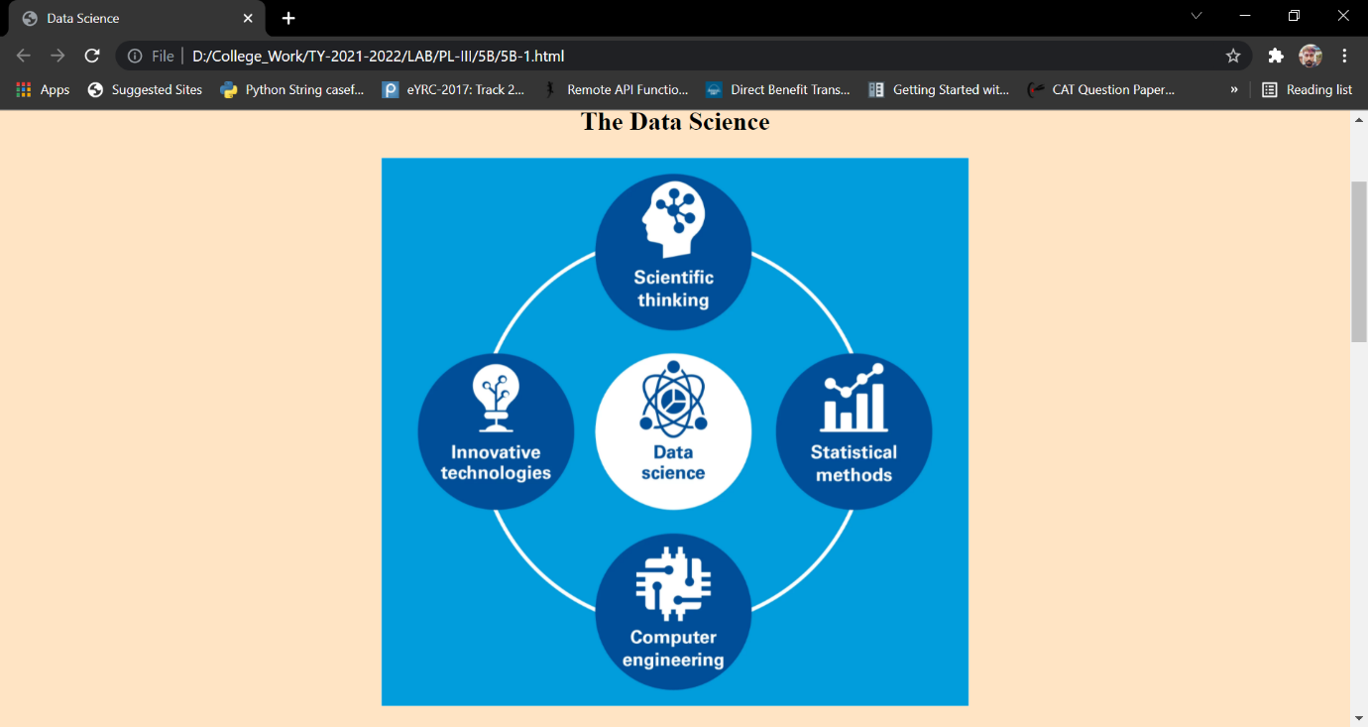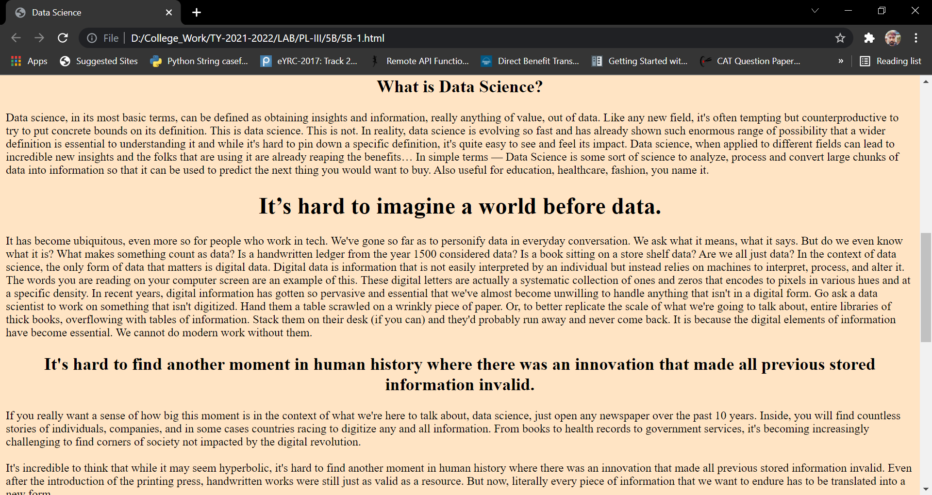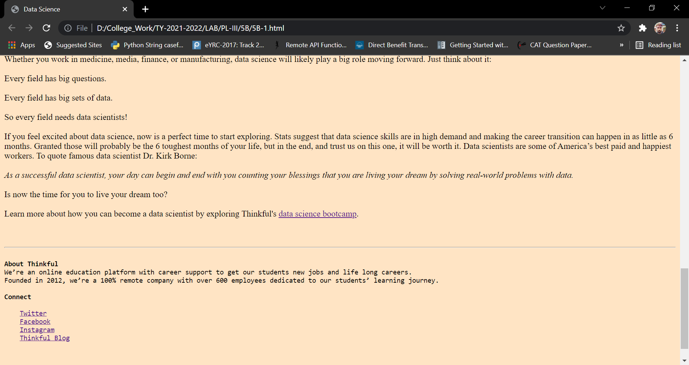

**Problem Statement 2**: Design and develop a static web page using HTML for following requirements. Access it locally and in LAN using a web server. It should have following sections:

1. Problem Statement: Write a code in any programming language that can find an armstrong number from a given range.

2. Code

3. Sample Input

4. Sample Output

5. Variables used in the program

6. Complexity

<!DOCTYPE html>

<html lang="en">

<head>

    <title>Armstrong Number</title>

</head>

<body style="background-color: rgb(13, 191, 235);">

    <header>

        <section>

            <p>

                <h2>

                    Code to find Armstrong number in the given range

                </h2>

            </p>

            <p>

                <b>Armstrong Number:</b> It is a number that is equal to the sum of the cubes of its digits.

                <br>

                For example 153.

                <br>

                Sum of the cubes of its digit = 1<sup>3</sup> + 5<sup>3</sup> + 3<sup>3</sup> = 1 + 125 + 27 = 153

            </p>

        </section>

    </header>

    <main>

        <p><b style="font-size: larger;">Sample code</b></p>

        <pre>

            <code>

                #include <iostream>

                #include <math.h>

                using namespace std;

                int main()

                {

                    int r, sum, temp, ans;

                    int x1, x2;

                    cout << "\n\n Find the Armstrong number for a given range of number:\n";

                    cout << " Input starting number of range: ";

                    cin >> x1;

                    cout << " Input ending number of range: ";

                    cin >> x2;

                    cout << " Armstrong numbers in given range are: " << endl;

                    for (int i = x1; i <= x2; i++)

                    {

                        temp = i;

                        sum = 0;

                        while (temp != 0)

                        {

                            r = temp % 10;

                            ans = pow(r, 3);

                            sum = sum + ans;

                            temp = temp / 10;

                        }

                        if (sum == i)

                            cout << i << " ";

                    }

                    cout << endl;

                }

            </code>

            <em>

                <p><b>Sample Input:</b></p>

                    Find the Armstrong number for a given range of number:

                    Input starting number of range: 25

                    Input ending number of range: 200

                <p><b>Sample output</b></p>

                    Armstrong numbers in given range are:

                    153

            </em>

        </pre>

    <section>

        <p>

            <b>Variables used in program-</b>

            <br>

            <br>

            In the above code total 7 variables used.

            <br>

            <br>

            <var>x1</var> stores the starting number of range.

            <br>

            <var>x2</var> stores end number of range.

            <br>

            <var>i</var> is used for iteration over the range.

            <br>

            <var>temp</var> is tempoarary variable stores current number.

            <br>

            <var>sum</var>is used to calculate sum of number.

            <br>

            <var>r</var> stores remainder by modulo operation.

            <br>

            <var>ans</var> stores cube of digit.

        </p>

        <p><B>Time Complexity-</B></p>

        <p>Since there  1 nested loop so time complexity of above code is O(n <sup>2</sup> )</p>

    </section>

    <hr>

    <p> Link for Reference</p>

    <nav>

        <a href="https://www.w3resource.com/cpp-exercises/numbers/cpp-numbers-exercise-44.php">W3resource</a>

    </nav>

    </main>

</body>

</html>

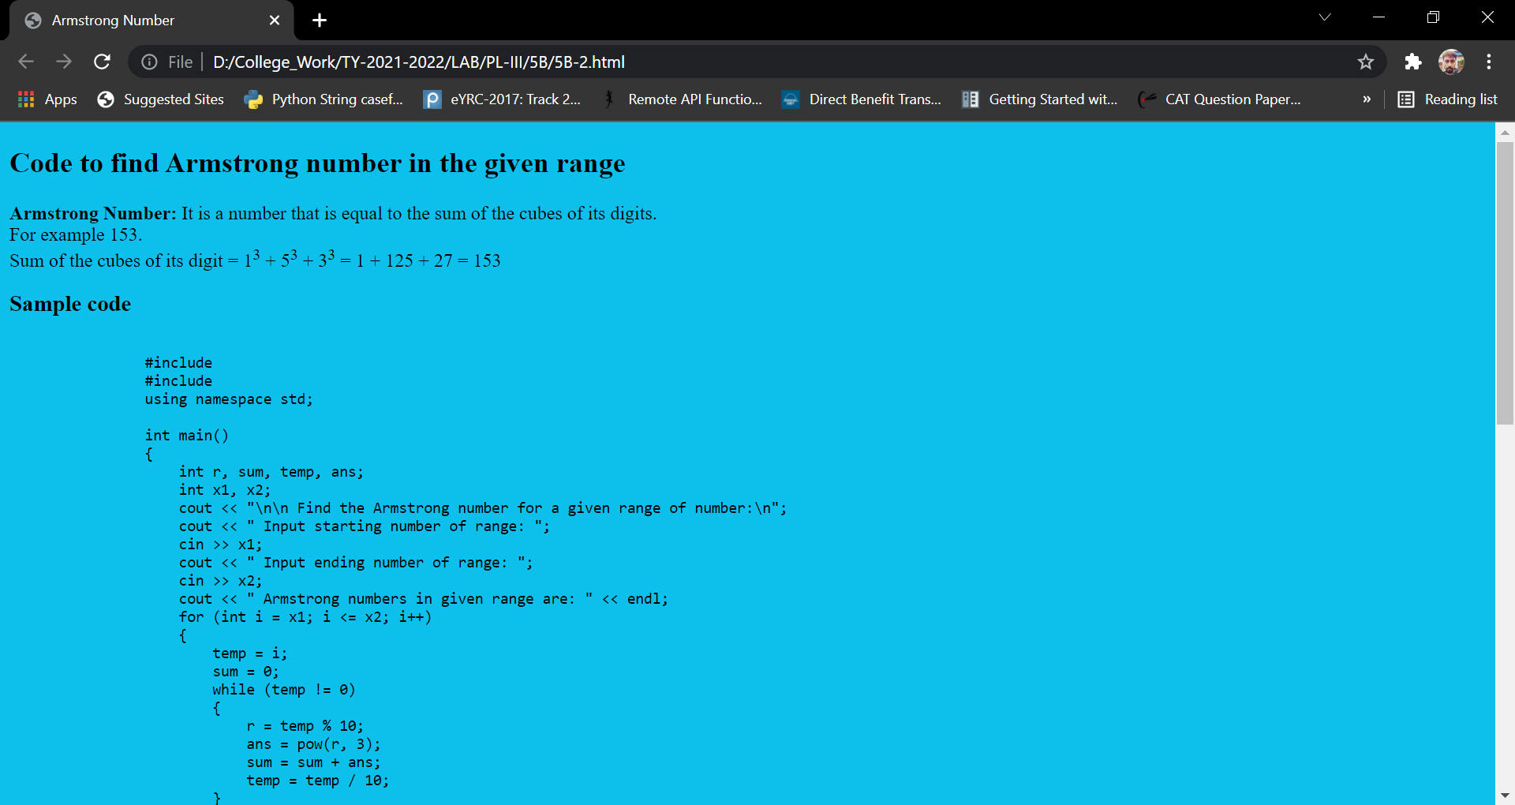

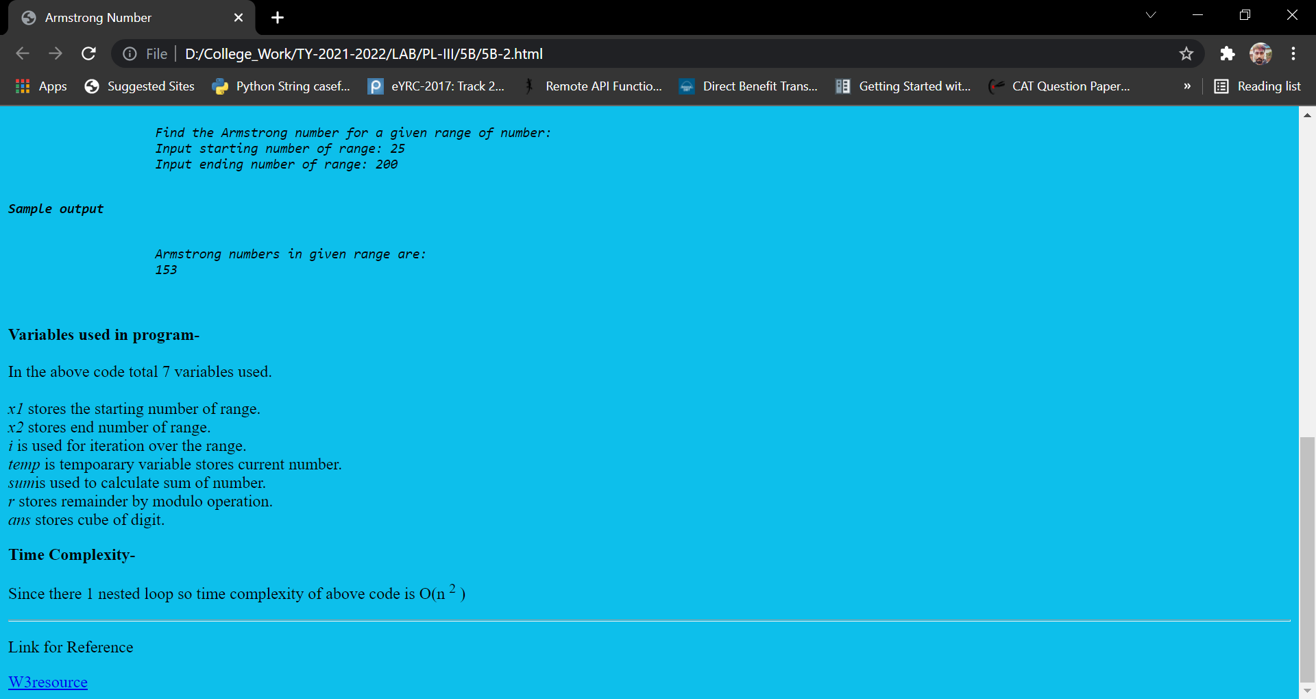

**Problem Statement 3**: Design and develop a static web page using HTML for following requirements. Access it locally and in LAN using a web server. It should have following sections:

1. Any three quotes from https://www.brainyquote.com/ with the name of the person who quoted it.

<!DOCTYPE html>

<html lang="en">

    <head>

        <title>Brainy Quote</title>

    </head>

    <body style="background-color: rgb(17, 252, 240);">

        <header>

            <h1>

                <q>Motivational Quotes</q>

            </h1>

        </header>

        <article>

            <br>

            <section>

                <br>

                <blockquote>

                    Life is 10% what happens to you and 90% how you react to it.<br><br>

                    <em>-Charles R. Swindoll</em>

                </blockquote>

                <br>

            </section>

            <hr>

            <br>

            <section>

                <br>

                <blockquote>

                    Excellence is not a skill, it's an attitude.<br><br>

                    <em>-Ralph Marston</em>

                </blockquote>

                <br>

            </section>

            <hr>

            <br>

            <section>

                <br>

                <blockquote>

                    Quality is not an act, it is a habit.<br><br>

                    <em>-Aristotle</em>

                </blockquote>

                <br>

            </section>

        </article>

        <hr>

        <br>

        <footer>

            <h2>

                <a href="https://www.brainyquote.com/">Brainy Quote</a>

            </h2>

        </footer>

    </body>

</html>

