COSMOS PM Admin Panel
User Workflow Guide

PM Admin Panel - Complete User Workflow Guide
A comprehensive guide for all user roles to understand and navigate the PM Admin Panel effectively.
________________________________________

Table of Contents
- [Getting Started](#getting-started)
- [Login](#login)
- [Password Management](#password-management)
- [Navigation Overview](#navigation-overview)
- [Panel Switcher](#panel-switcher)
- [Super Admin Panel](#super-admin-panel)
- [Dashboard Overview](#super-admin-dashboard-overview)
- [Manage Resources](#manage-resources)
- [Manage Clients](#manage-clients)
- [Manage Projects](#manage-projects)
- [Task Management](#super-admin-task-management)
- [Lead Management](#lead-management)
- [Knowledge Management](#super-admin-knowledge-management)
- [Expenses](#super-admin-expenses)
- [Reports](#super-admin-reports)
- [Calendar](#super-admin-calendar)
- [Admin Panel](#admin-panel)
- [Dashboard Overview](#admin-dashboard-overview)
- [Key Features](#admin-key-features)
- [Manager Panel](#manager-panel)
- [Dashboard Overview](#manager-dashboard-overview)
- [Quick Actions (Notes & Reminders)](#quick-actions-notes--reminders)
- [Notifications](#notifications)
- [Expense Management](#manager-expense-management)
- [Knowledge Management](#knowledge-management)
- [Employee Panel](#employee-panel)
- [Dashboard Overview](#employee-dashboard-overview)
- [Task Management](#task-management)
- [My Projects](#my-projects)
- [Calendar](#calendar)
- [Expense Submission](#employee-expense-submission)
- [Reports](#reports)
- [Client Panel](#client-panel)
- [Dashboard Overview](#client-dashboard-overview)
- [My Projects](#client-projects)
- [Task Tracking](#client-task-tracking)
- [Calendar](#client-calendar)
- [Reports](#client-reports)
________________________________________

Getting Started

Login
To access the PM Admin Panel, navigate to the application URL and you will be presented with the login page.
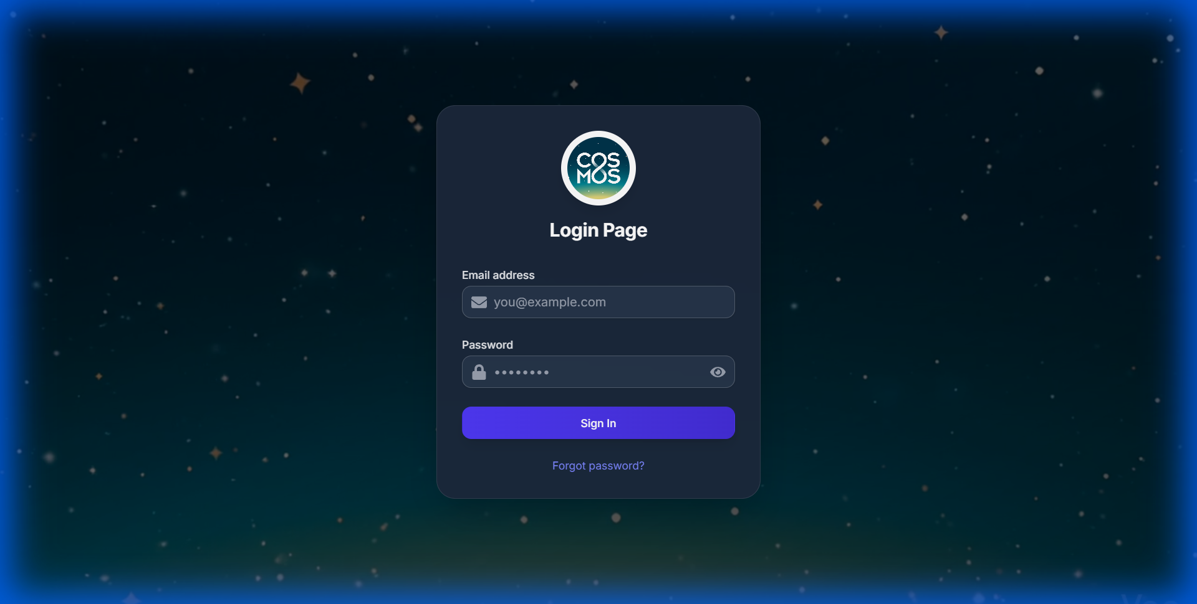
Login Page
Steps to Login:
- Enter your Email Address in the email field
- Enter your Password in the password field
- Click the Sign In button
- If you've forgotten your password, click "Forgot password?" link
NOTE: First-time users may be required to change their password upon initial login if configured by the administrator.
________________________________________

Password Management

Forgot Password
- Click "Forgot password?" on the login page
- Enter your registered email address
- Click Submit
- Check your email for a password reset link
- Click the link and set a new password

Reset Password
- Open the password reset link from your email
- Enter your new password
- Confirm the new password
- Click Reset Password
IMPORTANT: Password requirements: - Minimum 8 characters - Use a mix of letters, numbers, and special characters
________________________________________

Navigation Overview
After logging in, you'll see the main navigation sidebar on the left side of the screen with quick access to all features based on your role.
Role | Available Navigation
Super Admin | Dashboard, Manage Resources, Manage Clients, Manage Projects, Task Management, Lead Management, Knowledge Management, Expenses, Reports, Calendar
Admin | Dashboard, Manage Resources, Manage Clients, Manage Projects, Task Management, Knowledge Management, Expenses, Reports, Calendar
Manager | Dashboard, My Projects, Task Management, Calendar, Knowledge Management, Team Expenses, Reports, Settings
Employee | Dashboard, My Tasks, Projects, Calendar, Knowledge, My Expenses, Reports, Settings
Client | Dashboard, My Projects, Tasks, Calendar, Reports, Documents
________________________________________

Panel Switcher
If you have access to multiple roles, you can switch between panels using the Panel Switcher:
- Click on the current panel name in the sidebar header (e.g., "Super Admin Panel")
- A dropdown appears showing all available panels
- Click on the panel you want to switch to
- The page refreshes with the new panel view
TIP: Super Admins can access all panels to view the system from different user perspectives.
________________________________________

Super Admin Panel

Super Admin Dashboard Overview
The Super Admin Dashboard provides complete visibility into the entire system with project analytics, resource allocation, and task management.
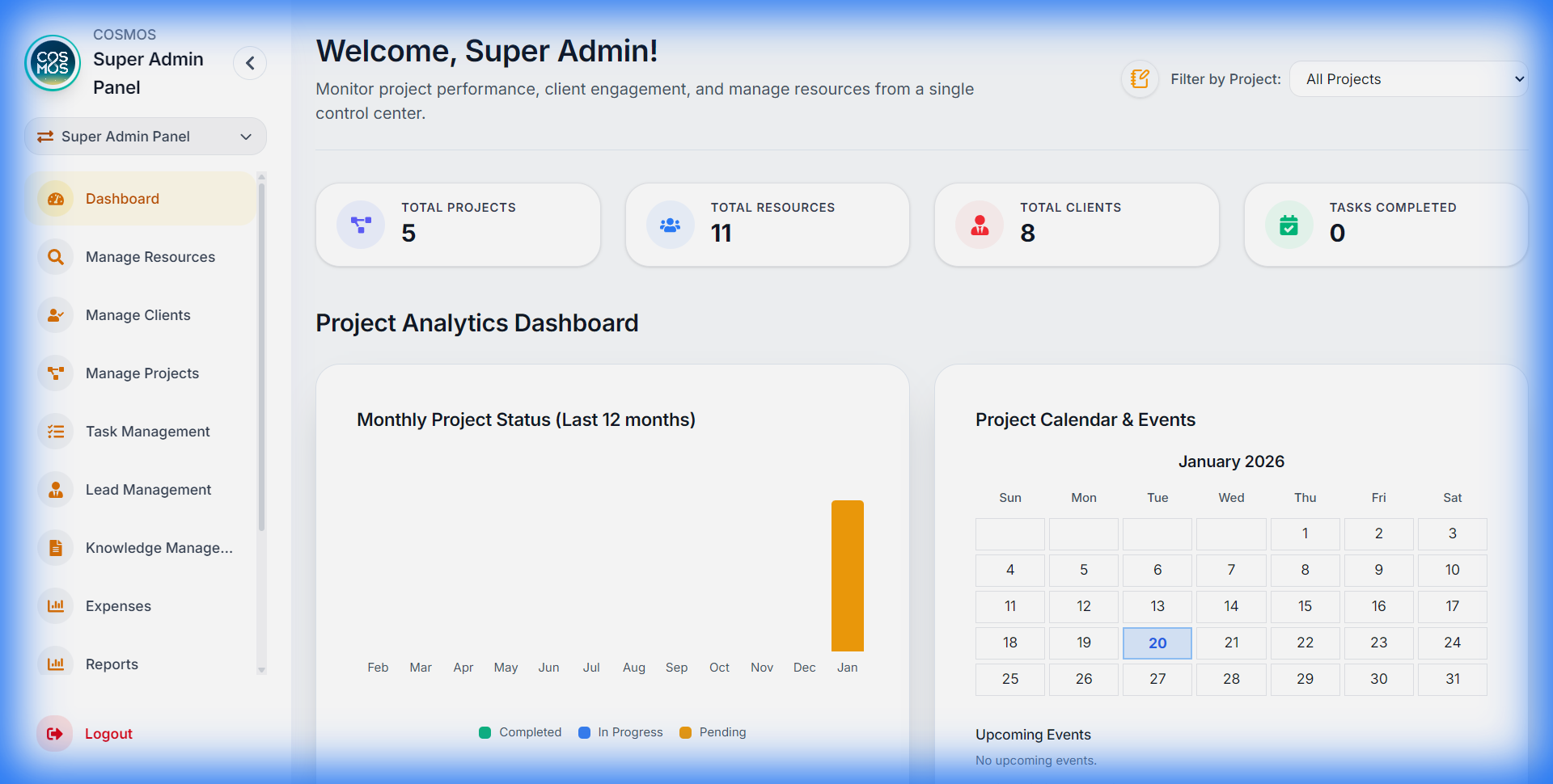
Super Admin Dashboard

Key Statistics Cards
Stat Card | Description
Total Projects | All projects in the system
Total Resources | Number of employees and contractors
Total Clients | Number of active clients
Tasks Completed | Total completed tasks across all projects

Project Analytics Dashboard
- Monthly Project Status Chart - Bar chart showing Completed, In Progress, and Pending projects per month
- Project Calendar & Events - Monthly calendar with project deadlines and events
- Upcoming Events - List of imminent deadlines and milestones
________________________________________

Manage Resources
Add, edit, and manage all users in the system.
To Add a New Resource:
- Navigate to Manage Resources from sidebar
- Click "+ Add Resource"
- Fill in user details:
- Name, Email, Phone
- Role (Super Admin, Admin, Manager, Employee)
- Department
- Reporting Manager
- Click Save
Resource Actions:
- Edit - Update user information
- Delete - Remove user from system
- View Profile - See detailed user information
- Assign to Projects - Add user to project teams

Add Hierarchy
Define organizational structure:
- Go to Manage Resources > Add Hierarchy
- Create departments and reporting structures
- Assign managers to departments
________________________________________

Manage Clients
Manage all client accounts and information.
Client Management:
- Navigate to Manage Clients
- View all clients in a table/grid format
Client Actions:
- Add Client - Create new client record
- Edit Client - Update client information
- Delete Client - Remove client (caution: may affect projects)
- View Projects - See all projects for a client
Client Information:
- Company name
- Contact person
- Email, Phone, Address
- Associated projects
- Client portal access status
________________________________________

Manage Projects
Create and manage all projects in the system.

Creating a New Project
- Navigate to Manage Projects
- Click "+ New Project"
- Fill in project details:
Field | Description
Project Name | The project title
Client | Select from client list
Start Date | Project commencement date
Deadline | Project completion deadline
Description | Project scope and details
Budget | Project budget (optional)
Team Members | Assign resources to project
Project Manager | Designate project manager
- Click Create Project

Project Settings
Configure project-specific settings:
- Status Settings - Define custom task statuses
- Team Hierarchy - Set project-specific reporting structure
- Access Control - Manage who can view/edit project
________________________________________

Super Admin Task Management
Full task management across all projects.
Features:
- View all tasks across all projects
- Filter by project, status, priority, assignee
- Create tasks and assign to any resource
- Bulk update task statuses
- Set deadlines and priorities
Task Actions:
- Create, Edit, Delete tasks
- Assign/reassign to resources
- Set priority (High, Medium, Low)
- Add subtasks
- View task history and activity
________________________________________

Lead Management
Manage sales leads and potential clients.
Lead Stages:
- New - Fresh lead incoming
- Contacted - Initial contact made
- Qualified - Lead verified as potential client
- Proposal - Proposal sent
- Won/Lost - Final outcome
Lead Actions:
- Add new leads
- Update lead status
- Add notes and follow-ups
- Convert lead to client
- View lead analytics
________________________________________

Super Admin Knowledge Management
Central knowledge base for the organization.
Features:
- Create knowledge categories
- Add documents and articles
- Set access permissions
- Search knowledge base
- Link knowledge to projects
________________________________________

Super Admin Expenses
Review and manage all expense claims across the organization.
Capabilities:
- View all submitted expenses
- Approve/reject expenses
- Generate expense reports
- Export expense data
- Set expense policies and limits
________________________________________

Super Admin Reports
Generate comprehensive system reports.
Report Types:
- Project Reports - Project status, progress, timelines
- Resource Reports - Utilization, workload distribution
- Financial Reports - Budget vs actual, expenses
- Task Reports - Completion rates, overdue tasks
- Client Reports - Client-wise project summaries
________________________________________

Super Admin Calendar
Organization-wide calendar view.
- View all project deadlines
- See task due dates across projects
- Track team events and meetings
- Add organization-wide events
________________________________________

Admin Panel

Admin Dashboard Overview
The Admin Dashboard is similar to Super Admin but with slightly limited scope, focusing on day-to-day administrative operations.

Key Features
Feature | Description
Dashboard | Similar stats to Super Admin (Projects, Resources, Clients, Tasks)
Manage Resources | Add/edit users (may have limitations on Super Admin accounts)
Manage Clients | Full client management
Manage Projects | Create and manage projects
Task Management | Manage tasks across projects
Knowledge Management | Manage knowledge base content
Expenses | Approve team expenses
Reports | Generate administrative reports
Calendar | View project calendars

Admin Key Features
Differences from Super Admin:
- Cannot modify Super Admin accounts
- May have restricted access to system settings
- Cannot change organization-wide configurations
- Limited access to sensitive financial data
Shared Capabilities:
- Full project management
- Client management
- Resource assignment
- Task oversight
- Expense approval
________________________________________

Manager Panel

Manager Dashboard Overview
The Manager Dashboard provides a comprehensive view of your managed projects and team performance.
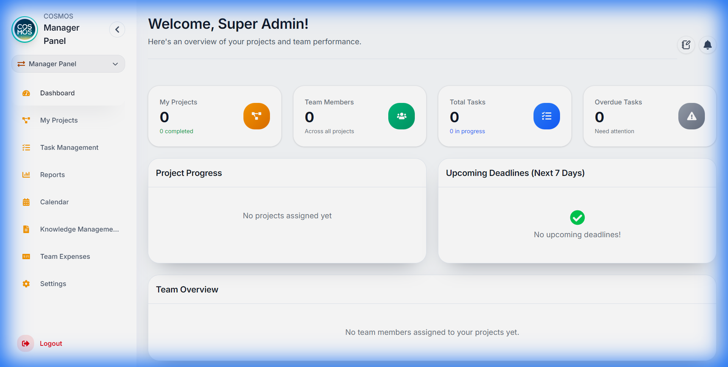
Manager Dashboard

Key Statistics Cards
The dashboard displays four primary stat cards at the top:
Stat Card | Description
Total Projects | Number of projects you manage
Completed Projects | Projects with all tasks completed
Total Tasks | All tasks across your projects
Team Size | Number of team members on your projects

Additional Metrics
- Completed Tasks - Total tasks marked as done
- In Progress Tasks - Tasks currently being worked on
- Overdue Tasks - Tasks past their due date
________________________________________

Project Progress Section
View progress for all your managed projects:
- Each project card shows:
- Project name
- Progress percentage bar
- Tasks completed vs total tasks
- Click on a project to see more details
________________________________________

Upcoming Deadlines (Next 7 Days)
This section displays tasks due within the next 7 days:
- Task title
- Due date
- Priority level
- Assigned team member
TIP: Use this section to prioritize follow-ups with team members on approaching deadlines.
________________________________________

Team Overview
See all team members working on your projects:
- Team member name
- Profile picture/avatar
- Current role
________________________________________

Quick Actions (Notes & Reminders)
Located in the top-right corner of the dashboard, click the notebook icon to access quick actions.

Quick Notes
Create and manage personal notes:
To Create a Note:
- Click the notebook icon in the header
- Select "Quick Notes"
- Type your note in the text field
- Click Save or press Enter
Note Features:
- Pin Notes - Click the pin icon to keep important notes at the top
- Edit Notes - Click on a note to modify it
- Delete Notes - Click the delete icon to remove a note
________________________________________

Reminders
Set personal reminders for important tasks:
To Set a Reminder:
- Click the notebook icon in the header
- Select "Reminders"
- Click "+ Add Reminder"
- Fill in:
- Title - Brief reminder description
- Date - When to be reminded
- Time - Specific time for the reminder
- Description (optional) - Additional details
- Click Save
Reminder Behavior:
- Reminders appear as toast notifications at the scheduled time
- They also appear in the notification bell
- Click X to dismiss a reminder
NOTE: Reminders check every 10 seconds for due items, so notifications appear promptly.
________________________________________

Notifications
Click the bell icon in the header to view notifications:
Notification Types:
Type | Icon Color | Description
Overdue Tasks | Red | Tasks past their due date
Project Deadlines | Orange | Projects approaching deadline (within 7 days)
New Tasks | Blue | Recently created tasks in your projects
Reminders | Purple | Personal reminders you've set
Actions:
- Click a notification to navigate to the relevant section
- Click X to dismiss individual notifications
- Click "Clear All" to dismiss all notifications
________________________________________

Manager Expense Management
Approve or reject expense claims from your team members.

Viewing Expenses
- Navigate to Expenses from the sidebar
- You'll see all expense claims from team members on projects you manage
Expense Information Displayed:
- Employee name
- Expense category
- Amount
- Status (Pending/Approved/Rejected)
- Submission date
- Attached documents/receipts

Approving an Expense
- Find the expense in the list
- Review the details and attached documentation
- Click the Approve button (green checkmark)
- The expense status changes to "Approved"

Rejecting an Expense
- Find the expense in the list
- Click the Reject button (red X)
- Enter a rejection reason in the popup
- Click Submit
- The employee will see the rejection reason
IMPORTANT: Always provide a clear reason when rejecting expenses to help employees understand and correct their submissions.
________________________________________

Knowledge Management
Access and manage project documentation and knowledge base articles.
- Navigate to Knowledge Management from the sidebar
- Browse available knowledge categories
- Click on a document to view its contents
- Search for specific topics using the search bar
________________________________________

Employee Panel

Employee Dashboard Overview
Your personal dashboard showing task summaries and performance metrics.
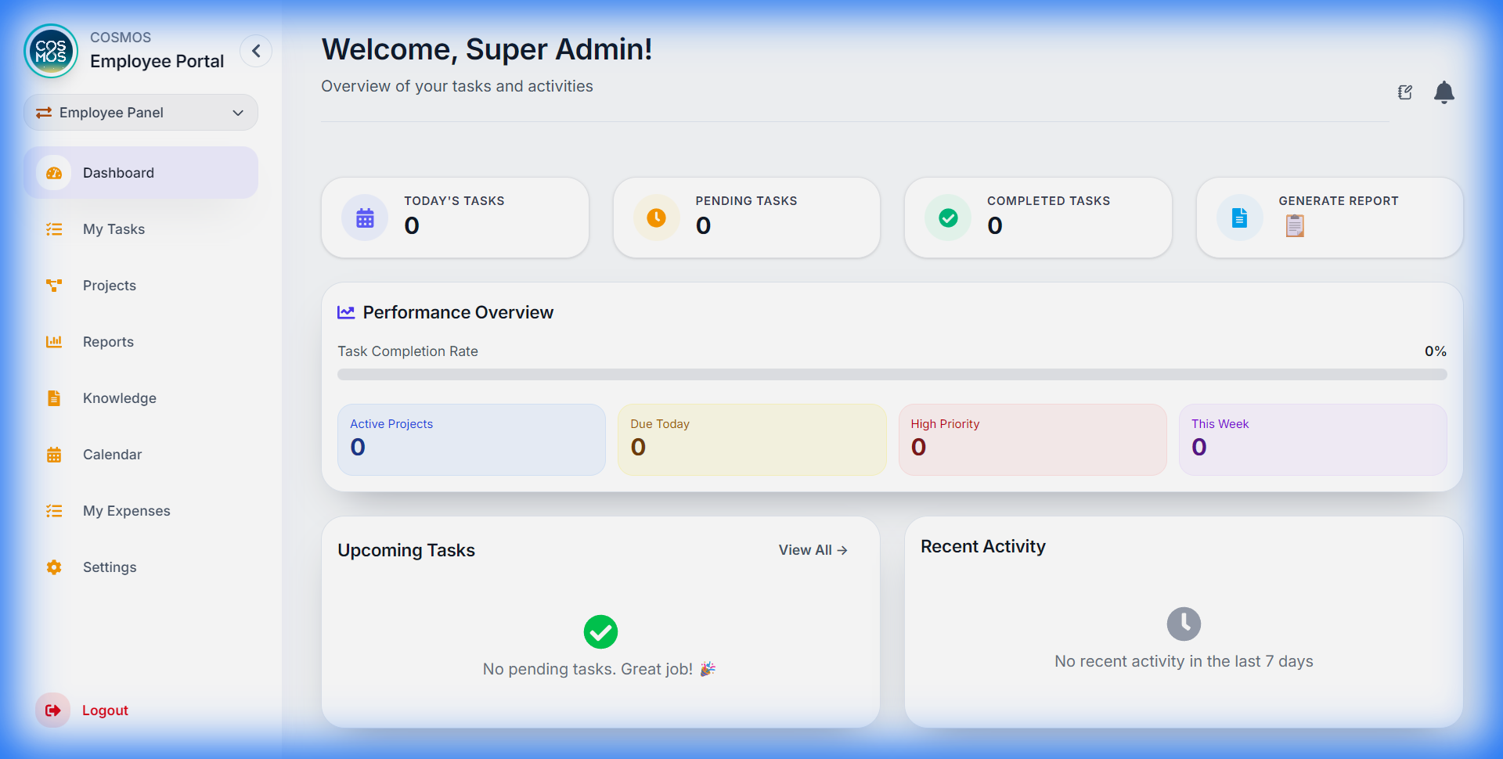
Employee Dashboard

Statistics Cards
Card | Description
Total Tasks | All tasks assigned to you
Completed | Tasks you've finished
In Progress | Tasks you're currently working on
Overdue | Tasks past their due date
________________________________________

Today's Tasks
View all tasks due today:
- Task title
- Priority level (High/Medium/Low)
- Project name
- Quick complete button
Quick Complete:
- Click the checkmark button on a task
- Optionally add a completion comment
- Click Submit
________________________________________

Performance Metrics
- Completion Rate - Percentage of tasks completed
- Active Projects - Number of projects you're involved in
- High Priority Tasks - Count of urgent tasks pending
________________________________________

Recent Activity
Shows tasks completed in the last 7 days:
- Task name
- Completion date
- Project name
________________________________________

Task Management
Navigate to Tasks from the sidebar for full task management capabilities.

Task Views
Switch between different task views using the tabs:
- All Tasks - Every task assigned to you
- To-Do - Tasks not yet started
- In Progress - Tasks you're working on
- Overdue - Tasks past due date
- Self Tasks - Tasks you created for yourself
________________________________________

Viewing Task Details
Click on any task to open the Task Detail Modal:
- Full task description
- Due date and time
- Priority level
- Project information
- Subtasks (if any)
- Activity history
________________________________________

Updating Task Status
Method 1: Quick Status Change
- Click the status dropdown on a task card
- Select the new status
Method 2: From Task Modal
- Open the task detail modal
- Click the status field
- Select the new status
Available Statuses:
- To-Do - Not started
- In Progress - Currently working
- Done - Completed
________________________________________

Marking Tasks Complete
- Change task status to "Done" OR click the complete button
- A completion modal appears
- (Optional) Enter a completion comment describing what was done
- Click Submit
TIP: Adding completion comments helps managers understand what was accomplished and aids in reporting.
________________________________________

Self Tasks
Create personal tasks for your own tracking:
To Create a Self Task:
- Go to the "Self Tasks" tab
- Click "+ Add Task"
- Fill in:
- Task title
- Due date
- Priority
- Description
- Click Create
Managing Self Tasks:
- Edit by clicking the edit icon
- Delete by clicking the delete icon
- Select multiple for bulk actions
________________________________________

Task Reminders
Set personal reminders for specific tasks:
- Click the bell icon on a task card
- Set the reminder date and time
- Add an optional note
- Click Save
The reminder will notify you at the scheduled time.
________________________________________

My Projects
View all projects you're assigned to.
- Navigate to Projects from the sidebar
- See project cards with:
- Project name
- Client name
- Your role in the project
- Project deadline
- Progress percentage
- Click a project card to see:
- Full project details
- All project tasks
- Team members
- Project timeline
________________________________________

Calendar
View all your tasks and events on a calendar.
- Navigate to Calendar from the sidebar
- View modes:
- Month View - See entire month overview
- Week View - Detailed weekly schedule
- Day View - Hour-by-hour view
- Calendar shows:
- Task due dates
- Meetings
- Events
- Deadlines
Interactions:
- Click a date to see all items for that day
- Click an item to open its details
- Navigate months using the arrow buttons
________________________________________

Employee Expense Submission
Submit expense claims for reimbursement.

Submitting an Expense
- Navigate to Expenses from the sidebar
- Click "+ New Expense" button
- Fill in the expense form:
Field | Description
Category | Type of expense (Travel, Meals, Equipment, etc.)
Amount | Expense amount in your currency
Date | Date the expense occurred
Description | Details about the expense
Project | Which project this expense is for
Receipt | Upload photo/document of receipt
- Click Submit for Approval OR Save as Draft
________________________________________

Expense Statuses
Status | Meaning
Draft | Saved but not submitted
Pending | Submitted, awaiting manager approval
Approved | Manager approved the expense
Rejected | Manager rejected (check rejection reason)
________________________________________

Viewing Your Expenses
- See all your submitted expenses in a table
- Filter by status (All, Pending, Approved, Rejected)
- Click an expense to view full details
- Edit or delete draft/rejected expenses
CAUTION: Once an expense is approved, it cannot be edited or deleted.
________________________________________

Reports
Generate and view your performance reports.
- Navigate to Reports from the sidebar
- Click "Generate Report" to create a new report
Report Contents:
- Task summary (completed, pending, overdue)
- Performance metrics (completion rate)
- Recent activity
- Today's focus tasks
Actions:
- Download - Save report as text file
- Edit - Modify report content before saving
________________________________________

Client Panel

Client Dashboard Overview
The Client Dashboard provides visibility into your projects and their progress.

Key Statistics Cards
Stat Card | Description
My Projects | Number of projects associated with your account
Total Tasks | All tasks across your projects
Completed Tasks | Tasks marked as done
Pending Tasks | Tasks still in progress

Dashboard Features
- Project Progress - Visual progress bars for each project
- Upcoming Tasks - Tasks scheduled in the near future
- Recent Activity - Latest updates on your projects
- Quick Notes - Personal notes linked to projects
________________________________________

Client Projects
View all projects assigned to your account.
- Navigate to Projects from the sidebar
- See project cards showing:
- Project name
- Current status
- Progress percentage
- Start and end dates
- Project team members
Project Details:
Click a project to view:
- Full project description
- All project milestones
- Task breakdown
- Team members with contact info
- Project documents
________________________________________

Client Task Tracking
Track tasks across your projects.
Task Views:
- View tasks by project
- Filter by status (To-Do, In Progress, Done)
- See priority levels
- Track due dates
Task Information:
- Task title and description
- Assigned team member
- Due date
- Current status
- Related project
NOTE: Clients can view task progress but cannot modify tasks directly. Contact your project manager for task changes.
________________________________________

Client Calendar
View project schedules and deadlines.
Calendar Features:
- Monthly calendar view
- Project milestone markers
- Task due date indicators
- Navigate between months
Interactions:
- Click a date to see items due
- Color-coded by project
- View upcoming deadlines at a glance
________________________________________

Client Reports
Access reports on your projects.
Available Reports:
- Project status summary
- Task completion metrics
- Timeline and milestone tracking
- Monthly progress reports
Actions:
- View reports online
- Download as PDF/Text
- Request custom reports from team
________________________________________

Tips for Success

For Super Admins & Admins
- Monitor system health - Regularly check resource utilization and project status
- Manage users proactively - Keep user roles and access updated
- Review reports weekly - Stay on top of organizational metrics
- Maintain knowledge base - Keep documentation current

For Managers
- Check notifications daily - Stay on top of overdue tasks and approaching deadlines
- Review expenses promptly - Keep your team's reimbursements flowing
- Use reminders - Set reminders for important check-ins with team members
- Monitor project progress - Use the dashboard to identify blocked projects

For Employees
- Update task status regularly - Helps managers track progress
- Add completion comments - Provide context for your work
- Check calendar daily - Never miss deadlines or meetings
- Submit expenses with receipts - Speeds up approval process
- Use self-tasks - Track personal to-dos alongside assigned work

For Clients
- Check project progress regularly - Stay informed on your projects
- Use the calendar - Track upcoming milestones
- Review reports - Understand project metrics
- Contact project manager - For any questions or changes needed
________________________________________

Keyboard Shortcuts
Shortcut | Action
`Escape` | Close modals
`Enter` | Submit forms
________________________________________

Troubleshooting

Common Issues
Can't Login:
- Verify email is correct
- Check Caps Lock for password
- Try "Forgot Password" if needed
- Contact administrator if account is locked
Tasks Not Loading:
- Refresh the page
- Check your internet connection
- Clear browser cache
- Try logging out and back in
Notifications Not Appearing:
- Check browser notification permissions
- Ensure you're on the dashboard page
- Wait a few seconds (reminders check every 10s)
Expense Upload Failed:
- Check file size (max 5MB)
- Use supported formats (PDF, JPG, PNG)
- Try a smaller file or different format
Panel Switcher Not Showing:
- You may only have access to one panel
- Contact Super Admin for multi-panel access
________________________________________

Getting Help
If you encounter issues not covered in this guide:
- Contact your system administrator
- Check with your project manager
- Refer to the technical documentation
________________________________________
*Last Updated: January 2026*
*Version: 2.0 - All User Roles*

