**Airflow DAG for Full refresh on stock price using Alpha Vantage API**

* **Set up required variables:**

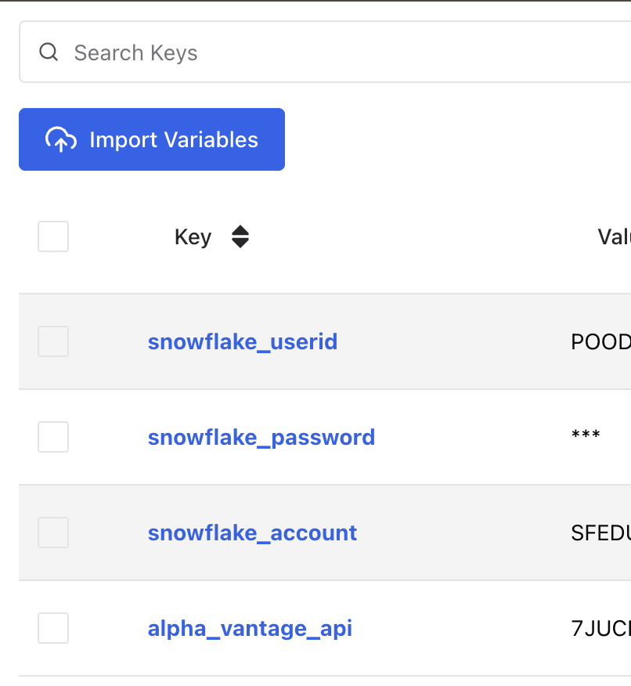

* **Set up Snowflake connection:**

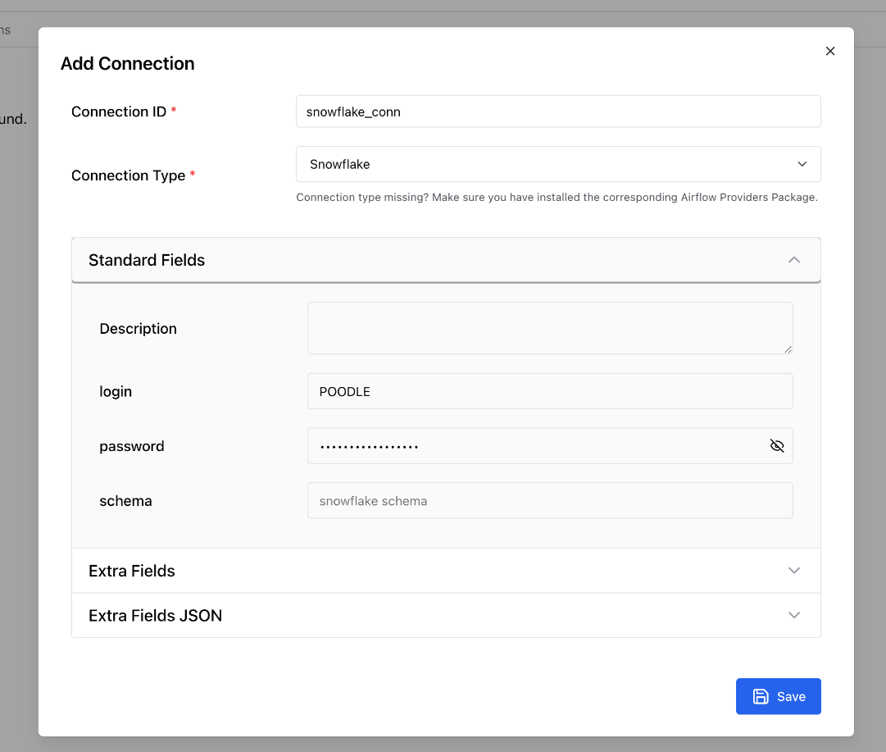

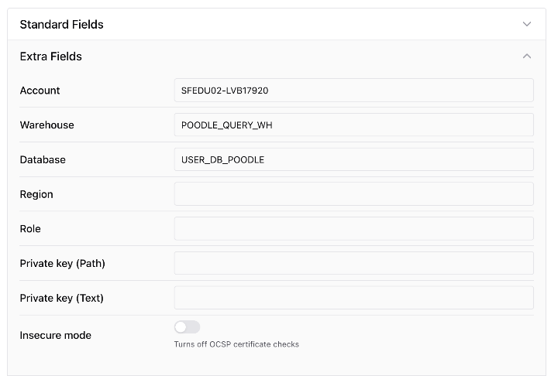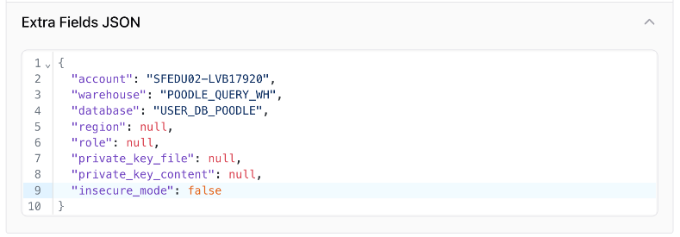

* 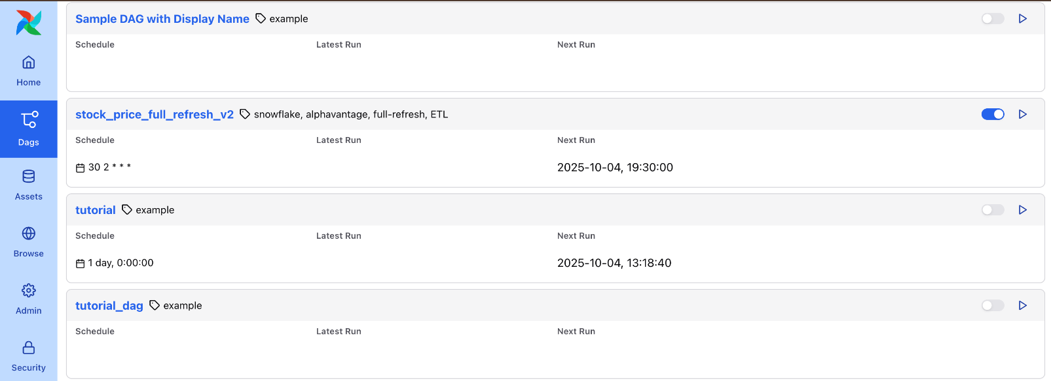**Airflow Homepage showing my DAG “stock_price_full_refresh_v2”:**
* 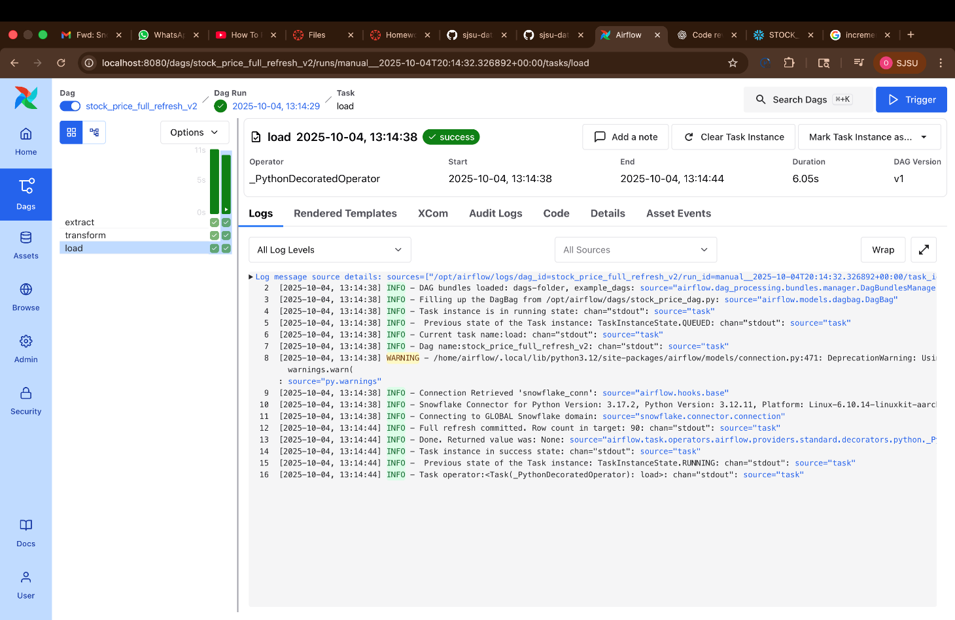**Log screen of my DAG (Load Operation):**
* 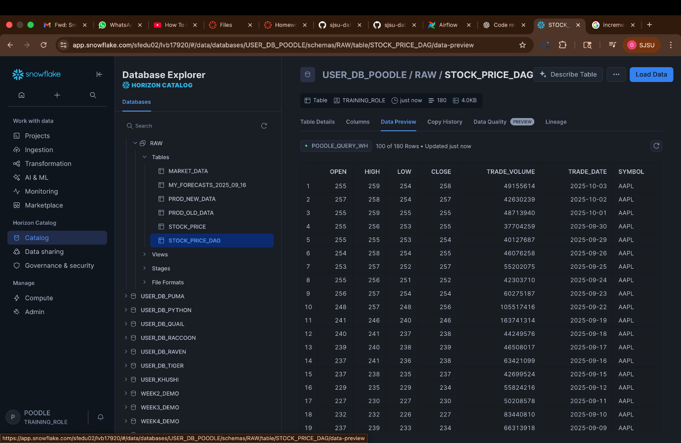**Extra Screenshots:**

**Snowflake UI showing the output table “STOCK_PRICE_DAG” after successful execution of airflow DAG**

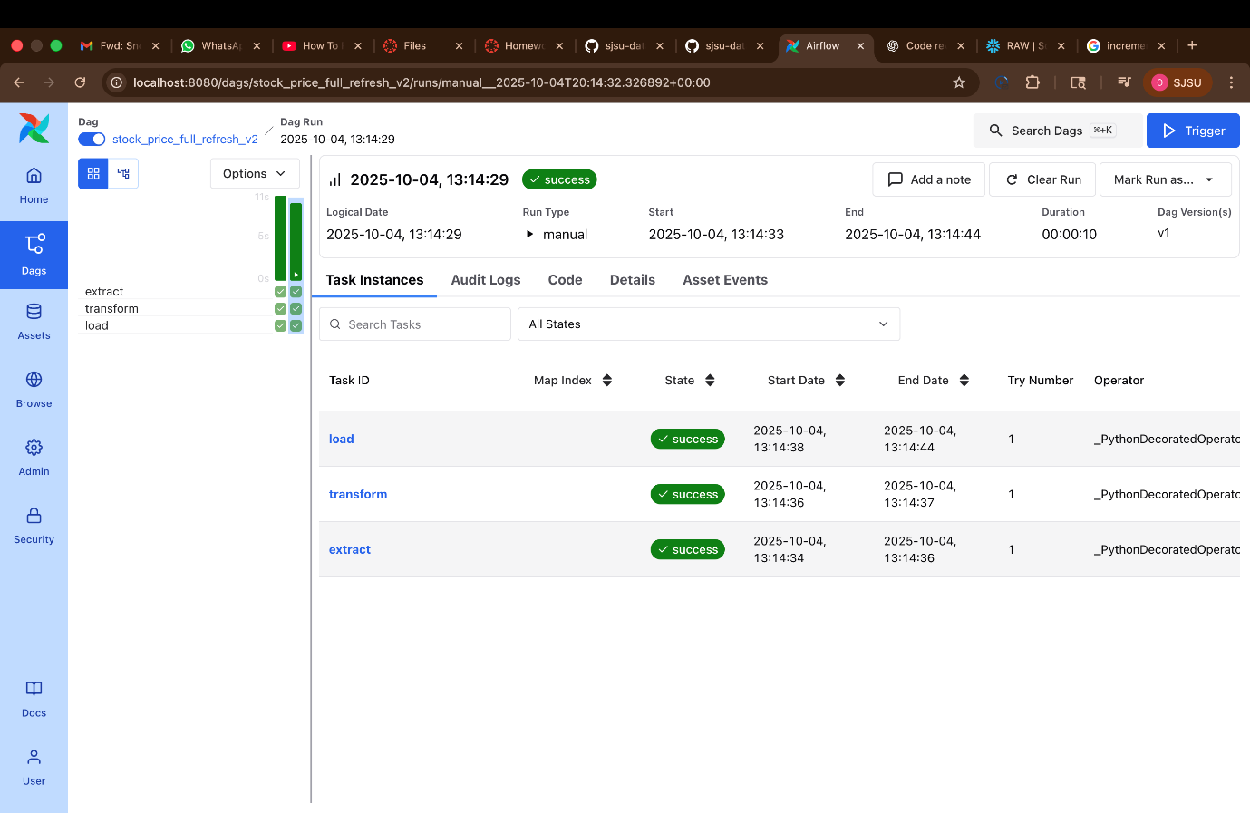

**Airflow UI showing successful execution of my ”stock_price_full_refresh_v2” DAG**

**- Omkar Rajale**