UrbanHeat AI
Simple page-by-page guide with screenshots
This guide explains each dashboard page in easy words: what it is for, what you click, where the data comes from, and how to read the result.

What the application does
UrbanHeat AI helps find hot places in Chhatrapati Sambhajinagar, explain why the model thinks they are hot, identify where people may be more exposed, and compare possible cooling actions.

The seven pages
- Project Overview — main summary cards.
- Urban Heat Hotspots — hottest locations and priority zones.
- Heat Drivers — which inputs influence the model most.
- Heat Vulnerability — heat plus population exposure.
- Cooling Strategy — test intervention sliders and see before/after results.
- Model Validation — how well the model performed in testing.
- About Project — inputs, outputs, team, and limitations.

Overall data flow
Prepared CSV files → Streamlit loads data → page shows cards/maps/charts/tables.
For Cooling Strategy: slider values → src/inference.py changes features → XGBoost predicts new LST → before/after comparison → charts, table, advisory, CSV download.

Important note about screenshots
The screenshots were captured from the local application. Map tiles may appear blank when external map services are unavailable; the filters, priority tables, charts, and simulation results still show the project data. “SC” means screenshot.

1. Project Overview

SC: Project Overview page with summary cards and navigation.
What it does: This is the home page. It gives a quick summary of the model, dataset, and heat situation.
How to use it: Open the app and read the cards. Then use the left menu to open a detailed page.
Data flow: dashboard_kpis_v3.csv provides the main cards. Hotspot, SHAP, and scenario summary CSVs provide the lower map/charts.
Result shown: Model R², mean absolute error, total sampled locations, priority-zone count, and high-heat share. Lower sections show a hotspot map, heat-category distribution, top SHAP drivers, and scenario cooling summaries.
Easy meaning: R² near 1 is better; MAE is average temperature error. The 50% high-heat share means the upper two heat categories in this sample, not half of the city’s land area.

2. Urban Heat Hotspots
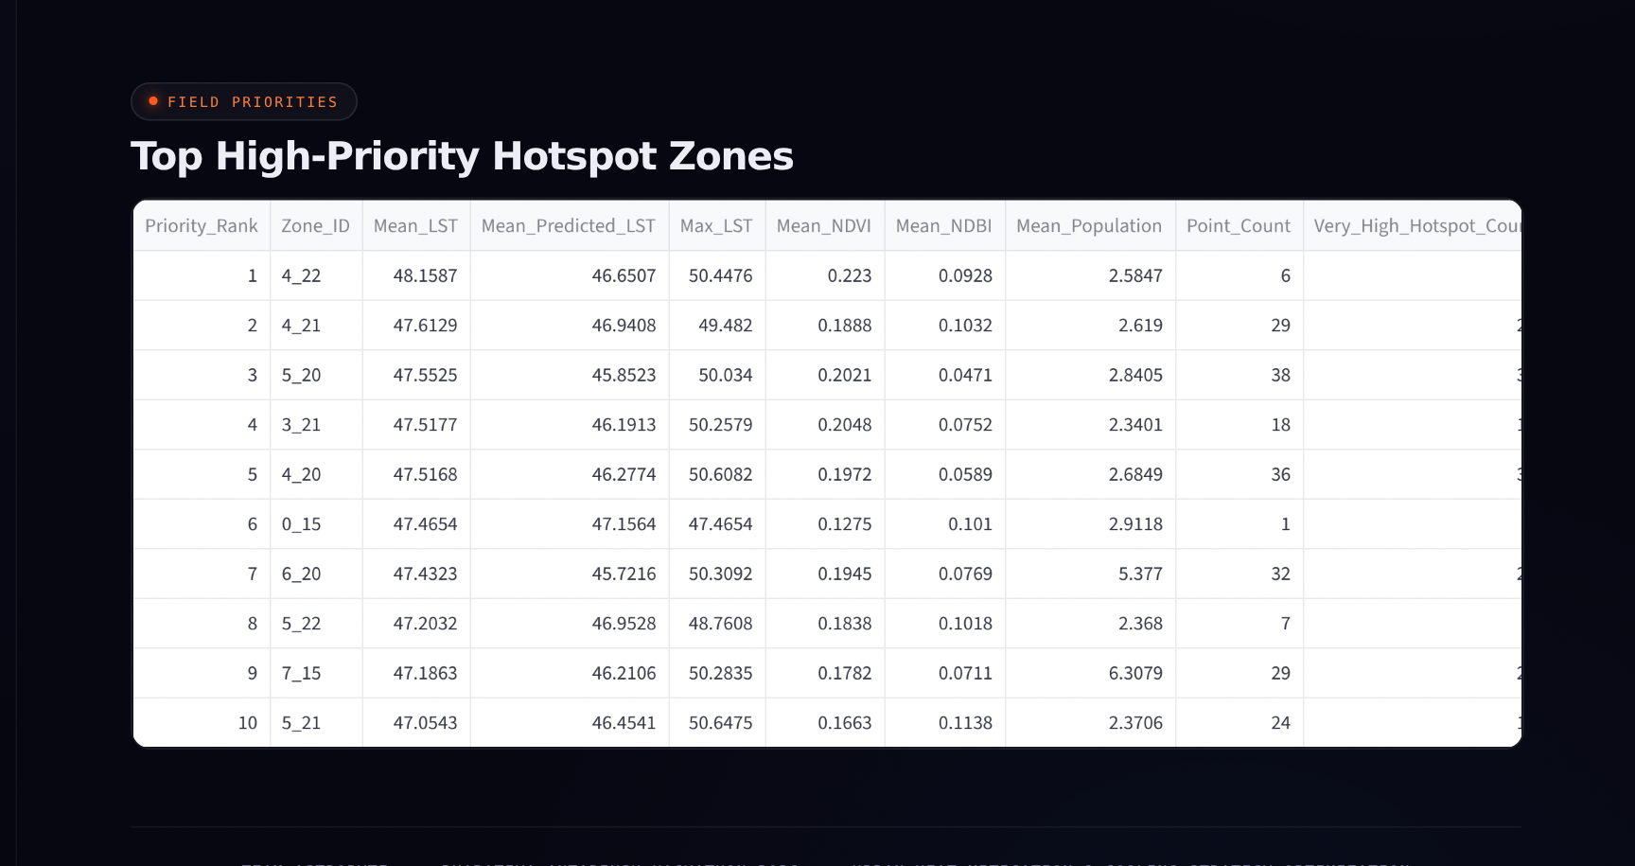
SC: Top High-Priority Hotspot Zones table. The map is above this table on the same page.
What it does: Shows where observed land surface temperature is highest and which zones should be checked first.
How to use it: Select heat categories such as High or Very High. The map filters. Scroll down to see the priority-zone table.
Data flow: dashboard_hotspot_map_v3.csv is filtered by Heat_Category for the map. dashboard_priority_zones_v3.csv supplies the ranked table.
Result shown: A color-coded map plus a table with Priority_Rank, Zone_ID, Mean_LST, Max_LST, Point_Count, and hotspot percentage.
Example: Zone 4_22 is ranked first with mean LST about 48.16 °C. It has only 6 sampled points, so it should be field-checked rather than treated as a final city-wide decision.

3. Heat Drivers
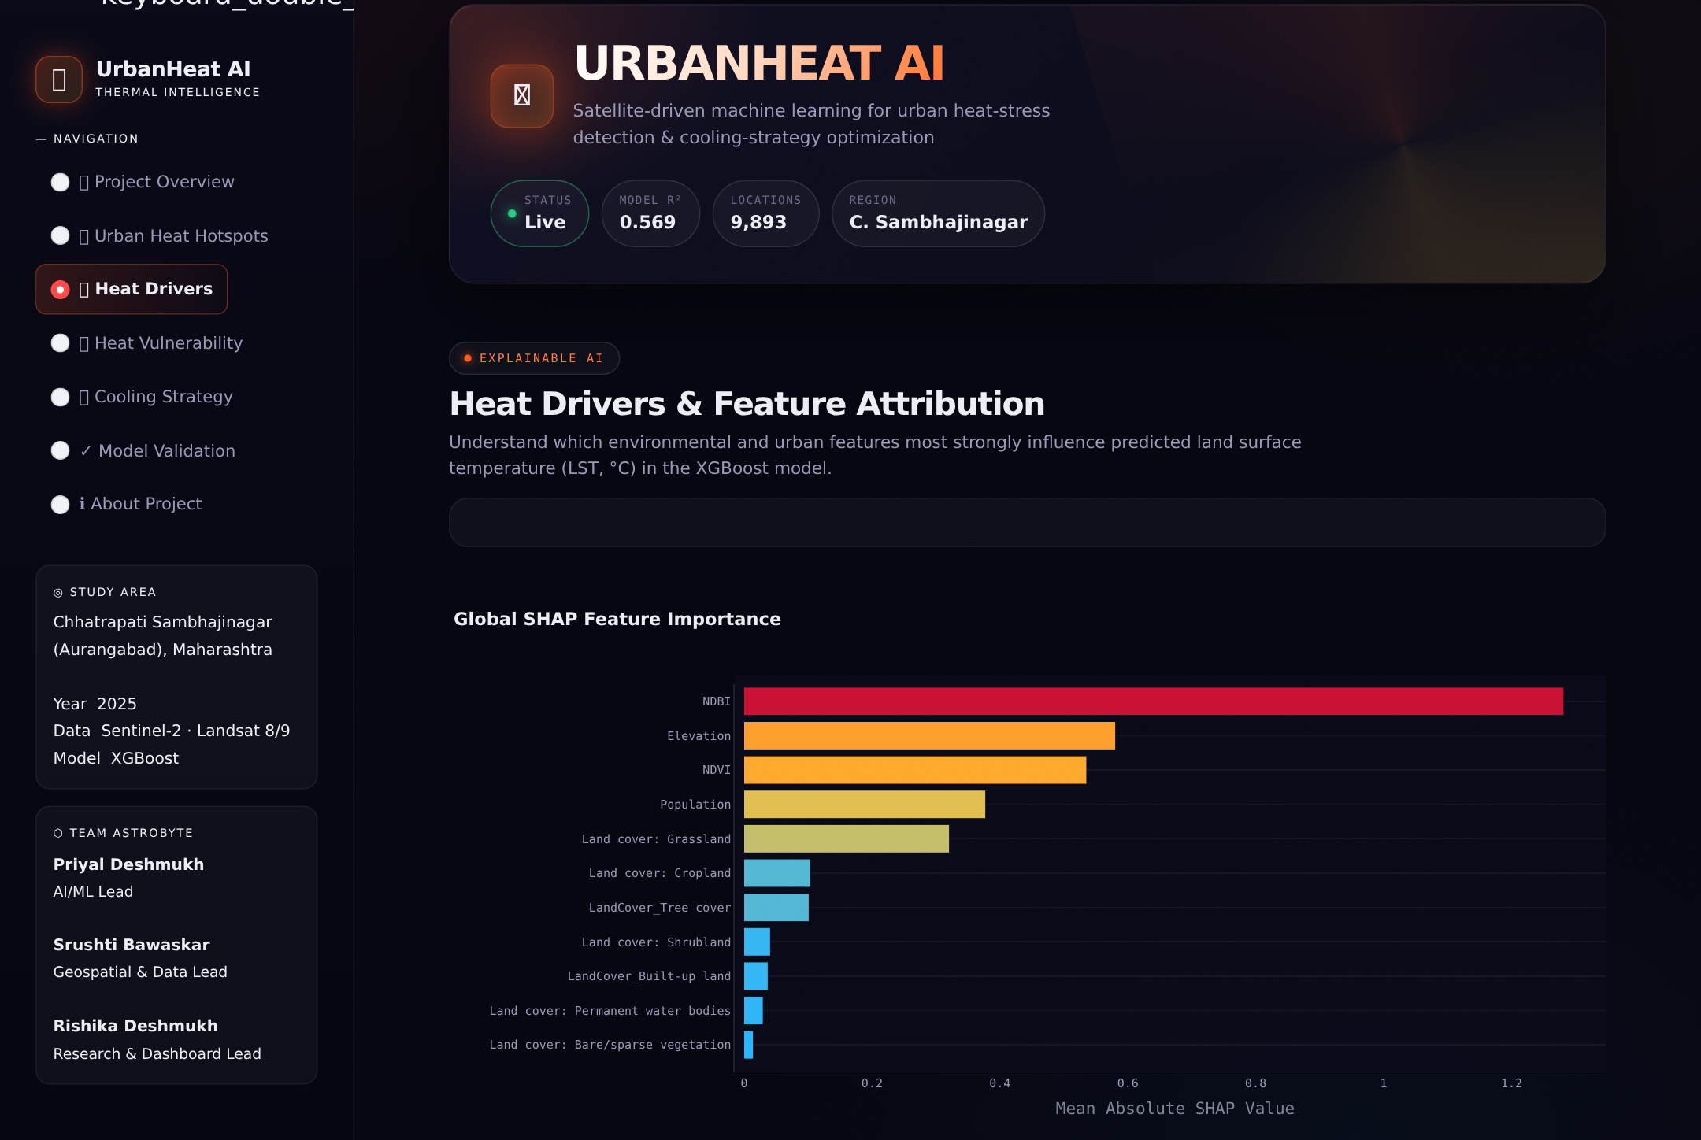
SC: Heat Drivers page showing the global SHAP feature-importance chart.
What it does: Explains which inputs have the strongest overall influence on the model’s predicted temperature.
How to use it: Read the horizontal bar chart. A longer bar means a stronger average influence. The table below gives the numeric values.
Data flow: SHAP values were calculated from the trained XGBoost model and saved in dashboard_shap_importance_v3.csv. Streamlit reads that file and draws the chart.
Result shown: NDBI, elevation, NDVI, and population are among the strongest drivers in the saved V3 analysis.
Easy meaning: This is model explanation, not proof of cause. It says the model used these features strongly; it does not prove that changing one feature will definitely change real temperature by a fixed amount.

4. Heat Vulnerability
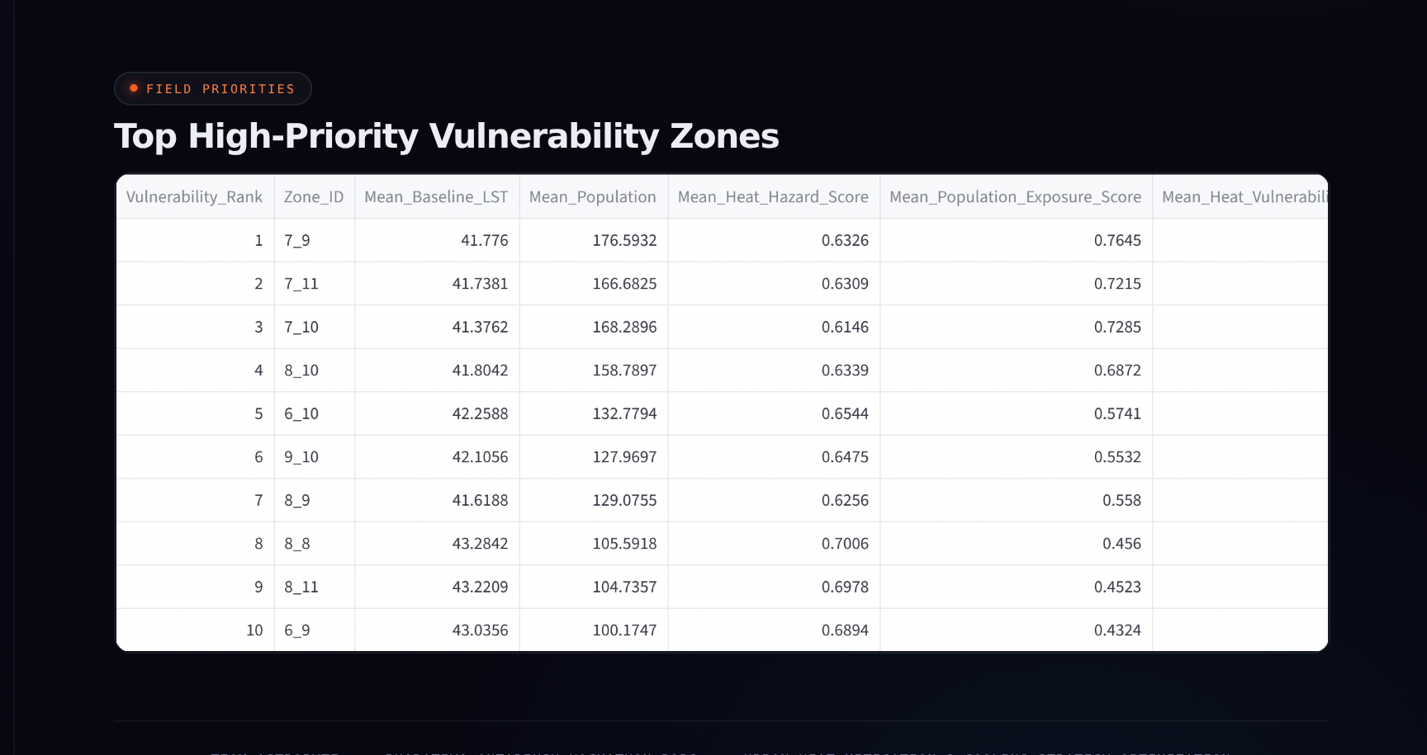
SC: Top High-Priority Vulnerability Zones table. The vulnerability map is above this table.
What it does: Finds places where heat and population exposure overlap. A very hot empty field may be less urgent than a moderately hot crowded area.
How to use it: Select vulnerability categories. The map filters. Scroll down to inspect the ranked vulnerability table.
Data flow: dashboard_vulnerability_map_v3.csv supplies map points. dashboard_vulnerability_zones_v3.csv supplies zone rankings.
Result shown: HVI score, population exposure, heat hazard, zone ID, and priority rank. HVI combines normalized predicted heat and normalized population with equal weight.
Example: Zone 7_9 is ranked first with HVI about 0.699 and mean population proxy about 176.6. It is not the same as the hottest thermal zone, which is why this page is useful.

5. Cooling Strategy — controls

SC: Cooling Strategy page with five intervention sliders and the Run AI Simulation button.
What it does: Lets you test a possible cooling mix, such as more trees, cool roofs, permeable surfaces, and less built-up intensity.
How to use it: Move the five sliders from 0 to 100, then click Run AI Simulation. Defaults are 20, 25, 15, 15, and 10.
Data flow: The app loads featured_uhi_v3.csv and the saved XGBoost model. src/inference.py converts slider values into assumed changes in NDVI, NDBI, and land-cover fractions.
Result shown: Before running, the page shows the selected intervention mix and a preview. After running, it shows before/after temperature results.
Easy meaning: The sliders are planning assumptions. They are not measured engineering effects or a guarantee that the city will cool by the displayed amount.

6. Cooling Strategy — results
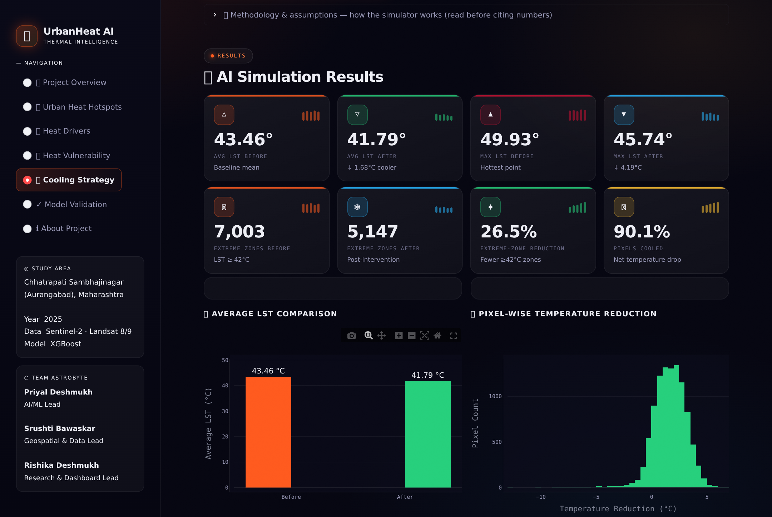
SC: Simulation result cards and before/after charts for the default slider mix.
What it does: Compares baseline predicted temperature with predicted temperature after the selected intervention mix.
How to use it: Read the cards first, then scroll to the hotspot table, category summary, advisory, and CSV download.
Data flow: Modified features → XGBoost predicts “after” LST → app compares it with “before” LST → cards, charts, tables, and CSV are produced.
Result shown: For the default mix: average LST changes from about 43.46 °C to 41.79 °C; points at or above 42 °C change from 7,003 to 5,147; about 90.1% of points show a positive reduction.
Easy meaning: The app label “extreme zones” here means sampled points at or above 42 °C. The result is a model-based what-if estimate, not a validated real-world cooling measurement.

7. Model Validation
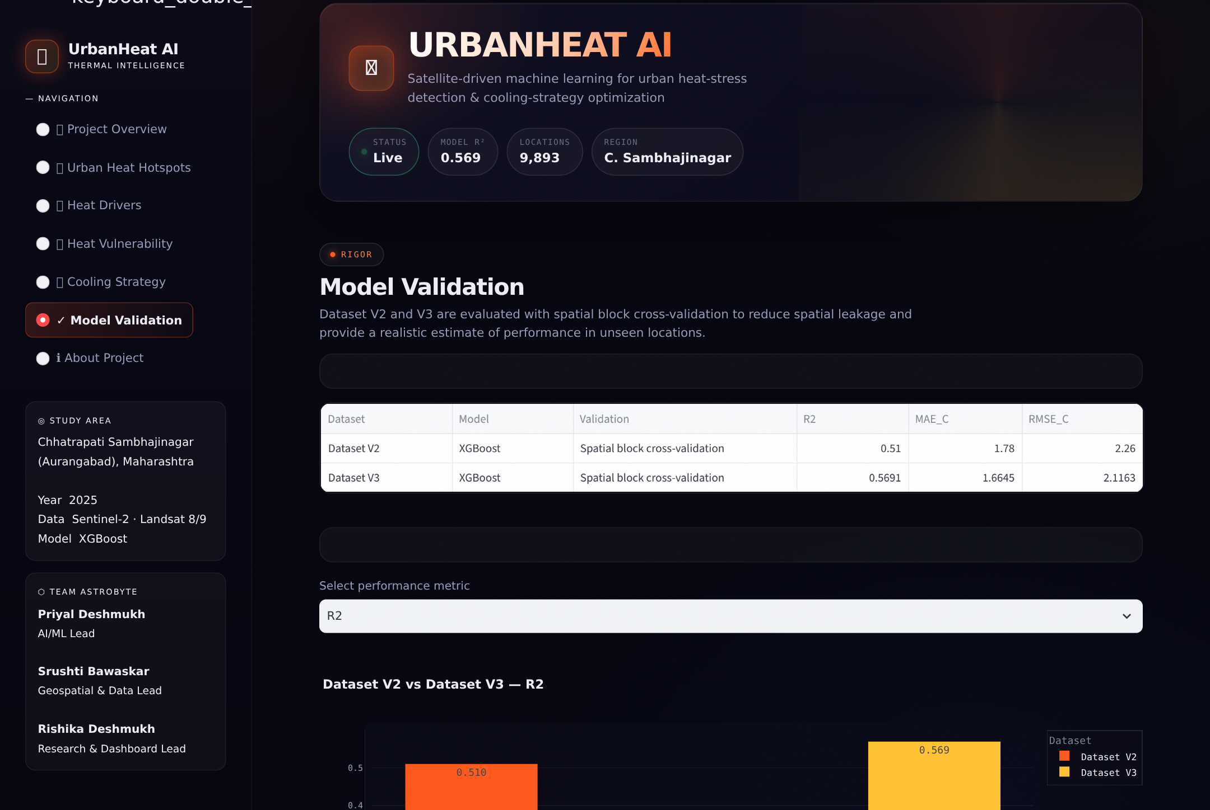
SC: Model Validation page comparing Dataset V2 and Dataset V3.
What it does: Shows how well the model performed during testing, so users can judge how much trust to place in predictions.
How to use it: Choose a metric such as R², MAE, or RMSE. The chart compares Dataset V2 and Dataset V3.
Data flow: dashboard_model_comparison.csv stores the saved comparison metrics. Streamlit displays the table and draws the selected metric chart.
Result shown: V3 XGBoost has R² about 0.5691, MAE about 1.6645 °C, and RMSE about 2.1163 °C in the saved V3 comparison.
Easy meaning: Spatial cross-validation tests the model on held-out geographic blocks. MAE means the average absolute temperature error is about 1.66 °C. V2 is historical context, not the deployed final model.

8. About Project

SC: About Project page with key inputs, key outputs, limitations, and team information.
What it does: Gives background information about the project, data sources, outputs, team, and limitations.
How to use it: Read it when you need to explain the project scope or remember what the system does and does not do.
Data flow: This page is mostly static project information, not a live analytical calculation.
Result shown: Key inputs such as Sentinel-2, Landsat, SRTM, WorldPop, and Google Earth Engine; key outputs such as hotspot maps, XGBoost predictions, SHAP, cooling comparison, and vulnerability zones.
Easy meaning: The page reminds users that satellite LST is not air temperature, population is only an exposure proxy, and field validation is needed before real implementation.

Quick recap
Page | Main question | Main result
Project Overview | What is the overall situation? | Summary cards and main charts
Urban Heat Hotspots | Where is it hottest? | Heat map and priority-zone table
Heat Drivers | Why does the model predict heat? | SHAP bar chart and table
Heat Vulnerability | Where are people more exposed? | HVI map and vulnerability ranking
Cooling Strategy | What cooling mix can we test? | Sliders, before/after cards, charts, CSV
Model Validation | How reliable is the model? | V2/V3 metric table and chart
About Project | What is the project scope? | Inputs, outputs, team, limitations

One-line explanation
UrbanHeat AI is a machine-learning dashboard that maps urban heat, explains heat drivers, ranks population-aware vulnerability, and simulates possible cooling strategies using prepared satellite-derived data, XGBoost, SHAP, Streamlit, and FastAPI.

