Preparation of Manuscripts for Journal of Electrical Engineering & Technology

Abstract – Abstract should not exceed 200 words and should concisely state what was done, how it was done, principal results, and their significance and/or contributions. It should be also noted that abstract should not contain any equations, references, or footnotes. This article plays the role of a template as well as the guidelines for prospective authors who will have to prepare the final manuscript accepted for publication by KIEE transactions on systems and control. Hence, it is not required to adhere to these instructions in submission of your works for initial review.

Keywords: Final manuscript, Guidelines, Instructions, Prospective authors, Template

1. Introduction

This article gives you guidelines for preparing papers that, after thoroughly reviewed by the referees, have been decided to be published for KIEE transactions on systems and control (SC). If you are using Microsoft Word 6.0 or later and reading a paper version of this document, please download the electronic file, J_KIEE.doc from the KIEE homepage so you can use this document as a template.
Otherwise, you may use this as just an instruction set. It is remarked that you do not have to follow this style file when your works is submitted for the initial review stage.

2. Detailed Formats of Manuscript

This section describes how to prepare each part of the final manuscript more specifically. Your manuscript should be typed double-spaced in two-column format on one side of a sheet only, with margins of about 1.5 cm on left and right side and 2.5 cm on top and bottom side, respectively, of each page. The suggested length of a regular paper would be 5~10 pages in this style. The subsequent headings, so called the subsections, may as well not exceed further than one-step lower level. In other words, the headings like ‘2.1.2 two-step lower level’ are not recommended while ‘2. Section’ and ‘2.1 Subsection’ would be validated. As for the fonts and the sizes of the headings, this manuscript in itself constitutes a good example. The paper should be written in A4 (210mm by 297mm) size. All fonts are Times New Roman.

2.1 Main Title and Author affiliation

The font size of the title and the authors is bold 16 pt and 12 pt, respectively. And the authors’ affiliation should appear in the lower left corner of the first page as a footnote.

2.2 Abstract and Keywords

Before the body of the abstract and the keywords, the terms ‘Abstract -’ and ‘Keywords:’ should come in bold 11 pts, respectively. Abstract should be limited to 50~200 words and keywords are usually composed of about five terms or phrases in alphabetical order, separated by commas.

2.3 Body

Full-length papers generally, for example, consist of introduction, nomenclature, if any, main parts of the body, conclusions. The font sizes of the section headings are bold 11 pts and those of the subsection headings bold 10 pts, respectively.

2.4 References and Authors’ information

Citations must be numbered consecutively in square brackets [1]. The sentence punctuation should be put after the brackets [2]. Multiple references [2], [3] are each numbered with separate brackets [1]-[3]. In sentences, refer simply to the reference number, as in [3]. Do not use ‘Ref. [3]’ or ‘reference [3]’ except at the beginning of a sentence. The list of references should be arranged in the order of citation in text, not in alphabetical order. The photographs, names, the vitae and the research interests of the authors should be given at the end of the paper.

3. Equations and Units

Equations should be placed at the center of the line and provided consecutively with equation numbers in parentheses flushed to the right margin, as in (1).

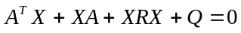 (1)

Be sure that the symbols used in your equation have been defined before the equation appears or immediately following.
It is strongly encouraged that the authors may use SI units only.

4. Useful Hints

The text must include a citation of each figure and table.
Letters in the figure should be large enough to be readily legible when the drawing is reduced. Do not forget to include the label, unit for each axis and the legend when they are required.

4.1 Figures

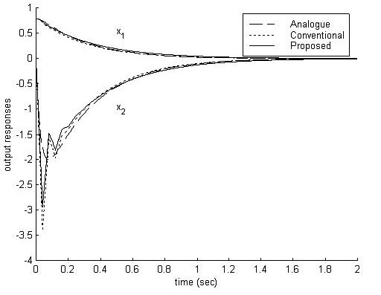
Fig. 1. The caption for a figure must follow the figure

4.2 Tables

Table 1. The caption must be followed by the table

 | A (ampere) | B (voltage)
a | 0.65 A | 0.83 V
b | 1.32 A | 1.09 V

4.3 Abbreviations and Acronyms

Abbreviation and acronyms should be defined the first time they appear in the text, even after the have already been defined in the abstract. Do not use abbreviations in the title unless they are unavoidable.

5. Conclusion

Even though a conclusion may review the main results or contributions of the paper, do not duplicate the abstract or the introduction. For a conclusion, you might elaborate on the importance of the work or suggest the potential applications and extensions.

Acknowledgements

This work was supported by the KIEE

References

[1] Joseph Vardi and Benjamin Avi-Itzhak, Electric Energy Generation; Economics, Reliability and Rates: MIT, 1981, p.75-94.
[2] Roy Billinton and Easin Khan, “A Security Based Approach to Composite Power System Reliability Evaluation,” IEEE Trans. Power Systems, vol.PS-7, no.1, pp.65-72, Feb. 1992.
[3] Jaeseok Choi, Hongsik Kim, Junmin Cha and Roy Billinton, “Nodal Probabilistic Congestion and Reliability Evaluation of a Transmission System under the Deregulated Electricity Market,” in Proceedings of IEEE PES SM2001 Conference, Vancouver, Canada, July 2001.

