**GOVERNMENT POLYTECHNIC, PUNE.**

(Autonomous Institute Of Government Of Maharashtra)



ACADEMIC YEAR 2020-21

A PROJECT REPORT ON

**“GramSwaraj : Digital GramPanchayat”**

**SUBMITTED BY:**

|  |  |
| --- | --- |
| Omkar Dayanand Sapkal | 1906112 |
| Isha Narendra Patil | 1906099 |
| Hindavi Vinod Lande | 1906077 |
| Vaishnavi Pramod Pardeshi | 1906093 |

UNDER THE GUIDENCE OF

**Prof. G. B. GARUD**

DEPARTMENT OF COMPUTER ENGINEERING

**GOVERNMENT POLYTECHNIC, PUNE.**

(Autonomous Institute Of Government Of Maharashtra)



**CERTIFICATE**

This is to certify that,

|  |  |
| --- | --- |
| **Omkar Dayananda Sapkal** | **1906112** |
| **Isha Narendra Patil** | **1906099** |
| **Hindavi Vinod Lande** | **1906077** |
| **Vaishnavi Pramod Pardeshi** | **1906093** |

of class Third Year (2021-22) have successfully completed project on

**‘GramSwaraj : Digital GramPanchayat’** under the guidance of **Mrs. Gauri B. Garud** in parallel fulfillment of requirement for the award of Diploma in Computer Engineering from Government Polytechnic, Pune.

|  |  |
| --- | --- |
| **Prof. SHANKAR B. NIKAM** | **DR. V.S.BANDAL** |
| (H.O.D) | (Principal) |

|  |  |
| --- | --- |
| **Prof. G. B. GARUD** |  |
| (Project Guide) | (External Examinar) |

ACKNOWLEDGEMENT

It gives me a great sense of pleasure to present the report of the Project Work undertaken

during Diploma in Computer Engineering Final Year.

My deepest thanks to my Project Guide **Prof. G.B. Garud**, Lecturer in Department of Computer Engineering, Government Polytechnic Pune for their timely co-operation, eminent guidance and lots of encouragement.

In a particular, we wish to offer our gratitude to honorable Head of Computer Engineering Department **PROF. SHANKAR B. NIKAM.**

I also do not like to miss the opportunity to acknowledge the contribution of all faculty

members of the department for their kind assistance and cooperation during the

development of my project.

Last but not the least, I acknowledge my friends for their contribution in the completion

of the project.

|  |  |
| --- | --- |
| **Omkar Dayananda Sapkal** | **1906112** |
| **Isha Narendra Patil** | **1906099** |
| **Hindavi Vinodrao Lande** | **1906077** |
| **Vaishnavi Pramod Pardeshi** | **1906093** |

TABLE OF CONTENTS

|  |  |  |
| --- | --- | --- |
| **SR.NO.** | **CONTENTS** | **PAGE NO.** |
|  | **TITLE PAGE** |  |
|  | **CERTIFICATE** |  |
|  | **ACKNOWLEDGEMENT** |  |
|  | **ABSTRACT** |  |
| **1.** | **INTRODUCTION** | **06** |
| **2.** | **PROJECT TIMELINE AND TARGET** | **07** |
| **3.** | **PROJECT PLANS**  3.1 Background And Purpose  3.2 Goal Of Study  3.3 Environment Of Implementation |  |
| **4.** | **PROJECT REQUIREMENTS**  4.1 Functional Requirements  4.2 Performance Requirements |  |
| **5.** | **DESIGN STRATEGY.**  5.1 Feasibility Study  5.2 Use Case Diagram |  |
| **6.** | **Project Output** |  |
| **7.** | **PROJECT TESTING.**  7.1 Unit Testing  7.2 Smoke Testing  7.3 Integration Testing  7.4 Regression Testing  7.5 System Testing |  |
| **8.** | **FUTURE SCOPE**  1. Advantages  2. Disadvantages  3. Future Development |  |
| **9.** | **CONCLUSION** |  |
| **10.** | **REFERENCES** |  |

ABSTRACT

Over the past two decades, India’s ability to create, select, adapt, use and profit from knowledge has become increasingly important to its sustainable economic growth and improvement of living standard. The growing role of Information and Communication Technology (ICT) tools has strengthened the human intellectual capacity and the formation of modern lifestyles.

With this background we has initiated and rolled forward the concept of ‘GramSwaraj : Digital Panchayat’ Application. Digital Panchayat means – an Application based dynamic digital interface created for each and every Panchayat in Maharashtra, giving information about particular panchayat in a two-way flow of content. It is user friendly application, as it is developed in android programming language, with back-end technology of ‘Google’s Firebase Cloud service’ also mainly platform independent Java Programming language. The objective is to facilitate and improve Panchayat functioning on day-to-day basis, through two way flow of information and content. The main objective of this project is to reach government service in a digital way. With the help of this project better communication may be developed between local village governing authority and the public and in this way it is helpful in information distribution. Panchayat staff will accept this application and verify and send this application to head office from where application will be approved. At present most of the services like birth/ death registration , income certificate, property / land related documents, etc. are done offline or in paper medium in that the villagers have to go for all the information in the Panchayat office and they face many difficulties.

This paper provides the application for reducing paper work at Grampanchayat and e-services will give the simple servicing. It also encloses the fact of reducing the labor of paper work.

1. INTRODUCTION

The main objective of this project is to reach government service in a digital way. In this online service, the public can see the list of government services in their cell phone and they are able to get information about call register documents and may apply for online services. With the help of this project better communication may be developed between government service providers and the public and in this way it is helpful in information distribution.

Panchayat staff will accept this application and verify and send this application to head office from where application will be approved. And the users can see the information of all the processes in the option of application status. At present all the services are done offline or in paper medium in that the villagers have to go for all the information in the Panchayat office and they face many difficulties. Enough line method the users may not know the application status in a proper way. They face many difficulties and they are unable to know where their application is posted in a proper way or not.

With the help of digital Gram Panchayat services the users may fill a form in an online way so they can see all the application status in their mobile in an easy way. That is all the information about whether the application is approved or rejected. The users can get easily information and they don’t have to go Panchayat office many times. And panchayat offices also do their work in an easy way and they also have no loads of file or paper. Every details of all the schemes will be on one click of user, in particular the user may fill the form.

1. PROJECT TIMELINE & TARGET

**8 Steps of Creating a Project Timeline**

No project plan or charter is complete without a project management timeline. Project management timelines provide a simple visual overview of a project from start to finish and lead to increased work efficiency among teams.

1. **Write a project scope statement:**

Determining the scope of your project is another part of the project management process you need to complete before you can create your project timeline. A project scope statement outlines the deliverables you plan to produce by the end of a project.

1. **Create a work breakdown structure (WBS):**

To create a work breakdown structure (WBS), start from your scope statement and break your deliverable or deliverables into smaller pieces. You aren’t getting into tasks yet, just smaller deliverables. Another name for this section is the scope baseline, and each sub-deliverable is called a work package.

1. **Break each work package into tasks:**

Now you can make a to-do list for each work package. Think about the gap between your baseline and your goal. What needs to happen to get from the starting point to the desired end point? Take note of tasks that are similar across work packages. This process will help you determine dependencies in the next step.

1. **Determine project dependencies:**

Dependencies are tasks that cannot be started until another task has been completed. For example, you can’t plant your tomatoes until after the ground has been tilled. In this scenario, determining dependencies for a project management timeline will be relatively straightforward, but for more complex processes, mapping dependencies might give you a few gray hairs.

Creating a flowchart or diagram is helpful for visualizing and identifying these dependencies. You may find it helpful to use swimlanes or color coding to designate which team or individual will take responsibility for each task.

1. **Determine total time needed for each task:**

Go back to your task list or dependency chart and consider how long it will take to accomplish each task. Assume that the responsible party is working diligently on the task without interruptions. If you are unable to accurately estimate the needed time, work on this section with an expert who can give you some guidance.

1. **Identify resource availability:**

Most often, your limiting resource will be the availability of your team members or employees. In this step, you need to consider when they will be able to spend time working on an allotted task. Even though it may only take a day of dedicated work to complete an assignment, you may need to expand the amount of designated time to a few days or even weeks if there are many other projects occurring simultaneously.

1. **Identify important milestones:**

Project milestones allow you to track the progress of your projects from start to finish. This way, if you get behind, you will know far in advance of your final deadline and be able to adjust your plans or expectations to stay on target.

1. **Build your project management timeline:**

This is the fun part! It's time to create your project timeline. Line your tasks end to end, adjust their lengths to reflect the amount of time allotted, and then add milestones to polish things off. You have a completed project management timeline.

**Project Target in Project Management:**

Project Target Dates are specific dates on a project schedule which the project performers should be focused on while executing a project. These dates are usually associated with readiness of certain project deliveries, achievement of certain milestones, etc. They contrast against the deadlines (each project stage or deliverable may have its deadline) which are certain time limits that a project must never go beyond, so if some deadline is violated it makes no more sense to continue working at this project (its competitive advantages are lost irrevocably), while the target dates are not so critical – if some of them are missed, then work should be continued and completed anyway.

In other words a deadline is a strict project constraint, while the target date is a desired objective which should be met according to project plan, but if it is violated, then a project gets into a state of schedule slippage (it risks to miss its completion deadline), and should be put back on track as soon as possible (probably by adding some additional resources, reviewing its scope, etc).

PROJECT DEVELOPMENT PLAN

9th April 2021 : Finalized Project Problem Statement.

1st Week : Requirement Gathering , Scope Analysing And Project Plan

2nd Week : Software and Other Project Requirement Installation And Project Design Finalization And Module Divisions

3rd Week :Desging phase: UML Diagrams.

4th week : Design Module 1 i.e GUI for Application.

5th to 6th Week : Testing The GUI And Making The AR Module And 3dModels.

7th Week : Integration Of Various modules into Single Application

8th Week : Testing And Other Documentational Work .

9th Week : Presentation Of The Product

1. PROJECT PLAN

## Background and Purpose:

The E-panchayat program holds great promise for rural India as it aims to transform panchayati raj institutions (PRIs) into symbols of modernity, transparency and efficiency. This is a one of its kind nationwide IT initiative introduced by the Ministry of Panchayati Raj (MoPR) to ensure people’s participation in decision making, implementation, and delivery of programmes.

The project aims to automate the functioning of the offices of around 2.5 lakh (elected) panchayat members and addresses all aspects of planning, monitoring, implementation, budgeting, accounting, social audit and delivery of citizen services such as issuance of certificates, and licenses, and the like.

The ultimate goal of rural administration is to empower PRIs to set the direction and implement developmental schemes at the village level. ICTs, clubbed with (Geographical Institution System) GIS solutions, make it much easier to capture, integrate and analyze data by PRI (Panchayat Raj institution) decision-making bodies, despite limited literacy.

## Goal of Study

This study is aimed at developing an Digital Gram Panchayat application which could work using Internet Connection which would provide various services to gram every gram panchayat sadasya. Even this application handles each procedure in digitalize manner. While using this application Internet Connection is mandatory to be able to verify your application’s current status, and to interact effectively with the application i.e GramPanchayat.

## Environment of Implementation

Environment refers to the collection of hardware and software tools a system developer uses to build software systems. As technology improves and user expectations grow, an environment's functionality tends to change.

Over the last 20 years the set of software tools available to developers has expanded considerably. We can illustrate this change by observing some distinctions in the terminology. Programming environment and software development environment are often used synonymously, but here we will make a distinction between the two. By "programming environment" we mean an environment that supports only the coding phase of the software development cycle—that is, programming-in-the-small tasks such as editing and compiling. By software development environment we mean an environment that augments or automates the activities comprising the software development cycle, including programming-in-the-large tasks such as configuration management and programming-in-the-many tasks such as project and team management. We also mean an environment that supports largescale, long-term maintenance of software.

In this chapter, we shall be explaining the technologies and tools, programming languages and methodology used in this project.

Technologies and Tools

**TECHNOLOGIES:**

* **Android Programming language:**

Android software development is the process by which applications are created for devices running the Android operating system. Google states that "Android apps can be written using Kotlin, Java, and C++ languages" using the Android software development kit (SDK), while using other languages is also possible. All non-Java virtual machine (JVM) languages, such as Go, JavaScript, C, C++ or assembly, need the help of JVM language code, that may be supplied by tools, likely with restricted API support. Some programming languages and tools allow cross-platform app support (i.e. for both Android and iOS). Third party tools, development environments, and language support have also continued to evolve and expand since the initial SDK was released in 2008. The official Android app distribution mechanism to end users is Google Play; it also allows staged gradual app release, as well as distribution of pre-release app versions to testers.

The Android software development kit (SDK) includes a comprehensive set of development tools. The Android SDK Platform Tools are a separately downloadable subset of the full SDK, consisting of command-line tools such as adb and fastboot. The Android Debug Bridge (ADB) is a tool to run commands on a connected Android device. Fastboot is a protocol used for flashing filesystems. Code written in C/C++ can be compiled to ARM, or x86 native code (or their 64-bit variants) using the Android Native Development Kit (NDK).

*Android Open Accessory Development Kit*

The Android 3.1 platform (also backported to Android 2.3.4) introduces Android Open Accessory support, which allows external USB hardware (an Android USB accessory) to interact with an Android-powered device in a special "accessory" mode. When an Android-powered device is in accessory mode, the connected accessory acts as the USB host (powers the bus and enumerates devices) and the Android-powered device acts as the USB device. Android USB accessories are specifically designed to attach to Android-powered devices and adhere to a simple protocol (Android accessory protocol) that allows them to detect Android-powered devices that support accessory mode.

* 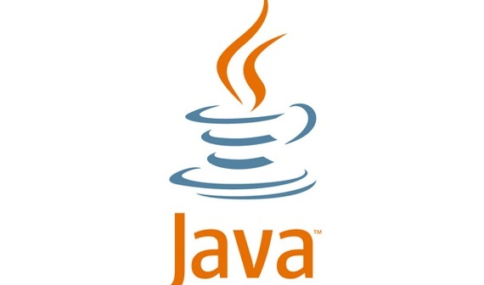**Java Programming Language:**

Java is a high-level, class-based, object-oriented programming language that is designed to have as few implementation dependencies as possible. It is a general-purpose programming language intended to let programmers write once, run anywhere (WORA),[17] meaning that compiled Java code can run on all platforms that support Java without the need to recompile.[18] Java applications are typically compiled to bytecode that can run on any Java virtual machine (JVM) regardless of the underlying computer architecture. The syntax of Java is similar to C and C++, but has fewer low-level facilities than either of them. The Java runtime provides dynamic capabilities (such as reflection and runtime code modification) that are typically not available in traditional compiled languages. As of 2019, Java was one of the most popular programming languages in use according to GitHub,[19][20] particularly for client–server web applications, with a reported 9 million developers.[21]

Java was originally developed by James Gosling at Sun Microsystems and released in May 1995 as a core component of Sun Microsystems' Java platform. The original and reference implementation Java compilers, virtual machines, and class libraries were originally released by Sun under proprietary licenses. As of May 2007, in compliance with the specifications of the Java Community Process, Sun had relicensed most of its Java technologies under the GPL-2.0-only license. Oracle offers its own HotSpot Java Virtual Machine, however the official reference implementation is the OpenJDK JVM which is free open-source software and used by most developers and is the default JVM for almost all Linux distributions.

As of March 2022, Java 18 is the latest version, while Java 17, 11 and 8 are the current long-term support (LTS) versions. Oracle released the last zero-cost public update for the legacy version Java 8 LTS in January 2019 for commercial use, although it will otherwise still support Java 8 with public updates for personal use indefinitely. Other vendors have begun to offer zero-cost builds of OpenJDK 8 and 11 that are still receiving security and other upgrades.

* **Firebase:**

****Firebase is a platform developed by Google for creating mobile and web applications. It was originally an independent company founded in 2011. In 2014, Google acquired the platform and it is now their flagship offering for app development.

Firebase evolved from Envolve, a prior startup founded by James Tamplin and Andrew Lee in 2011. Envolve provided developers an API that enables the integration of online chat functionality into their websites. After releasing the chat service, Tamplin and Lee found that it was being used to pass application data that were not chat messages. Developers were using Envolve to sync application data such as game state in real time across their users. Tamplin and Lee decided to separate the chat system and the real-time architecture that powered it. They founded Firebase as a separate company in 2011 and it launched to the public in April 2012.

Firebase's first product was the Firebase Realtime Database, an API that synchronizes application data across iOS, Android, and Web devices, and stores it on Firebase's cloud. The product assists software developers in building real-time, collaborative applications.

**TOOLS:**

**Android Studio:**

****Android Studio is the official integrated development environment (IDE) for Google's Android operating system, built on JetBrains' IntelliJ IDEA software and designed specifically for Android development. It is available for download on Windows, macOS and Linux based operating systems or as a subscription-based service in 2020.It is a replacement for the Eclipse Android Development Tools (E-ADT) as the primary IDE for native Android application development.

Android Studio was announced on May 16, 2013, at the Google I/O conference. It was in early access preview stage starting from version 0.1 in May 2013, then entered beta stage starting from version 0.8 which was released in June 2014.The first stable build was released in December 2014, starting from version 1.0.On May 7, 2019, Kotlin replaced Java as Google's preferred language for Android app development. Java is still supported, as is C++.

**Features**

The following features are provided in the current stable version:

* Gradle-based build support
* Android-specific refactoring and quick fixes
* Lint tools to catch performance, usability, version compatibility and other problems
* ProGuard integration and app-signing capabilities
* Template-based wizards to create common Android designs and components
* A rich layout editor that allows users to drag-and-drop UI components, option to preview layouts on multiple screen configurations
* Support for building Android Wear apps
* Built-in support for Google Cloud Platform, enabling integration with Firebase Cloud Messaging (Earlier 'Google Cloud Messaging') and Google App Engine.Android Virtual Device (Emulator) to run and debug apps in the Android studio.
* Android Studio supports all the same programming languages of IntelliJ (and CLion) e.g. Java, C++, and more with extensions, such as Go; and Android Studio 3.0 or later supports Kotlin and "all Java 7 language features and a subset of Java 8 language features that vary by platform version."

External projects backport some Java 9 features. While IntelliJ states that Android Studio supports all released Java versions, and Java 12, it's not clear to what level Android Studio supports Java versions up to Java 12 (the documentation mentions partial Java 8 support). At least some new language features up to Java 12 are usable in Android.

Once an app has been compiled with Android Studio, it can be published on the Google Play Store. The application has to be in line with the Google Play Store developer content.

1. PROJECT REQUIREMENTS

Requirement Analysis is the first phase of software development process. This phase focuses to understand the problem. Requirement Analysis is on identifying what is need from these systems, not how the system will achieve its goals. In this phase often at least two parties are involved in Software Development-a client and a developer. The developer has to develop the system to satisfy the clients’ needs. The developer and client arrange a meeting and discuss his/her own views. The developer asks the clients for his/her needs. After a meeting the developer understands what the requirements of the client are. Before starting of the development process, the developer analyze, test the requirements which are given by the clients. According to those requirements the developer starts development process. Hence the developer needs a user’s problem.

Requirement Analysis, also known as Requirement Engineering, is the process of defining user expectations for a new software being built or modified. In software engineering, it is sometimes referred to loosely by names such as requirements gathering or requirements capturing. Requirements analysis encompasses those tasks that go into determining the needs or conditions to meet for a new or altered product or project, taking account of the possibly conflicting requirements of the various stakeholders, analyzing, documenting, validating and managing software or system requirements.

In the software requirement we are dealing with the requirements of the proposed system, that’s the capabilities of that system, which is yet to be developed, should have. The **Software Requirement Specification (SRS)** is a document that completely describes what the proposed software should do without describing how the software will do it. So the basic goal of Requirement Phase is to produce the SRS, which describes the complete external behavior of the proposed software.

The basic aim of problem analysis is to obtain the clear understanding of the needs of the clients and the user, what exactly described from the software, and what the constraints on the solution are? This involves a meeting of user and developers.

The developer may ask the following questions to users-:

**Who will use the developed software?**

The developed software will be used by the gram panchayat sadasya. Digital Gram Panchayat application which could work using Internet Connection which would provide various services to gram every gram panchayat sadasya. Even this application handles each procedure in digitalize manner. While using this application Internet Connection is mandatory to be able to verify your application’s current status, and to interact effectively with the application i.e GramPanchayat.

What types of characteristics may have the software?

The characteristics of the software are:

* To put every Panchayat on the global digital map.
* To generate an ICT environment in every panchayat.
* e-trade and e-commerce platform.
* Online public grievance redressal forum.
* Local online resource center.
* Online communication and information networking platform.
* An e-Governance platform.
* Applying certificates/ yojans efficiently.
* Track the progress of your application.

**4.1 FUNCTIONAL REQUIREMENTS:**

In the development process, we have ensured that the software will work under the condition that every user gets the proper interface to interact worth the system in an ease. The software achieves the capability that the users interacting with this system is completely satisfied.

**USER REQUIREMENTS:**

The main requirement of the user is that the system should be used by the Users and administrator for proper maintaining. The developer can face a number of requirements given by the user. So, the software should have a number of facilities. According to the User Requirements the system is built in the way that it provides the number of facilities to the users and administrators. The user may require the followings:

1. **CORRECTNESS:**

Correctness is the degree to which the software performs its required function. The extent to which the software satisfies its specifications and fulfills customer’s mission objectives. This system adapts the degree of Correctness by achieving the facilities and the User requirements. The software is correct in all manner because the testing is done in each unit of the system. Thus we can say that our system to be correct system as it meets all the requirements of the users.

1. **PERFORMANCE:**

The main motto of the degree of performance is that the developed system should perform all the tasks the user has specified. The performance of our software is measured on the basis of response time taken to display the record of the particular student. All the requirements of our software directly relates to its performance. The software response is measured on the basis of execution of the program constraints. In the Performance, the software “process all the operations quickly”. So the performance of our system is measured by throughput, efficiency, response time and the processing speed.

1. **USER FRIENDLY:**

The developed software is user friendly by which the user can understand the software easily. It provides a good interface thus it is said to be user friendly. Our software is developed in rather than GUI, therefore the developed software is friendlier. The Base of our system is developed by using the Unity as a user interface. The software provides integrated and consistent information. The information is completely reliable.

1. **MAINTENANCE:**

The user wants that the software must be maintained properly before accepting the software. Thus the software provides the maintenance to the users. Software needs to be maintained not because some of its components wear out and need to be replaced, but because there are often same residual errors remaining in the system that must be removed as they are discovered. The Maintenance of the software is given to the user by using the maintainability. The maintainability is ease with which a program can be corrected, if an error is encountered. The maintenance depends on the user’s requirement because there are many kind of maintenance. Thus, the user requires maintenance because, maintenance involves understanding the software (code and related modules), understanding the effects of change, making new changes. Because often during development some needs are not kept in mind. Thus by considering all the above points we can say that our system adapts the degree of maintainability.

**4.2 PERFORMANCE REQUIREMENTS**

Performance requirements typically comprise a set of criteria which stipulate how things should perform or the standards that they must achieve in a specific set of circumstances. This is as opposed to prescriptive specifications which set out in precise detail how something should be done.

* **PORTABILITY**

The system portability should be taken care of without any interventions. Portability means the capability of the software to be transferred from one environment to another. Thus our system provides the portability that it can run on any machine with backward compatibility.

Portability is the ability of an application to run properly in a different platform to the one it was designed for, with little or no modification. Where modification is needed, the task of modifying the software to allow it to run in the new environment is known as porting.

* **SECURITY**

The system should be secure from unknown interventions and the modification of the internal code should not be permitable to unknown users.

System security encompasses all facets of accessing information assets. From authentication, to software updates, anti-virus protection, and modifications - security is a key component to a device operating at its optimum. These best practices help to mitigate various security concerns.

* **EFFICIENCY**

The system should be capable of providing the required performance related to the amount of resources of the organization.

Efficiency measures the amount of each engineer's “productive” code, or code that provides business value. An engineer creating a whole new solution or implementing sweeping code changes will likely deal with lots of trial and error with a low efficiency rate.

* **RELIABILITY**

Our system should be capable enough to maintain the level of performance. Application reliability is the probability of a piece of software operating without failure while in a specified environment over a set duration of time. In a perfect world, a reliable piece of software is completely defect free, does not create downtime, and performs correctly in every scenario.

1. DESIGN STRATEGY

**5.1 FEASIBILITY STUDY:**

A feasibility study is an evaluation of a proposal designed to determine the difficulty in carrying out a designated task. Generally, a feasibility study precedes technical development and project implementation.

The feasibility study identifies various aspects of the project, which includes mapping out potential roadblocks, offering alternative solutions, identifying project objectives, human resources requirements, budgets, timeframe, etc. A feasibility study usually assesses areas such as:

* Legality – What are the legal requirements of the project? Is it possible to meet these legal requirements?
* Budget – Is there adequate financial resources to start and complete the project? What is the cost/benefit analysis of the project? Is it sufficient to warrant starting the project?
* Time – What is the likelihood that the project will be completed in the stipulated timeframe?
* Risk – Are there risks associated with undergoing this project? What is the risk-to-reward ratio of the project?
* Technical capability – Does the organization have both technical resources to accomplish the project?

In carrying out a feasibility study, this can be divided into various studies. For instance, you can have a technical feasibility study, economic feasibility study, and operational feasibility. These studies have different requirements that must be fulfilled before starting the project. Today, our focus will be on the operational feasibility study and how you can get it done accurately.

* **TECHNOLOGY AND SYSTEM FEASIBILITY:**

This assessment focuses on the technical resources available to the organization. It helps organizations determine whether the technical resources meet capacity and whether the technical team is capable of converting the ideas into working systems. Technical feasibility also involves the evaluation of the hardware, software, and other technical requirements of the proposed system. As an exaggerated example, an organization wouldn’t want to try to put Star Trek’s transporters in their building—currently, this project is not technically feasible.

* **ECONOMIC FEASIBILITY:**

Economic analysis is the most frequently used method for evaluating the effectiveness of a new system. More commonly known as cost/benefit analysis, the procedure is to determine the benefits and savings that are expected from a candidate system and compare them with costs. If benefits outweigh costs, then the decision is made to design and implement the system. An entrepreneur must accurately weigh the cost versus benefits before taking an action.

This assessment typically involves a cost/ benefits analysis of the project, helping organizations determine the viability, cost, and benefits associated with a project before financial resources are allocated. It also serves as an independent project assessment and enhances project credibility—helping decision-makers determine the positive economic benefits to the organization that the proposed project will provide.

* **COST BASED STUDY:**

It is important to identify cost and benefit factors. Cost and benefits can be categorized into the following categories. Basically it is an analysis of the costs to be incurred in the system and benefits derivable out of the system. In a broad sense the costs can be divided into two types:

1. Development costs

2. Operating costs.

* **TIME BASED STUDY:**

Contrast to the traditional system management it can generate any information of data just by single scan and it saves user time .No extra time is being provided to deliver application.

* **OPERATIONAL FEASIBLITY:**

It is a measure of how well a proposed system solves the problems, and takes advantages of the opportunities identified during scope definition and how it satisfies the requirements identified in the requirements analysis phase of system development.

Operational feasibility is based on issues such as manager support, required training, workforce reduction, and adverse effects to users and customers.

This assessment involves undertaking a study to analyze and determine whether—and how well—the organization’s needs can be met by completing the project. Operational feasibility studies also examine how a project plan satisfies the requirements identified in the requirements analysis phase of system development.

## 5.2 UML DIAGRAMS

**5.2.1 USE CASE DIAGRAM:**

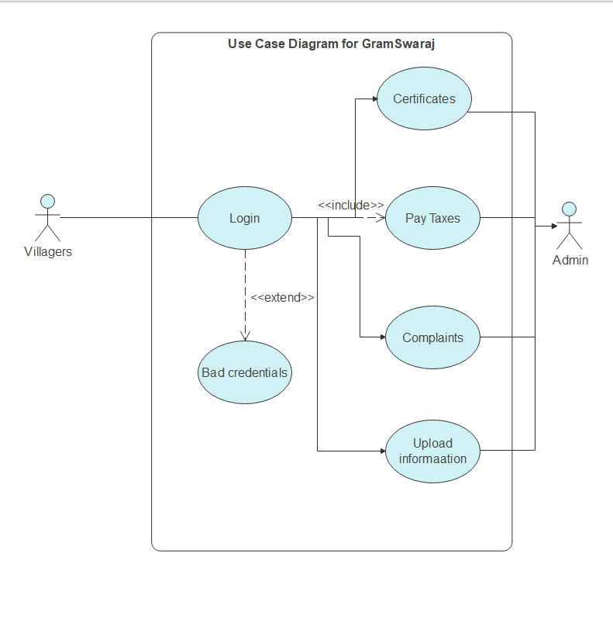

**5.2.2 CLASS DIAGRAM:**

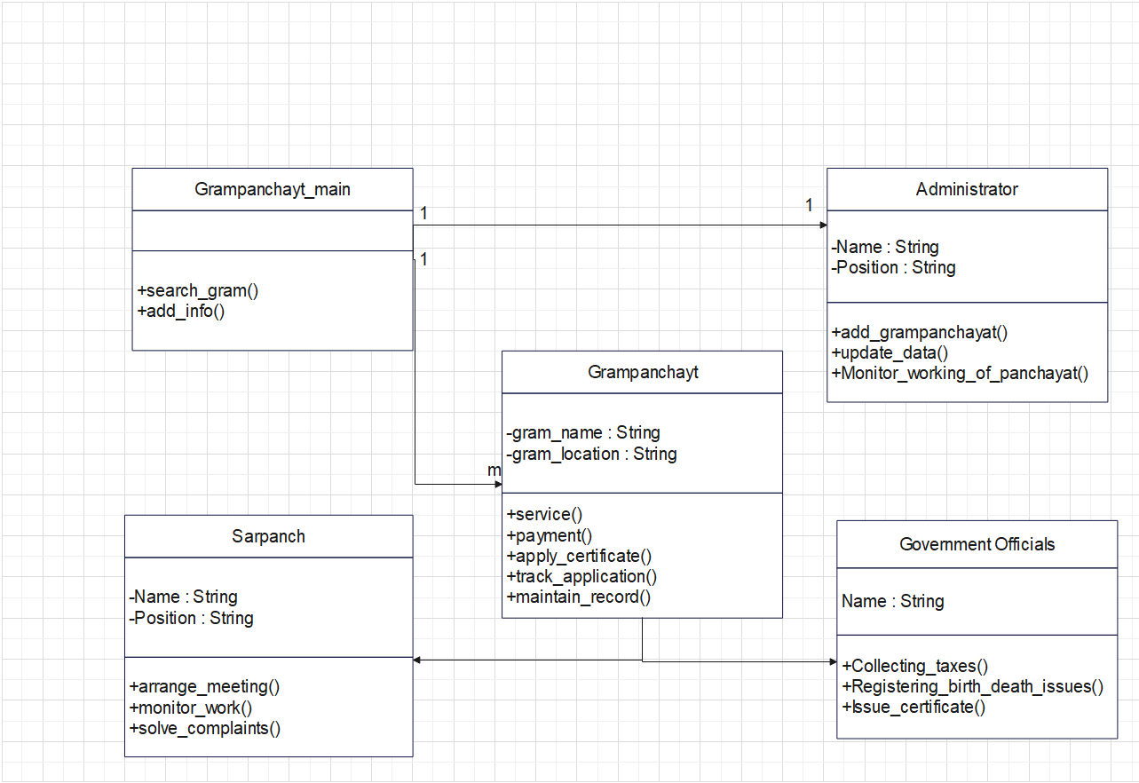

**5.2.2 ARCHITECTURE DIAGRAM:**

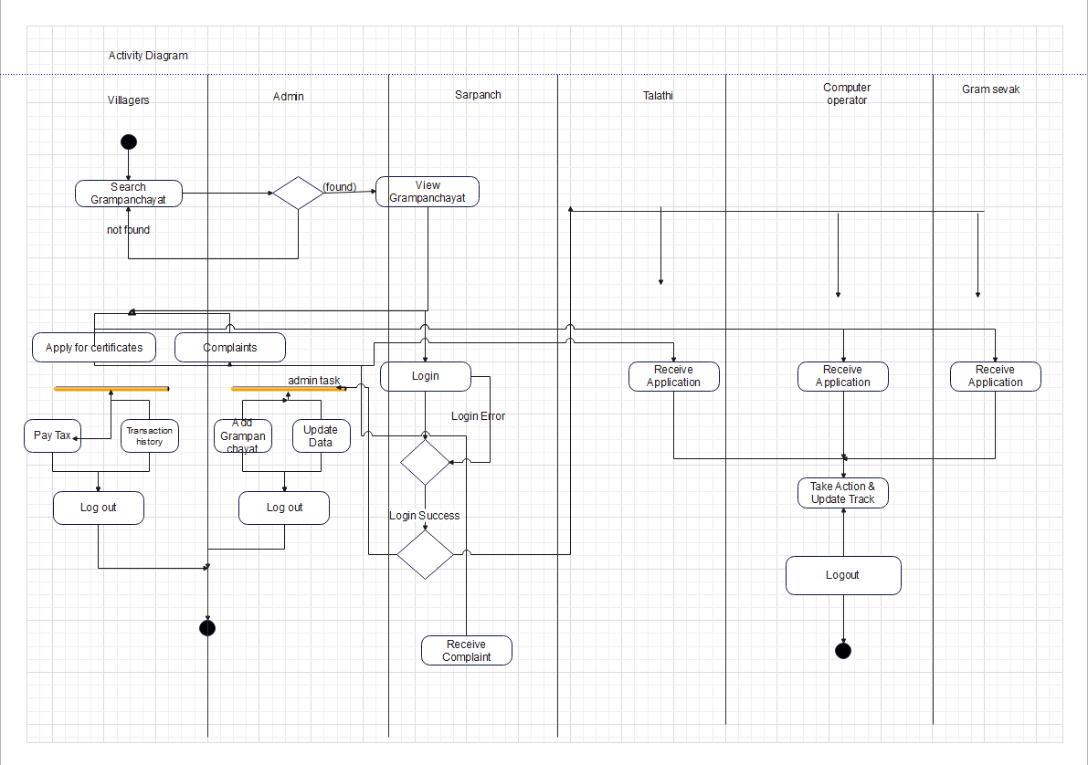

PROJECT OUTPUT

**Application layout**

PROJCT TESTING

Testing is the process of executing a program with the aim of finding errors. To make our software perform well it should be error-free. If testing is done successfully it will remove all the errors from the software.

*Principles of Testing:-*

1. All the test should meet the customer requirements
2. To make our software testing should be performed by a third party
3. Exhaustive testing is not possible. As we need the optimal amount of testing based on the risk assessment of the application.
4. All the test to be conducted should be planned before implementing it
5. It follows the Pareto rule (80/20 rule) which states that 80% of errors come from 20% of program components.
6. Start testing with small parts and extend it to large parts.

**FUNCTIONAL TESTING:**

In software testing, functional testing is a practice that delivers huge benefits to the development process. When done properly, it increases communication between analysts, developers, and testers. The progress of the entire project is objectively visible at any point in time to management by examining the passing (and failing) functional tests. Eventually, the speed of development increases because well-communicated requirements result in less re-work. The tests also drive a more modular architecture with subsystems that have clear responsibilities.

Types of Functional testing are :

1. **UNIT TESTING**

Unit Testing is a type of software testing where individual units or components of a software are tested. The purpose is to validate that each unit of the software code performs as expected. Unit Testing is done during the development (coding phase) of an application by the developers. Unit Tests isolate a section of code and verify its correctness. A unit may be an individual function, method, procedure, module, or object.

* It’s hard to diagnose failed tests.
* Test fixtures work around known issues rather than diagnosing and fixing them.

Unit Testing is a software testing technique by means of which individual units of software i.e. group of computer program modules, usage procedures and operating procedures are tested to determine whether they are suitable for use or not. It is a testing method using which every independent modules are tested to determine if there are any issue by the developer himself. It is correlated with functional correctness of the independent modules.

Unit Testing is defined as a type of software testing where individual components of a software are tested.

Unit Testing of software product is carried out during the development of an application. An individual component may be either an individual function or a procedure. Unit Testing is typically performed by the developer.

In SDLC or V Model, Unit testing is first level of testing done before integration testing. Unit testing is such type of testing technique that is usually performed by the developers. Although due to reluctance of developers to tests, quality assurance engineers also do unit testing.

Objective of Unit Testing:

* + To isolate a section of code.
  + To verify the correctness of code.
  + To test every function and procedure.
  + To fix bug early in development cycle and to save costs.
  + To help the developers to understand the code base and enable them to make changes quickly.
  + To help for code reuse.

1. **SMOKE TESTING**

Smoke testing is performed on the ‘new’ build given by developers to QA team to verify if the basic functionalities are working or not. It is one of the important functional testing types. This should be the first test to be done on any new build. In smoke testing, the test cases chosen cover the most important functionality or component of the system. The objective is not to perform exhaustive testing, but to verify that the critical functionality of the system is working fine.

Smoke Testing is a software testing process that determines whether the deployed software build is stable or not. Smoke testing is a confirmation for QA team to proceed with further software testing. It consists of a minimal set of tests run on each build to test software functionalities. Smoke testing is also known as "Build Verification Testing" or “Confidence Testing.”

In simple terms, we are verifying whether the important features are working and there are no showstoppers in the build that is under testing.

It is a mini and rapid regression test of major functionality. It is a simple test that shows the product is ready for testing. This helps determine if the build is flawed as to make any further testing a waste of time and resources.

1. **INTEGRATION TESTING:**

Integration testing is performed to test individual components to check how they function together. In other words, it is performed to test the modules which are working fine individually and do not show bugs when integrated. It is the most common functional testing type and performed as automated testing.

Generally, developers build different modules of the system/software simultaneously and don’t focus on others. They perform extensive black and white box functional verification, commonly known as unit tests, on the individual modules. Integration tests cause data and operational commands to flow between modules which means that they have to act as parts of a whole system rather than individual components. This typically uncovers issues with UI operations, data formats, operation timing, API calls, and database access and user interface operation.

Integration Testing is defined as a type of testing where software modules are integrated logically and tested as a group. A typical software project consists of multiple software modules, coded by different programmers. The purpose of this level of testing is to expose defects in the interaction between these software modules when they are integrated

Integration Testing focuses on checking data communication amongst these modules. Hence it is also termed as 'I & T' (Integration and Testing), 'String Testing' and sometimes.

1. **REGRESSION TESTING**

Regression Testing is defined as a type of software testing to confirm that a recent program or code change has not adversely affected existing features.

Regression Testing is nothing but a full or partial selection of already executed test cases which are re-executed to ensure existing functionalities work fine.

This testing is done to make sure that new code changes should not have side effects on the existing functionalities. It ensures that the old code still works once the latest code changes are done.

Whenever developers change or modify the functionality/feature, there’s a huge possibility that these updates may cause unexpected behaviors. Regression testing is performed to make sure that a change or addition hasn’t broken any of the existing functionality. Its purpose is to find bugs that may have been accidentally introduced into the existing build and to ensure that previously removed bugs continue to stay dead. There are many functional testing tools available which support regression testing.

Regression testing can become a challenge for the testers as well. Here are some of the reasons:

* The Number of test cases in the regression suite increases with each new feature.
* Sometimes, the execution of the entire regression test suite becomes difficult due to time and budget constraints.
* Minimizing the test suite while achieving maximum test coverage is not a cake walk.
* Determination of frequency of Regression Tests after every modification or every build update or after a bunch of bug fixes is always a challenge.

1. **SYSTEM TESTING**

This software is tested such that it works fine for the different operating systems. It is covered under the black box testing technique. In this, we just focus on the required input and output without focusing on internal working.

System Testing is a type of software testing that is performed on a complete integrated system to evaluate the compliance of the system with the corresponding requirements.

In system testing, integration testing passed components are taken as input. The goal of integration testing is to detect any irregularity between the units that are integrated together. System testing detects defects within both the integrated units and the whole system. The result of system testing is the observed behavior of a component or a system when it is tested.

System Testing is carried out on the whole system in the context of either system requirement specifications or functional requirement specifications or in the context of both. System testing tests the design and behavior of the system and also the expectations of the customer. It is performed to test the system beyond the bounds mentioned in the software requirements specification (SRS).

In this, we have security testing, recovery testing, stress testing, and performance testing.

**Test case for application:**

|  |  |  |  |  |  |
| --- | --- | --- | --- | --- | --- |
| **Test Step** | **Test Case** | **Test Data** | **Expected Result** | **Actual Result** | **Status** |
|  |  |  |  |  |  |
|  |  |  |  |  |  |
|  |  |  |  |  |  |
|  |  |  |  |  |  |
|  |  |  |  |  |  |
|  |  |  |  |  |  |
|  |  |  |  |  |  |

FUTURE SCOPE

**Future Development:**

This system has been designed keeping in mind the requirements of gram panchayat staff and enables the admin and staff of panchayat to make entries in the database about villagers, personal details, and their related services. This system also provides him the authority to manipulate his account. we can add much more feature in the system i.e., alert system, receive notification to user and gram panchayat staff about some action. By using this system data collected from different gram panchayats will be helpful for implementing different schemes and will help in natural calamities and data can be useful in other fields.

CONCLUSION

This mobile application will be helpful to the villagers of that village. it will bring transparency, accountability, and efficiency in administration. Document and their related record will be available on this application. It helps to make administration more accountable as well as more transparent. The above survey and proposed system will help the Gram panchayat system to work efficiently. This system provides ID and password for the villager. Account history provides information about the services that are previously submitted by the villagers. Both analysis and evaluation results confirm that the proposed web base system can provide an effective solution for submitting the services/schemes that are useful for the villagers in online mode. This will help to minimize corruption in the system, and also save the effort and time of common man and government officers.

1. **REFERENCES**