A Project Stage-1 Report

On

INTELLIGENT PRE-TOLL PROCESSING AND DYNAMIC LANE MANAGEMENT SYSTEM

By

Prathamesh Warkhede Roll No. 404A041
Omkar Sonawane Roll No. 404A040
Omkar Walse Roll No. 404A039

BE (ELECTRONICS &TELECOMMUNICATION)
Under the guidance of

PROF. R. R. KATKAR



DEPARTMENT OF ELECTRONICS & TELECOMMUNICATION ENGINEERING

Sinhgad College of Engineering, Vadgaon (Bk.), Pune-411041
Affiliated to Savitribai Phule Pune University, Pune.

INTELLIGENT PRE-TOLL PROCESSING AND DYNAMIC LANE MANAGEMENT SYSTEM

A Project Report submitted in partial fulfillment of the requirements for award of the degree

BACHELOR OF ENGINEERING
In

ELECTRONICS & TELECOMMUNICATION
Of
SAVITRIBAI PHULE PUNE UNIVERSITY
By

PRATHAMESH WARKHEDE Roll No. 404A041 OMKAR SONAWANE Roll No. 404A040
OMKAR WALSE Roll No. 404A039

Under the guidance of
PROF. R. R. KATKAR

DEPARTMENT OF ELECTRONICS & TELECOMMUNICATION ENGINEERING

Sinhgad College of Engineering,
Vadgaon (Bk.), Pune-411041

CERTIFICATE

This is to certify that the Project Stage-1 entitled

“INTELLIGENT PRE-TOLL PROCESSING AND DYNAMIC LANE MANAGEMENT SYSTEM”

Submitted By
Prathamesh Warkhede Omkar Sonawane Omkar Walse

Has successfully completed their project Stage-1 under the supervision of Prof. R. R. Katkar for the partial fulfillment of Bachelor of Engineering ELECTRONICS & TELECOMMUNICATION of Savitribai Phule Pune University. This work has not been submitted elsewhere for any degree.

Prof. R. R. Katkar | Prof. V. B. Baru | Dr. R. S. Kawitkar
Guide | Project Coordinator | H.O.D. (E & TC)

Examiner Dr. S. D. Lokhande
Principal SCOE, Pune

Contents

No. | Contents | Page No.
 | List of Figure | i
 | Abstract | ii
 | Acknowledgment | iii
 | Abbreviation | iv
1 | Introduction | 1
1.1 | Introduction | 1
1.2 | Aim | 1
1.3 | Objectives | 2
1.4 | Block Diagram | 2
2 | Literature Review | 3
2.1 | Introduction | 3
2.2 | Literature Review | 3
2.3 | Summary | 4
3 | Methodology | 5
3.1 | Introduction | 5
3.2 | Methodology 1 | 5
3.2.1 | Part 1 | 5
3.2.2 | Algorithms | 6
3.2.3 | Flow Charts | 6
3.3 | Methodology 2 | 6
4 | Results & Discussions | 7
4.1 | Results | 6
4.2 | Simulation and Result | 9
4.3 | Discussions | 10
5 | Conclusions | 11
5.1 | Conclusions | 11
5.2 | Future Scope | 11
 | References | 12

List of Figures
  - Block Diagram of Intelligent Toll Management System
  - Flow chart of Number Plate And Vehicle Detection AI-Based Vehicle Detection
  - Testing Result of Number Plate Detection
  - Testing Result of Vehicle Detection
  - Simulation
  - Simulation Result

ABSTRACT

The Intelligent Pre-Toll Processing and Dynamic Lane Management System is designed to reduce toll-plaza congestion and vehicle waiting time through automated vehicle verification. The system combines RFID-based vehicle identification with camera-based number plate recognition for dual verification. An ESP32 controller compares the RFID and number plate data to identify mismatched or unauthorized vehicles. OLED provides local status information, while Blynk IoT enables remote monitoring. The system also supports dynamic lane management and automated toll-barrier control using servo motors, providing an efficient and reliable toll-management solution.

ACKNOWLEDGEMENT

We are feeling very humbled in expressing our gratitude. It will be unfair to bind the precious help and support which we got from many people in few words. But words are the only media of expressing one’s feelings and my feeling of gratitude is absolutely beyond these words. It would be my pride to take this opportunity to say the thanks.
Firstly, we would thank our beloved guide Prof. R. R. Katkar for her valuable guidance, patience and support; She was always there to force us a bit forward to get the work done properly and on time. She has always given us freedom to do major project work and the chance to work under his supervision.
We would like to express our sincere thanks to Prof. V. B. Baru, Major Project Coordinator, Department of E&TC, for his constant encouragement, valuable suggestions, and coordination throughout the successful completion of our major project.
We would also like to express our sincere thanks to Dr. R. S. Kawitkar, Head, Department of E&TC for his co-operation and useful suggestions. We would also like to thank Dr. S. D. Lokhande, Principal, Sinhgad College of Engineering. He always remains a source of inspiration for us to work hard and dedicatedly.
It is the love and blessings of our families and friends which drove us to complete this project work.
Thank you all!

Prathamesh Warkhede Omkar Sonawane Omkar Walse

Abbreviations

- ANPR – Automatic Number Plate Recognition
- OCR – Optical Character Recognition
- RFID – Radio Frequency Identification
- YOLO – You Only Look Once
- CNN – Convolutional Neural Network
- Blynk – IoT Platform for Hardware Monitoring and Control
- OLED – Organic Light-Emitting Diode
- Wi-Fi – Wireless Fidelity
- GPS – Global Positioning System
- SVM – Support Vector Machine
- CPU – Central Processing Unit
- GPU – Graphics Processing Unit
- API – Application Programming Interface

Chapter 1

INTRODUCTION

The Intelligent Pre-Toll Processing and Dynamic Lane Management System is a smart transportation solution developed to improve the efficiency of toll-plaza operations. Conventional toll plazas often experience congestion and increased waiting time due to manual verification, vehicle queues, and delays in toll processing. The proposed system aims to minimize these problems by introducing automated vehicle identification and verification before the vehicle reaches the toll barrier.
The system uses an RFID reader to identify vehicles through their unique RFID tags. At the same time, a camera module captures the vehicle's number plate, which can be processed using image-processing and Automatic Number Plate Recognition (ANPR) techniques. The ESP32 microcontroller acts as the central processing unit and compares the RFID information with the detected vehicle number to perform dual verification. This helps identify mismatched, unauthorized, or exceptional vehicles.
The system also incorporates dynamic lane management to improve the movement of vehicles through the toll plaza. Based on vehicle verification and lane conditions, the appropriate lane can be selected and controlled. Servo motors are used to operate the toll barriers automatically, while an OLED display provides vehicle and lane information to the operator or user.
Furthermore, Blynk IoT and Wi-Fi connectivity can be used for remote monitoring of vehicle verification, lane status, and system activities. The proposed system provides a cost-effective, reliable, and scalable prototype that can be further developed using AI, cloud databases, FASTag integration, and advanced traffic analysis. It can be applied to highways, expressways, parking areas, residential entry systems, and intelligent transportation systems.

Aim:

To design and develop an Intelligent Pre-Toll Processing and Dynamic Lane Management System using ESP32, RFID, and camera-based number plate recognition to provide automated vehicle verification, reduce waiting time, and improve toll-plaza traffic Management.

Objectives:

- To identify vehicles using RFID-based identification.
- To capture and recognize vehicle number plates using a camera and image processing.
- To perform dual verification by comparing RFID and number plate data.
- To use an ESP32 microcontroller for vehicle verification and system control.
- To detect RFID–vehicle mismatches and handle unverified vehicles.
- To implement dynamic lane management based on vehicle and queue conditions.
- To control toll barriers automatically using servo motors.
- To enable remote monitoring using Blynk IoT and Wi-Fi.
- To develop a reliable, efficient, and scalable prototype for intelligent toll management.

Block Diagram

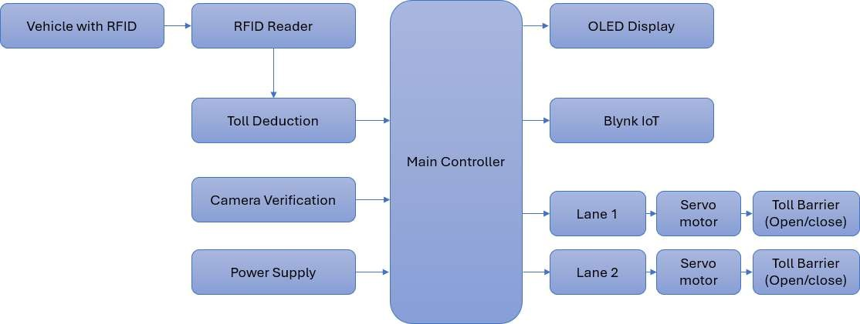

Fig 1.1 Block Diagram of Intelligent Pre-Toll Processing and Dynamic Lane Management System

Chapter 2 Literature Review
  - Introduction
The literature review provides an overview of existing technologies and research related to intelligent transportation, RFID-based vehicle identification, wireless communication, and automatic number plate recognition. Various researchers have proposed systems for improving toll collection, vehicle identification, and traffic management using RFID, computer vision, IoT, and artificial intelligence. The study of these existing systems helps in understanding their working principles, advantages, limitations, and the scope for developing an improved toll management system. In the proposed project, RFID is used for vehicle identification and AI-based image processing is considered for detecting vehicles and recognizing their number plates. The combination of these technologies can provide reliable vehicle verification and reduce manual intervention at toll plazas

  - Literature Review
Existing studies have focused on automatic vehicle identification and toll management systems. Gajurel et al. (2024) used YOLOv8, BoT-SORT, and CNN for vehicle and number plate detection and recognition. ESP32 documentation (2024) highlights its Wi-Fi and IoT communication capabilities for real-time applications. Abdulla R. (2014) studied long-range active RFID technology for reliable vehicle identification and data communication. These studies show that RFID provides fast and contactless identification, while AI-based number plate recognition provides visual verification. ESP32 can integrate these technologies and control the overall system. Therefore, the proposed system combines RFID-based identification and AI-based number plate recognition to provide dual vehicle verification and improve the efficiency and security of toll management.

  - Summary

Sr.No. | Title | Author(s) | Year | Method | Principle
1 | Automatic Number Plate Detection and Recognition Using YOLOv8  and CNN | Kshitiz Gajurel, Manoj Kumar  Baniya, Khushilal Mahato, Manish Kathet, Suwarna Lingden, and Pukar Karki | 2024 | YOLOv8, BoT-  SORT  tracking and CNN | Detects vehicle number  plates, tracks vehicles, segments characters and recognizes characters using CNN.
2 | Documentation for ESP32 Wi-Fi  Microcontroller | The Authors | 2024 | ESP32 Wi-Fi  communicati on | Uses the ESP32 microcontroller's Wi-  Fi capability for wireless communication and IoT-based applications.
3 | A Conceptual Study of Long range Active RFID  System for Reliable Data Communication | Abdulla R | 2014 | Long-range active RFID | Uses active RFID technology for  reliable long-distance identification and data communication.

Chapter 3 Methodology

Introduction
The proposed Intelligent Toll Management System uses AI-based vehicle detection and number plate recognition to automate vehicle identification. A camera captures images or video of vehicles approaching the toll lane. The captured data is processed using artificial intelligence and image processing techniques. The system first detects the vehicle and then identifies its number plate. OCR technology is used to extract the registration number from the detected plate. The obtained information can be used for vehicle verification. RFID/FASTag information can also be integrated for dual verification. This approach helps to reduce manual work and improve toll processing efficiency.

Methodology 1
The first methodology focuses on AI-based vehicle detection using the YOLO object detection model. A camera captures the road scene and provides images or video frames as input to the system. The YOLO model processes each frame and identifies vehicles present in the scene. It can detect different vehicle classes such as cars, motorcycles, buses, and trucks. Bounding boxes are generated around the detected vehicles along with confidence scores. The detected vehicle information is then passed for further processing. This module provides the basic vehicle detection capability of the proposed toll management system.

Part 1
The vehicle detection module is implemented using Python and the YOLO framework. The required input image or video is provided to the trained or pre-trained detection model. The model analyzes each frame and identifies the vehicles present in it. For every detected vehicle, the system generates a bounding box and assigns a corresponding vehicle class. A confidence score is also displayed to indicate the reliability of detection. The output is displayed on the screen for testing and verification. This module can be further optimized for real-time roadside camera applications.

Algorithms
The main algorithm used in the proposed system is YOLO (You Only Look Once), which is a real-time object detection algorithm. It processes the complete image in a single forward pass through the neural network. The algorithm predicts the location and class of objects using bounding boxes. It then calculates confidence scores for the detected objects. Non-Maximum Suppression is used to remove duplicate bounding boxes. The final output contains the detected vehicles along with their classes and confidence values. YOLO provides fast and efficient vehicle detection for the proposed application.

Flow Charts
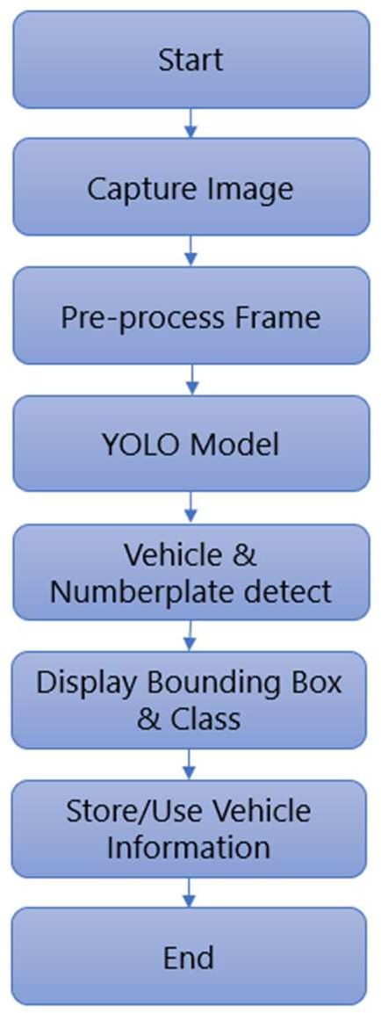

Fig 3.1 Flow chart of Number Plate and Vehicle Detection

Methodology 2
The second methodology focuses on number plate detection and recognition. After detecting the vehicle, the system identifies the number plate region from the captured image. Image processing techniques are used to extract and improve the number plate region. OCR technology is then applied to recognize the characters present on the plate. The extracted registration number can be stored and used for vehicle identification. The system can also distinguish different number plate types based on their appearance. The recognized number can be compared with RFID/FASTag information for verification. This provides an additional layer of security and supports automated toll management.

Design and Calculation

Design:

1. ESP32: Main controller connected to all sensors and output devices.
Connection: 5V → VIN, GND → GND.

2. RFID Reader: Reads the RFID tag attached to the vehicle.
Connection: VCC → 3.3V, GND → GND, SPI → ESP32.

3. OLED Display: Displays vehicle and verification status.
Connection: VCC → 3.3V, GND → GND, SDA/SCL → ESP32.

4. Servo Motor: Controls the toll barrier.
Connection: VCC → 5V, GND → GND, Signal → ESP32 GPIO.

5. Power Supply: Provides regulated power to the complete prototype.
Connection: 5V → ESP32 and 5V modules, 3.3V → required modules, common GND.

Calculation:

ESP32 Power Calculation:
Input: V = 5V, I = 240mA
P = V × I = 5 × 0.24 = 1.20W
Output: 1.20W

RFID Reader Power Calculation:
Input: V = 3.3V, I = 50mA
P = V × I = 3.3 × 0.05 = 0.165W
Output: 0.165W

OLED Display Power Calculation:
Input: V = 3.3V, I = 20mA
P = V × I = 3.3 × 0.02 = 0.066W
Output: 0.066W

Servo Motor Power Calculation:
Input: V = 5V, I = 500mA
P = V × I = 5 × 0.50 = 2.50W
Output: 2.50W

Total Power Consumption:
Input: ESP32 = 1.20W, RFID Reader = 0.165W, OLED Display = 0.066W, Servo Motor = 2.50W
P = 1.20 + 0.165 + 0.066 + 2.50 = 3.931W, Output: 3.931W
Considering 20% additional power for losses and future expansion:
P = 3.931 × 1.2 = 4.717W, Output: Approximately 4.72W, Therefore, a 5V, 1A

Chapter 4
Results & Discussions

  - Results

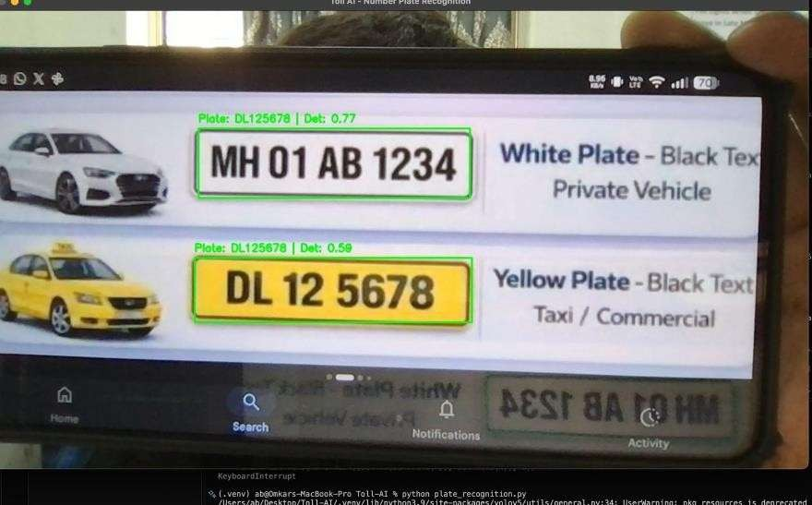

Fig 4.1 Testing Result of Number Plate Detection

The number plate detection module was successfully tested using different vehicle images and input frames. The system detects the number plate region from the vehicle and extracts the registration characters using OCR. During testing, number plates such as MH 01 AB 1234 and DL 12 5678 were successfully detected and recognized. The detected plate is displayed along with the vehicle information, allowing the system to identify the vehicle automatically. The system can process multiple vehicles present in an image and identify their corresponding number plates. The results demonstrate that AI-based number plate recognition can reduce manual identification and improve the automation of toll operations. This module can be further improved by using high-resolution cameras and better lighting conditions for accurate recognition.in.real-time.environments.

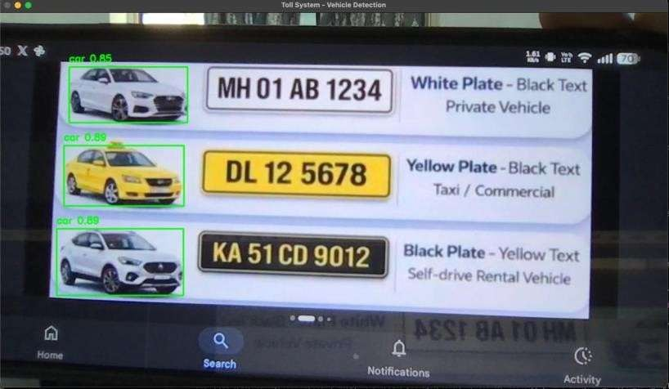

Fig 4.2 Testing Result of Vehicle Detection

The vehicle detection module was tested using different images and video frames containing multiple types of vehicles. The AI model successfully detected cars, motorcycles, buses, and trucks and marked each detected vehicle using bounding boxes. The model can identify multiple vehicles simultaneously within a single frame and assign the corresponding vehicle class to each detection. The testing results show that the system can distinguish different vehicle categories and monitor their movement through the input video. This information can be useful for vehicle counting, traffic monitoring, lane monitoring, and toll management. The results confirm that the vehicle detection module can serve as an important part of the proposed intelligent toll management system. Performance can be further improved by using a larger and more diverse dataset containing different vehicle sizes, angles, speeds, weather conditions, and lighting conditions.

Simulation

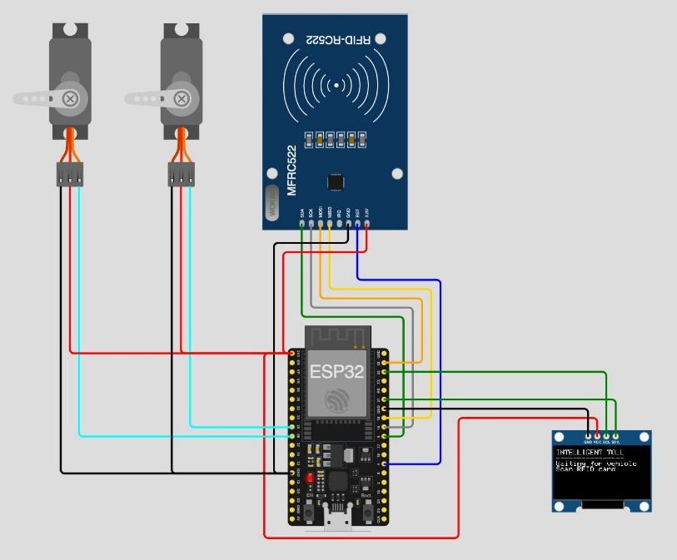

Fig 4.3 Simulation

4.2.1 Simulation Result

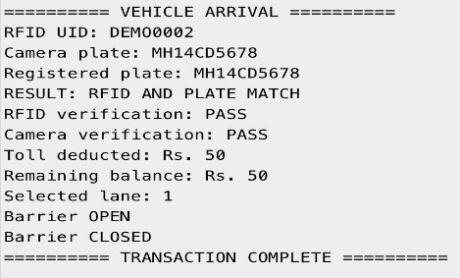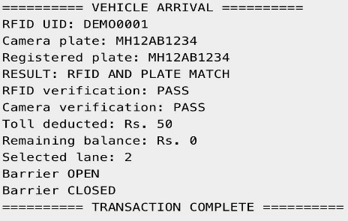

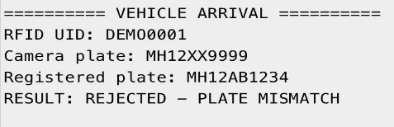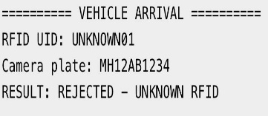

Fig 4.4 Simulation Result

Discussions

The testing results demonstrate that the proposed AI-based toll management system can effectively detect vehicles and recognize their number plates. The vehicle detection model successfully identifies different vehicles such as cars, motorcycles, buses, and trucks. The number plate recognition module accurately detects and extracts registration numbers from the captured images. The system was able to recognize plates such as MH 01 AB 1234, DL 12 5678, and KA 51 CD 9012 during testing. The detected vehicles are marked using bounding boxes, making identification clear and easy. The results show that the system can process multiple vehicles in a single image. The performance depends on factors such as image quality, lighting, camera position, and plate visibility. The detected information can be used for vehicle verification and automated toll processing. The system can also be integrated with RFID or FASTag for dual verification. Overall, the results indicate that the proposed system is suitable for prototype-level intelligent toll management.

The simulation successfully demonstrated different vehicle verification conditions. When the RFID UID and detected number plate matched, the system displayed “RESULT: VERIFIED – PASS” and the barrier was opened. When the number plate did not match the registered RFID information, the system displayed “RESULT: REJECTED – PLATE MISMATCH” and prevented unauthorized access. The simulation also tested an unknown RFID condition, where the system displayed “RESULT: REJECTED – UNKNOWN RFID.” After successful verification, the system displayed the deducted toll amount, selected lane, and transaction completion message. These results confirm that the proposed dual-verification logic can identify valid and invalid vehicles and control the toll barrier accordingly.

Chapter 5 Conclusions

Conclusions

The proposed Intelligent Toll Management System aims to improve the efficiency, accuracy, and automation of toll collection by integrating vehicle detection and identification technologies. As part of the project, an AI-based vehicle detection model was implemented and tested using the YOLO framework. The model successfully detects vehicles such as cars, motorcycles, buses, and trucks from road images and video streams.
The software testing demonstrates that AI-based vehicle detection can be effectively used as a core component of an intelligent toll system. The detected vehicle information can further be integrated with RFID-based identification, number plate recognition, and automated toll processing to provide reliable vehicle verification and reduce manual intervention.
The developed prototype establishes the basic AI and software foundation of the proposed system. In the future, the system can be extended with real-time camera processing, RFID/FASTag integration, number plate recognition, toll payment verification, lane monitoring, and automated barrier control. Thus, the proposed system has the potential to provide a faster, smarter, and more efficient solution for modern toll management.

Future Scope

The proposed Intelligent Pre-Toll Processing and Dynamic Lane Management System can be further enhanced by integrating AI-based Automatic Number Plate Recognition (ANPR) for faster and more accurate vehicle identification. The system can be connected with FASTag and centralized toll databases for automated toll collection and transaction management. In the future, machine learning can be used to analyse traffic density and predict congestion for intelligent lane allocation. Cloud-based data storage and mobile applications can also be implemented for real-time monitoring and data management. The system can be expanded with advanced vehicle classification, improved security features, and automated toll operations, making it suitable for highways, expressways, parking systems, and smart-city traffic management.

References

    - 2024 Kshitiz Gajurel, Manoj Kumar Baniya, Khushilal Mahato, Manish Kathet, Suwarna Lingden, and Pukar Karki. Automatic Number Plate Detection and Recognition Using YOLOv8 and CNN. Proceedings of the 15th IOE Graduate Conference, Volume 15, pp. 143–149

    - 2024 The Authors. IET Intelligent Transport Systems published by John Wiley & Sons Ltd on behalf of The Institution of Engineering and Technology Documentation for ESP32 Wi-Fi microcontroller
    - Abdulla R, “A conceptual study of long range active RFID system for reliable data communication”, In Frontiers of Communications, Networks and Applications (ICFCNA 2014-Malaysia), International Conference on IET, 2014,
pp. 1-6.

Plagiarism Checker:

