**DBMS Assignment 3: SQL DDL and Updates**

|  |  |
| --- | --- |
| Name: Omkar Oak | MIS: 112103099 |
| Div: 2 | Batch: T1 |

Statement : Write the DDL and DML statements for the following.

* Each offering of a course (i.e. a section) can have many Teaching assistants; each teaching assistant is a student. Extend the existing schema(Add/Alter tables) to accommodate this requirement.

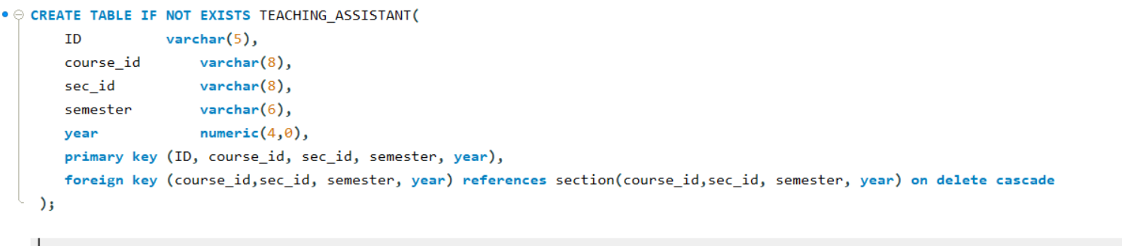

According to the existing schema, one student can have only one advisor.

* Alter the schema to allow a student to have multiple advisors and make sure that you are able to insert multiple advisors for a student.

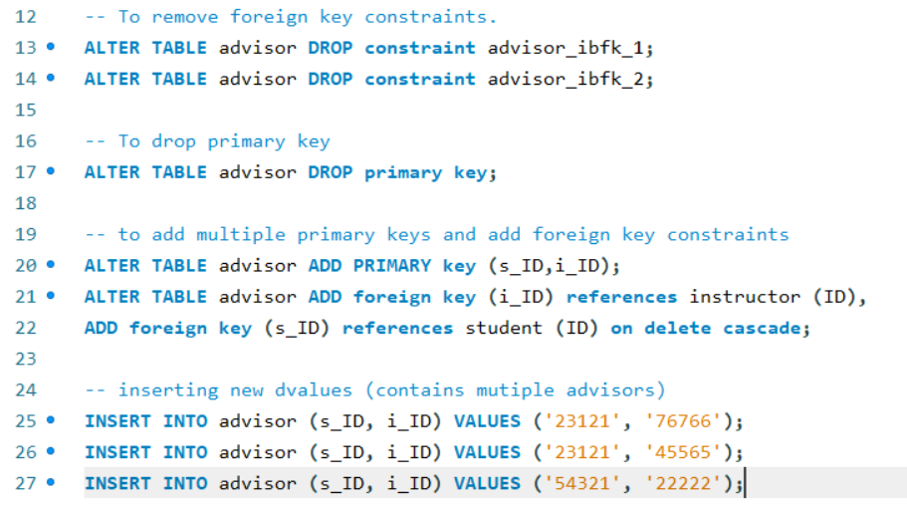

Write SQL queries on the modified schema. You will need to insert data to ensure the query results are not empty.

* Find all students who have more than 3 advisors

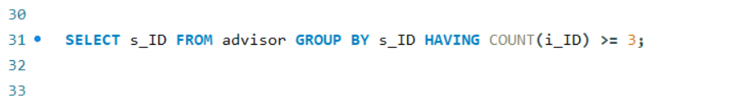

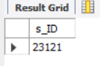

* Find all students who are co-advised by Prof. Srinivas and Prof. Ashok.

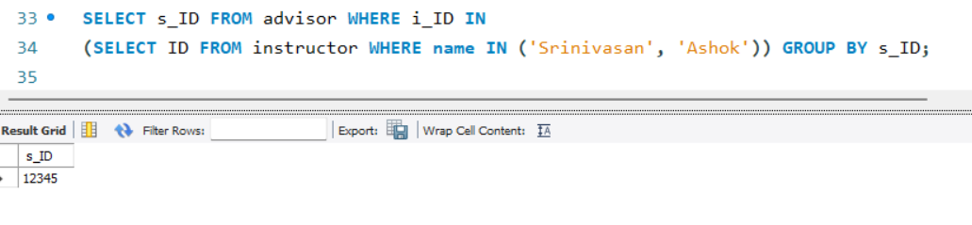

* Find students advised by instructors from different departments. etc.

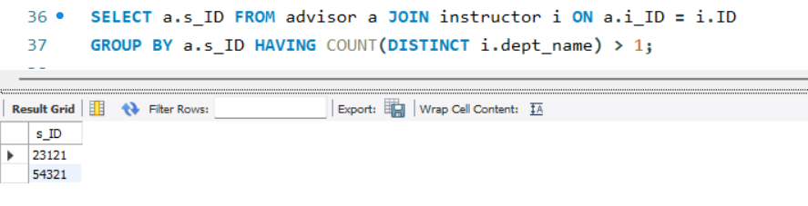

Write SQL queries for the following:

* Delete all information in the database which is more than 10 years old. Add data as necessary to verify your query.

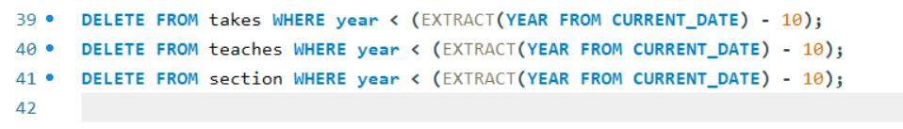

* Delete the course CS 101.  Any course which has CS 101 as a prereq should remove CS 101 from its prereq set.  Create a cascade constraint to enforce the above rule, and verify that it is working.

