**DBMS Assignment 4: Schema creation and constraints**

|  |  |
| --- | --- |
| Name: Omkar Oak | MIS: 112103099 |
| Div: 2 | Batch: T1 |

Statement: Create the schema and constraints on the relations.

Modify the trains schema which we saw earlier to create constraints to check the following:

* The value of timein is always less than or equal to timeout

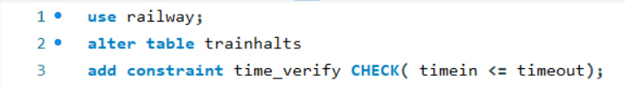

* When a train is removed from service, all its halts should be deleted.

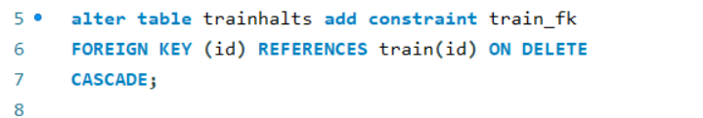

* Insert inconsistent data and verify the constraints.





Write SQL Create table statements to create the following schema.  Include all appropriate primary and foreign key declarations.  Choose appropriate types for each attribute.

* + remotecentre(centreId, college, town, state)

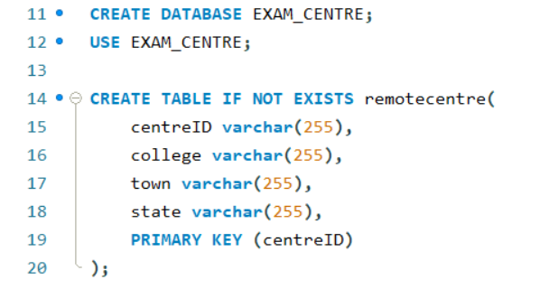

* + person(ID, name, email)

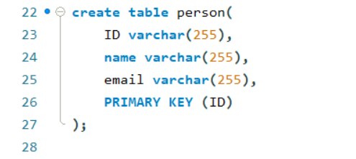

* + programme(progId, title, fromdate, todate)

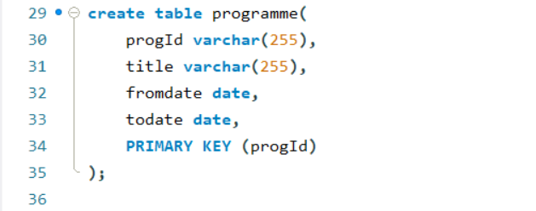

* + coordinator(ID, progId, centreId)

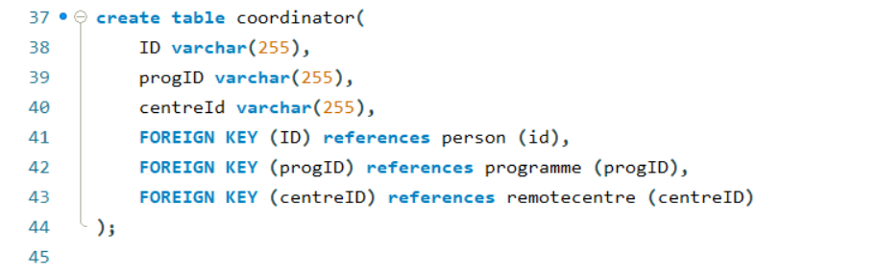

* + participant(ID, progId, centreId)

