2)

Steps to set-up the AWS EC2 account:

i) Verified the email address and created the password

ii) Chose “Basic AWS” for free-tier beginner’s account which was auto-selected

iii) Selected “Business - for your work, school, or organization” and entered the details

iv) Entered the card details for billing

v) Selected EC2 from services and chose “Launch instance”

vi) Chose “Ubuntu Server 18.04 LTS (HVM), SSD Volume Type” and Review and Launch

vii) On the “Select an existing keypair or create a new key pair” tab, select “Create a new Key pair” from the dropdown menu; and downloaded it

viii) After that select launch instance and view instance

ix) Connected instance after retaining auto-selected username “ubuntu”

Free Amazon EC2 Instance set up (*Ubuntu Server 20.04 LTS (HVM), SSD Volume Type*) :

(User name : ubuntu)

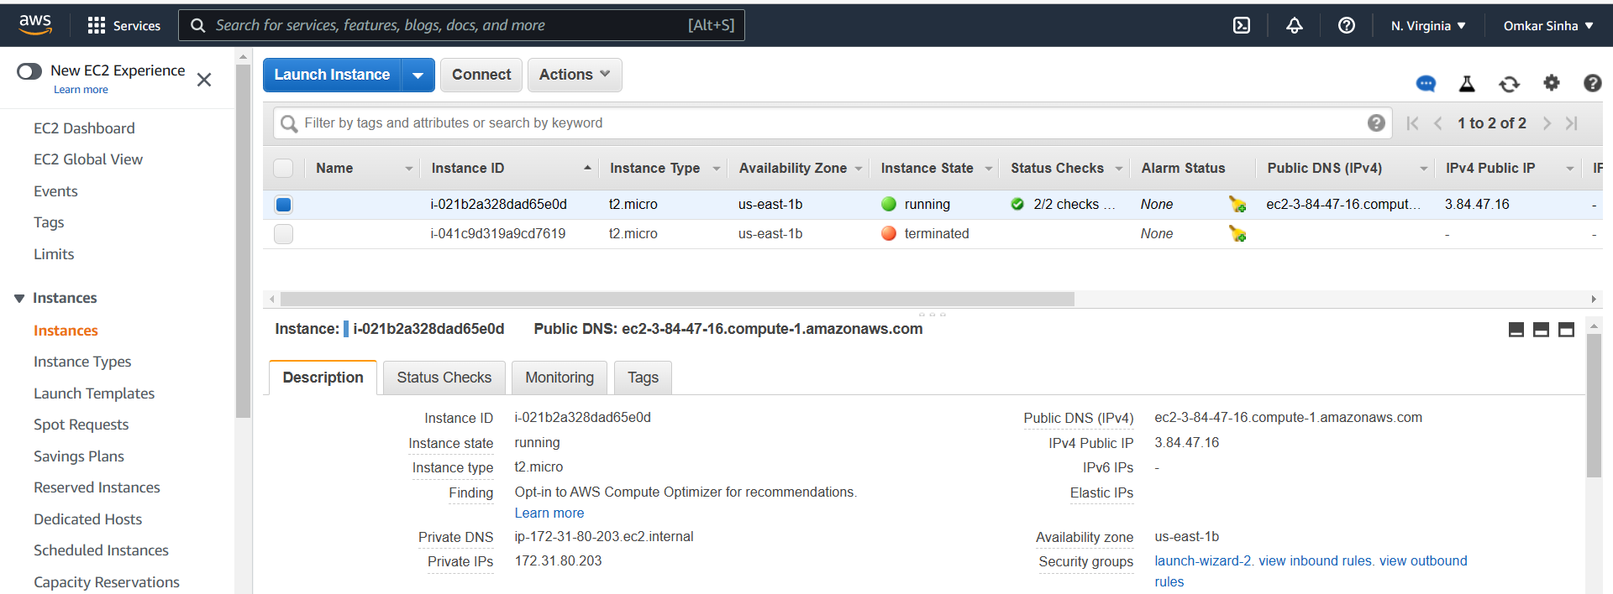

After launching this instance we get the following terminal:

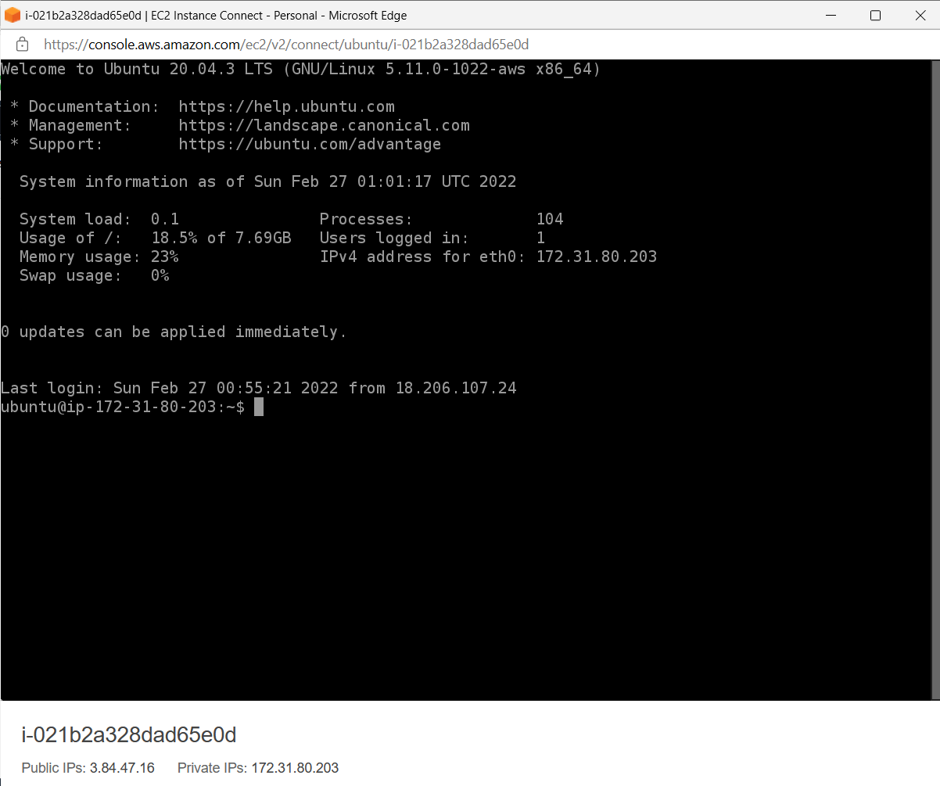

Now we execute the commands specified in the assignment:

1. uname -a

‘uname’ prints all the system information. Suffix -a indicates all. Information is in following order: kernel name, nodename, kernel-release, kernel-version, machine, processor and hardware-platform

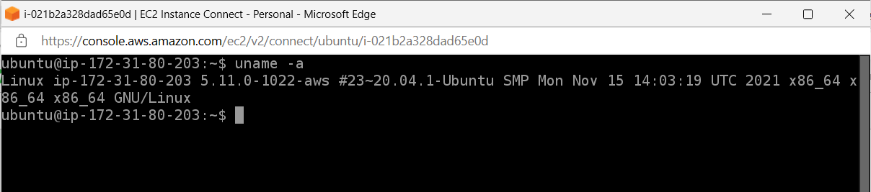

1. whoami

This command gives the user-name associated with the current effective user ID. In our case the user name is “ubuntu” which was auto-selected by the system when the instance was created.

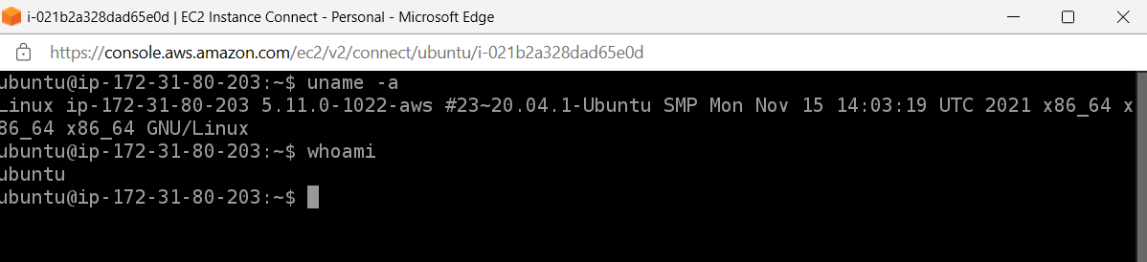

1. df -h

df displays the amount of disk space available on the file system containing each file name argument. If no file name is given(as in this case), the space available on all currently mounted file systems is shown. Option “-h” stands for human readable version of the output.

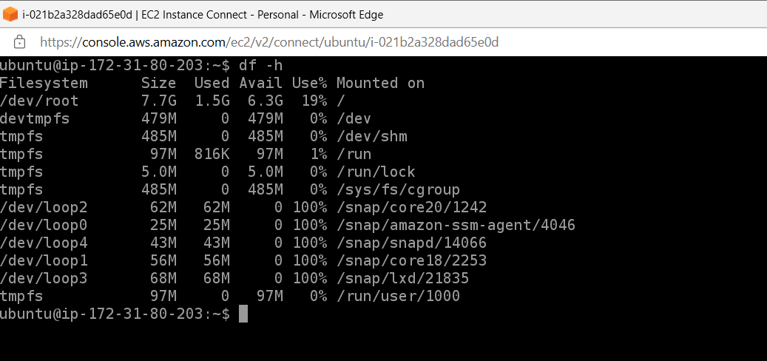

1. ifconfig -a

Ifconfig is used to configure the kernel-resident network interfaces. It is used at boot time to set up interfaces as necessary. If no arguments are given, ifconfig displays the status of the currently active inter‐faces. ‘-a’ option displays all the interfaces – active or down.

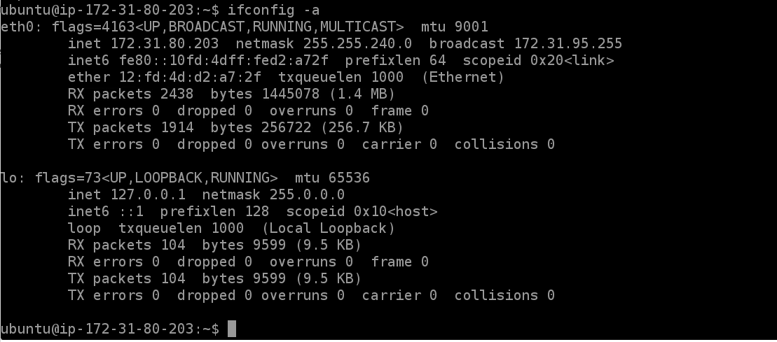

1. netstat

Print network connections, routing tables, interface statistics, masquerade connections, and multicast memberships. The following output is truncated because of length.

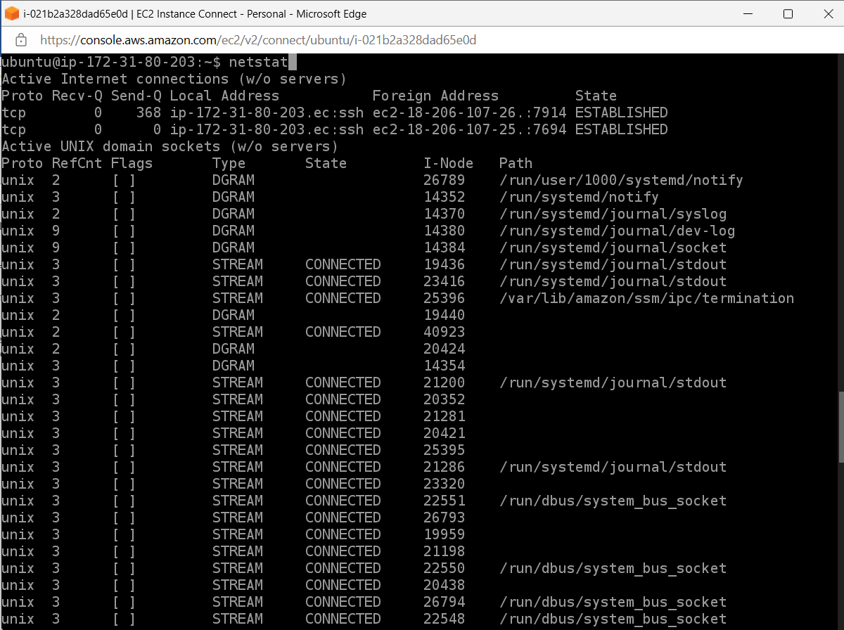

1)

i) Creating an SQS Queue with my name as queue name:

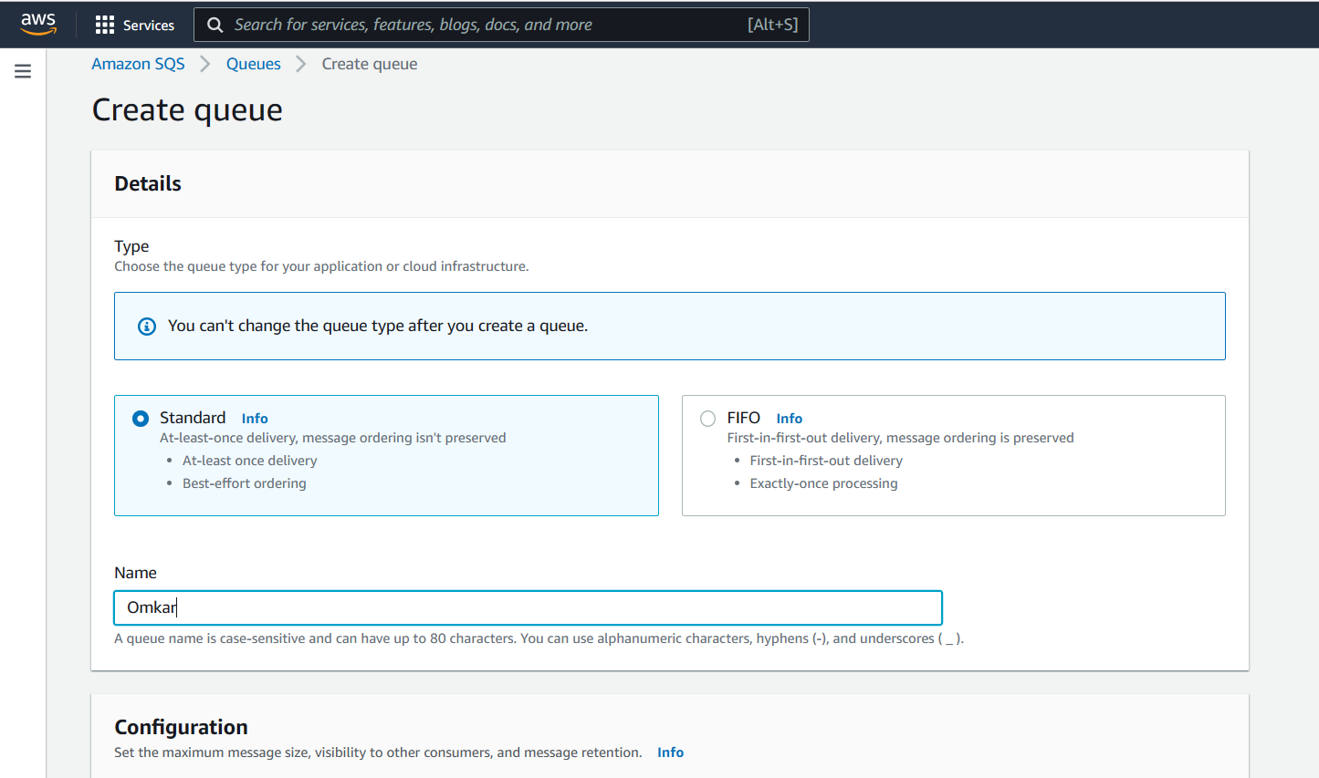

ii) Queue is created as follows:

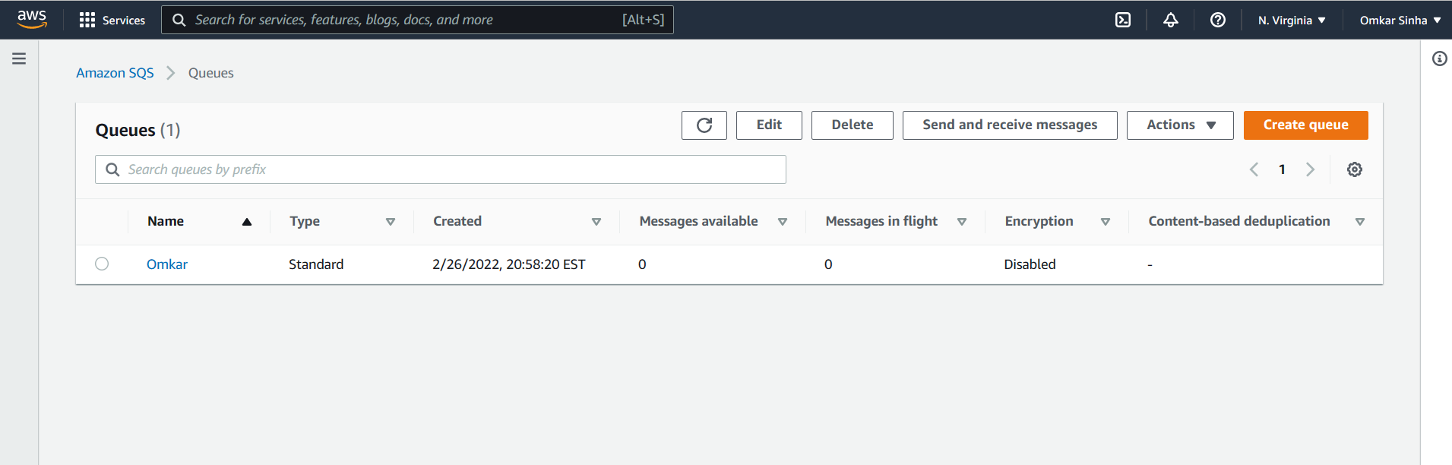

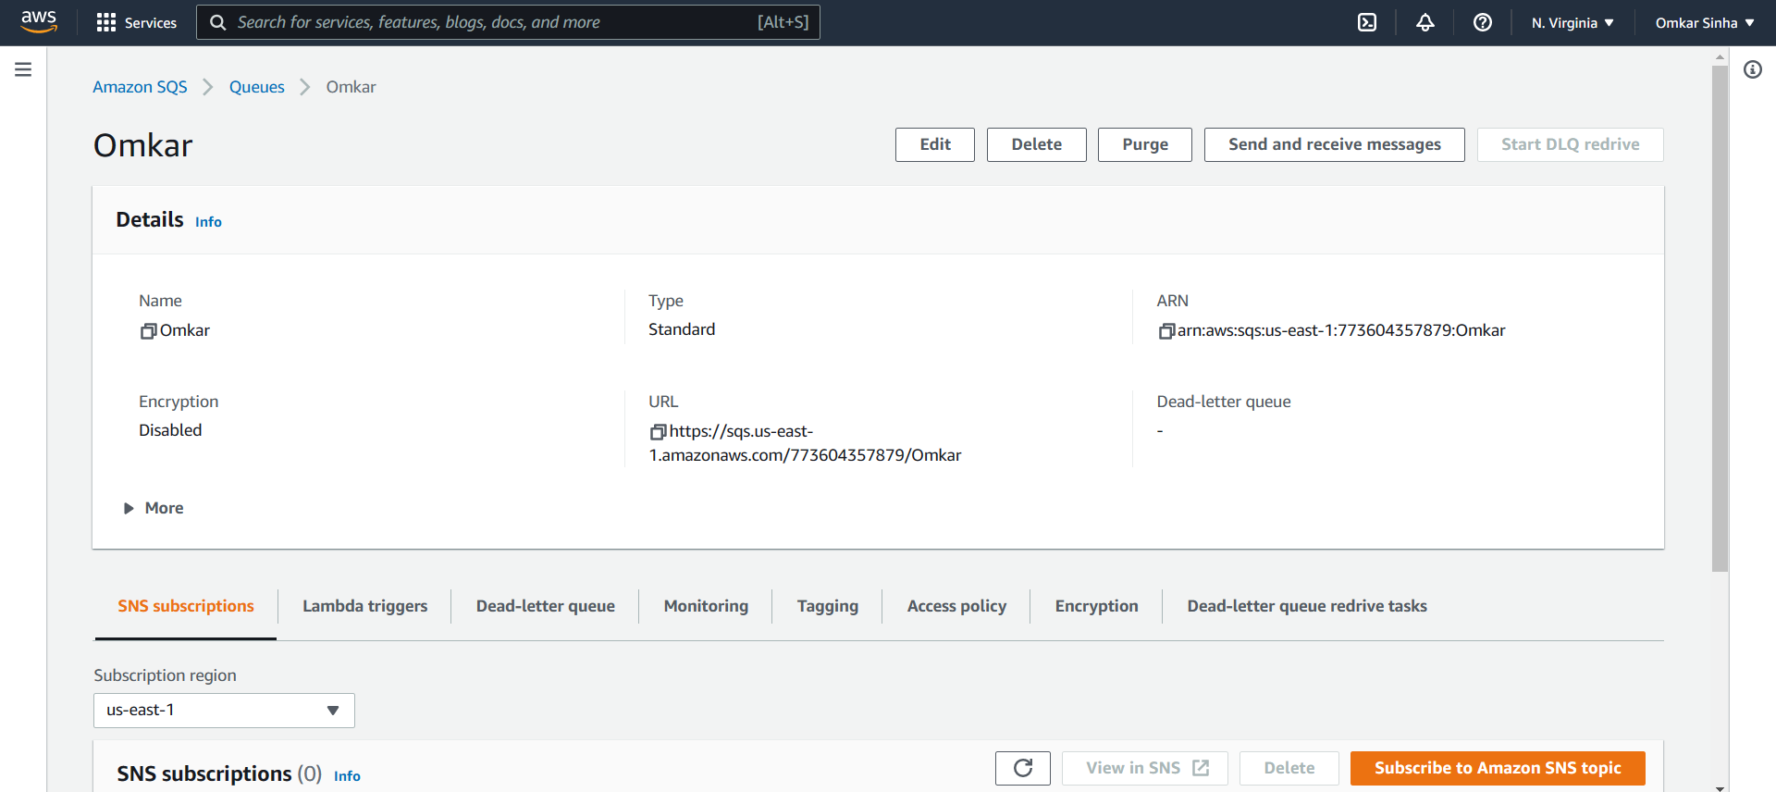

iii) Creating and sending a “fun” message. Some optional attributes(Message name, data type, and type) are put as below:

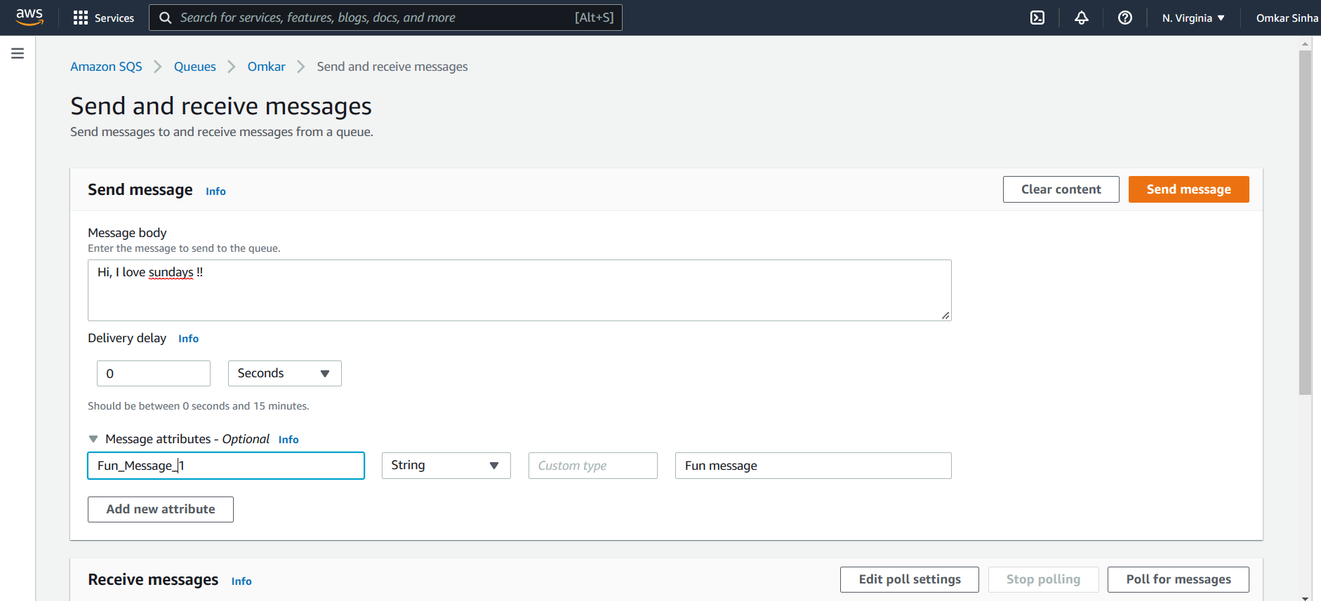

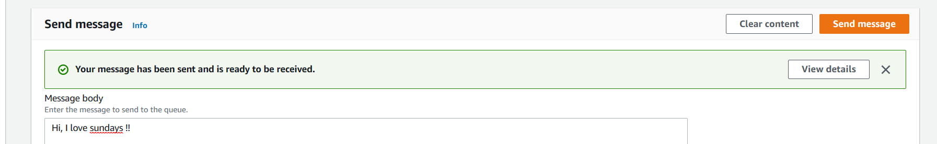

iv) Polling and viewing the message:

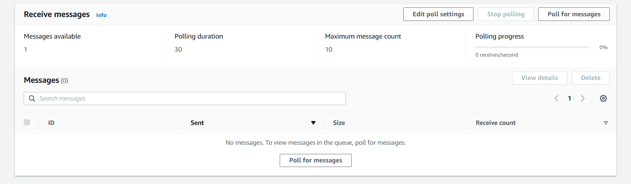

After we click “Poll for messages”, we see one message:

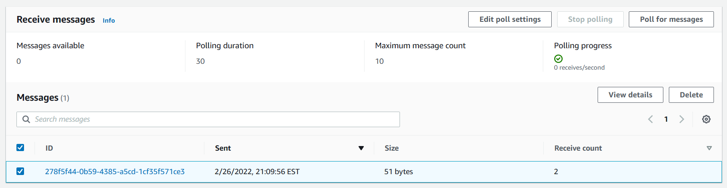

We select the message and view it. This is the same message we had sent to queue and it can be received by other applications:

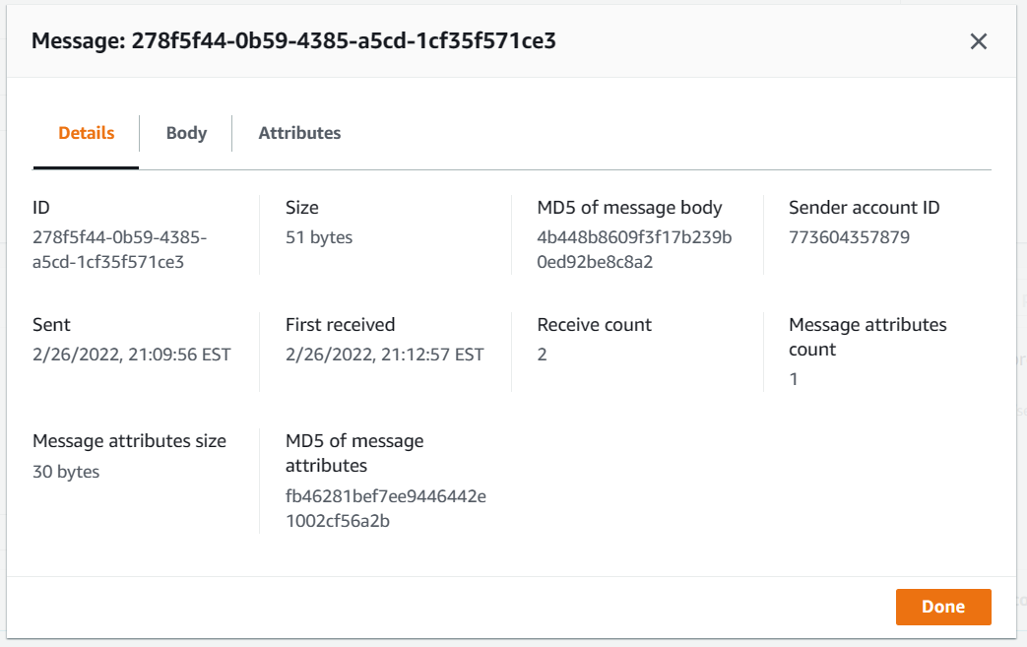

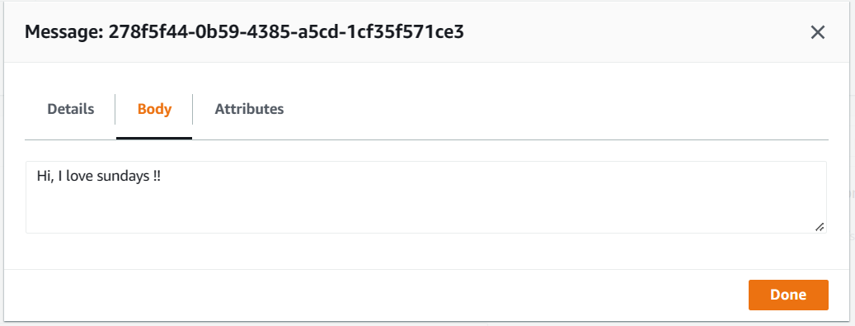

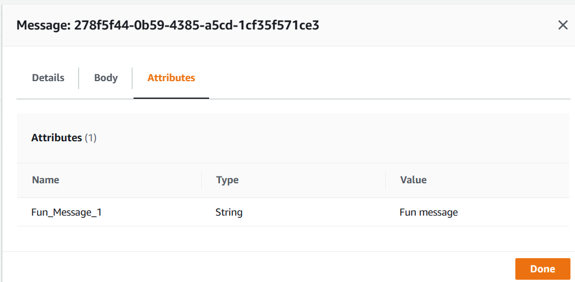

v) We delete the message:

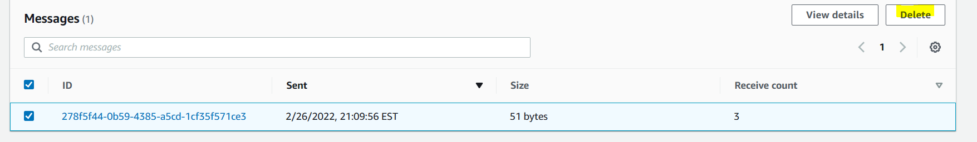

vi) We delete the queue :

