Omkar Sinha

10468312

6

1. Variance. Variance of the projected data samples has to be maximum in order to get a reliable PC(principle component) axis. We choose a Principle component axis (PC) that maximizes the variance of the projected data samples
2. Reconstruction error. In PCA, the principle component axis is chosen such that the reconstruction error, i.e, the squared sum of the perpendicular distance from the projected data-points to the original data point is as small as possible.
3. Fischers Linear discriminant analysis(LDA) tries to find the projection that maximises the variance of the sample data set.
4. Please find ans below:

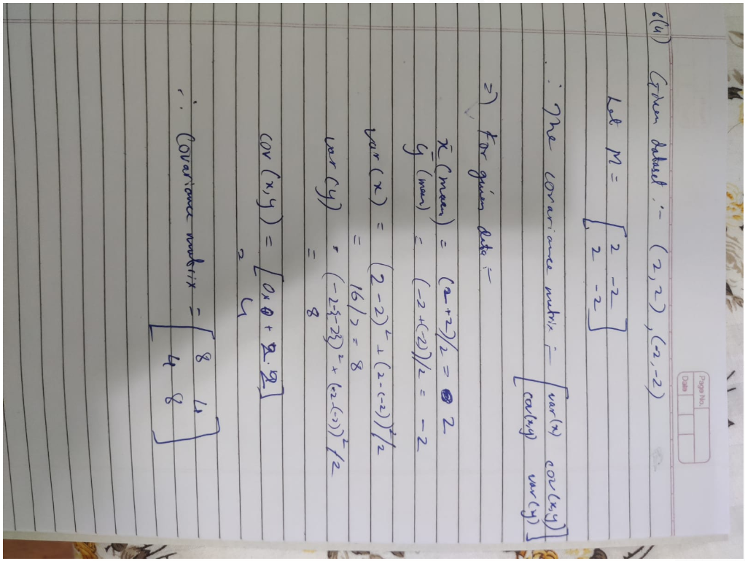

1. Plz find ans below:

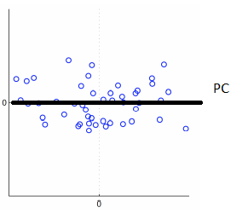

1. The variance of data projected on first component axis will be alpha as that is the variance along the horizontal axis.

5

1.F

2.F

3.F

4.T

5.F

6.F

7.T

8.T

9.T

10.F

11.T

4)  
  
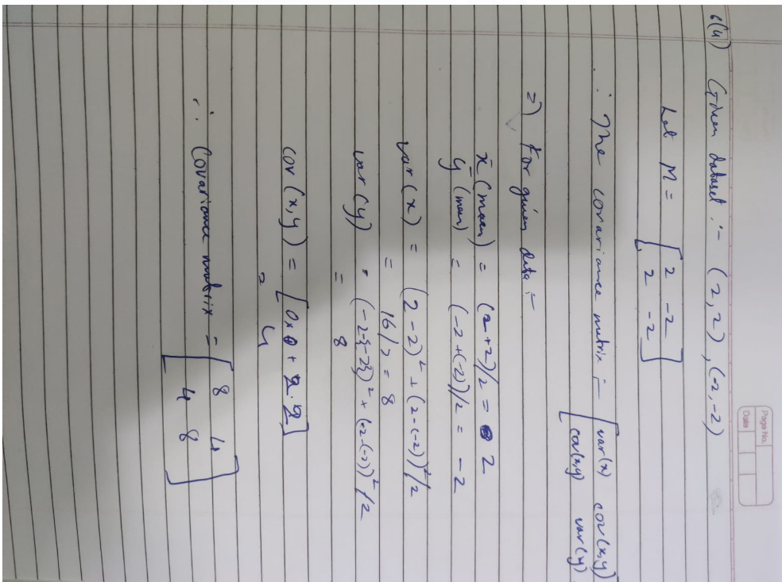

2)

a) b

b) a

3)

a) <=

b) <=

c) <=

d) <=

e) <=

1

