Task 1: Research & Summarize

Introduction to Sora
Sora is an artificial intelligence video-generation model developed by OpenAI. It was designed to create realistic or imaginative videos from written descriptions, images, and other visual inputs. Users describe a scene in natural language, and a video-generation model produces moving visual content containing objects, backgrounds, lighting, and camera actions that aim to match the description.
Sora was designed for text-to-video generation, animation of still images, and extending or modifying video content. Such tools can make video creation more accessible and support educational demonstrations, short films, advertisements, and creative visual stories.

Comparison with DALL·E and Alternatives
Sora focuses on moving video sequences, while DALL·E generates still images from text prompts. For example, DALL·E can create a picture of a student learning robotics, whereas a video generator can show the student assembling and testing a robot. Alternatives such as Runway and Pika offer AI-assisted video-generation workflows, and Google Flow is another option for creating and assembling AI video clips. Features, quality, access, and generation limits vary by platform.

Ethical Considerations
AI-generated videos can be misused to spread misinformation, impersonate people, or create misleading evidence. Users should obtain appropriate consent before using a person's likeness or voice and respect privacy, copyright, intellectual property, and creators' rights. Generated content may reproduce bias, and viewers may mistake synthetic footage for real recordings. Responsible creators should label AI-generated content when appropriate, verify factual claims, avoid deceptive impersonation, and follow tool policies.

Conclusion
Sora demonstrated how generative AI can transform text descriptions into moving visual stories. Unlike image generators such as DALL·E, video generators focus on motion and scene progression. Tools such as Runway, Pika, and Google Flow provide other ways to explore AI video creation for education, entertainment, and communication when used creatively and responsibly.

Task 2: Prompt Engineering Practice

Create a 10-second educational 3D animation showing the human heart pumping blood through the circulatory system. Begin with a detailed anatomical view of the heart, then show red and blue blood cells flowing through arteries and veins. Use clear visual transitions, realistic medical animation, a clean blue background, smooth camera movement, and scientifically inspired visuals. Make the video suitable for college students and avoid graphic imagery.

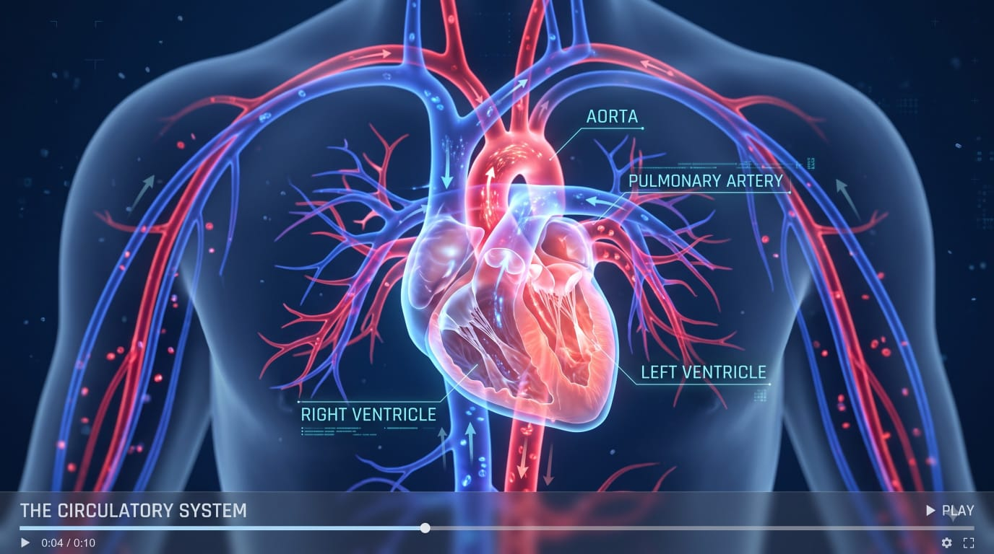PASTE IMAGE HERE
Paste the generated image or video screenshot here (16:9 ratio)

Task 3: AI + Creativity Simulation
Chosen Role: Educator and Technology Content Creator
Topic: How AI Works | Duration: 15 seconds | Format: 16:9 widescreen

Google Flow Prompt
Create a 15-second futuristic 3D educational video explaining how AI works: show data entering a computer, glowing neural-network nodes identifying patterns, and a computer recognizing a cat image as the final result. Use a dark navy background, cyan and electric-blue glows, smooth transitions, cinematic camera movement, and a clear voice-over: “AI learns from data, identifies patterns, and generates useful results.” End with “DATA → LEARNING → RESULTS”. Keep the visuals clean, consistent, and professional in 16:9 widescreen.

Scene-by-Scene Breakdown

Scene 1 — Data Input (0–5 seconds)
Show text, numbers, and images flowing into a futuristic computer. Voice-over: “AI begins by receiving data.”

Scene 2 — Learning Patterns (5–10 seconds)
Show glowing interconnected neural-network nodes processing information. Voice-over: “It identifies patterns in the data.”

Scene 3 — Generating Results (10–15 seconds)
Show an AI interface recognizing a cat image, ending with “DATA → LEARNING → RESULTS”. Voice-over: “AI uses patterns to generate useful results.”
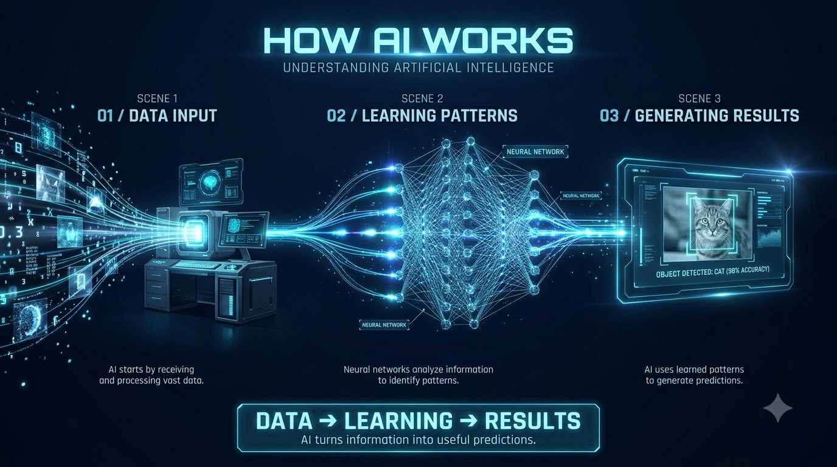

Conclusion
This practical demonstrates how concise prompts can guide AI video-generation tools. The planned video explains the basic AI process—data input, pattern learning, and result generation—through three connected scenes.

