LINUX COMMANDS

1.ls
What: ls is a command used to display the list of files and folders in a directory.
Why: It helps you quickly see what contents are available in the current location.

2.touch
What: touch is a command used to create a new empty file or update the timestamp of an existing file.
Why: It helps you quickly make files or refresh file modification time.

3.mkdir
What: mkdir is a command used to create a new directory (folder).
Why: It helps you organize files by making separate folders for storage.

4.pwd
What: pwd is a command used to show the full path of the current working directory.
Why: It helps you know exactly where you are in the file system.
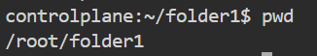

5.cd
What: cd is a command used to change the current directory.
Why: It helps you move between folders to access different files and locations.
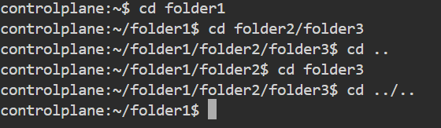

6.vi
What: vi is a command-line text editor used to create and edit files.
Why: It helps you write or modify file content directly from the terminal.


- i ->What: i is a key in vi editor used to enter Insert mode for typing text.
Why: It allows you to start editing and adding content inside the file.
- Esc->What: Esc is a key in vi used to exit Insert mode and return to Command mode.
Why: It helps you stop typing and run vi commands like save or quit.
- :wq->What: :wq is a vi command used to save the file and exit the editor.
Why: It helps you store changes and close vi safely.

7.cat
What: cat is a command used to display the content of a file on the terminal.
Why: It helps you quickly view or check what is inside a file.
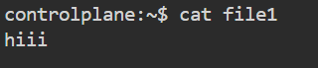

8.nano
What: nano is a simple command-line text editor used to create and edit files.
Why: It allows easy editing of files directly in the terminal with on-screen instructions.
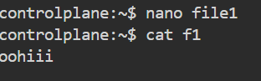changed file content and name to f1
9.rm
What: rm is a command used to delete files or directories.
Why: It helps you remove unwanted files or clean up space.
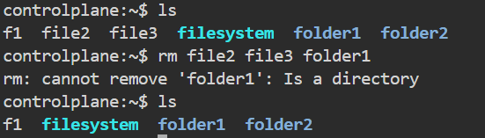

- Rm -rf <filename> -> this will delete folder or file even if folder is not empty
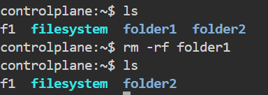

10.rmdir
What: rmdir is a command used to delete an empty directory.
Why: It helps you remove unnecessary folders from the system.
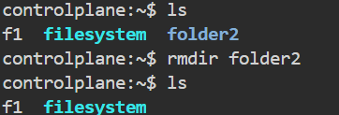

11.history
What: history is a command used to show a list of previously executed commands.
Why: It helps you review or reuse past commands easily.

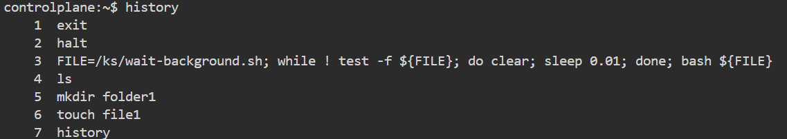

12.cal
What: cal is a command used to display a calendar in the terminal.
Why: It helps you quickly check dates without leaving the command line.
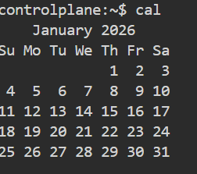

13.df
What: df is a command used to display the available and used disk space on file systems.
Why: It helps you check storage usage and manage disk space.
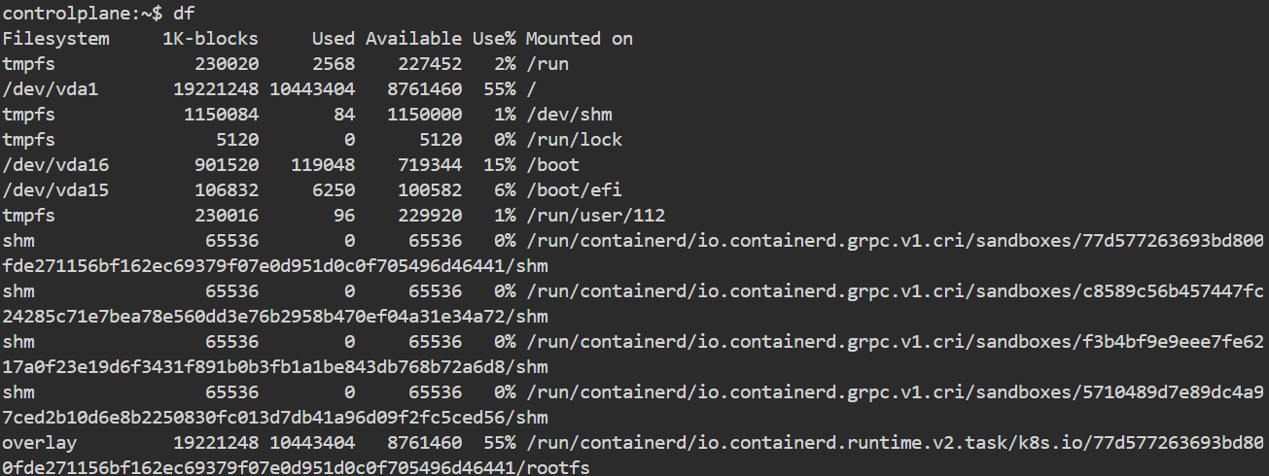

14.whoami
What: whoami is a command used to display the current logged-in user.
Why: It helps you confirm which user account is active in the session.
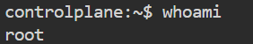

15.ping
What: ping is a command used to check the network connectivity to a server or IP address.
Why: It helps you verify if a device or website is reachable and measure response time.
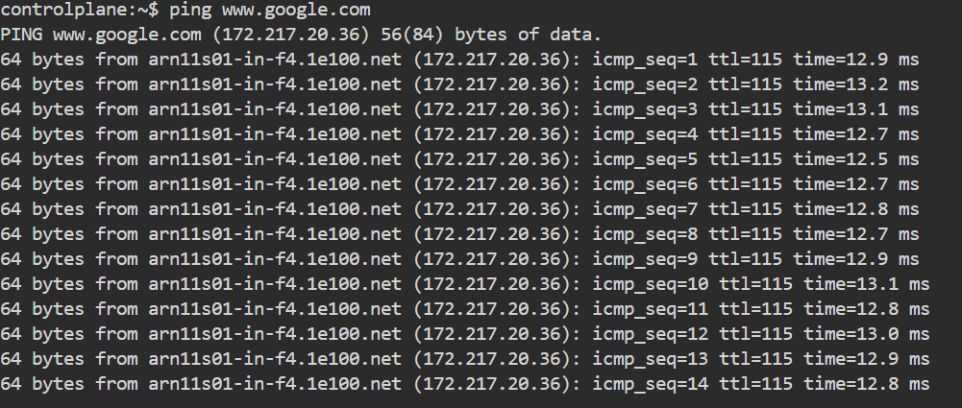

16.mv
What: mv is a command used to move or rename files and directories.
Why: It helps you organize files by relocating them or changing their names.
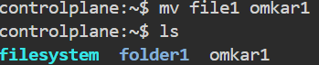
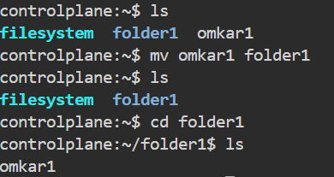

17.cp
What: cp is a command used to copy files or directories.
Why: It helps you create duplicates for backup or use in different locations.

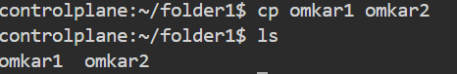

18.wget
What: wget is a command used to download files from the internet using a URL.
Why: It helps you quickly fetch web content or software directly from the terminal.
