REQUIREMENTS:-

- Install jerkins (Port-8080)
- Install tomcat(Port-8081)
- Install java
- Install git
- With in manage Jenkins -> plugins->available plugins add deploy and maven plugins
- With in manage jenkins->tools give paths of git,jdk,maven ,etc

PIPELINES STEPS:-
1.Open jerkins on browser
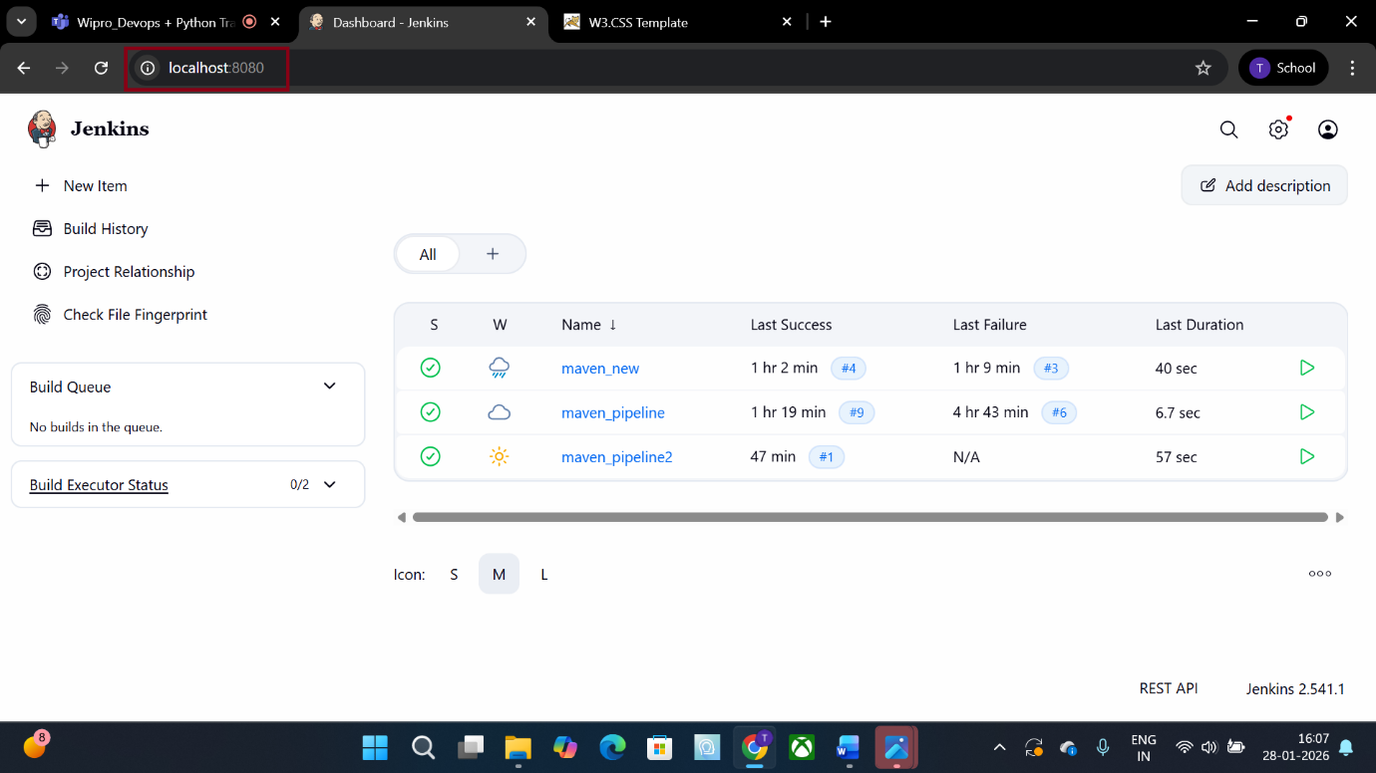

2.CLICK ON New Item to create new pipeline
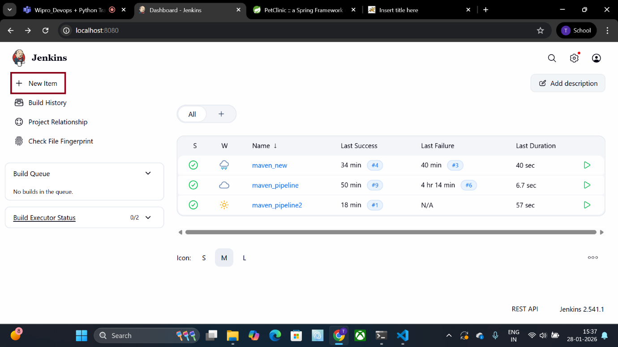

3.Give name and select pipeline type and after that click ok
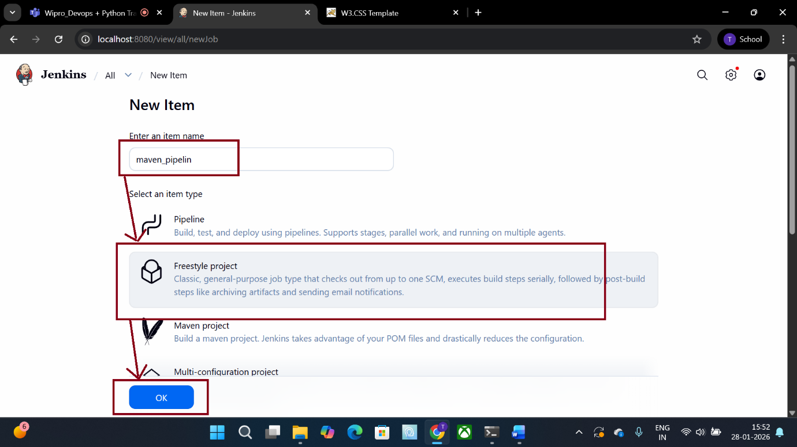

4.Select git and give repository path

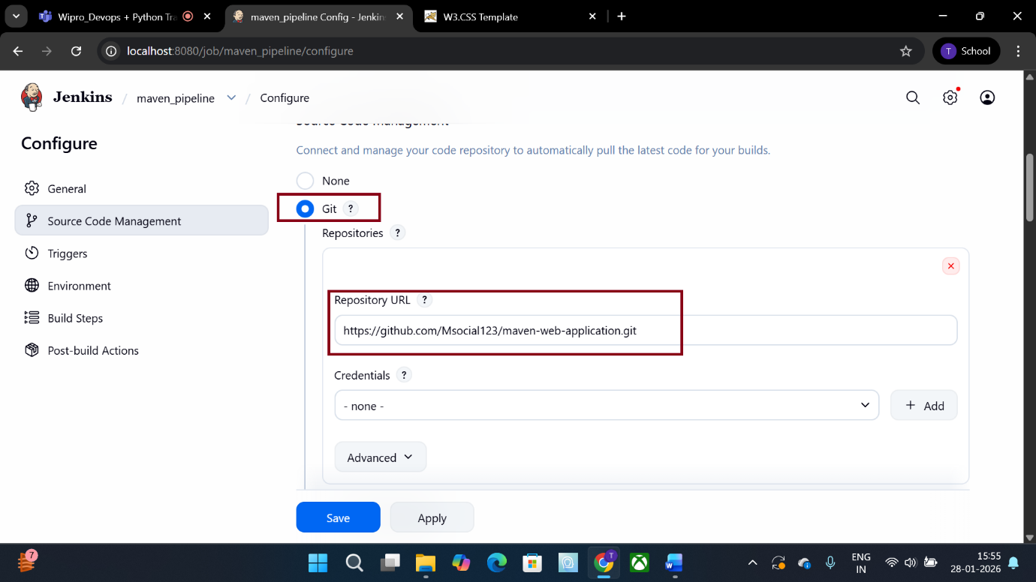

5.CLICK on build project and then invoke top level meven target after that give maven as version and goals as clean package
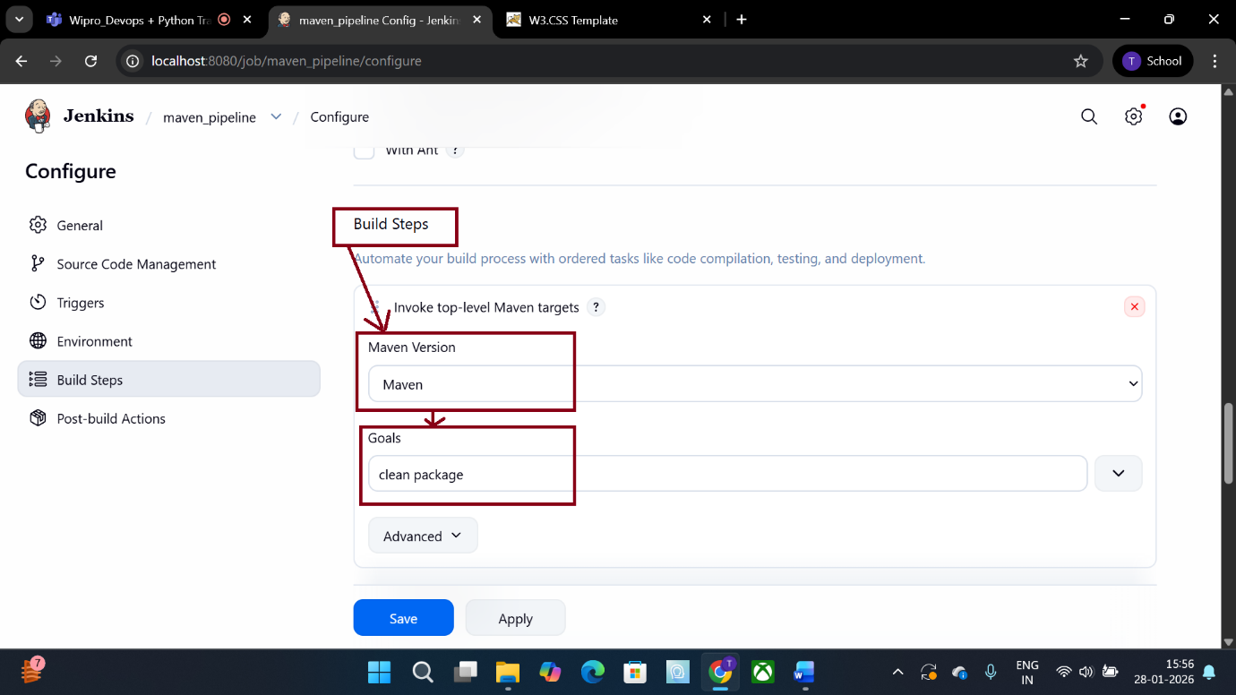

6.Specify the branch get from git location
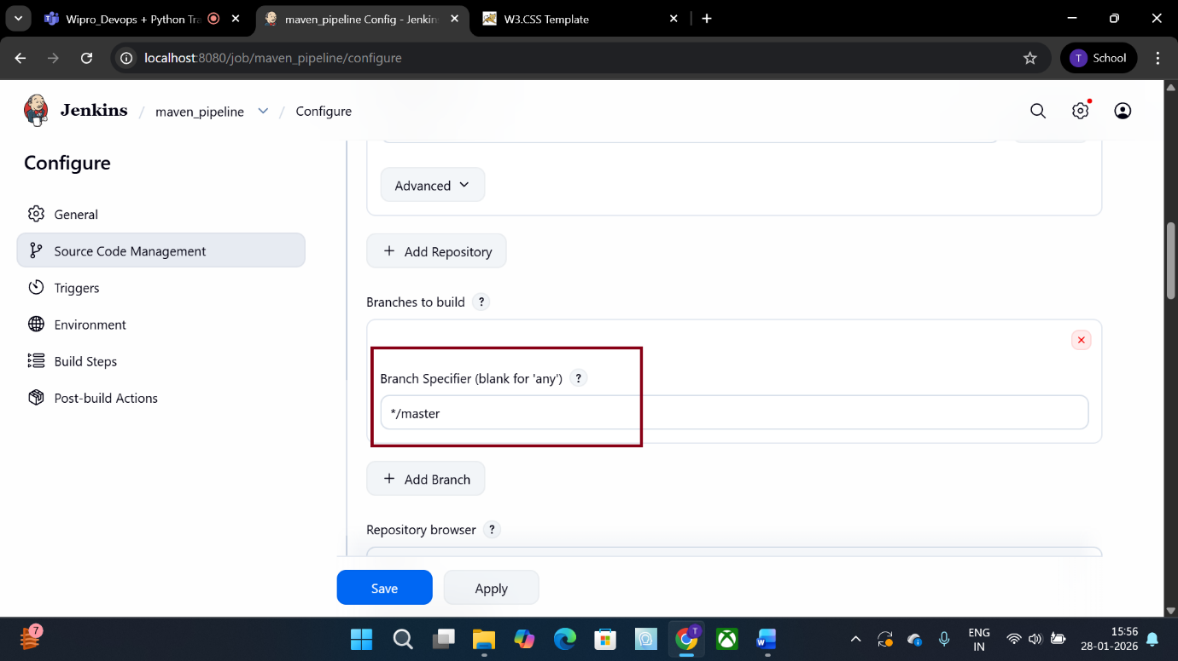

7.Click on post build gelect .war/ear file option give war file location you get it by clicking on ? in front of war/ear files
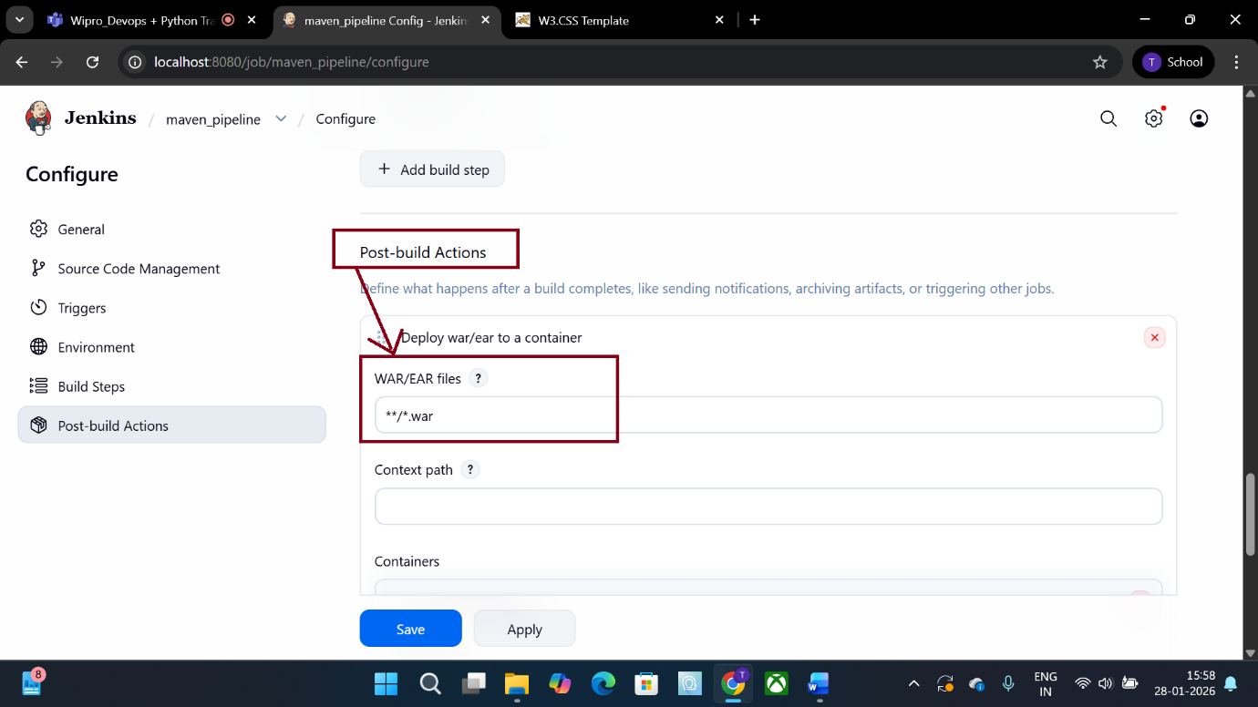

8.CLICK on container select tomcat type give credentials of tomcat and url after that apply and save
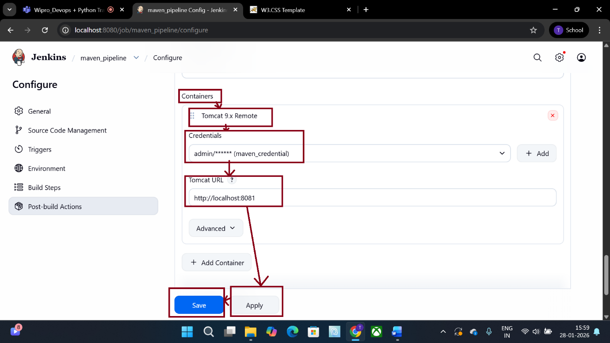
9.after that click on buld project after that click on symbol that shown in photo then we get console
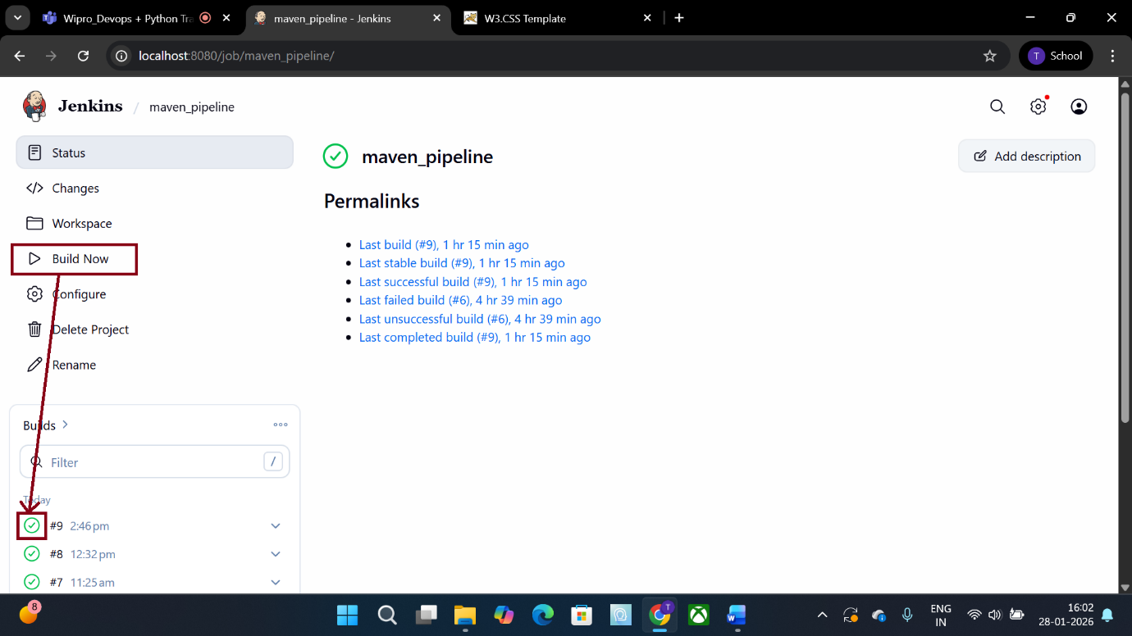

10.console shows success if fails its gives reason and sort accordingly
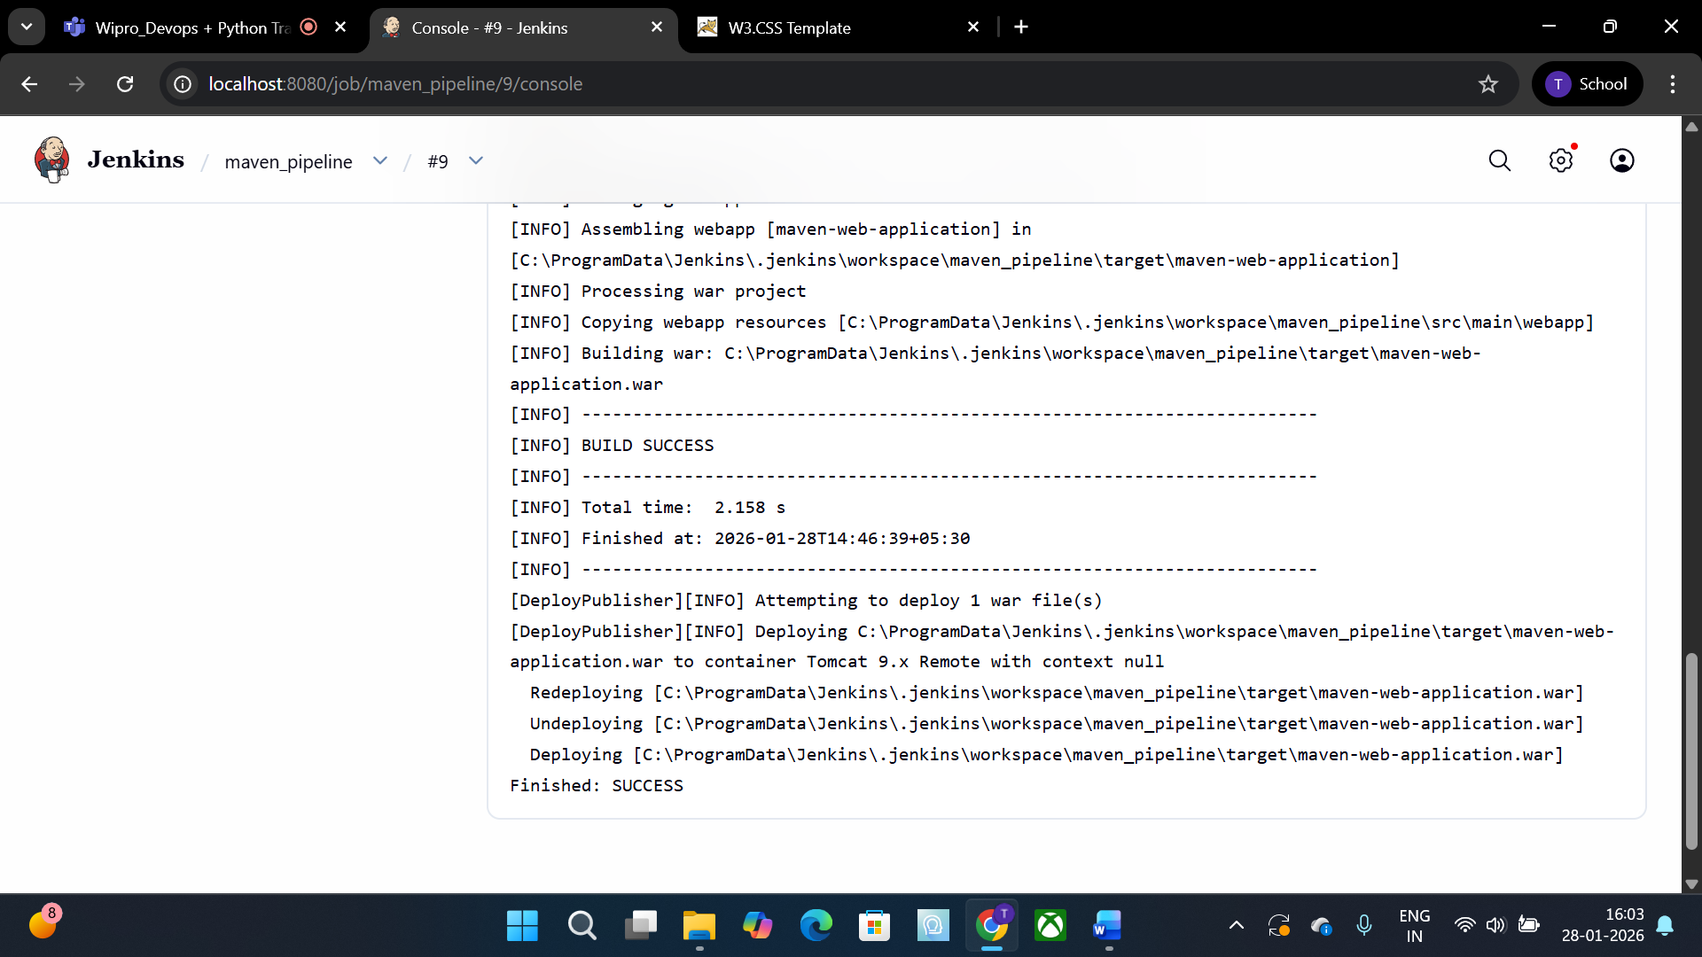

11.open tomcat on browser and click on manager app

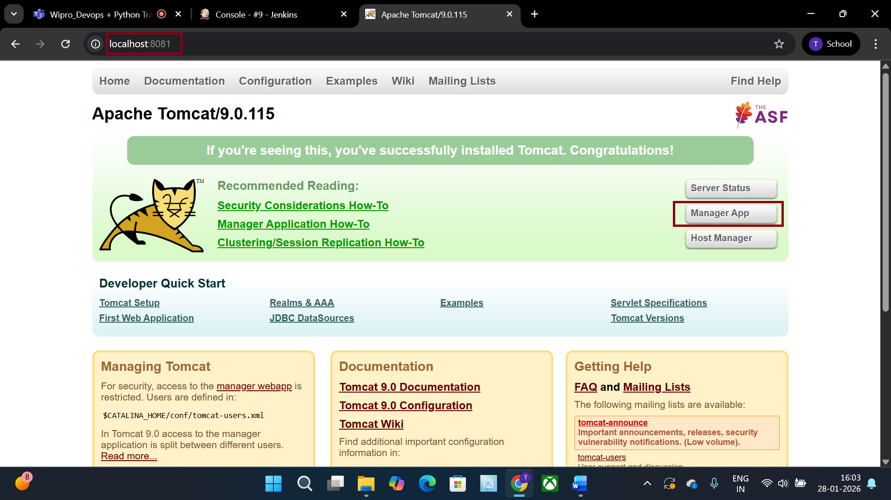

12.click on application
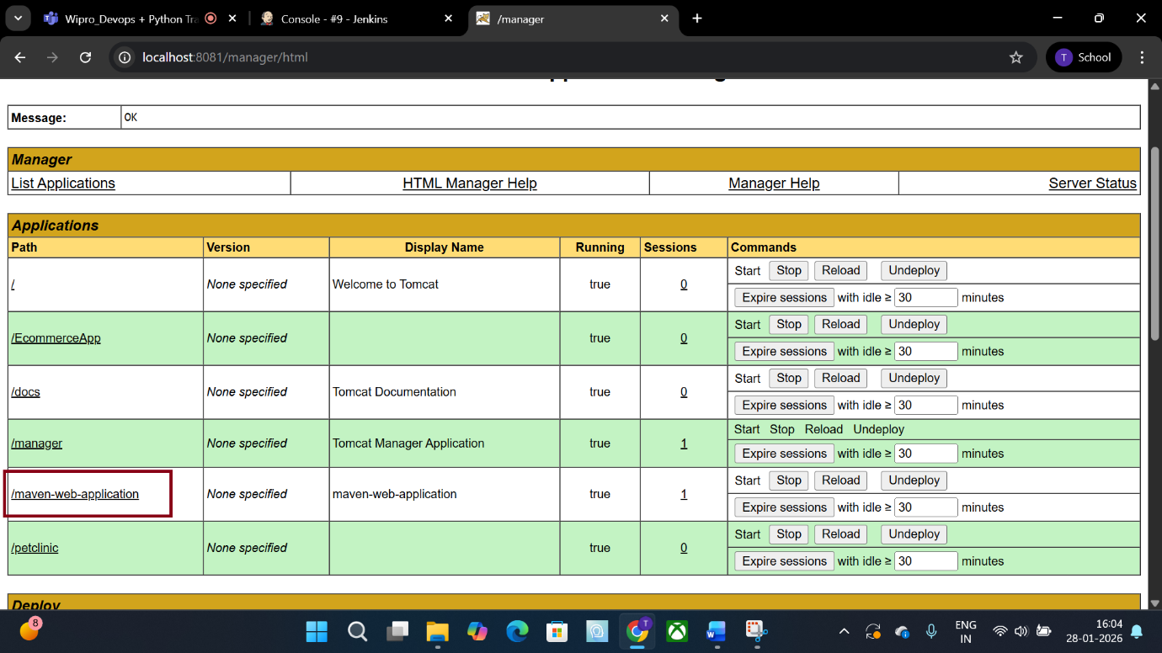

13.this is the result

