4) Docker Deployment
• Candidates must write their own Dockerfile to build the BMS app image.
• Build Docker image and push to DockerHub via Jenkins.
• Run container locally and validate accessibility on port 3000.

Step 1: install Jenkins and docker on the instance same as done for task 3 i.e in CI/CD Jenkins pipeline and start Jenkins and also write Dockerfile in bookmyshow-app folder

FROM node:latest

WORKDIR /app

COPY package*.json ./

RUN npm install
RUN npm install chokidar

COPY . .

ENV HOST=0.0.0.0

EXPOSE 3000

CMD ["npm","start"]

Step 2:Install plugins
  - Docker API Plugin.
  - Docker Commons Plugin.
  - Docker Pipeline.
  - Docker plugin.
  - docker-build-step.
  - Pipeline Stage View Plugin.

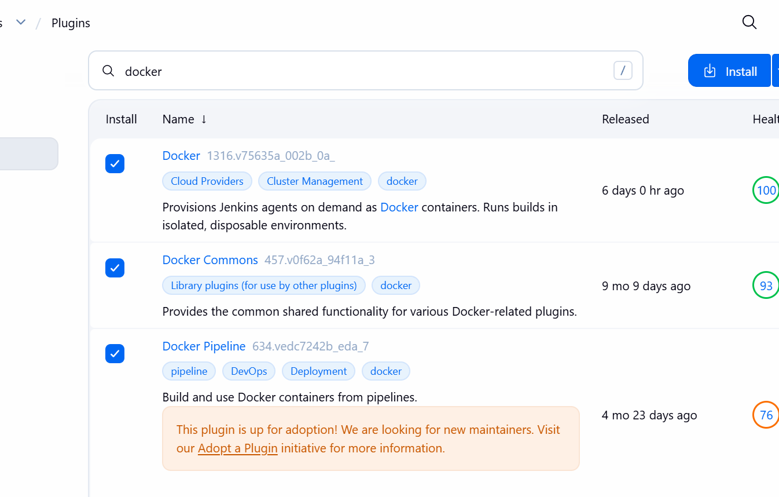

Step 3: Add docker credential select username and password
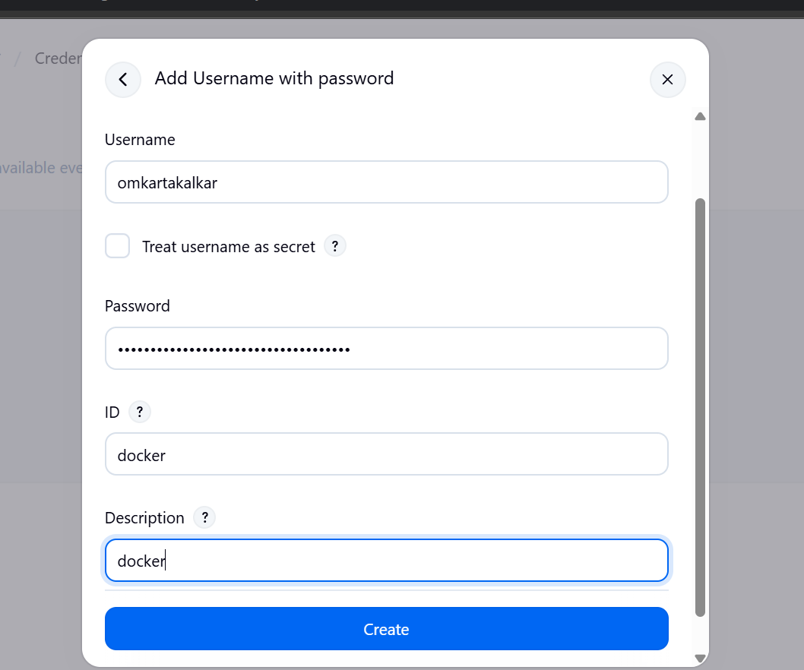

Step 4: Create Pipeline
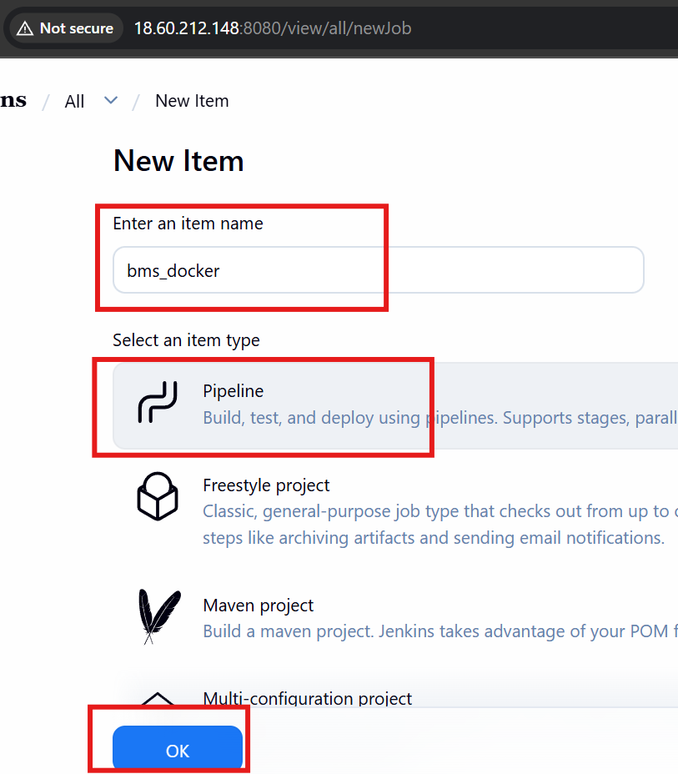

Step 5:Write Pipeline Script

pipeline {
agent any

stages {

stage('Checkout Code') {
steps {
git branch: 'main', url: 'https://github.com/omkartakalkar19/Book-My-Show.git'
sh 'ls -la'
}
}
stage('Docker Build & Push') {
steps{
script{
withDockerRegistry(credentialsId: 'docker', toolName: 'docker') {
sh 'docker build -t bms-app:v1.0.0 bookmyshow-app'
sh 'docker tag bms-app:v1.0.0 omkartakalkar/bms-app:v1.0.0'
sh 'docker push omkartakalkar/bms-app:v1.0.0'
}
}
}
}

stage('Deploy Container') {
steps {
sh '''
docker stop bms || true
docker rm bms || true

docker run -d --name bms -p 3000:3000 omkartakalkar/bms-app:v1.0.0
'''
}
}
}
}

Step 6: Run pipe and build it
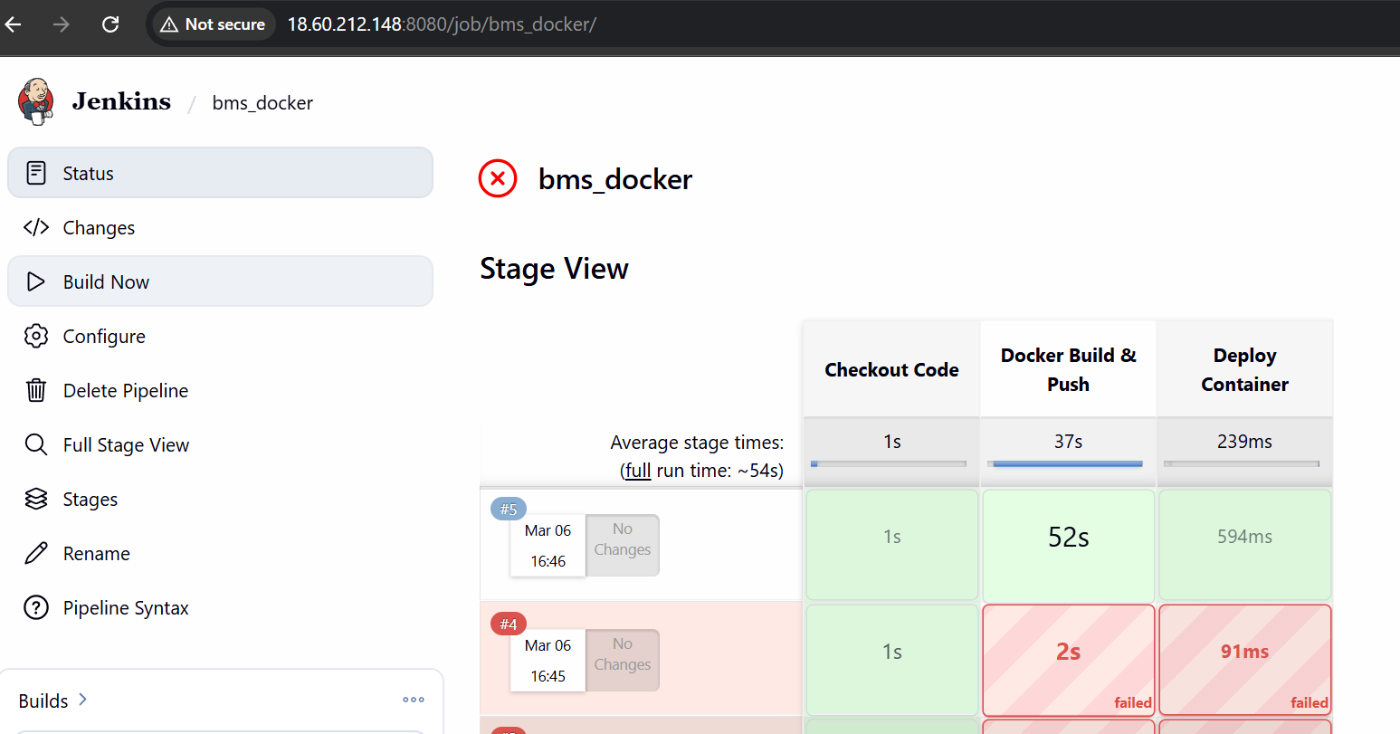
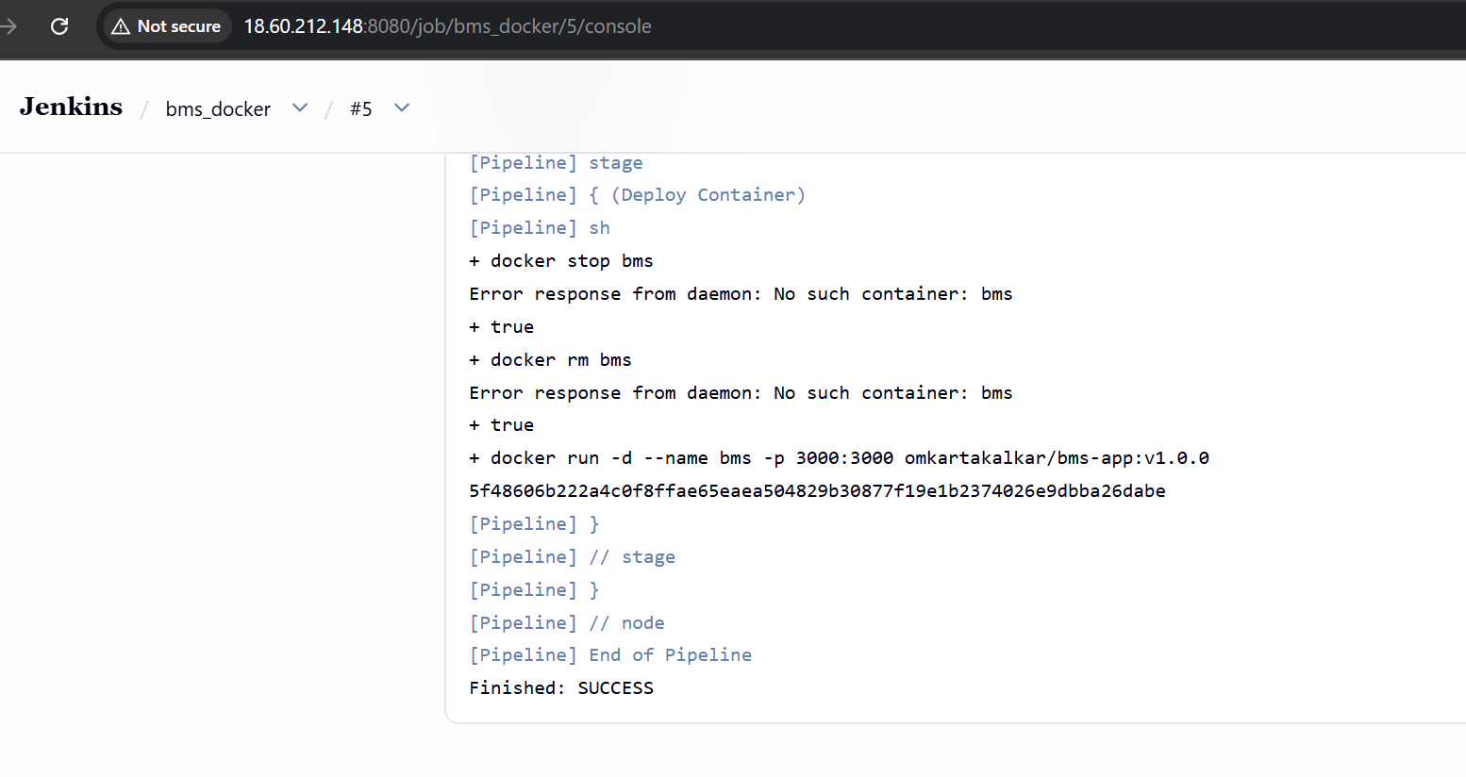

Step 7:Check is docker image is created or not in docker hub
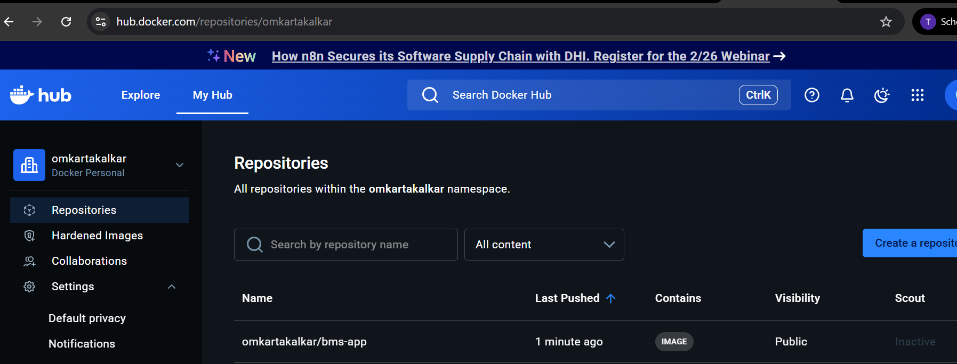

Step 8: Check image and container in instance
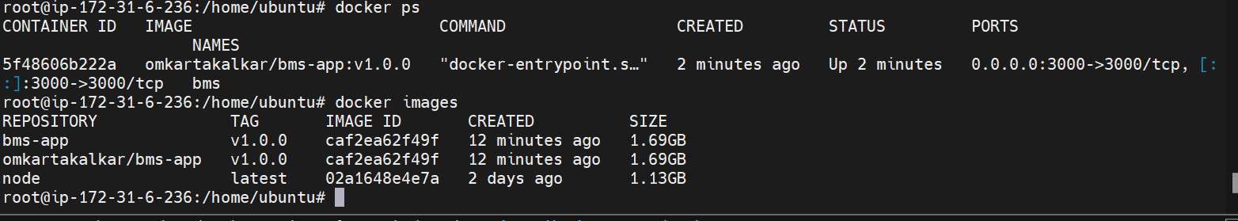

Step 9: Check deployed app on port 3000


