5) Kubernetes Deployment (EKS)
• Candidates must write their own Kubernetes manifests (`deployment.yaml`, `service.yaml`).
• Deploy the application on EKS cluster.
• Expose service using NodePort or LoadBalancer.
• Validate deployment using 'kubectl get pods' and 'kubectl get svc'.

Step 1:Set up EKS CLUSTER
- Create a Linux server with ubuntu os for setting up eks cluster
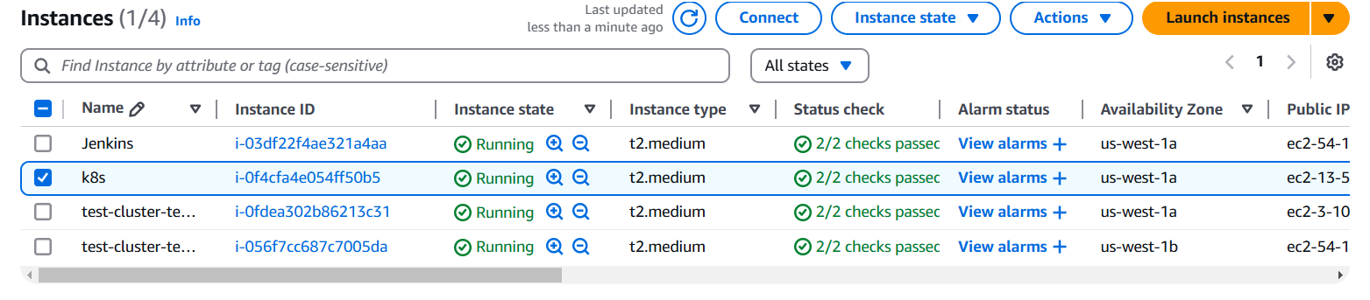

- Connect your ec2 instance with putty or mobaxterm using shh client
- After that you have to install following cli tools

- Eksctl
Description: - eksctl is a simple CLI tool for creating and managing clusters on EKS - Amazon's managed Kubernetes service for EC2. It is written in Go, uses CloudFormation
Command: # for ARM systems, set ARCH to: `arm64`, `armv6` or `armv7`
ARCH=amd64
PLATFORM=$(uname -s)_$ARCH

curl -sLO "https://github.com/eksctl-io/eksctl/releases/latest/download/eksctl_$PLATFORM.tar.gz"

# (Optional) Verify checksum
curl -sL "https://github.com/eksctl-io/eksctl/releases/latest/download/eksctl_checksums.txt" | grep $PLATFORM | sha256sum --check

tar -xzf eksctl_$PLATFORM.tar.gz -C /tmp && rm eksctl_$PLATFORM.tar.gz

sudo mv /tmp/eksctl /usr/local/bin

- Kubectl
Description: - kubectl is the command-line tool for interacting with Kubernetes clusters. It allows users to manage Kubernetes resources and perform various tasks such as deploying applications, inspecting and modifying cluster resources, and troubleshooting cluster issues.
Command: -
- Install kubectl binary with curl on Linux
curl -LO https://dl.k8s.io/release/$(curl -L -s https://dl.k8s.io/release/stable.txt)/bin/linux/amd64/kubectl
- Validate the binary (optional)
Download the kubectl checksum file:
curl -LO https://dl.k8s.io/release/$(curl -L -s https://dl.k8s.io/release/stable.txt)/bin/linux/amd64/kubectl.sha256
- Validate the kubectl binary against the checksum file:
echo "$(cat kubectl.sha256) kubectl" | sha256sum –check
- Install kubectl
sudo install -o root -g root -m 0755 kubectl /usr/local/bin/kubectl
- Test to ensure the version you installed is up-to-date:
kubectl version --client
- If kubectl version is not visible execute following commands (its optional)
chmod +x kubectl
mkdir -p ~/.local/bin
mv ./kubectl ~/.local/bin/kubectl
kubectl version --client

- AWS CLI
Description: - The AWS Command Line Interface (CLI) is a tool provided by Amazon Web Services that enables users to interact with AWS services from a terminal or command prompt. It allows you to perform various AWS tasks directly from the command line, including managing resources, configuring settings, and automating workflows.
Command: -
apt install unzip -y
curl "https://awscli.amazonaws.com/awscli-exe-linux-x86_64.zip" -o "awscliv2.zip"
unzip awscliv2.zip
sudo ./aws/install

Confirm the installation with the following command: -
aws --version

- AWS access key and secret key you have to provide before that you have to create one IAM user with administrator access permission then generate access key and secret key and you configure these keys on your terminal
aws configure (execute this command on your terminal)
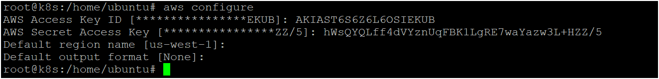

- Now you can create eks cluster by executing following command
eksctl create cluster --name <cluster_name> --region <your_region> --zones <availability_zones> --nodegroup-name <nodegroip_name> --node-type <instance_type> --nodes <no.of.nodes>

- Now your cluster is ready as shown below image 👇
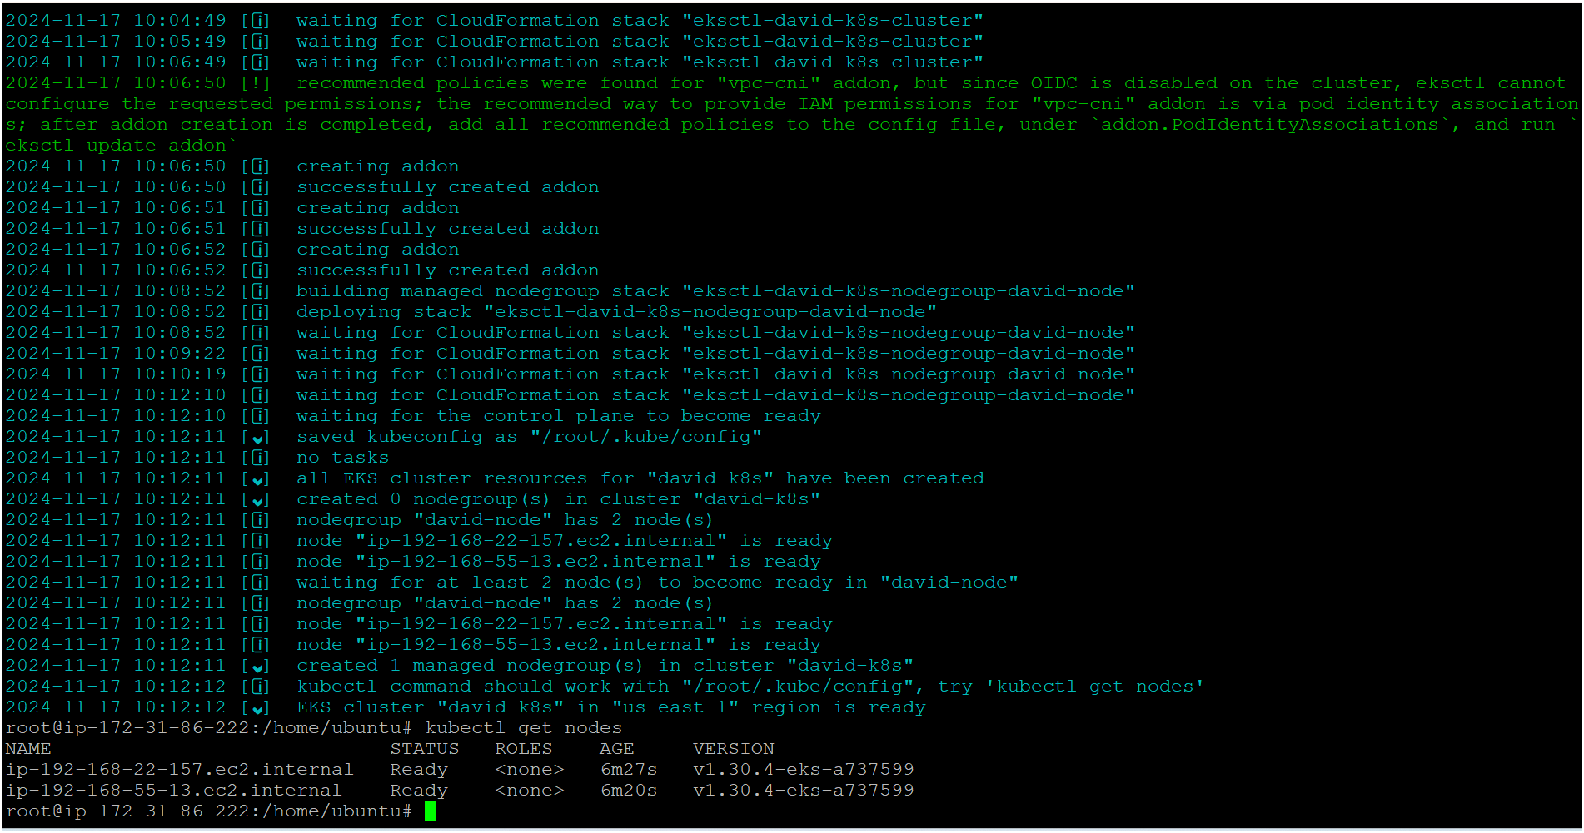

Step 2: Create deployment.yml file

apiVersion: apps/v1
kind: Deployment
metadata:
name: bms-app
namespace: omkar-ns
spec:
replicas: 3
selector:
matchLabels:
app: bms-app
template:
metadata:
labels:
app: bms-app
spec:
containers:
- name: bms-container
image: omkartakalkar/bms-app:v1.0.0
ports:
- containerPort: 3000

Step 3: Create service.yml file

apiVersion: v1
kind: Service
metadata:
name: bms-service
namespace: omkar-ns
spec:
selector:
app: bms-app
ports:
- protocol: TCP
port: 80
targetPort: 3000 # container port, it should be same as container port defined in deployment.yaml
type: LoadBalancer

Step 4:Create the namespaceand apply the yaml files
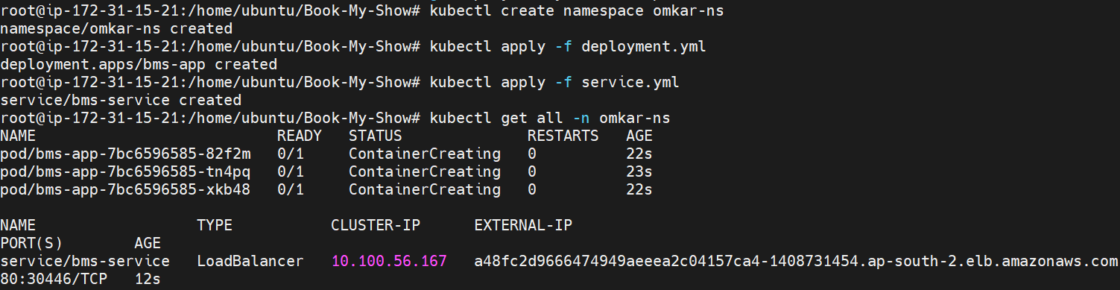
Step 5: Check pods and svc
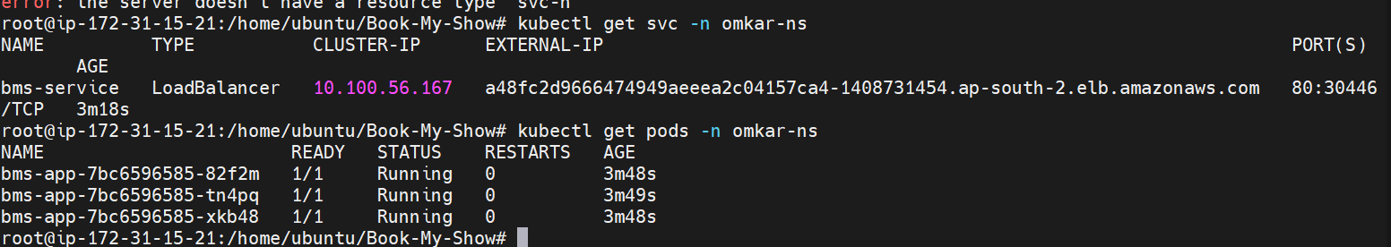

Step 6:Check the deployed app as we run on loadbalancer


