- Monitoring & Observability
- Install Prometheus and Node Exporter to collect metrics.
- Integrate Jenkins metrics into Prometheus.
- Install Grafana, configure Prometheus as a data source.
- Add dashboards for Node health and Jenkins performance.
- Submit Grafana screenshots in deliverables.

Step 1:Installing of Prometheus and Grafana
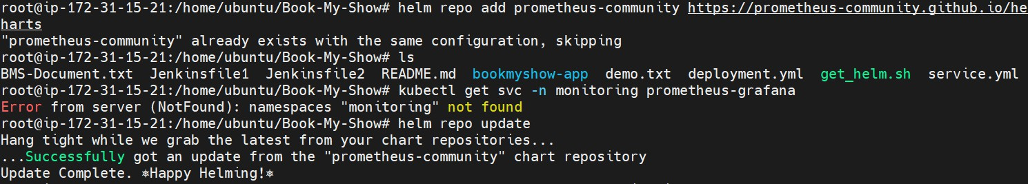
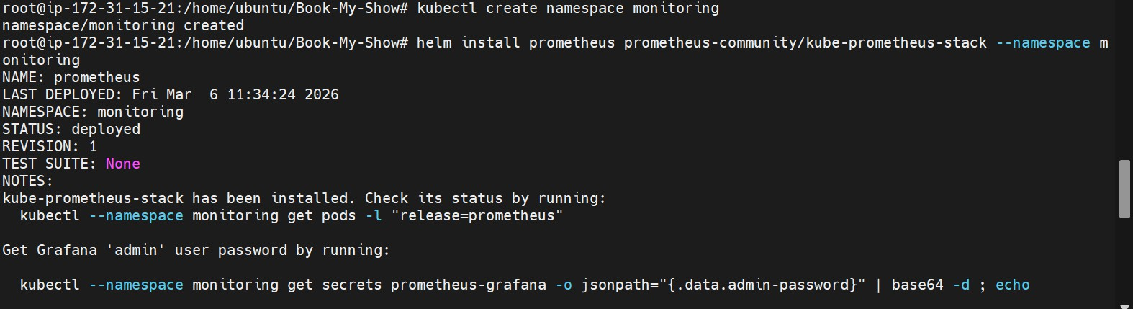
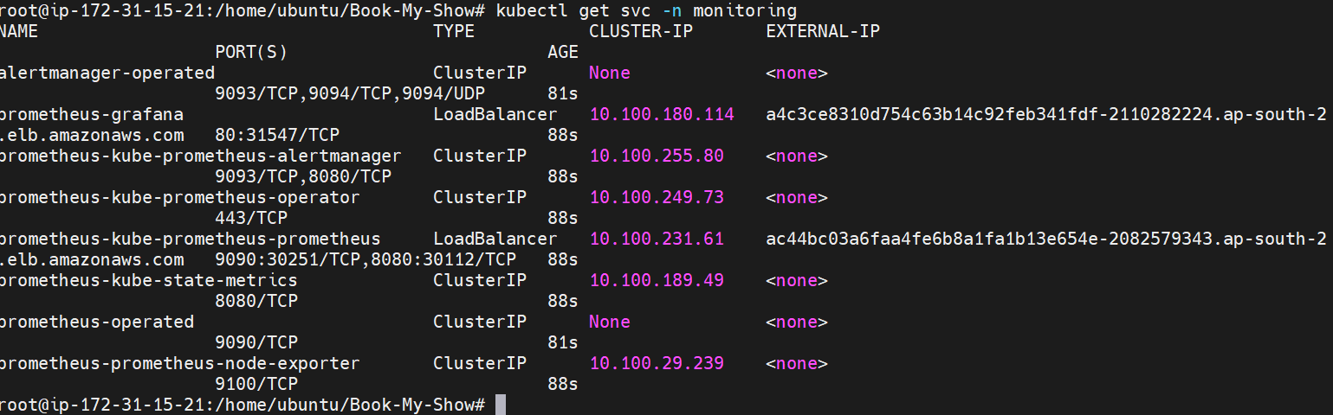

Step 2: Check Prometheus is it installed correctly or not
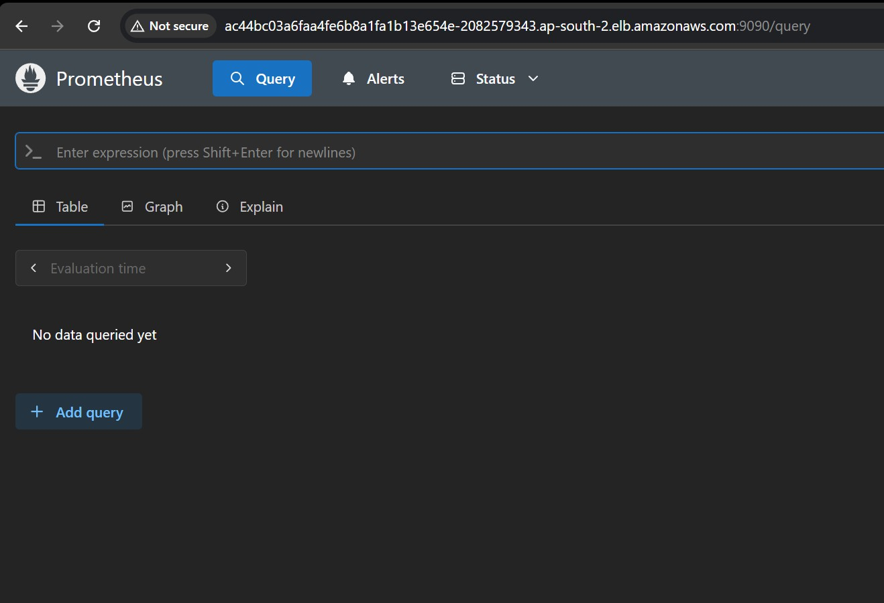
Step 3:Similarly, Check grafana is it installed correctly
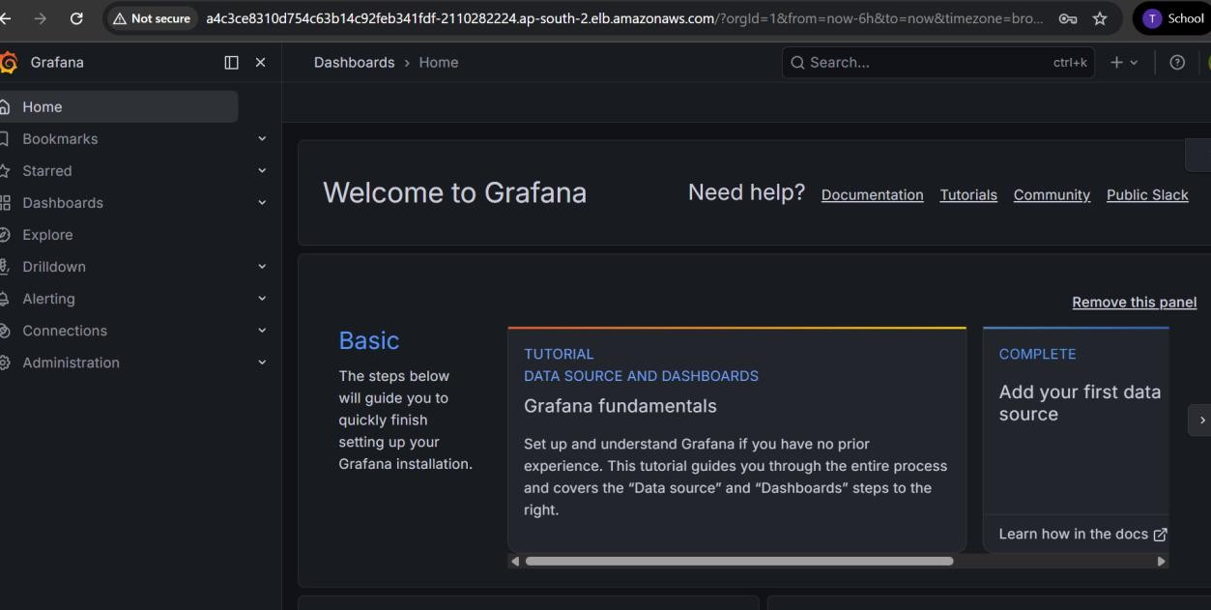

Step 4:Add datasource to the grafana use promethus url and do connection

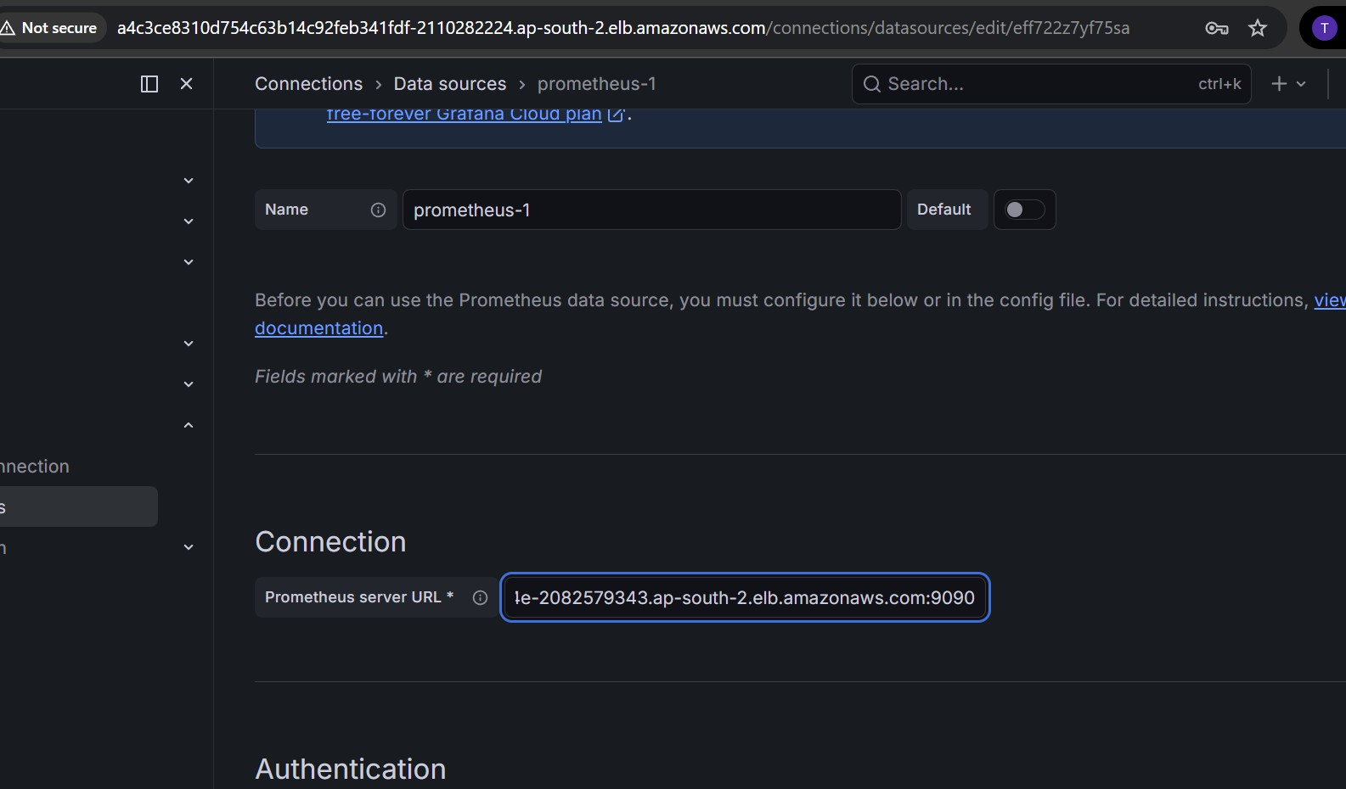

Step 5: import the dashboard
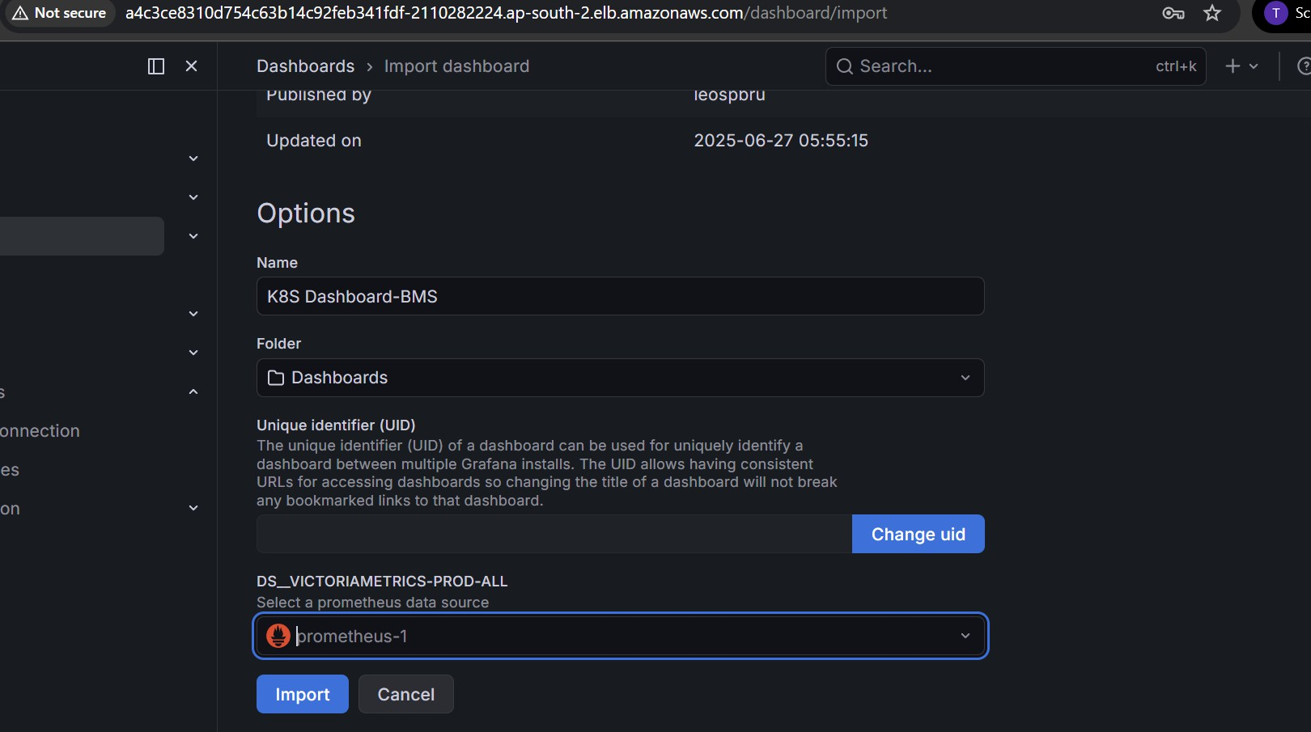

Step 6: Check the dashboard –k8s dashboard
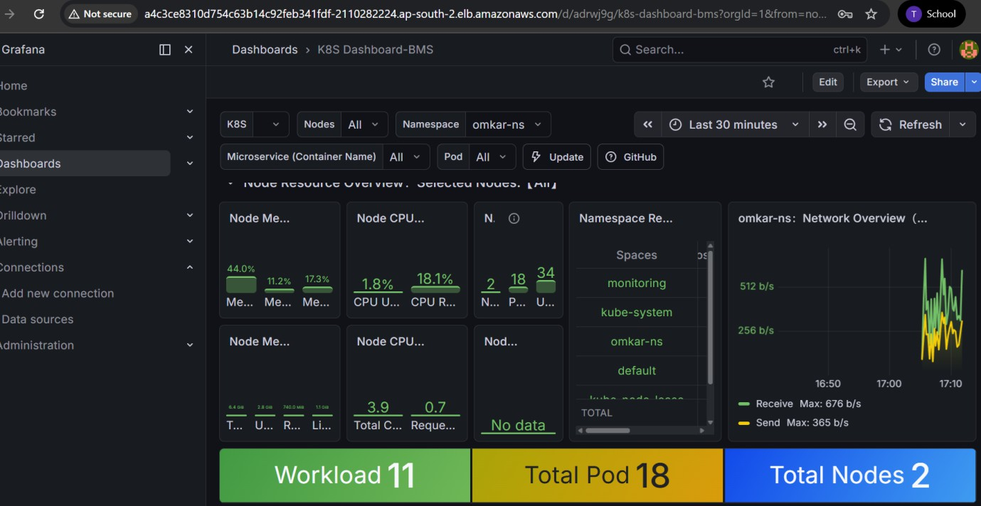

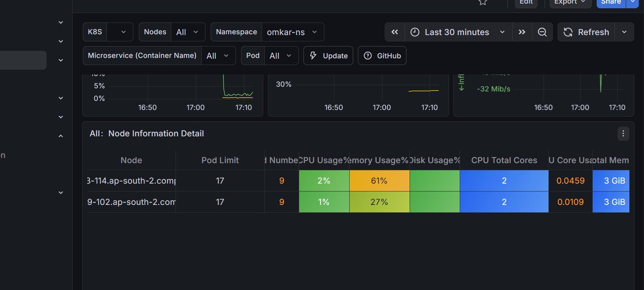

Import another dashboard -Kubernetes Dashboard
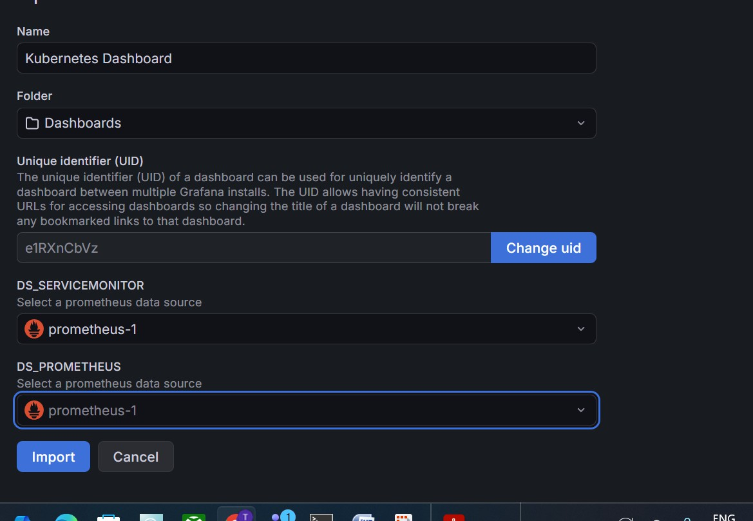
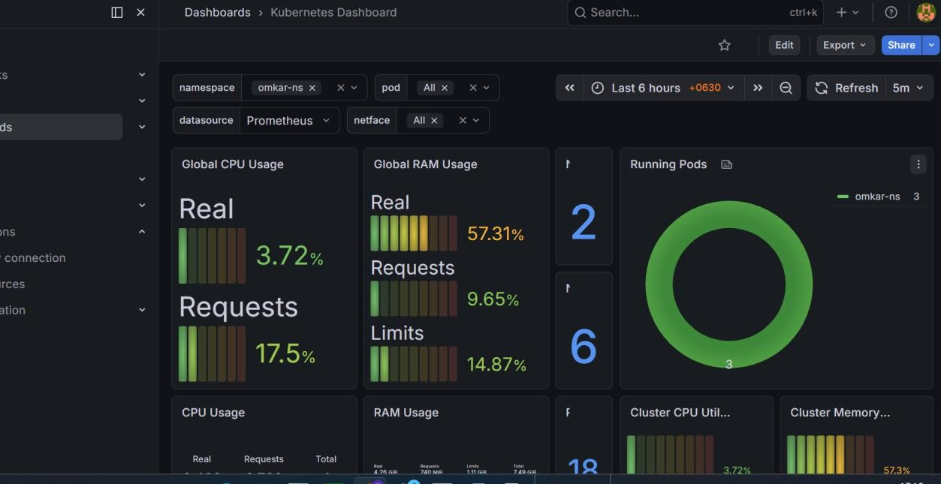

Import another dashboard –Node Exporter Full
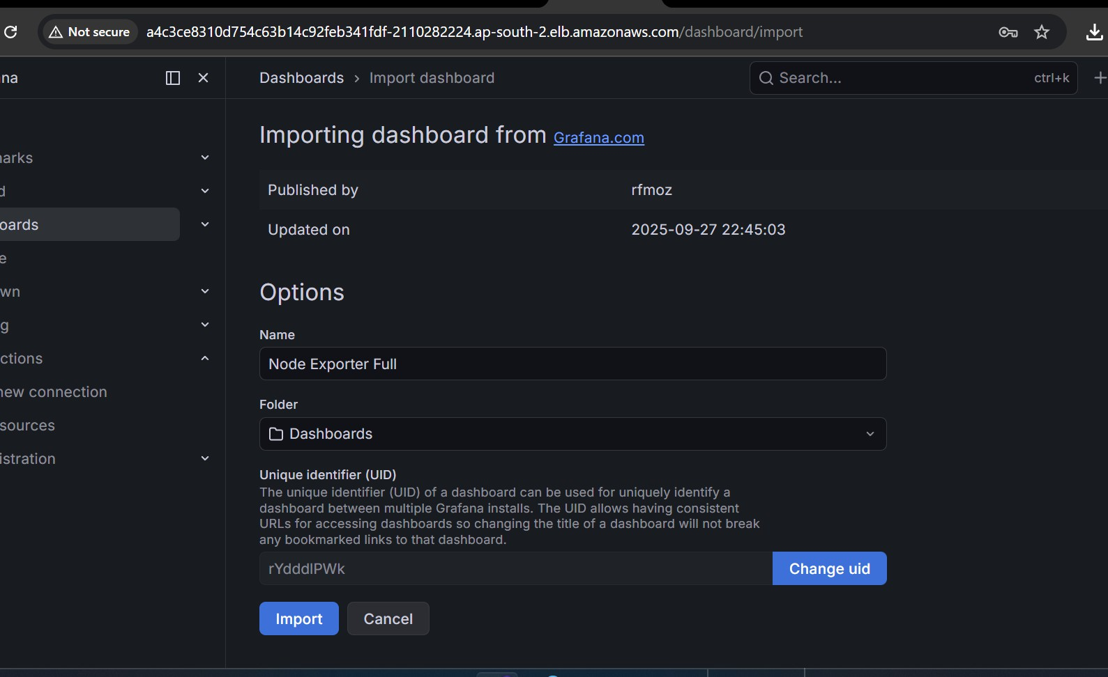
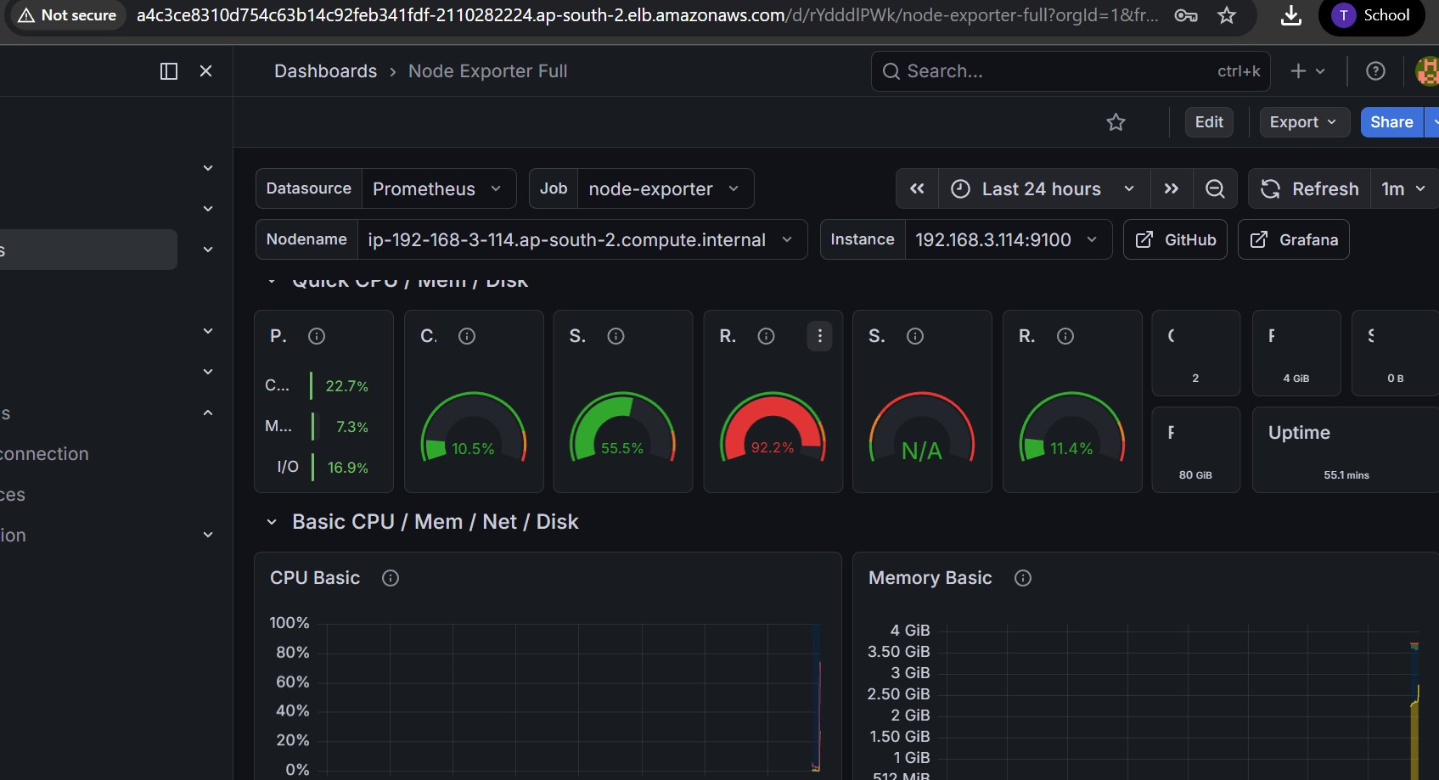

Step 7 :Check the Prometheus status
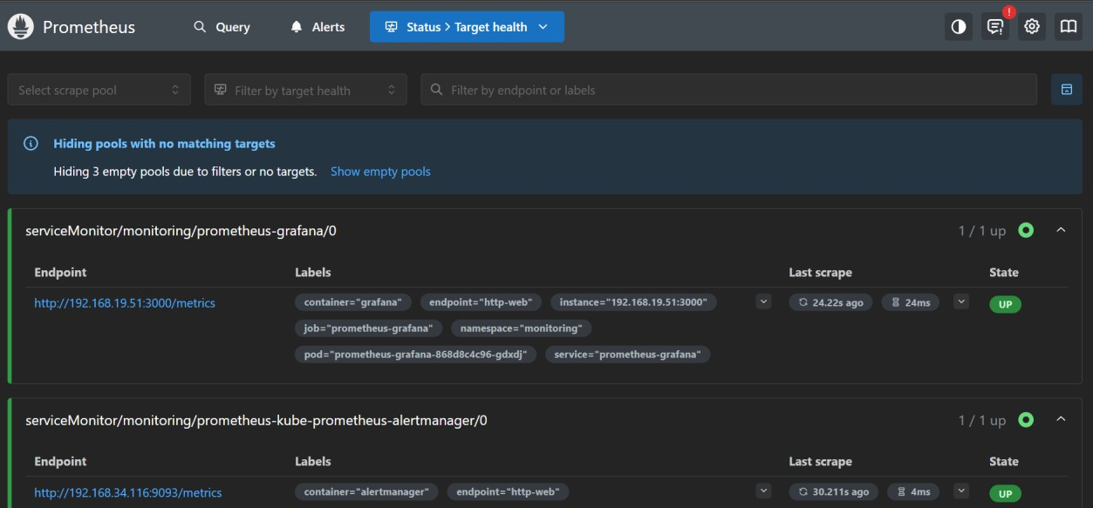
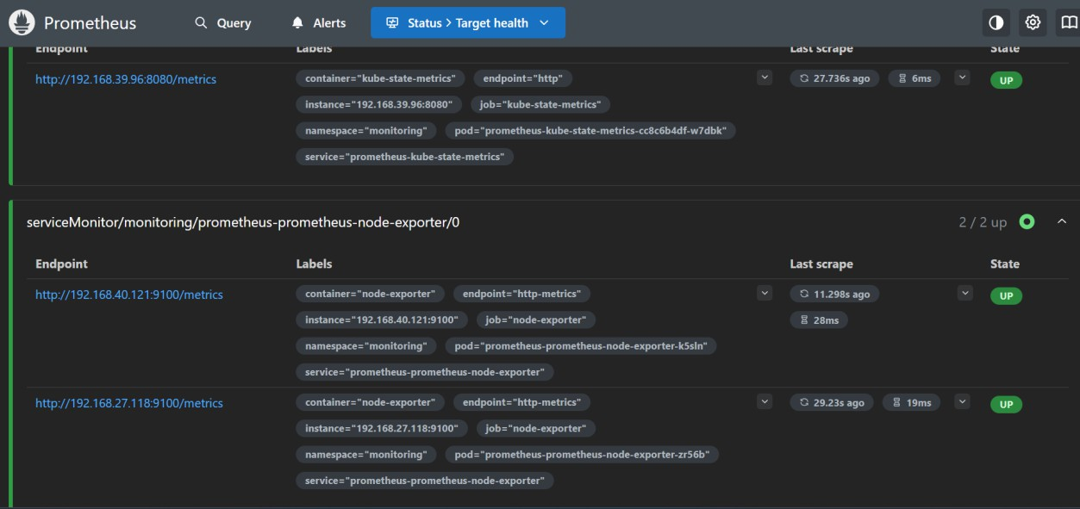

Step 8 : Set up alert to slack from Grafana
- Go to slack official site make login and click on create new app
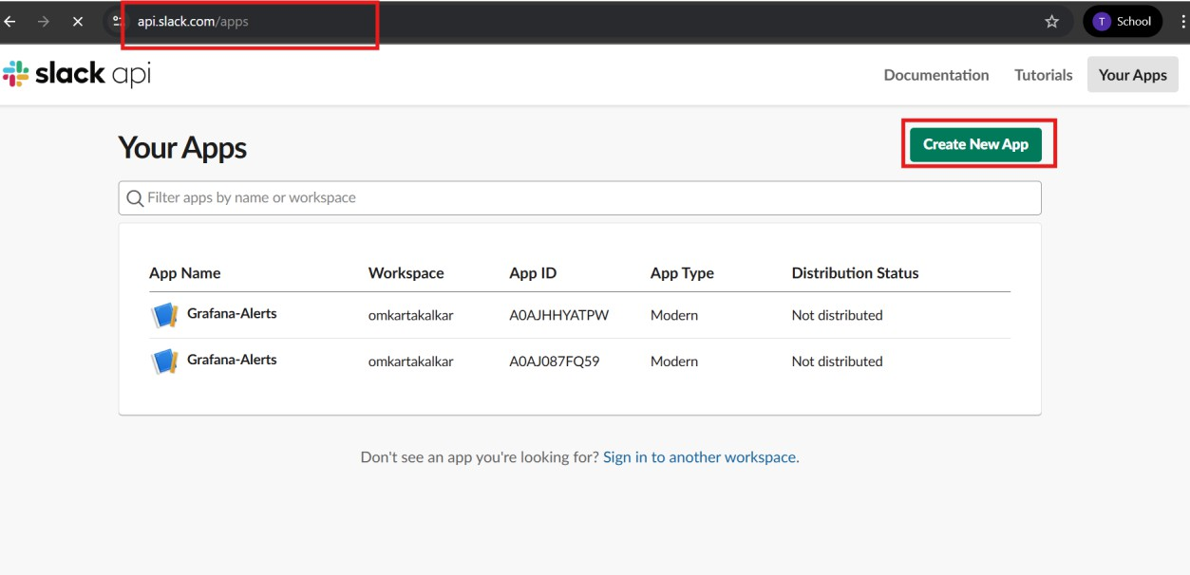
- Click on from scratch
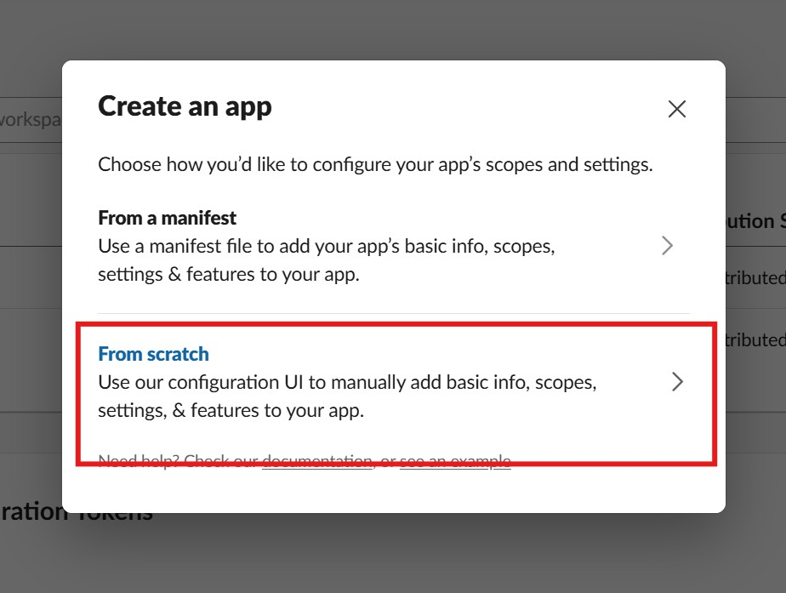

- Give app name and choose workplace
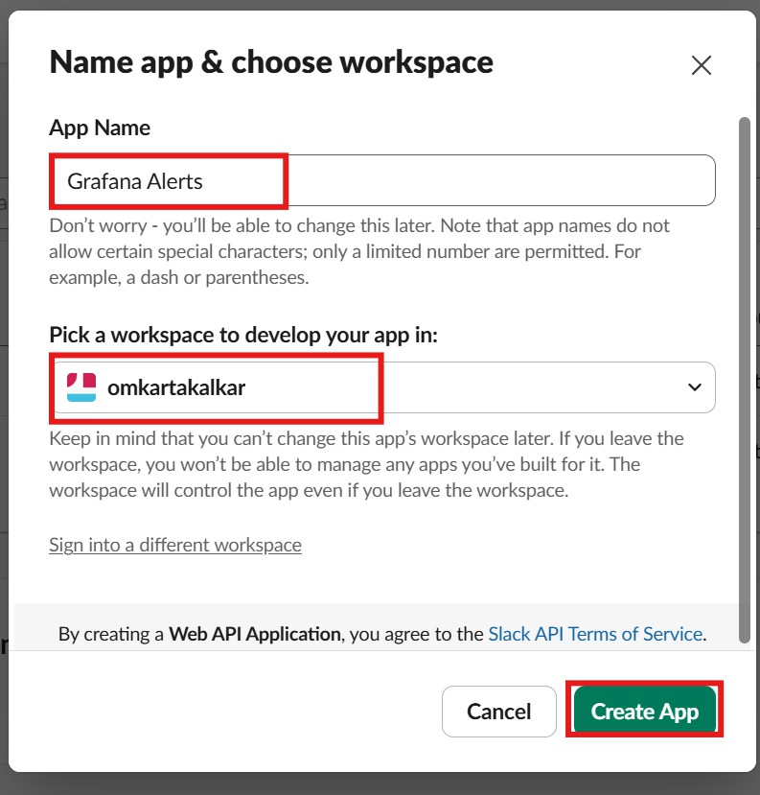
- Activate incoming webhook

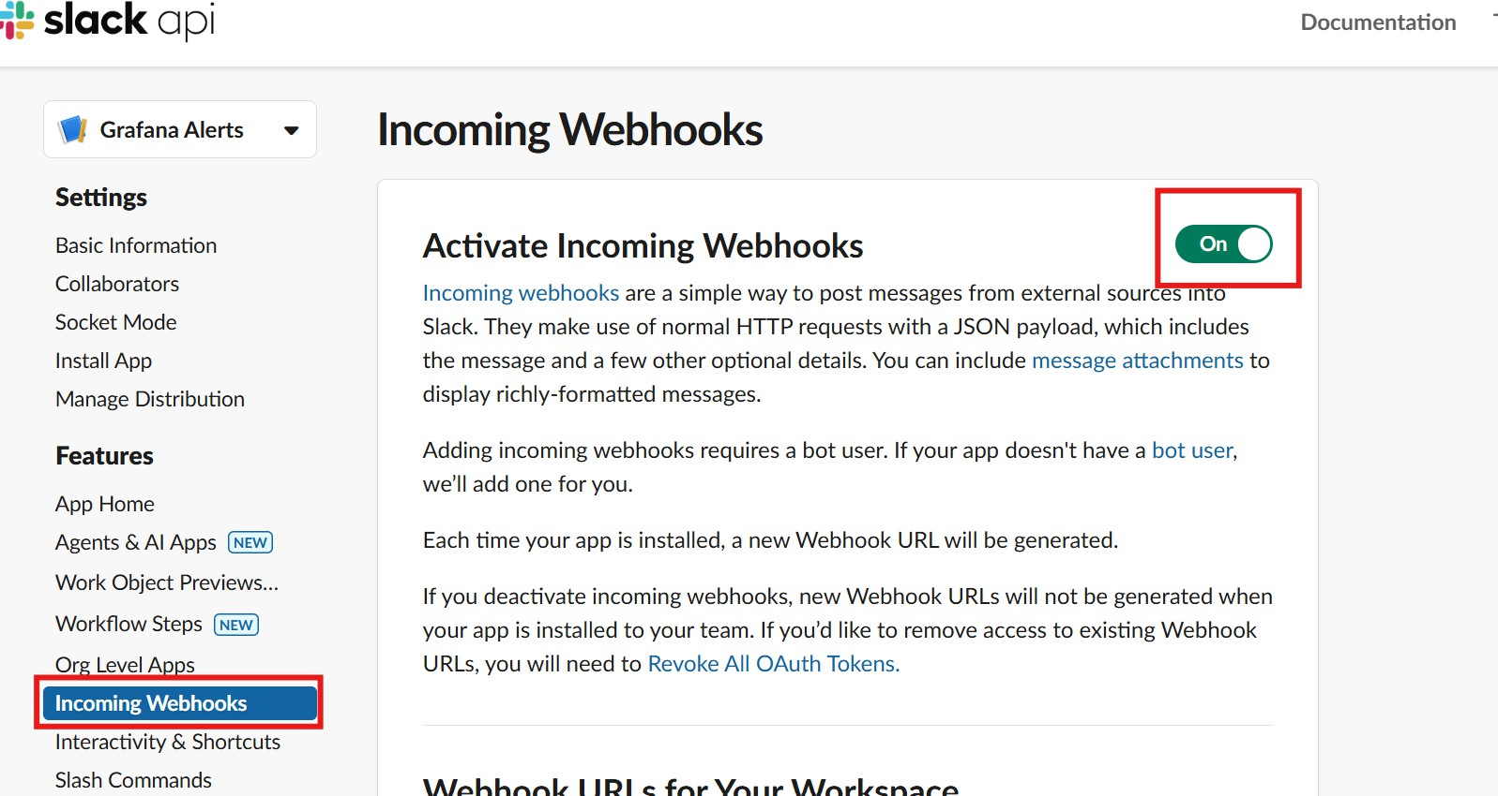

- Add a Webhook URL
  - Scroll down to Webhook URLs for Your Workspace
  - Click "Add New Webhook to Workspace"
  - Add the channel for webhook
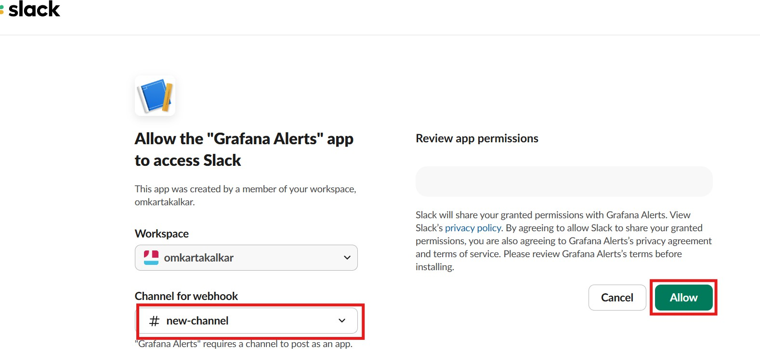

- Copy webhook URL

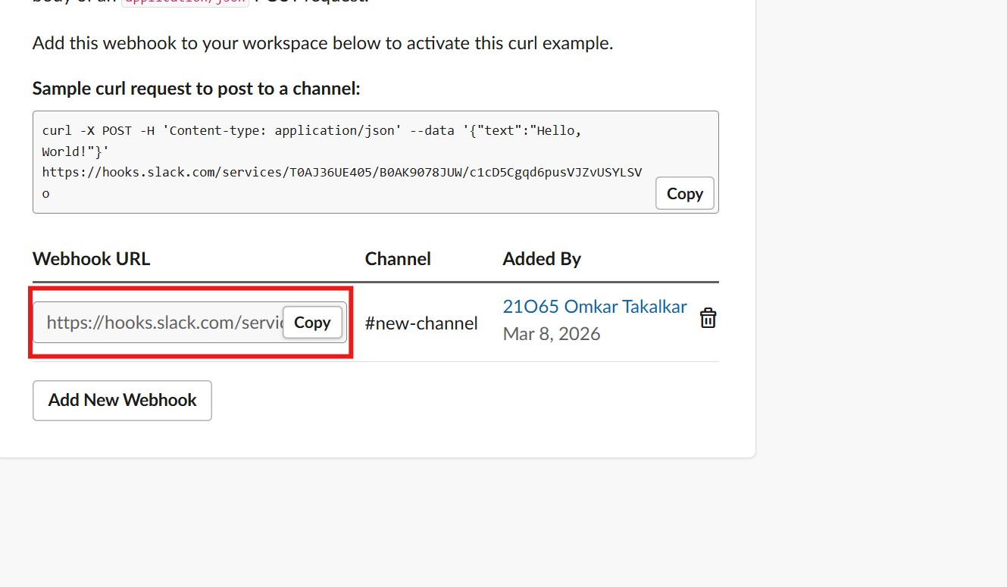
- Add This Webhook to Grafana
  - Open Grafana
  - Go to Alerting → Contact points
  - Click "New contact point"
  - Create contact point
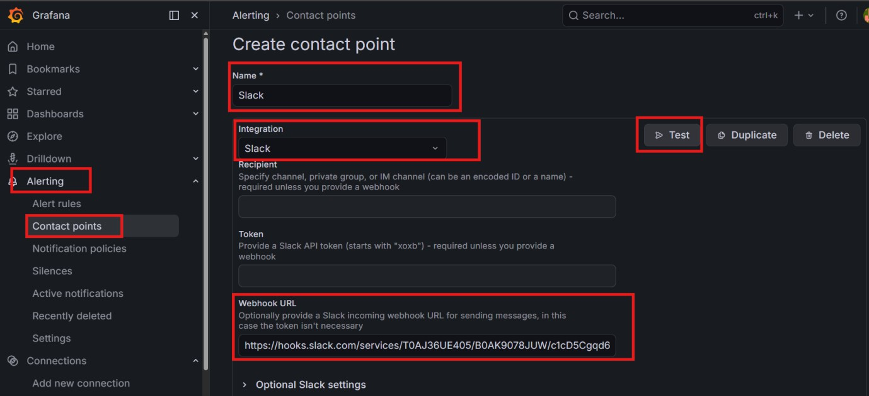
- Check test message

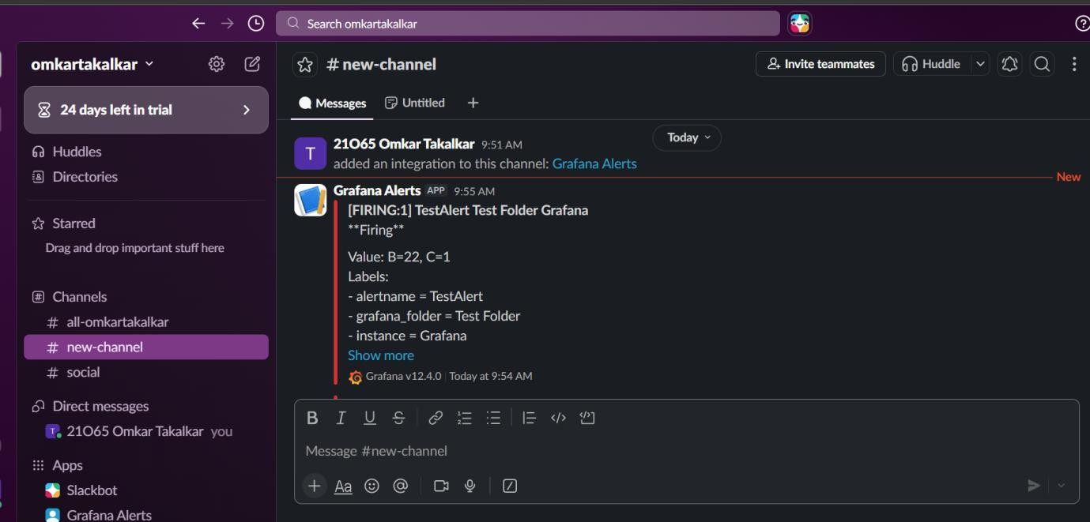
- Alert #1: High CPU Usage Create Alert Rule
  - Go to Grafana → Alerting → Alert Rules
  - Click New alert rule
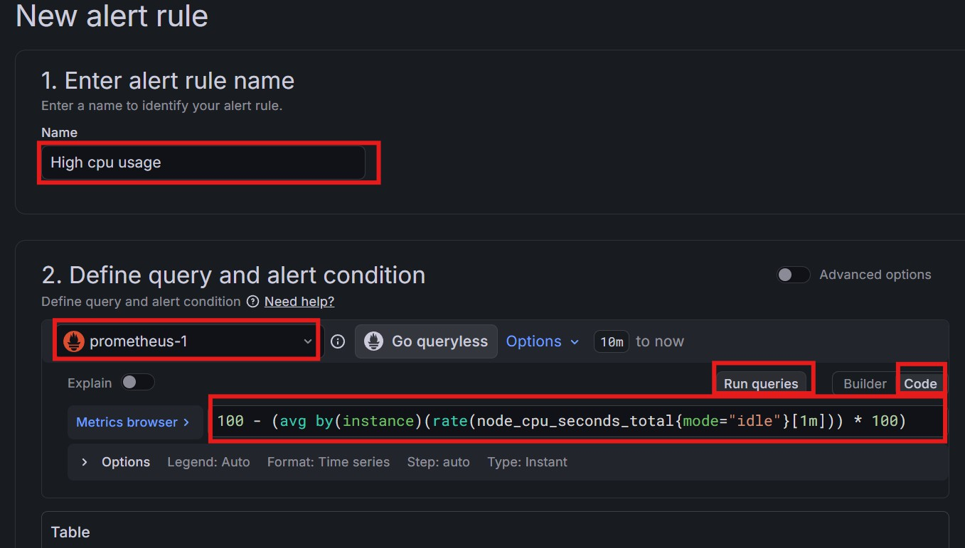

  - Set condition and create folder

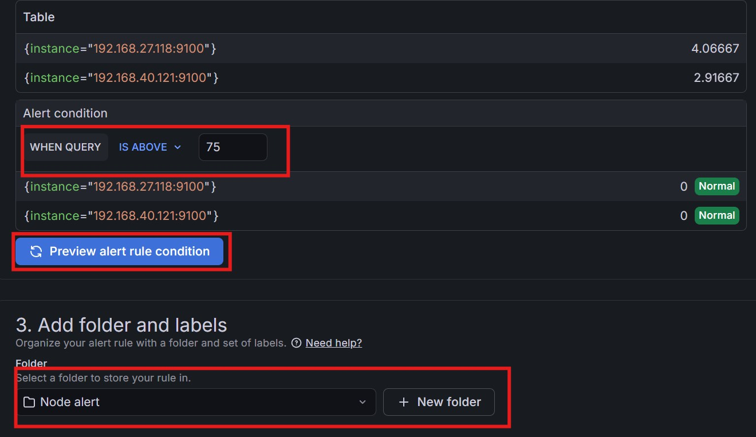
  - Set Evaluation group and interval
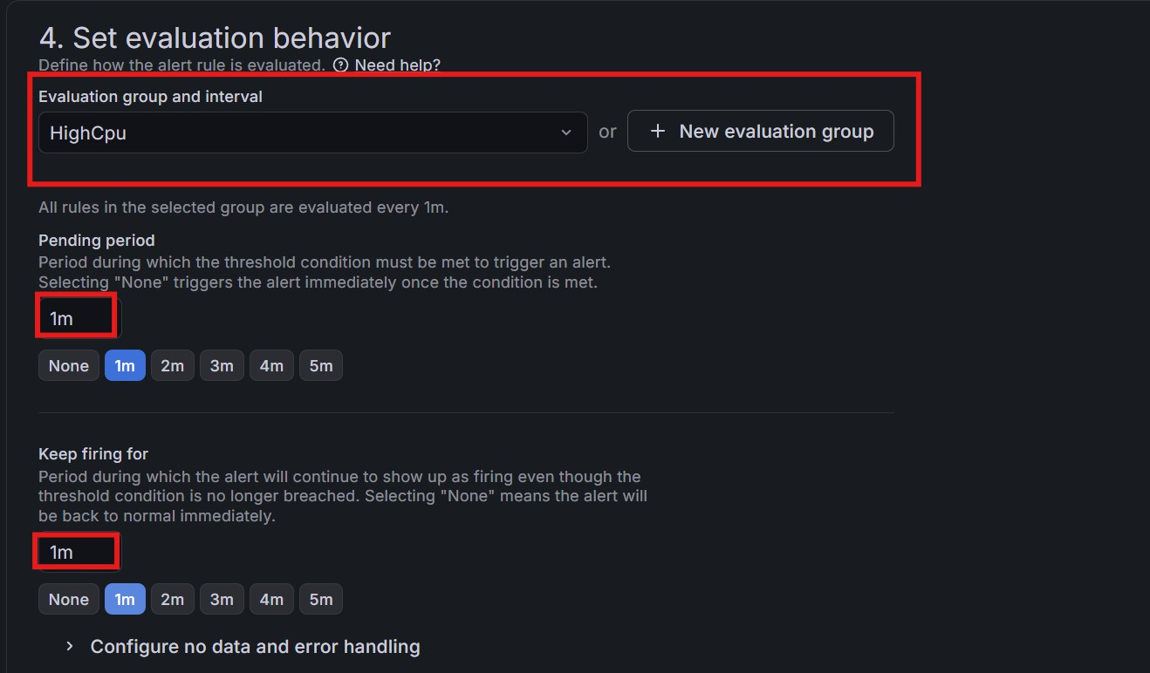

  - Select contact point and save the alert message

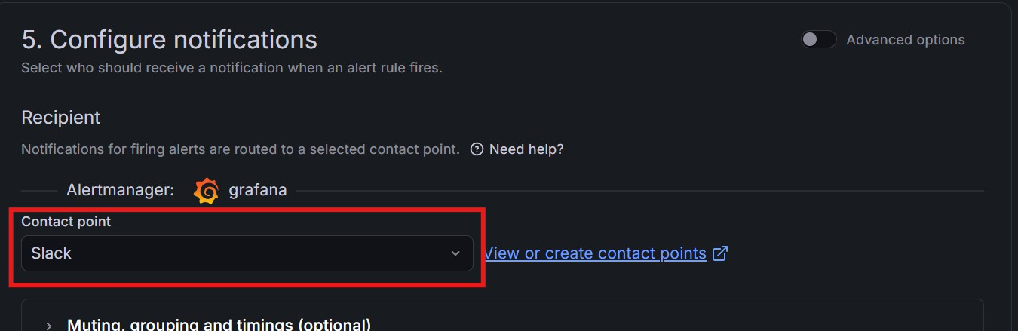
  - New alert message is set
