Omkar_Geetaram_Takalkar -
Capstone_project : Book-My-Show DevOps Lifecycle

1)Jira Workflow
• Each candidate must assign themselves tasks in Jira.
• Track task progress using Jira board (To Do → In Progress → Done).
• Export the board as part of the final submission.

Step 1 :Creating Space for the BMS_Project
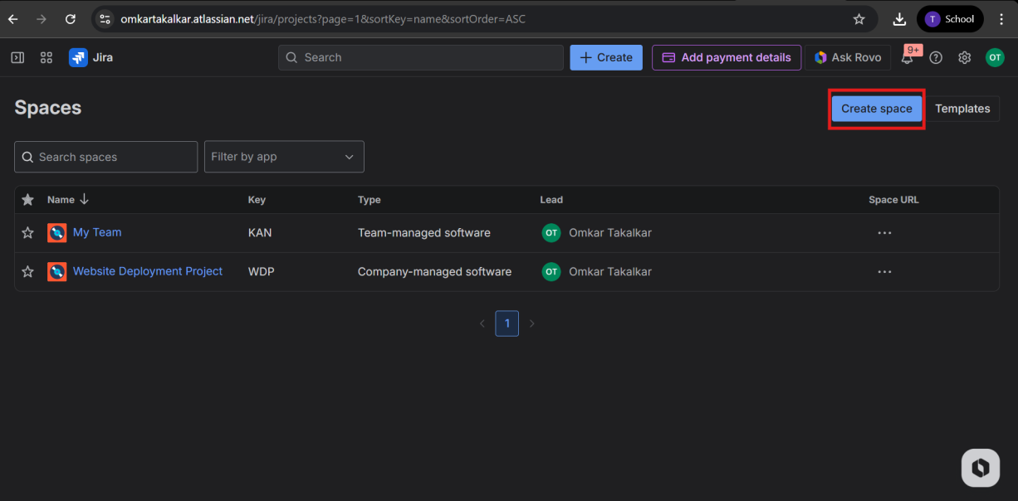
Step 2:Selecting Project space Template
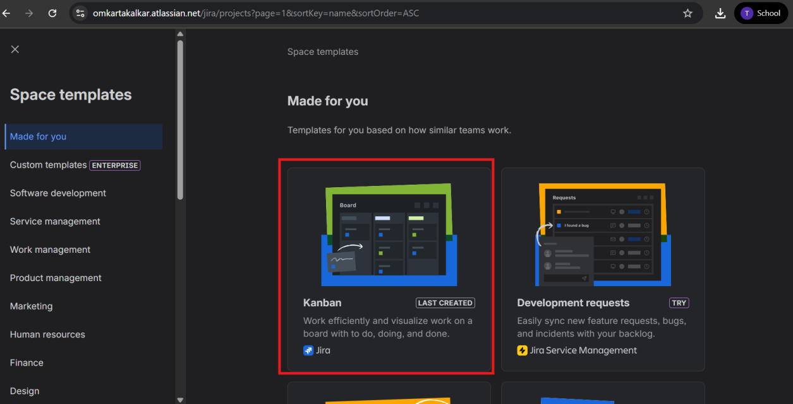
Step 3: Giving name for the project space
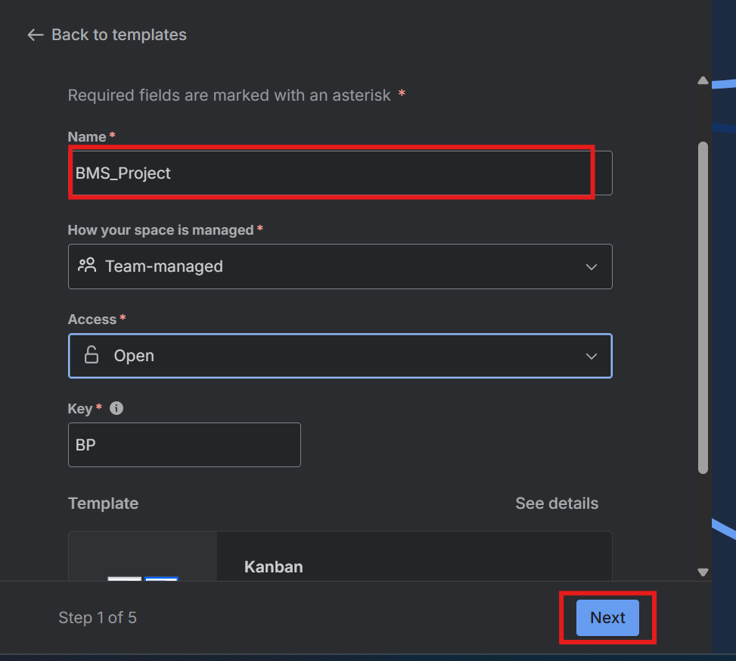

Step 4:Selecting worktypes for project space
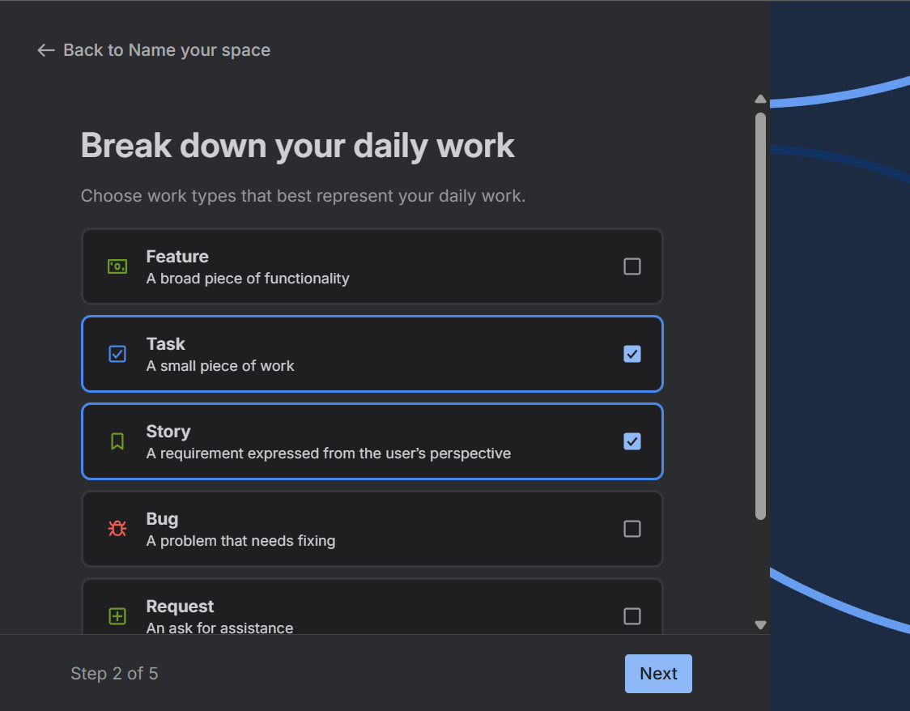

Step 5:Selecting progress status we needed and cretating space
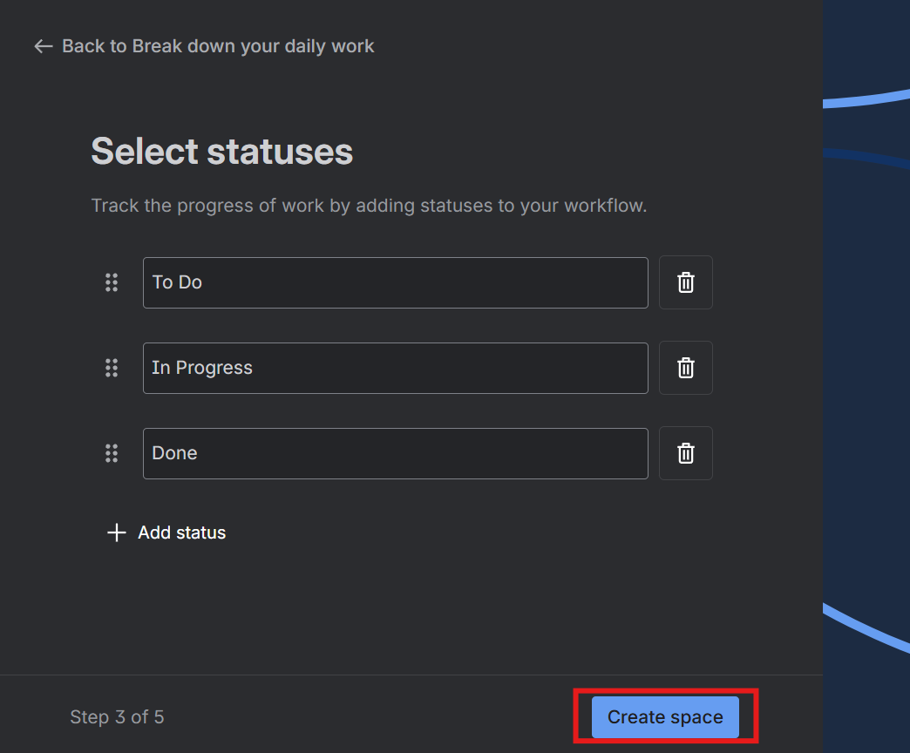
Step 6: Creating tasks and assigning it to self and giving duedate
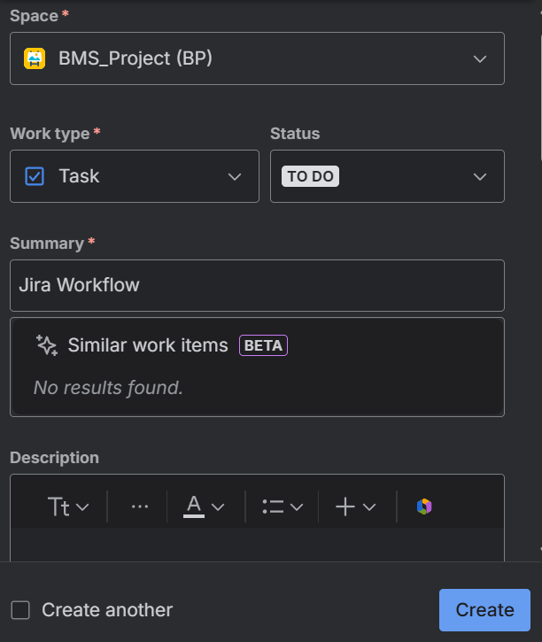
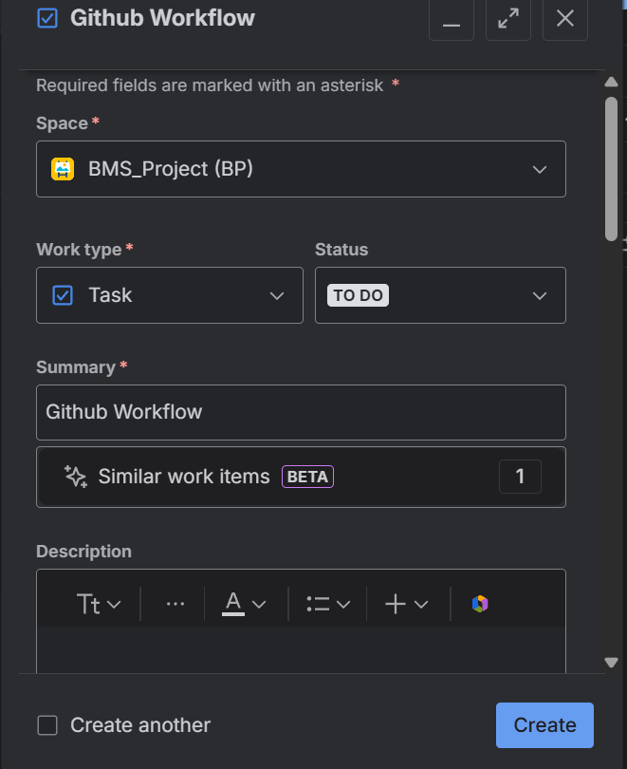

Similarly, we create all task
1.Jira Workflow
2.Github Workflow
3. Jenkins CI/CD Pipeline
4. Docker Deployment
5. Kubernetes Deployment (EKS)
6. Monitoring & Observability

Step 7:This is list of all task
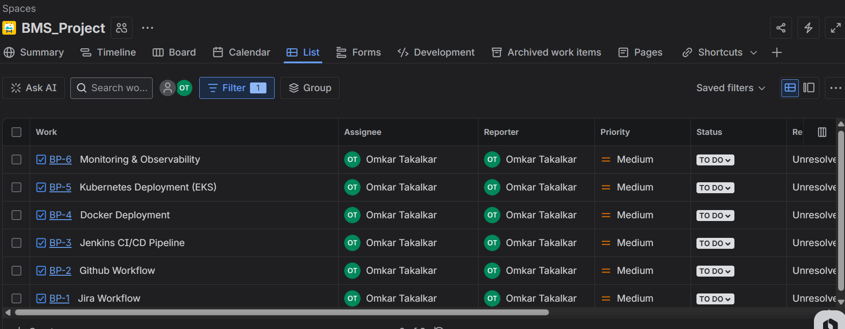
Step 8:Jira workflow is in progress and other task is yet to start
