JIRA
JIRA:
Jira is a project management and issue-tracking tool used by teams to plan, track, assign, and manage work throughout the software development lifecycle.
It helps teams organize work into items such as Epics, Stories, Tasks, and Bugs, assign them to team members, track progress using workflows (To do, in progress, done) and ensure timely delivery.
Jira is widely used by Product, Development, QA, and DevOps teams to collaborate efficiently, maintain transparency, and improve project visibility.
Following are the steps to proceed using JIRA:
Step1: Create a team. Open JIRA and click on teams
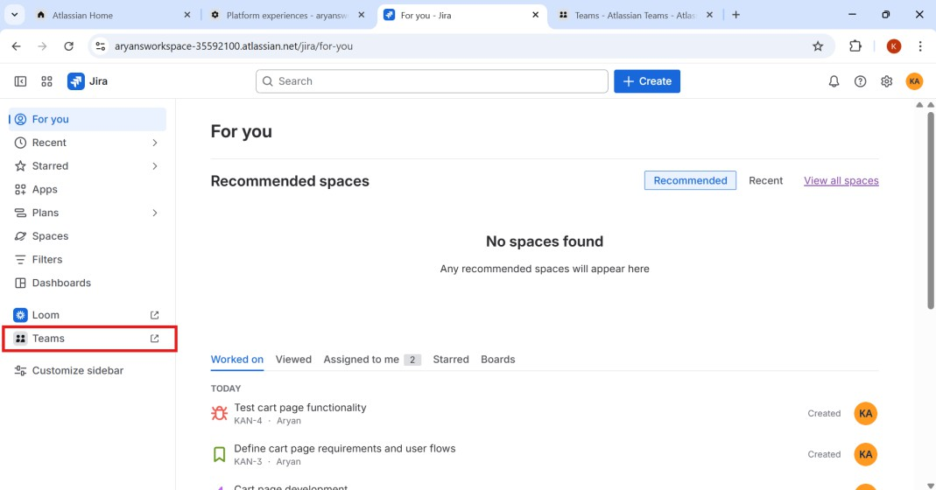
Step2: Click on Create and select Team.

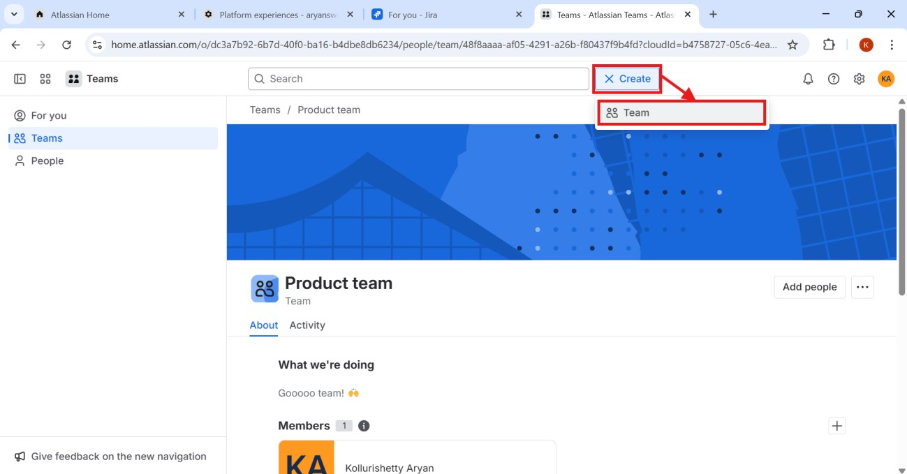

Step3: After selecting teams, enter the Team name and add members. Then click on create.
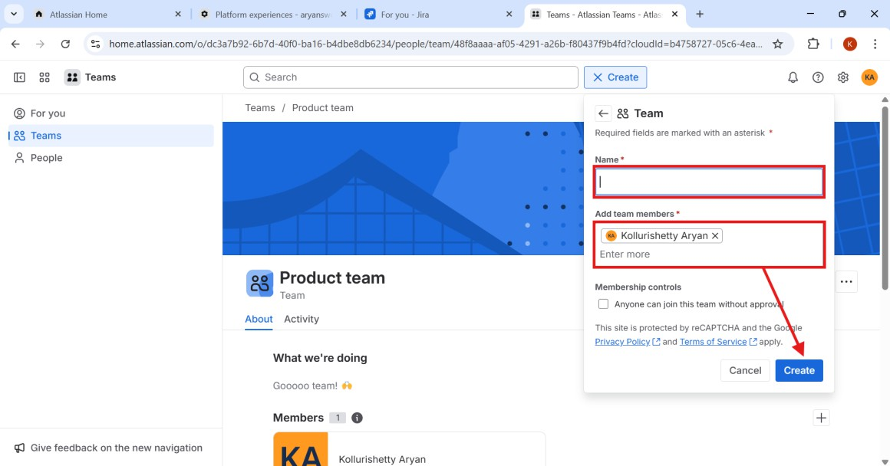
Step4: Now, get back to the home page. To create tickets, click on create.

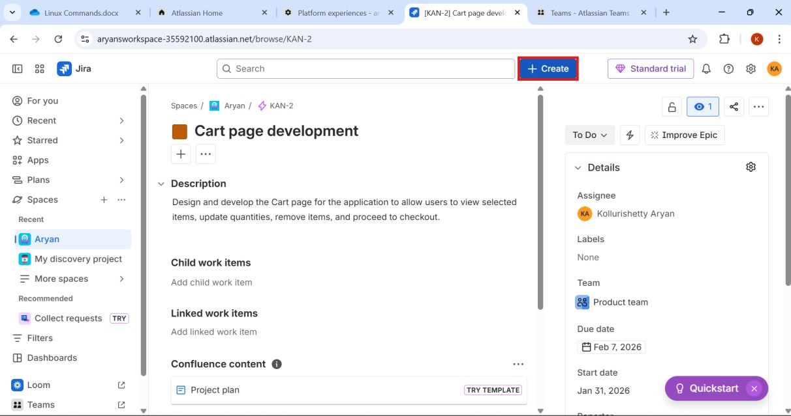
Step5: Select space to create a ticket.
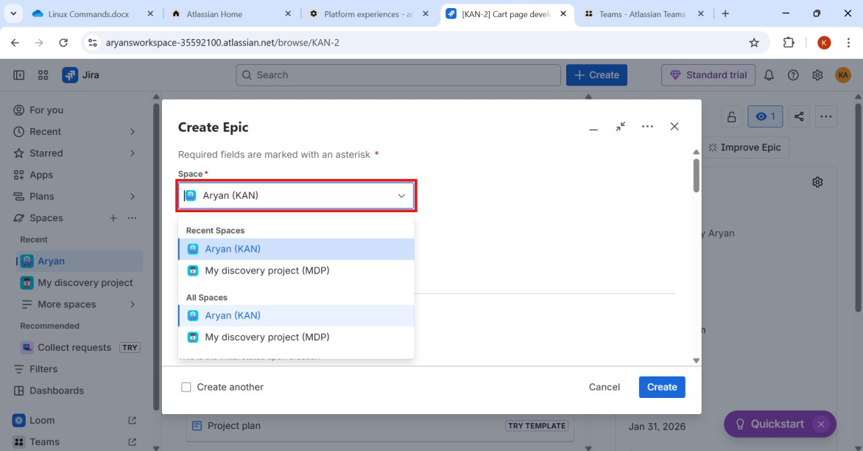
Step6: Select the work type as shown below.

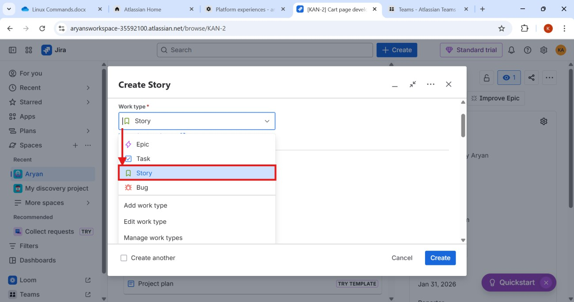

Step7: Enter the summary of the ticket.
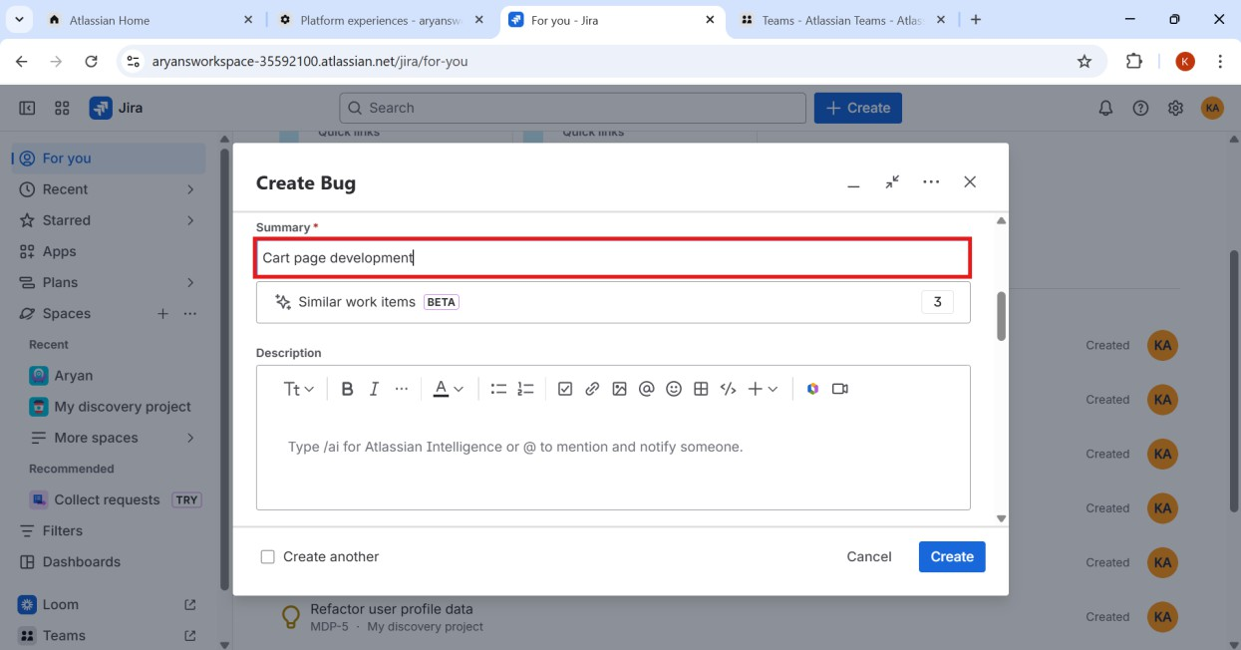
Step8: Enter the description of the ticket as shown.

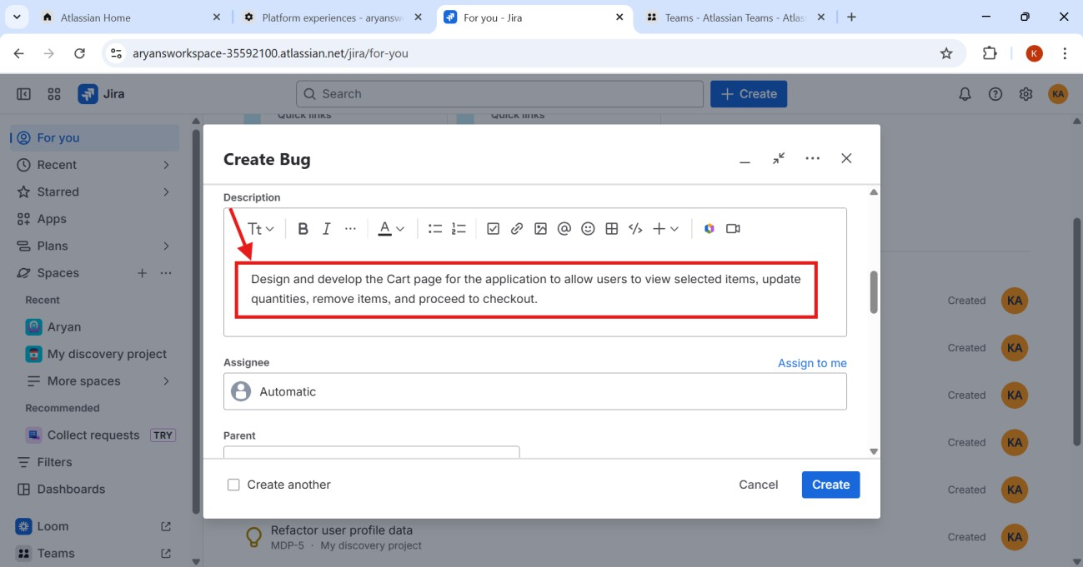

StepG: Select the due date that employees should submit.
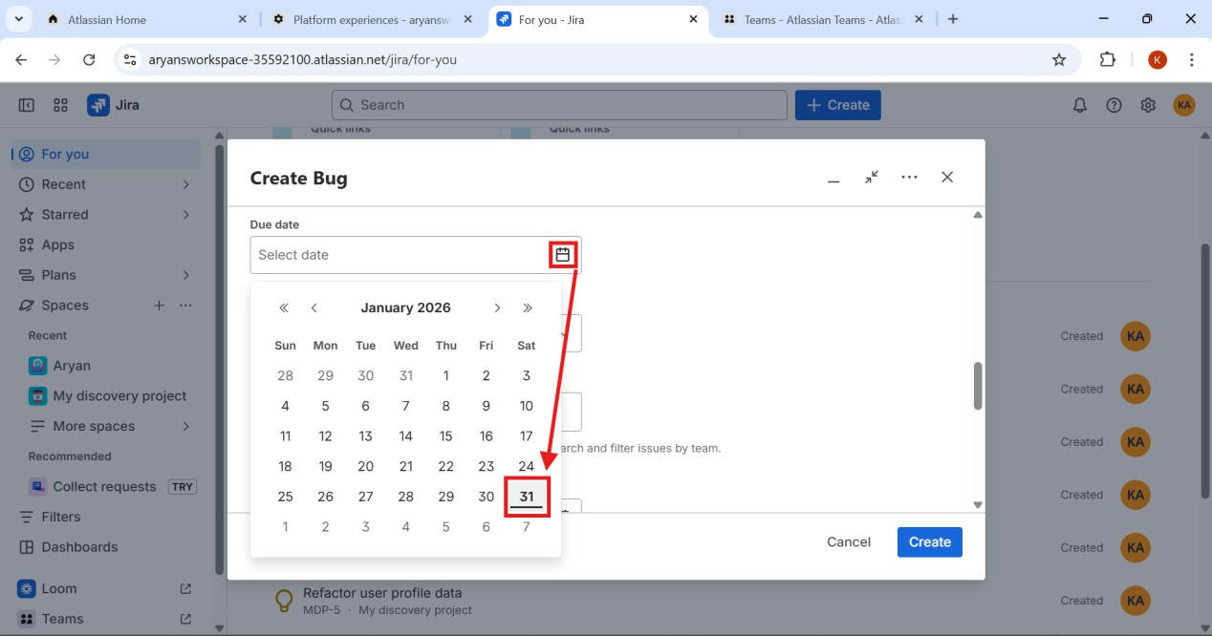
Step10: Now choose a team that work needed to be assigned.

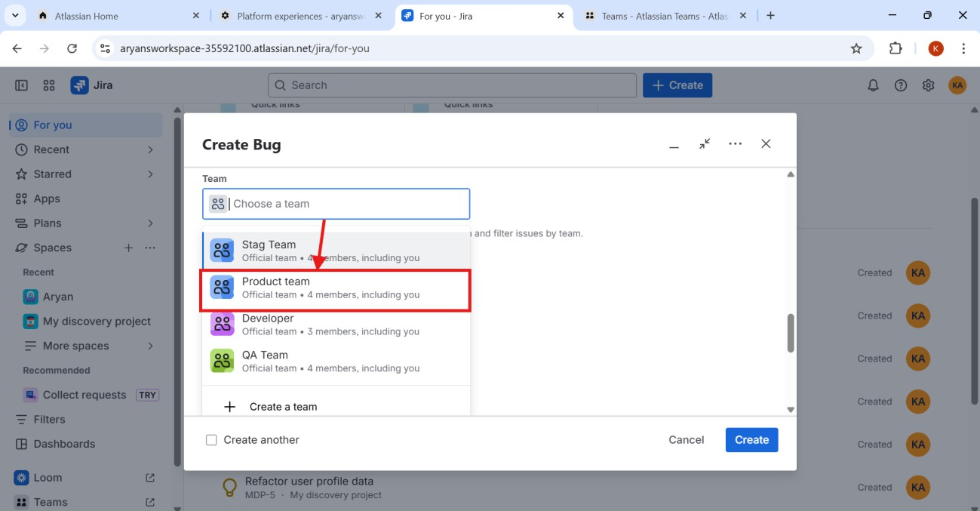

Step11: Select the start date of the work by employees.
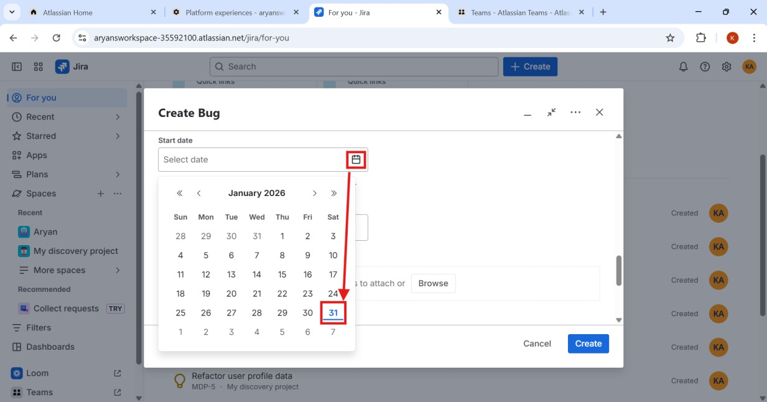
Step12: Enter the Reporter name or id, to verify the work done.

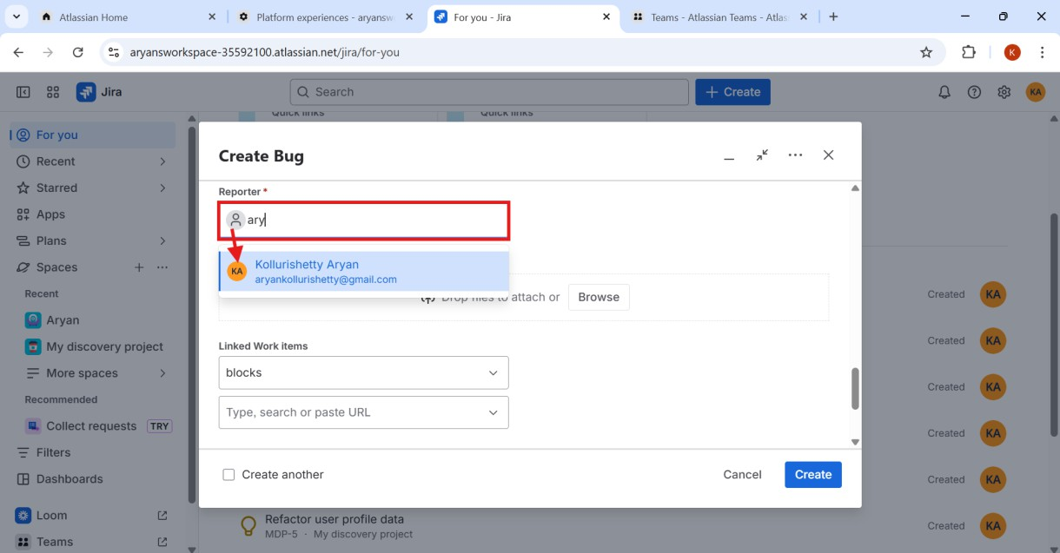
Step13: If any required files are needed to be uploaded, place them here.
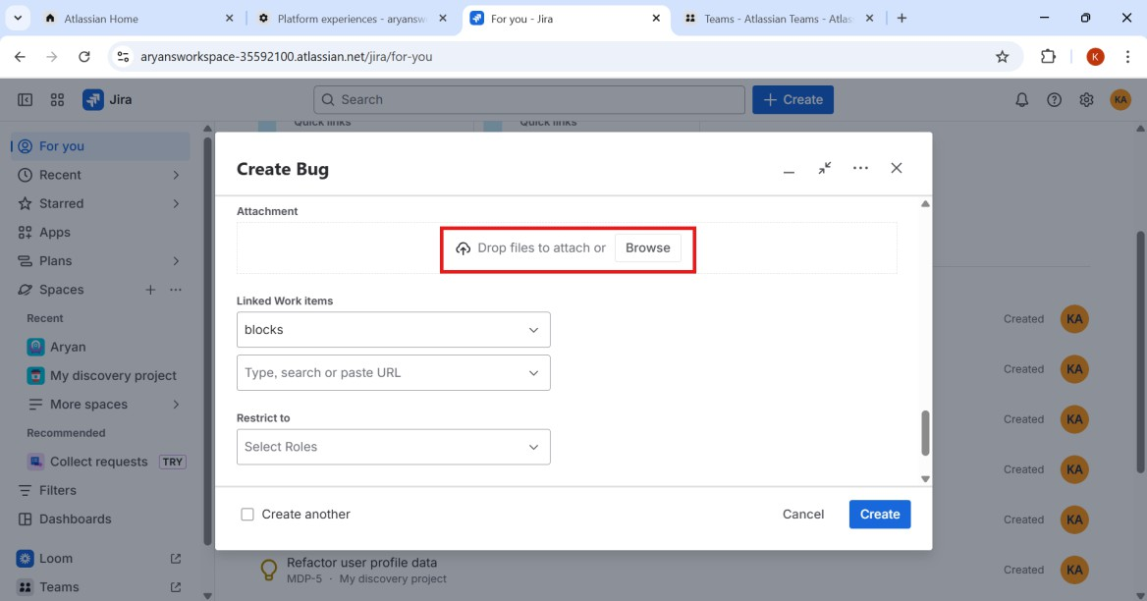
Step14: To complete the process, click on “Create”.

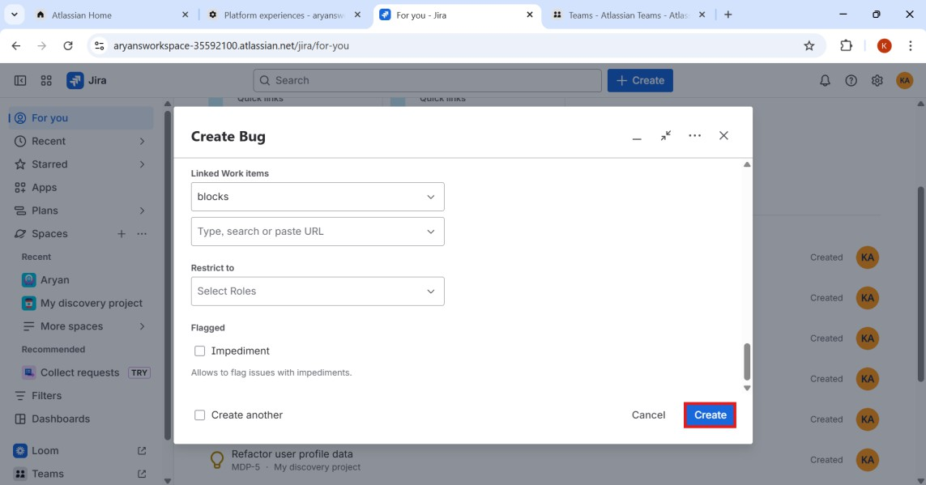
Step15: After creating the tickets, the results will be as shown.
