3) Jenkins CI/CD Pipeline Pipeline stages to implement:
1. Clean Workspace
2. Checkout Code from GitHub
3. SonarQube Analysis (Quality Gate)
4. Install Dependencies (NPM)
5. Trivy FS Scan (Optional)
6. OWASP Dependency Check (Optional)
7. Docker Build & Push to DockerHub (via Jenkins)
8. Deploy to Docker Container
9. (Optional) Deploy to Kubernetes (EKS)
10. Email Notification on build result

Step 1:Create a ec2 instance
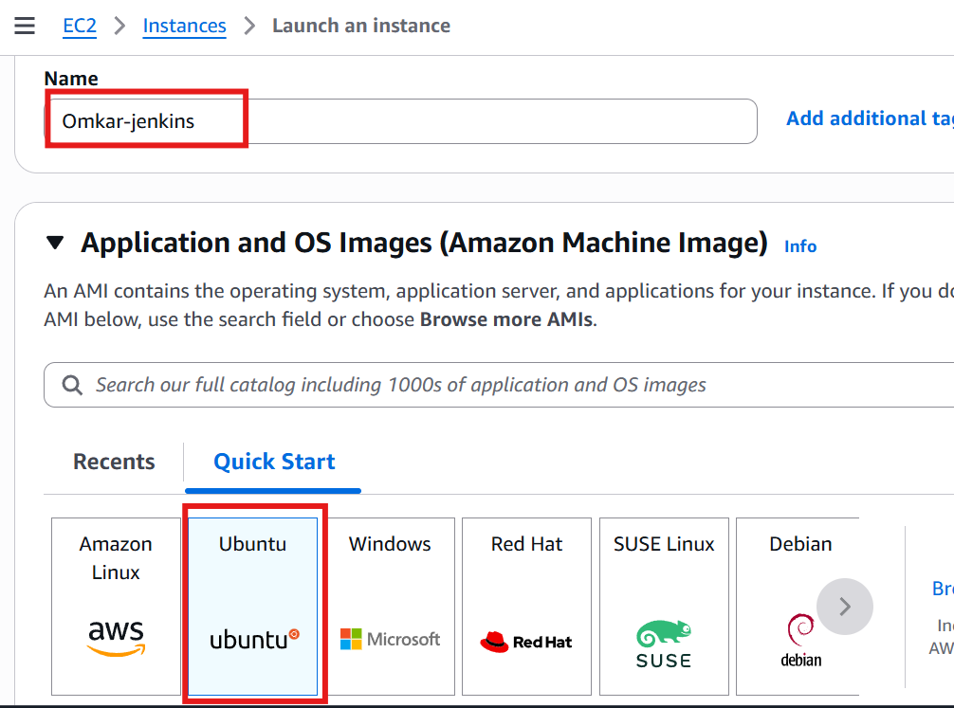
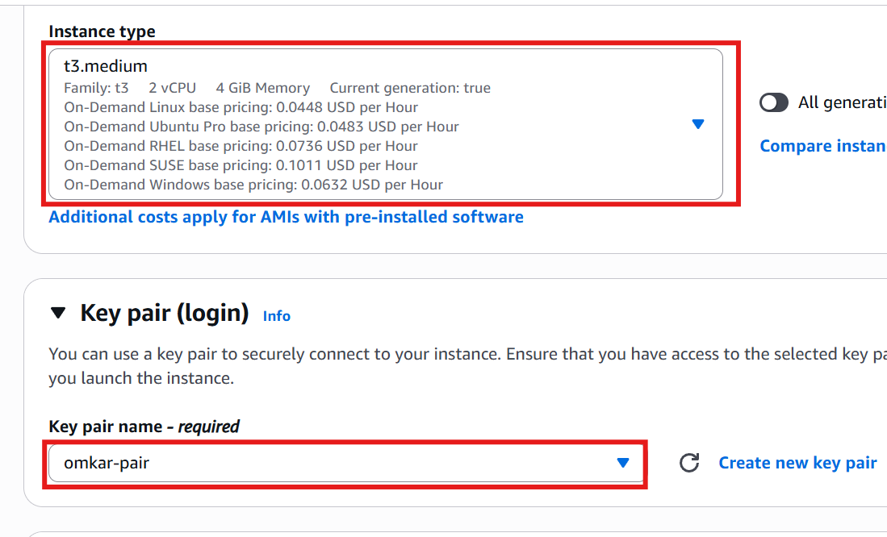
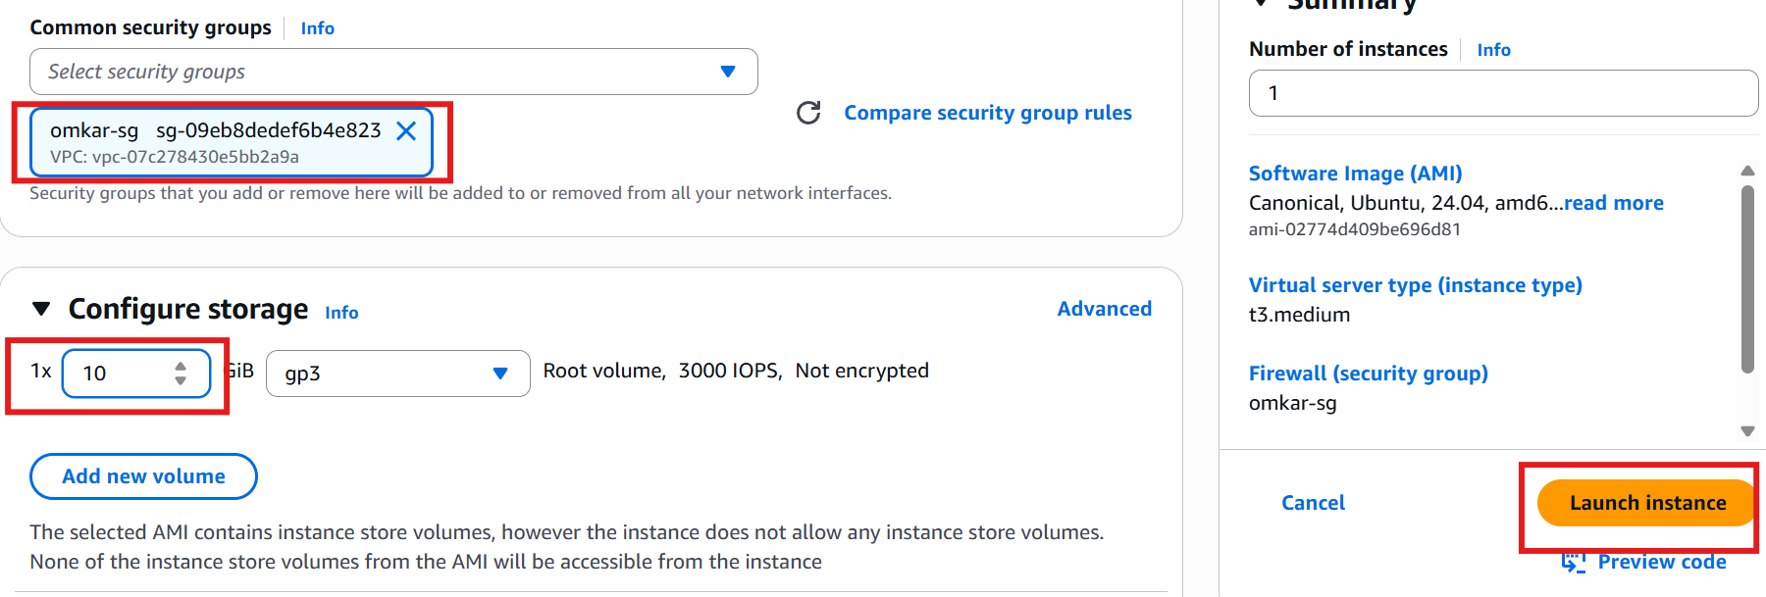

Step 2:Connect that instance with MobaXterm
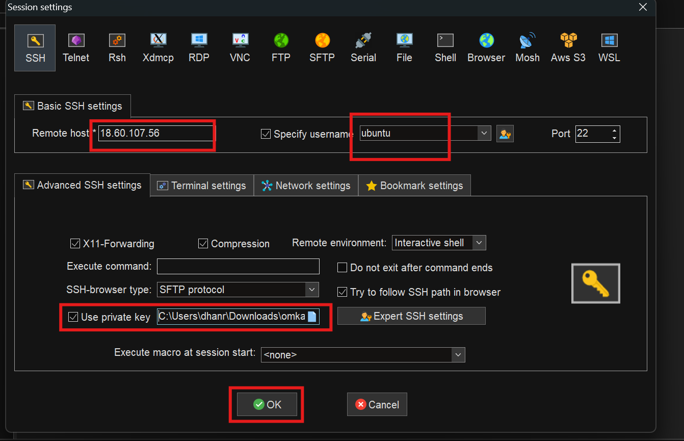

Step 3:Install java , Jenkins , docker and sonarqube
# install java

sudo apt update
sudo apt install fontconfig openjdk-21-jre
java -version

# install jenkins on ubuntu os

sudo wget -O /etc/apt/keyrings/jenkins-keyring.asc \
https://pkg.jenkins.io/debian-stable/jenkins.io-2026.key
echo "deb [signed-by=/etc/apt/keyrings/jenkins-keyring.asc]" \
https://pkg.jenkins.io/debian-stable binary/ | sudo tee \
/etc/apt/sources.list.d/jenkins.list > /dev/null
sudo apt update
sudo apt install jenkins

# start jenkins service

sudo systemctl enable jenkins

sudo systemctl start jenkins

sudo systemctl status Jenkins

apt install docker.io

docker run -d --name sonar -p 9000:9000 sonarqube:community

Step 4: Add inbound rule
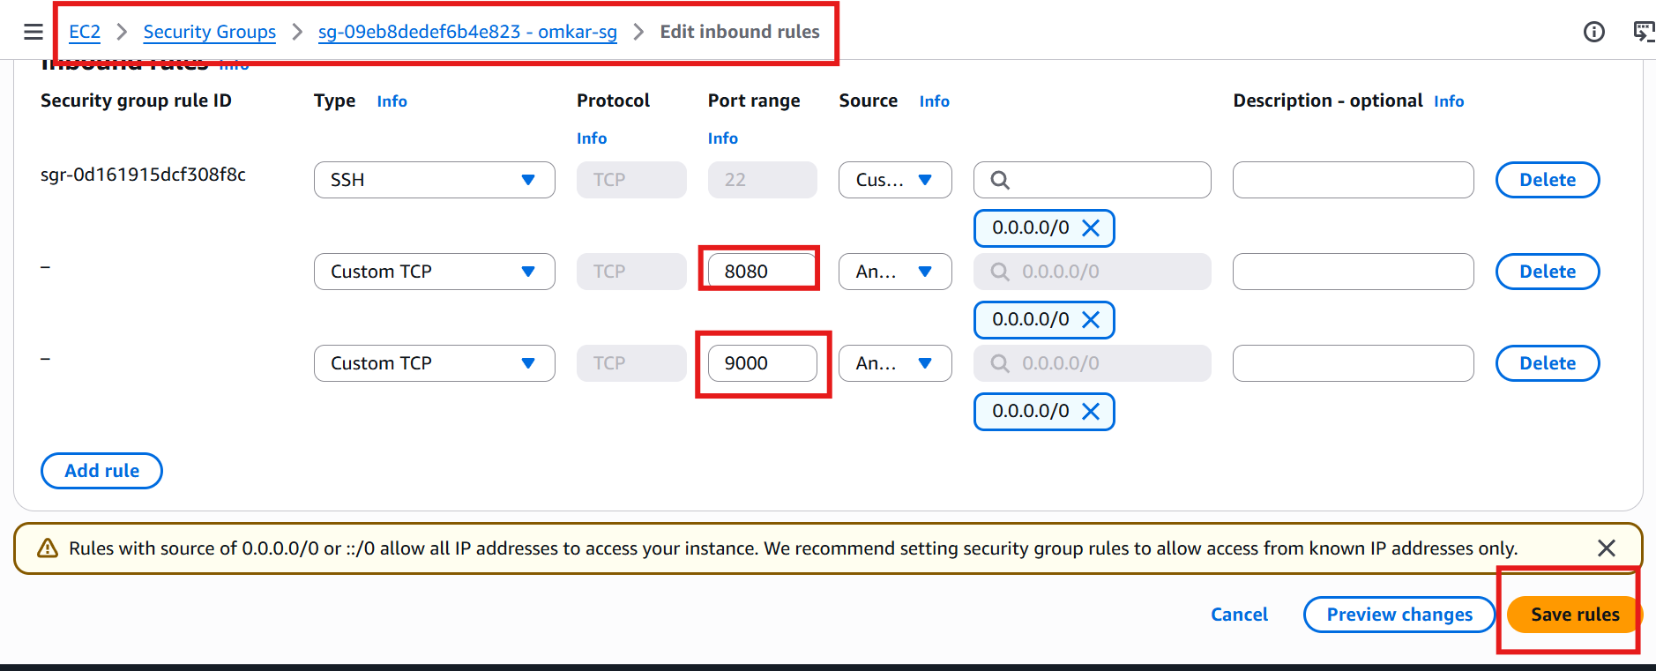

Step 5:Login to sonarQube
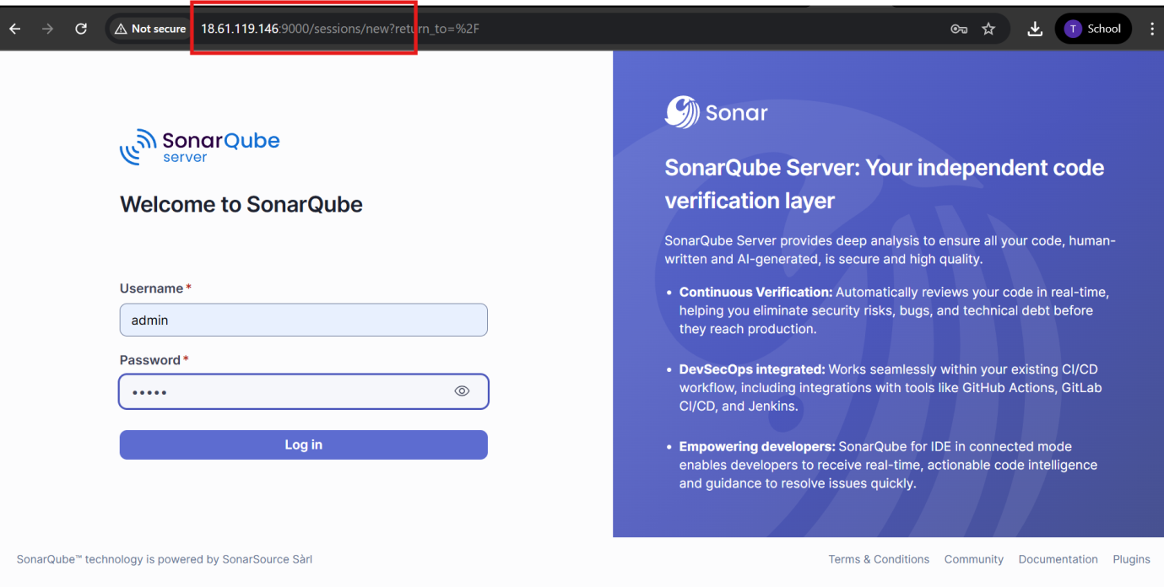

Step 6:Login to Jenkins
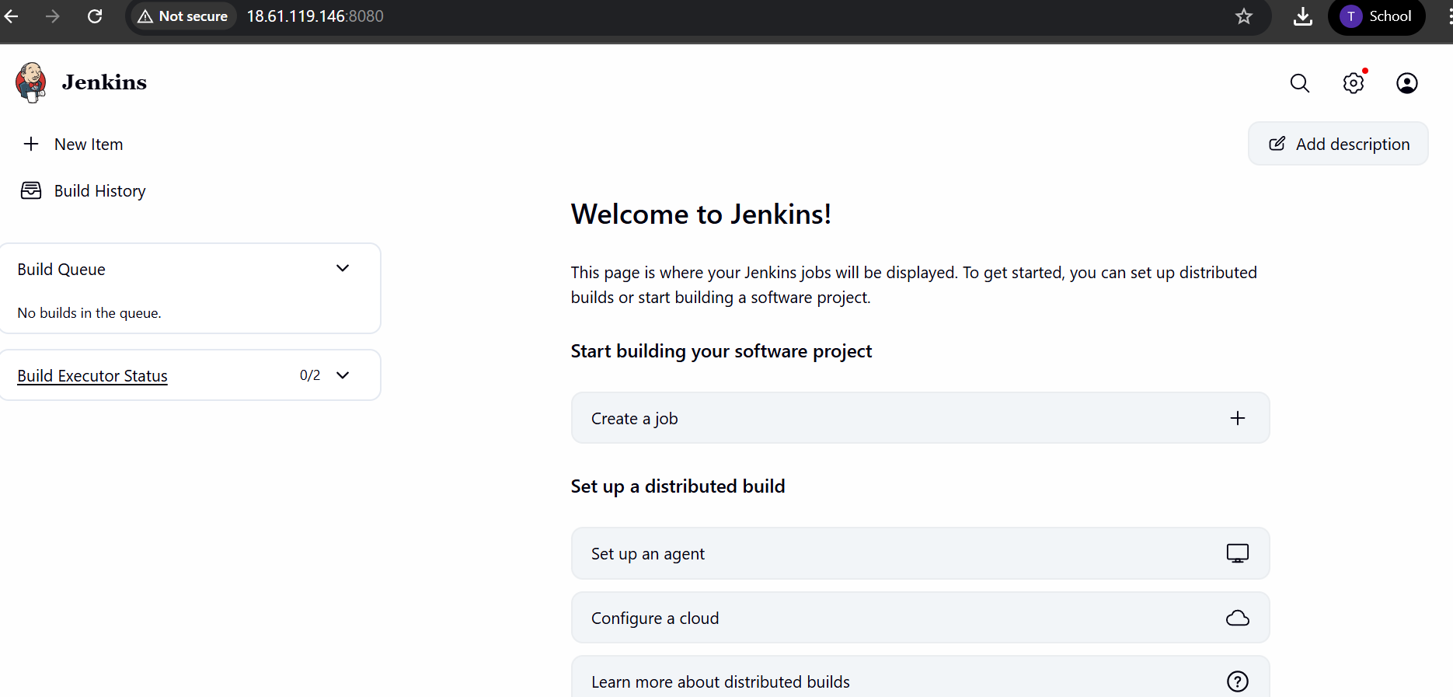

Step 7:Install Plugins:
  - Docker API Plugin.
  - Docker Commons Plugin.
  - Docker Pipeline.
  - Docker plugin.
  - docker-build-step.
  - Maven Integration plugin.
  - Github Integration
  - SonarQube Scanner for Jenkins.
  - Email Extension Template Plugin.
  - Eclipse Temurin Installer
  - Nodejs
  - Pipeline Stage View Plugin.

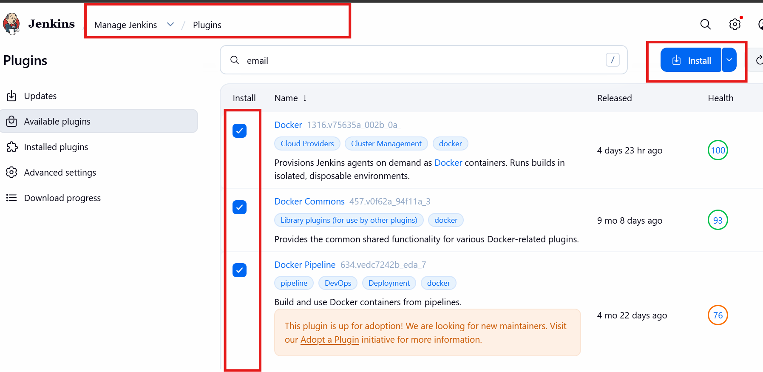

Step 8: Create a local project on sonarqube
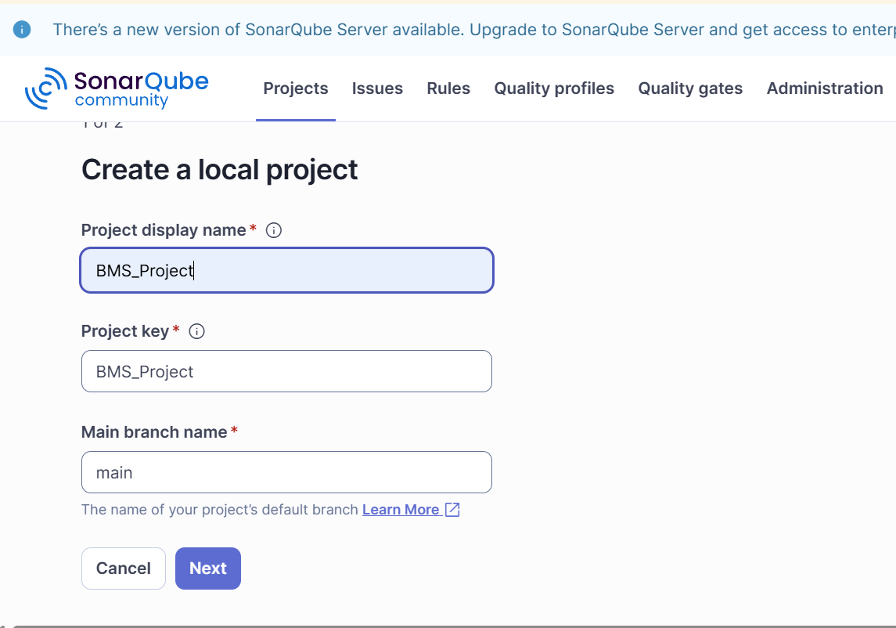

Step 9:Generate token id for sonarqube project
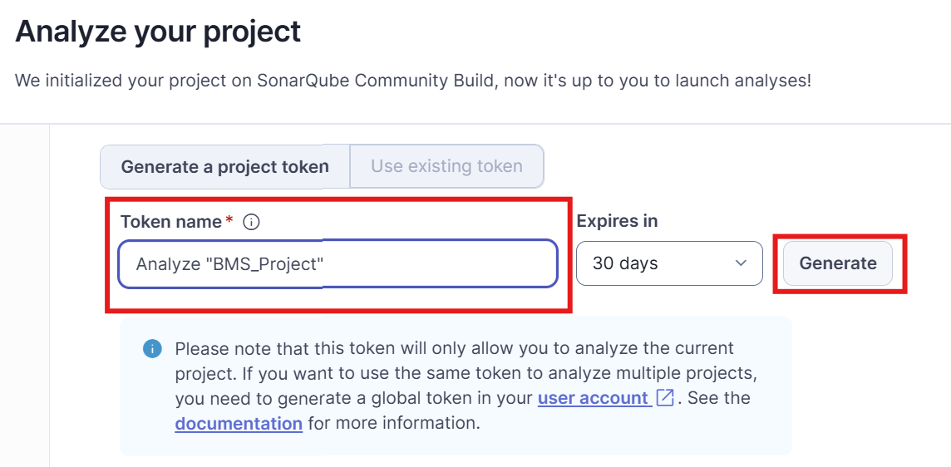
Step 10 :Go to manage jenkins->credential->global credential->add secret text
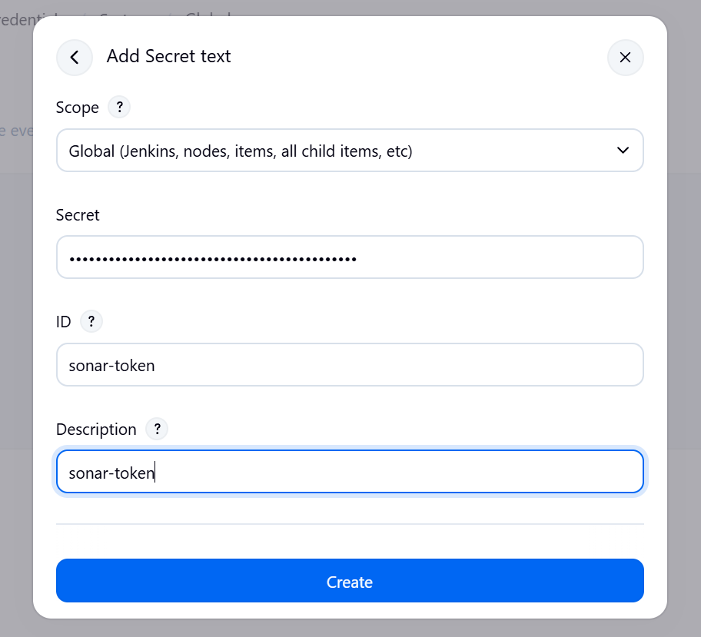
Step 11: Create docker credential select username and password
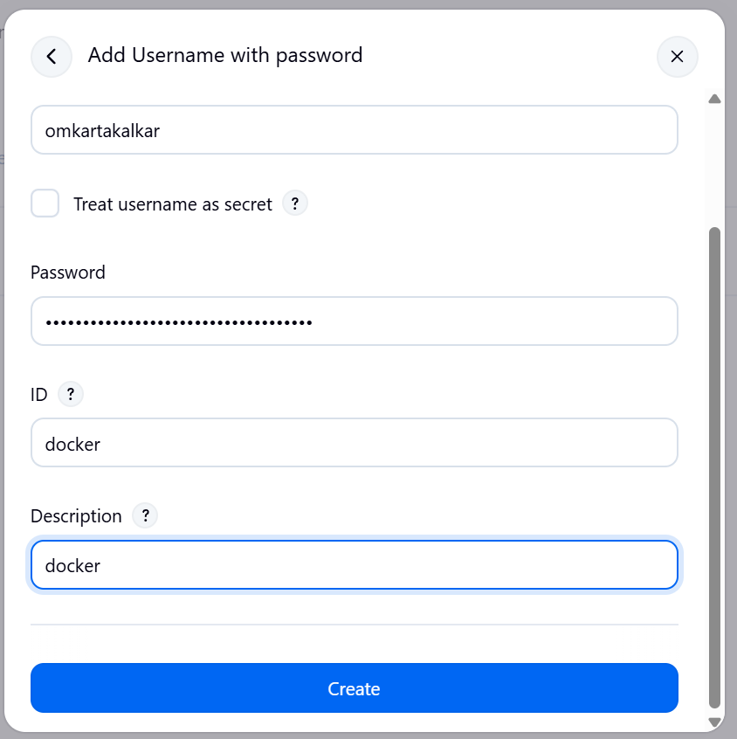

Step 12: Add email and password in manage Jenkins->system to test the email notification and test configuration
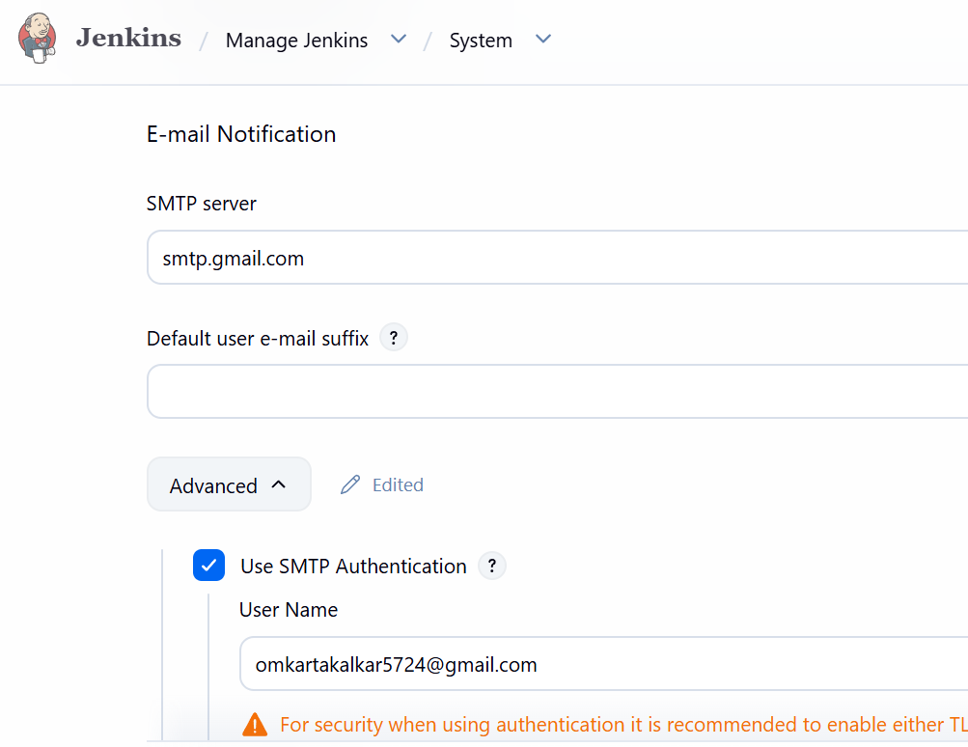

Step 13: Create email credential select username and password
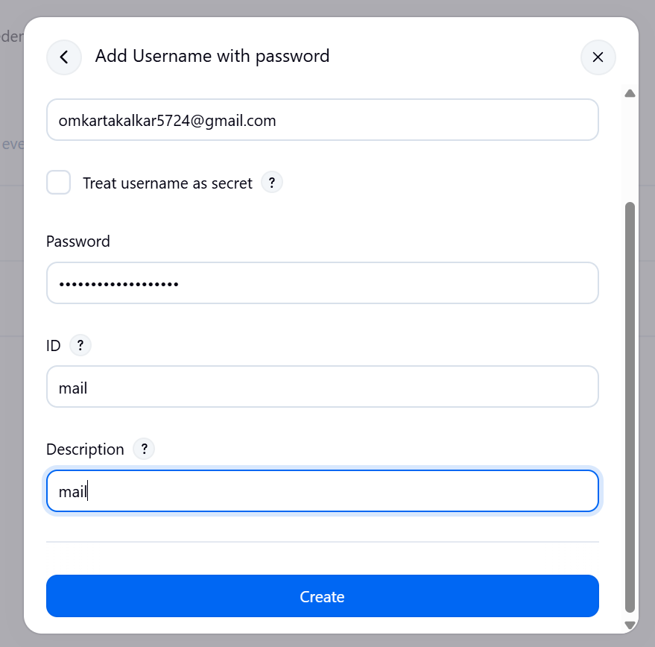
Step 14:install tools java ,sonarqube, nodejs and docker
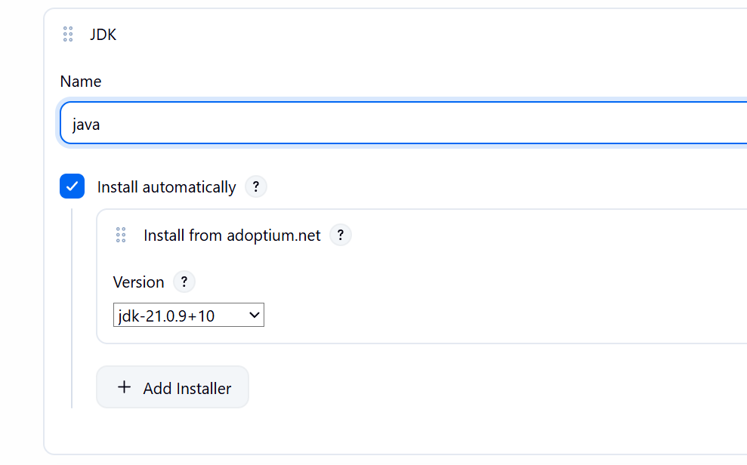
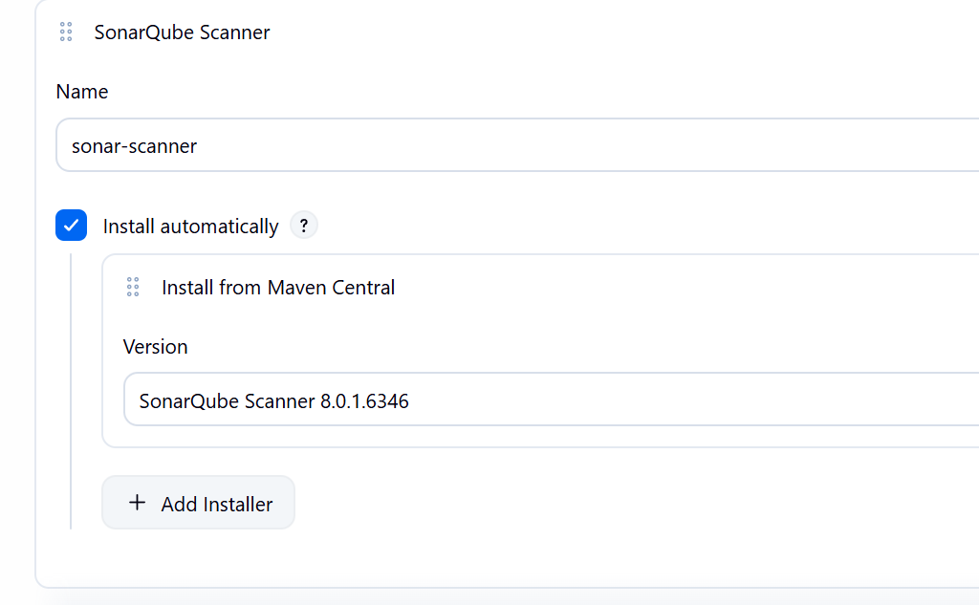

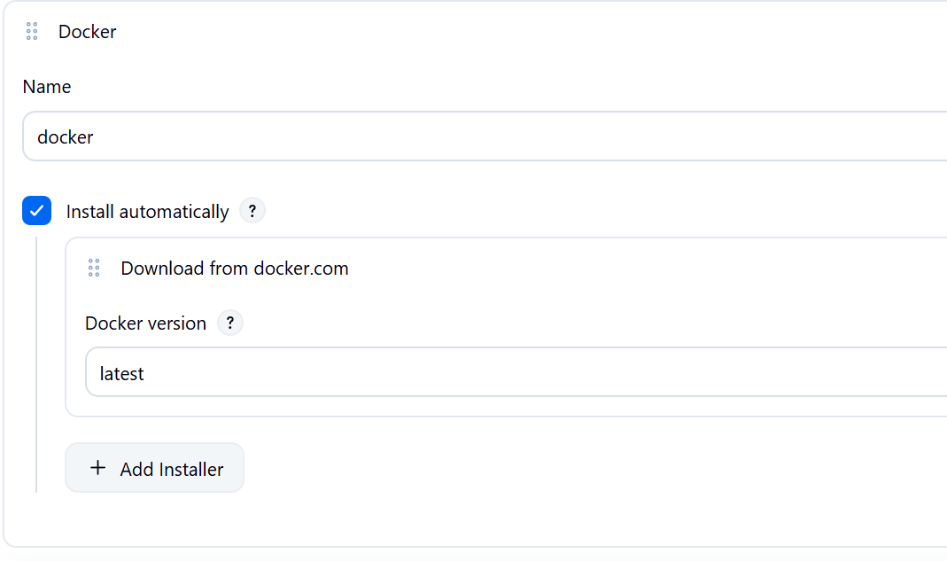
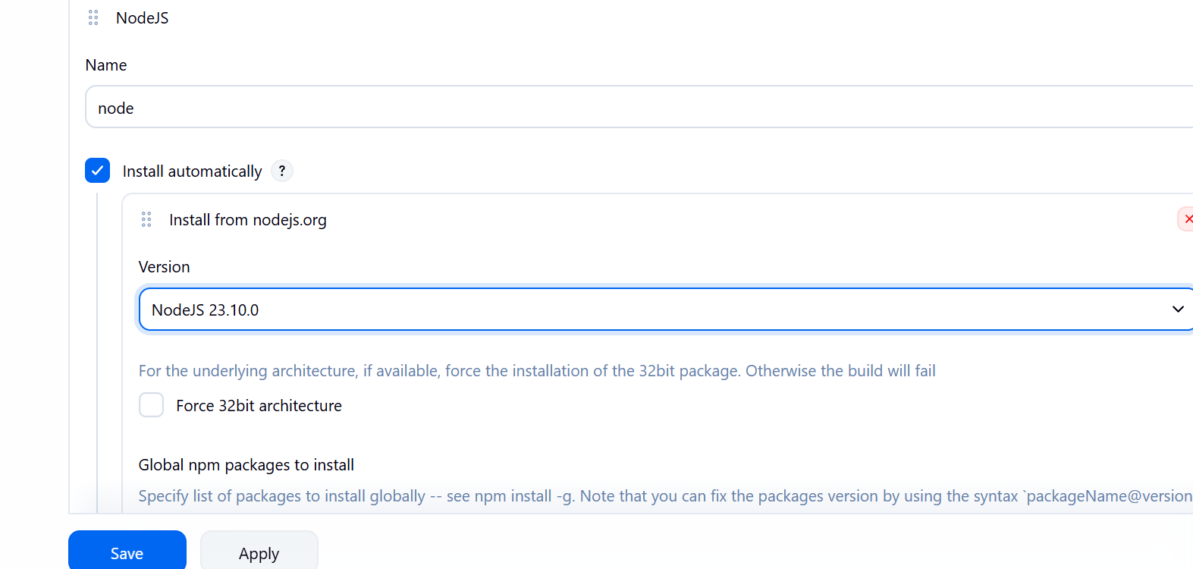
Step 15:Add sonar server in system
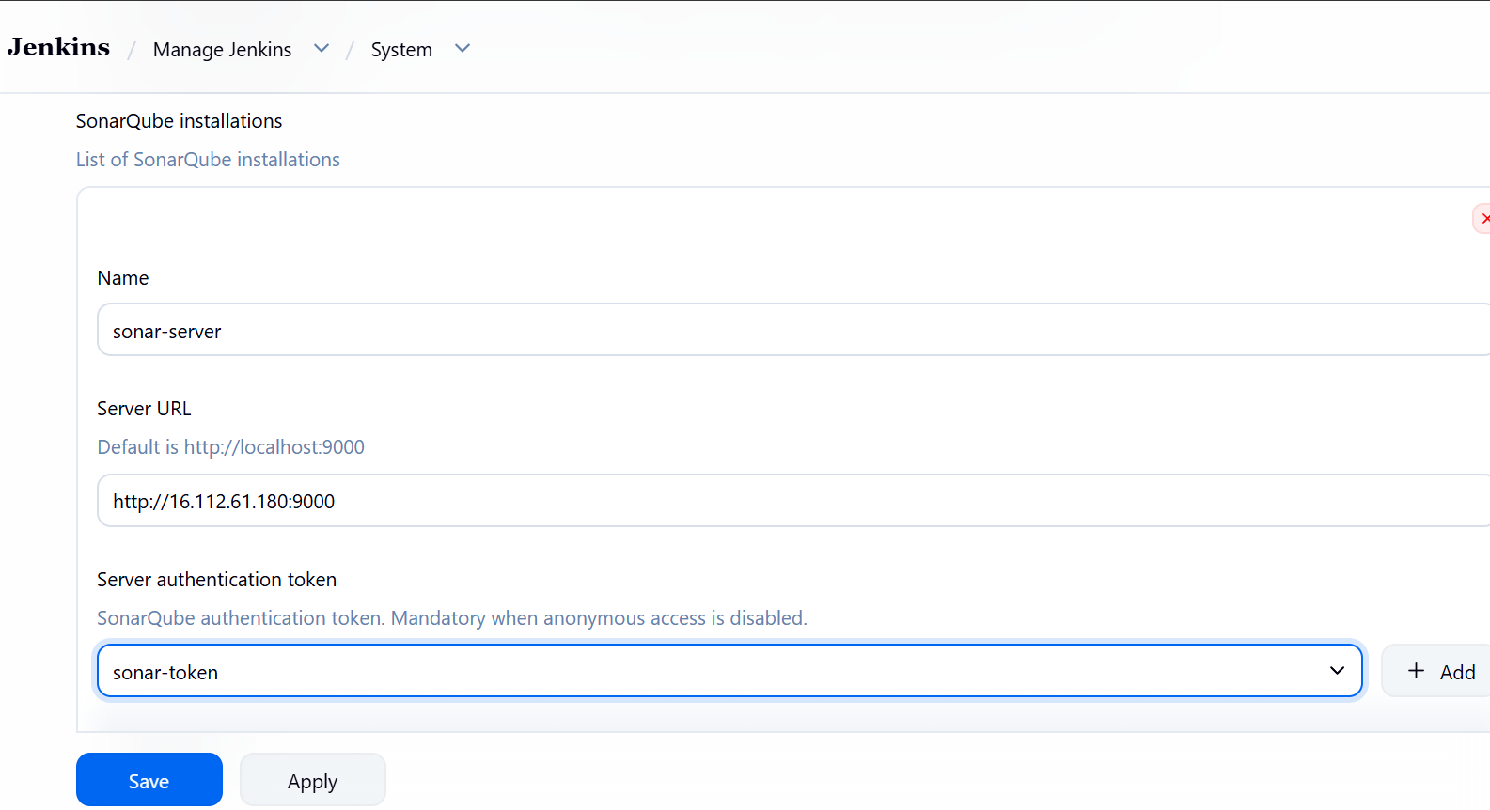

Step 16: Start creating pipeline-bms_pipes
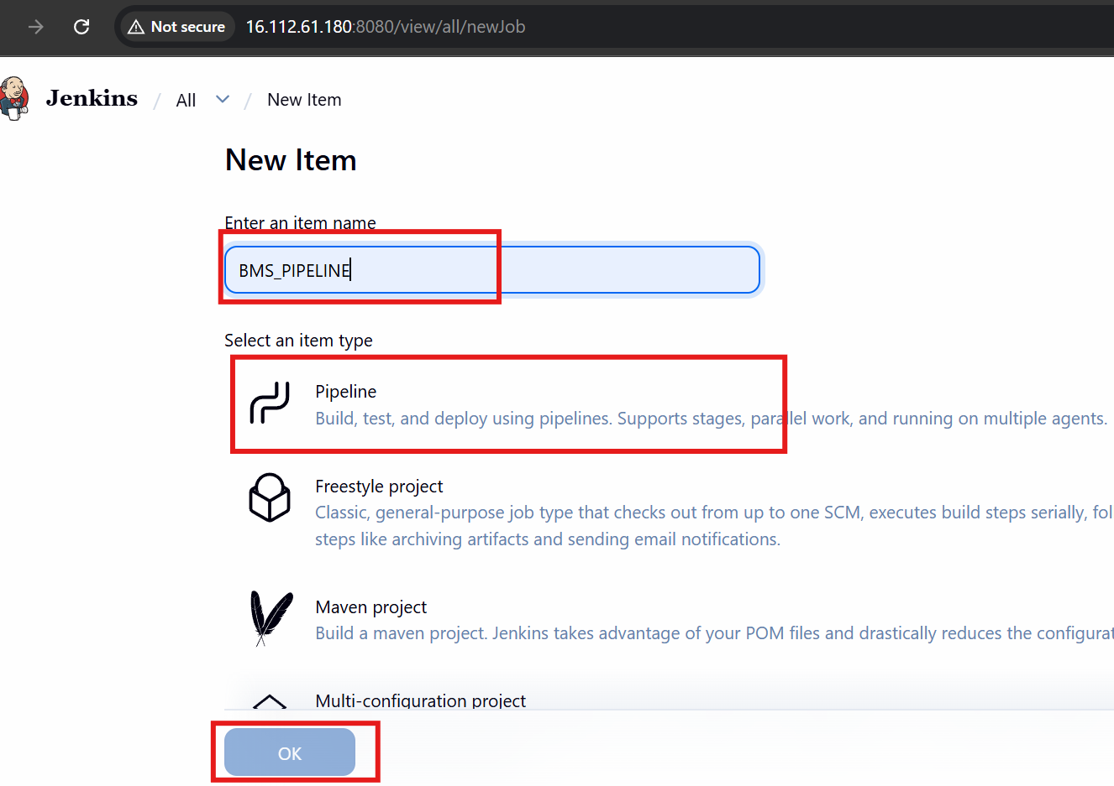
Step 17:Add webhook in sonarQube
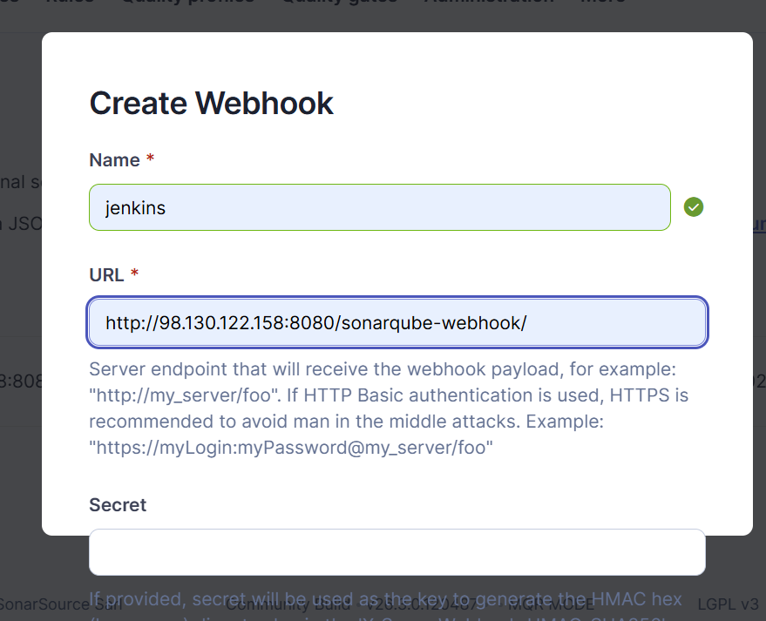
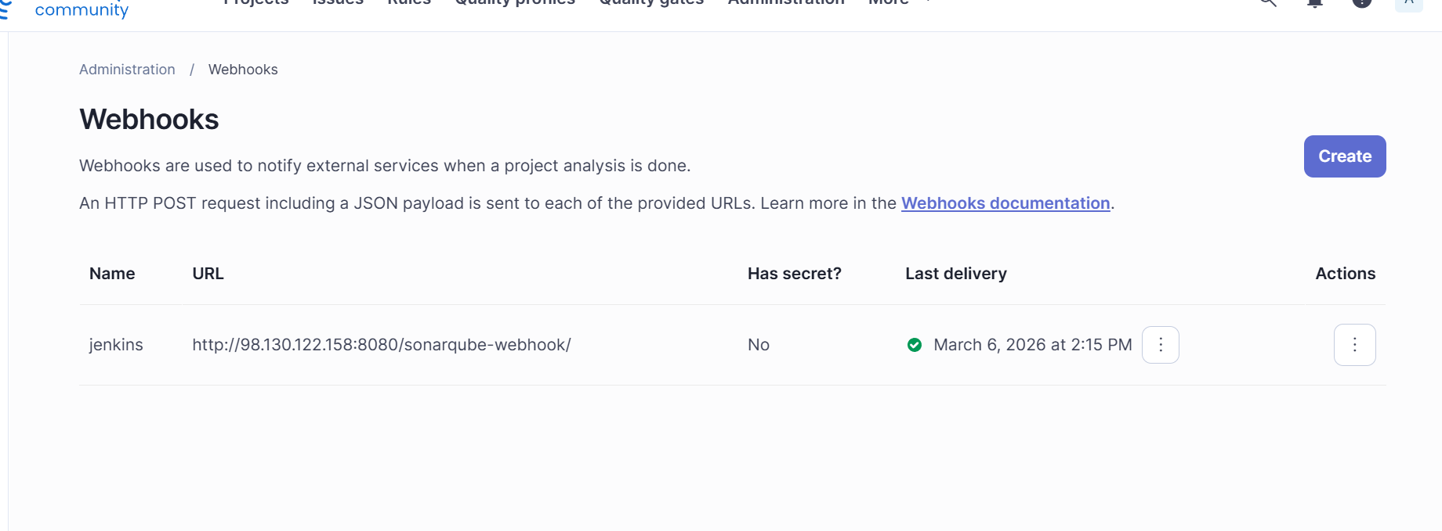

Step 18: write the pipeline script
pipeline {
agent any

tools {
jdk 'java'
nodejs 'node'
}

environment {
SCANNER_HOME = tool 'sonar-scanner'
}

stages {

stage('Clean Workspace') {
steps {
cleanWs()
}
}

stage('Checkout Code') {
steps {
git branch: 'main', url: 'https://github.com/omkartakalkar19/Book-My-Show.git'
sh 'ls -la'
}
}

stage('SonarQube Analysis') {
steps {
withSonarQubeEnv('sonar-server') {
withCredentials([string(credentialsId: 'sonar-token', variable: 'SONAR_TOKEN')]) {
sh '''
cd bookmyshow-app
$SCANNER_HOME/bin/sonar-scanner \
-Dsonar.projectKey=BMS_Project \
-Dsonar.projectName=BMS_Project \
-Dsonar.sources=. \
-Dsonar.host.url=http://98.130.122.158:9000 \
-Dsonar.token=$SONAR_TOKEN
'''
}
}
}
}

stage('Quality Gate') {
steps {
script {
waitForQualityGate abortPipeline: false
}
}
}

stage('Install Node Dependencies') {
steps {
sh '''
cd bookmyshow-app
npm install
'''
}
}

stage('Docker Build & Push') {
steps {
withCredentials([usernamePassword(credentialsId: 'docker', usernameVariable: 'DOCKER_USER', passwordVariable: 'DOCKER_PASS')]) {
sh '''
echo $DOCKER_PASS | docker login -u $DOCKER_USER --password-stdin

docker build -t omkartakalkar/bms:latest bookmyshow-app

docker push omkartakalkar/bms:latest

docker logout
'''
}
}
}

stage('Deploy Container') {
steps {
sh '''
docker stop bms || true
docker rm bms || true

docker run -d --name bms -p 3000:3000 omkartakalkar/bms:latest
'''
}
}
}

post {

success {
emailext (
subject: "SUCCESS: Pipeline Completed",
body: "Build completed successfully.",
to: 'omkartakalkar5724@gmail.com'
)
}

failure {
emailext (
subject: "FAILED: Pipeline",
body: "Build failed. Please check Jenkins.",
to: 'omkartakalkar5724@gmail.com'
)
}

}
}

Step 19: Run pipeline and build it
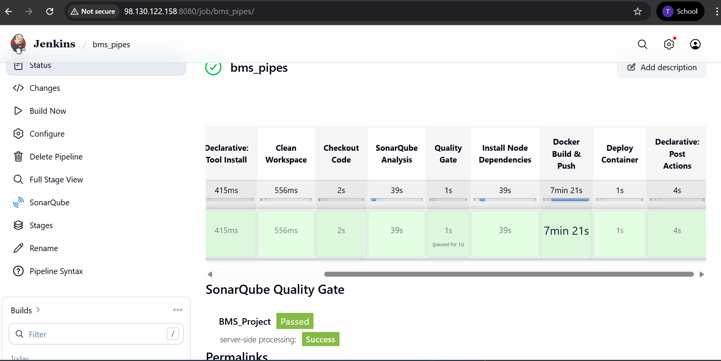

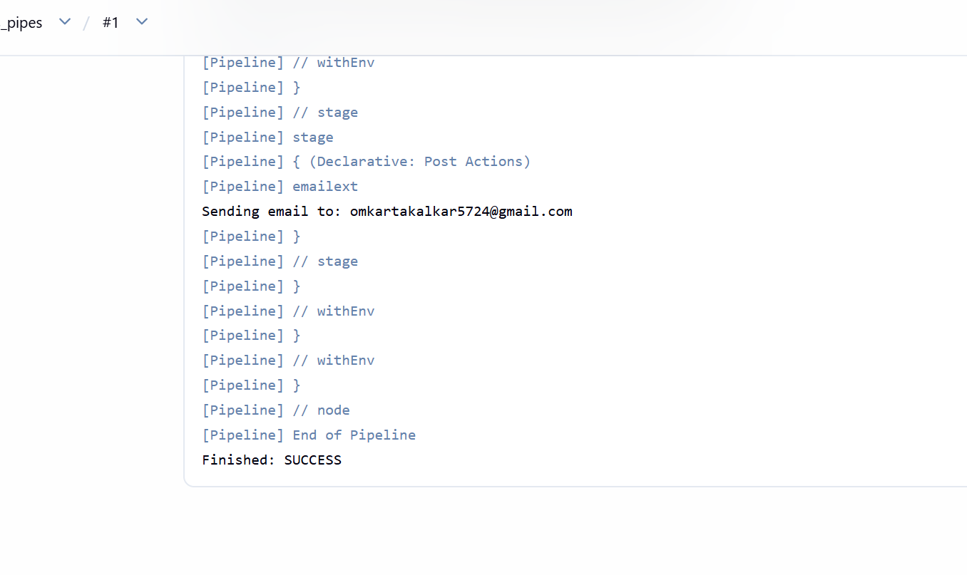
Step 20 : Check it on sonarQube
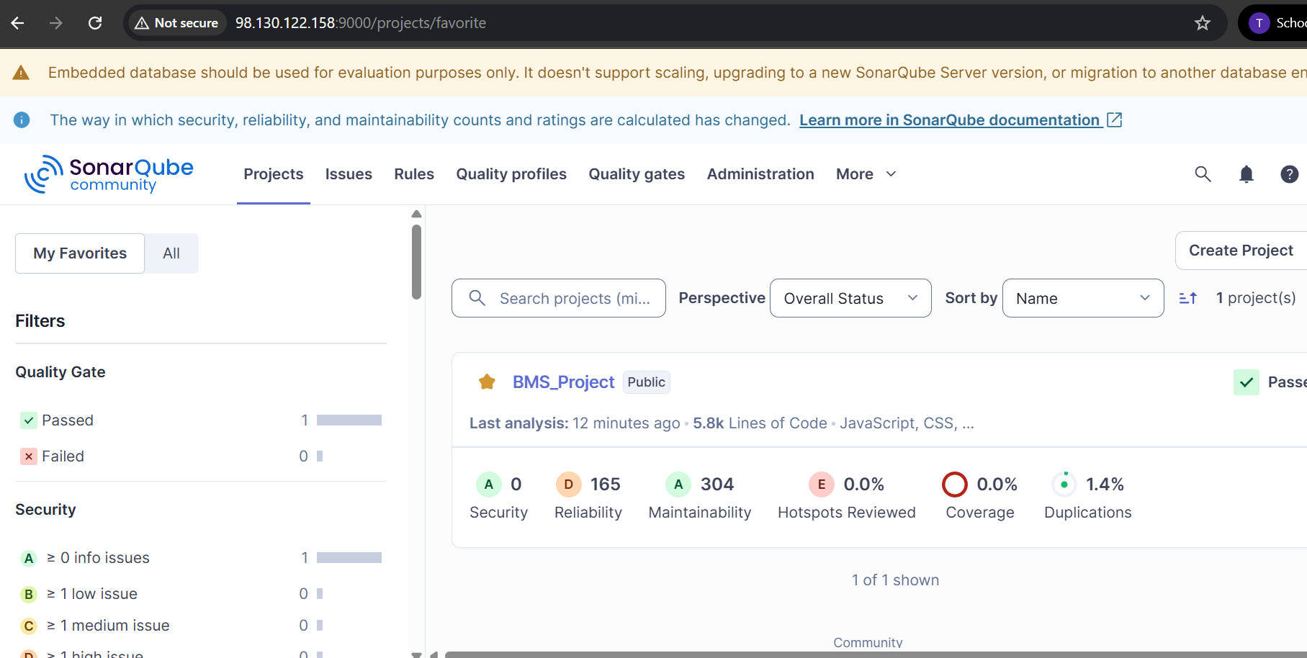

Step 21: Check is docker image generated or not
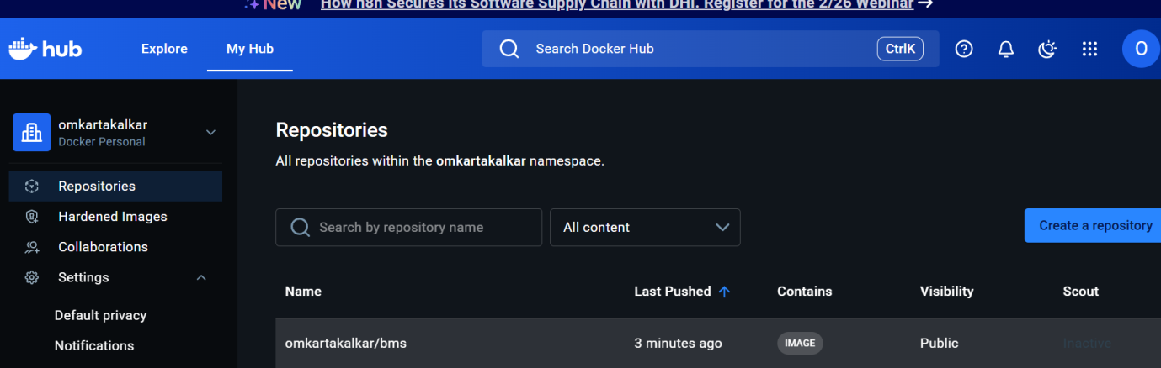

Step 21: Add inbound rule 3000
