Omkar_Geetaram_Takalkar -
Capstone_project : Book-My-Show DevOps Lifecycle

1)Jira Workflow
• Each candidate must assign themselves tasks in Jira.
• Track task progress using Jira board (To Do → In Progress → Done).
• Export the board as part of the final submission.

Step 1 :Creating Space for the BMS_Project
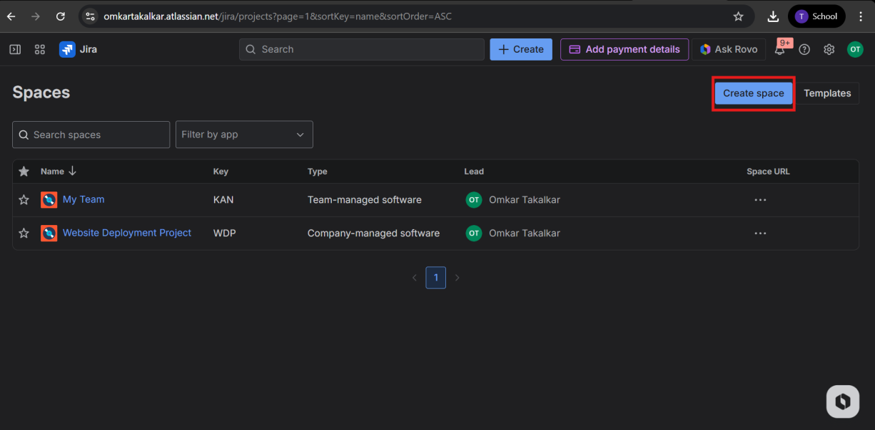
Step 2:Selecting Project space Template
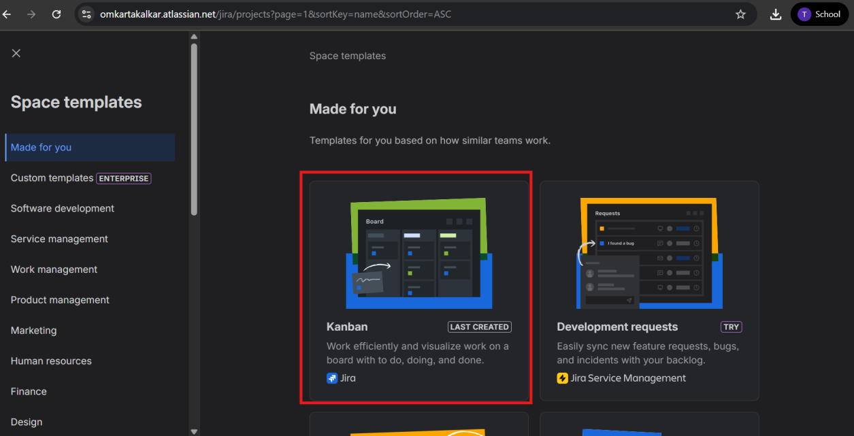
Step 3: Giving name for the project space
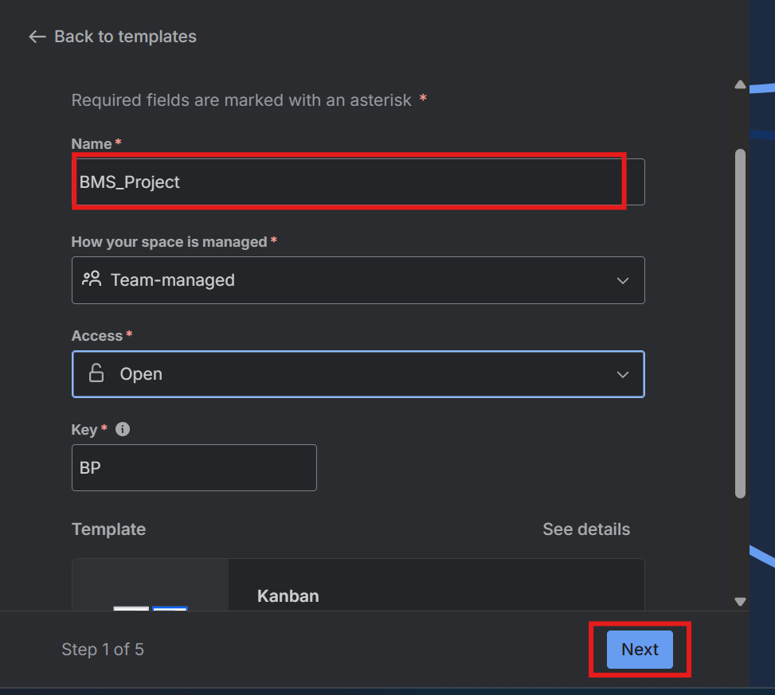

Step 4:Selecting worktypes for project space
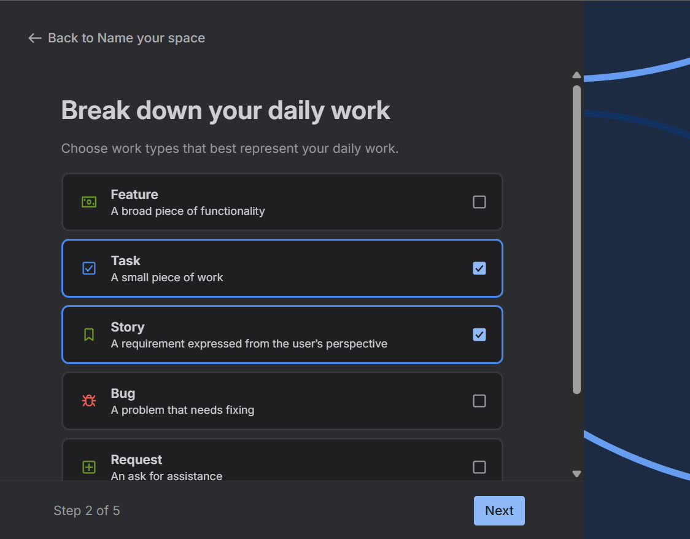

Step 5:Selecting progress status we needed and cretating space
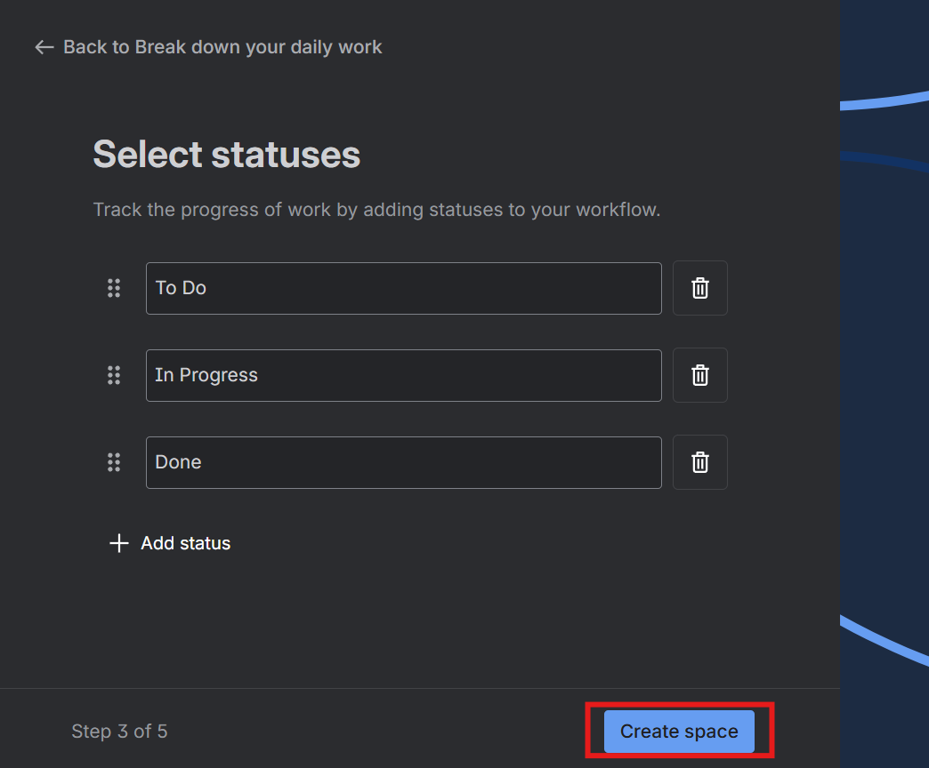
Step 6: Creating tasks and assigning it to self and giving duedate
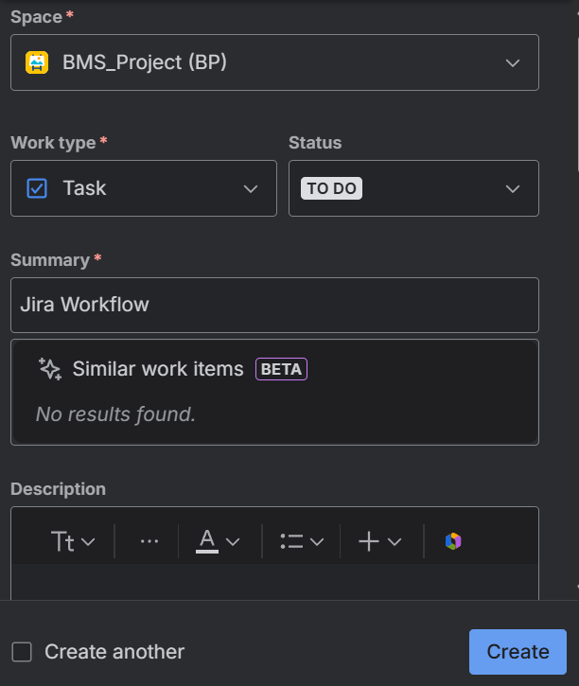
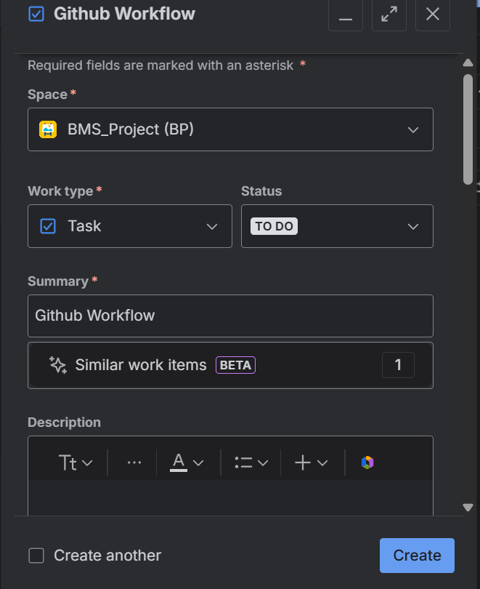

Similarly, we create all task
1.Jira Workflow
2.Github Workflow
3. Jenkins CI/CD Pipeline
4. Docker Deployment
5. Kubernetes Deployment (EKS)
6. Monitoring & Observability

Step 7:This is list of all task
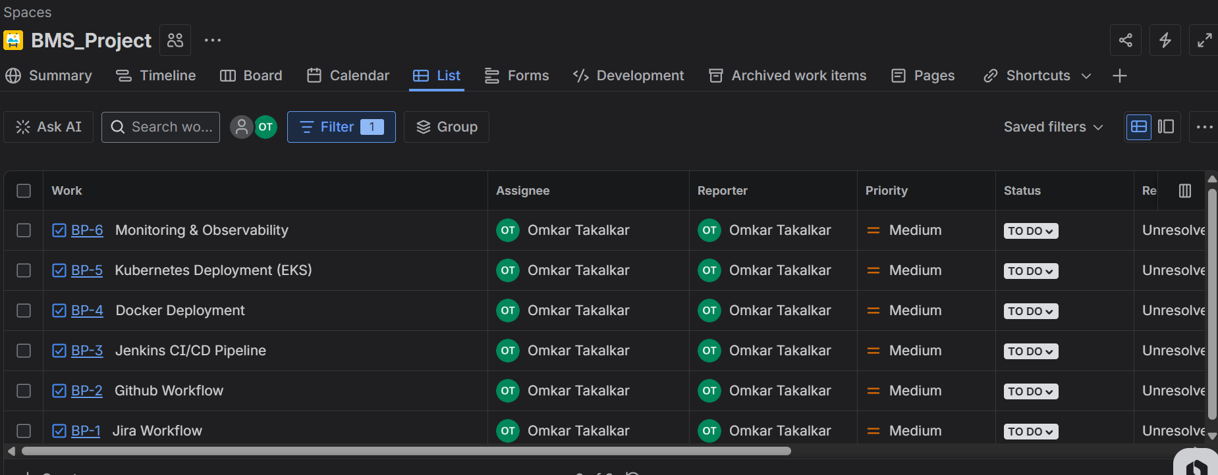

Step 8:Jira workflow is in progress and other task is yet to start
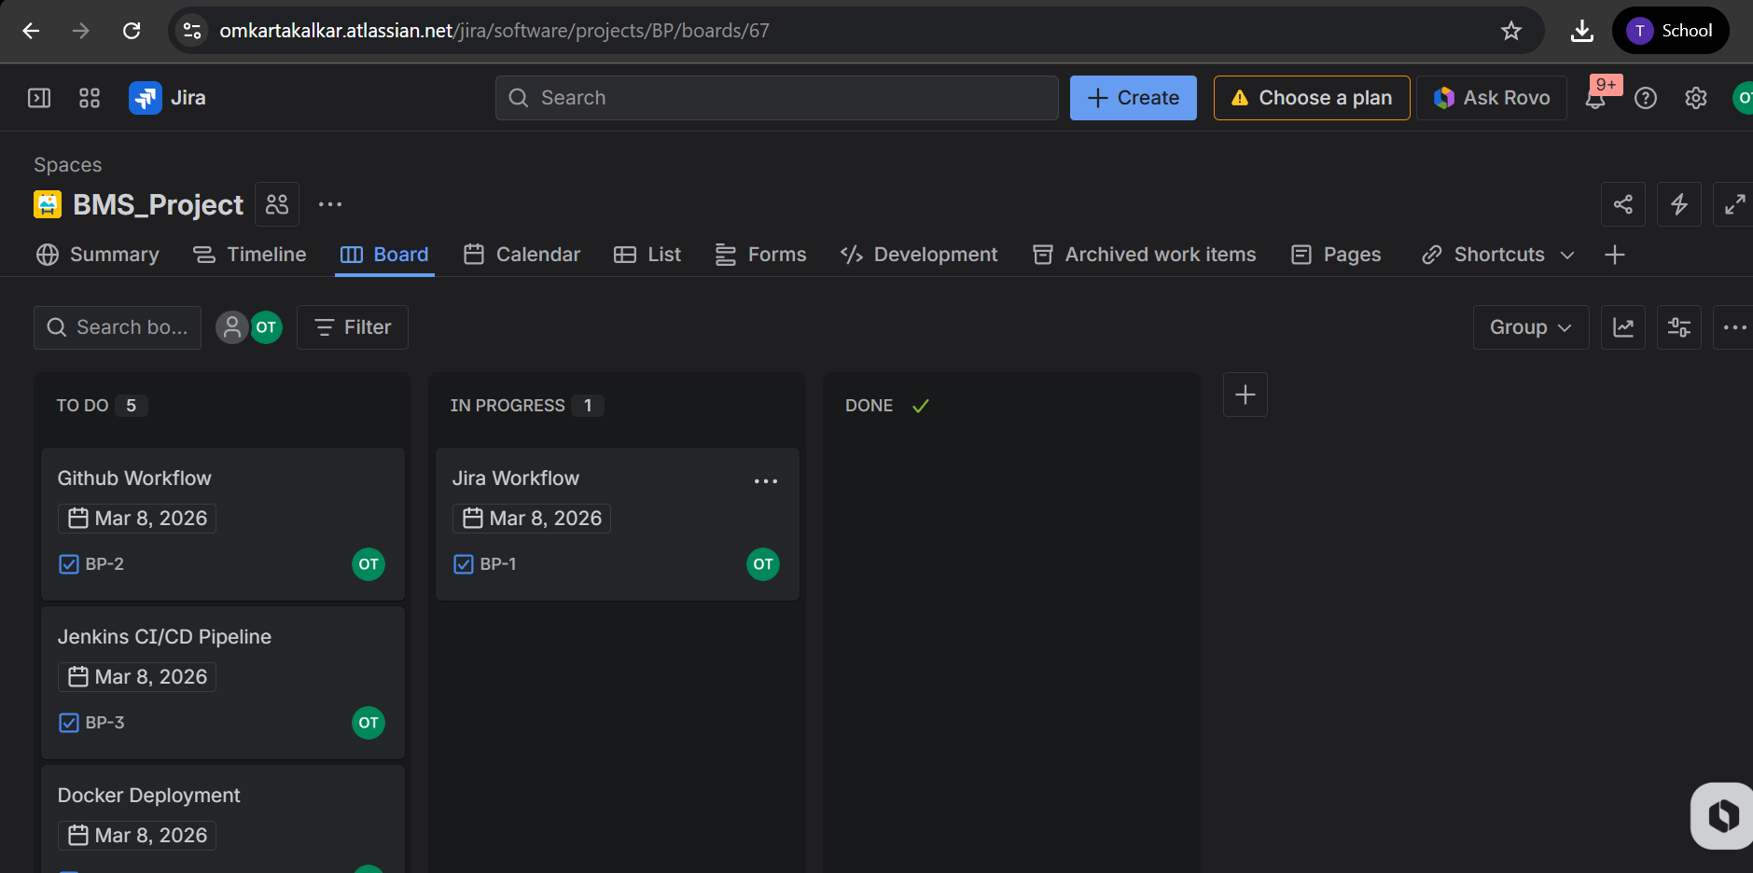

Step 9:Github workflow and jira workflow is in progress other till to do
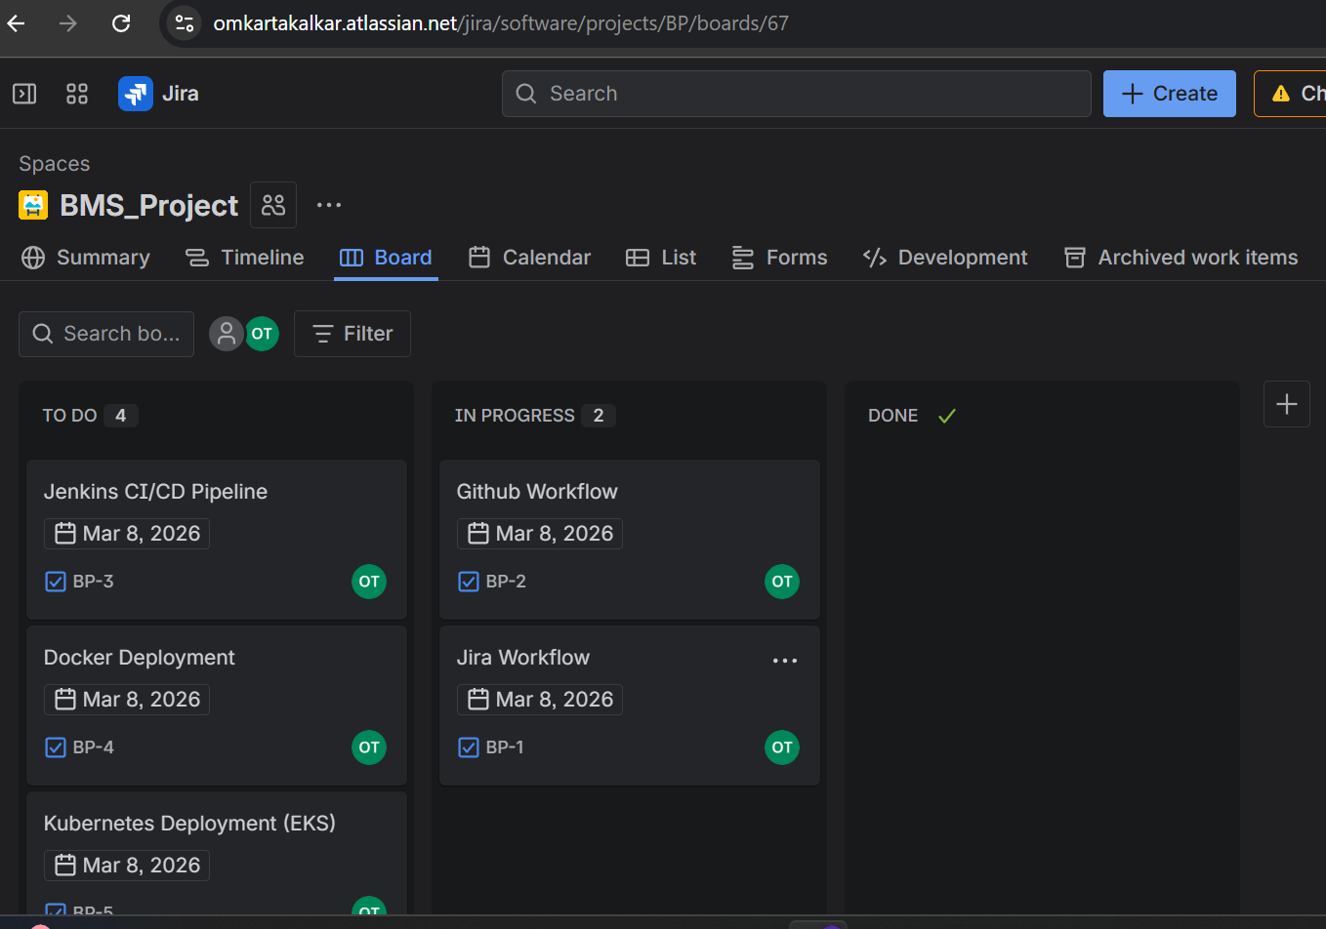
Step 10:Github workflow done and Jenkins CI/CD in progress
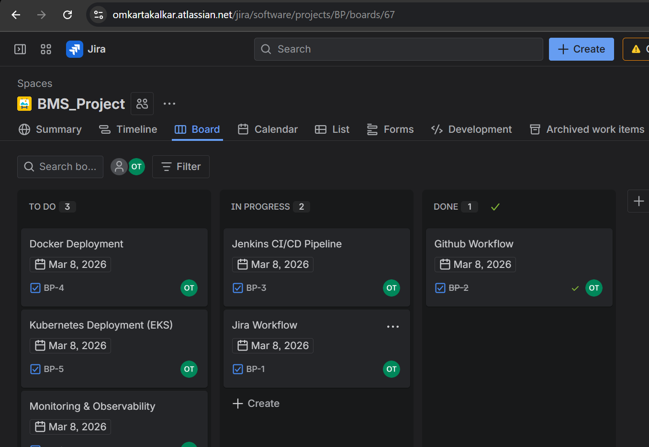

Step 11:Jenkins CI/CD pipeline done and docker deployment in progress
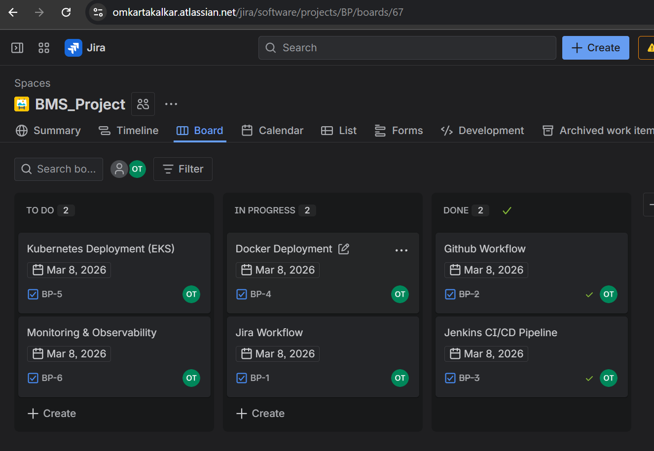

Step 12:Docker deployment is done and kubernate deployment is in progress
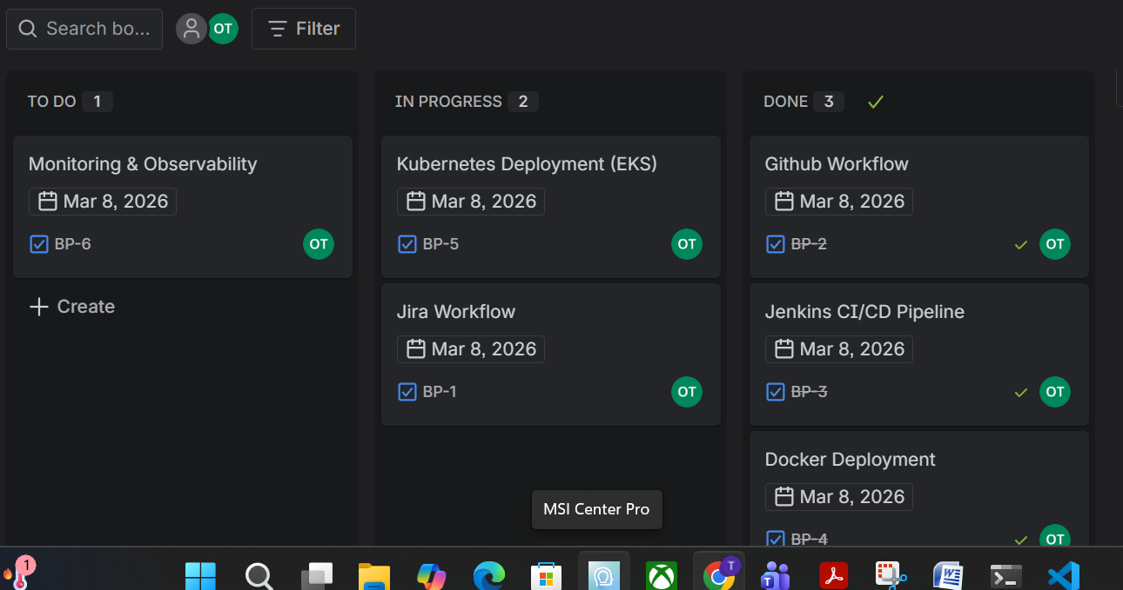

Step 13: kubernate deployment is done and monitoring and observability is in progress
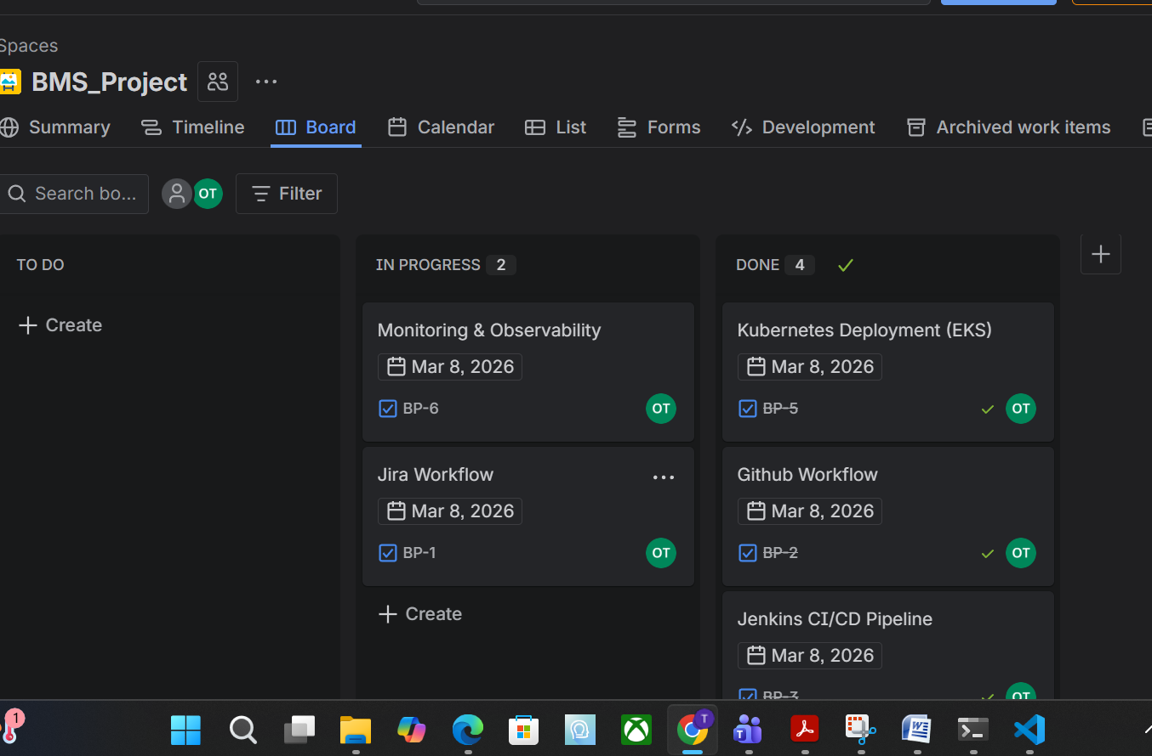
Step 14: monitoring and observability is done
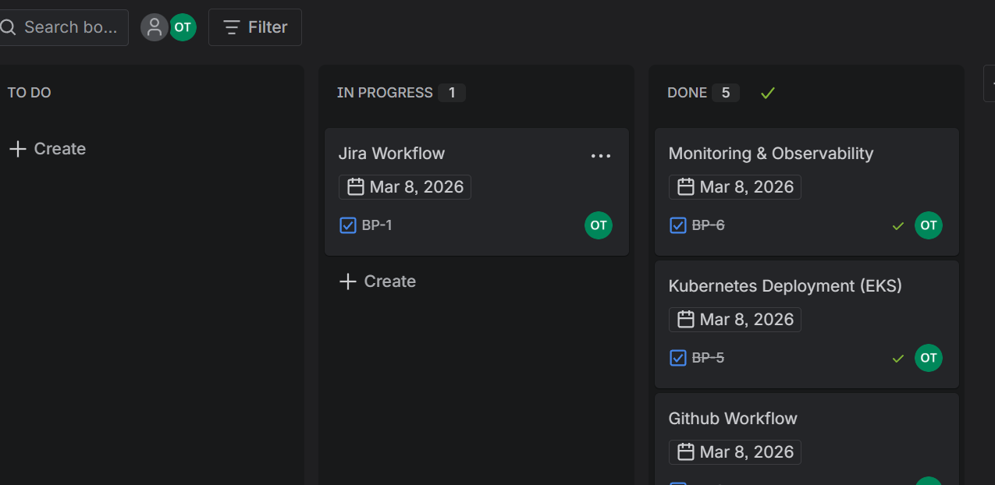

Step 15:Jira workflow is also done
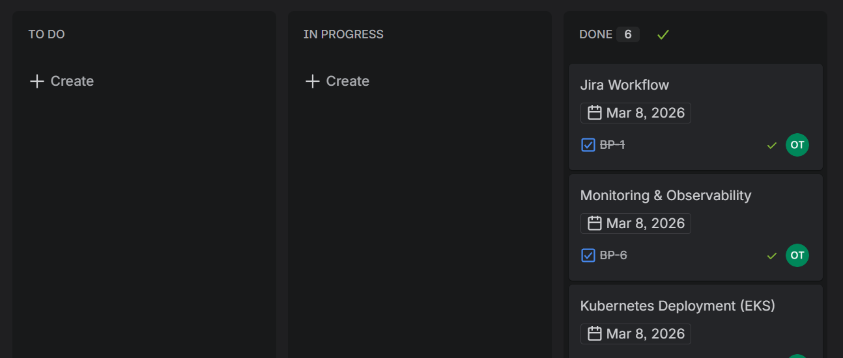

2) GitHub Workflow
• Clone the GitHub repository: https://github.com/akshu20791/Book-My-Show/
• Create a feature branch and make changes.
• Push changes and raise a Pull Request (PR).
• Review peers' PRs and approve before merging into the main branch.
• Submit the final PR link as deliverable.

Step 1: First we need to fork the repo and give name to repo
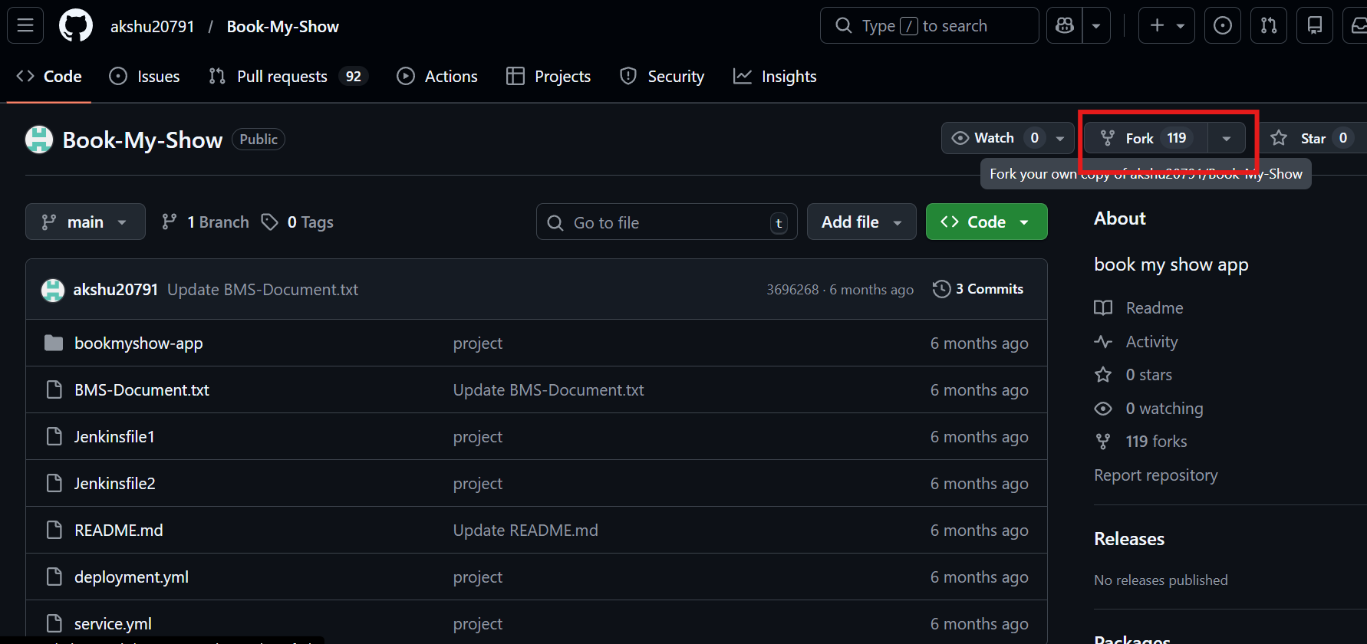
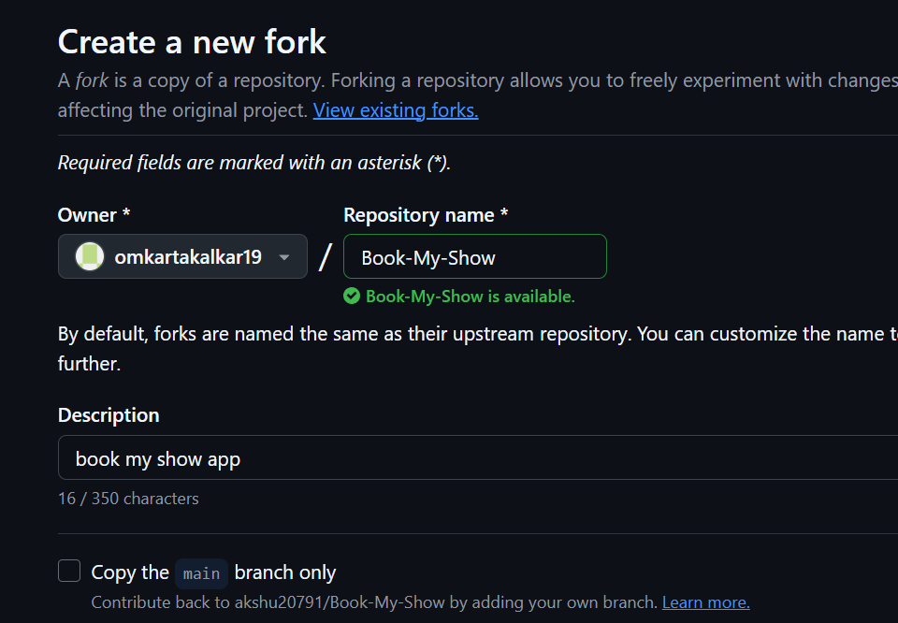
Step 2:Clone the repo and move into the project
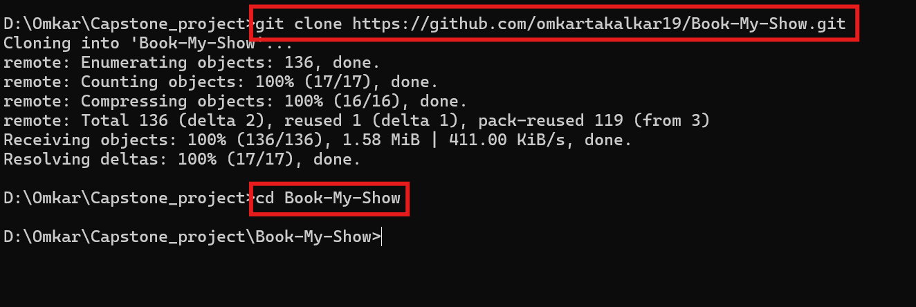

Step 3:Create new feature branch
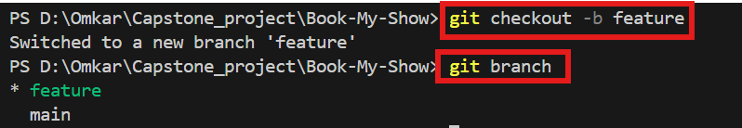

Step 4:Adding file to feature branch
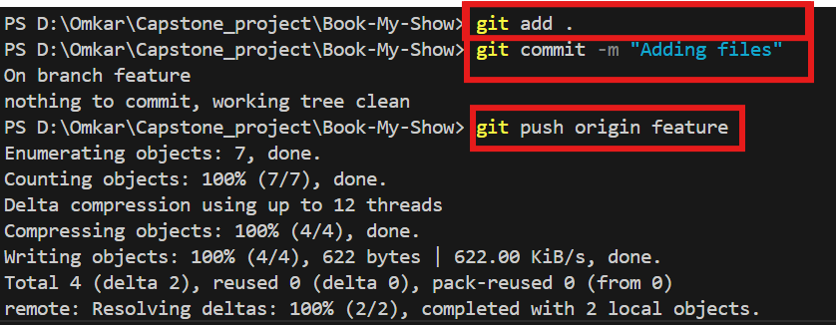

Step 5:Creating new pull request

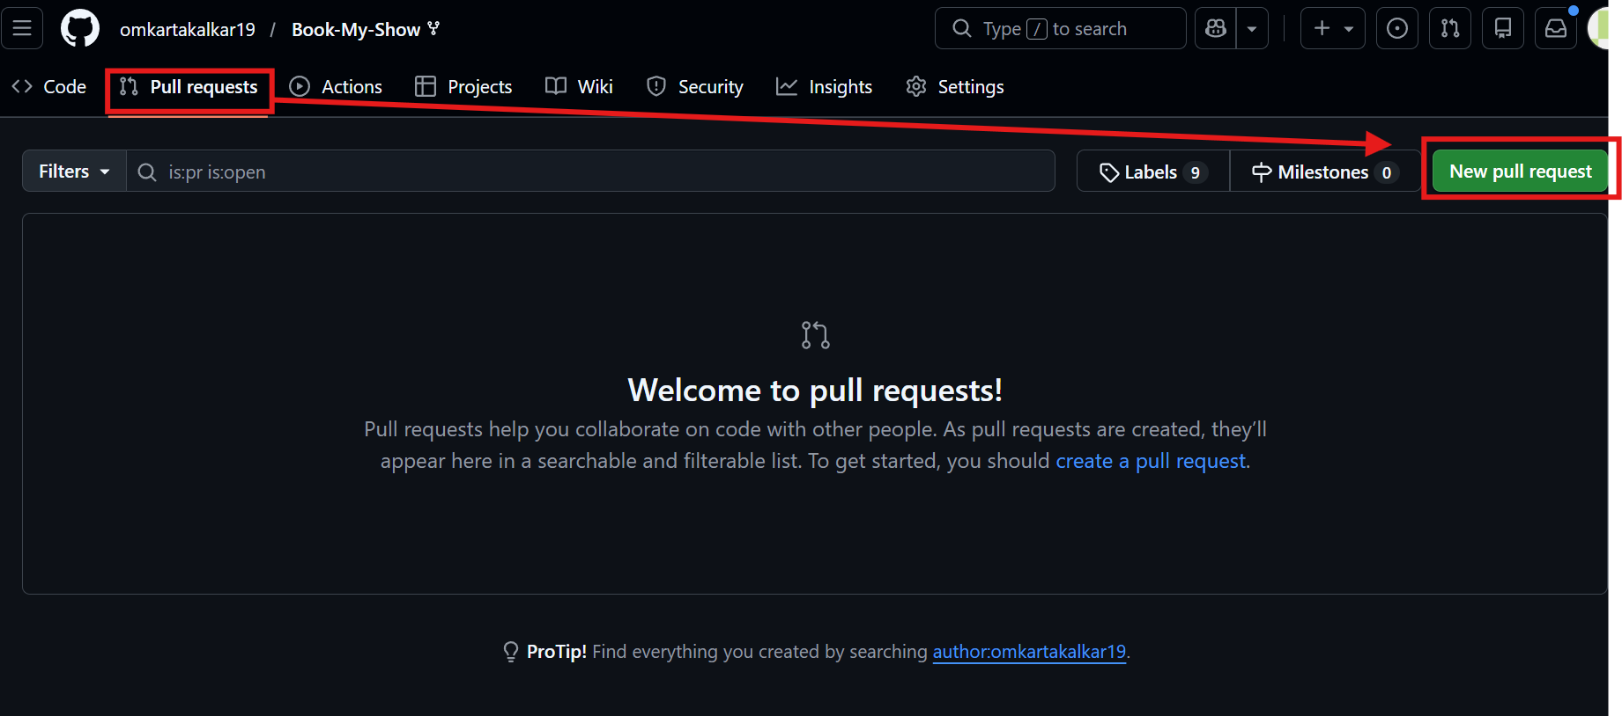

Step 6: Comparing changes in main and feature branch
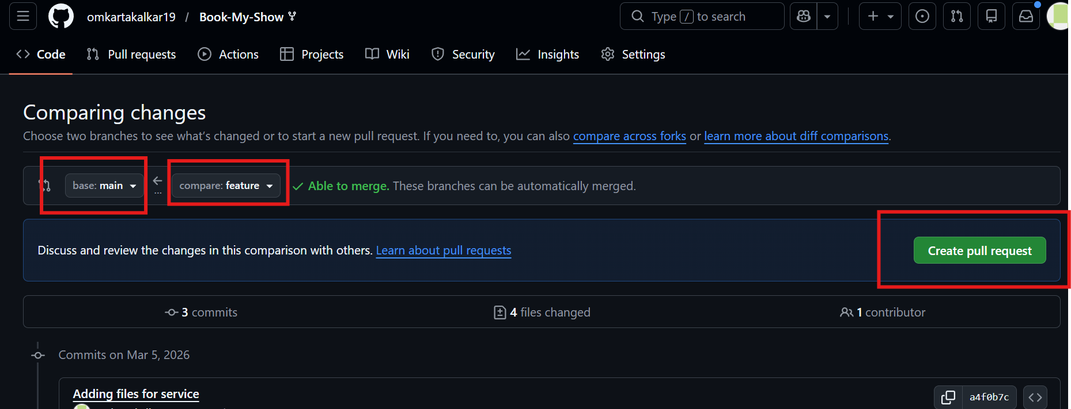

Step 7:Giving description and titlefor pull request
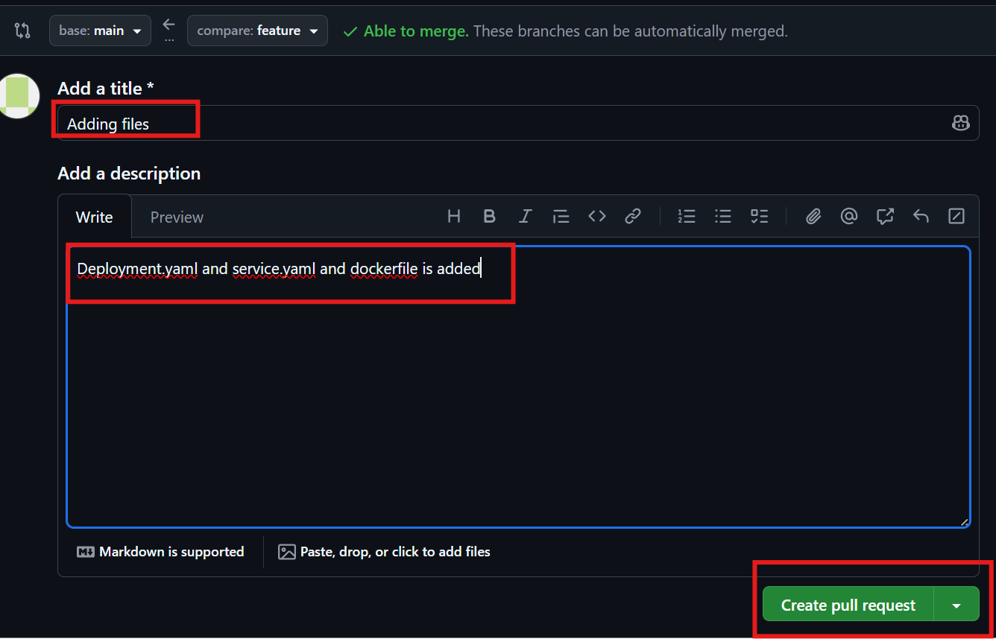

Step 8:Merging pull request and confirming it
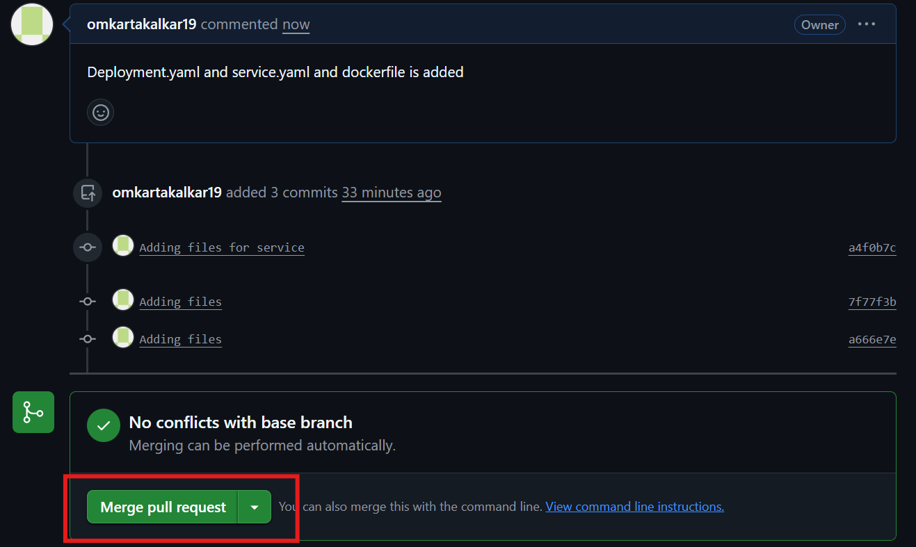

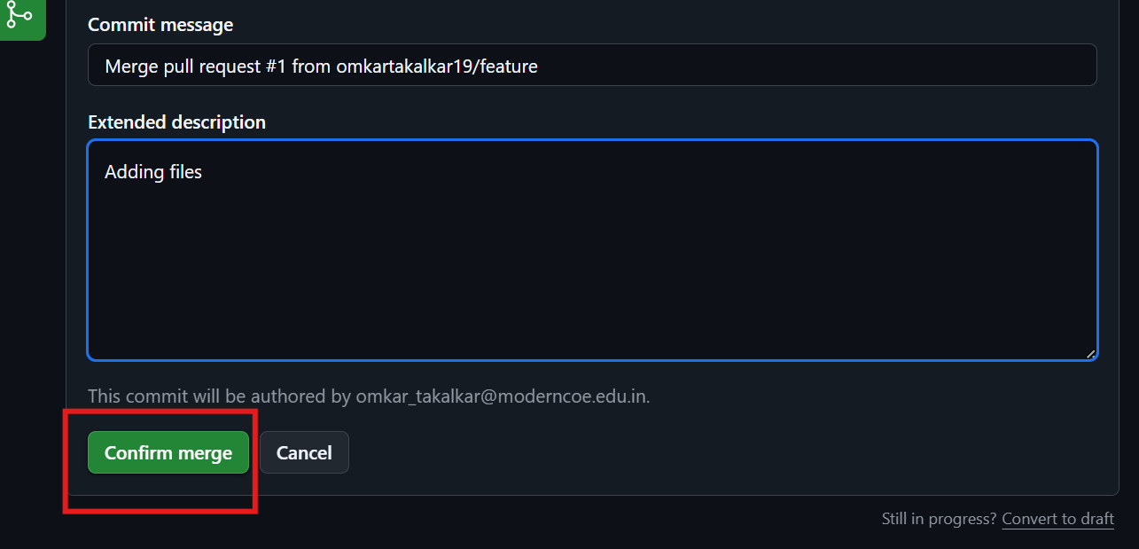

Step 9: Changes has been reflected at main branch
