2) GitHub Workflow
• Clone the GitHub repository: https://github.com/akshu20791/Book-My-Show/
• Create a feature branch and make changes.
• Push changes and raise a Pull Request (PR).
• Review peers' PRs and approve before merging into the main branch.
• Submit the final PR link as deliverable.

Step 1: First we need to fork the repo and give name to repo
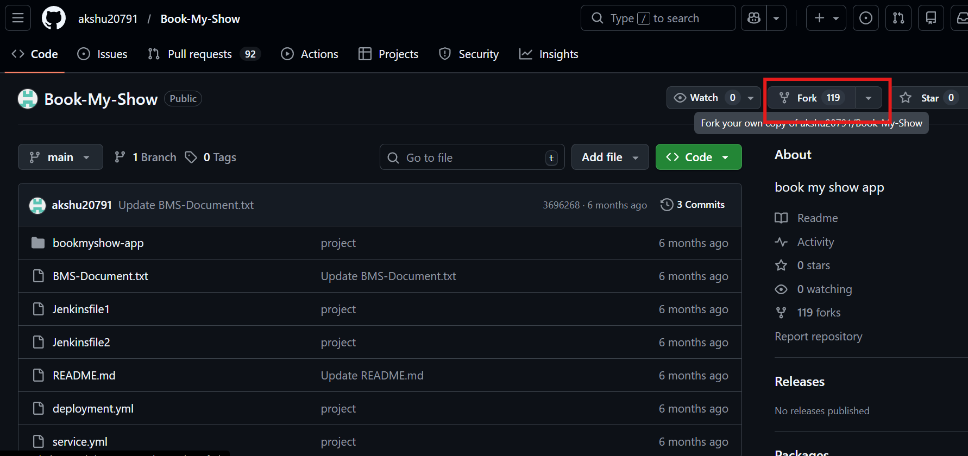
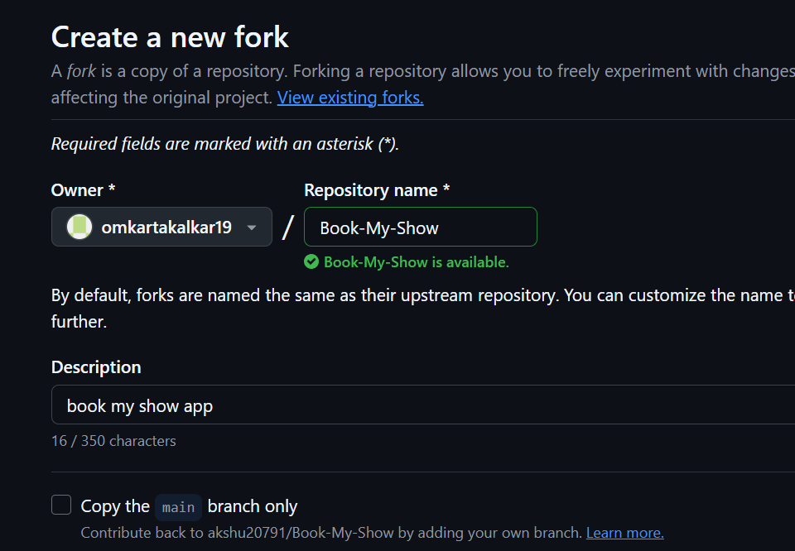
Step 2:Clone the repo and move into the project
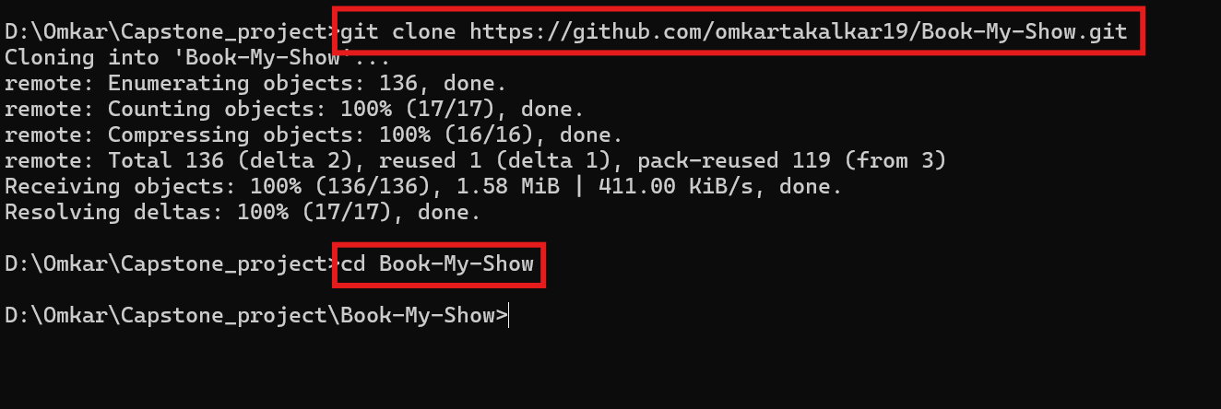

Step 3:Create new feature branch
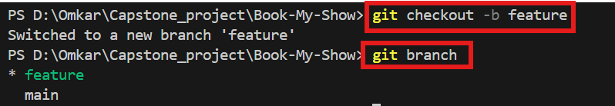

Step 4:Adding file to feature branch
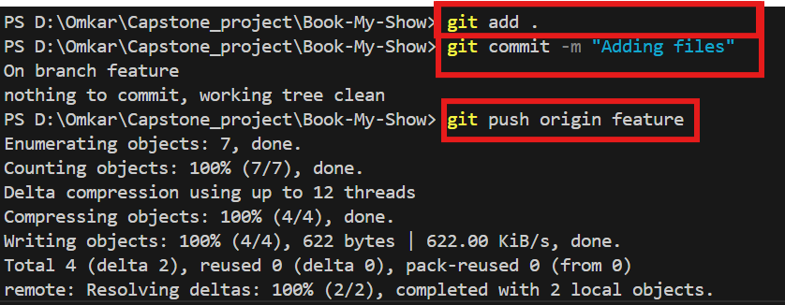

Step 5:Creating new pull request

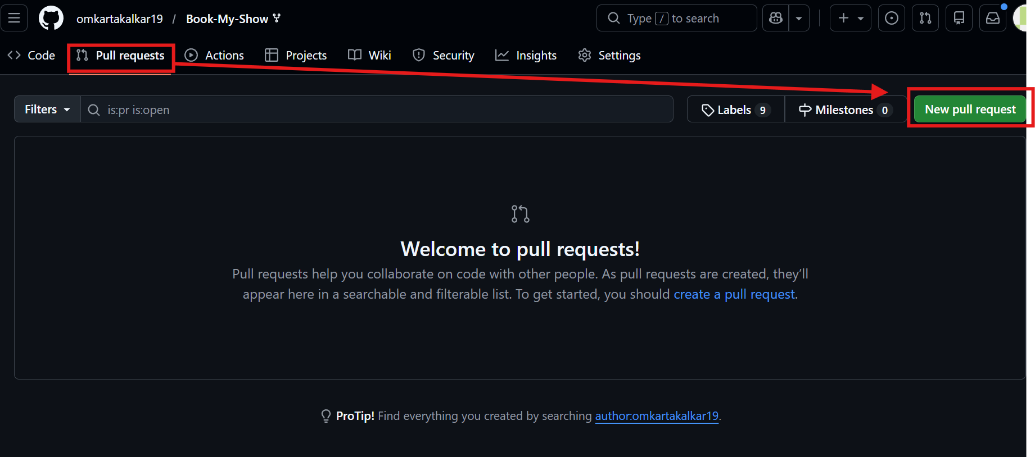

Step 6: Comparing changes in main and feature branch
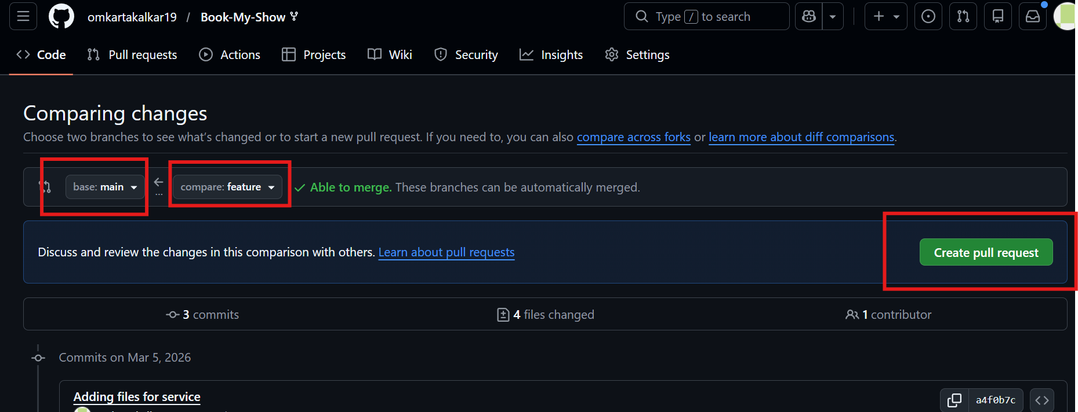

Step 7:Giving description and titlefor pull request
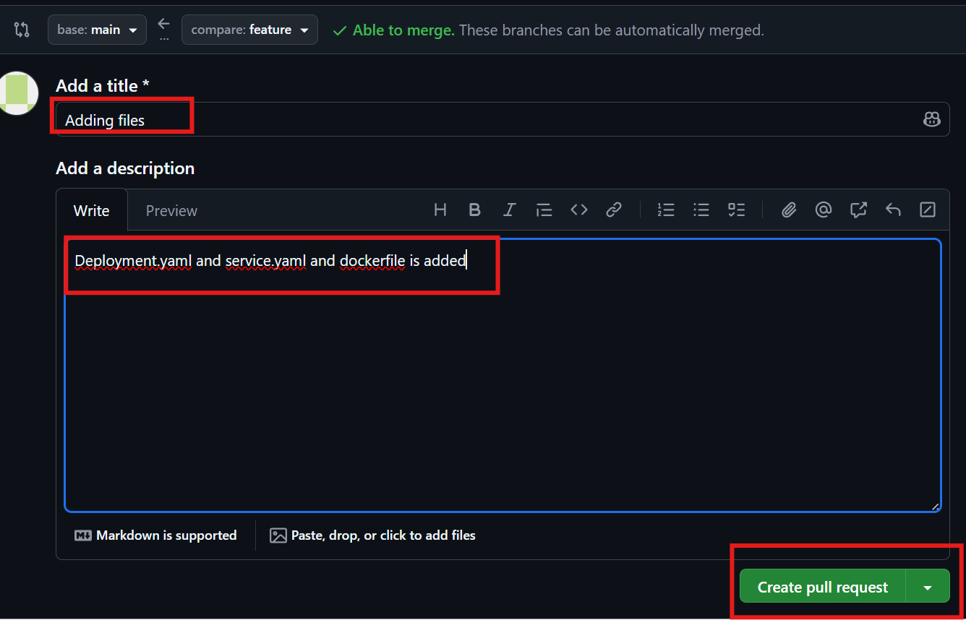

Step 8:Merging pull request and confirming it
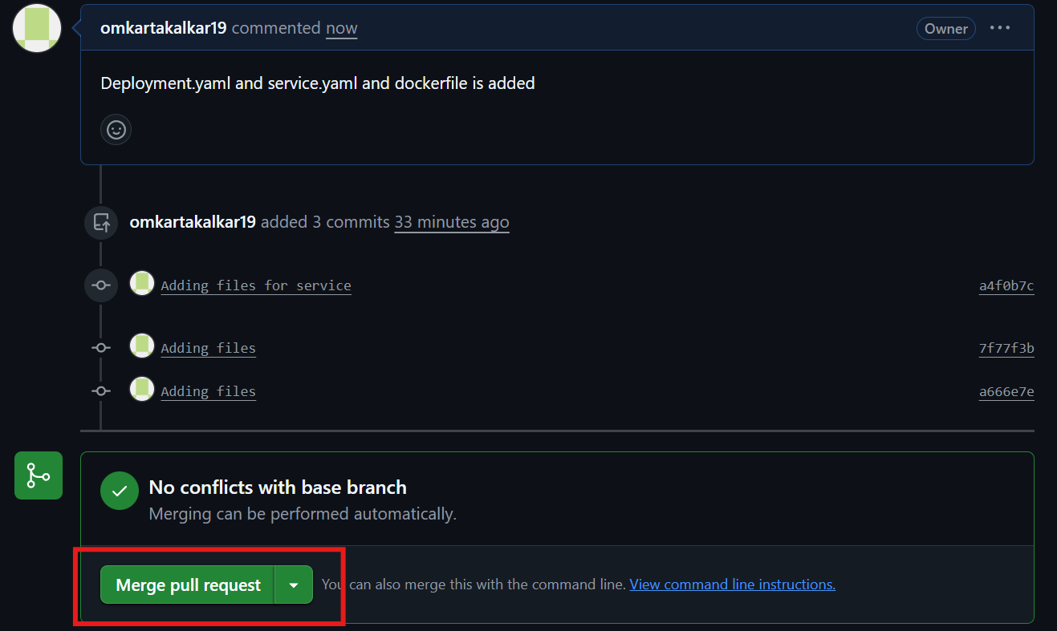

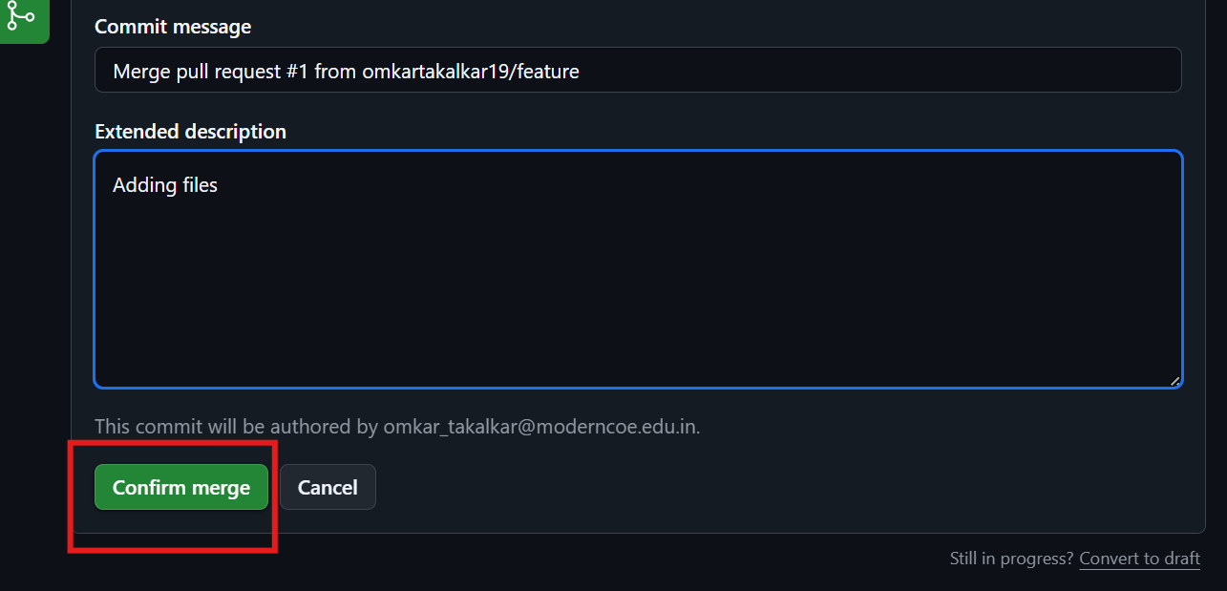

Step 9: Changes has been reflected at main branch
