**Master of Science / Postgraduate Diploma in Data Analytics**

**Business Intelligence and Business Analytics**

**Continuous Assessment One**

**2 Hours**

**Student Name: Omkar Ratnoji Tawade**

**Student Number: 19232136**

**Directions:**

**Once completed, please submit your completed MICROSOFT WORD document to the TurnItIn Link on Moodle**

**DOCUMENTS SUBMITTED IN ANY OTHER FORMAT WILL BE AWARDED ZERO MARKS**

**Answer ALL questions**

**Please Answer the questions using Red Font**

**Where a question states list, simply list the required.**

**Where a question states briefly, be brief with your response.**

**Bear in mind the marks awarded for each question and quantify your answers based upon the given marking. E.g for a 4 mark question, there is no need to provide an entire page for your answer.**

**Business Intelligence and Business Analytics: Enterprise Systems**

1. **Provide a Definition of the following Enterprise Solutions and provide a Real World example of each solution:**

* **ERP:** ERP is an enterprise-wide information system that can integrates and controls all the business process in the organization, or it can be also defined as software architecture that facilitate the flow of information among the different function within an enterprise.

Examples: Microsoft Dynamics and SAP.

* **CRM:** Customer relationship management is a scientific approach for building and sustaining long term business with the customer to satisfy them. It is mainly focused on existing and potential customer. Operational, Analytical and Collaborative are the types of CRM.

Examples: Apple CRM (targeted marketing), Coca-Cola (Collaborative) and Amazon CRM (Analytical).

* **SCM:** Supply chain management is the management of goods and services, involving the movement and storage of raw materials of work in progress inventory and of finished goods from the point of origin to the point of consumption.

Example: Walmart and Amazon.

* **PLM:** The process of managing the entire lifecycle of a product from its conception, though design and manufacture to service and disposal. PLM integrates people, data and business system and provides product information backbone for companies and their extended enterprise.

Example: Upchain and Teamcenter Siemens.

* **BPM:** Business process management is a corporate methodology to optimizing the business process in the organization It combines the flexibility of custom, end to end business solutions; the predictive power of machine learning and freedom from the effort and expense of building hand coded applications.

Example: Employee onboarding and Account management.

**[10 Marks]**

1. **Discuss the purpose of CIP (Continuous Improvement Programs) and the Potential Advantages**

**Purpose:**

Continuous Improvement Program is predicted on four value and seven principle and the purpose of this program is eliminating these seven wastes and increase customer value for- ever by optimizing people, materials, space, and equipment resources. Seven waste are as follows Overproduction, Transport, Motion, Waiting, Inventory, Over-processing and defect correction.

**Advantages:**

1. Reduction in delivery times.

2. Decreased employer turnover rate.

3. More competitive products and services.

4. Having an enterprising learning culture.

**[4 Marks]**

1. **Compare and contrast Six Sigma with Kaizen CIP**

|  |  |
| --- | --- |
| **Six Sigma** | **Kaizen CIP** |
| Road maps | Kaizen Umbrellas |
| Immediate perfection | Continuous improvement |
| Reducing Variations and Defects | Mistakes as possibility of improvement |
| Short-term results | Long-term results |
| Prioritizing Projects | Every possible Improvement |
| Ensuring Profitability | Providing quality |
| Creation of project teams | Participation of every single employee |

**[4 Marks]**

1. **Explain what an enterprise solution is and highlight 3 of the fundamental goals of implementing such a system.**

Enterprise solution is a solution which integrates business processes with the aim of creating value and reducing cost by making right information available to right people at the right time to help them make good decision in managing resources efficiently.

The complexity of enterprise applications, however, pushes most corporations to outsource the development of applications they need to run operations. After development, the applications are brought back in-house for deployment, a job that usually requires a specialized information technology team.

**[4 Marks]**

1. **There are many functions supported by ES (Enterprise Systems) upon their implementation within an organization. Highlight 4 such functions and provide details on how these functions are supported. E.G An example of such a function would be ‘Marketing’**

* Accounting: Enterprise system allows companies to keep track on financial transactions data. It comprises modules specific to billing and payroll, accounts, receivable, accounts payable and more.
* Manufacturing: It provides advanced functionality for manufacturing-specific needs. It integrates core business process with manufacturing process allowing full visibility and control over manufacturing process.
* Marketing: It has ability to combine forces in an organization to increase sales and attract large audiences.
* Finance: It helps to view the financial resources and overall financial health of the business. It will show how you majority of profits are coming from and also determining the return on investment for any buy

**[4 Marks]**

1. **Provide a Brief History regarding the evolution of MRP systems**

Evolution 1: MRP

Material Requirement Planning system is designed to handle ordering and scheduling of dependent demand inventories in terms or raw material and components. But ordering and scheduling is not easy process as it needs to tract number of inventories and to differentiate between dependent and independent demand.

Evolution 2: Closed loop MRP

MPR was initially developed without any capacity checks or input from other departments. IN closed loop MRP this capacity checks were included in the system which are used with master production schedule and the component production plan to generate feasible schedules.

Evolution 3: MPR II

MPR had already evolved from a material requirement planning into a planning and control system resources in manufacturing processes. Databases started replacing traditional file system. This led to better systems integration and greater query capabilities which lead to better decision making.

Evolution 4: ERP

It strives to plan and schedule supplier resources as well, based on dynamic customer demand and schedules. Practically, among the most important attributes of ERP is its ability to; automate and integrate an organizations business processes, share common data and practices across the entire enterprise and produce and access information in a real-time environment.

**[4 Marks]**

1. **MRP is considered a heuristic based on 3 main inputs, explain these inputs.**

The Master Production Schedule, which specifies how many products are going to be produced during a period of time; the Bill of Materials, which describes how those products are going to be built and what materials are going to be required; and the Inventory Record File, which reports how many products, com- ponents, and materials are held in-house.

**[3 Marks]**

1. **Complete the missing components of the diagram given below:**

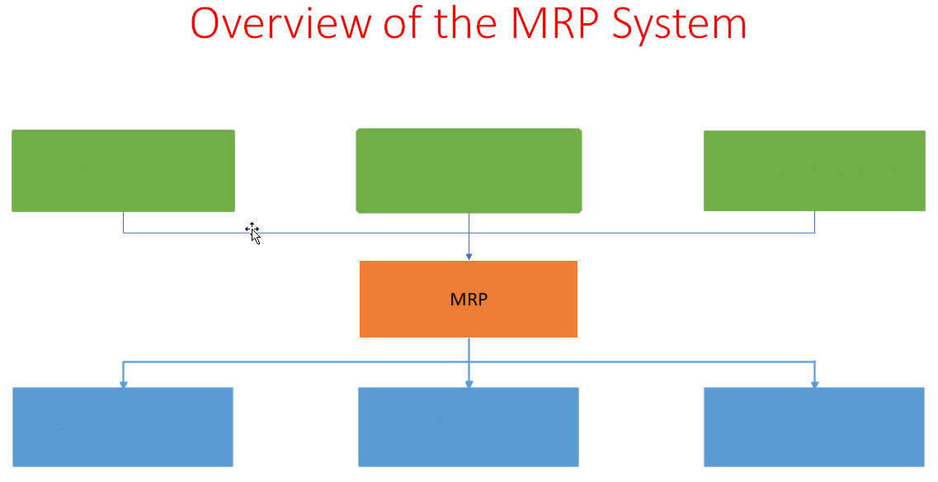

6

5

4

3

2

1

1 – The bill of materials

2 – Master production schedule

3 – Inventory Record File

4 – Manufacturing orders

5 – Purchase orders

6 – Various reports

**[6 Marks]**

1. **The implementation of an Enterprise System (ERP) can provide substantial benefits to an organization with regards to efficiencies of operations, business agility and internal governance, but with this there are also potential risks. List the four main potential risks of implementation of an ERP system.**

Strong buy in from the Team: Employee doesn’t have idea of operating such system and they have not been offered a chance of contributing their idea.

No Plan or checkpoints: To achieve successful implementation there should be a well published and communicated plan. A shared plan cha help individual to set their individual milestones. By updating plan regularly can easily identify and resolve the bottleneck issues.

Financial Budget and value Realization: This risk originates from lac of comprehensive scoping and budgeting of the project, unanticipated financial forecast changes. It will impact the confidence in the business and value priority of the project.

Change and cultural adoption: Before implementing the changes it should be reconciled so that reworking can be resolved and also will ultimately reduce the cost.

**[4 Marks]**

1. **The balanced scorecard was first published in 1992 by Kaplan and Norton, list the 4 key segments of the Balanced Scorecard**

**Financial:** Operating income growth, Same store Sales growth, Inventory turns and Expense/sales growth ratio

**Customer:** Frequency of purchases Units per transaction, Transection size and Customer feedback

**Internal:** Category market shape, Category margin, Sales psf and Quality/returns Out of stock

**Learning and growth:** Employee climate survey, Turnover, Strategic skill coverage and Systems versus plan

**[4 Marks]**

1. **List 3 Key reasons / justifications for implementing a Balanced Scorecard approach to strategic planning and management.**

**Better Strategic planning:** BSC is a powerful framework for building and communicating strategy. The business model is visualized in a strategic map which helps manager to think cause and effect relationships between different strategic objectives.

**Improved Performance Reporting**: The Balanced Scorecard can be used to guide the design of performance reports and dashboards. This ensures that the management reporting focuses on the most important strategic issues and helps companies monitor the execution of their plan.

**Better Process Alignment**: Well, implemented Balanced Scorecards also help to align organizational processes such as budgeting, risk management and analytics with the strategic priorities. This will help to create a truly strategy focused organization.

**[3 Marks]**

**Business Intelligence and Business Analytics: Tools**

1. **Explain the main concept of Power BI**

The process starts from data collection, storage and management. Next step is Extract transform and load the data. After loading the data next step is do data analysis which means to understand the data and what information can be extracted from the data. After analyzing the data next step is to generate dashboards and report which help to visualize the data and last step of this process is data mining for predictive analysis.

**[5 Marks]**

1. **What is Get Data in Power BI? Also explain the data connections supported.**

Get data is used to import/use our data in the power BI. There are few methods of Get data. First method is importing in which power bi will store a copy of your dataset in the application. Second method is to use a direct query in which schema is passed from database to power bi, but data will remain in database and power bi will interact with database using queries. The third method is establishing a live connection and, in this power, bi directly ask the queries to databases.

**[3 Marks]**

1. **What do you understand about dashboards in Power BI?**

Dashboard work as a very quick sort of one-off glance at what the current state is, so it’s a very a high-level look at the data that’s being presented to the user and then gives them ability to then to drill down or open the specific report they want to look.

**[3 Marks]**

1. **Which of the below best describes a typical operation in Power BI**
2. **Load and Edit Data – Dashboards/Reports/etc – Publish**
3. **Load and Edit Data – Configure User Access Rights – Clean Data**
4. **Clean Data – Load Data – Extract Report – Publish – Clean Data**

**[2 Marks]**

1. **PowerBI is typically supported by Cloud Technologies in a SAAS Solution (SoftwareAsAService)**

**Which of the below best describes the advantages of such an implementation**

1. **The software is free as it is on the Cloud / Supports multiple OS Platforms / Supports Multi Tenancy and Load Balancing / can only support Other Cloud Data Sources.**
2. **Accessible from anywhere / available on multiple end Devices / Persistent Back-up and redundancy / No device/capital pre-requisites before use.**

**[2 Marks]**

1. **Explain the Term ERD and provide clarification of the purpose of this function in PowerBI.**

A diagram that pictorially represents entities, the relationships between them and the attributes used to describe them. It helps to accurately calculate results and display the correct information in our reports. We can work with the data in both tables s if they were as single table.

**[4 Marks]**

1. **Compare and contrast the capabilities of Tableau and PowerBI and make a selection on your preferred implementation of either of these solutions.**

|  |  |
| --- | --- |
| **Tableau** | **Power BI** |
| Better performance with large amount of data | It can handle limited amount of data |
| Has access to multiple number of different servers and database sources | Limited access to other servers and databases |
| Used for more scalable approach | It can easily integrate with different data sources like Share point, Azure, Power apps. |
| Data modelling is not offered | It provides power pivot, ax which are more accessible to the users |

**[3 Marks]**

**Business Intelligence and Business Analytics: BI & Dashboards**

1. **Define the Term Business Intelligence.**

Business Intelligence is broad category of applications and technologies for gathering, storing, analyzing, and providing access to data to help clients make better decisions.

**[2 Marks]**

1. **In your own words explain the importance of BI within a highly competitive marketplace.**

Business intelligence is a technology driven process of analyzing the data and present the actionable information to executives for decision making. It combines with variety of tools, technologies, and methods with the intent of driving positive change and boosting company performance. By improving access to company’s data, BI can increase overall profitability through effective decision making and optimize internal process and as well as help business to discover new revenue. Also, BI helps to identify the market trends and spot the business problems.

**[5 Marks]**

1. **List and Briefly Explain the 3 types of Dashboards commonly used in Enterprise**

**Strategic Dashboard:** It is used to monitor’s organization progress in achieving predefined goals. It is used on highest level of the organization to enable a deep dive to lower level of the organization.

**Tactical Dashboard:** It is used for tracing the trend in relation to organization goals and initiatives. It is used by managers to control how market reacts on company’s actions. All factors and metrics in tactical dashboards are measure against the preset goal.

**Operational Dashboard:**  Strategic and tactical dashboards are being used by executives. But operational dashboard is used at department level and that’s why operational dashboard provides detailed insights, while general reviews are not part of their user interest.

**[6 Marks]**

1. **Highlight and Briefly Explain the missing elements in the below diagram**

Intent

Interest

Awareness

Awareness: Awareness is the uppermost stage of the marketing funnel. Potential customers are drawn into this stage through marketing campaigns and consumer research and discovery. Here, lead generation takes place, as information is collected, and leads are pulled into a lead management system for nurturing further down the funnel.

Interest: Once leads are generated, they move on to the interest stage, where they learn more about the company, its products, and any helpful information and research it provides. Here is an opportunity for brands to develop a relationship with the people in its lead database and introduce its positioning. Marketers can nurture leads through emails, content that is more targeted around industries and brands, classes, newsletters, and more.

Intent: To get to the intent stage, prospects must demonstrate that they are interested in buying a brand’s product. This can happen in a survey, after a product demo, or when a product is placed in the shopping cart on an ecommerce website. This is an opportunity for marketers to make a strong case for why their product is the best choice for a buyer.

**[5 Marks]**

1. **Behaviorism and Cognition are 2 schools of thought with regards to human behavior.**

**Within the context of BIBA what is the advantage to enterprise of understanding such consumer behavioral theories?**

Consumer Differentiation: Consumer differentiation will help to tailor your strategies to the needs of varying customer groups. When consumer differentiation is done, you can expand the width and breadth of your services. You will be able to effectively serve a wider group of people.

Retention of Customers: When a customer is happy about a particular product, he/she will repeat the purchase. Therefore, marketing the product should be done in such a way that it will convince customers to buy the product again and again.

Innovate New Products: Today’s consumers have greater choices and opportunities, which means they can easily switch to a company that offers better products and services.

**[5 Marks]**

1. **You are currently employed in small enterprise specializing in IT consultancy and solutions.**

**The company is not currently using any BI or analytical tools.**

**Justify the investment in such tools and eco-systems to upper management in a maximum of 6 lines /sentences.**

**[5 Marks]**