Executive summary: Are Action movies more successful for Disney?
To: Studio leadership, green-light committee
From: Business analytics
Scope: 148 Disney releases, 1984-2016, with budget data. Gross is domestic, inflation-adjusted.

Bottom line
Action films earn more at the box office because Disney spends more on them. At comparable budget, quality and star power, Action adds no detectable premium (-0.4%, p = 0.98), and it returns less per budget dollar. Green-light decisions should rest on budget-adjusted expected return and quality, not on genre.

Findings
- Without controls, Action films do gross more: $206M vs $121M on average (+71%). A Welch t-test gives p = 0.045, so the gap clears the 5% bar.
- Most of that gap is budget. Action films cost 1.81x as much. With budget, IMDb score and star power held constant, the Action effect is -0.4% (95% CI -22% to +27%, p = 0.98), which is not statistically significant.
- Budget and quality are what move gross. A 1% bigger budget goes with about 0.79% more gross (diminishing returns), and one extra IMDb point with +47% (p = 0.0009). Star power shows no effect (p = 0.40). The model has R-squared 0.39 on n = 148 films.
- Per budget dollar, Action does worse: mean ROI 1.23x vs 1.92x for other genres (p = 0.003). Leave Marvel out and Action returns a pooled 1.05x, against 1.49x for all other genres.
- Marvel is the outlier. Its 7 films are 4.7% of the sample but earn 14.2% of sample revenue, at a pooled 1.89x ROI. Without Marvel, the Action effect is -8.8% (p = 0.50).
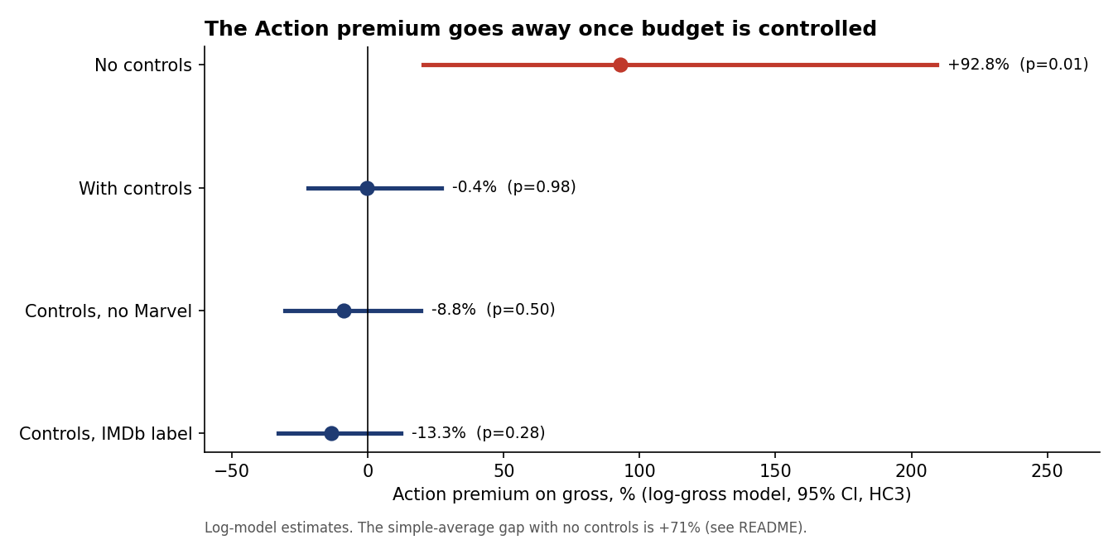

Key numbers
Metric | Action | Non-Action
Films | 20 | 128
Average adj. gross | $206M | $121M
Average adj. budget | $146M | $81M
Mean ROI (gross/budget) | 1.23x | 1.92x

Recommendation for green-lighting decisions
- Stop using genre as a green-light criterion. Judge each project on budget-adjusted expected return. The what-if model in excel/Disney_Genre_Performance.xlsx works as a first-pass screen.
- Put quality ahead of spend. In the model, +0.5 IMDb points is worth about +21% gross. Doubling the budget adds about 73%, so return per budget dollar falls as budgets grow.
- Treat Marvel-type franchises as a separate portfolio. They are not evidence that Action works: non-Marvel Action returned 1.05x per budget dollar vs 1.49x for other genres.
- Worked example from the What_If sheet: a $150M film with a 6.8 IMDb score and star power 800 is expected to gross $239M as Action and $239M as non-Action. Raising the expected score to 7.3 lifts it to $289M.

Limitations
- Small sample. 148 films have budgets and only 20 are labelled Action, so the Action interval is wide.
- Selection. Only 148 of 579 Disney titles have a correct budget match, and older and smaller releases drop out.
- The data is observational. Budgets are set with expected demand in mind, so the model shows association, not causation.
- Gross is domestic only and budgets exclude marketing. International, streaming and merchandise revenue are not counted.
- Disney and IMDb label genres differently (20 vs 43 Action films). The result holds under both labels.

