DMAIC Report: Reducing Returns Disposition Defects
Project Lead: Omkar Vyas (personal project) | Period analysed: 1 Jul 2025 to 30 Jun 2026 | Data is synthetic, generated by src/generate_data.py to mirror e-commerce returns patterns. No Amazon or employer data is used.

Executive summary
Returned items were graded into the wrong disposition 6.8% of the time (audited baseline, Jul 2025 to Feb 2026), or about 3.0 sigma. Each wrong call lost an average of $16.90 more recovery value than a correct one. Some sent resellable items to the shredder, and others shipped used items as new.
Four causes explained most of the problem: new associates in their first 30 days, an unclear grading SOP for open-box and electronics, the night shift, and a missing photo-grading step at RC-CENTRAL. The January backlog after peak season made all of them worse.
Three fixes were piloted at RC-CENTRAL in March and April 2026: SOP v3.0 with a visual open-box / electronics grading matrix, an 8-point grading checklist, and a mandatory photo step. The pilot site's defect rate fell from 8.5% to 2.6% (p = 4.5e-11), while the other sites stayed flat (6.3% to 5.9%). After the network rollout in May, the network defect rate averaged 3.0%, below the 3.5% goal.
What it means for the business, at current volume (150,918 units a year):
- About 5,826 fewer wrong dispositions and $98,483 of recovery value protected a year.
- Recovery rate up from 95.7% to 97.4% of potential.
- Waste down from 44.1 to 15.3 resellable units scrapped per 10,000 (about 435 units a year).
- Customer complaints down from 1.21% to 0.69% of units (about 783 fewer a year).
Decisions requested:
- Approve SOP v3.0, the checklist and the photo step as permanent standard work.
- Fund a 2-week buddy period for Q4 seasonal hires. This is recommended but was not piloted.
- Make the Returns QA Manager the owner of the control plan and dashboard.
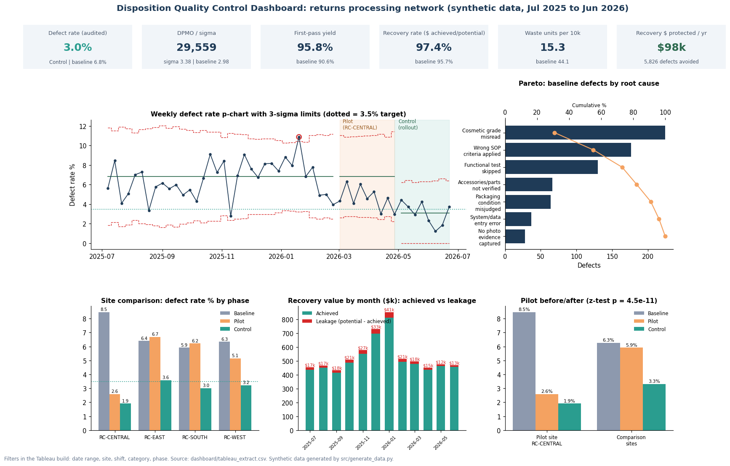
Dashboard preview

1. Define
Problem. 6.8% of audited units got the wrong disposition. Over eight months $195,203 of recovery value leaked and 468 resellable units were scrapped.
Goal. Control-period defect rate at or below 3.5% by 30 June 2026, recovery rate at or above 97%, waste per 10k down at least 50%, mean cycle time at or below 12 hours. See docs/01_Project_Charter.md.
Scope. Grading and disposition at four returns centers, all shifts. Customers and CTQs are in docs/02_SIPOC.md and docs/03_VOC_CTQ_Tree.md.

2. Measure
Data. 150,918 units over 365 days, 15,689 QA audits (about 10%, or 20% at the pilot site during the pilot), 194 anonymized associates. Raw files were cleaned before analysis:
table | check | rows
returns_units | raw rows | 151,098
returns_units | duplicate unit rows removed | 180
returns_units | category variants standardized | 400
returns_units | negative prices corrected (abs) | 12
returns_units | missing prices imputed (category median) | 350
returns_units | missing shift derived from received hour | 250
returns_units | clean rows | 150,918
unit_cycle_stages | rows with negative stage time set to NULL | 25
audits | duplicate audit rows removed | 15
audits | orphan audits removed (no matching unit) | 8
audits | clean rows | 15,689

Operational definitions. A defect is an audited unit whose assigned disposition differs from the auditor's disposition, with one opportunity per unit. DPMO = defects / audited units x 1,000,000. First-pass yield (FPY) = audited units correct and not sent back for re-grade / audited units. Sigma uses the conventional 1.5-sigma shift.
Baseline and phase results (SQL: `sql/02_baseline_defect_rate_dpmo_sigma.sql`).
Phase | Site | Audited | Defects | Defect rate | DPMO | FPY | Sigma
Baseline | NETWORK | 10,636 | 725 | 6.8% | 68,165 | 90.6% | 2.98
Baseline | RC-CENTRAL | 2,646 | 224 | 8.5% | 84,656 | 86.7% | 2.87
Baseline | RC-EAST | 2,855 | 183 | 6.4% | 64,098 | 92.0% | 3.02
Baseline | RC-SOUTH | 1,909 | 113 | 5.9% | 59,193 | 91.8% | 3.06
Baseline | RC-WEST | 3,226 | 205 | 6.3% | 63,546 | 91.8% | 3.02
Pilot | NETWORK | 2,854 | 133 | 4.7% | 46,601 | 93.3% | 3.17
Pilot | RC-CENTRAL | 1,081 | 28 | 2.6% | 25,902 | 95.6% | 3.44
Pilot | RC-EAST | 598 | 40 | 6.7% | 66,890 | 91.5% | 2.99
Pilot | RC-SOUTH | 418 | 26 | 6.2% | 62,201 | 91.9% | 3.03
Pilot | RC-WEST | 757 | 39 | 5.1% | 51,519 | 92.3% | 3.13
Control | NETWORK | 2,199 | 65 | 3.0% | 29,559 | 95.8% | 3.38
Control | RC-CENTRAL | 573 | 11 | 1.9% | 19,197 | 96.7% | 3.57
Control | RC-EAST | 612 | 22 | 3.6% | 35,948 | 95.1% | 3.29
Control | RC-SOUTH | 364 | 11 | 3.0% | 30,220 | 96.4% | 3.37
Control | RC-WEST | 650 | 21 | 3.2% | 32,308 | 95.2% | 3.34

Cycle time. Baseline mean dock-to-disposition time was 15.1 h (p50 12.4 h, p95 32.6 h). 1.16% of baseline units exceeded the 48-hour SLA, and Ppk on log hours was 0.85. The daily mean peaked at 27.2 h on 2026-01-16.
Measurement system. Audit cause codes were reviewed with QA. An attribute agreement study between auditors is planned (target kappa at or above 0.8). Until then the audit result is the reference.

3. Analyze
Pareto. The top three causes (Cosmetic grade misread, Wrong SOP criteria applied, Functional test skipped) account for 73.1% of baseline defects.
Cause | Defects | Share | Cumulative
Cosmetic grade misread | 224 | 30.9% | 30.9%
Wrong SOP criteria applied | 176 | 24.3% | 55.2%
Functional test skipped | 130 | 17.9% | 73.1%
Accessories/parts not verified | 66 | 9.1% | 82.2%
Packaging condition misjudged | 64 | 8.8% | 91.0%
System/data entry error | 37 | 5.1% | 96.1%
No photo evidence captured | 28 | 3.9% | 100.0%

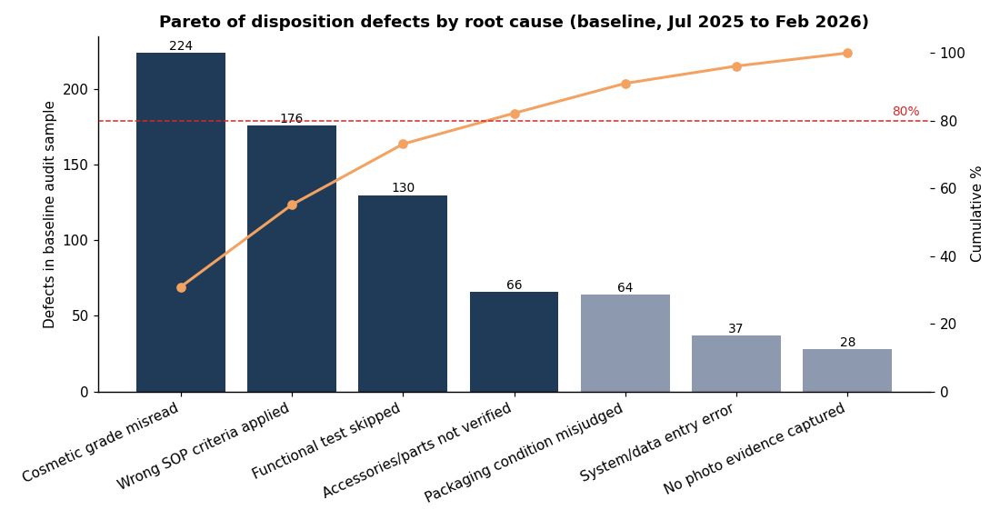
Pareto of defect causes
Fishbone. The team brainstormed causes across People, Method, Machine, Measurement, Materials and Environment, then tested the likely ones with data.
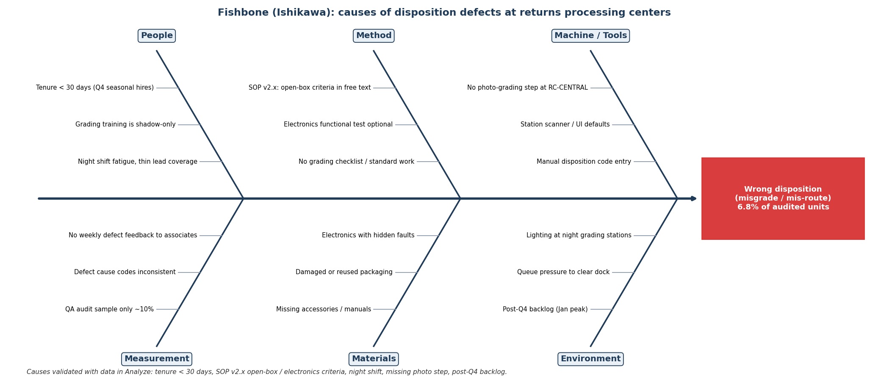
Fishbone diagram
Stratification (baseline).
- Tenure: associates in their first 30 days misgraded 13.2% of audited units vs 6.0% for 365+ days. New hires handled 16.5% of audited units in November and December, when Q4 seasonal hires start.
- SOP clarity: Electronics ran at 9.9% vs a 6.8% network rate, and units whose correct disposition was open-box ran at 11.1%.
- Shift: night shift 8.8% vs 6.3% for day and swing (chi-square p = 7.6e-05).
- Photo step: units graded without a photo 8.7% vs 6.1% with one. RC-CENTRAL, the site without the step, ran at 8.5%.
- Backlog: January ran at 8.5% and December at 7.8%, vs 5.7% in July.
- Direction: 27.3% of baseline defects were upgrades (graded too high). The rest were downgrades that lose recovery value or create waste.
Root-cause verification (logistic regression on 10,636 baseline audits). Each driver was tested while holding the others constant. Every validated cause was significant at p < 0.01. Swing shift was not.
Driver | Odds ratio | 95% CI | p-value | Share of baseline audits
Associate tenure < 30 days | 2.42 | 1.91 to 3.06 | 2.6e-13 | 6.8%
Item is truly open-box | 1.92 | 1.62 to 2.27 | 4.4e-14 | 18.8%
Electronics category | 1.66 | 1.41 to 1.96 | 2.3e-09 | 22.0%
No photo-grading step | 1.54 | 1.31 to 1.81 | 1.4e-07 | 27.8%
Night shift (vs Day) | 1.41 | 1.16 to 1.71 | 5.5e-04 | 20.0%
Associate tenure 30-89 days | 1.39 | 1.12 to 1.74 | 3.3e-03 | 12.9%
Peak backlog month (Dec-Jan) | 1.31 | 1.11 to 1.55 | 1.2e-03 | 35.1%
Swing shift (vs Day) | 1.05 | 0.88 to 1.26 | 5.6e-01 | 35.2%

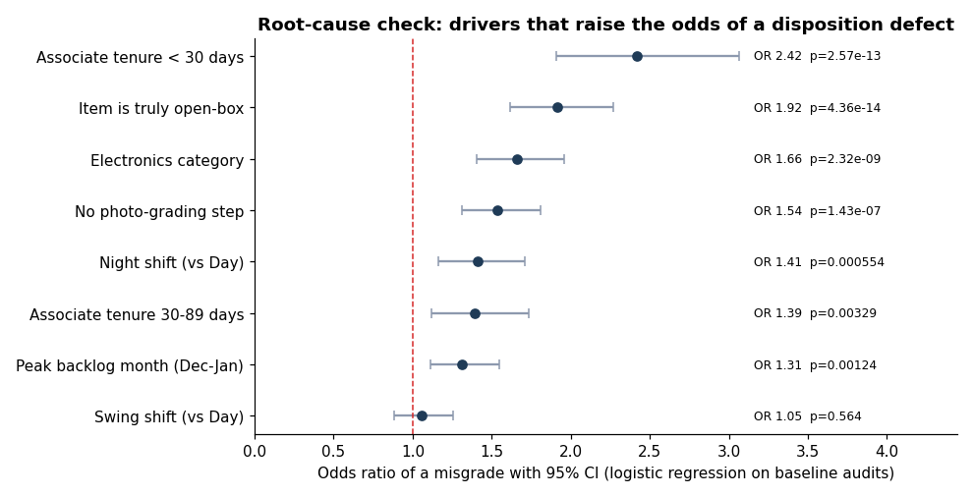
Odds ratios
Value stream. In a normal month, triage and grading (the value-added steps) were only 8% of a 11.2-hour flow. In the Dec-Jan peak the queue to grading grew to 14.4 h and total time to 22.1 h. The I-MR chart shows the post-Q4 backlog as special-cause variation: 195 of 212 days from October to April sat above the reference UCL of 10.2 h.
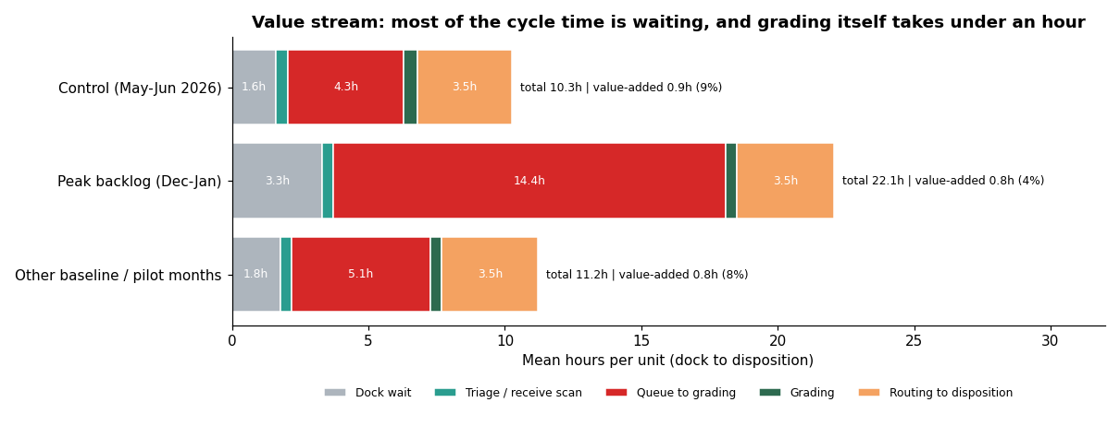
Value stream
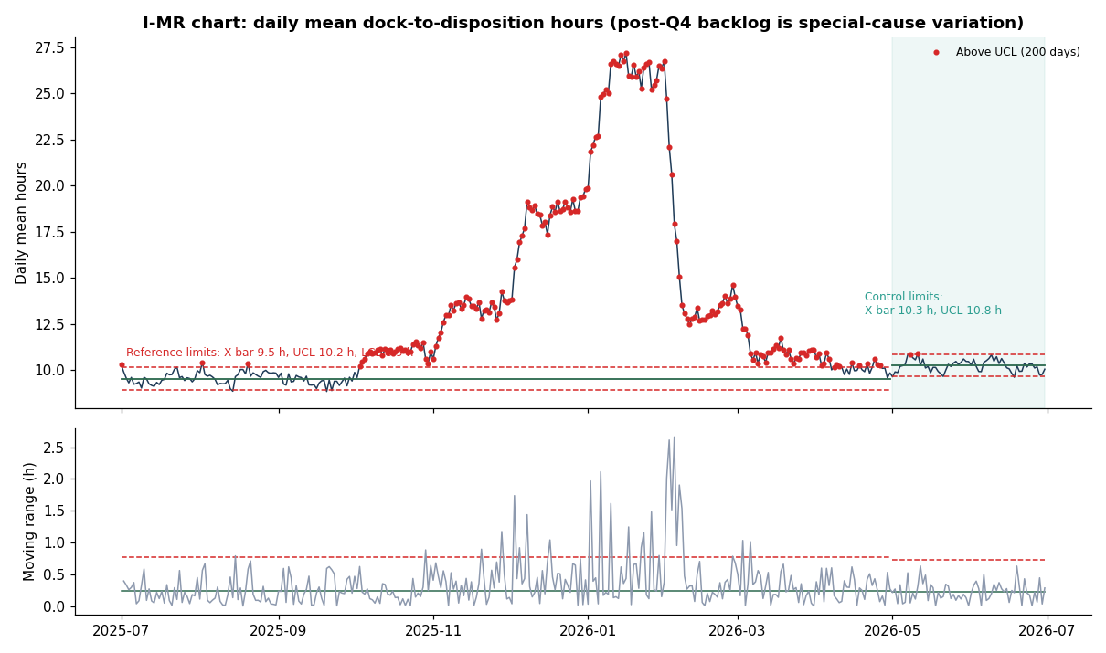
I-MR chart

4. Improve
Solutions selected (impact vs effort).
- SOP v3.0: a visual grading matrix for open-box and electronics (addresses "Wrong SOP criteria applied" and "Functional test skipped").
- 8-point grading checklist in the grading tool, including accessories and functional test (addresses "Accessories/parts not verified").
- Mandatory photo capture before a disposition can be submitted (addresses "Cosmetic grade misread" at RC-CENTRAL).
- Recommended but not piloted: a 2-week buddy period and Electronics certification for new hires, earlier Q4 seasonal hiring, and flex grading stations when the backlog index passes 1.1.
Pilot design. RC-CENTRAL, 1 Mar to 30 Apr 2026, with the audit rate raised to 20% for statistical power. The other three sites kept SOP v2.2 and served as the comparison group over the same weeks.
Group | Phase | Audited | Defects | Defect rate | Leakage $/unit | Waste / 10k | Mean cycle h
Pilot site (RC-CENTRAL) | Baseline | 2646 | 224 | 8.5% | $2.06 | 49.1 | 15.8
Pilot site (RC-CENTRAL) | Pilot | 1081 | 28 | 2.6% | $0.83 | 7.3 | 10.9
Pilot site (RC-CENTRAL) | Control | 573 | 11 | 1.9% | $0.94 | 8.8 | 10.7
Comparison sites | Baseline | 7990 | 501 | 6.3% | $1.77 | 42.5 | 14.8
Comparison sites | Pilot | 1773 | 105 | 5.9% | $1.72 | 35.9 | 10.7
Comparison sites | Control | 1626 | 54 | 3.3% | $1.13 | 17.5 | 10.1

Hypothesis test. H0: the pilot-site defect rate did not fall. Two-proportion z-test: z = -6.48, one-sided p = 4.5e-11. The rate fell by 69%, a change of -7.3 to -4.5 percentage points (95% CI). The comparison sites showed no significant change over the same weeks (p = 0.29). A difference-in-differences logistic model gives an interaction odds ratio of 0.31 (p = 3.2e-07), so the drop is not explained by seasonality alone.
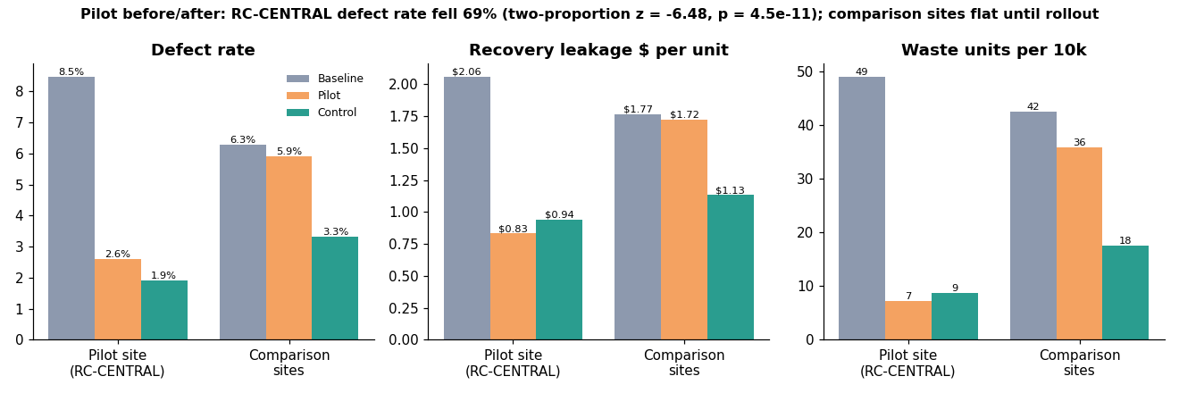
Pilot before and after

5. Control
Rollout. SOP v3.0, the checklist and the photo step went live at all four sites on 1 May 2026.
Result. The network defect rate fell from 6.8% to 3.0% (z = -6.86, p = 3.5e-12). DPMO went from 68,165 to 29,559, sigma from 2.98 to 3.38 and FPY from 90.6% to 95.8%. The comparison sites fell from 5.9% in the pilot window to 3.3% after rollout (p = 1.7e-04), so the pilot result repeated at the other three sites.
p-chart. Limits were recalculated for the Control period: centre line 3.09% vs 6.83% at baseline (full weeks only). The Control period had 0 out-of-control signals in 8 full weeks. 4 of those weeks were at or below the 3.5% target. Weekly values bounce around because each week has only about 251 audits.
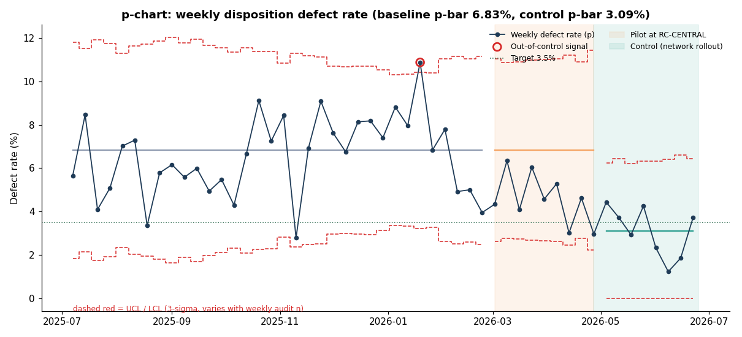
p-chart
Cycle time and capability. Control mean 10.3 h, p95 17.0 h, 0.00% over the 48-hour SLA, Ppk 1.62 (baseline 0.85). Lower spring volume explains much of the cycle-time gain. The checklist has a small cost: mean grading time was 0.48 h per unit in Control vs 0.43 h in normal baseline months (value-stream chart).
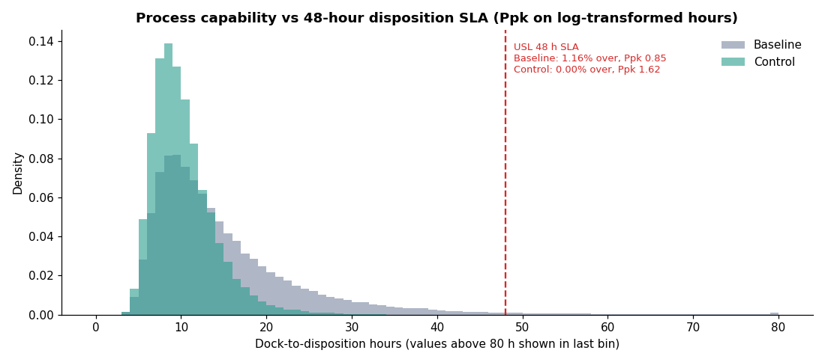
Capability
Control plan, dashboard and hand-off. See docs/06_Control_Plan.md (10 metrics with limits, owners and reaction plans) and docs/04_Requirements_Disposition_QC_Dashboard.md. The weekly feed is sql/09_weekly_control_chart_feed.sql, and the Excel tracker is excel/DMAIC_Defect_Tracker.xlsx.

6. Financial impact (method)
Incremental leakage per defect = mean leakage on defective audited units - mean leakage on correct audited units (baseline) = $16.90. Annual benefit = annual units x (baseline rate - control rate) x incremental leakage = 150,918 x (6.82% - 2.96%) x $16.90 = $98,483. At exactly the 3.5% target the benefit would be $84,603. The figure excludes complaint handling cost, second-return processing and the value of waste avoided beyond recovery $, so it is a conservative estimate. The Excel Scenario tab lets Finance change the target and the inputs.

7. Limitations and next steps
- The data is synthetic. Effect sizes were built into the generator, and the analysis recovers them. A real project would also run an attribute agreement analysis on the auditors.
- The new-hire fix was not piloted, and the Control-period new-hire defect rate (4.9%) is based on only 61 audits.
- The next Q4 peak is the real test of the control plan. The reaction plan for a backlog index above 1.1 should be rehearsed in October.

