1.Adam is working in an IT company. He has been given a task to reduce the load of a system by killing some of the processes running in the LINUX operating system. Which commands will he use to complete the given task with the help of the following operation?
- Kill processes by name
- Kill a process based on the process name
- Kill a single process at a time with the given process ID
CODE:
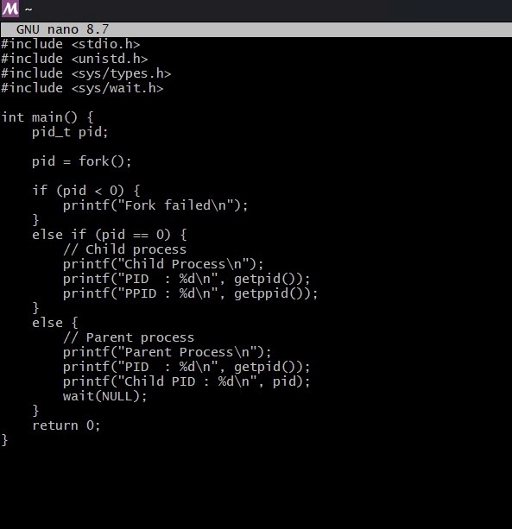

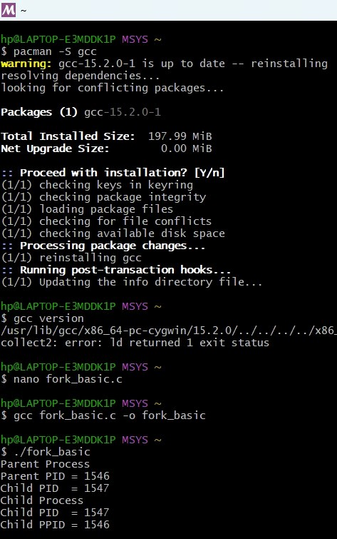

2. Write a program for process creation using C
(i) Orphan Process (ii) Zombine Process CODE:
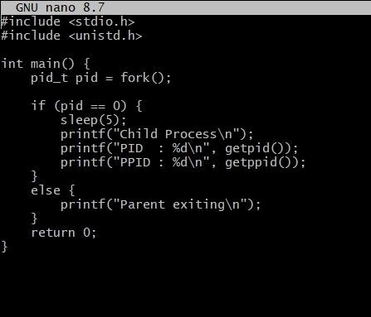
OUTPUT: 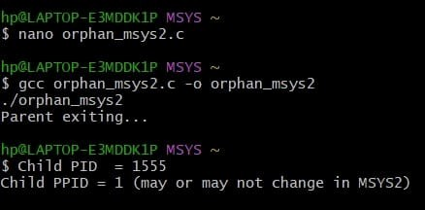
3. Create the process using fork () system call.
- Child Process creation
- Parent process creation
- PPID and PID CODE:
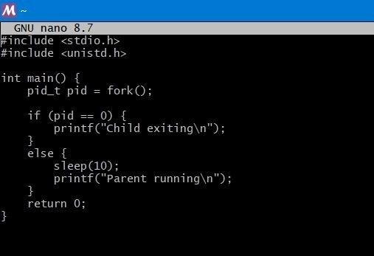
OUTPUT:
