1. BACKEND CORE LOGIC
This code builds a 43,632-sample synthetic grid and trains RandomForestRegressor(n_estimators=100, random_state=42) on hour, rain, passenger count and temperature using the locked risk formula.
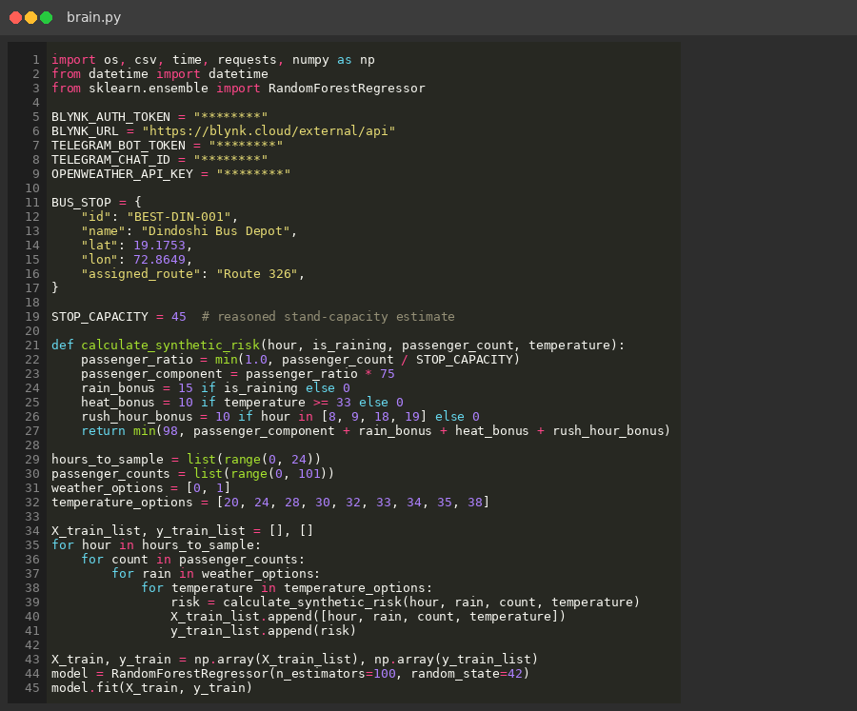
Image.1: Backend Core Logic

2. LIVE MONITORING AND CSV LOG
This code fetches Dindoshi weather from OpenWeatherMap, reads V1 and V4 from Blynk, predicts risk, classifies NORMAL / WARNING / CRITICAL, and appends one row to bus_stop_log.csv every five seconds.
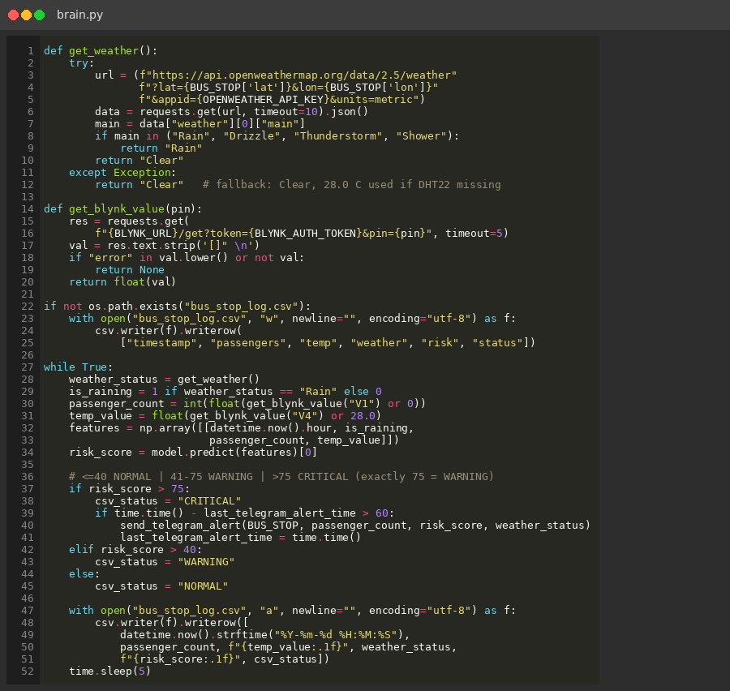
Image.2: Live Loop and CSV Logging

3. TELEGRAM ALERT AND BLYNK WRITE
This code sends a Telegram overcrowding alert when risk is above 75, subject to a 60-second cooldown, and writes weather, risk, time and status back to Blynk pins V2, V3, V5 and V6.
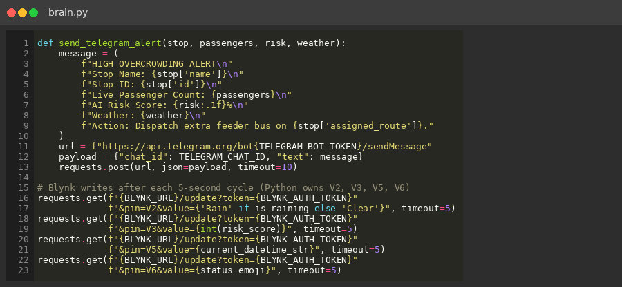
Image.3: Telegram and Blynk Output

4. ESP32 FIRMWARE LOGIC
This firmware confirms a passenger crossing after two consecutive VL53L0X readings below 400 mm, applies V7 as max(0, count-30), drives the LEDs from the Python risk on V3, and publishes V1, V4 and V8.
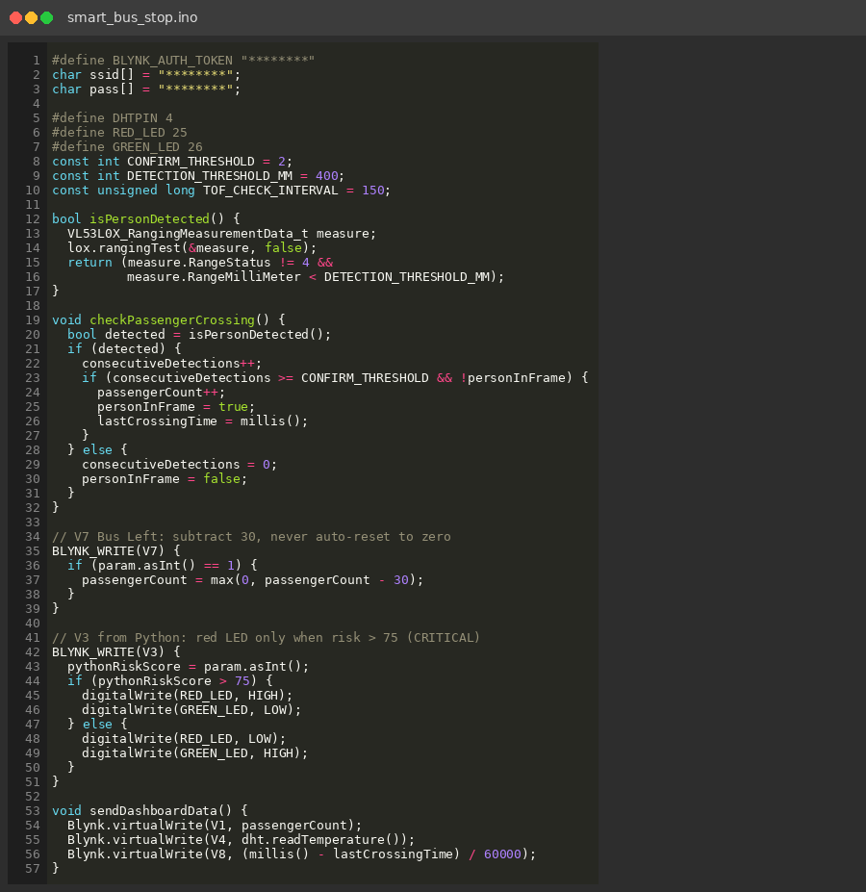
Image.4: ESP32 Crossing, V7 and LED Logic

5. CSV SENSOR LOG
This extract of bus_stop_log.csv shows live cycles at Dindoshi, including 65.0% WARNING at 30 passengers with rain and 90.0% CRITICAL at full-capacity rain cases.
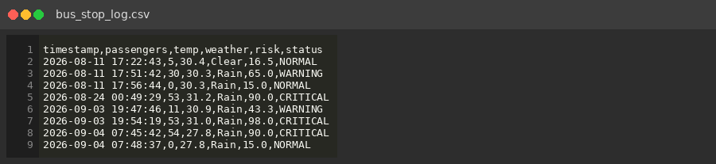
Image.5: CSV Log Extract

