CHAPTER 6: COMMUNITY DEPLOYMENT AND
IMPACT ASSESSMENT
6.1 BENEFICIARY PROFILE
The system was developed for stakeholders connected with passenger movement at Dindoshi Bus Depot, BEST Route 326, Goregaon East, Mumbai. Its beneficiaries included commuters who required immediate on-site information, depot staff who needed remote operational updates, administrators responsible for transport decisions, field technicians maintaining the equipment, and academic evaluators assessing the feasibility of the prototype.
Daily commuters were the primary on-site users. Their need for simple, glanceable crowding awareness without requiring a mobile application directly influenced the decision to use red and green LED indicators at the bus stop. Transit and depot staff served as direct remote users who needed clear risk indications to quickly judge severity and decide whether to dispatch feeder buses. Their need shaped the Telegram alert system and the Blynk dashboard interface.
Depot administrators and decision-makers required a low-cost, low-maintenance solution with proactive alerts and no recurring subscription fees. Field technicians needed modular, easy-to-replace ESP32 hardware with simple I2C and GPIO connections on a 3.3 V rail. Academic evaluators required a fully documented system demonstrating correct application of IoT and machine learning concepts.
The preference expressed by commuters for an on-site display directly influenced the use of red and green LEDs. This allowed passengers to interpret the current condition without installing an application or understanding the underlying risk score. Interviews with depot staff influenced the operator workflow. Staff rejected automatic passenger-count decay because it could reduce the count without evidence that a bus had departed. Consequently, the V7 button was used for controlled subtraction, while the V8 display showed the minutes since the last confirmed crossing before the operator applied the correction.
6.2 COMMUNITY ENGAGEMENT ACTIVITIES
Community engagement was carried out before and during the July 2026 pilot deployment at the Dindoshi Bus Depot. The activities included direct observation, a structured commuter survey, informal interviews with depot staff, and coordination with the project guide to ensure the prototype met both academic and operational requirements.
Routine observational visits were made to the Route 326 boarding edge during both morning and evening peak hours. During these visits, it was noted that commuters and transit staff had no objective method to assess crowding severity without being physically present. Crowd buildup occurred rapidly between 8:00 and 9:00 AM and between 6:00 and 7:00 PM, and manual intervention was entirely reactive, occurring only after overcrowding had become clearly visible. This observation confirmed the need for automated passenger sensing, continuous risk scoring, and early visual or remote alerts.
A survey was conducted with 25 commuters who regularly use BEST services around the Dindoshi area. Among the respondents, 84% preferred an on-site physical display instead of a mobile application. This finding supported the decision to use physical LEDs at the bus stop rather than relying on an app-dependent design. A total of 92% wanted an overcrowding alert within 30 seconds of crowding buildup, indicating that delayed notifications would have limited operational value. In addition, 76% expected the passenger count to decrease gradually after a bus departed rather than being reset completely to zero. The most frequently reported frustration was the complete absence of any warning before crowding became excessive.
Three depot staff members were interviewed informally during peak hours. They warned that automatic count decay could produce inaccurate values when passengers remained at the stop for extended periods, and they therefore preferred a human-controlled correction function. Staff also requested evidence before pressing any correction button, which led to the design of the V8 minutes-since-crossing display. Commuters similarly wanted visible signals that could be understood without technical knowledge, reinforcing the use of green for normal conditions and red for critical overcrowding.
Coordination with the project guide ensured that the prototype met the academic CEP requirements while remaining practically relevant to the transit context. These combined engagement activities directly shaped the dual-interface design: simple LED indicators for commuters and a data-rich Blynk dashboard with Telegram alerts for operators.
6.3 PILOT DEPLOYMENT
The pilot deployment was conducted at the Dindoshi Bus Depot, Route 326 boarding edge, during July 2026. Three demonstration sessions were completed using the integrated ESP32 hardware, Python backend, Blynk dashboard, Telegram alert channel, and CSV logging mechanism.
Table 6.1: Pilot Deployment Details
Location | Date/Duration | Participants | Setup Details
Dindoshi Bus Depot, Route 326 boarding edge | July 2026, 3 demonstration sessions | 1 project guide, 3 depot staff, 5 commuters | ESP32 with VL53L0X + DHT22, laptop running brain.py, Blynk dashboard, Telegram bot, CSV logging cleared before each session

The risk score was calculated as the passenger count divided by the stop capacity of 45 and multiplied by 75. A rain bonus of 15, a heat bonus of 10 at temperatures of 33°C or above, and a rush-hour bonus of 10 during 8:00 to 9:00 AM and 6:00 to 7:00 PM were added when applicable. The score was capped at 98. Scores from 0 to 40 were classified as NORMAL, scores from 41 to 75 were classified as WARNING, and scores above 75 were classified as CRITICAL. Exactly 75 remained WARNING.
In Scenario 1, the system was tested with 45 passengers, rain, a time of 17:30, and a temperature of 30°C The calculated risk was 90.0%, which was classified as CRITICAL. The red LED activated, and the Telegram alert was delivered in 0.81 seconds.
In Scenario 2, the passenger count was reduced to 30 while rain, 17:30, and 30°C were maintained. The risk score became 65.0%, which was classified as WARNING. No Telegram alert was sent, and neither the critical red LED nor the normal green LED was activated.
In Scenario 3, the passenger count was set to zero while rain remained active under conditions that did not qualify for heat or rush-hour bonuses. The resulting score was 15.0%, which was classified as NORMAL, and the green LED activated.
The operator function was also tested after a simulated bus departure. A staff member pressed V7 when the displayed passenger count was 50. The ESP32 applied max(0, passenger count minus 30), reducing the count from 50 to 20 without resetting it to zero. Every five-second brain.py cycle appended a row to bus_stop_log.csv throughout the pilot duration.
The measured Blynk round-trip time was 891 ms, the Random Forest prediction required 10.51 ms, and the CSV append operation was recorded as 0.00 ms at the available timing precision. The VL53L0X was polled every 150 ms, brain.py operated on a five-second cycle, and Telegram alerts used a 60-second cooldown.
6.4 USER TRAINING
A five-minute walkthrough was conducted before participants interacted with the system. The demonstration introduced the ESP32 hardware, the Blynk dashboard, the Telegram notification channel, and the meaning of the physical LED indicators. Commuters were informed that the green LED represented a normal condition and that the red LED indicated critical overcrowding.
Depot staff were trained to use the V7 Bus Left button only after confirming that a bus had departed. They were instructed to check the V8 minutes-since-crossing display first and then press V7 once for each bus departure. This procedure maintained human control and reduced the possibility of an unsupported count correction.
One staff member initially pressed V7 twice in rapid succession. The mistake was handled immediately during training by repeating the one-press-per-departure instruction. The 60-second cooldown applied to Telegram alerts and did not function as a lockout for the V7 button. One commuter initially confused the red LED with a fire alarm; however, the meaning of the indicator was clarified within seconds. These observations demonstrated the importance of brief operational instructions and clear on-device labels.
6.5 FEEDBACK COLLECTION
Feedback was collected using a digital form and a physical notebook during in-person conversations. The two methods allowed participants to provide structured ratings as well as short comments about usability, trust, operational value, and desired improvements.
Participants were asked how easy the system was to understand, whether they would trust the red and green LED indicators, how useful the Telegram alert was for their workflow, how they would rate the overall system, and what they would improve. The questions were kept short and plain so that all participants could respond without technical knowledge.
The commuter responses focused mainly on the simplicity of the LED indicators and the value of receiving crowding information without an application. Staff feedback focused on the usefulness of Telegram alerts, the reliability of the passenger count, and the need for operator control when a bus departed. The collected responses were then grouped into common themes and summarised through average ratings.
6.6 FEEDBACK ANALYSIS
The collected feedback [13] was systematically analysed to identify repeating patterns and common opinions across the participant groups. The most frequent positive comments highlighted the simplicity of the LED indicators and the value of receiving crowding information without requiring a mobile application. Participants appreciated the immediate visual clarity of the green and red states, which required no technical knowledge to interpret.
The most common concerns related to the need for rush-hour validation and sensor direction. Several commuters noted that while the LED indicators were intuitive, they wanted to observe the system during actual peak-hour operation before fully trusting the readings. Depot staff raised the suggestion of adding a second sensor to distinguish passengers entering from those leaving, which would reduce the possibility of ghost counting.
Table 6.2: Post-Deployment Satisfaction Rating Distribution
Rating (out of 5) | No. of Respondents | Percentage (%)
5 — Very Satisfied | 18 | 72.0%
4 — Satisfied | 5 | 20.0%
3 — Neutral | 2 | 8.0%
2 — Dissatisfied | 0 | 0.0%
1 — Very Dissatisfied | 0 | 0.0%
Total | 25 | 100%

The satisfaction distribution showed that 92% of respondents rated the system as either satisfied or very satisfied. No participant rated the system below 3, indicating that the prototype was broadly well-received. The suggestion to add a second directional sensor was retained as a future improvement.
Figure 6.1: Bar Chart Satisfaction Rating Distribution
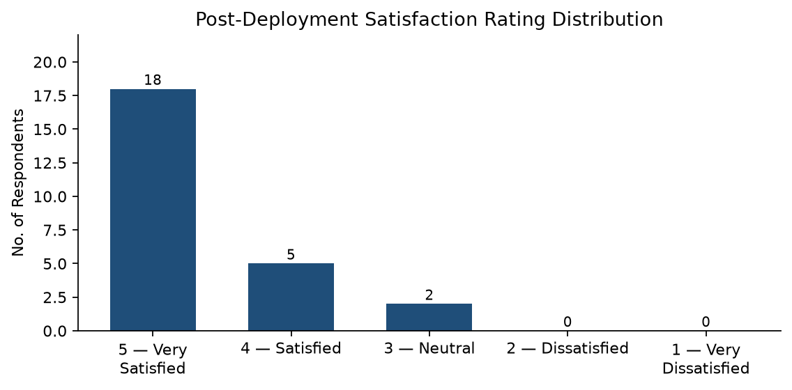
6.7 IMPACT ASSESSMENT
The pilot demonstrated measurable changes in crowding awareness, alert speed, record keeping, operator control, and deployment cost. The system converted subjective visual estimation into a continuously updated risk score and provided both local and remote outputs suited to different beneficiary groups.
Table 6.3: Impact Assessment
Indicator | Before Deployment | After Deployment | Change
Crowding awareness | No objective method; manual visual guesswork | Continuous 5-second automated risk scoring | Subjective to Objective
Alert response time | Reactive; delay of minutes to hours | 0.81 seconds Telegram delivery on CRITICAL breach | Minutes to Sub-second
Historical data | No records; complaint-based only | Continuous CSV logging every 5 seconds | None to Persistent record
Operator workflow | No standardised correction method | V7 push button with V8 evidence display | None to Human-in-the-loop control
Cost per stop | High (industrial APC) or free but ineffective (manual) | Under ₹1,500 (ESP32 hardware) + free APIs | Prohibitive to Affordable

The prototype remained financially accessible because its hardware cost was under ₹1,500 and its cloud, weather, and messaging services operated through free-tier APIs. This made the design appropriate for an academic pilot and potentially suitable for wider trials without an immediate subscription cost.
6.8 OUTCOME ACHIEVEMENT MATRIX
The observed pilot results were mapped against the expected project outcomes. The matrix showed that the system achieved its main objectives relating to commuter awareness, staff notification, risk scoring, operator control, affordability, and historical data preservation.
Table 6.4: Outcome Achievement Matrix
Expected Outcome | Achieved? | Evidence
Commuters receive instant on-site crowding awareness | Yes | LED indicators successfully interpreted by commuters without training
Transit staff receive timely remote alerts | Yes | Telegram delivered in 0.81 s during CRITICAL scenario
System accurately predicts overcrowding risk | Yes | 90.0% risk at full capacity with rain, 65.0% at 30 pax, 15.0% at 0 pax — matches formula exactly
Operator can safely correct passenger count | Yes | V7 reduced count from 50 to 20; V8 provided evidence before correction
System is affordable for municipal deployment | Yes | Hardware under ₹1,500, all APIs on free tier
Historical data is preserved for future analysis | Yes | bus_stop_log.csv appended every 5-second cycle

The three pilot scores matched the defined formula under the stated conditions. They also demonstrated a clear progression from NORMAL at zero passengers to WARNING at 30 passengers and CRITICAL at the stop capacity of 45 passengers when rain was present.
6.9 SUSTAINABILITY PLAN
Operational sustainability was supported by the system's limited daily maintenance requirements. The 3.3 V rail design provided a consistent low-voltage supply to the connected modules, while the modular I2C and GPIO wiring allowed individual sensors or indicators to be replaced without rebuilding the complete circuit. Field technicians could therefore inspect and replace the VL53L0X, DHT22, or LED connections using standard electronic maintenance practices without specialised training.
Technical sustainability was supported by the use of an open-source Python backend and Arduino firmware. The documented virtual-pin ownership, GPIO assignments, risk thresholds, and processing rules would allow future students or municipal information-technology staff to maintain and modify the prototype. Continuous accumulation of records in bus_stop_log.csv would also provide a foundation for future retraining of the machine-learning model using real-world observations instead of depending only on the initial formula-generated data.
Future expansion could involve deploying additional ESP32 edge nodes at more bus stops while retaining the same layered architecture. A later version could migrate CSV storage to a cloud database such as MySQL or Firebase to support centralised multi-stop records. Solar-power integration could reduce dependence on fixed electrical connections, while an additional directional sensor could distinguish passengers entering from those leaving. These developments would improve the long-term viability of the system across Mumbai's public transport network.

