FIELD VISIT PHOTOGRAPHS
Image.1
The prototype device is mounted on the shelter pillar during field testing on a stop containing a passenger queue. The setup demonstrates real-world bus-stop overcrowding monitoring with GPS location recording for depot maintenance.
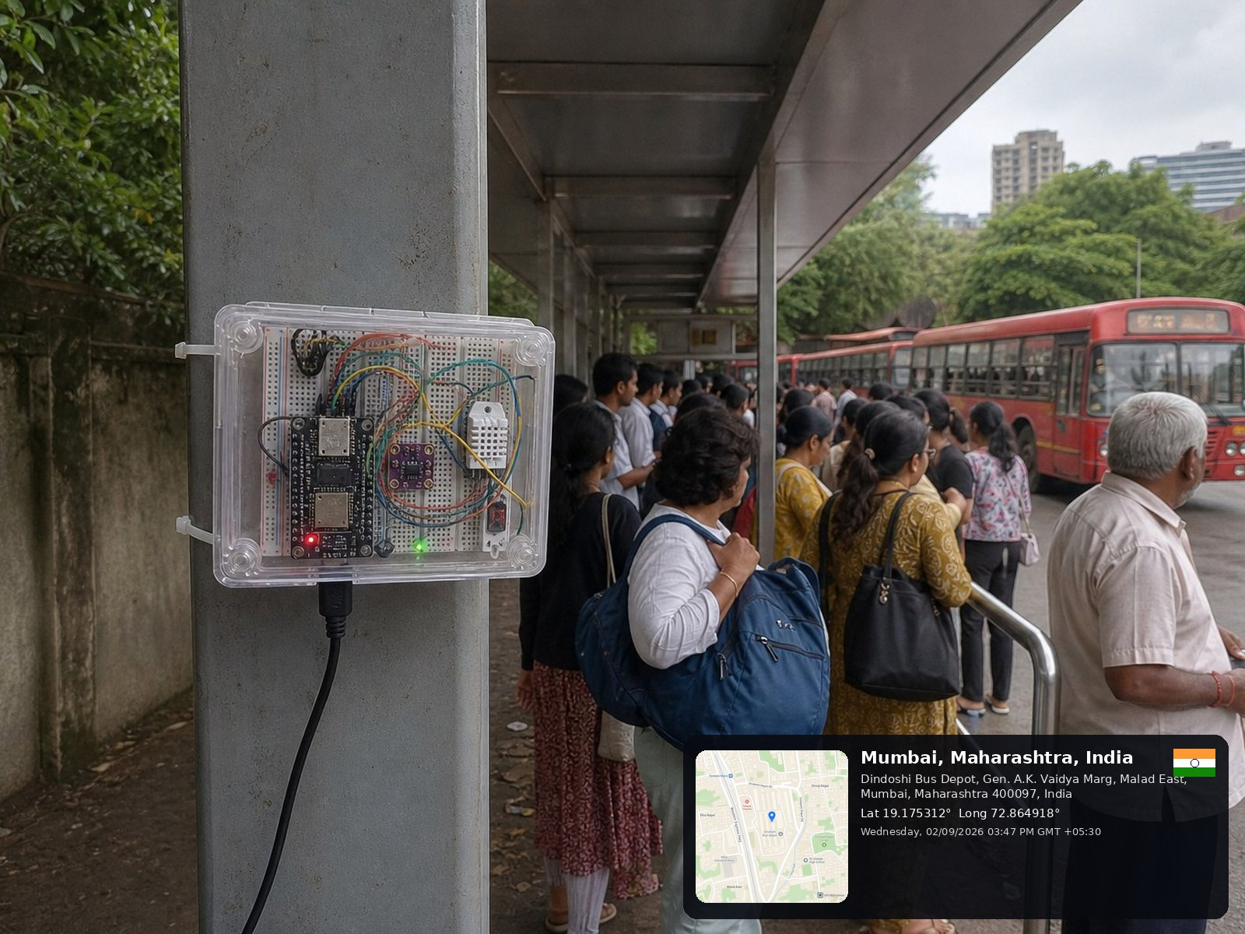
Image.1: Field Demonstration
Image.2
Close-up view showing the enclosed electronic components mounted securely on the shelter pillar for sensor-based overcrowding monitoring.
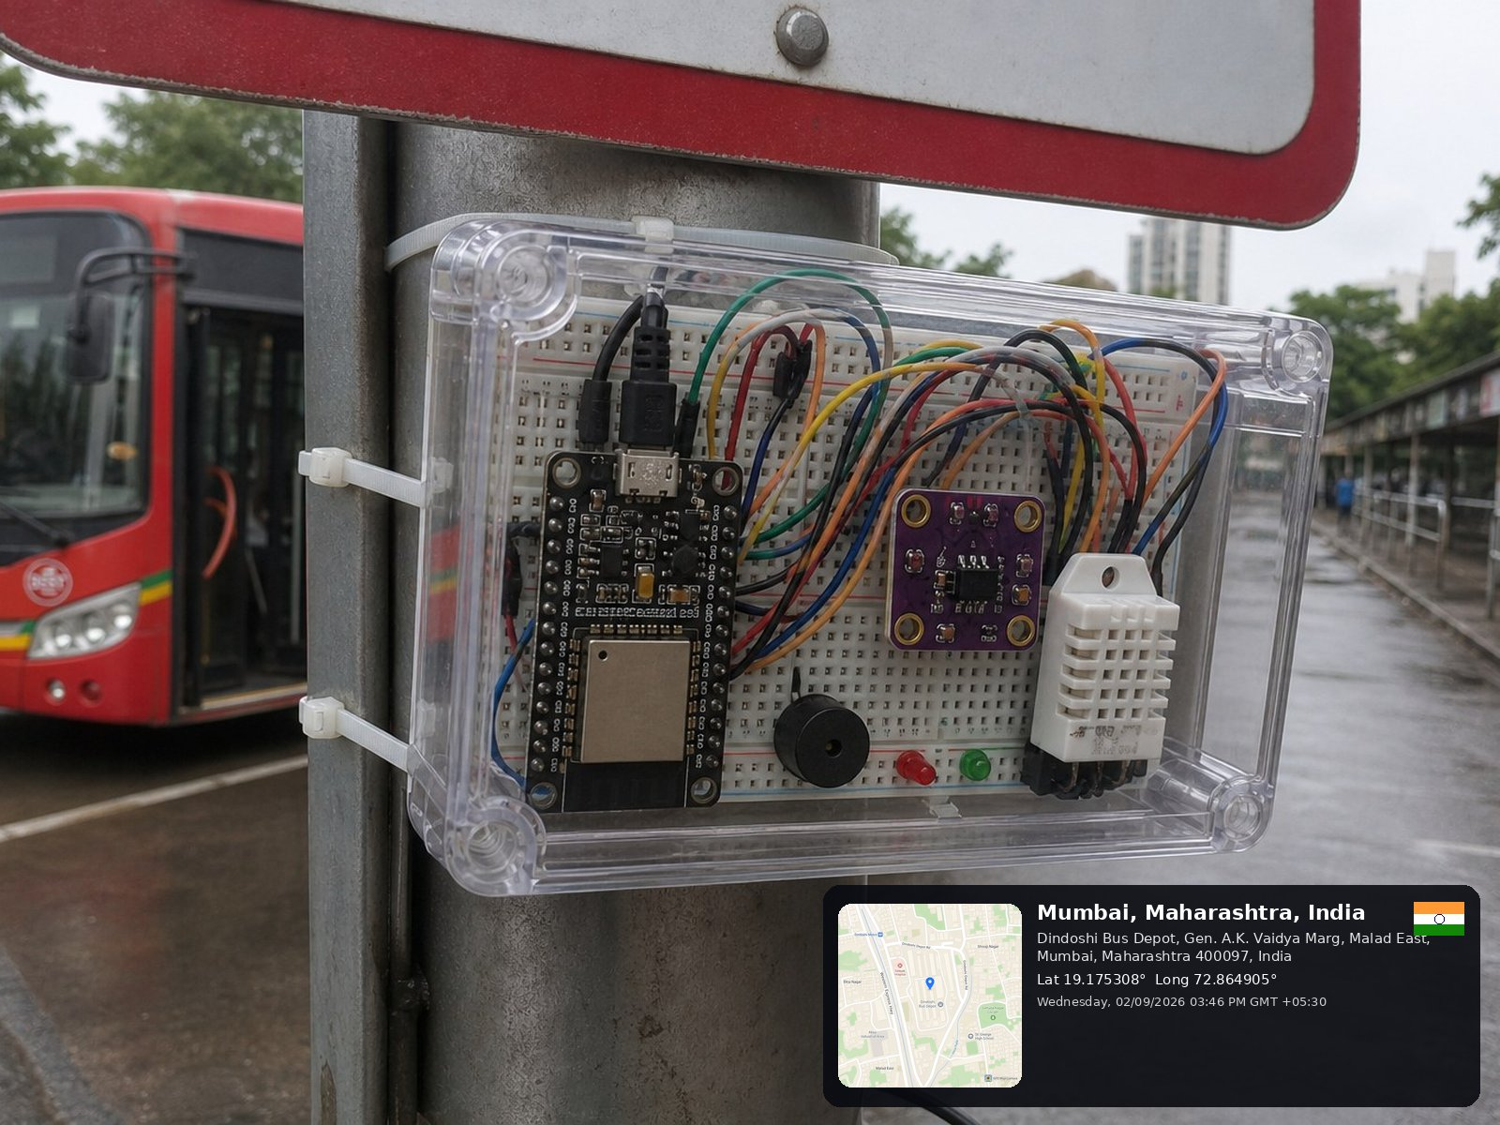
Image.2: Close-up Prototype on Shelter Pillar

Image.3
The original photograph shows the approach to the Dindoshi bus-stop shelter, its railings and waiting passengers. The bus and pedestrian movement provide context for selecting a sensing location.
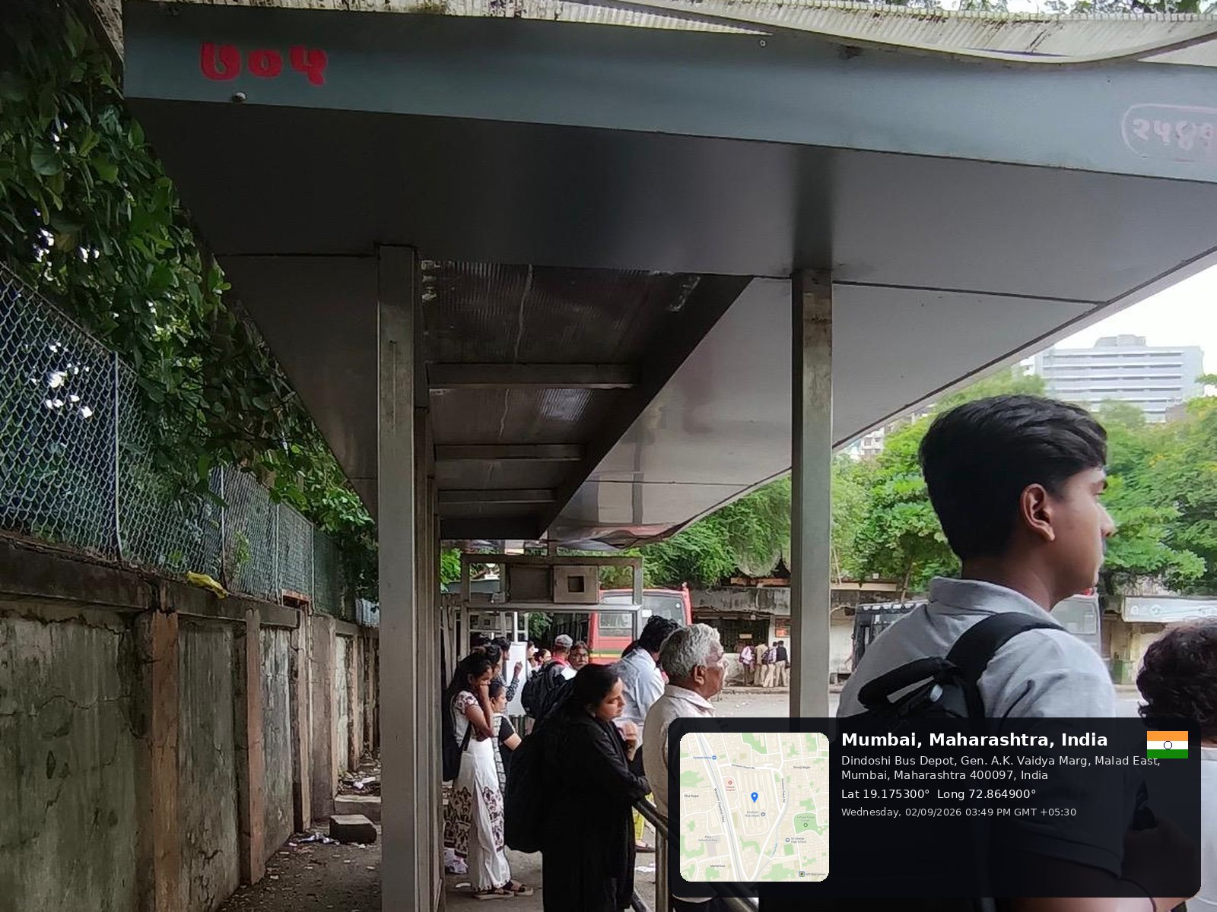
Image.3: Bus-Stop Approach and Waiting Area
Image.4
This image shows a bus stop with several commuters queued along the shelter after daytime operations. Many of the passengers are waiting under the canopy, while BEST buses stand in the depot yard.
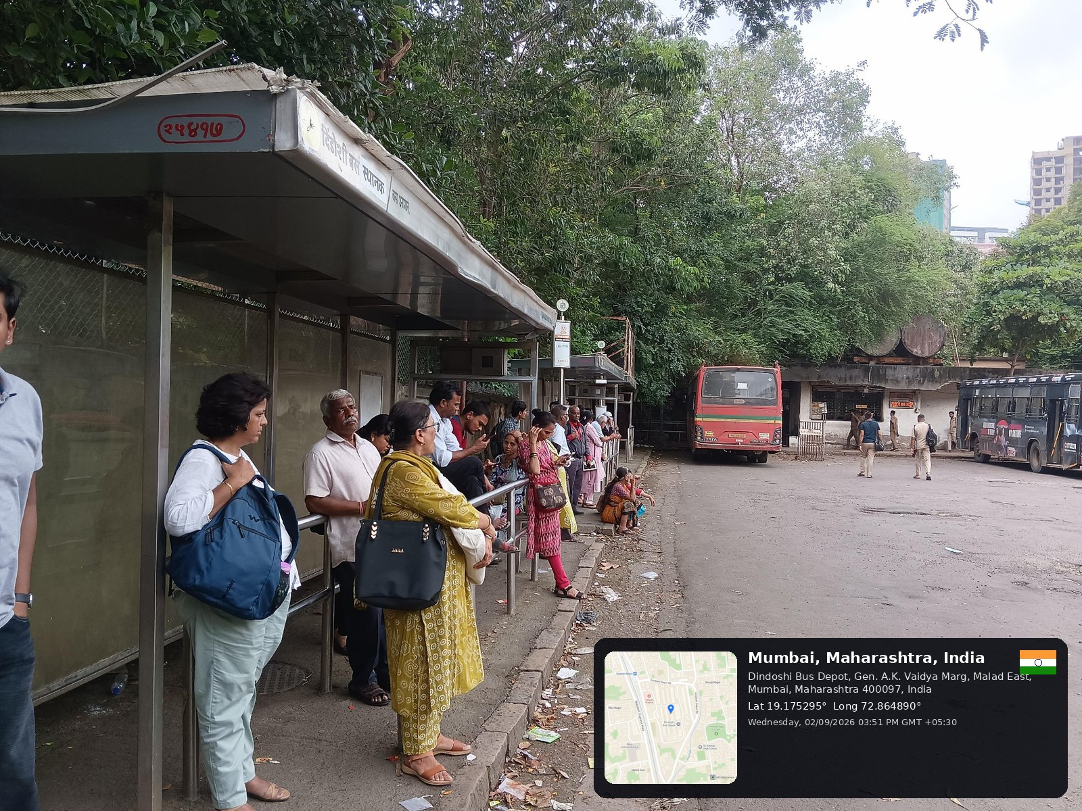
Image.4: Field Observation of an Overcrowded Bus Stop
The crowded waiting area is harder to judge by eye alone. The image provides a real-world example of overcrowding in a busy urban depot.

Image.5
This original wide view shows parked BEST buses and the covered passenger platform. It records the surrounding depot layout and the relationship between the waiting area and vehicle movement.
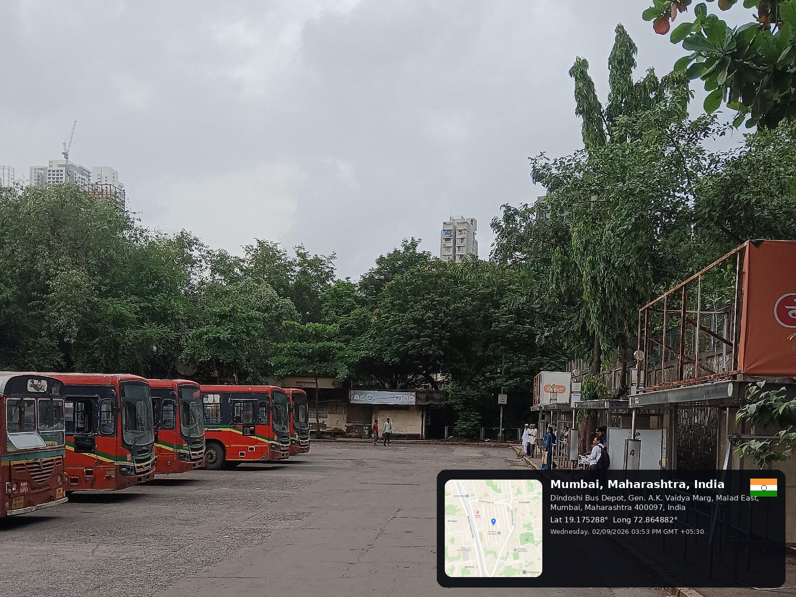
Image.5: Dindoshi Bus Depot Yard
Image.6
The original photograph shows the shelter pillars, railing and queue beneath the canopy at Dindoshi Bus Depot.
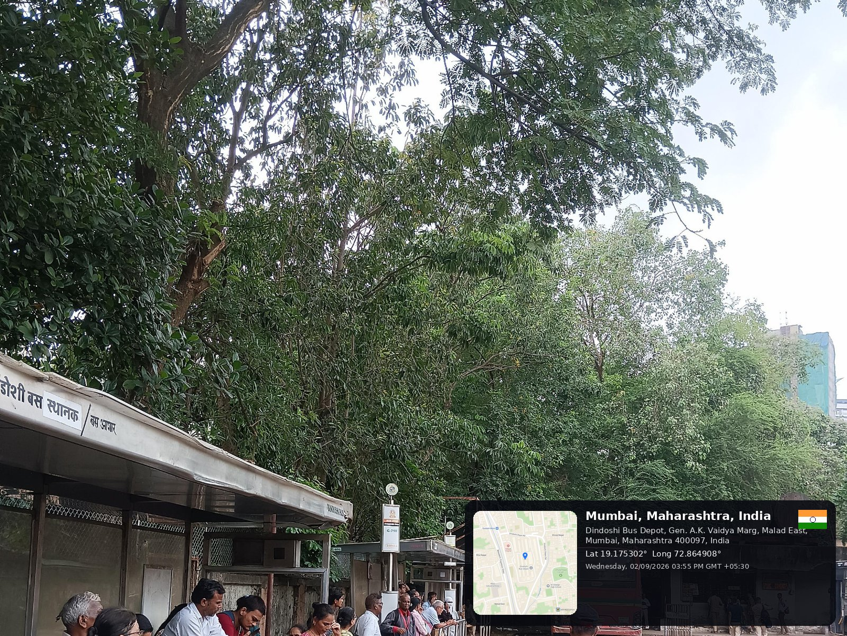
Image.6: Passenger Queue at Dindoshi Bus Depot

